

**National University of Computer and Emerging Sciences**

FYP Report Document

**“MedTrove”**

**(Development)**



**Group Members:**

Aliza Ibrahim 21I-0470

Kissa Zahra 21I-0572

Hamna Sadia Rizwan 21I-0603

**Supervisor: Co-Supervisor:**

Mr. Bilal Khalid Dar Ms. Zoya Mahboob

# Table Of Contents

Table Of Contents 1

List of Figures 4

List of Tables 4

Chapter 1- Introduction 5

1.1 Problem Statement 5

1.2 Scope 6

1.3 Modules 7

1. Medi-bot 7

2. Substitute Drug Identifier 7

3. Smart Search and Recommendation 7

4. Substitute Comparison 7

5. Payment 7

6. Donation 7

7. Drug Interaction Checker 7

8. Pharmacy Locator 8

9. Medication Reminder 8

10. Profile Management 8

1.4 User Classes and Characteristics 9

1.5 Stakeholders 9

Chapter 2 - Project Requirements 10

2.1 Use case 10

Substitute Drug Identifier 10

**High Level/Brief Use Case** 10

**Fully Dressed Use Case** 10

Search and Recommendation 12

**High Level/Brief Use Case** 12

**Fully Dressed UseCase** 12

Profile Management 14

**High Level/Brief Use Case** 14

**Fully Dressed UseCase** 14

2.2 Functional Requirements 16

1. (Module) Substitute Drug Identifier 16

2. (Module) Search and Recommendation 16

3. (Module) Drug Interaction Checker 16

4. (Module) Medication Reminder 17

5. (Module) Substitute Comparison 17

6. (Module) Profile Management 17

7. (Module) Medi-bot 17

8. (Module) Payment 18

9. (Module) Donation 18

10. (Module) Pharmacy Locator 18

2.3 Non-Functional Requirements 19

● Performance 19

● Usability 19

● Reliability 19

Chapter 3 - System Overview 20

•Architectural Diagram 20

• Use Case diagram 21

• Domain Model Diagram 22

• Class Diagram 23

• Entity relationship diagram (ERD) 24

• Activity Diagram 25

Substitute Drug Identifier 25

Search and Recommendation 26

Profile Management 27

• System Sequence Diagram 28

• Sequence Diagram 30

Substitute Drug Identifier 30

Search and Recommendation 31

Profile Management 32

• Wireframes 33

Implementation 35

Iteration 1 35

Implementation Screenshots 36

Conclusion 43

*Bibliography* 44

# List of Figures

Figure 1: Architectural Diagram 20

Figure 2: Use Case Diagram for MedTrove 21

Figure 3: Domain Model for MedTrove 22

Figure 4: Class Diagram for MedTrove 23

Figure 5: Entity Relationship Diagram for MedTrove 24

Figure 6: Activity Diagram for Substitute Drug Identifier 25

Figure 7: Activity Diagram for Search and Recommendation 26

Figure 8: Activity Diagram for Profile Management 27

Figure 9: System Sequence Diagram for MedTrove 29

Figure 10: Sequence Diagram for Substitute Drug Identifier 30

Figure 11: Sequence Diagram for Search and Recommendation 31

Figure 12: Sequence Diagram for Profile Management 32

Figure 13: Timeline 35

# List of Tables

Table 1: User Classes and Characteristics 9

Table 2: High level use case for Substitute Drug Identifier 10

Table 3: Fully dressed use case for Substitute Drug Identifier 11

Table 4: High level use case for Search and Recommendation 12

Table 5: Fully dressed use case for Search and Recommendation 13

Table 6: High level use case for Profile Management 14

Table 7: Fully dressed use case for Profile Management 15

# Chapter 1- Introduction

The product described in this document is **MedTrove**, a cross-platform application that helps users find alternative medications with similar ingredients at lower costs. It also offers features like managing profiles, drug interactions and providing chatbot assistance.

This document is intended for several types of readers. Developers will use it to understand the technical requirements needed to build the app. Project managers will refer to it to ensure the project stays on track and meets the set goals. Marketing staff will gain insights to promote the product effectively. Users will be able to understand how the app works and what features it offers. Testers will use the document to identify what aspects need testing to ensure quality and documentation writers will use it to create user guides and other necessary documentation.

## 1.1 Problem Statement

Unfortunately, the capitalisation of healthcare has become a pressing concern. Over the past few years the cost of medications have skyrocketed, making it increasingly difficult for Pakistanis to afford potentially life saving medicines.

In 2019, Drug Regulatory Authority of Pakistan (DRAP*)* approved the increase of the prices of medicines by up-to 15 percent. Hardship medicines which include medicines for heart patients and diabetics have increased up to 200%. [1]. In 2024, this trend continued as the caretaker, federal cabinet approved a further increase in prices of an approximate 146 critical medications. [2]

Diabetes and heart disease are one of the more common health issues in Pakistan, given that 26.7% of Pakistanis are affected by diabetes [3] whereas 29% of deaths in Pakistan are due to heart diseases. [4]. Therefore, the increased cost of the related medicine proves to be threatening to public health.

It is absolutely imperative to also note that as of 2024, 40% of Pakistanis now live below the poverty line according to the World Bank making it even more difficult to afford life-saving medication. [5]

With sky high inflation rates and the tradition of bribery between doctors and pharmaceutical companies disguised as “academic activities” to manipulate doctors into prescribing overpriced medications, innovative solutions are required to bridge the gap between Pakistanis and their right to affordable healthcare. [6]

## 1.2 Scope

MedTrove will be a cross-platform application that users can download onto their mobile device. After downloading the app, our users can create their account or login.

If the user decides to manage their profile, they can change their credentials, profile picture, delivery address and save it. An option to delete the account will also be available.

If the user decides to search for some medication, they may get recommended searches based on their previous search/order history and alternative medication of their searched medication. The user may select a medicine to view it’s detailed information such as its side effects, usage instructions including dosage, details on the diseases it is used to treat and compare it with other alternatives. An add to cart option will also be available.

Once they are finished, the user can checkout and begin the payment process. Payment can be made either by credit/debit card or JazzCash. Once completed, a verification message will pop up and the order-will be sent.

Alternatively, the user may also choose to check for drug interactions using our drug interaction check feature. For this the user must enter two different types of medication and the result will be whether or not such medication can be taken together at once.

MedTrove also provides a chatbot called Medibot which will provide preliminary medical advice, information about medication and help break down difficult words doctors use in a friendly, conversational manner.

Finally, if the user has the means and is willing to, they can provide donations to help those who may not have the means to pay for their medication.

## 1.3 Modules

We have 10 different modules in our project, which are as follows:

### Medi-bot

This module is designed to provide users with instant access to preliminary-advice and give detailed information about medications. This AI-powered assistant enhances user engagement by offering real time guidance.

### Substitute Drug Identifier

This module helps users find cheaper alternatives to their prescribed medications. It uses a detailed drug database to suggest substitute medicines that have similar ingredients.

### 

### Smart Search and Recommendation

This module uses smart techniques to look at what users search for and give them alternative medicine recommendations. It will also show the medication they searched for if it's available.

### Substitute Comparison

This module is designed to provide users with a detailed analysis of a possible substitute medication. It compares alternative medication based on several factors that enable users to make informed decisions.

### Payment

The goal of this module is to simplify secure financial-transactions for purchasing medications.

### Donation

This module is designed to help pay for users in need. It allow users to contribute into a fund that will be used to provide discounted medications for underprivileged individuals.

### 

### Drug Interaction Checker

This module will analyse the interactions between two medications and evaluate whether they are safe to take at a time or not.

### Pharmacy Locator

The purpose of this module is to help users find pharmacies nearby. Users will have access to real-time information on pharmacy locations, contact details and business hours.

### Medication Reminder

This module is designed with the purpose of efficiently assisting users in managing their medication schedules. Users will receive timely reminders to help them take their medication.

### Profile Management

This module is designed with the purpose of providing users a secure platform for managing their personal information. Users will be able to customise their profiles by managing their health data and access services.

## 1.4 User Classes and Characteristics

|  |  |
| --- | --- |
| **User Class** | **Description** |
| User | The primary users of the app who seek alternatives for their prescribed medicines, these users should have basic smartphone literacy. |

Table : User Classes and Characteristics

## 1.5 Stakeholders

* Our Team: Kissa Zahra, Hamna Sadia Rizwan and Aliza Ibrahim
* Supervisor: Mr. Bilal Khalid Dar
* Co-supervisor: Ms. Zoya Mahboob
* FAST-NUCES FYP committee ISB
* Patients
* Pharmacist

# Chapter 2 - Project Requirements

## 2.1 Use case

### Substitute Drug Identifier

#### **High Level/Brief Use Case**

|  |  |
| --- | --- |
| **Use Case** | Substitute Drug Identifier |
| **Actors** | User |
| **Type** | Primary |
| **Description** | The system shall identify the list of substitute drugs according to the drug selected by the user. |

Table : High level use case for Substitute Drug Identifier

#### 

#### **Fully Dressed Use Case**

|  |  |
| --- | --- |
| **Use case** | Substitute Drug Identifier |
| **Scope** | MedTrove |
| **Level** | User goal |
| **Primary actor** | Users |
| **Stakeholders & Interests** | 1. Users 2. MedTrove Developers 3. Supervisor: Mr. Bilal Khalid Dar 4. Co-Supervisor: Ms. Zoya Mahboob 5. FAST-NUCES FYP committee (Islamabad) |
| **Preconditions** | The medication database is up to date and accessible by the system. |
| **Success guarantee** | The system successfully retrieves the appropriate alternative medications and displays the results  Relevant data about the medication is shown (e.g: price and availability). |
| **Main success scenario** | 1. User successfully navigate to the search page. 2. The user searches for the name of the medicine. 3. The system processes the search query. 4. The system retrieves the searched medication and alternative medications according to the chemical formula 5. The system displays the recommended alternatives with their details |
| **Extensions** | **1a:** No alternatives found:   * The system does not find any alternative substitutes and informs the user |
| **Special requirements** | The system shall be able to retrieve the substitute medicine list within 5 seconds. |
| **Technology & Data Variations** | None. |

### 

Table : Fully dressed use case for Substitute Drug Identifier

### Search and Recommendation

#### **High Level/Brief Use Case**

|  |  |
| --- | --- |
| **Use Case** | Search and Recommendation |
| **Actors** | User |
| **Type** | Primary |
| **Description** | The user can input the name of the medicine and the system will recommend a list of alternative medications, prioritising cheaper price. |

Table : High level use case for Search and Recommendation

#### **Fully Dressed UseCase**

|  |  |
| --- | --- |
| **Use Case** | Search and Provide Recommendations |
| **Scope** | MedTrove |
| **Level** | User goal |
| **Primary actor** | User |
| **Stakeholders & Interests** | 1. Users 2. MedTrove Developers 3. Supervisor: Mr. Bilal Khalid Dar 4. Co-Supervisor: Ms. Zoya Mahboob 5. FAST-NUCES FYP committee (Islamabad) |
| **Preconditions** | The medication database is up to date and accessible by the system. |
| **Success guarantee** | The system successfully displays a list of medications including cheaper alternatives.  Relevant data about the medication is shown (e.g: price and availability). |
| **Main success scenario** | 1. User successfully logs in and navigates to search page. 2. The user enters the name of a medicine. 3. The system processes the search query. 4. The system retrieves relevant medication data and recommendations. 5. The system displays the search results and recommended alternatives sorted by price. 6. The user can select a medication for more details. |
| **Extensions** | **1a:** Invalid Search Query:   * If the user enters an invalid query the system shows an error message and suggests correcting the search input.     **3a:** No Relevant Recommendations Found:   * If no suitable alternatives are found the system shows the users that no cheaper substitutes are available for the entered medication. |
| **Special requirements** | The system shall be able to display a list of alternative medicines within 5 seconds. |
| **Technology & Data Variations** | None. |

Table : Fully dressed use case for Search and Recommendation

### Profile Management

#### **High Level/Brief Use Case**

|  |  |
| --- | --- |
| **Use Case** | Profile Management |
| **Actors** | User |
| **Type** | Primary |
| **Description** | Users can create, update and delete their profile. The profile includes health-related information, previous medication history and other preferences. |

Table : High level use case for Profile Management

#### **Fully Dressed UseCase**

|  |  |
| --- | --- |
| **Use Case** | Profile Management |
| **Scope** | MedTrove |
| **Level** | User goal |
| **Primary Actor** | User |
| **Stakeholders & Interests** | 1. Users 2. MedTrove Developers 3. Supervisor: Mr. Bilal Khalid Dar 4. Co-Supervisor: Ms. Zoya Mahboob 5. FAST-NUCES FYP committee (Islamabad) |
| **Preconditions** | The user must have successfully logged into the system. |
| **Success Guarantee** | User profile is updated and stored securely in the database. |
| **Main Success Scenario** | 1. User log-in to the MedTrove app. 2. User navigate to the “Profile Management” section. 3. The system displays the current user profile details. 4. Users edit their personal details (e.g: Delete or Update). 5. User confirms the changes. 6. System updates the user profile in the database. 7. The system displays a success message, confirming the changes. |
| **Extensions** | **4a:** If the user enters invalid information:   * The system displays an error message. * Users will be prompted to correct the input before proceeding further.   **5a:** User cancels the update:   * No changes are made to user profile.   **6a:** System fails to update the profile due to network or some other issue:   * The system notifies the user about the issue. * No changes will be made to the profile * The system will ask the user to try later. |
| **Special Requirements** | The system shall be able to load and update profile within 5 seconds. |
| **Technology & Data Variations** | None. |

Table : Fully dressed use case for Profile Management

## 2.2 Functional Requirements

### (Module) Substitute Drug Identifier

* The system shall allow user to input the name of the prescribed medication.
* The system shall be able to access drug database.
* The system shall identify alternative medicines with similar ingredients.
* The system shall compare alternative drugs based on price.
* The system shall display a list of alternative drugs ranked by relevance.
* The system shall display detail information on each alternative drug.
* The system shall give the option to buy the alternative drug.
* The system shall display disclaimer advising the user to consult healthcare professionals before taking any medication.

### (Module) Search and Recommendation

* Users shall be able to search for medicines by entering its name.
* The system shall provide auto-complete suggestion as users type the name of the medicine.
* The system shall allow filtering of search results based on price.
* The system shall give the option to buy the medicine.
* The system shall provide recommendations to user based on previous searches.
* The system shall display search results and recommendations in a clear and user-friendly manner.

### (Module) Drug Interaction Checker

* The system shall allow users to input the name of two medications.
* The system shall access a drug interaction database.
* The system shall classify interactions based on severity such as minor, moderate and major.
* The system shall display whether the medications can be taken together or not.

### (Module) Medication Reminder

* The user shall be able to set medication reminder.
* The system shall allow users to input medication details, like the name, dosage, date and timing.
* The system shall provide timely reminders and notifications to the user.
* The system shall allow users to set a new alert time.
* The system shall provide options to reschedule missed doses.
* The system shall maintain a log of medication intake including date and time of each dose taken.

### (Module) Substitute Comparison

* The system shall allow users to input the name of the prescribed medication they want to compare substitutes for.
* The system shall do a comparison between alternative medications based on price and potential side effects.
* The system shall highlight key differences between the prescribed medication and its respective substitutes.

### (Module) Profile Management

* The system shall allow new user to register by providing personal details such as email, phone number and password.
* The user shall be able to login using their email address and password.
* The system shall allow users to update personal information.

### (Module) Medi-bot

* The system shall provide user-friendly interface for initiating and conducting conversations with chatbot.
* The user shall be able to enter medical questions in the chat.
* The system shall provide preliminary medical advice on common health issues based on user input.
* The system shall provide information about medication including recommended dosage and side effects.
* The system shall guide users on when to seek professional medical help for their symptoms.

### (Module) Payment

* The system shall allow users to select a payment method including credit/debit cards and JazzCash.
* The system shall provide an option to save payment information for any future use.
* The system shall display an order summary before confirming the payment.
* The system shall send a confirmation notification to the user upon successful payment.
* The system shall maintain a record of all user transactions.
* The system shall notify users of successful payments, failed transactions and any other payment related updates.

### (Module) Donation

* The system shall allow user to make donations through various payment methods including credit or debit cards and digital wallets.
* The system shall maintain log for all donations made by users including the amount, date and the payment method.
* The system shall provide users with a history of their donations.
* The system shall allow allocation of donated funds to discount orders for underprivileged users.
* The user shall fill a form to prove their eligibility for discounts and funds.

### (Module) Pharmacy Locator

* The system shall allow users to search for nearby pharmacies based on their current location.
* The system shall display detailed information about the nearby pharmacies.
* The system shall provide directions to searched pharmacies
* The system shall allow users to save favourite pharmacies for easy access.

## 2.3 Non-Functional Requirements

### Performance

* + PER-1: The application shall load within 4 seconds.
  + PER-2: Medicine results shall be displayed within 5 seconds.

### Usability

* + USE-1: The user interface shall be easy to navigate.
  + USE-2: There shall be at least 2 helping screens between each frame.

### Reliability

* + The system shall have an uptime of 95%.
  + Backups and recovery mechanisms shall be implemented to prevent data loss.

# Chapter 3 - System Overview

## •Architectural Diagram

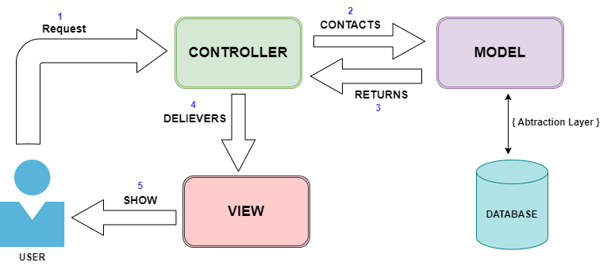

Figure : Architectural Diagram

MedTrove will be designed using the Model-View-Controller (MVC) architecture, to provide a personalised experience for each user.

The model will manage the apps data, the view would display this data and the controller would handle user input and update the model and view for each of its users.

## • Use Case diagram

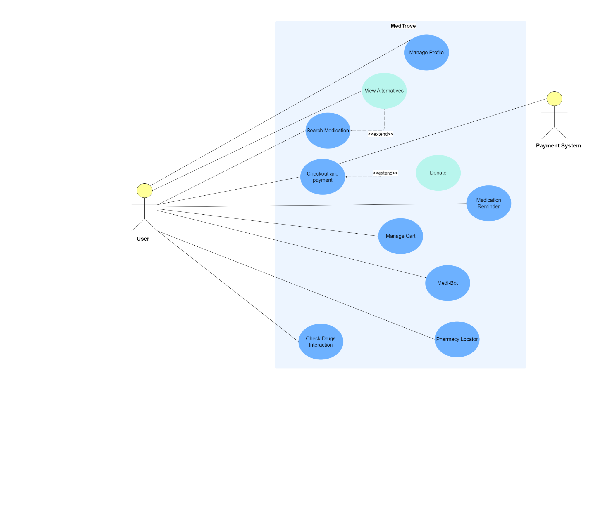

Figure : Use Case Diagram for MedTrove

## • Domain Model Diagram

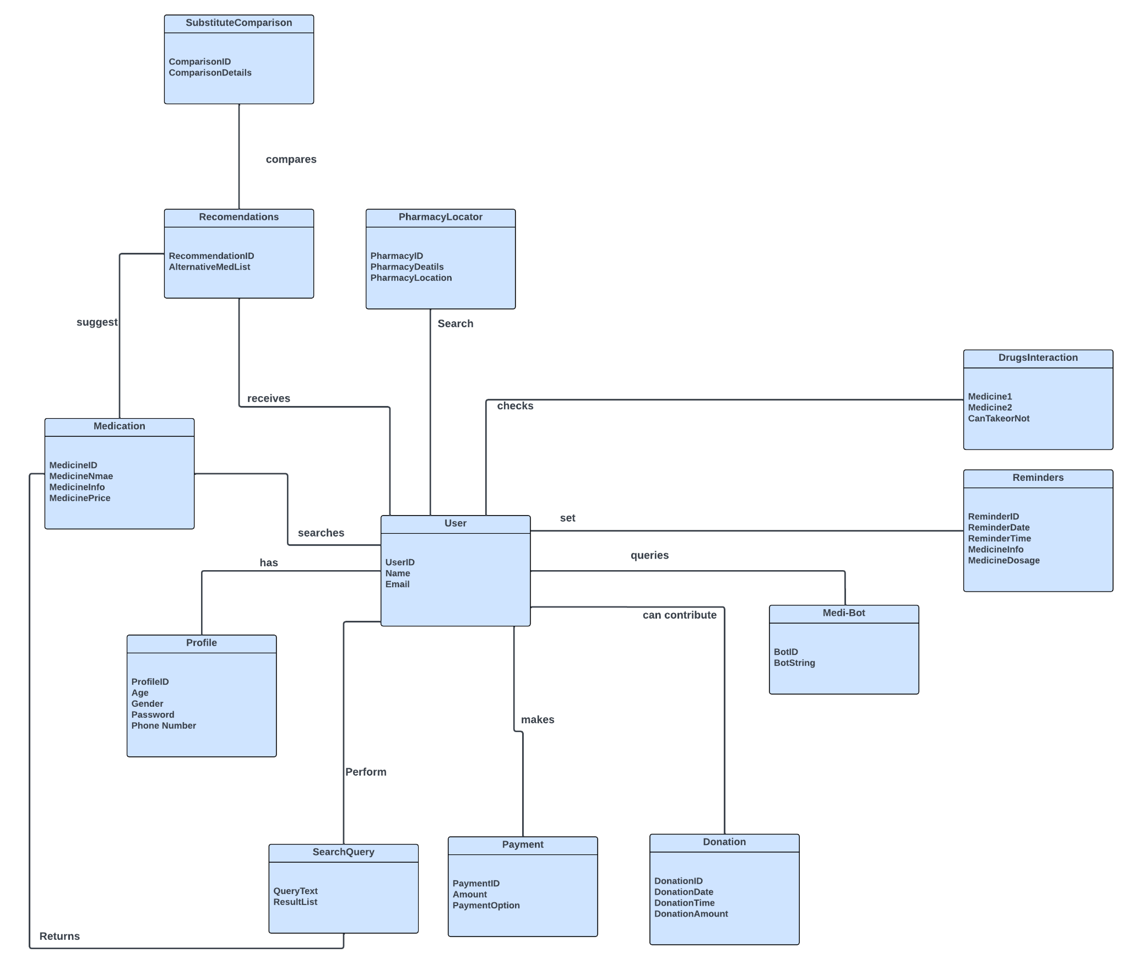

Figure : Domain Model for MedTrove

## • Class Diagram

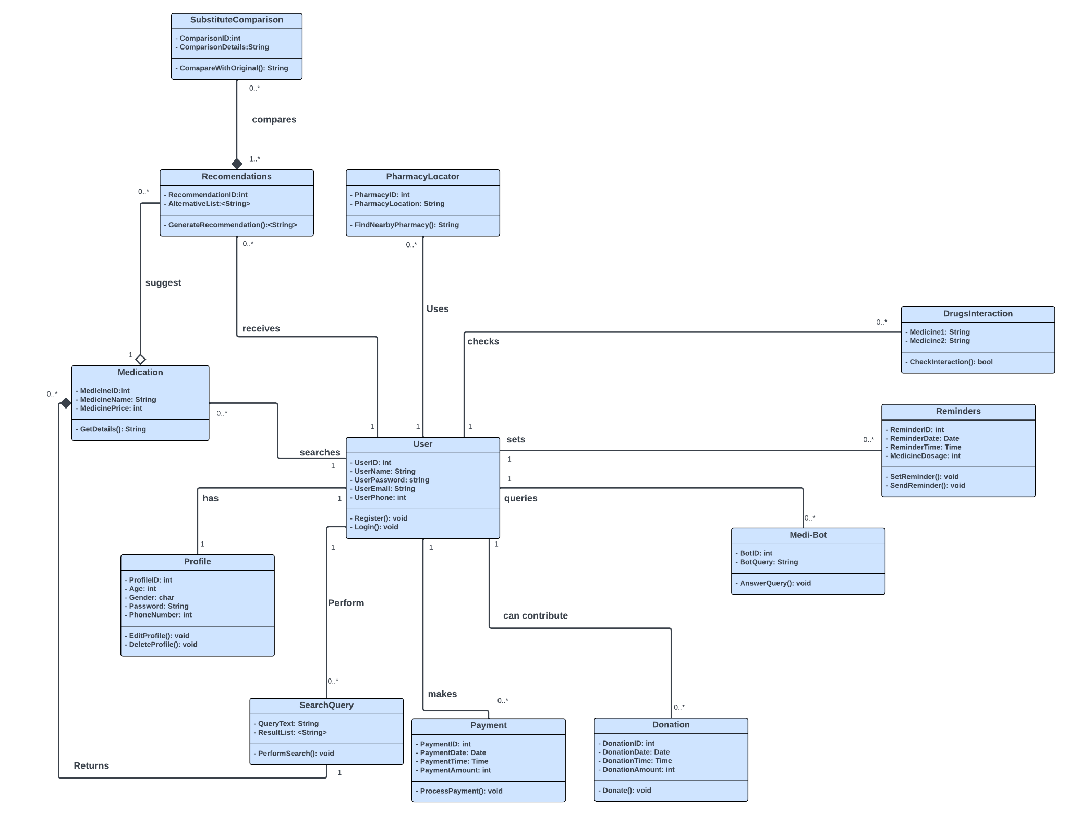

Figure : Class Diagram for MedTrove

## • Entity relationship diagram (ERD)

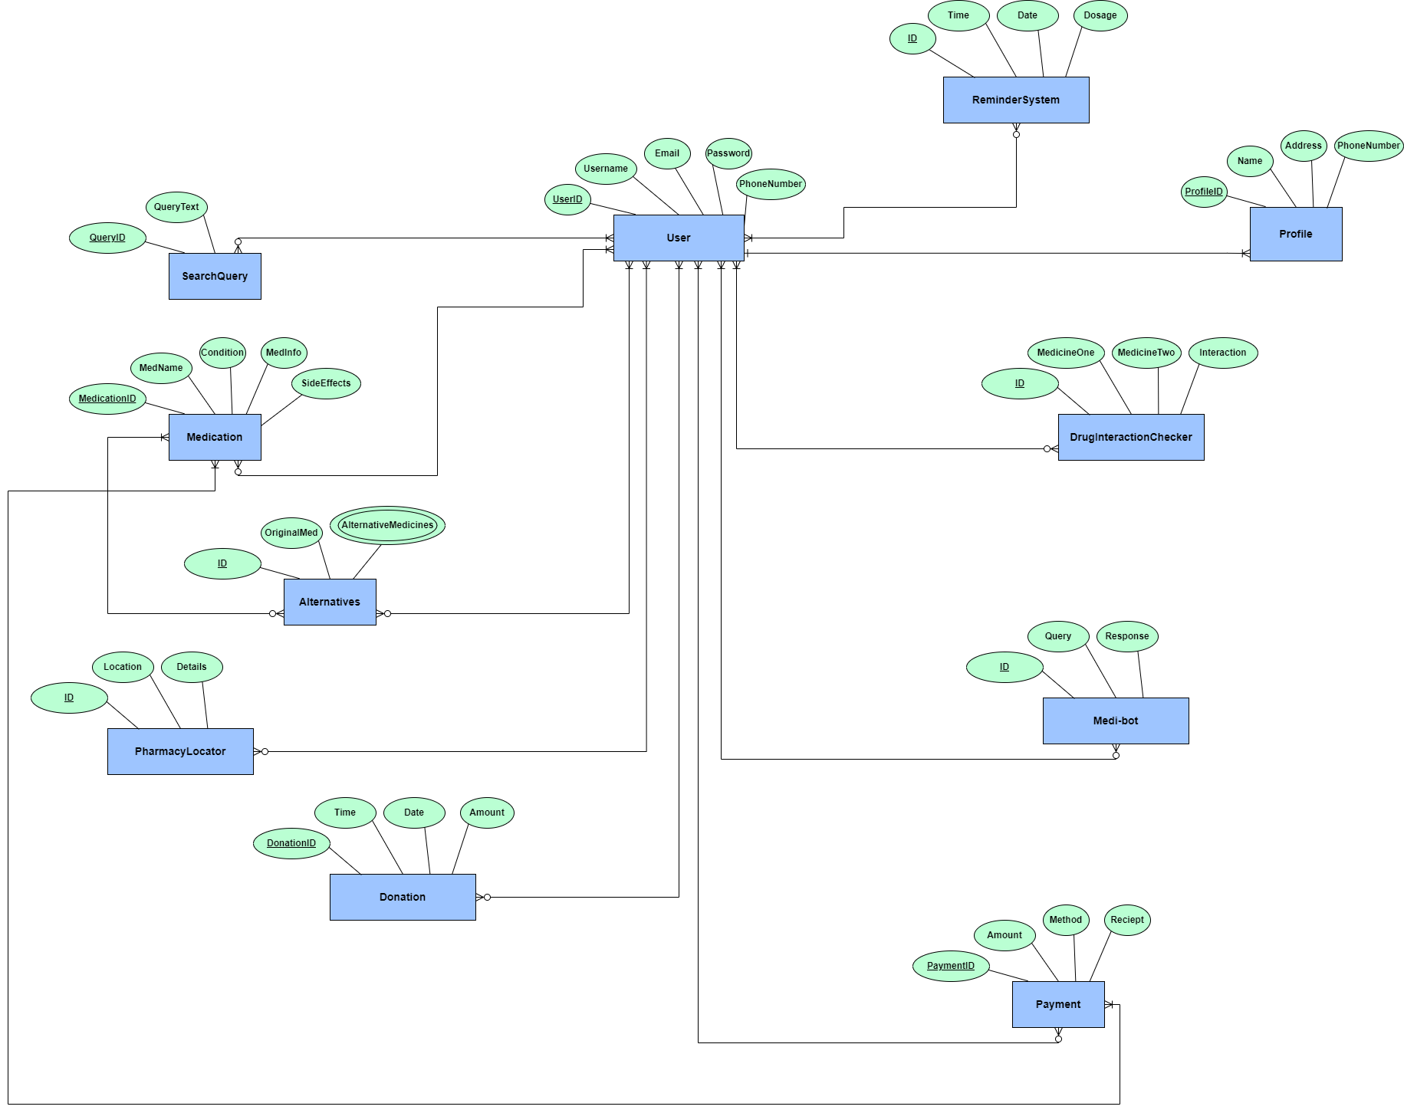

Figure : Entity Relationship Diagram for MedTrove

## • Activity Diagram

### Substitute Drug Identifier

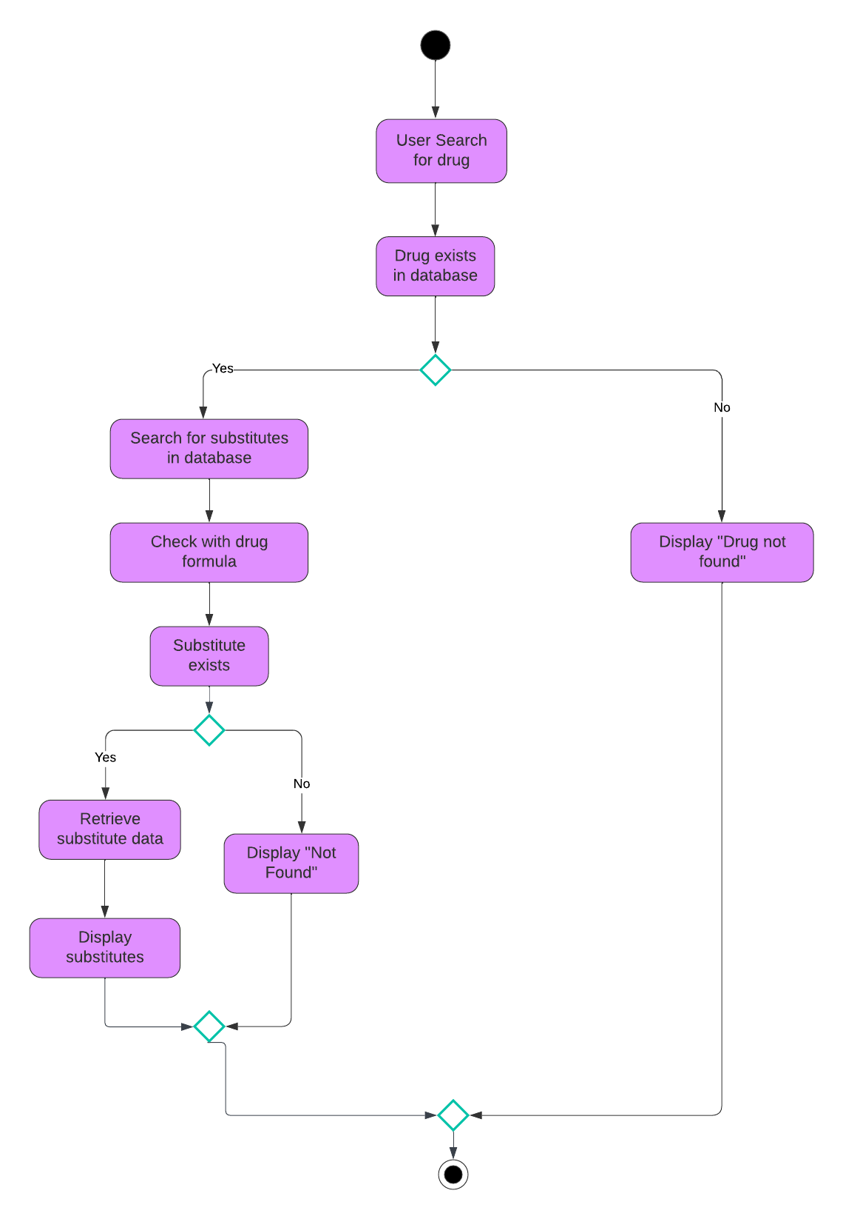

Figure : Activity Diagram for Substitute Drug Identifier

### Search and Recommendation

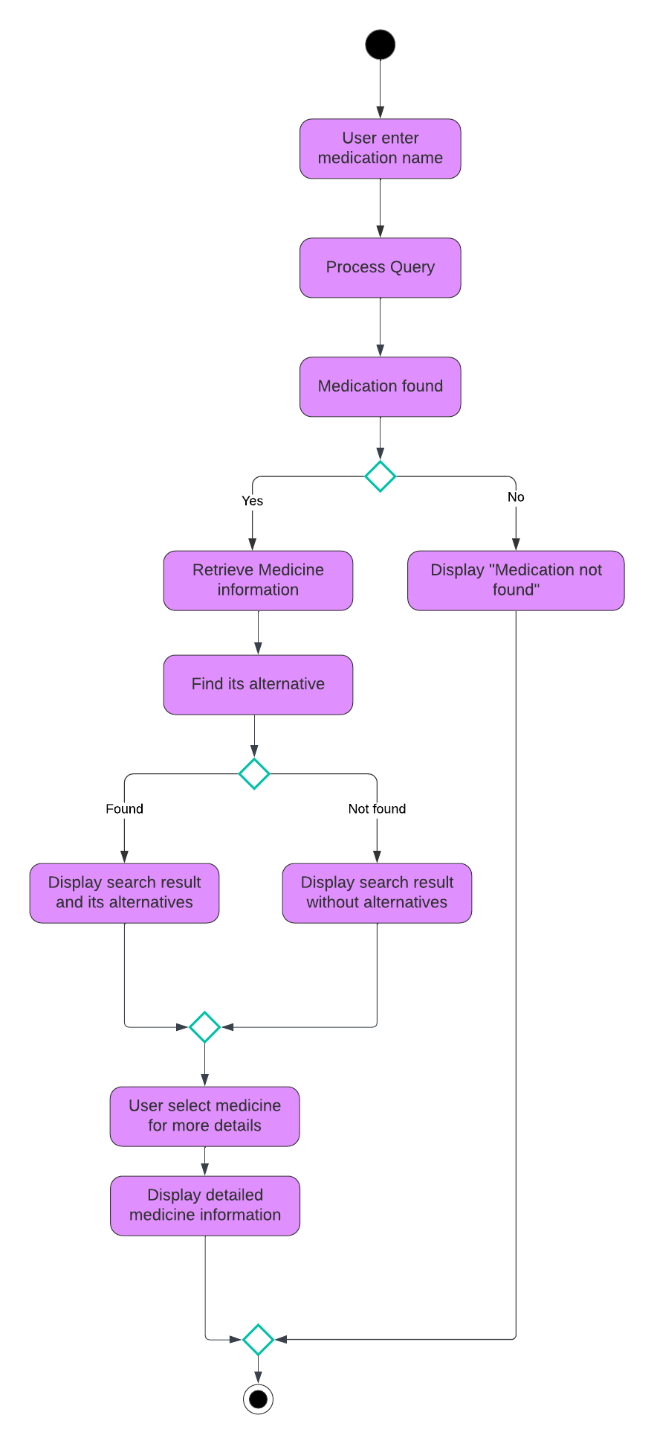

Figure : Activity Diagram for Search and Recommendation

### Profile Management

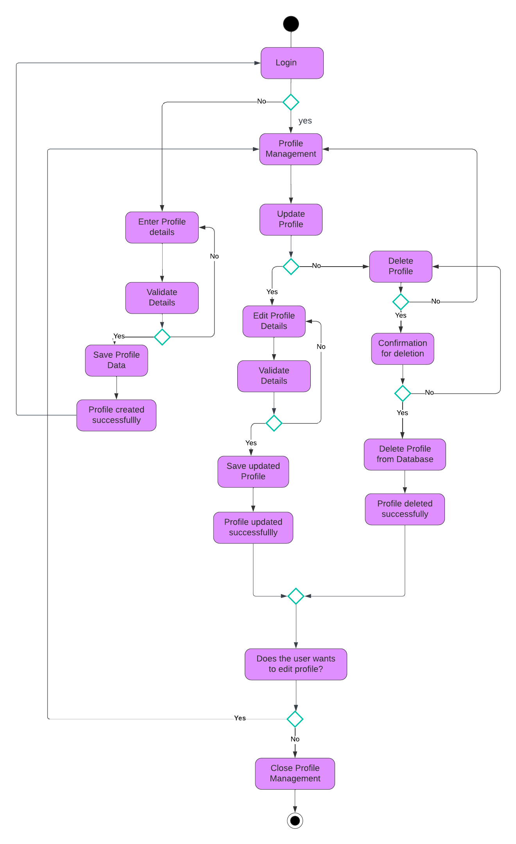

Figure : Activity Diagram for Profile Management

## • System Sequence Diagram

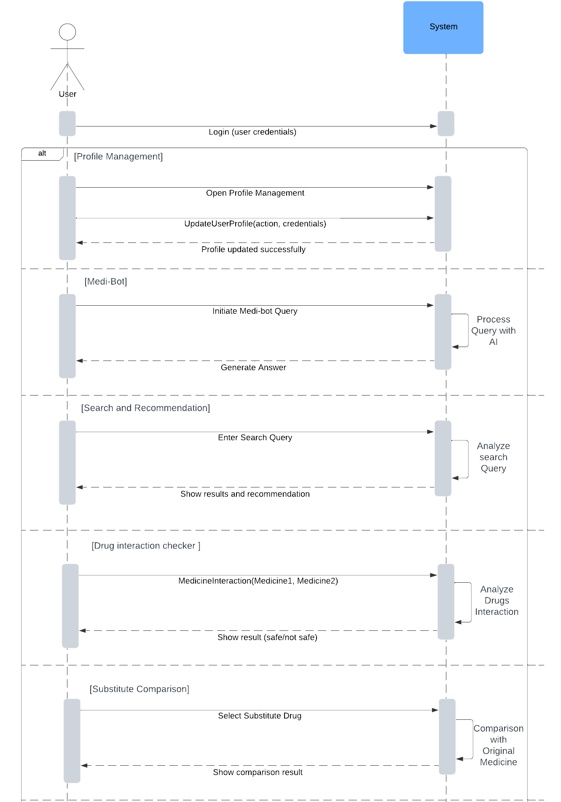

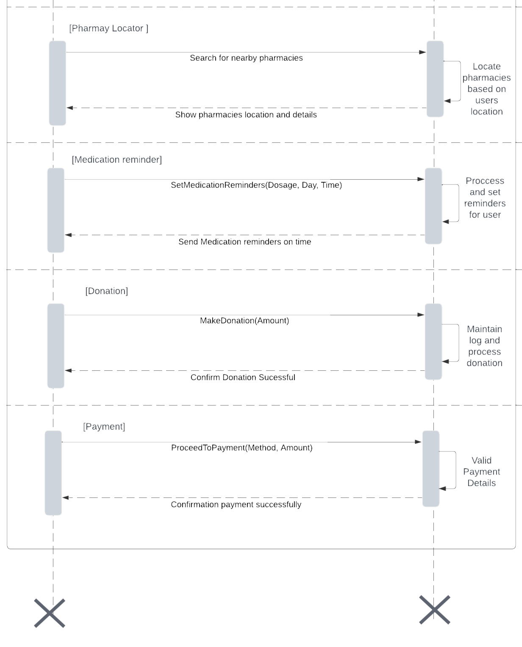

Figure : System Sequence Diagram for MedTrove

## • Sequence Diagram

### Substitute Drug Identifier

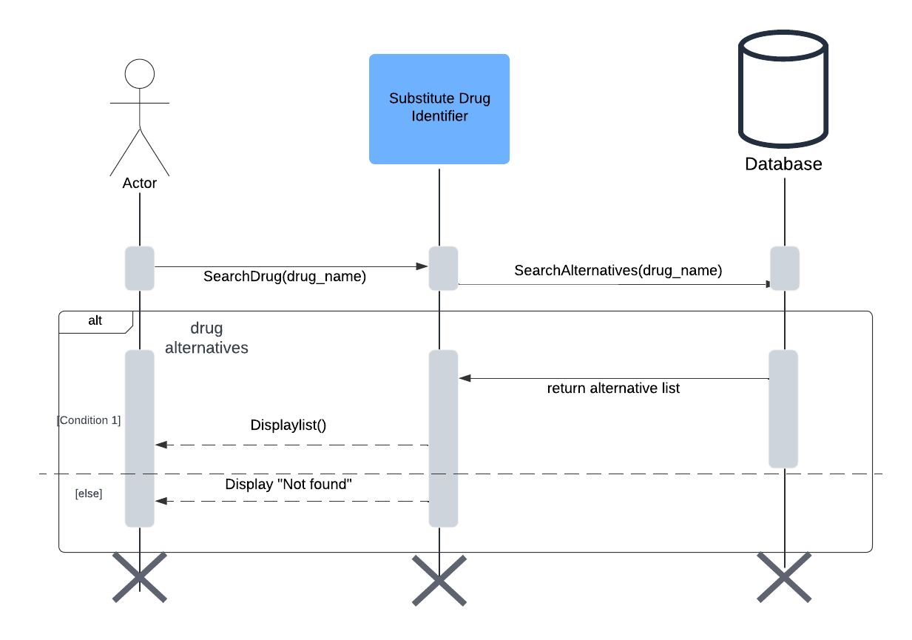

Figure : Sequence Diagram for Substitute Drug Identifier

### Search and Recommendation

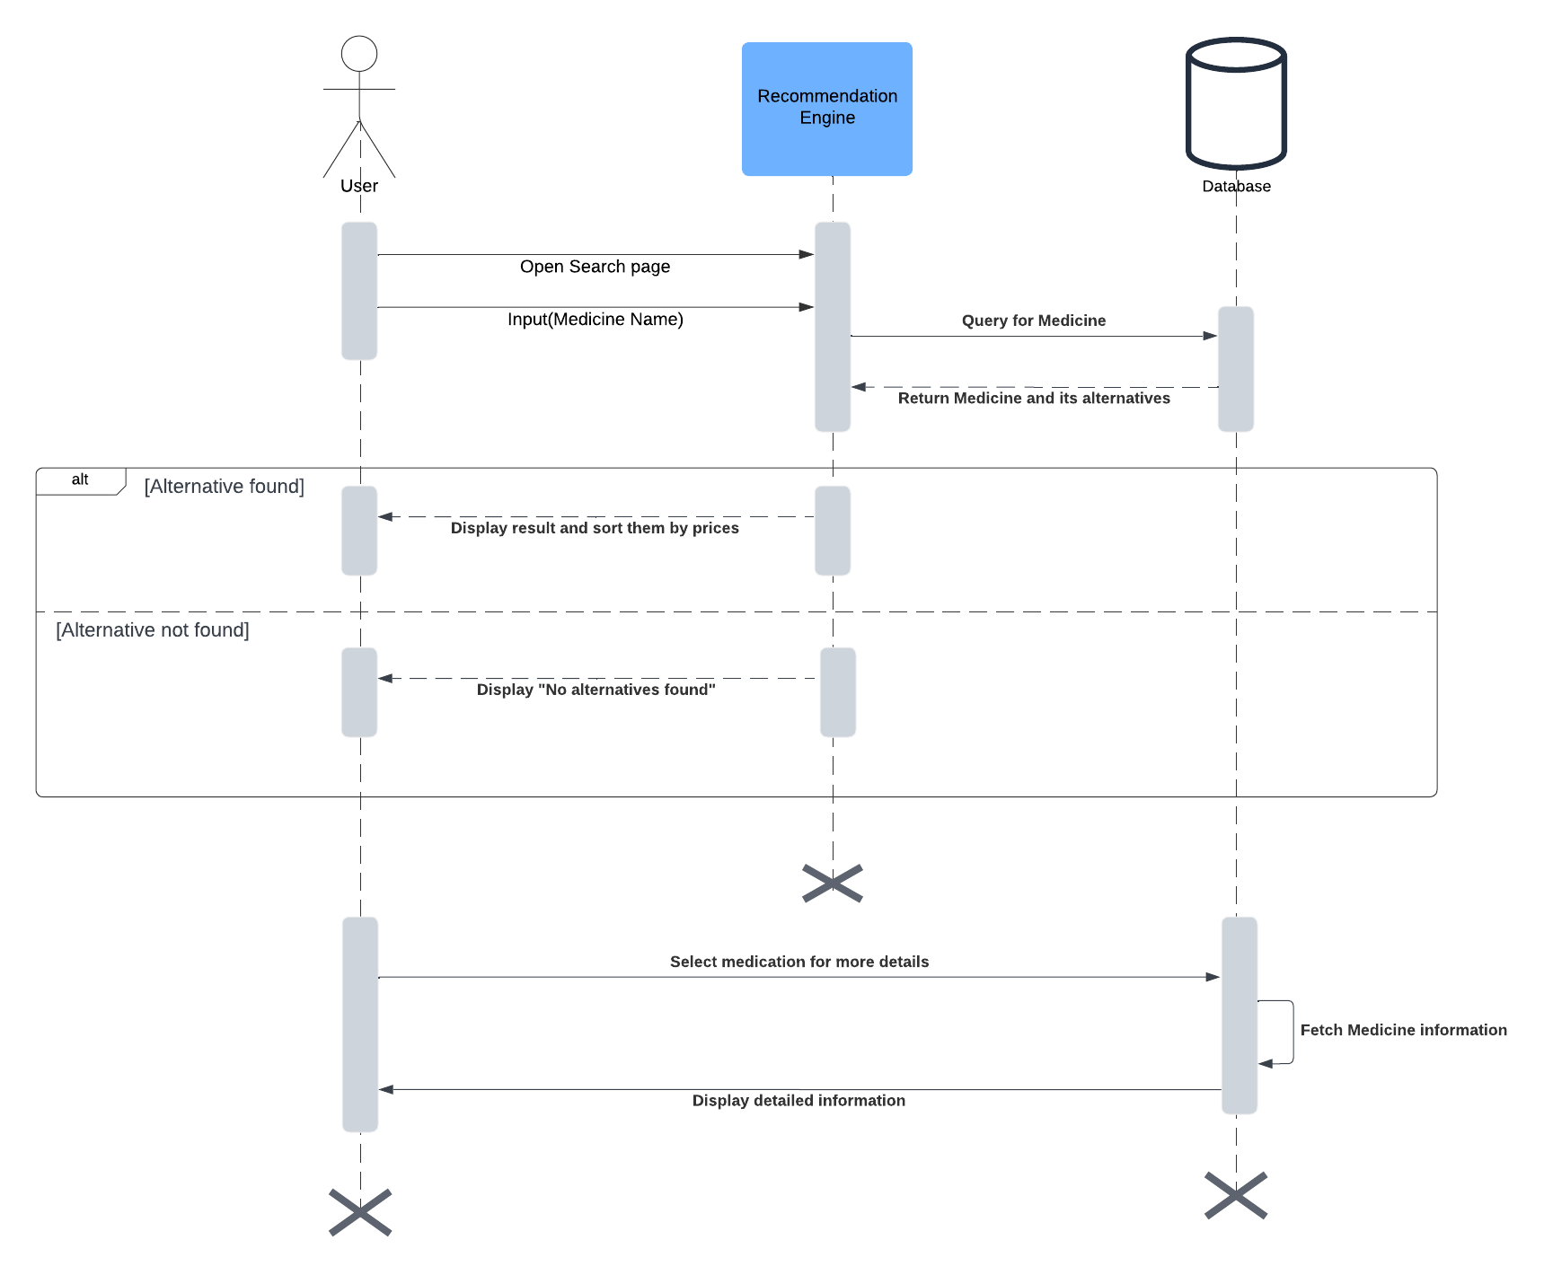

Figure : Sequence Diagram for Search and Recommendation

### Profile Management

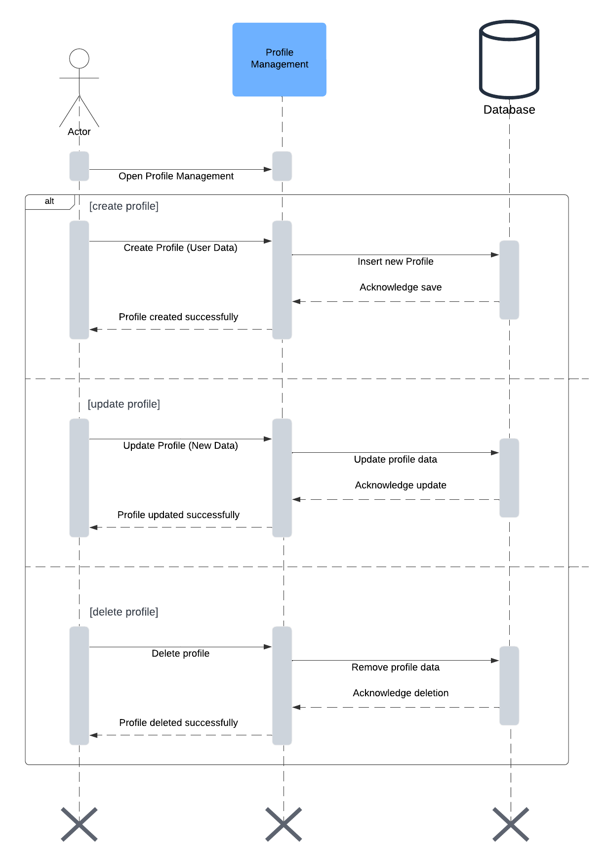

Figure : Sequence Diagram for Profile Management

## • Wireframes

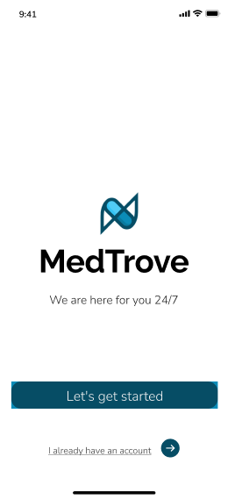 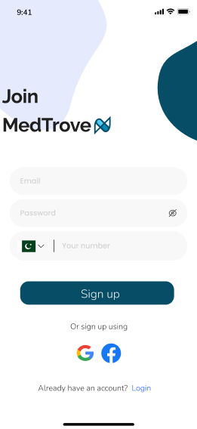 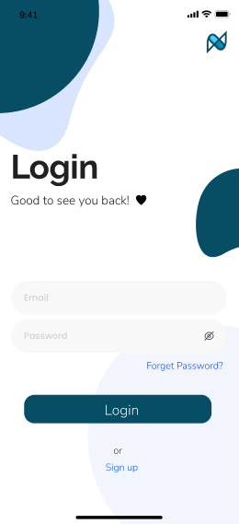

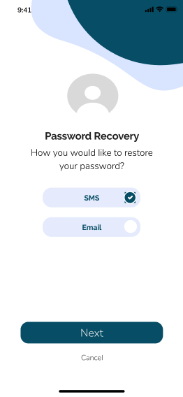 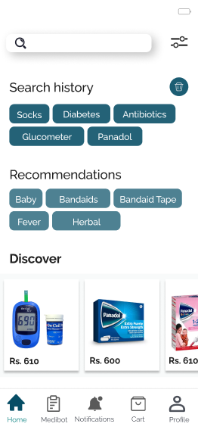 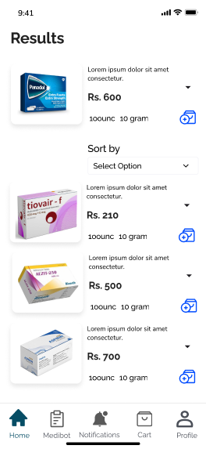

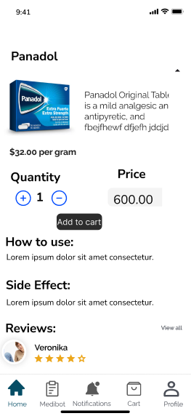 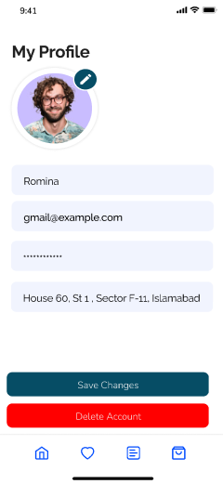 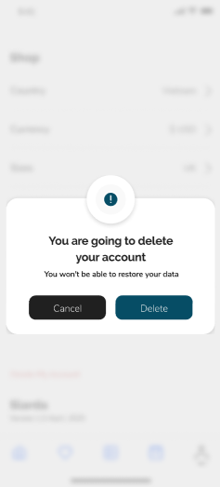

# Implementation

## Iteration 1

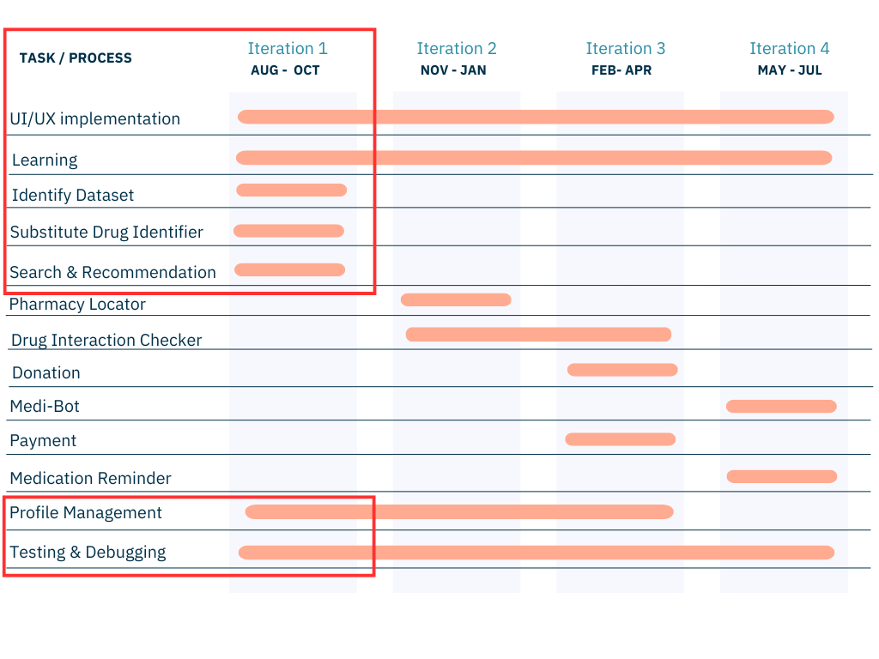

Figure : Timeline

## Implementation Screenshots

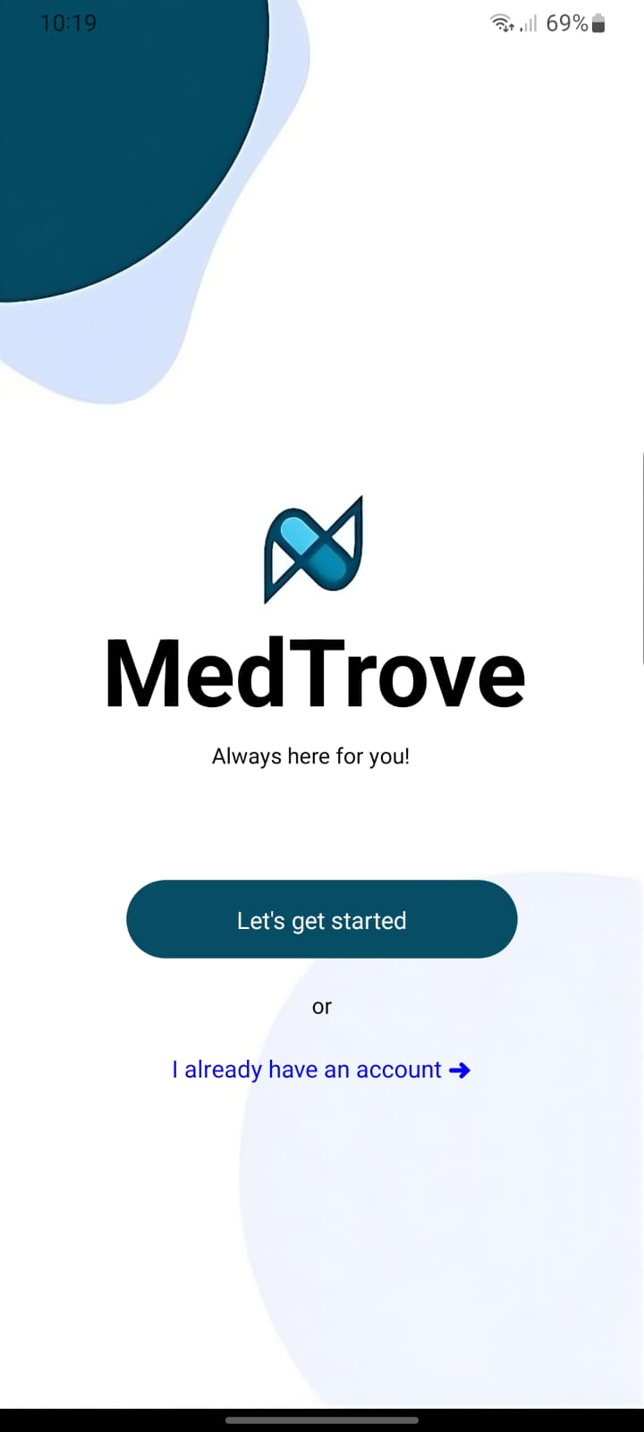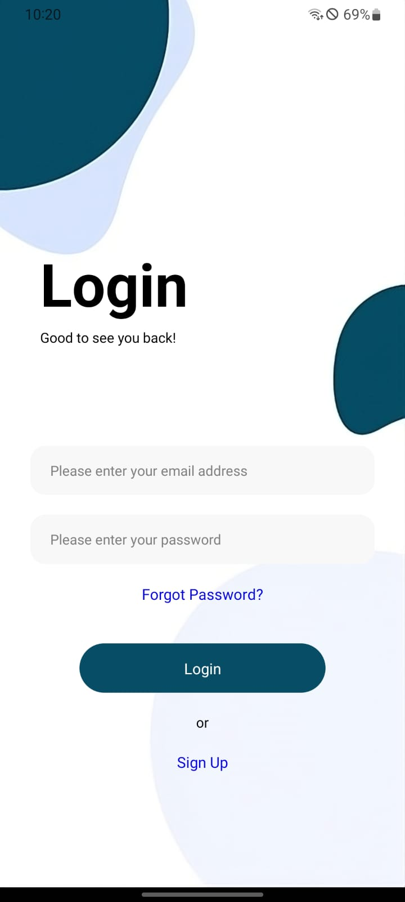

This page allows users to choose to This screen is the login screen. It also has

Either login or sign up. the option to signup in case one does

not have an account.

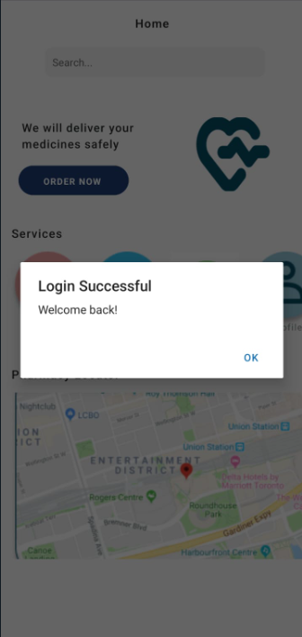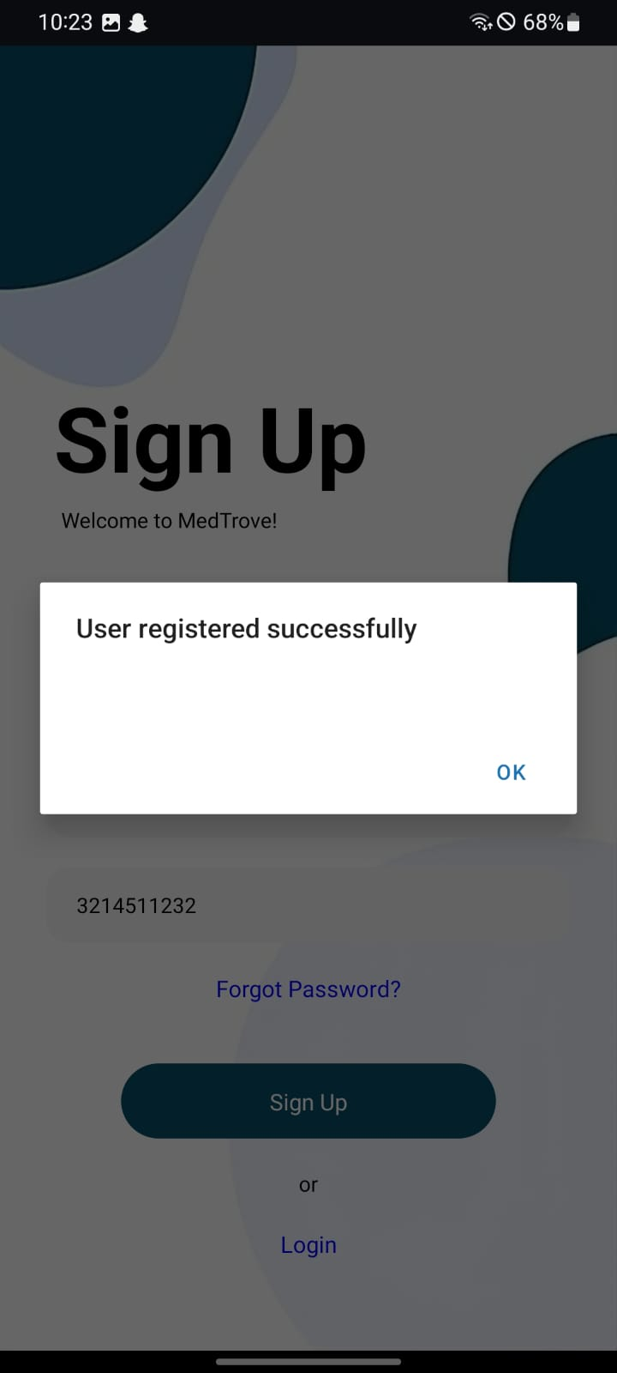

# 

# 

# 

# 

# 

This is the notification a user gets when Login Successful!

they successfully get signed up.

# 

# 

# 

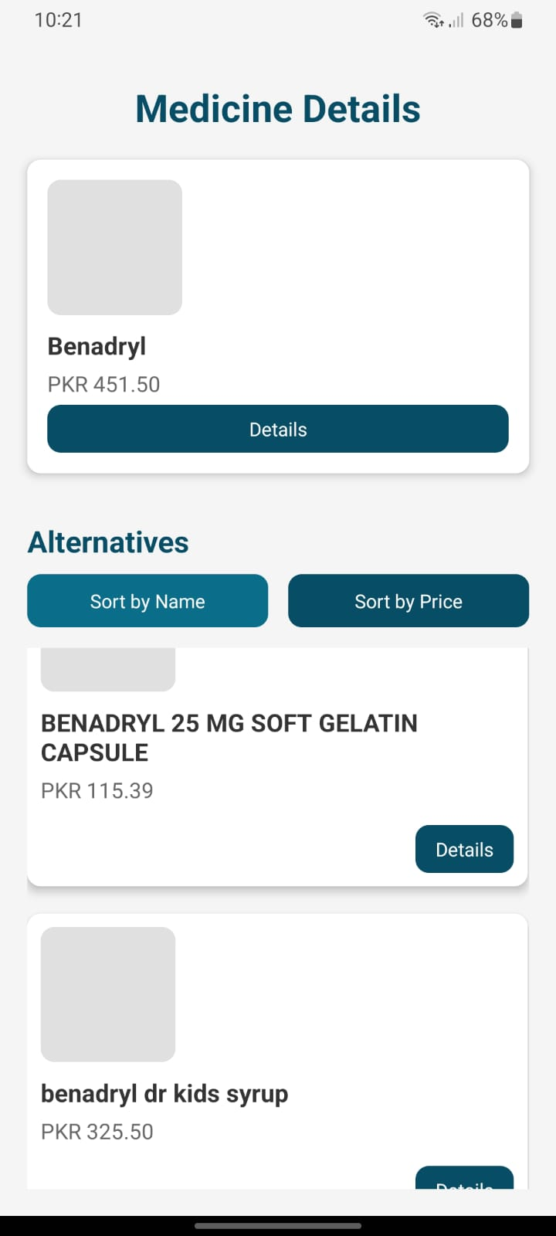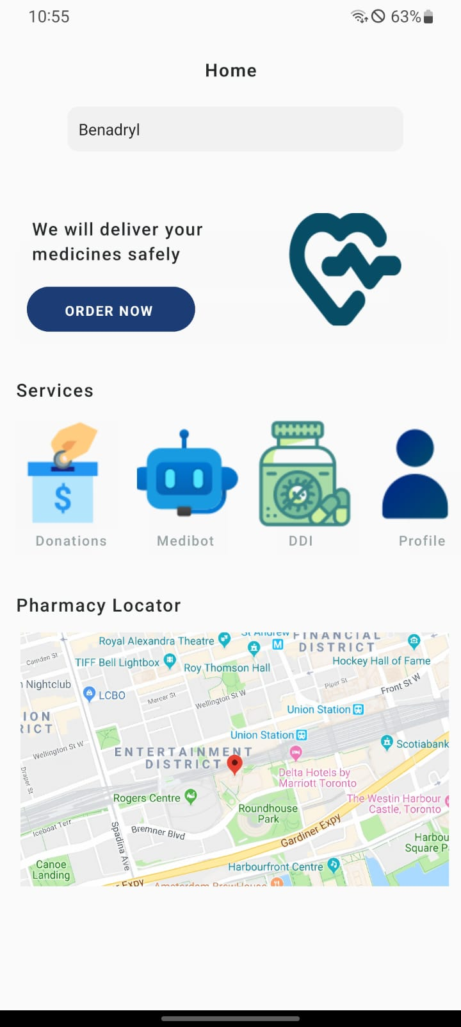

# 

# 

This is the dashboard where the user This is the search result’s page. It

will originally land. The user can displays the medicine searched for

navigate to other pages such as the alongside all the relevant alternative

Medibot, donation, profile, pharmacy medication. These are clickable to see

locator, drug interaction checker. relevant information,

The user can also search for medication

from the search bar as well.

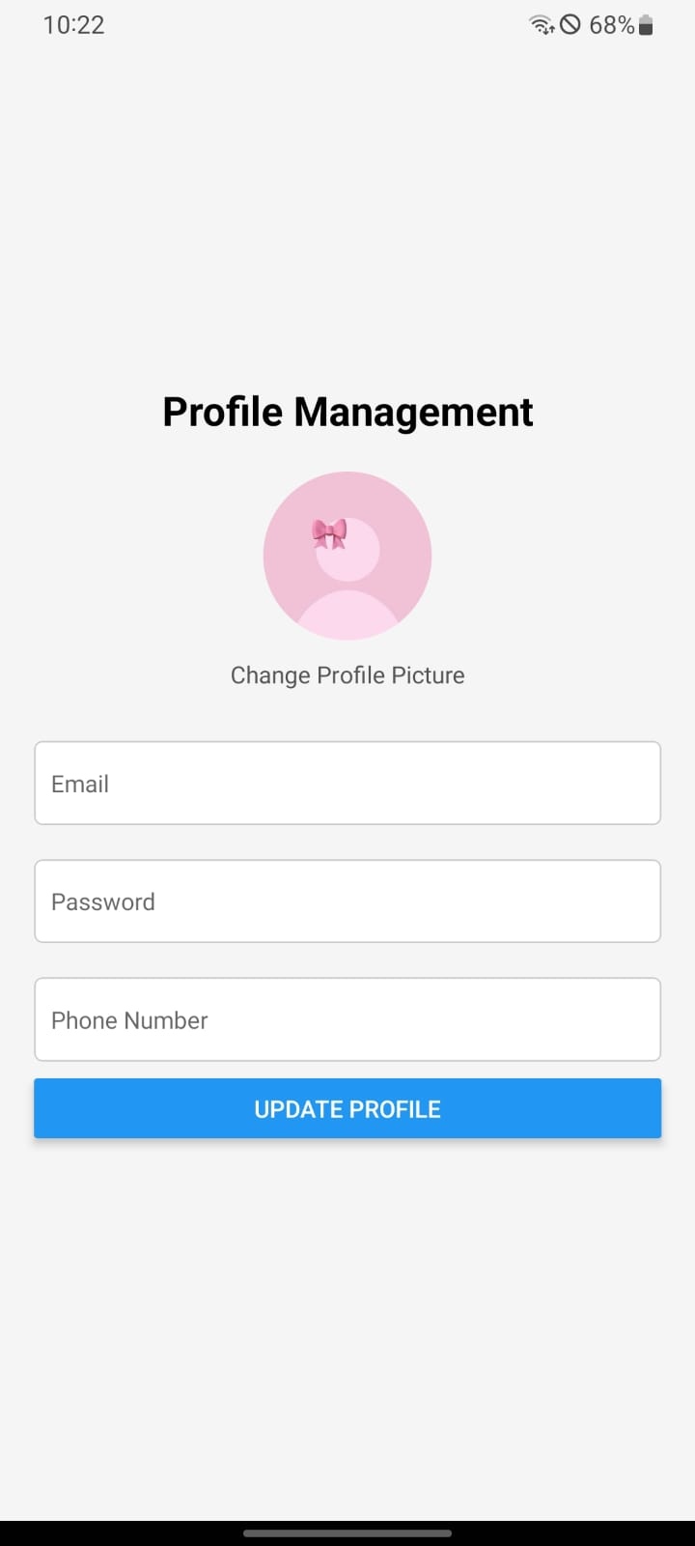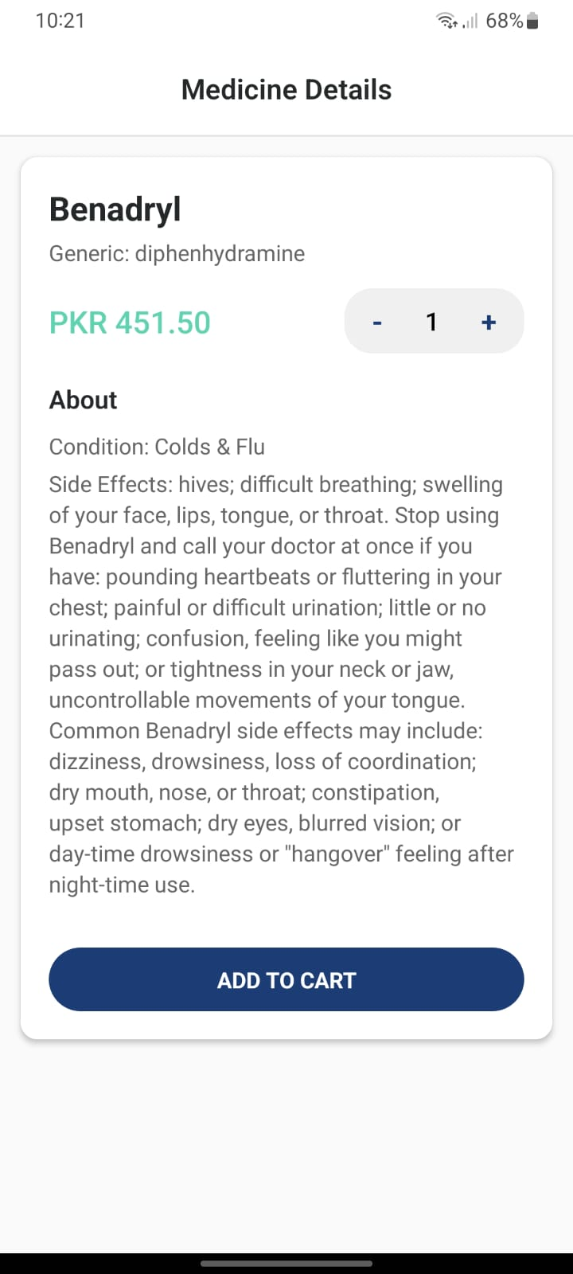

Upon clicking a medication, users can This is the profile management page.

view the details of a medication , the It displays the user’s details which can

price and add the desired amount to be edited and updated by the user. The   
 their cart. User can also change the profile picture

If they wish to.

# 

We implemented the backend of our application using MongoDB, here is the JSON schema of our database:

**Alternative Table Schema**

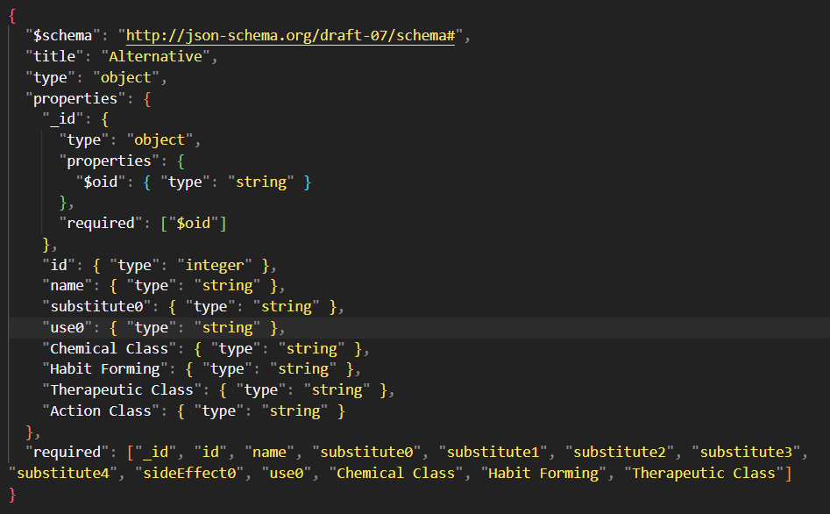

**MedInfo Table Schema**

**User Table Schema**

# Conclusion

In our timeline, we set out to implement key features for MedTrove including substitute drug identifier, search & recommendation and user profile management. For the UI/UX, we focused on creating a user-friendly interface that allows easy navigation through these features. Additionally, we conducted thorough testing to ensure that the app functions smoothly and delivers accurate results for each use case.

# 

# *Bibliography*

# 

|  |  |
| --- | --- |
| [1] | F. Durrani, “Increase in drug prices highest in last 40 years,” 8 April 2019. [Online]. Available: https://www.thenews.com.pk/print/454864-increase-in-drug-prices-highest-in-last-40-years. [Accessed 12 July 2024]. |
| [2] | “Govt approves increase in prices of 146 essential life-saving medicines,” 1 February 2024. [Online]. Available: https://www.dawn.com/news/1810395. [Accessed 12 July 2024]. |
| [3] | “The increasing rate of diabetes in Pakistan: A silent killer,” [Online]. Available: https://www.ncbi.nlm.nih.gov/pmc/articles/PMC9289249/. [Accessed 12 July 2024]. |
| [4] | I. Junaidi and R. Zakaria, “'47 people die of heart attack every hour in Pakistan',” 30 September 2021. [Online]. Available: https://www.dawn.com/news/1649189. [Accessed 12 July 2024]. |
| [5] | “PAKISTAN: Implementing an Ambitious, Credible and Clearly Communicated Economic Reform Plan Critical for Robust Recovery, Poverty Reduction, says World Bank,” 2 April 2024. [Online]. Available: https://www.worldbank.org/en/news/press-release/2024/04/01/pakistan-implementing-an-ambitious-credible-and-clearly-communicated-economic-reform-plan-critical-for-robust-recovery-p. [Accessed 12 July 2024]. |
| [6] | Dawn, “Big Pharma and Physicians,” 6 October 2008. [Online]. Available: https://www.dawn.com/news/845158/big-pharma-and-physicians. |