Lab No 1: Introduction
SQL (Structured Query Language) is the standard programming language used to interact with relational databases. It allows you to store, manipulate, and retrieve data using simple, English-like commands.
Core Concepts
- Relational Database Management System (RDBMS): The foundation for SQL. Data is organized into tables, which consist of rows (records) and columns (fields).
- SQL Standards: While ANSI/ISO standards exist, different "flavors" like MySQL, PostgreSQL, and Microsoft SQL Server have their own unique extensions.
Categories of SQL Commands
SQL commands are grouped by their specific purpose:
- DQL (Data Query Language): Used to fetch data. The most common command is SELECT.
- DML (Data Manipulation Language): Used to modify data. Includes INSERT, UPDATE, and DELETE.
- DDL (Data Definition Language): Used to define or change the database structure. Includes CREATE, ALTER, and DROP.
- DCL (Data Control Language): Used to manage access and permissions, such as GRANT and REVOKE.
- TCL (Transaction Control Language): Used to manage database transactions, such as COMMIT and ROLLBACK

Lab No 3: How To Create Data Base Table And Select Query

Create Table:
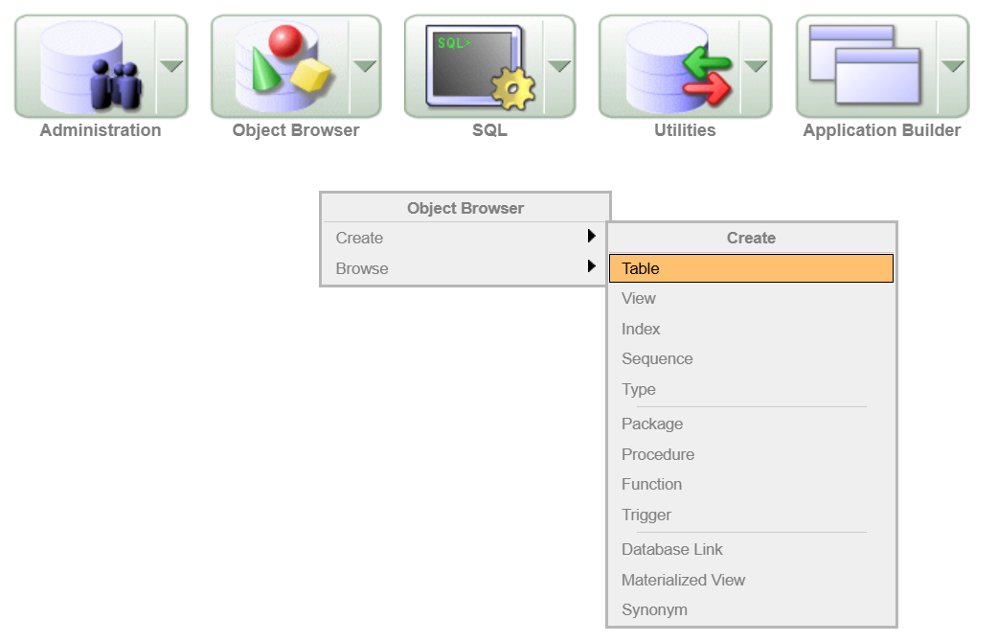

Add Columns:
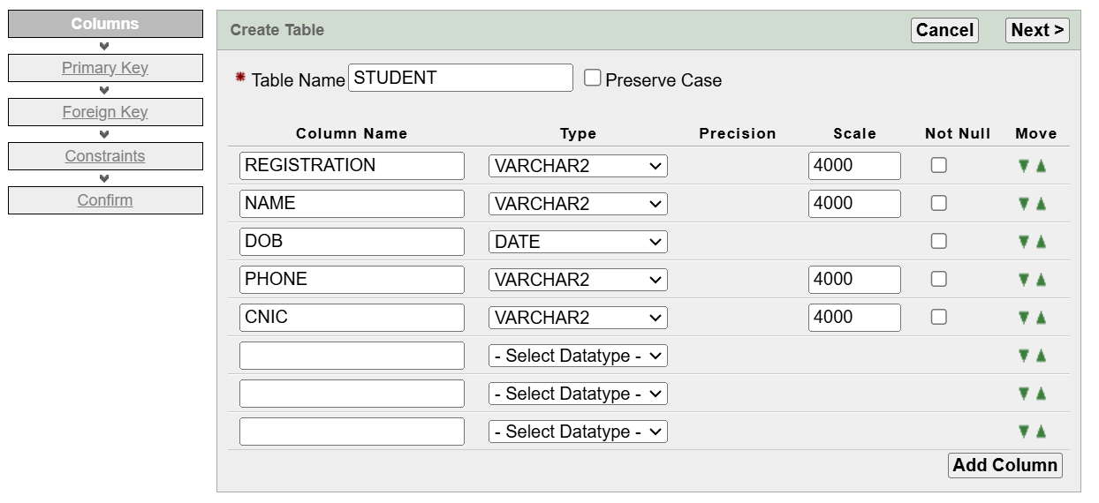

Primary Key:
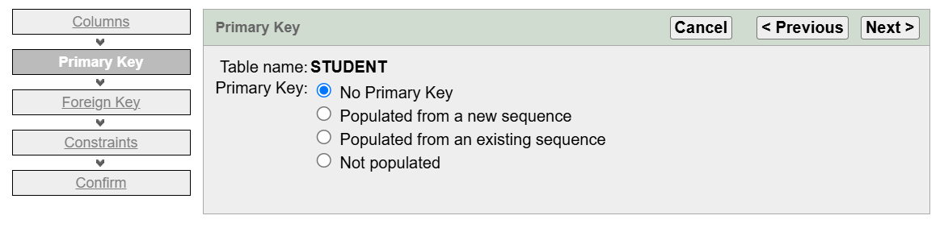

Foreign Key:
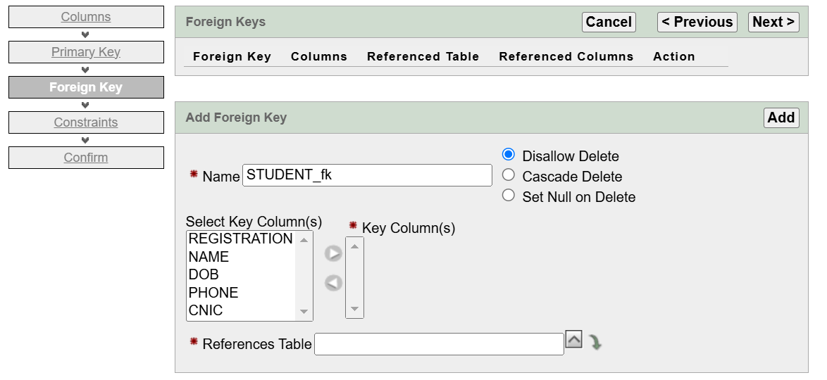

Constraints:
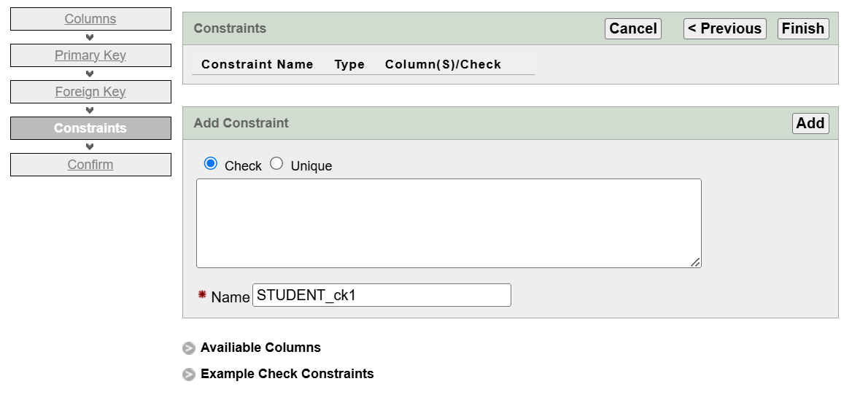

Confirm:
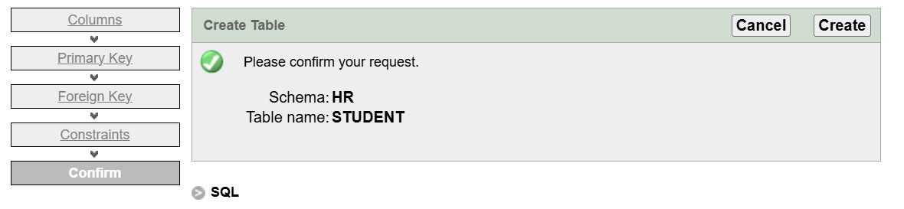

Table Schema:
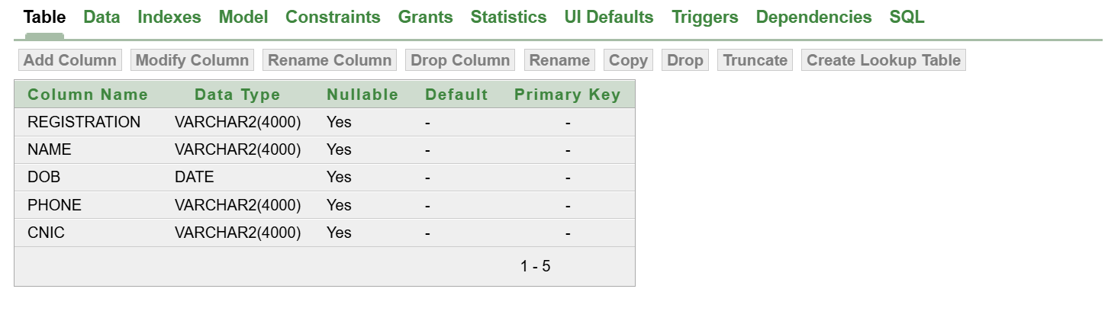
Lab No 4: Where query

Task 1:

Inserting Values in the Table using INSERT Command

Create “STUDENT_RESULT” Table
CREATE TABLE "STUDENT_RESULT"
( "STUDENT_ID" NUMBER(3,0) NOT NULL ENABLE,
"STUDENT_NAME" VARCHAR2(20),
"SUB_MARKS" NUMBER(5,0),
"SUB_GPA" NUMBER NOT NULL ENABLE,
"SUB_GRADE" CHAR(1),
"SUB_NAME" VARCHAR2(20)
)

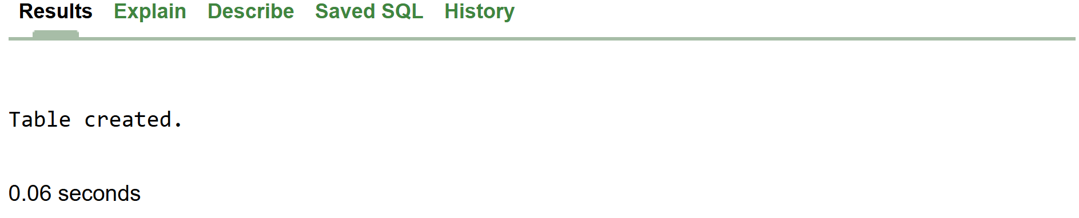

Adding STUDENT_SEMESTER Column
ALTER TABLE STUDENT_RESULT
ADD STUDENT_SEMESTER VARCHAR2(3)

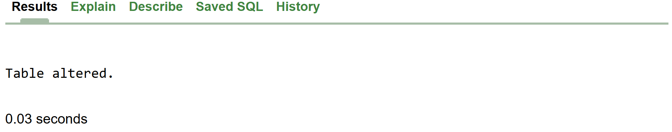

Renaming Column
ALTER TABLE STUDENT_RESULT
RENAME COLUMN SUB_CGPA TO SUB_GPA

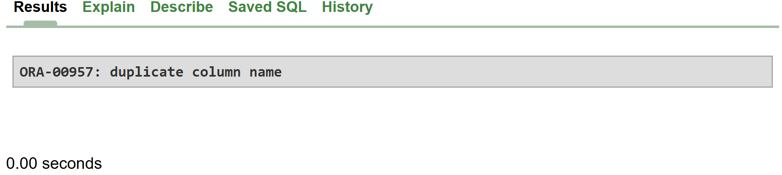

Insert Query
INSERT INTO STD_RESULT(STUDENT_ID, STUDENT_NAME, SUB_MARKS, SUB_GPA, SUB_GRADE, SUB_NAME)
VALUES (01,'ABC',65,3.8,'A','DB')

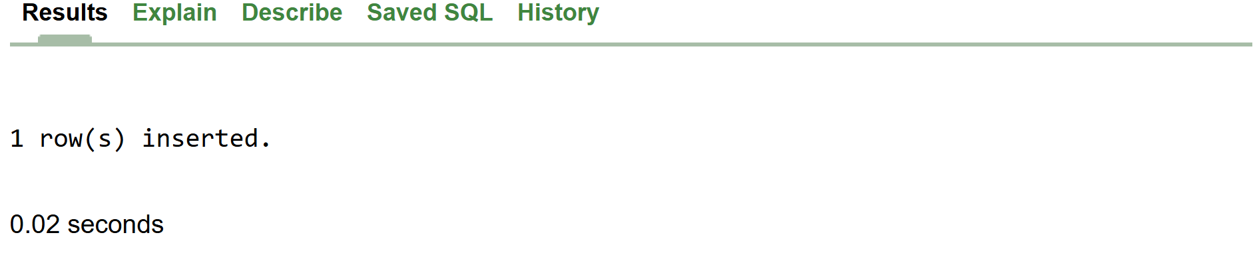

Select Query
SELECT * FROM STD_RESULT;

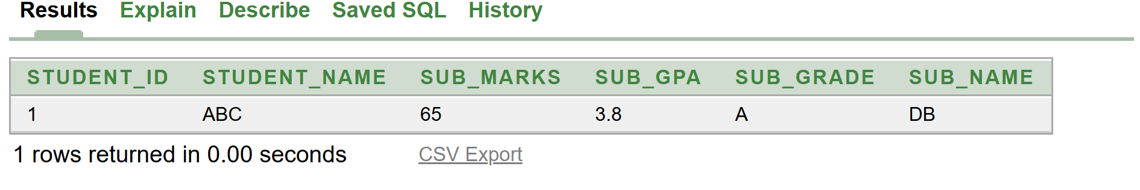

Inserting another Row in existing Data
INSERT INTO STD_RESULT(STUDENT_ID, STUDENT_NAME, SUB_MARKS, SUB_GPA, SUB_GRADE, SUB_NAME)
VALUES (003,'JKL',59,3.9,'B','DB');

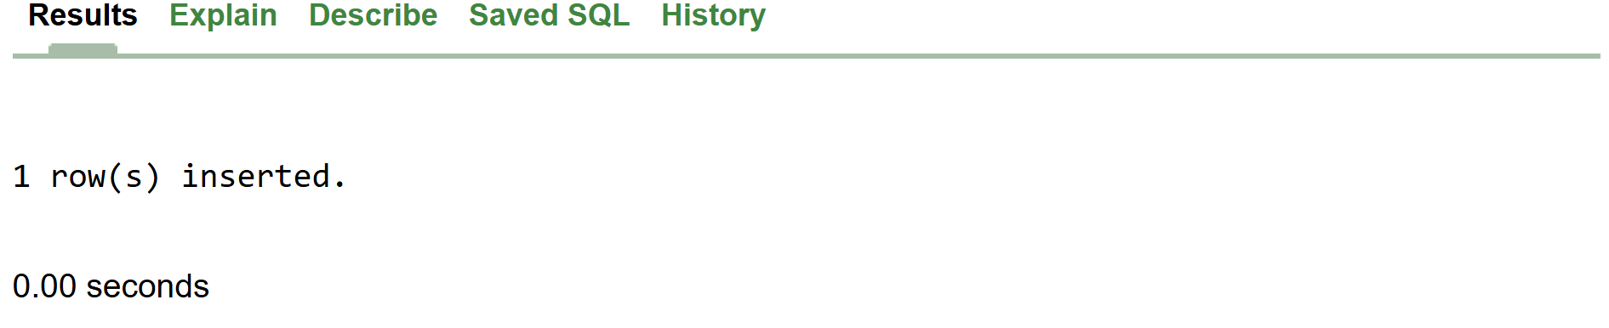

Task 2:
Inserting Multiple Values in the Table using INSERT ALL Command

2.1 Single statement:
INSERT INTO TUF_STUDENTS
VALUES ('2023-BS-AI-017', 'HAMNA', TO_DATE('01-08-2023', 'DD-MM-YYYY'), '+923669998996', '33100-5555092-0');

2.2 Dual statement:
INSERT ALL
INTO TUF_STUDENTS
VALUES ('2023-BS-AI-020', 'MISHAL', TO_DATE('22-08-2023', 'DD-MM-YYYY'), '+923998865409', '33100-59875347-0')
INTO TUF_STUDENTS
VALUES ('2023-BS-AI-021', 'YUMNA', TO_DATE('24-08-2023', 'DD-MM-YYYY'), '+923998654408', '33100-75314579-0')
SELECT * FROM dual;

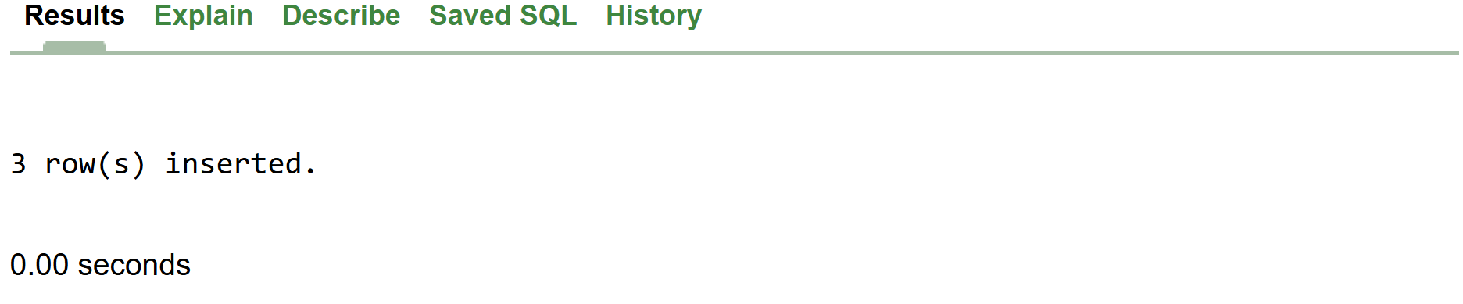

Task 3:

Update Table Using UPDATE Command

3.1 Updating All Values of TUF_STUDENTS
UPDATE TUF_STUDENTS
SET NAME = 'ABC'

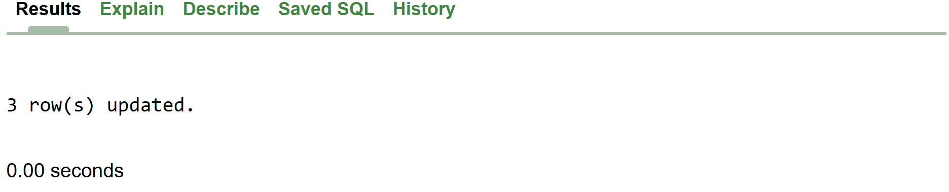

3.1.1 Updated Structure of Table
SELECT * FROM TUF_STUDENTS;

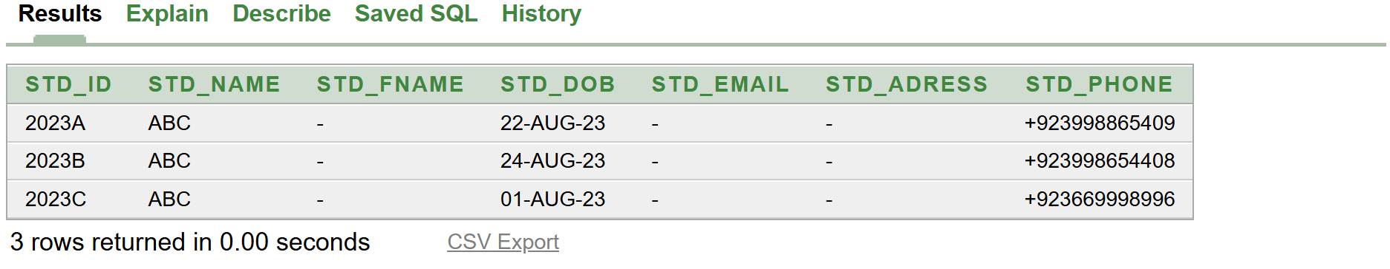

3.1.2 Updating Specific Values Using WHERE Command
UPDATE TUF_STUDENTS
SET NAME = 'XYZ'
WHERE REGISTRATION = '2023-BS-AI-017';

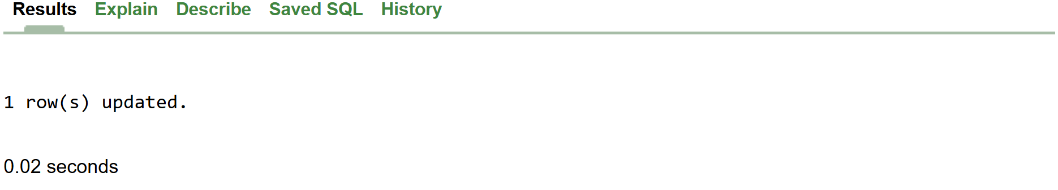

3.1.3 Delete Table TUF_STUDENTS
DELETE TUF_STUDENTS

Lab No 5: Types Of Sql Command And Ddl

Create Table Using SQL Command:
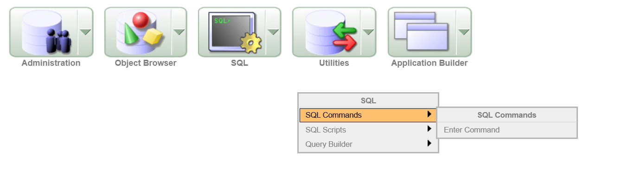

Enter Commands:

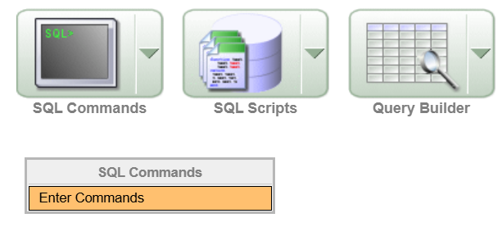

Task No 1:
Query:
CREATE TABLE "TUF_STUDENTS"
("STD_ID" VARCHAR2(5),
"STD_NAME" VARCHAR2(10),
"STD_FNAME" VARCHAR2(10),
"STD_DOB" DATE,
"STD_EMAIL" VARCHAR2(7),
"STD_ADRESS" VARCHAR2(10),
"STD_PHONE" NUMBER(11)
)
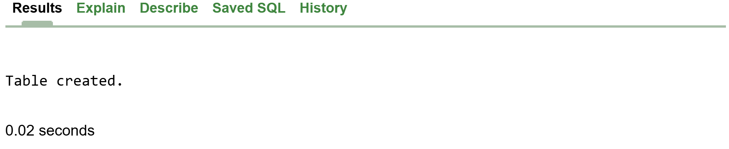

DESCRIBE "TUF_STUDENTS";

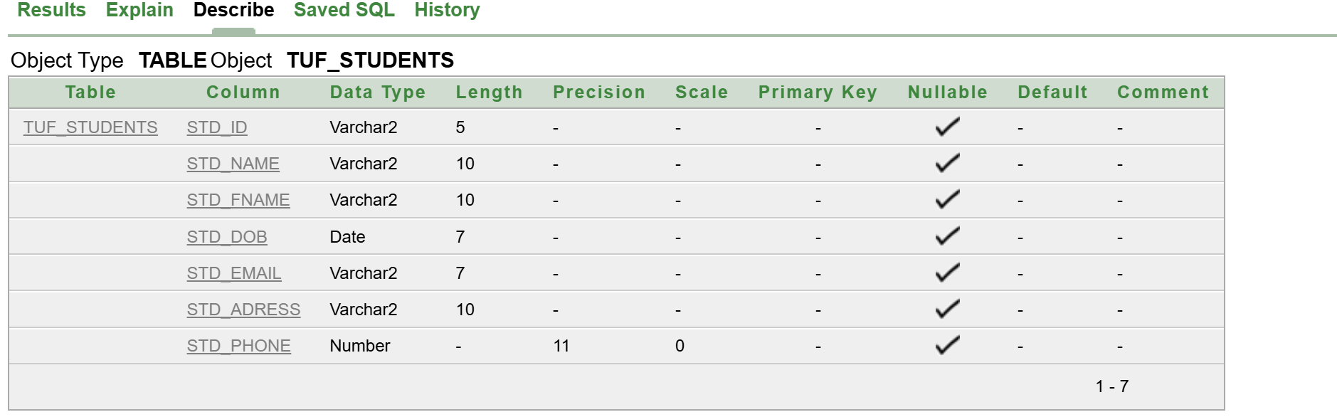

Task No 2:
CREATE TABLE "GPTS" (
"CODING_GPT" VARCHAR2(10),
"MATH_GPT" VARCHAR2(10),
"NUMBER_OF_USERS" NUMBER(10),
"LAUNCH_DATE" DATE,
"RATING" FLOAT
);

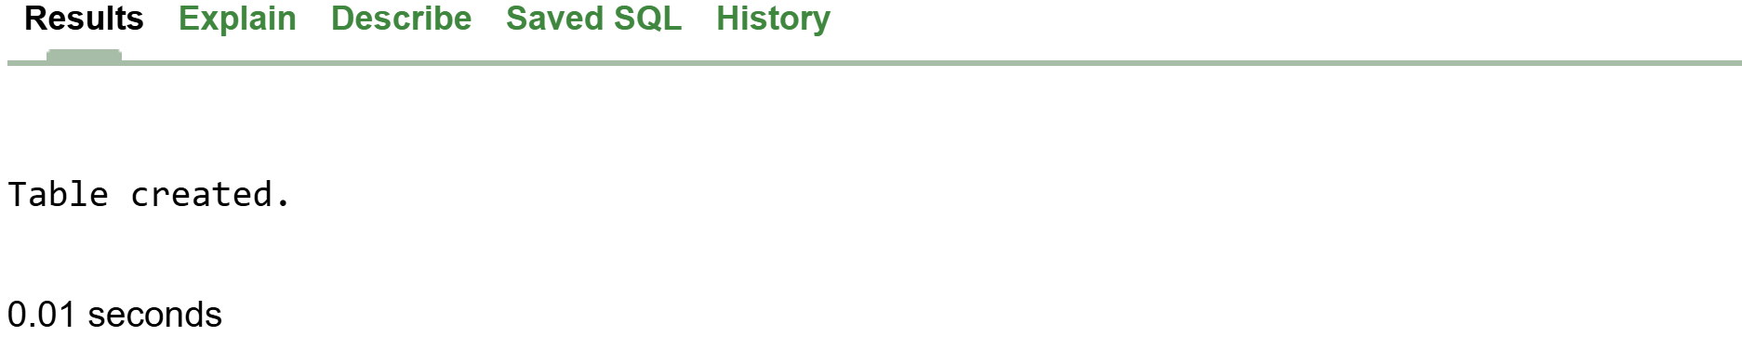

Task 2:
Making Changes to Table using ALTER Command

DESCRIBE "TUF_STUDENTS";

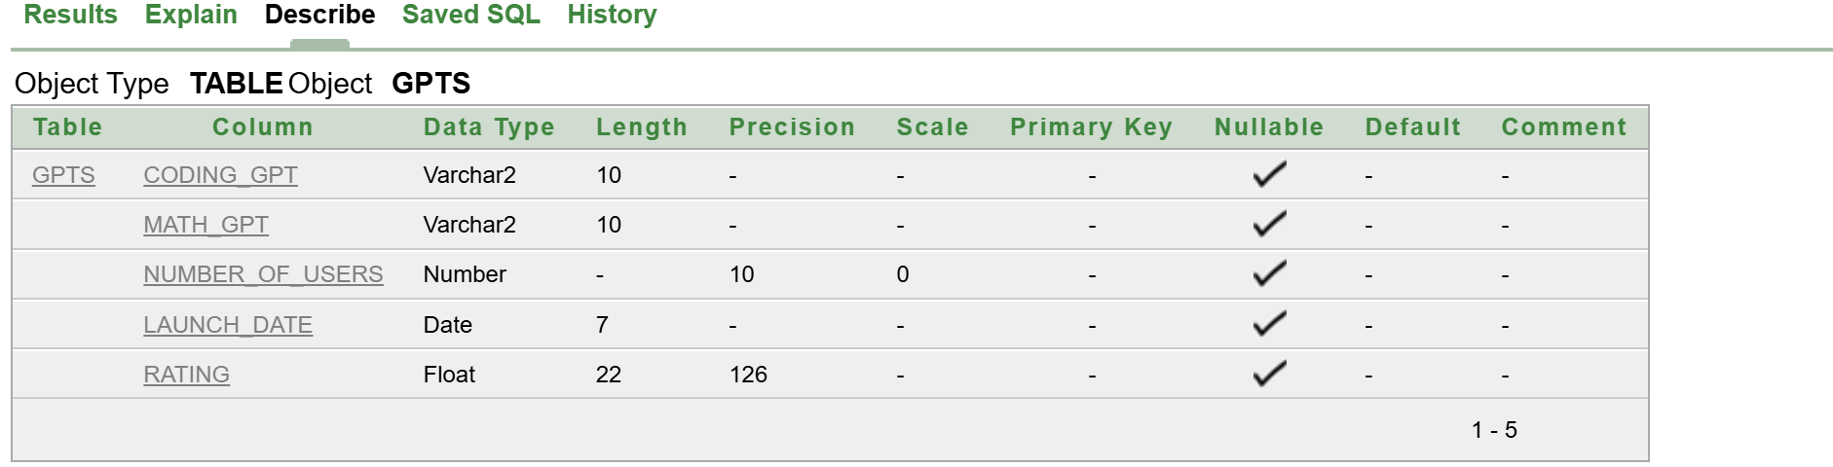

Alter Table
ALTER TABLE TUF_STUDENTS
ADD STD_PERMANENT_ADRESS VARCHAR2(50);

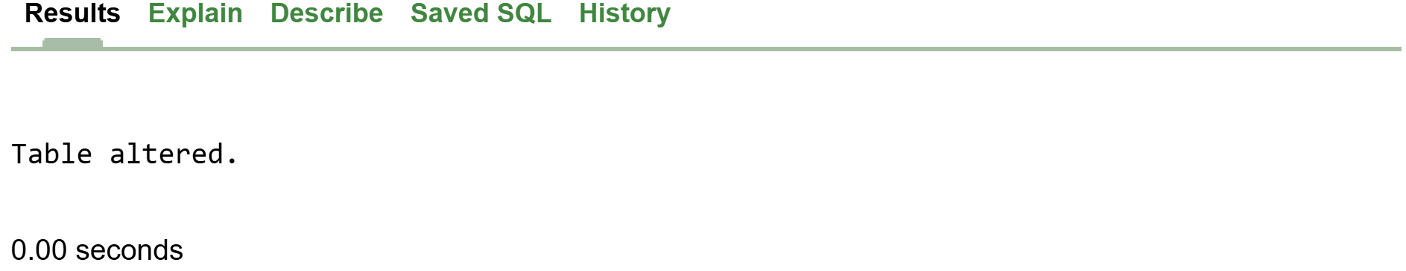

Table Structure After Adding One Column:
DESCRIBE "TUF_STUDENTS";

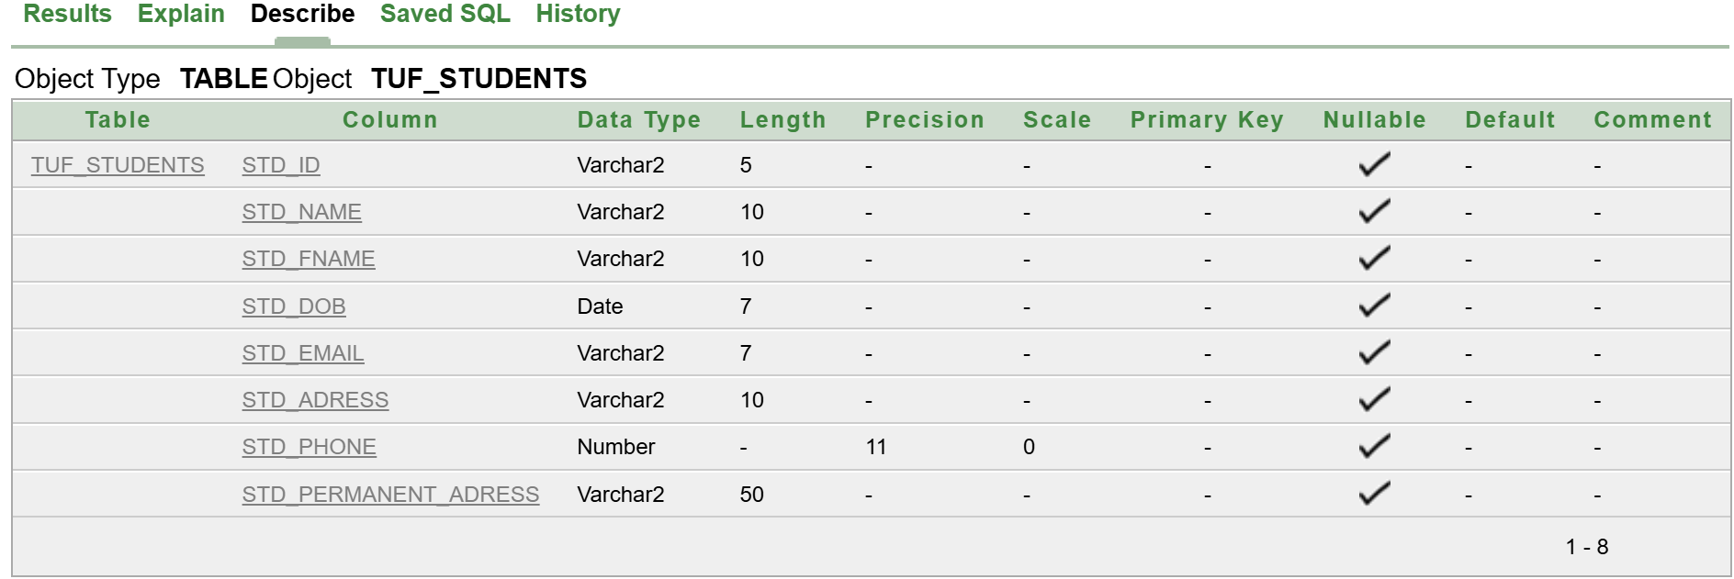

2.1.1 Rename Column:

Query:
ALTER TABLE TUF_STUDENTS
RENAME COLUMN STD_PERMANENT_ADRESS TO RELIGION;
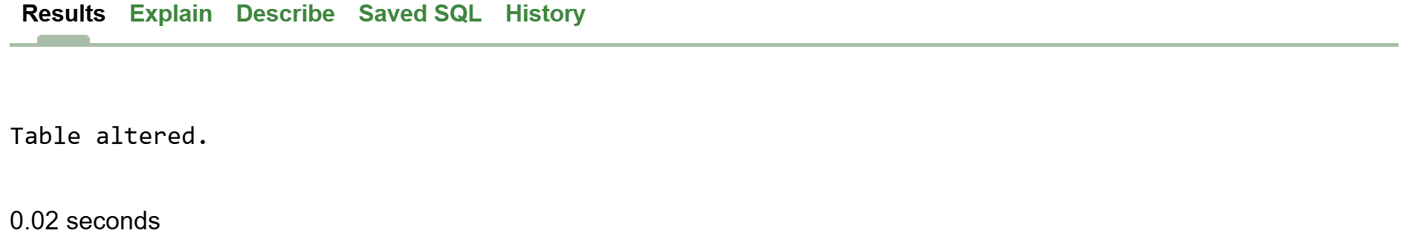

Modify Column

Query:
ALTER TABLE TUF_STUDENTS
MODIFY RELIGION VARCHAR(10);
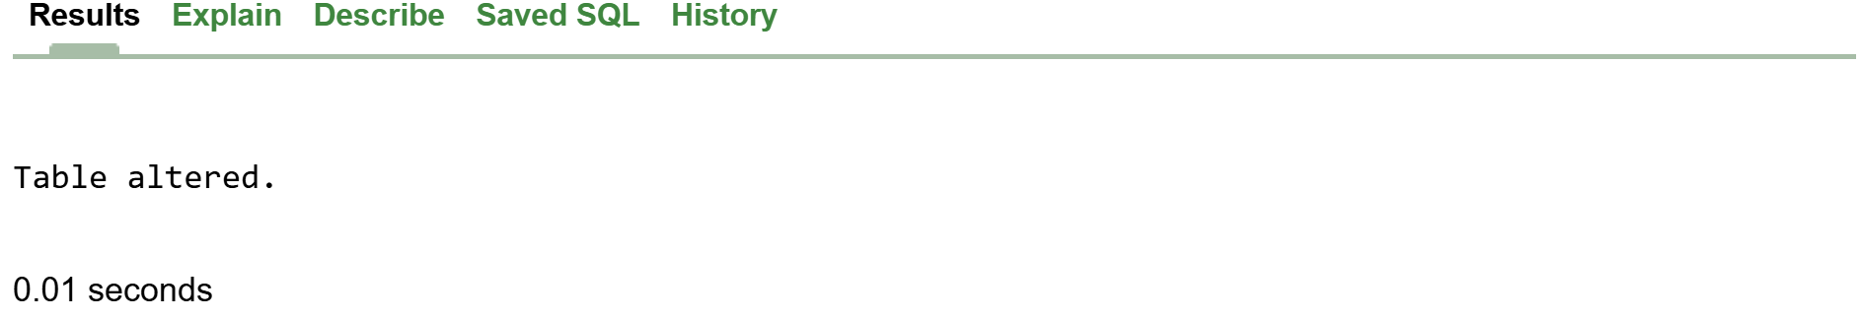

Using DROP Command for Dropping Column

DROP QUERY

ALTER TABLE TUF_STUDENTS
DROP COLUMN GENDER;

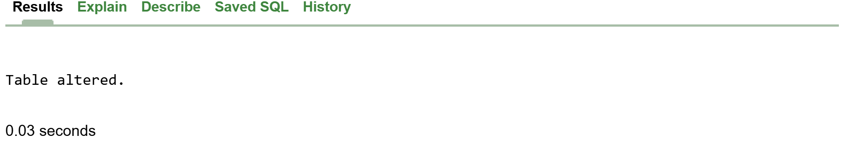

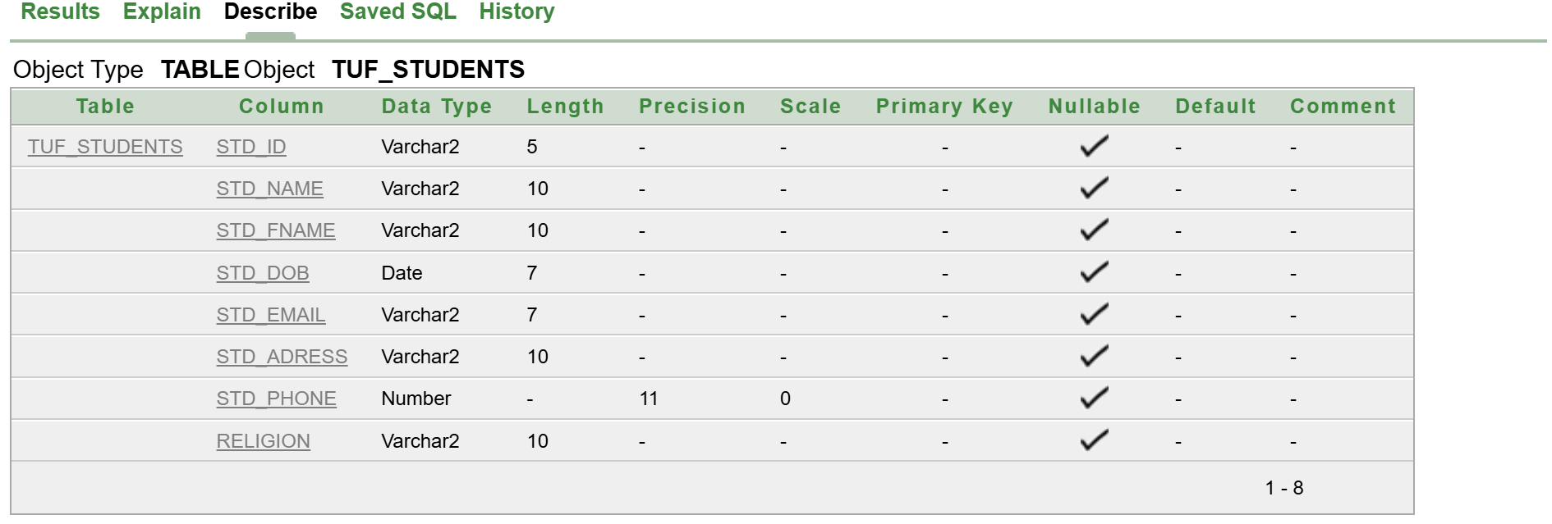

Rename Table Using RENAME Command

RENAME TABLE TUF_STUDENTS TO BSAI
DESCRIBE "BSAI";
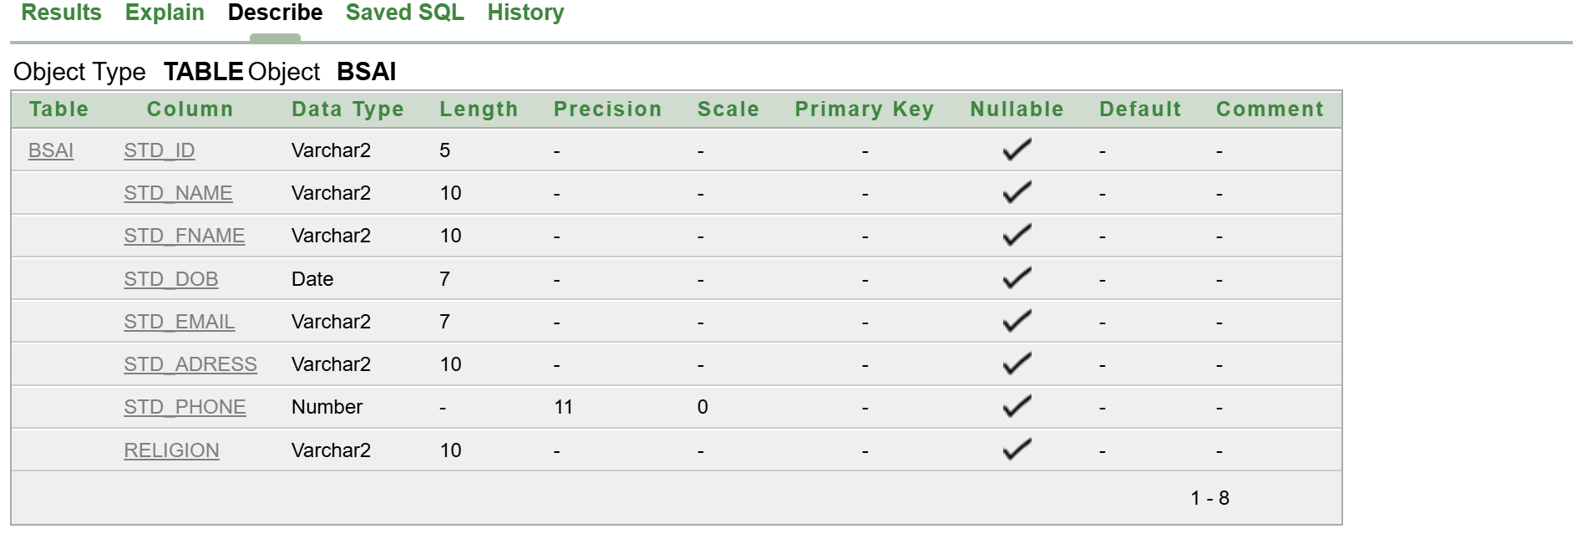

Task 3:
CREATE TABLE "LOGIN_PAGE" (
"ID" VARCHAR(10),
"USERNAME" VARCHAR2(10),
"PASSWORD" NUMBER(10)
);

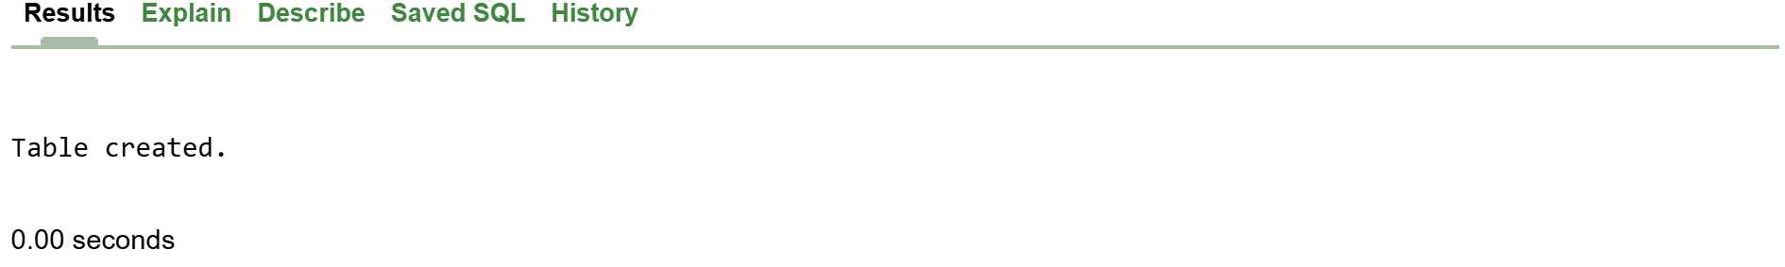
DESCRIBE "LOGIN_PAGE";

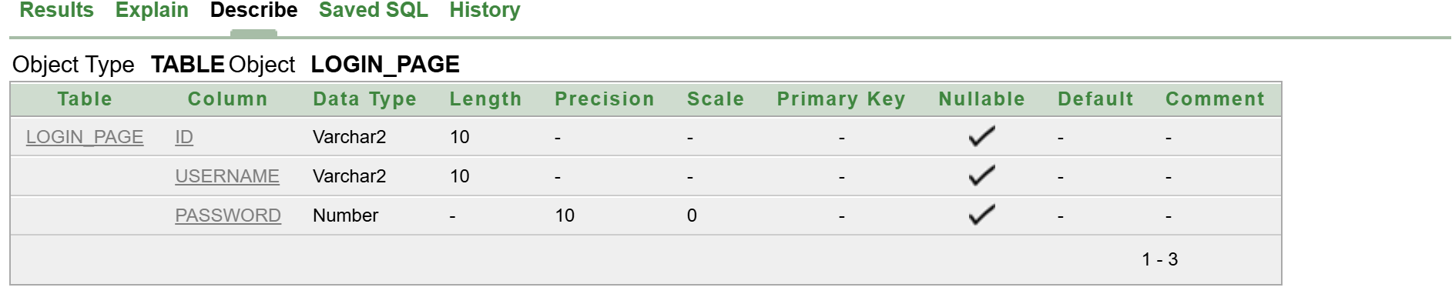

DROP TABLE "LOGIN_PAGE";

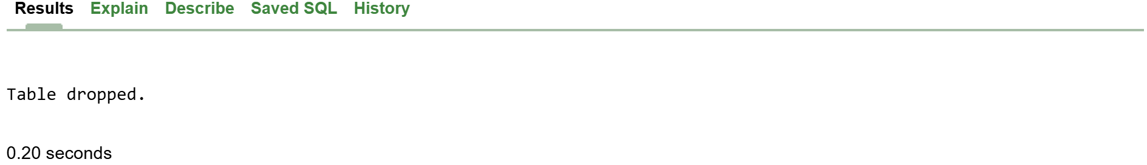

DESCRIBE "LOGIN_PAGE";
