LAB: 06
Managing File Operations Using CMD
- Creating Different Types of Files

📄 Create a Word File (.docx)
echo. > "C:\Users\%USERNAME%\Desktop\Document.docx"
This creates an empty Word file on the Desktop.

📝 Create a Notepad File (.txt)
echo This is a sample text file. > "C:\Users\%USERNAME%\Desktop\Notes.txt"
👉 This creates a Notepad file and writes text inside it.

📊 Create a PowerPoint File (.pptx)
echo. > "C:\Users\%USERNAME%\Desktop\Presentation.pptx"
👉 This creates an empty PowerPoint file on the Desktop.

2️. Copying Files

C:\Users\CS\Desktop>copy "C:\Users\CS\Desktop\me\take\report.doc" "C:\Users\CS\Desktop\me\taken\binary.doc"

Overwrite C:\Users\CS\Desktop\me\taken\binary.doc? (Yes/No/All): yes

1 file(s) copied.

3️. Opening a File Using CMD

📄 Open a Word File

start winword "C:\Users\%USERNAME%\Desktop\binary.docx"

📝 Open a Notepad File

start notepad "C:\Users\%USERNAME%\Desktop\Notes.txt"

📊 Open a PowerPoint File

start powerpnt "C:\Users\%USERNAME%\Desktop\Presentation.pptx"

4️.Closing an Open File Using CMD

Forcefully Close Word, Notepad, or PowerPoint

taskkill /F /IM winword.exe (For Word)

taskkill /F /IM notepad.exe (For Notepad)

This command will immediately force-terminate all instances of notepad.exe that are running.

Important Notes:

Using /F ensures that the process is killed without giving it a chance to close gracefully, which could result in unsaved data being lost.

taskkill /F /IM POWERPNT.EXE

👉 This will close the application without saving changes.

5️. Opening a Closed File Again
Once closed, you can reopen the file using the same commands from Step 3.

Summary of CMD Operations
✅ Created Word, Notepad, and PowerPoint files
✅ Replaced an old file with a new one
✅ Opened files directly from CMD
✅ Closed files forcefully using CMD
✅ Reopened closed files

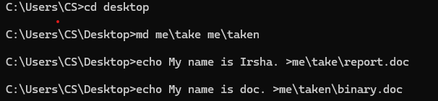

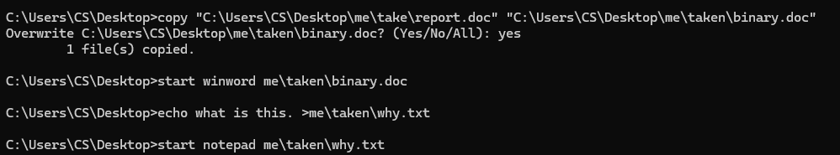

C:\Users\CS\Desktop>del me\taken\binary.doc

Task 1: Creating and Managing Files
📌 Goal: Create Word, Notepad, and PowerPoint files, then view the file structure.

Steps:
1️. Navigate to the Desktop:
cd /d C:\Users\%USERNAME%\Desktop
2️. Create an empty Word file:
echo. > Document.docx
3️. Create a Notepad file with content:
echo This is a sample Notepad file. > Notes.txt
4️. Create an empty PowerPoint file:
echo. > Presentation.pptx
5. View the folder structure:
tree /f
📌 Expected Outcome: Three files (Document.docx, Notes.txt, Presentation.pptx) should be created and visible in CMD.

Task 2: Opening, Replacing, and Closing Files
📌 Goal: Open files, replace an existing file, and close an open file.

Steps:
1️. Open the Word document:
start winword Document.docx
2️. Open the Notepad file:
start notepad Notes.txt
3️. Replace the Notepad file with a new version:
echo This is the updated content. > NewNotes.txt
replace NewNotes.txt Notes.txt
4️. Close Notepad without saving:
taskkill /F /IM notepad.exe
5️. Verify the replacement:
type Notes.txt
📌 Expected Outcome:
- Notepad file content should be updated.
- Notepad should be closed forcefully.

Task 3: Automating File Deletion
📌 Goal: Delete files.

Steps:
1️. Delete the Word file:
del Document.docx
2️. Delete all .txt files:
del /q *.txt
📌 Expected Outcome:
- Files should be deleted.

Summary of Learning
✅ Created Word, Notepad, and PowerPoint files
✅ Opened and replaced files
✅ Forcefully closed applications
✅ Deleted files and explored recovery options

