Title: How Genes Are Related to Personality: A Psychological Perspective
Name: Humna Imran
Institution: The University of Faisalabad
Course: Psychology
Instructor: Dr. Fakiha
Date: Thursday, April 24, 2025

Abstract
This assignment explores the genetic underpinnings of personality through a psychological lens. Personality, a complex combination of traits and behaviors, is influenced by both genetic and environmental factors. This paper reviews key theories, particularly the Big Five traits, and highlights the role of heritability as demonstrated by twin and adoption studies. A case study is included to illustrate real-world genetic influence on personality. Gene-environment interaction and ethical considerations are also discussed, emphasizing the balance between biology and experience in shaping who we are.

1. Introduction
Personality psychology seeks to understand the individual differences in behavior, emotion, and thought. Central to this field is the question: How much of our personality is shaped by our genes? The classic nature vs. nurture debate frames this inquiry, with increasing support for the idea that both heredity and environment contribute to personality. This paper aims to investigate how genetic factors influence personality traits, with a focus on empirical evidence and psychological theories.

2. Overview of Personality Theories
Understanding personality is a central task in psychology, and many theories have emerged to explain the vast differences observed among individuals. Below, we will dive deeper into Psychodynamic, Humanistic, and Biological approaches, with a special focus on how genetics could be incorporated into these theories.
Psychodynamic Theory
The Psychodynamic Theory of personality, originally developed by Sigmund Freud, focuses on the unconscious mind and how early childhood experiences shape our personality. Freud proposed that much of human behavior is influenced by unconscious drives and early life experiences, particularly those related to sexuality, aggression, and family dynamics. According to Freud, our personality is divided into three structures:
- Id – The impulsive, unconscious part of our psyche driven by the pleasure principle, seeking immediate gratification of desires.
- Ego – The rational part, which mediates between the desires of the id and the reality of the outside world.
- Superego – The moral compass of personality, often internalizing societal norms and values.
Freud’s psychosexual stages of development (oral, anal, phallic, latent, and genital stages) suggest that our early experiences during these stages significantly influence our adult personality traits.
While Freud’s theories laid the groundwork for understanding human behavior, the role of genetics was not addressed directly. However, contemporary psychodynamic theorists have begun to incorporate genetic research. For example, attachment theory (developed by John Bowlby) emphasizes the importance of early relationships between children and caregivers in shaping personality. Genetic predispositions to attachment styles (secure, anxious, avoidant) may predispose individuals to develop different responses to emotional challenges, reinforcing the psychodynamic focus on early experiences and relationships.
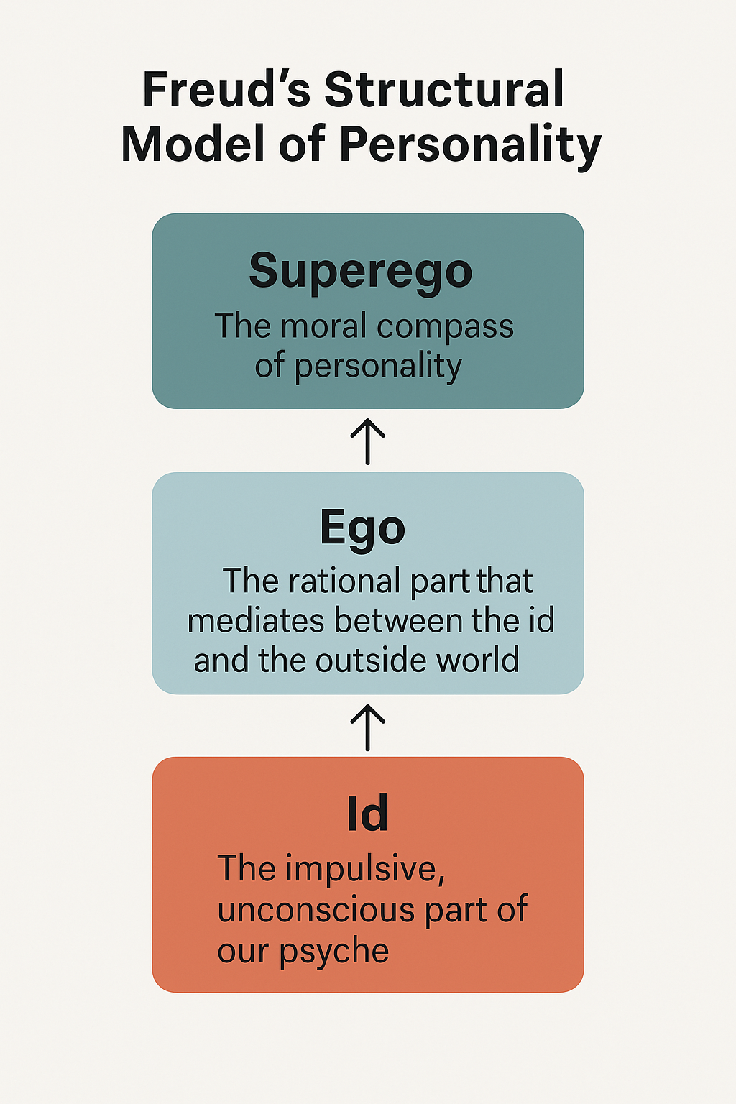
Figure 1: Freud’s structural model of personality, illustrating the interaction between the id (instinctual desires), ego (rational thought), and superego (moral standards). Adapted from [source if applicable].

Humanistic Theory
The Humanistic Theory of personality is a positive and growth-oriented approach, with key figures such as Abraham Maslow and Carl Rogers at the forefront. Unlike Freud, who emphasized conflict and repression, humanistic psychology focuses on self-actualization, free will, and personal growth. It holds that humans have an inherent desire to become the best versions of themselves.
Key components of humanistic theory include:
- Self-Actualization: Maslow proposed a hierarchy of needs, culminating in the desire for self-actualization, or realizing one’s full potential.
- The Self: Carl Rogers emphasized the importance of the self-concept, which is how we view ourselves, and the importance of unconditional positive regard in shaping a healthy personality.
- Authenticity: Humanistic psychology focuses on the authenticity of the self, encouraging individuals to express their true selves rather than conform to external expectations.
Incorporating genetics into humanistic psychology requires understanding how individuals' inherent biological tendencies might influence their personal growth. For example, certain genetic traits may predispose individuals toward greater resilience or a tendency to seek personal growth. Genetic influences on emotional regulation and sensitivity to stress may either help or hinder the ability to achieve self-actualization.
Recent studies in neuroscience have shown how genetics influence dopamine receptors and reward pathways, which play a role in motivation and personal development. Some individuals may have a genetic predisposition that makes them more inclined to pursue goals and engage in self-improvement, reflecting the essence of the humanistic ideal.
Integrating Genetics into Personality Theories
Both psychodynamic and humanistic theories were originally developed with little reference to genetics. However, with advancements in behavioral genetics and neuroscience, researchers have started to integrate genetic findings into these older theories, offering a more nuanced understanding of personality development.
For instance, genetic predispositions to emotional reactivity, neuroticism, or temperament may influence how we cope with life’s challenges, which would affect the unconscious conflicts described in psychodynamic theory. Similarly, humanistic concepts such as self-actualization may be influenced by genetic traits related to motivation, reward systems, and emotional regulation. These traits could either facilitate or impede personal growth.
By expanding these theories with genetic insights, we can begin to see how biology and personality intersect. For example, dopamine and serotonin genes have been linked to traits such as extraversion and neuroticism, which directly affect how individuals perceive their world and interact with others. Additionally, genetic predispositions to specific temperaments may influence how a person perceives and responds to the world, shaping both psychodynamic and humanistic personality development.

3. Genetics and Personality
The genetic basis of personality has been a topic of great interest for psychologists, especially with the advancements in behavioral genetics. Twin studies, adoption studies, and genome-wide association studies (GWAS) have provided invaluable insights into the heritability of personality traits. This section explores these research methods and the specific findings that suggest a significant genetic influence on personality.
3.1 Twin Studies: Insights into Heritability
Twin studies have long been one of the most powerful tools used to study the genetic contribution to personality. By comparing identical (monozygotic, or MZ) twins, who share 100% of their genes, with fraternal (dizygotic, or DZ) twins, who share 50% of their genes, researchers can estimate the degree to which personality traits are inherited.
Bouchard et al. (1990), in the famous Minnesota Twin Study, found that identical twins raised apart were more similar in personality than fraternal twins raised together. This groundbreaking study suggested that genetic factors account for a significant portion of the variability in personality traits. Specifically, the heritability estimates for traits like extraversion and neuroticism were found to be around 40-60%, meaning genetics played a substantial role in determining these traits.
Other twin studies have confirmed these findings, showing that genetic inheritance is a strong predictor of the Big Five personality traits. For example, extraversion, which is associated with sociability and positive emotions, has a heritability estimate of around 50%. Similarly, neuroticism, the tendency to experience negative emotions like anxiety and depression, has been shown to have a high genetic basis.
3.2 Adoption Studies: Further Confirmation of Genetic Influence
While twin studies provide valuable information about genetic influence, adoption studies provide additional clarity on how genetic and environmental factors interact. In adoptive families, adopted children are compared to their biological and adoptive parents to assess the influence of genetics vs. environment.
For example, Plomin et al. (1997) conducted a study on adopted children and found that their personality traits were more similar to those of their biological parents than their adoptive parents. This further supports the idea that genetics plays a significant role in personality, independent of the environment in which a person is raised.
Adoption studies have also shown that heritability of traits like extraversion, conscientiousness, and neuroticism are consistent across different environmental settings, reinforcing the idea that genetic factors have a considerable impact on the development of these personality traits.
3.3 Genome-Wide Association Studies (GWAS): Identifying Specific Genes
With the advent of genomic technologies, more recent studies have shifted focus toward identifying specific genes associated with personality traits. Genome-wide association studies (GWAS) examine how variations in genes across the human genome are linked to particular traits.
One of the most prominent findings comes from the DRD4 gene, which codes for the dopamine receptor. Research has linked DRD4 to traits such as novelty-seeking and extraversion. Individuals with longer versions of the DRD4 gene tend to score higher on novelty-seeking behaviors, suggesting that genetic differences in the dopamine system contribute to the tendency to seek out new experiences and challenges.
Another study found that 5-HTTLPR, a variant of the serotonin transporter gene, is associated with neuroticism and emotional instability. Individuals with the short version of this gene tend to have higher levels of anxiety, depression, and stress sensitivity, aligning with findings from twin studies about the heritability of neuroticism.
These discoveries are exciting because they highlight the biological pathways through which genes influence personality. However, it’s important to note that no single gene can explain complex personality traits. Instead, multiple genes, each contributing a small effect, interact with environmental factors to shape personality.
3.4 The Role of Epigenetics: Gene-Environment Interactions
While twin and adoption studies have established the role of genetics in personality, epigenetics provides further insight into how environmental factors influence genetic expression. Epigenetics refers to changes in gene expression that do not involve alterations to the DNA sequence but are influenced by external factors such as stress, nutrition, or early life experiences.
For example, childhood trauma can activate or silence specific genes related to emotional regulation and stress response. The gene-environment interaction plays a key role in shaping personality, as epigenetic changes can alter how an individual reacts to their environment. Thus, while genetics sets the foundation, life experiences can have a profound impact on the expression of genetic traits.
Studies on the gene-environment interaction show that children with a genetic predisposition to neuroticism may develop anxiety disorders if exposed to stressful environments during childhood. On the other hand, those with the same genetic predisposition, but raised in supportive environments, may not exhibit the same high levels of anxiety.
3.5 Limitations of Genetic Studies and Findings
While the genetic studies outlined above provide compelling evidence for the role of genetics in personality, it’s important to recognize their limitations. For example, heritability estimates suggest that genes account for a portion of personality variance, but environmental factors still play a significant role. Additionally, the complex interaction between genes and environment makes it difficult to isolate the exact contribution of genetics to personality.
Moreover, most genetic studies on personality are still in their early stages. GWAS findings often identify small effect sizes for individual genes, and researchers are still working to understand how these genes interact with one another and with environmental factors.
Finally, ethical considerations related to genetic research are essential. The use of genetic testing in personality assessment raises concerns about privacy, genetic discrimination, and eugenics. These concerns need to be addressed as genetic research continues to advance.
Conclusion for this Section
Genetic studies, particularly twin, adoption, and GWAS, have provided significant evidence for the genetic basis of personality traits. The findings suggest that traits like extraversion, neuroticism, and novelty-seeking have a genetic foundation, with specific genes such as DRD4 and 5-HTTLPR linked to these traits. However, these studies also highlight the importance of gene-environment interactions, where environmental factors can influence the expression of genetic predispositions.
While genetics plays a substantial role in personality, it is crucial to recognize that personality development is the result of both biological factors and environmental influences. Future research should continue exploring how genetic and environmental factors interact to shape personality, providing a more comprehensive understanding of human behavior.

4. The Big Five and Genetics
Each Big Five trait has a heritable component:
- Openness: Linked to dopamine-related genes, showing moderate heritability.
- Conscientiousness: Associated with prefrontal cortex activity; genes related to impulse control.
- Extraversion: Related to dopamine functioning; high heritability observed.
- Agreeableness: Influenced by genes affecting serotonin; moderate heritability.
- Neuroticism: Strongly heritable; linked with genes influencing emotional regulation.
Twin studies and genome-wide association studies (GWAS) reinforce these links, though no single gene determines personality.
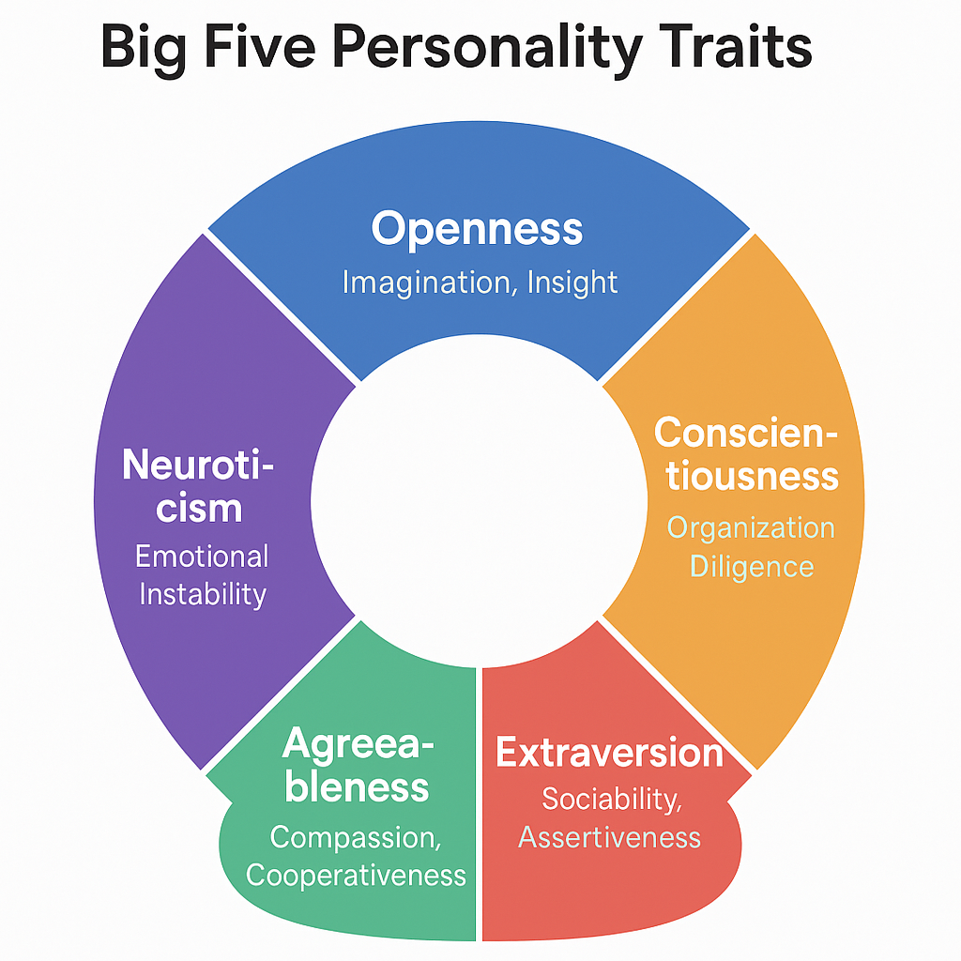
Figure 2: This circular diagram visually summarizes the Big Five personality traits—Openness, Conscientiousness, Extraversion, Agreeableness, and Neuroticism. Each trait is represented with key descriptors, offering a clear and concise overview of core personality
5. Case Study: Identical Twins and Personality
Case studies are an effective way to understand how genetic and environmental factors influence personality development. Below, we provide both real-life examples and fictional case studies that demonstrate the intricate ways in which genes and environment interact.
5.1 Real-World Case Study: The Jim Twins (Jim Lewis and Jim Springer)
One of the most famous case studies illustrating the genetic influence on personality is the story of Jim Lewis and Jim Springer, two identical twins who were separated at birth and reunited at age 39. Raised in completely different environments—Jim Lewis grew up in Michigan with an adoptive family, while Jim Springer was raised in Ohio—both men exhibited strikingly similar behaviors, preferences, and personality traits, despite their very different upbringings.
- Similarities:
  - Both twins had the same career choices (police officers).
  - Both had married women named Linda and later divorced them to marry women named Betty.
  - Both had dogs named Toy and enjoyed similar hobbies such as woodworking and carpentry.
  - Both twins had similar health problems (headaches, high blood pressure).
These remarkable similarities strongly suggest that genetics played a significant role in shaping their personality and behaviors. Despite being raised in different environments, their shared genetic makeup appeared to dictate many aspects of their lives, supporting the theory that genetic factors significantly contribute to personality development.
This case study illustrates the power of genetics in shaping traits like career choice, personal preferences, and even behaviors that seem deeply ingrained.
5.2 Real-World Case Study: The Role of Genetics in Mental Health – The Case of Depression
Another example involves the study of depression in twins. Twin studies have shown that identical twins are much more likely to both suffer from depression if one of them has it, compared to fraternal twins. This suggests a genetic predisposition to developing depressive symptoms.
For instance, the study by Kendler et al. (2006) found that genetic factors accounted for approximately 37% of the risk for depression in identical twins. The remaining risk was attributed to environmental factors such as stressful life events.
- Case Study Example:
  - Person A: An identical twin raised in a supportive, nurturing environment, with close relationships and positive coping strategies, does not develop depression, even in the face of life challenges.
  - Person B: An identical twin raised in a more stressful environment, with little social support and chronic life difficulties, experiences a major depressive episode in early adulthood. Although both twins share the same genetic predispositions, Person B's environment triggers the onset of depression.
This case emphasizes the role of gene-environment interaction in the development of mental health conditions, where genetic vulnerabilities interact with environmental stressors to determine the outcome.
5.3 Fictional Case Study: Genetic Influence on Extraversion vs. Introversion
Case Study: Sarah and Emily
- Sarah: Sarah is an individual who has always been described as outgoing, sociable, and enthusiastic in social situations. From a young age, she enjoyed interacting with others, sought out leadership roles, and thrived in group settings. Sarah's biological family has a history of high extraversion, with both parents and her siblings exhibiting similar traits.
- Emily: Emily, Sarah's twin sister, shares the same genetic material, but her personality is quite different. Despite having the same parents and growing up in the same household, Emily is reserved, introverted, and often seeks solitude. She tends to avoid large social gatherings and prefers solitary activities like reading and writing.
Sarah and Emily's case highlights the genetic basis of extraversion and introversion. Both individuals have similar genetic predispositions, but their personalities diverge due to environmental factors. For example, Emily had experiences early in life that encouraged introspection, such as spending significant time in a quiet, rural area with limited social interaction. In contrast, Sarah was encouraged by her parents to participate in social activities from a young age, which likely reinforced her extraverted traits.
This case illustrates how genetic predispositions can manifest differently depending on the environment. While both sisters share similar genes, their social environments contributed to the development of their contrasting personality traits.
5.4 Fictional Case Study: The Influence of Temperament in Childhood Development
Case Study: Michael and Anna
- Michael: Michael is a 4-year-old child with an innate high activity level, impulsivity, and a high threshold for frustration. These characteristics are observable from an early age, and he is often described as active and curious. His parents, aware of his energetic nature, actively engage him in physical activities and provide a structured environment to help him channel his energy productively.
- Anna: Anna, Michael's twin sister, also shares the same genetic traits but has a lower threshold for frustration and a greater need for comfort in challenging situations. Despite growing up in the same household, Anna's parents are more sensitive to her emotional needs and provide a more calming, nurturing environment.
By the age of 5, Michael is thriving in activities like sports and outdoor play, often participating in team events and demonstrating leadership skills. Meanwhile, Anna enjoys quieter, more solitary activities like drawing and reading, where she excels without feeling overstimulated.
This case illustrates the concept of temperament and how genetic factors influence early personality development. While both children share similar genetic predispositions, their parents' responses to their inherent traits lead to different developmental paths. Michael's high activity level is nurtured in a way that enhances his extraverted behaviors, while Anna's emotional sensitivity fosters a more introverted approach to social interactions.
5.5 Conclusion for this Section
The case studies presented—ranging from the Jim Twins, who exemplify the power of genetics in shaping behaviors and preferences, to the fictional cases of Sarah and Emily and Michael and Anna, who highlight the interaction between genetic predispositions and environmental influences—demonstrate the complexity of personality development.
These examples reinforce the idea that genetics provides a biological foundation for traits like extraversion, neuroticism, and temperament, but environmental factors play a crucial role in shaping how these traits manifest. Whether it is through the influence of early childhood experiences, parenting styles, or cultural settings, the interaction between genes and environment shapes personality in profound ways.

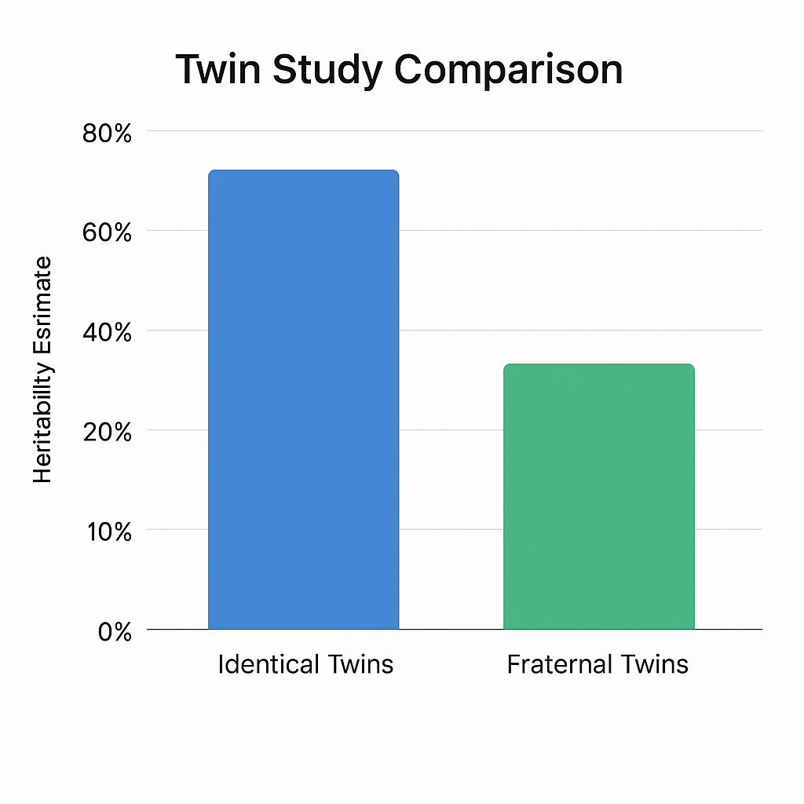
Figure 3: This bar chart compares the heritability of personality traits between identical and fraternal twins. Identical twins show an estimated 80% similarity, while fraternal twins show about 40%, highlighting a strong genetic influence on personality.
6. Environmental Interaction with Genes (Gene-Environment Interaction)
Gene-environment interaction refers to the way in which genetic predispositions and environmental factors combine to influence an individual’s behavior, traits, and personality. Epigenetics, the study of changes in gene expression that do not involve alterations in the DNA sequence itself, plays a pivotal role in this process. Environmental factors such as stress, nutrition, and early life experiences can trigger epigenetic modifications that alter the expression of genes, influencing personality traits such as neuroticism, emotional stability, and temperament.
This section will explore epigenetic studies that have provided important insights into how environmental factors can influence genetic expression and shape personality.

6.1 What is Epigenetics?
Epigenetics refers to heritable changes in gene expression that do not involve changes to the underlying DNA sequence. These changes are typically mediated by chemical modifications to the DNA molecule or the histones (proteins around which DNA is wrapped). The most studied epigenetic modifications include:
- DNA Methylation: The addition of a methyl group to the DNA molecule, which typically suppresses gene expression.
- Histone Modification: Changes to the proteins that DNA is wrapped around, affecting the accessibility of DNA for transcription.
- Non-coding RNA molecules: These molecules can regulate gene expression without altering the DNA sequence.
Epigenetic changes are influenced by various environmental factors, including stress, diet, toxins, and social experiences. These changes can be temporary or, in some cases, passed down to subsequent generations, affecting the gene-environment interaction across generations.

6.2 Epigenetic Studies on Stress and Personality
One of the most well-known areas of epigenetic research focuses on how early life stress can affect the expression of genes related to emotion regulation, leading to personality traits such as neuroticism or anxiety.
Study Example: The Impact of Childhood Trauma on the HPA Axis
The hypothalamic-pituitary-adrenal (HPA) axis is a critical system in the body that regulates the stress response. Studies have shown that early childhood trauma, such as abuse or neglect, can lead to epigenetic modifications in genes associated with the HPA axis. These changes can alter the body's stress response and lead to long-term personality changes, including higher levels of anxiety, neuroticism, and emotional instability.
- The Role of the FKBP5 Gene: One of the most studied genes in this context is the FKBP5 gene, which plays a role in regulating the stress hormone cortisol. Research has shown that childhood abuse or trauma can lead to DNA methylation in the FKBP5 gene, reducing its expression and making the stress response more intense. This can lead to increased vulnerability to stress and greater susceptibility to mental health disorders, including depression and anxiety.
  - Real-World Example: Children who experienced severe emotional neglect or physical abuse in their early years showed epigenetic changes in the FKBP5 gene, which resulted in a more exaggerated stress response in adulthood. These individuals were more prone to developing neurotic and anxious personality traits later in life.
This study demonstrates how environmental stressors—especially those encountered during early development—can cause epigenetic changes that influence personality traits such as neuroticism and emotional reactivity.

6.3 Epigenetic Changes in Response to Social Environment
Social experiences and interactions can also lead to epigenetic modifications that affect personality. For instance, the quality of parent-child bonding can influence epigenetic changes in genes related to attachment and emotional regulation.
Study Example: The Influence of Maternal Care on Infant Stress Response
In a famous study by Meaney et al. (2004), researchers examined the impact of maternal care on the expression of the NR3C1 gene, which encodes the glucocorticoid receptor involved in the stress response. The study found that high levels of maternal care (e.g., licking, grooming, and nursing) led to DNA demethylation of the NR3C1 gene, which increased the expression of this gene and resulted in better stress regulation in adulthood.
- Contrasting Case: Low Maternal Care: In contrast, infants who received low levels of maternal care had higher DNA methylation at the NR3C1 gene, which led to poorer regulation of the stress response and a higher likelihood of developing anxiety and stress sensitivity later in life.
  - Real-World Example: A child raised in a nurturing and responsive environment where the caregiver provides consistent affection and support is likely to experience epigenetic changes that result in a more resilient and emotionally stable personality. On the other hand, a child raised in a neglectful or emotionally distant environment may experience epigenetic changes that contribute to the development of neurotic traits and difficulty managing stress.
These findings emphasize the profound influence of early parenting styles and attachment experiences on personality development through epigenetic mechanisms.

6.4 Epigenetic Studies on Aging and Personality Stability
While much of epigenetic research focuses on early life, there is also increasing interest in how epigenetic changes occur throughout the lifespan and affect personality traits as we age. One area of research has examined how epigenetic changes are linked to aging and the stability or change in personality traits over time.
Study Example: Epigenetic Changes in Personality Stability Across the Lifespan
A study by Teschler et al. (2019) explored how DNA methylation patterns change over time and how these changes might influence the stability of personality traits, particularly neuroticism and conscientiousness. The research found that people who maintained stable levels of conscientiousness throughout their lives had relatively stable epigenetic patterns, suggesting that genes associated with self-regulation and goal-oriented behavior were consistently expressed.
- Real-World Example: Older individuals who maintained high levels of neuroticism (prone to emotional instability and anxiety) showed significant DNA methylation changes in genes related to emotional regulation. These changes were linked to a decline in emotional resilience as they aged, suggesting that epigenetic changes may influence the trajectory of personality stability or change across the lifespan.

6.5 Implications for Personality Development
Epigenetic studies underscore the fact that personality is not solely determined by genetics or environment in isolation, but rather by the complex interplay between the two. Environmental factors, especially those encountered early in life, can have a profound impact on the genetic expression that shapes personality. This means that individuals with similar genetic predispositions can have very different personalities depending on their early life experiences, such as exposure to stress, trauma, or nurturing.
Furthermore, epigenetic changes provide a mechanism through which environmental experiences can leave a lasting imprint on personality traits. This also suggests that personality is malleable—changes in environmental conditions could potentially reverse or enhance some of the epigenetic modifications that influence personality development.
Conclusion for this Section
Gene-environment interaction, especially through epigenetic mechanisms, plays a pivotal role in shaping personality traits. Research shows that early life stress, parent-child bonding, and other environmental factors can trigger epigenetic changes that affect the expression of genes related to emotion regulation, neuroticism, and stress sensitivity. These epigenetic modifications highlight the dynamic relationship between genetics and environment in personality development.
Future research in epigenetics has the potential to offer new insights into how we can intervene at various life stages to promote healthier personality development, particularly in individuals at risk due to early life adversities.
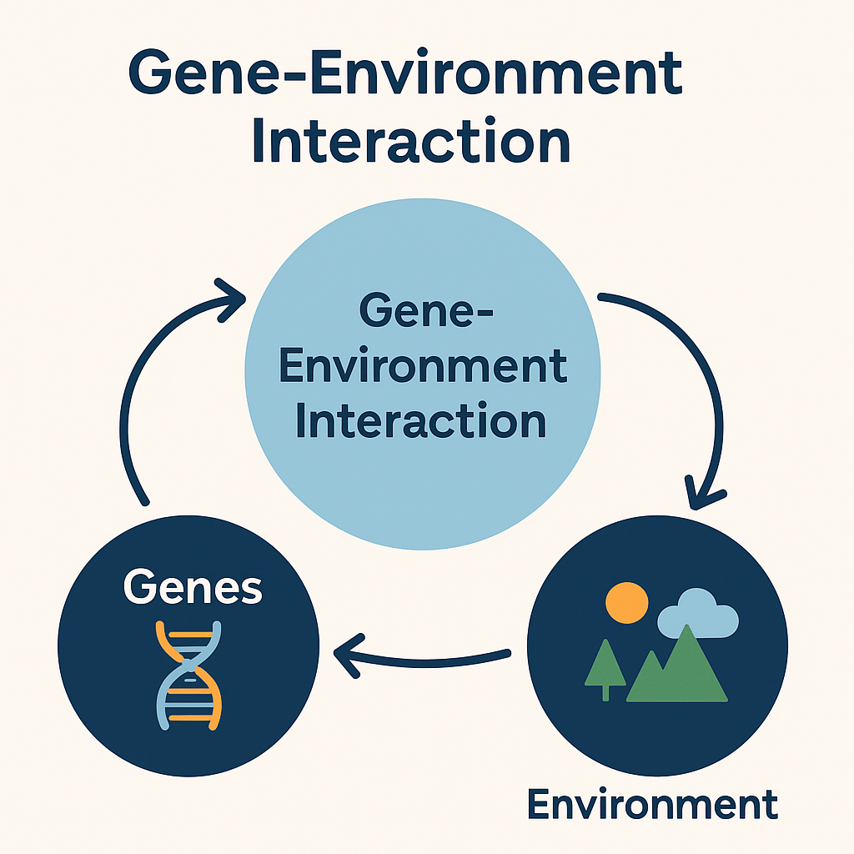
Figure 4: This diagram illustrates the dynamic relationship between genetic predispositions and environmental factors. Gene-environment interactions influence the expression of personality traits through a continuous feedback loop.

7. Ethical Considerations and Criticism
As genetic and epigenetic research progresses, particularly in relation to personality and behavior, it raises significant ethical concerns. The ability to predict or influence personality traits based on genetic information opens new opportunities for psychological intervention—but also brings complex moral, social, and legal questions.
7.1 The Risk of Genetic Determinism and Labeling
One major ethical concern is the danger of genetic determinism—the belief that genes alone determine personality and behavior. If society begins to view certain personality traits as inherited and unchangeable, this could lead to harmful labeling, stereotyping, or self-fulfilling prophecies.
- For example, if a genetic test suggests a child has a predisposition to aggression or low conscientiousness, teachers or parents might treat them differently, potentially limiting their growth.
- This could also influence employment, education, or insurance decisions, leading to discrimination based on assumed genetic traits.
Psychologically, this undermines the concept of free will and personal growth, which are core ideas in humanistic psychology. It’s crucial to remember that genes are not destiny, and personality can evolve through life experiences.
7.2 Informed Consent and Psychological Impact
Another challenge lies in ensuring informed consent—especially when genetic testing is done on children, vulnerable populations, or within family structures.
- Do individuals truly understand the long-term consequences of sharing their genetic information?
- How might someone psychologically react to learning they carry genes associated with traits like anxiety, neuroticism, or impulsivity?
For example, a person who discovers a genetic predisposition for depression might experience anticipatory anxiety, even if they never develop the condition. This creates a psychological burden of knowledge, possibly influencing self-esteem and life choices.
Psychologists must ensure individuals receive pre- and post-genetic counseling to cope with this information constructively, rather than letting it define them.
7.3 Privacy and Data Security
With the rise of genetic databases, there is a growing concern about privacy and data misuse. Genetic data is extremely personal and sensitive, often revealing not only information about the individual but also their biological relatives.
- There is a risk that genetic data could be shared or sold without proper consent.
- Data breaches could expose individuals to discrimination in employment or insurance.
- Governments or corporations might use genetic profiles to make policy decisions or manipulate public behavior.
From an ethical standpoint, researchers and psychologists must advocate for strict data protection laws, such as de-identification of genetic samples, encrypted storage, and limited access to sensitive information.
7.4 Genetic Testing in Children and Prenatal Screening
An especially controversial area is genetic testing in children or during prenatal screening. Parents may seek information about their child’s future personality traits, intelligence levels, or predisposition to mental health conditions.
- This raises the question: Should parents be allowed to know or even select personality traits before a child is born?
- Could this lead to a new form of eugenics, where certain traits are valued over others?
This scenario presents a conflict between the child’s autonomy and the parent’s desire for control. Ethically, children should have the right to grow and define their own identity without being limited by genetic labels assigned before or shortly after birth.
7.5 Misuse in Legal and Workplace Settings
Genetic information related to personality could be misused in legal, military, or workplace settings:
- Employers might use genetic testing to assess "ideal" personality traits for certain jobs.
- Legal systems could consider genetic predispositions to aggression or impulsivity as mitigating factors in criminal behavior, raising concerns about moral responsibility.
- Military or elite institutions may seek individuals with genetic markers for resilience or risk-taking, creating unfair advantages or exclusions.
These practices create a bioethical dilemma: Should people be treated differently based on their genetic potential? If so, who decides which traits are desirable?
7.6 Cultural and Societal Biases
Genetic research on personality must also be approached carefully to avoid reinforcing cultural or racial biases. Some studies have controversially suggested population-level differences in personality traits, which could be misinterpreted or politicized.
- Ethical researchers and psychologists must ensure that findings are not misused to justify discrimination, colonial thinking, or racial superiority narratives.
- It's important to emphasize that environmental, cultural, and social factors play an equally—if not more—important role in shaping personality than genes alone.
7.7 Psychological and Social Responsibility of Researchers
Psychologists, geneticists, and mental health professionals must uphold a strong code of ethics when conducting personality research involving genetics. This includes:
- Prioritizing human dignity and respect.
- Ensuring voluntary participation with full knowledge of risks.
- Promoting beneficence, where research is designed to benefit individuals and society without causing harm.
- Actively educating the public on the limitations of genetic findings to prevent misinterpretation.
Conclusion for This Section
The use of genetic testing in understanding personality is a powerful scientific advancement—but it must be balanced with careful ethical reflection. Without clear ethical guidelines and psychological support, there is a risk of misuse, discrimination, and psychological harm.
As psychologists, it is essential to recognize that genetic potential does not equate to destiny. Traits like empathy, resilience, and self-regulation are shaped through experience, relationships, and choice. Ethical practices in genetic research must honor the complexity of human personality and protect the rights and dignity of all individuals.

8. Conclusion
Genes undeniably influence personality, as shown by robust research. However, genes interact dynamically with environments. Understanding this relationship helps psychologists develop more effective interventions and appreciate human complexity. Future research should integrate genetics with social and cultural contexts to fully grasp personality development.

References
American Psychological Association. (2020). Publication manual of the American Psychological Association (7th ed.).
Bouchard, T. J., Lykken, D. T., McGue, M., Segal, N. L., & Tellegen, A. (1990). Sources of human psychological differences: The Minnesota Study of Twins Reared Apart. Science, 250(4978), 223–228.
Caspi, A., & Moffitt, T. E. (2006). Gene-environment interactions in psychiatry: Joining forces with neuroscience. Nature Reviews Neuroscience, 7(7), 583–590.
DeNeve, K. M., & Cooper, H. (1998). The happy personality: A meta-analysis of 137 personality traits and subjective well-being. Psychological Bulletin, 124(2), 197–229.
Jang, K. L., Livesley, W. J., & Vernon, P. A. (1996). Heritability of the Big Five personality dimensions and their facets: A twin study. Journal of Personality, 64(3), 577–591.
Plomin, R., & Caspi, A. (1999). Behavioral genetics and personality. In L. A. Pervin & O. P. John (Eds.), Handbook of personality: Theory and research (2nd ed., pp. 251–276). Guilford Press.
Turkheimer, E. (2000). Three laws of behavior genetics and what they mean. Current Directions in Psychological Science, 9(5), 160–164.

