

Lab Manual
Subject: Database System

By
Abdul Bari 2024-BS-CS-289
Semester 4th
Course Code CS-213
Supervised by Mam Eman Basharat
The University of Faisalabad
Bachelors of Science in Artificial Intelligence
DEPARTMENT OF COMPUTER SCIENCE

Table of Content
Week | No. | Date | Lab Content
Week 1 | 1 | 13-02-2025 | Creating Tables using an Oracle User Interface
Week 2 | 2 | 20-02-2025 | Creating tables using DDL Queries in SQL:  • CREATE TABLE  • ALTER TABLE (ADD, MODIFY, DROP)  • DROP TABLE  • RENAME TABLE
Week 3 | 3 | 27-02-2025 | Insert, Update and Delete values in the Table using the DML:  • INSERT INTO TABLE  • Update  • Delete
Week 4 | 4 | 06-03-2025 | The practice of DDL and DML queries with different case scenarios
Week 5 | 5 | 13-03-2025 | Where and Order By Clause
Week 6 | 6 | 20-03-2025 | Other Restricting Data Constraints
Week 7 | 7 | 27-03-2025 | Practical Test (Create, Alter, Drop, Insert, Update, Delete)
Week 8 | 8 | 03-04-2025 | Database Setup using XAMPP
Week 9 |  | Mid Exam Week
Week 10 | 9 | 17-04-2025 | MySQL DDL queries using different scenarios
Week 11 | 10 | 24-04-2024 | MySQL DML queries using different scenarios
Week 12 | 11 | 02-05-2025 | Practical Test (Create Database and Table, Alter, Drop, Insert, Update, Delete, Where, Order By and Other Restricting Data Constraints)
Week 13 | 12 | 08-05-2025 | Join (Cross, Inner and Outer Join (Left, Right, Full))
Week 14 | 13 | 14-05-2025 | Math and String Functions
Week 15 | 14 | 20-05-2025 | Date Functions
LAB 1 (CREATE TABLE USING ORACLE USER INTERFACE)
- CREATE TABLE STD_INFORMATION USING GUI:
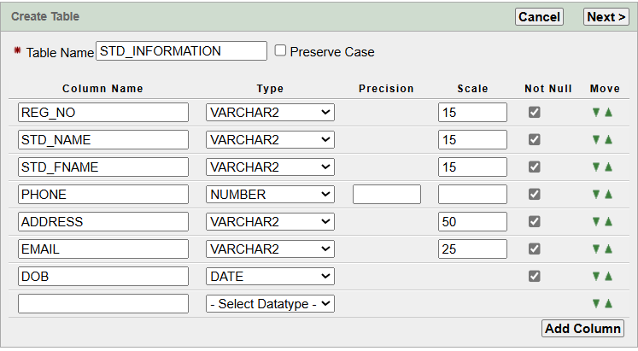
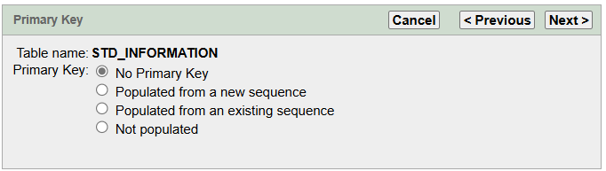
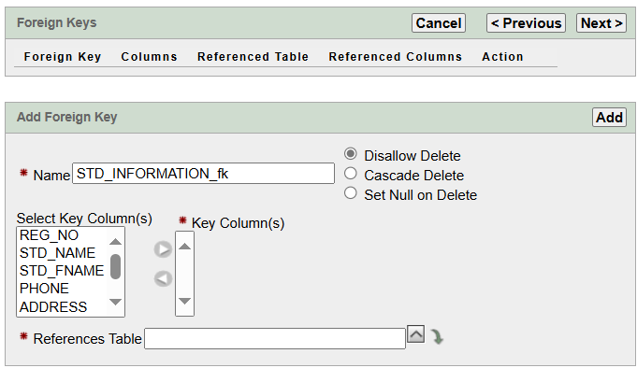
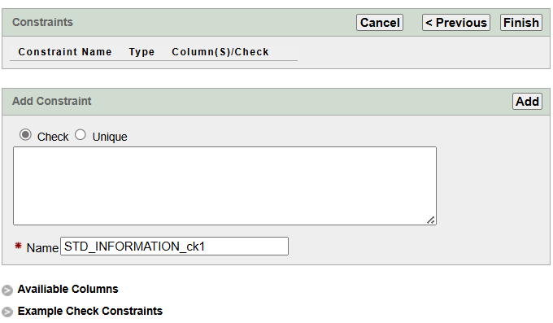
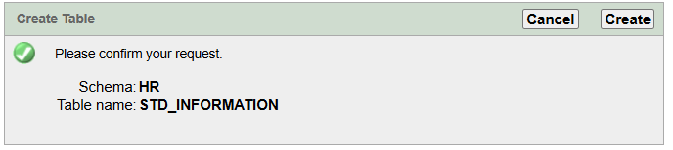
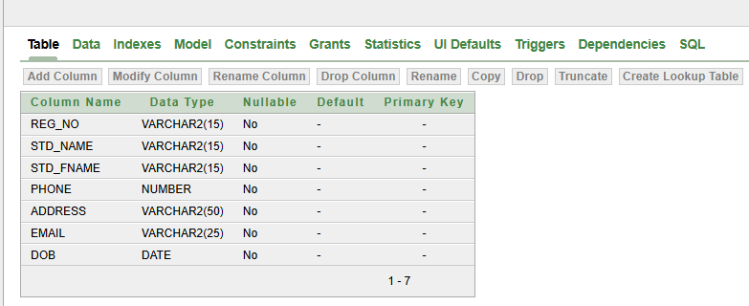
- CREATE TABLE USER_INFO USING GUI:
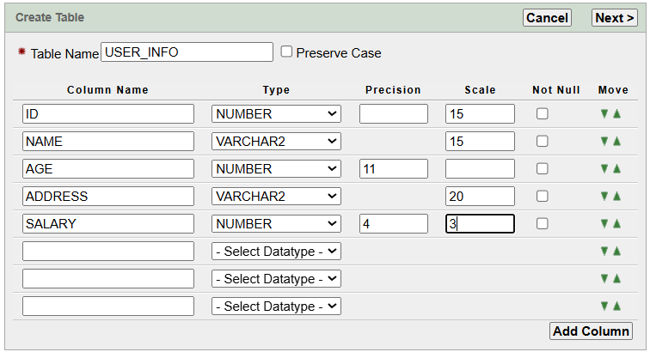
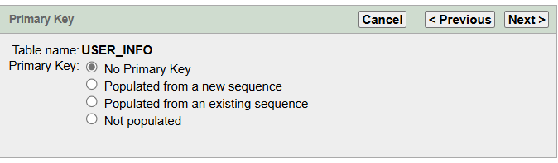
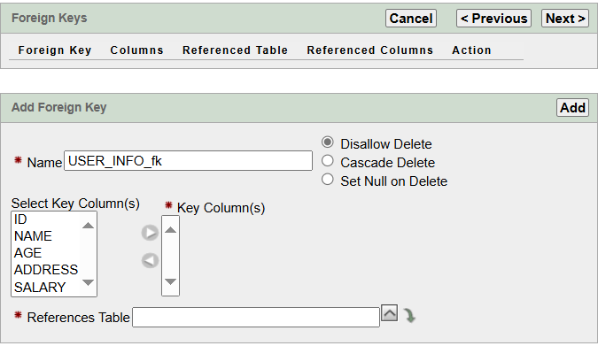
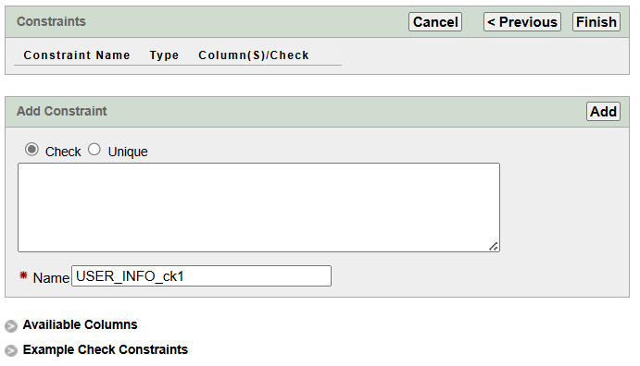
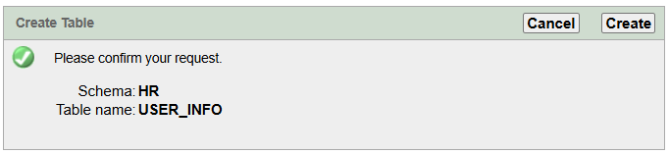
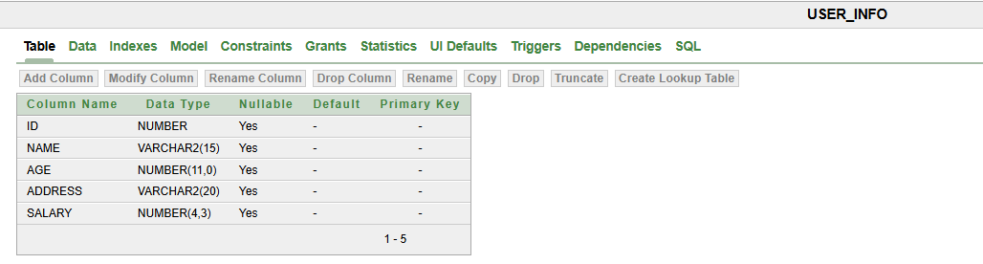

LAB 2 (CREATE TABLE USING SQL COMMAND)
QUERY:
CREATE TABLE TUF_STUDENTS(
STD_REG VARCHAR2(10),
STD_FNAME VARCHAR2(15),
STD_GENDER CHAR(1),
STD_DOB DATE,
STD_PHONE NUMBER(11),
STD_ADDRESS VARCHAR2(30),
STD_EMAIL VARCHAR2(20));
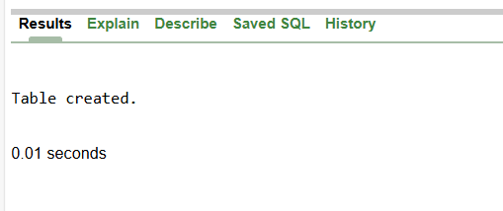
NEW QUERY:
DESCRIBE TUF_STUDENTS;
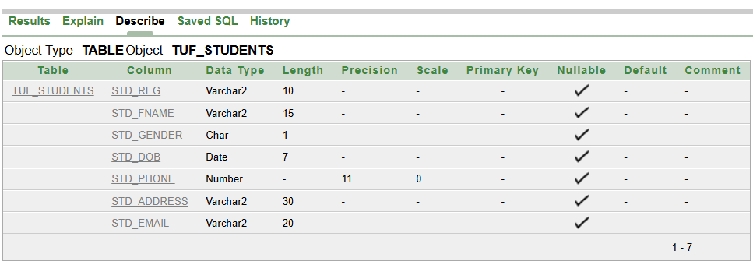
QUERY TO ADD NEW ATTRIBUTE:
ALTER TABLE TUF_STUDENTS
ADD STD_SEMESTER NUMBER(2);
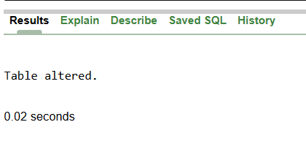
DESCRIBE TUF_STUDENTS;
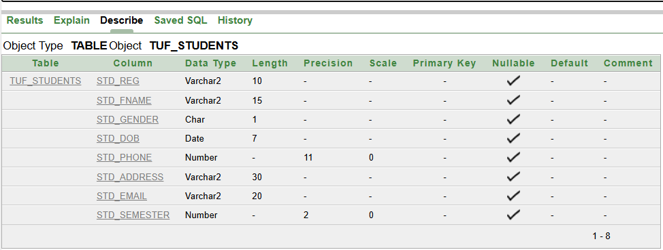
NEW QUERY:
ALTER TABLE TUF_STUDENTS
ADD STD_P_ADDRESS VARCHAR2(30);

DESCRIBE TUF_STUDENTS;
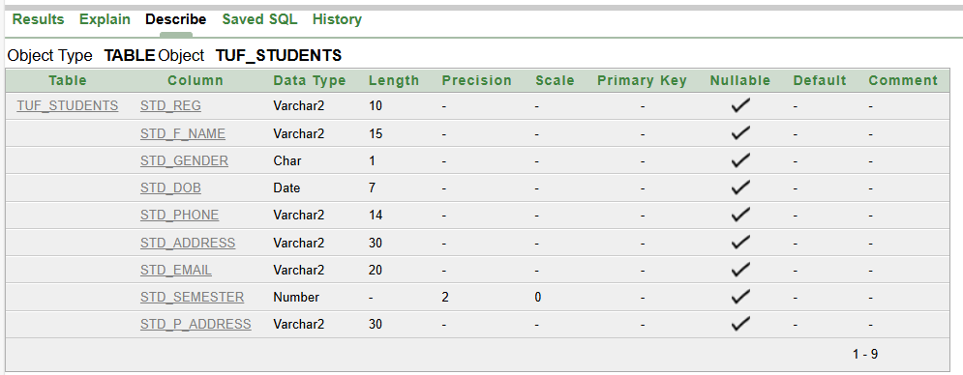

QUERY TO MODIFY TABLE:
ALTER TABLE TUF_STUDENTS
MODIFY STD_PHONE VARCHAR2(14);
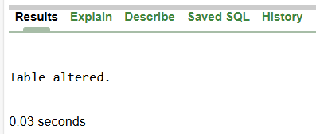
DESCRIBE TUF_STUDENTS;
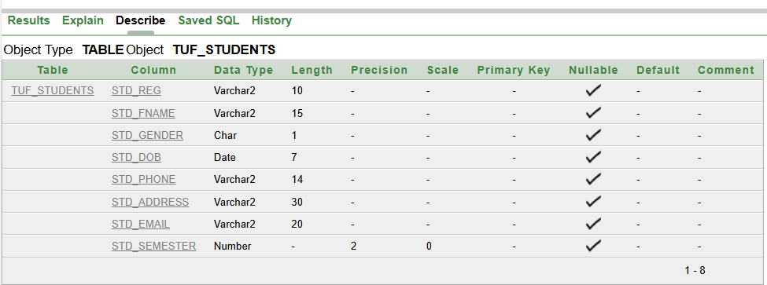
QUERY TO RENAME A COLUMN:
ALTER TABLE TUF_STUDENTS
RENAME COLUMN STD_FNAME TO STD_F_NAME;
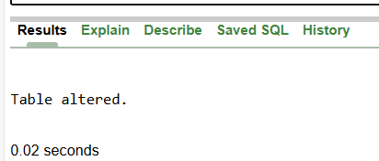
DESCRIBE TUF_STUDENTS;
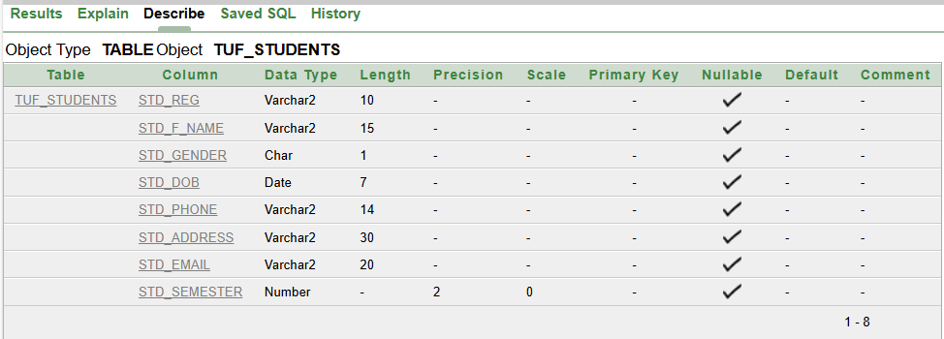
QUERY TO DROP COLUNM:
ALTER TABLE TUF_STUDENTS
DROP COLUMN STD_P_ADDRESS;

DESCRIBE TUF_STUDENTS;
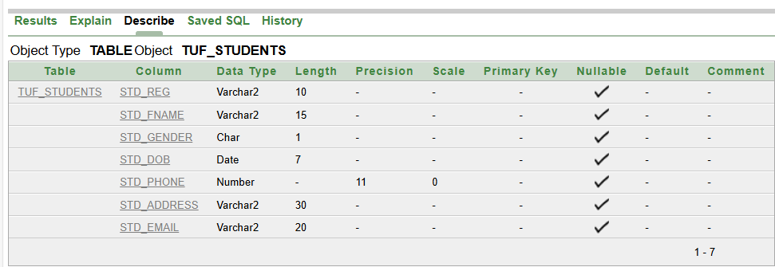
QUERY TO RENAME TABLE:
RENAME TUF_STUDENTS TO TUF_STUDENTS_BSAI;
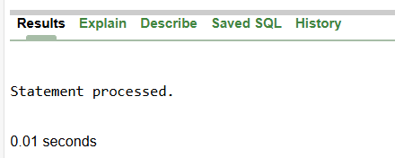

DESCRIBE TUF_STUDENTS_BSAI;
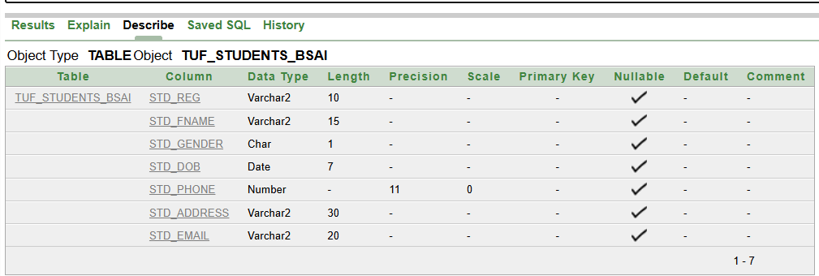
QUERY TO DROP TABLE:

DROP TABLE USER_INFORMATION;
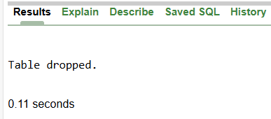
LAB TASK:
CREATE A TABLE USER_INFO:
QUERY:
CREATE TABLE USER_INFO(
USER_ID VARCHAR2(10),
USER_NAME VARCHAR2(10),
USER_PASSWORD NUMBER(4),
USER_CONFIRM_PASSWORD NUMBER(4));
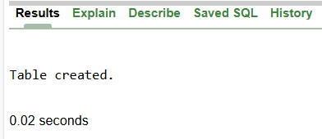
DESCRIBE USER_INFO;
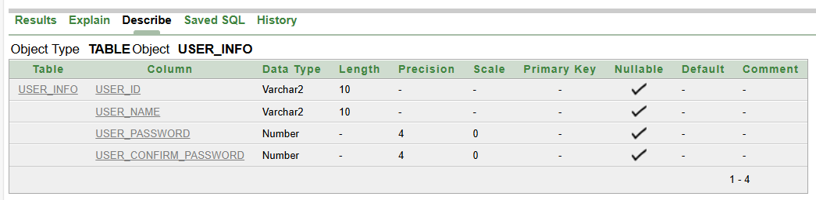
ADD A NEW ATTRIBUTE USER_EMAIL:
QUERY:
ALTER TABLE USER_INFO
ADD USER_EMAIL VARCHAR2(10);
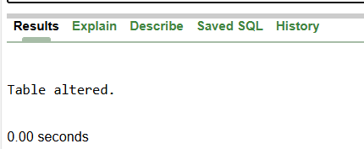
DESCRIBE USER_INFO;
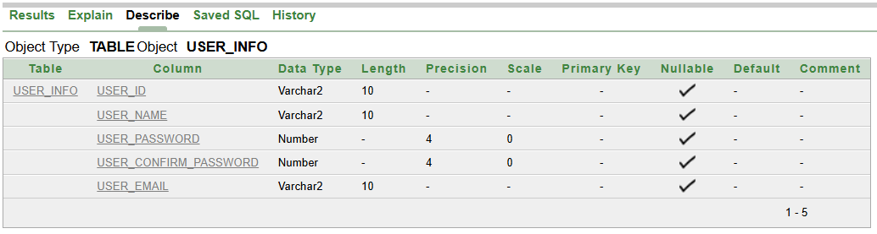
DROPPING A COLUMN USER_CONFIRM_PASSWORD:
QUERY:
ALTER TABLE USER_INFO
DROP COLUMN USER_CONFIRM_PASSWORD;
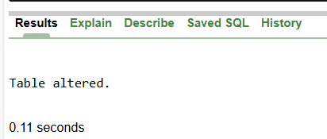
DESCRIBE USER_INFO;
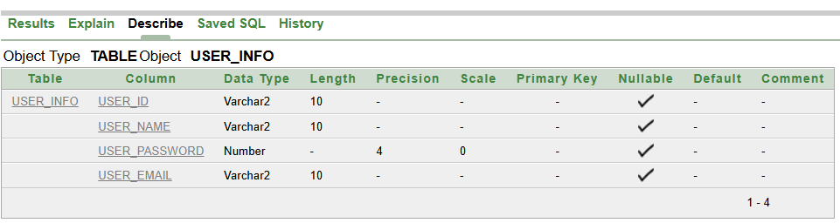
RENAMING THE TAB LE:
QUERY:
RENAME USER_INFO TO USER_INFORMATION;
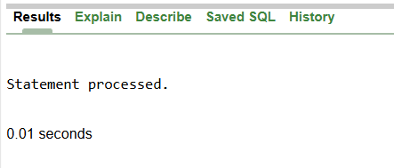
DESCRIBE USER_INFORMATION;
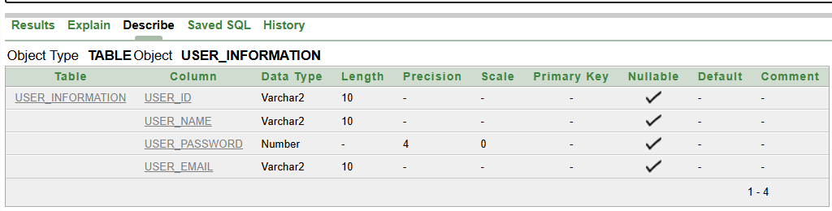
INSERTING VALUES THROUGH DML:
QUERY:

INSERT INTO TUF_STUDENTS_BSAI(STD_REG,STD_FNAME,STD_GENDER,STD_DOB,STD_PHONE,STD_ADDRESS,STD_EMAIL)
VALUES('2023-BSAI','ABC','F',TO_DATE('01/01/2004','DD/MM/YYYY'),03091166739,'GULSHAN COLONY','2023-BSAI@TUF.EDU');
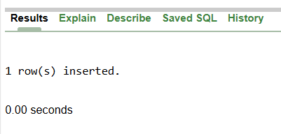
LAB 3 ( DML COMMANDS)

INSERTING ALL VALUES THROUGH DML:
QUERY:
INSERT ALL
INTO TUF_STUDENTS_BSAI VALUES('2023-BSAI','ABC','F',TO_DATE('01/01/2004','DD/MM/YYYY'),03091166739,'FAISALABAD','2023-BSAI@TUF.EDU')
INTO TUF_STUDENTS_BSAI VALUES('BSAI-141','LAIBA','F',TO_DATE('14/10/2004','DD/MM/YYYY'),03006651835,'GULSHAN COLONY','BSAI-141@TUF.EDU')
INTO TUF_STUDENTS_BSAI VALUES('144-BSCS','ABC','M',TO_DATE('01/JAN/2004','DD/MON/YYYY'),03226014440,'GULBERG','2023-BSAI@TUF.EDU')
INTO TUF_STUDENTS_BSAI VALUES('2023-ADP','DEF','F',TO_DATE('10/01/2004','MM/DD/YYYY'),03765432189,'PAKISTAN','2023-BSAI@TUF.EDU')
INTO TUF_STUDENTS_BSAI VALUES('2023-BSAI','ABC','F',TO_DATE('2025/07/03','YYYY/MM/DD'),03226789421,'CANAL ROAD','DATA@TUF.EDU')
SELECT * FROM DUAL;
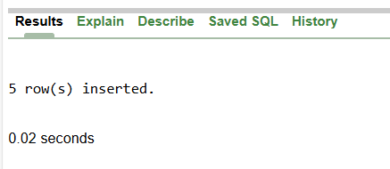
UPDATING VALUES THROUGH DML:
QUERY:
UPDATE TUF_STUDENTS_BSAI
SET STD_ADDRESS = 'FSD'
WHERE STD_ADDRESS = 'FAISALABAD';
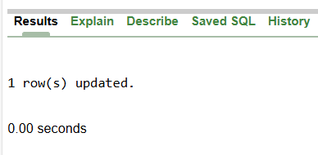
SHOW THE DATA OF THE TABLE:
QUERY:
SELECT * FROM TUF_STUDENTS_BSAI
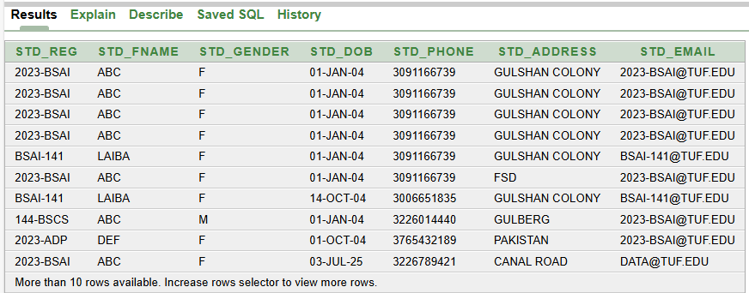
QUERY:
UPDATE TUF_STUDENTS_BSAI
SET STD_ADDRESS = 'PAK',STD_EMAIL = '141@GMAIL.COM'
WHERE STD_REG = '2023-BSAI';
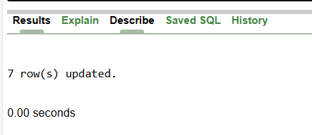

DELETING ATTRIBUTES THROUGH DML:
QUERY:
DELETE FROM TUF_STUDENTS_BSAI
WHERE STD_REG = '2023-BSAI';
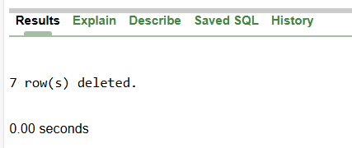

SELECT * FROM TUF_STUDENTS_BSAI
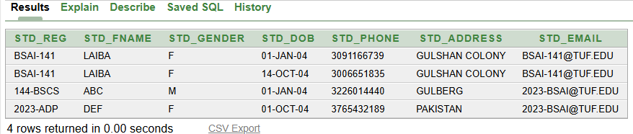
DELETING DATA THROUGH DML:
QUERY:
DELETE TUF_STUDENTS_BSAI;
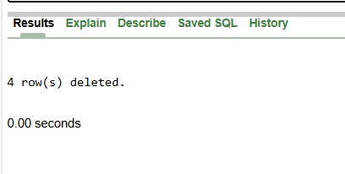
LAB TASK:
- CREATE A TABLE:
QUERY:
CREATE TABLE EMPLOYEES1(
EMPLOYEE_ID NUMBER(10),
NAME VARCHAR(10),
AGE NUMBER(3),
DEPARTMENT VARCHAR(10));
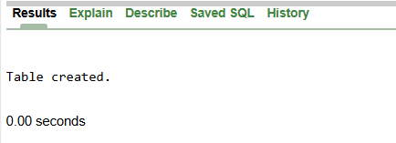
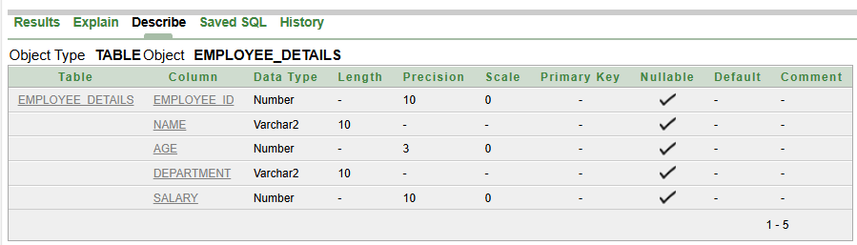
- ADD A NEW COLUMMN IN TABLE:
QUERY:
ALTER TABLE EMPLOYEES1
ADD SALARY NUMBER(10);
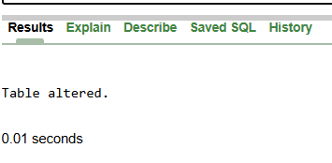
- RENAME THE TABLE:
QUERY:
RENAME EMPLOYEES1 TO EMPLOYEE_DETAILS;
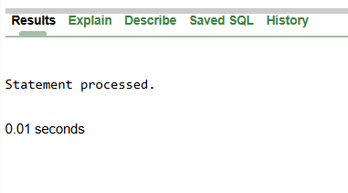
- INSERTING A RECORD IN TABLE:
QUERY:
INSERT INTO EMPLOYEE_DETAILS(EMPLOYEE_ID,NAME,AGE,DEPARTMENT,SALARY)
VALUES(123,'ABC',25,'CS',10000);
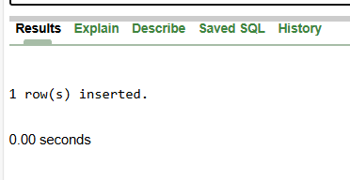

SELECT * FROM EMPLOYEE_DETAILS
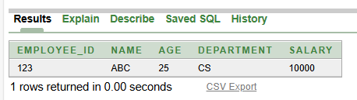
- UPADATING A VALUE IN TABLE:
QUERY:
UPDATE EMPLOYEE_DETAILS
SET DEPARTMENT = 'HR'
WHERE DEPARTMENT = 'IT'
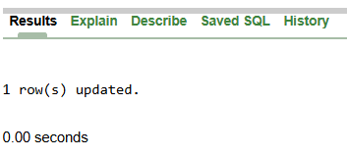
SELECT * FROM EMPLOYEE_DETAILS
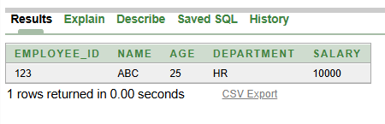
- DELETING A RECORD IN TABLE:
QUERY:
DELETE FROM EMPLOYEE_DETAILS
WHERE EMPLOYEE_ID = 123;
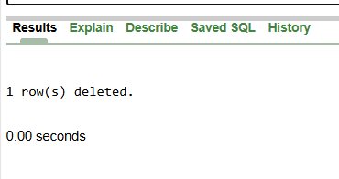
MODIFY TO ADD PRIMARY KEY:
QUERY:
ALTER TABLE EMPLOYEE_DETAILS
MODIFY EMPLOYEE_ID NUMBER(10) PRIMARY KEY;
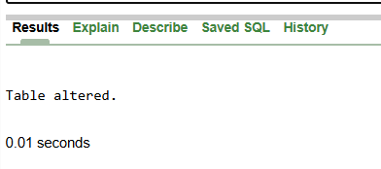
LAB 4 (PRACTICE)

LAB TASK:
- CREATE A TABLE:
QUERY:
CREATE TABLE ORDERS(
ORDER_ID NUMBER(3) PRIMARY KEY,
CUSTOMER_NAME VARCHAR2(15) NOT NULL,
PRODUCT_NAME VARCHAR2(15) UNIQUE,
ORDER_DATE Date);
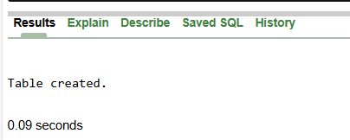
- ADD A NEW COLUMMN IN TABLE:
QUERY:
ALTER TABLE ORDERS
ADD ORDER_STATUS VARCHAR2(10);
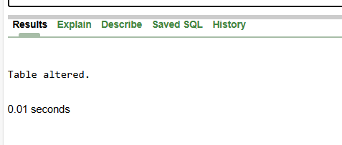
DESCRIBE ORDERS;
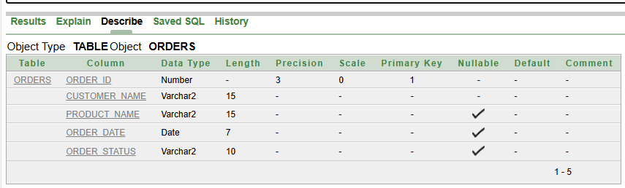
- RENAME THE TABLE:
QUERY:
RENAME ORDERS TO CUSTOMER_ORDERS;
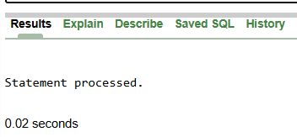
DESCRIBE CUSTOMER_ORDERS;
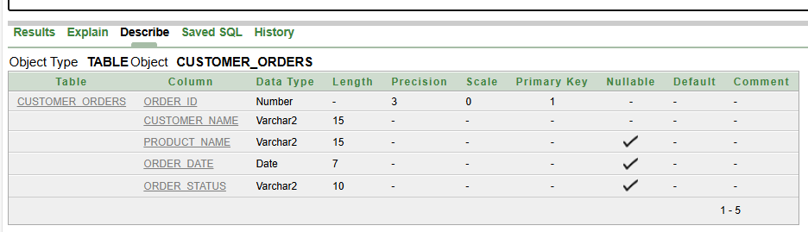
- INSERTING A RECORD IN TABLE:
QUERY:
INSERT INTO CUSTOMER_ORDERS(ORDER_ID,CUSTOMER_NAME,PRODUCT_NAME,ORDER_DATE,ORDER_STATUS)
VALUES(123,'ABC','DEF',TO_DATE('01/10/2004','DD/MM/YYYY'),'PENDING');
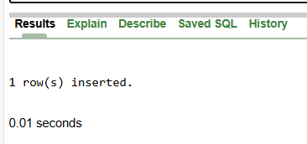
SELECT * FROM CUSTOMER_ORDERS;
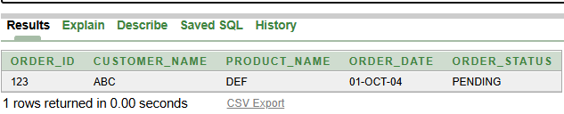
- INSERT ALL COMMAND:
QUERY:
INSERT ALL
INTO CUSTOMER_ORDERS VALUES(243,'ABC','FGH',TO_DATE('23/07/2020','DD/MM/YYYY'),'SHIPPED')
INTO CUSTOMER_ORDERS VALUES(242,'ABC','FOP',TO_DATE('23/07/2020','DD/MM/YYYY'),'DELIVERED')
INTO CUSTOMER_ORDERS VALUES(098,'ABC','THE',TO_DATE('09/12/2025','DD/MM/YYYY'),'PENDING')
SELECT * FROM DUAL;
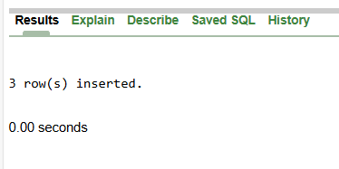

- UPADATING A VALUE IN TABLE:
QUERY:
UPDATE CUSTOMER_ORDERS
SET ORDER_STATUS = 'SHIPPED'
WHERE ORDER_STATUS = 'PENDING';
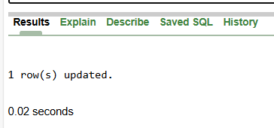
- DELETING A RECORD IN TABLE:
QUERY:
DELETE FROM CUSTOMER_ORDERS
WHERE ORDER_STATUS = 'PENDING';
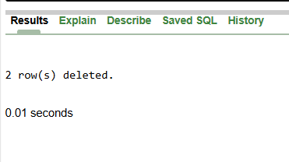
LAB 5 (DQL COMMAND)
- WHERE CLAUSE:
QUERY:
SELECT *
FROM EMPLOYEES
WHERE EMPLOYEE_ID = 102;
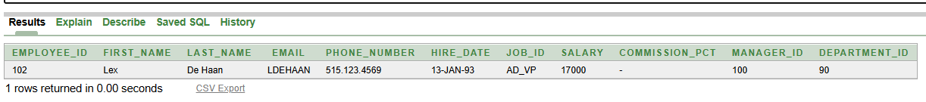
- CHARACTER AND STRING, DATES:
QUERY:
SELECT *
FROM EMPLOYEES
WHERE LAST_NAME = 'KING';
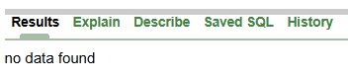
QUERY:
SELECT *
FROM EMPLOYEES
WHERE LAST_NAME = 'King';
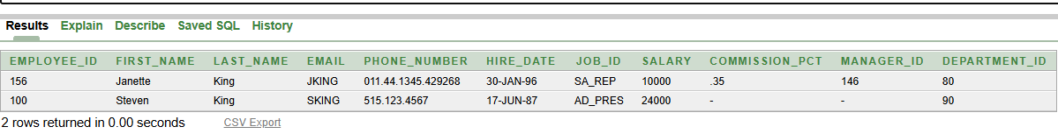
QUERY:
SELECT *
FROM EMPLOYEES
WHERE DEPARTMENT_ID = 90;
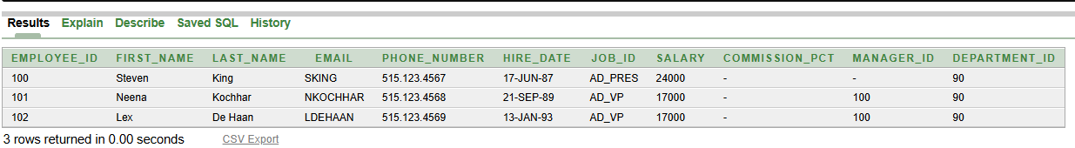
- GET SPECIFIC DATA
QUERY:
SELECT EMPLOYEE_ID,FIRST_NAME,EMAIL
FROM EMPLOYEES;
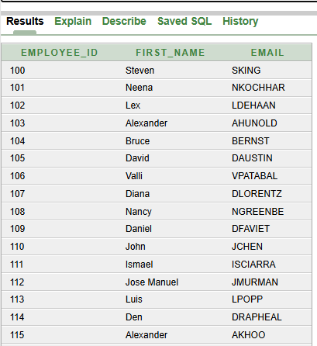
- COMPARISON CONDITIONS:
QUERY:
SELECT LAST_NAME,SALARY
FROM EMPLOYEES
WHERE SALARY<=3000;
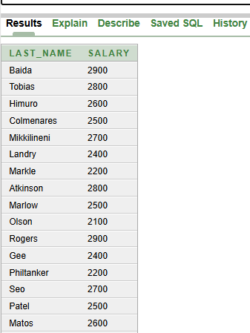
QUERY:
SELECT EMPLOYEE_ID
FROM EMPLOYEES
WHERE SALARY>15000;
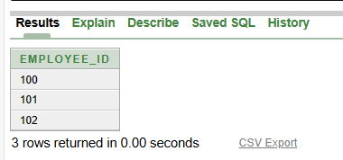T
- USING BETWEEN CONDITION:
QUERY:
SELECT EMPLOYEE_ID
FROM EMPLOYEES
WHERE SALARY BETWEEN 15000 AND 25000;
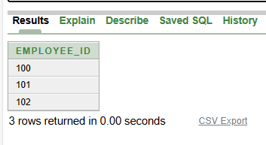
QUERY:
SELECT LAST_NAME,SALARY
FROM EMPLOYEES
WHERE SALARY BETWEEN 15000 AND 25000;
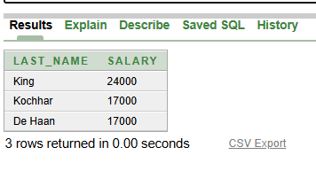
- USING IN CONDITION:
QUERY:
SELECT EMPLOYEE_ID,LAST_NAME,SALARY,MANAGER_ID
FROM EMPLOYEES
WHERE MANAGER_ID IN (100 , 101, 201);
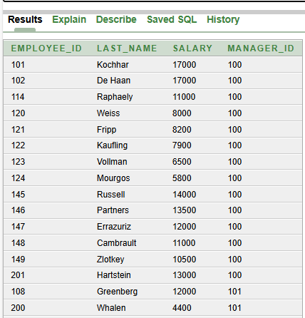
- USING LIKE CONDITION:
QUERY:
SELECT FIRST_NAME
FROM EMPLOYEES
WHERE FIRST_NAME LIKE 'S%';
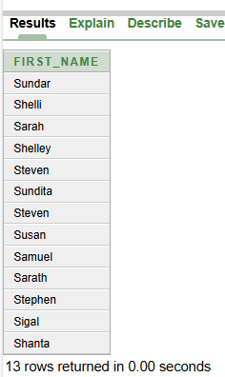
QUERY:
SELECT FIRST_NAME
FROM EMPLOYEES
WHERE FIRST_NAME LIKE 'Ki%';
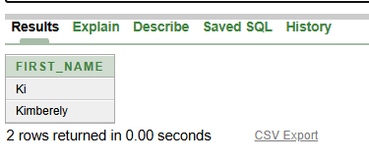
QUERY:
SELECT LAST_NAME
FROM EMPLOYEES
WHERE LAST_NAME LIKE '_o%';
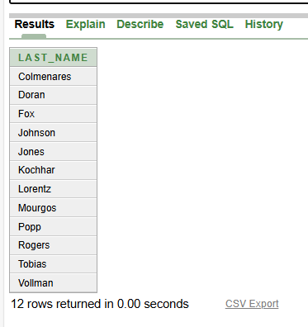
QUERY:
SELECT FIRST_NAME,EMAIL,JOB_ID
FROM EMPLOYEES
WHERE JOB_ID LIKE'%MAN';
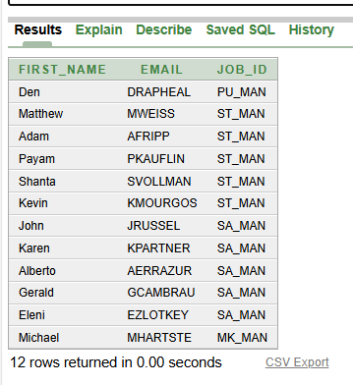
- USING NULL CONDITION:
QUERY:
SELECT LAST_NAME,MANAGER_ID
FROM EMPLOYEES
WHERE MANAGER_ID IS NULL;
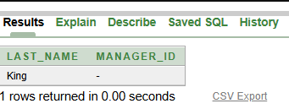
Lab 6 (Practice Task)
LAB TASK:
- Create Table Query
CREATE TABLE MONTHLY_SALES(
CUST_ID NUMBER(1),
PROD_ID NUMBER(1),
PROD_NAME VARCHAR2(7),
PRICE NUMBER(3),
QUANTITY NUMBER(2),
BILL_TOTAL NUMBER(3),
DATES DATE);
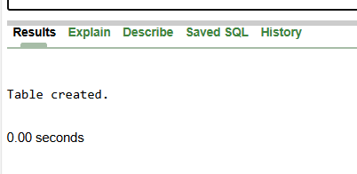
- Insert All Query:
INSERT ALL
INTO MONTHLY_SALES
VALUES(1,1,'Shampoo',165,2,330,TO_DATE('26/Mar/23','DD/MON/YY'))
INTO MONTHLY_SALES
VALUES(2,2,'Soap',32,10,320,TO_DATE('26/Mar/23','DD/MON/YY'))
INTO MONTHLY_SALES
VALUES(3,3,'Cream',85,1,85,TO_DATE('26/Mar/23','DD/MON/YY'))
INTO MONTHLY_SALES
VALUES(4,1,'Shampoo',165,1,165,TO_DATE('27/Mar/23','DD/MON/YY'))
INTO MONTHLY_SALES
VALUES(5,3,'Cream',85,2,170,TO_DATE('28/Mar/23','DD/MON/YY'))
SELECT * FROM DUAL;
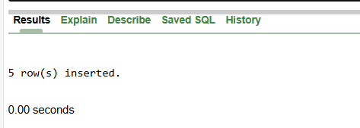
- Add Column Query:
ALTER TABLE MONTHLY_SALES
ADD RETURN_DATE DATE;
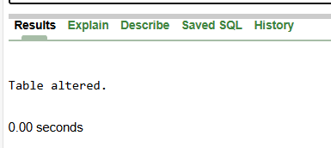
- Rename Column Query:

ALTER TABLE MONTHLY_SALES
RENAME COLUMN DATES TO SALES_DATE;
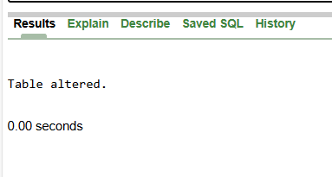
- Delete Column Query:
ALTER TABLE MONTHLY_SALES
DROP COLUMN RETURN_DATE;
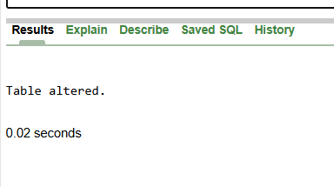
- Update Values Query:
UPDATE MONTHLY_SALES
SET PRICE = 100
WHERE PROD_ID =3;
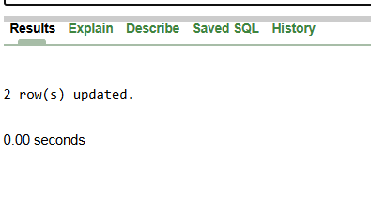
SELECT * FROM MONTHLY_SALES;
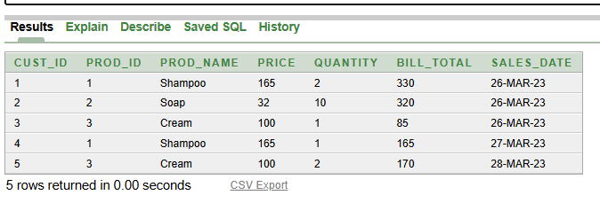
CREATE TABLE STUDENT(
NAME VARCHAR2(7),
ADDRESS VARCHAR2(12),
CLASS VARCHAR2(4),
CGPA NUMBER(1,2));
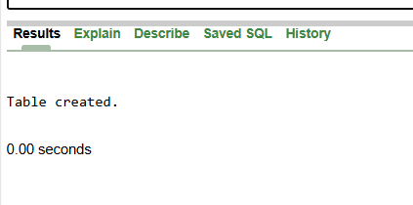

Lab 7 (PRACTICE GUI OF XAMPP)
LAB TASK:
- Create Database
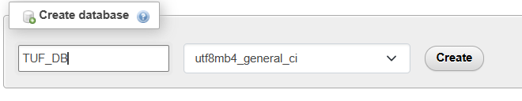
- Create Table
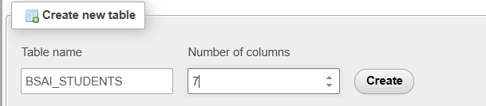
- Creating Attributes
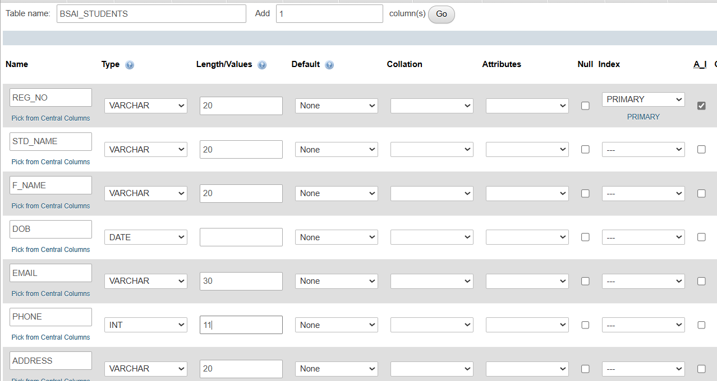
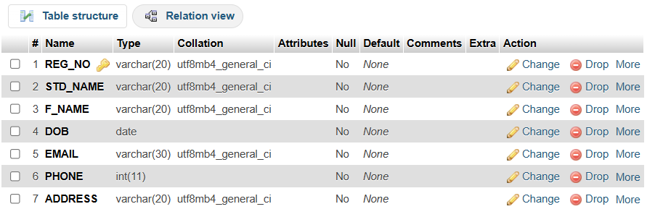
- Entering Values
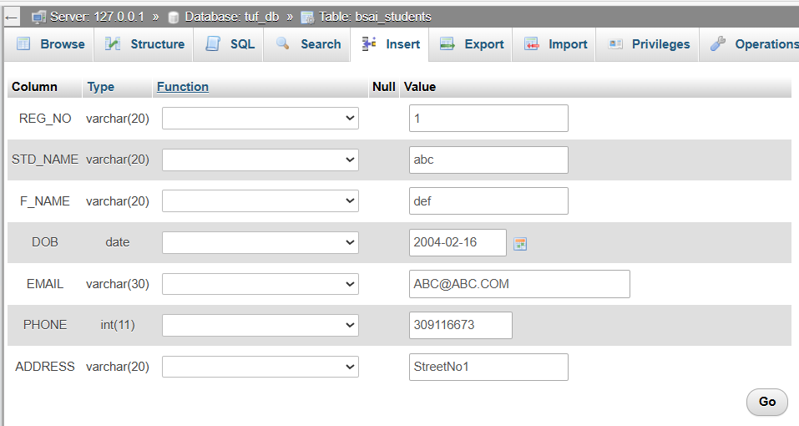
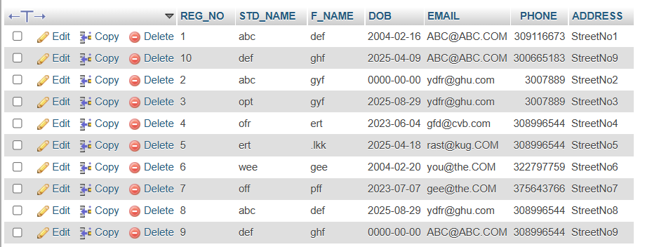

Lab 8 (PRACTICE QUERIES ON XAMPP)

- Creating Table Team
Query:
CREATE TABLE TEAM(
TEAM_ID CHAR(3) PRIMARY KEY,
NAME CHAR(50) NOT NULL UNIQUE
);
Describe table
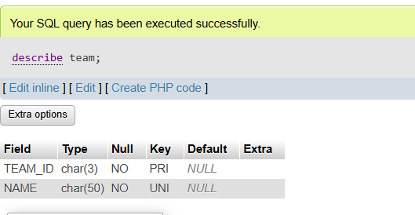
- Foreign key
Query:
CREATE TABLE MEMBER(
MEMBER_ID CHAR(50) PRIMARY KEY,
NAME CHAR(3) NOT NULL,
TEAM CHAR(3),
FOREIGN KEY(TEAM)
REFERENCES TEAM(TEAM_ID)
);
Describe table
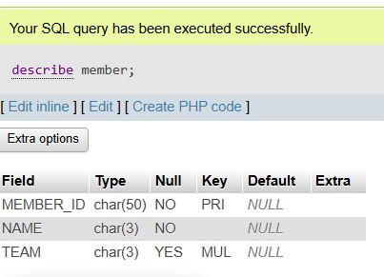
- Show tables
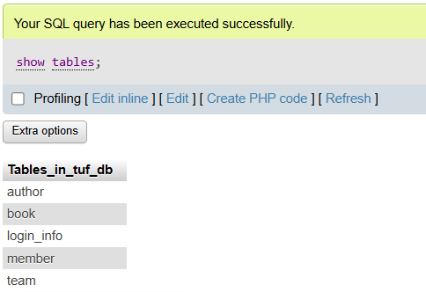
Lab 9 (MY SQL USING DML QUERY)
LAB TASK 1:
- Create table
CREATE TABLE STUDENT_TABLE(
STUDENT_ID INT PRIMARY KEY,
NAME VARCHAR(30) NOT NULL,
ADDRESS VARCHAR(50),
CLASS VARCHAR(4),
CGPA DECIMAL(3,2));
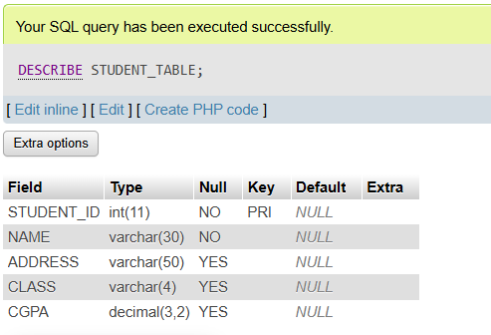
- Insert Values
insert into student_table
values(1,'Bilal','Islamabad','BSCS',3.65),
(2,'Faisal','Bahawalnagar','BSIT',3.45),
(3,'Aqsa','Lahore','BSCS',3.70);
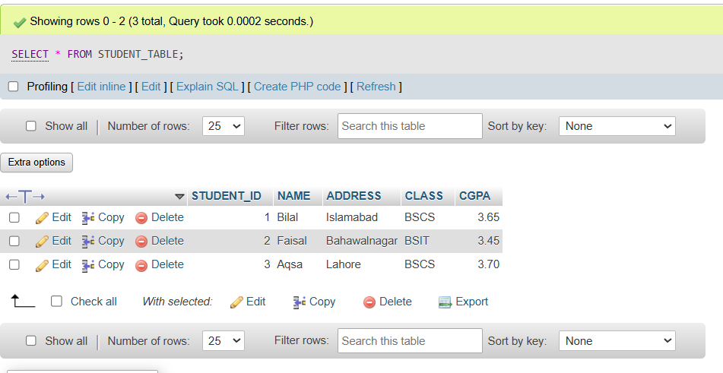
- Display Columns
SELECT NAME,CGPA FROM STUDENT_TABLE;
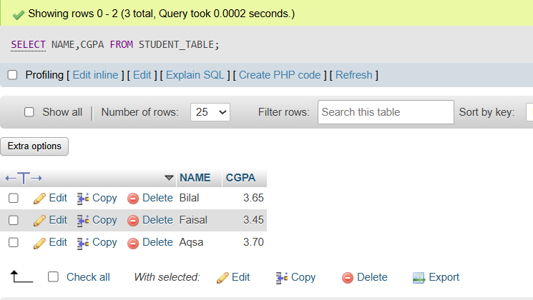
- Display Specific Columns
SELECT NAME FROM STUDENT_TABLE
WHERE CGPA = 3.5;
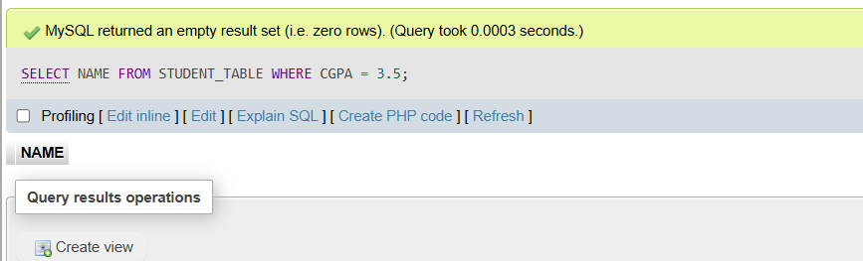
LAB TASK 2:
- Create table
CREATE TABLE MONTHLY_SALES(
CUST_ID INT PRIMARY KEY,
PROD_ID INT,
PROD_NAME VARCHAR(15),
PRICE INT,
QUANTITY INT,
BILL_TOTAL INT,
DATE DATE);
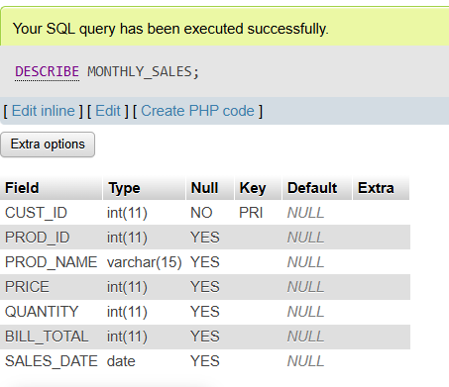
- Insert Values
INSERT INTO MONTHLY_SALES
VALUES (1,1,'Shampoo',165,2,330,'26-Mar-23'),
(2,2,'Soap',32,10,320,'26-Mar-23'),
(3,3,'Cream',85,1,85,'26-Mar-23'),
(4,1,'Shampoo',165,1,165,'27-Mar-23')
(5,3,'Cream',85,2,170,'28-Mar-23');
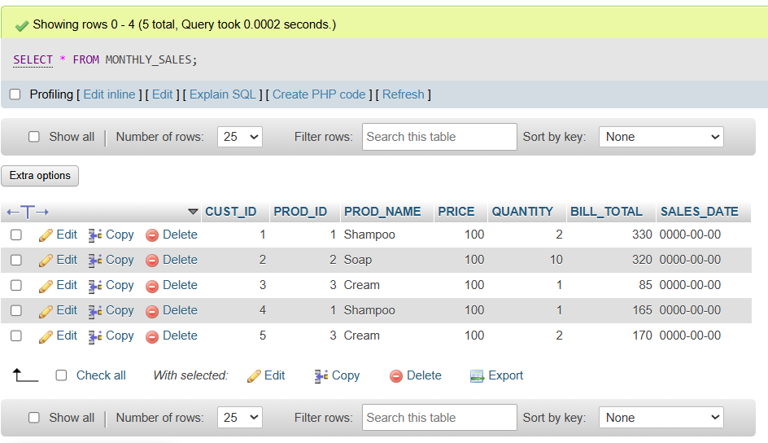
- Add New Column
ALTER TABLE MONTHLY_SALES
ADD RETURN_DATE DATE;
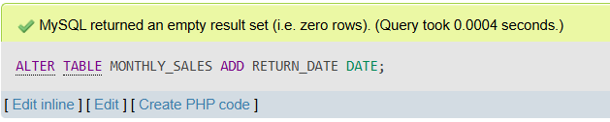
- Add New Column
ALTER TABLE MONTHLY_SALES
CHANGE DATE SALES_DATE DATE;
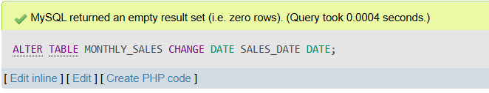
- Delete Column
ALTER TABLE MONTHLY_SALES
DROP COLUMN RETURN_DATE;
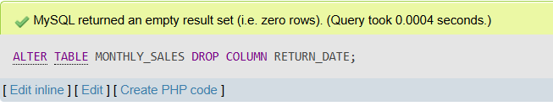
- Update Values
UPDATE MONTHLY_SALES
SET PRICE = 100
WHERE PROD_ID = 3;
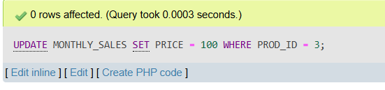

Lab 10 (PRACTICAL TEST)
Scenario 1: Online Food Delivery
- Create a database called FoodDeliveryDB and select it for use.
Query:
CREATE DATABASE FOODDELIVERYDB;
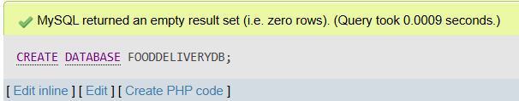
USE FOODDELIVERYDB;
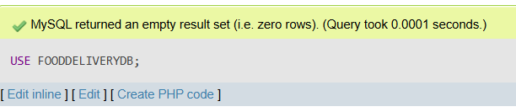
- Create a table named Orders with fields for:
- Order ID,
- Customer name,
- Food item,
- Quantity,
- Order date,
- Delivery status.
- ⚠️ OrderID is the primary key.
- ⚠️ Quantity must be greater than 0 (CHECK constraint).
- ⚠️ DeliveryStatus will default to 'Pending' if not specified.
Query:
CREATE TABLE ORDERS(
ORDER_ID INT PRIMARY KEY,
CUSTOMER_NAME VARCHAR(10),
FOOD_ITEM VARCHAR(10),
QUANTITY INT CHECK (QUANTITY>0),
ORDER_DATE DATE,
DELIVERY_STATUS VARCHAR(10) DEFAULT ‘PENDING’
);
- Show all databases and show tables inside FoodDeliveryDB.
SHOW DATABASES;
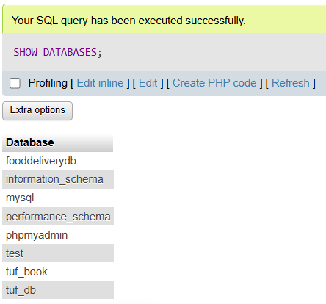
SHOW TABLES;
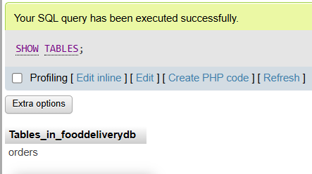
- Add a new column called TotalPrice to the Orders table.
ALTER TABLE ORDERS
ADD TOTAL_PRICE INT;
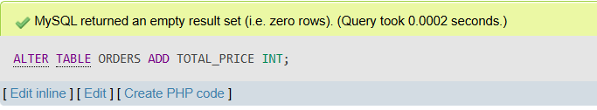
- Insert ten food order records into the table.
INSERT INTO ORDERS (ORDER_ID, CUSTOMER_NAME, FOOD_ITEM, QUANTITY, ORDER_DATE, TOTAL_PRICE)
VALUES
(1, 'ALI', 'BURGER', 2, '10-MAR-2025', 800),
(2, 'ABDULLAH', 'PIZZA', 2, '09-DEC-2025', 700),
(3, 'AHMAD', 'BURGER', 4, '10-JAN-2025', 2100),
(4, 'FIZAA', 'WRAP', 2, '09-OCT-2025', 400),
(5, 'AIMAN', 'FRIES', 1, '03-MAR-2025', 1500),
(6, 'ALIYAN', 'COKE', 3, '01-JUN-2025', 700),
(7, 'AYESHA', 'MOMOS', 2, '11-JUL-2025', 150),
(8, 'AMNA', 'BIRYANI', 1, '10-APR-2025', 400),
(9, 'ZAINAB', 'BURGER', 2, '10-NOV-2025', 300),
(10, 'LAIBA', 'KFC', 2, '10-FEB-2025', 200);
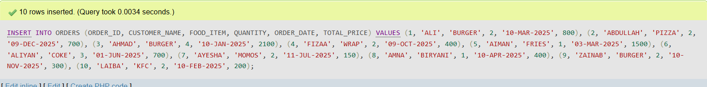
- Update the delivery status of the order with ID 202 to 'Delivered'.
UPDATE Orders
SET Delivery_Status = 'Delivered'
WHERE Order_ID = 202;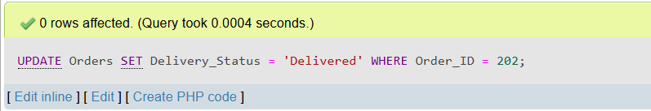
- Delete any orders where the quantity is greater than 3.
DELETE FROM Orders
WHERE Quantity > 3;
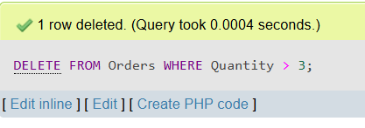
- Select and display all delivered orders, ordered by total price from highest to lowest.
SELECT * FROM Orders
WHERE Delivery_Status = 'Delivered'
ORDER BY Total_Price DESC;
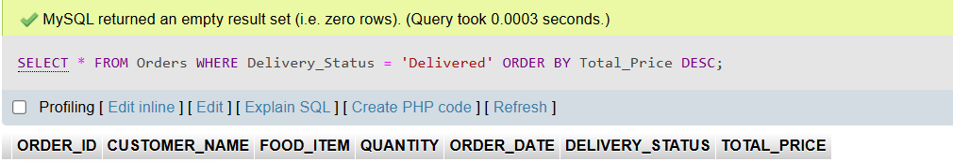
- Drop the Orders table.
DROP TABLE Orders;
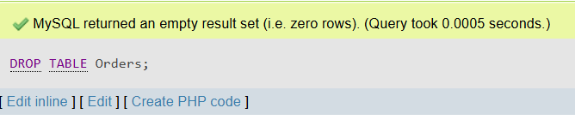
Scenario 2: Hospital Management
- Create a database called HospitalDB and select it for use.
CREATE DATABASE HospitalDB;
USE HospitalDB;
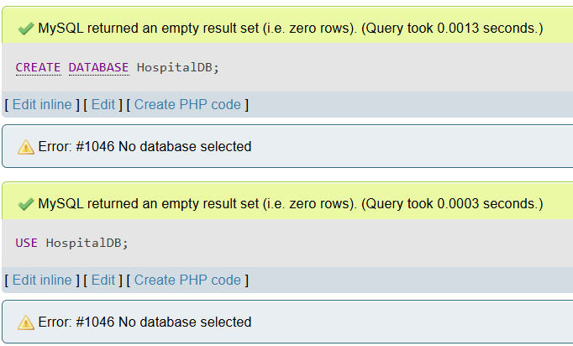
- Create a table named Patients with fields for:
- Patient ID,
- Full name,
- Age,
- Gender,
- Admission date.
- ⚠ PatientID is the primary key.
- ⚠ Age must be 0 or higher (CHECK constraint).
- ⚠ AdmissionDate cannot be null.
CREATE TABLE Patients (
PatientID INT PRIMARY KEY,
FullName VARCHAR(50),
Age INT CHECK (Age >= 0),
Gender VARCHAR(10),
AdmissionDate DATE NOT NULL
);
- Show all available databases and all tables inside the selected database.
SHOW DATABASES;
SHOW TABLES;
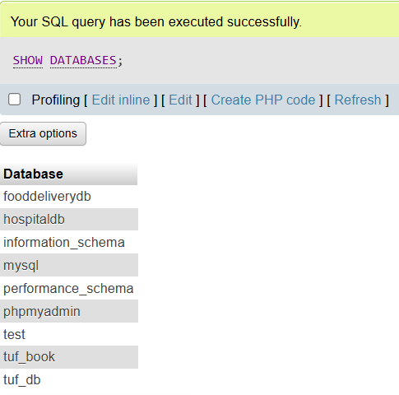
- Add a new column called BloodGroup to the Patients table.
ALTER TABLE Patients
ADD BloodGroup VARCHAR(5);
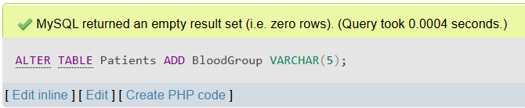
- Insert ten patient records into the Patients table with relevant details.
INSERT INTO Patients VALUES
(1, 'Ali Raza', 25, 'Male', '2025-04-20', 'A+'),
(2, 'Sara Khan', 30, 'Female', '2025-04-22', 'B+'),
(3, 'Zain Shah', 40, 'Male', '2025-04-25', 'O+'),
(4, 'Ayesha Noor', 22, 'Female', '2025-04-26', 'AB-'),
(5, 'Hassan Ali', 28, 'Male', '2025-04-27', 'A-'),
(6, 'Fatima Ahmed', 33, 'Female', '2025-04-28', 'B-'),
(7, 'Tariq Jamil', 50, 'Male', '2025-04-29', 'O-'),
(8, 'Mariam Iqbal', 27, 'Female', '2025-04-30', 'A+'),
(9, 'Omar Latif', 35, 'Male', '2025-05-01', 'AB+'),
(10, 'Noor Fatima', 45, 'Female', '2025-05-02', 'B+');
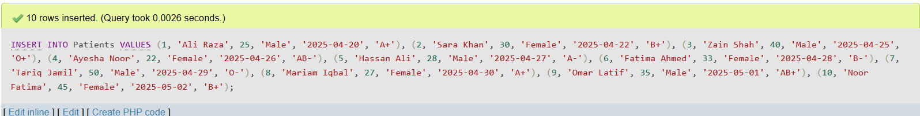
- Update the age of the patient with PatientID = 1 by changing it to 46.
UPDATE Patients
SET Age = 46
WHERE PatientID = 1;
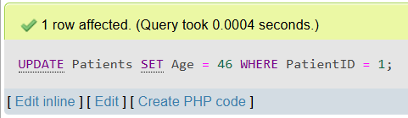
- Delete the record of the patient whose gender is 'Female'.
DELETE FROM Patients
WHERE Gender = 'Female';
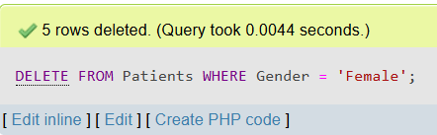
- Select and display all patients older than 25 years, ordered by admission date (latest first).
SELECT * FROM Patients
WHERE Age > 25
ORDER BY AdmissionDate DESC;
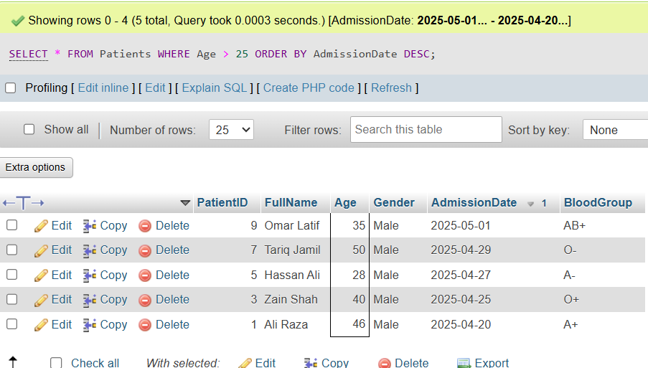
- Delete (Drop) the entire Patients table from the database.
DROP TABLE Patients;
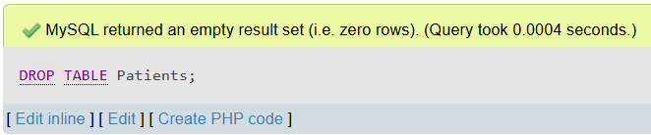
Lab 11 (Cross Join)
- Create employee table
CREATE TABLE Employee (
EmpID INT PRIMARY KEY,
EmpFname VARCHAR(50),
EmpLname VARCHAR(50),
Age INT,
EmailID VARCHAR(100),
PhoneNo VARCHAR(15),
Address VARCHAR(100)
);
- Insert Values
INSERT INTO Employee (EmpID, EmpFname, EmpLname, Age, EmailID, PhoneNo, Address)
VALUES
(1, 'Vardhan', 'Kumar', 22, 'vardy@abc.com', '9876543210', 'Delhi'),
(2, 'Himani', 'Sharma', 32, 'himani@abc.com', '9977554422', 'Mumbai'),
(3, 'Aayushi', 'Shreshth', 24, 'aayushi@abc.com', '9977555121', 'Kolkata'),
(4, 'Hemanth', 'Sharma', 25, 'hemanth@abc.com', '9876545666', 'Bengaluru'),
(5, 'Swatee', 'Kapoor', 26, 'swatee@abc.com', '9544567777', 'Hyderabad');
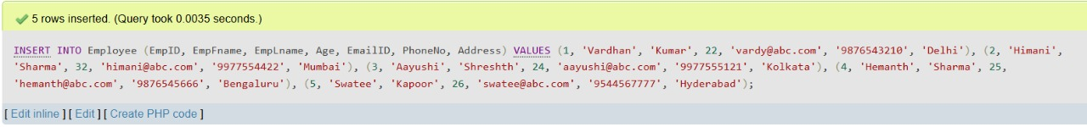
- Show Table
Select * from employee;
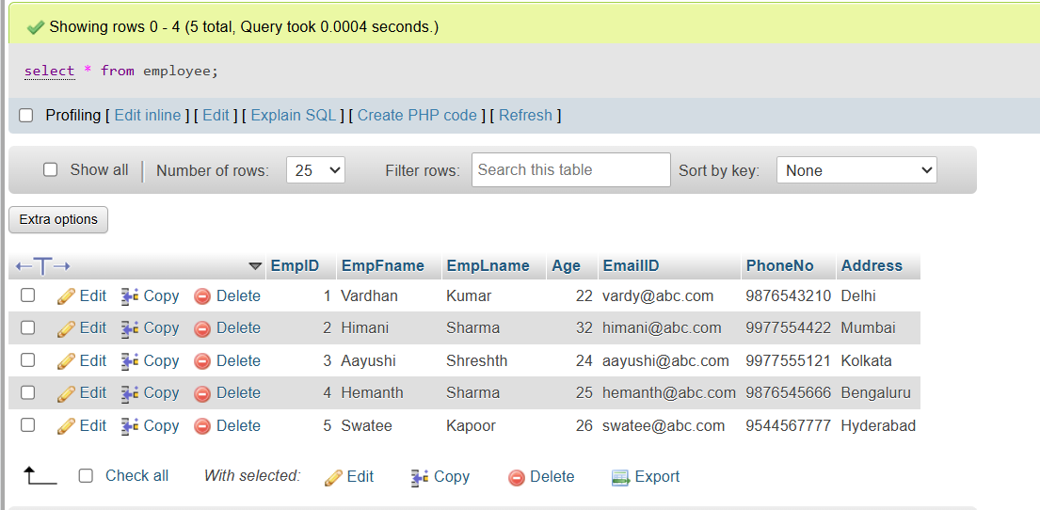
- Create Table
CREATE TABLE Client (
ClientID INT PRIMARY KEY,
ClientFrame VARCHAR(50) NOT NULL,
ClientIname VARCHAR(50) NOT NULL,
Age INT,
ClientEmailID VARCHAR(100),
PhoneNo VARCHAR(15),
Address VARCHAR(100),
EmpID INT
);
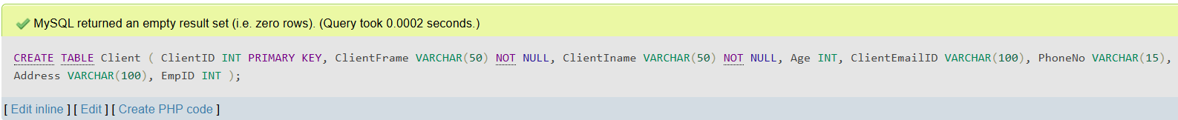
- Insert Values
INSERT INTO Client (ClientID, ClientFrame, ClientIname, Age, ClientEmailID, PhoneNo, Address, EmpID)
VALUES
(1, 'Susan', 'Smith', 30, 'susan@adn.com', '9765411231', 'Kolkata', 3),
(2, 'Mois', 'Ali', 27, 'mois@jsq.com', '9876543561', 'Kolkata', 3),
(3, 'Soma', 'Paul', 22, 'soma@wja.com', '9966332211', 'Delhi', 1),
(4, 'Zainab', 'Daginawala', 40, 'zainab@qkq.com', '9955884422', 'Hyderabad', 5),
(5, 'Bhaskar', 'Reddy', 32, 'bhaskar@xyz.com', '9636963269', 'Mumbai', 2);
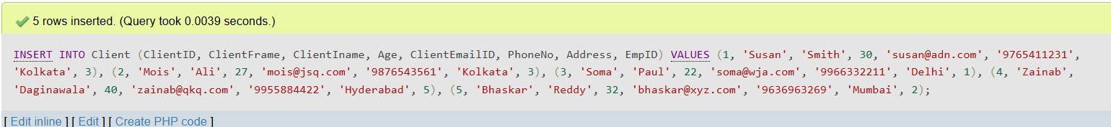
- Show Table
select * from client;
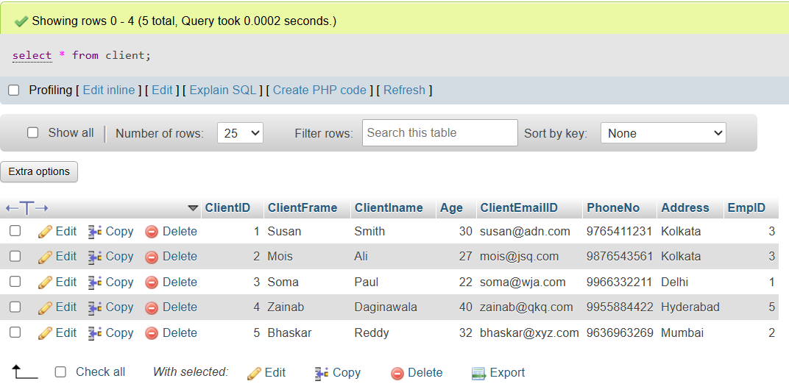
- Create Table
CREATE TABLE Project (
ProjectID INT PRIMARY KEY,
EmpID INT,
ClientID INT,
ProjectName VARCHAR(50) NOT NULL,
ProjectStartDate DATE NOT NULL,
FOREIGN KEY (ClientID) REFERENCES Client(ClientID),
FOREIGN KEY (EmpID) REFERENCES Employee(EmpID)
);
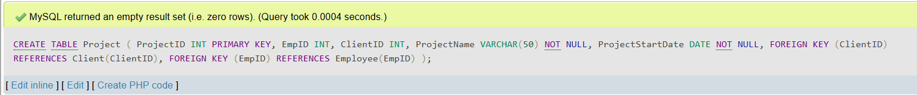
- Insert Values
INSERT INTO Project
VALUES
(111, 1, 3, 'Project1', '2019-04-21'),
(222, 2, 1, 'Project2', '2019-02-12'),
(333, 3, 5, 'Project3', '2019-01-10'),
(444, 3, 2, 'Project4', '2019-04-16'),
(555, 4, 4, 'Project5', '2019-05-23'),
(666, 2, 1, 'Project6', '2019-01-12'),
(777, 1, 2, 'Project7', '2019-07-25'),
(888, 3, 3, 'Project8', '2019-08-20');
- Show Table
select * from project;
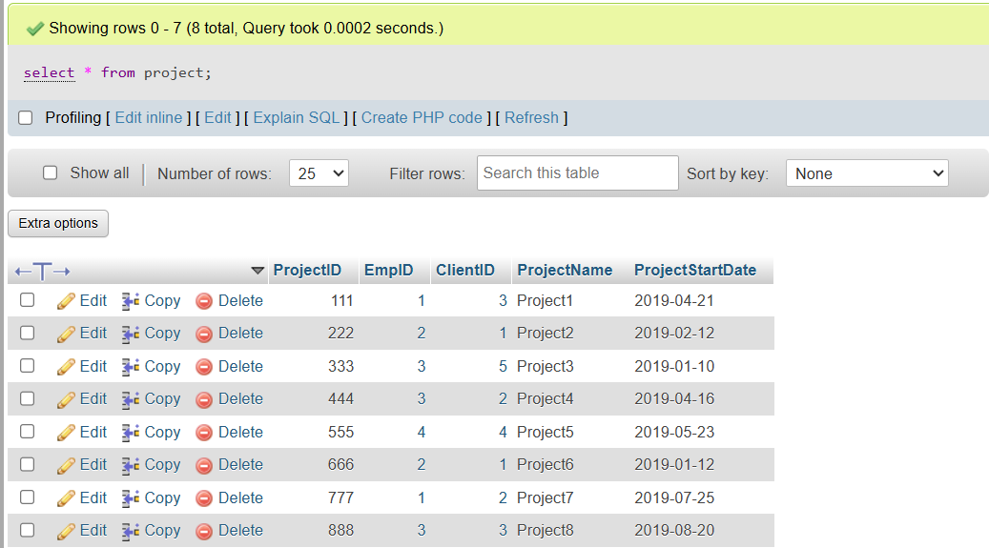
- Cross Join Employee and Project Table
SELECT * FROM employee CROSS JOIN project;
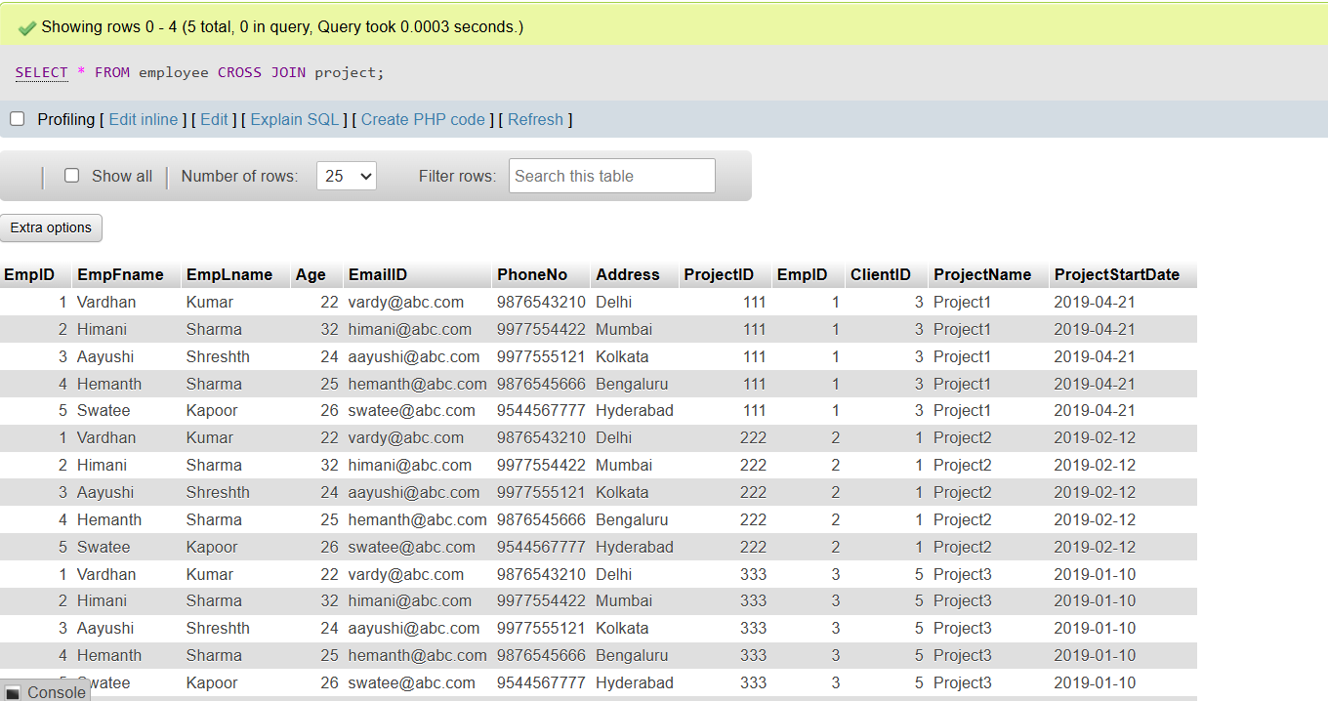
Lab 12 (Inner Join)
LAB TASK 1:
- Create Employee Table
CREATE table employee(
first_name varchar(30),
last_name varchar(30),
salary int,
department_id int);
- Insert Values In Employee Table
insert into employee
values ('William','Shakespare',1500,50),
('Emily','Dickinson',2700,50),
('John','Denne',3800,90),
('Oscar','Wide',4200,90);
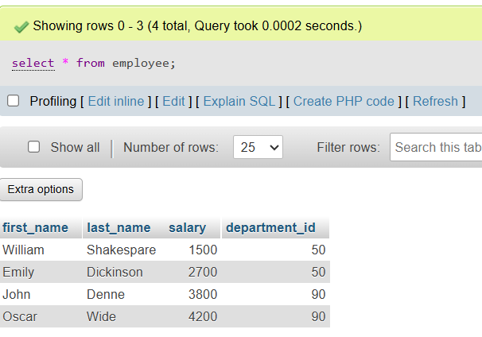
- Create Department Table
create table department(
department_id int,
department_name varchar(40),
region_id int);
- Insert Values In Department Table
insert into department
values (50,'IT',700),
(90,'HR',800);
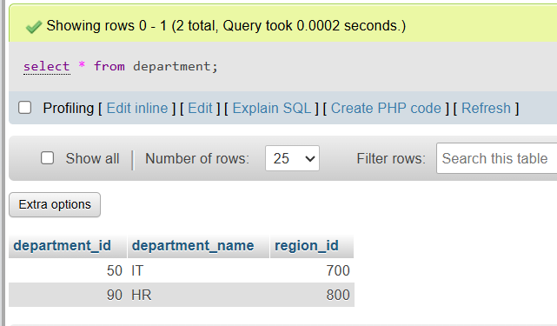
- Cross Join Employee & Department
SELECT * from employee cross join department;
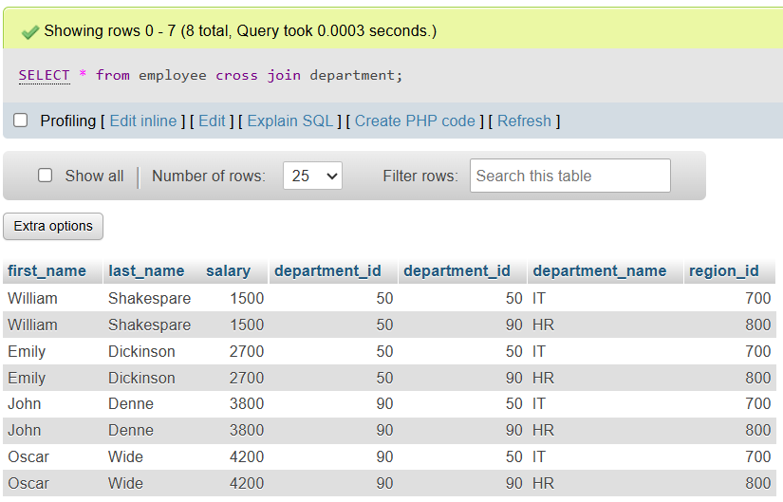
- Inner Join Employee & Department
SELECT employee.first_name,department.department_name
from employee inner join department
on employee.department_id = department.department_id;

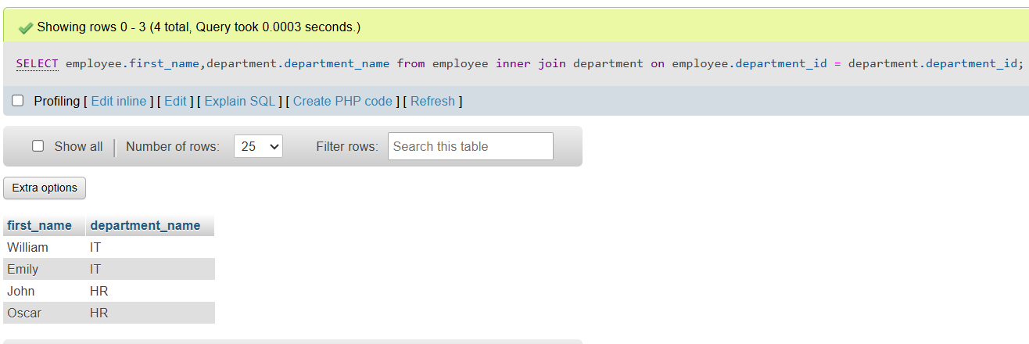
- Right Inner Join Employee & Department
SELECT employee.first_name,department.department_name
from employee right join department
on employee.department_id = department.department_id;
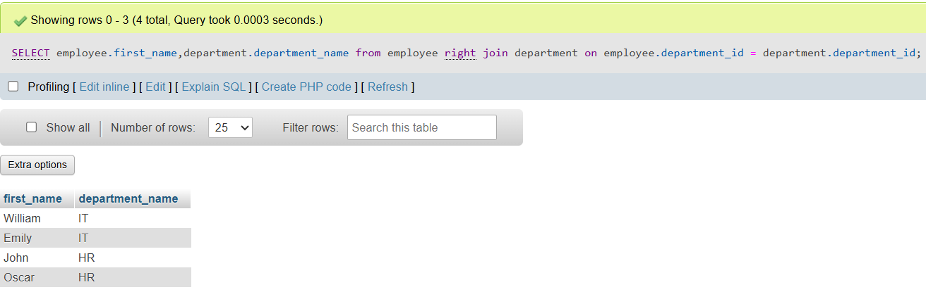
- Left Inner Join Employee & Department
SELECT employee.first_name,department.department_name
from employee left join department
on employee.department_id = department.department_id;
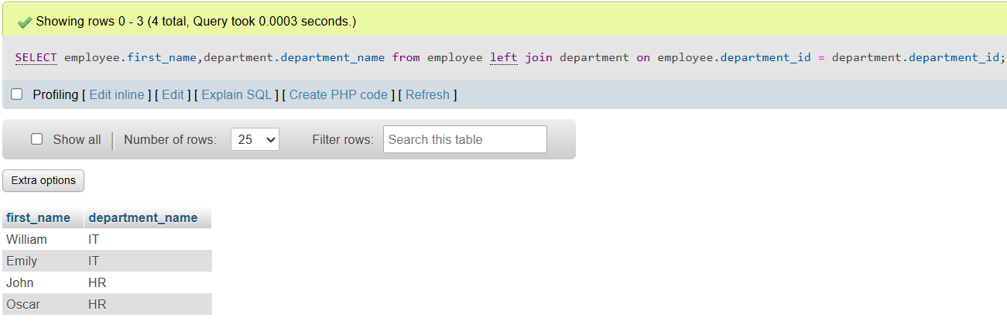
LAB TASK 2:
- Inner Join Employee & Project
SELECT * FROM Employee inner join Project
on employee.EmpID = project.EmpID;
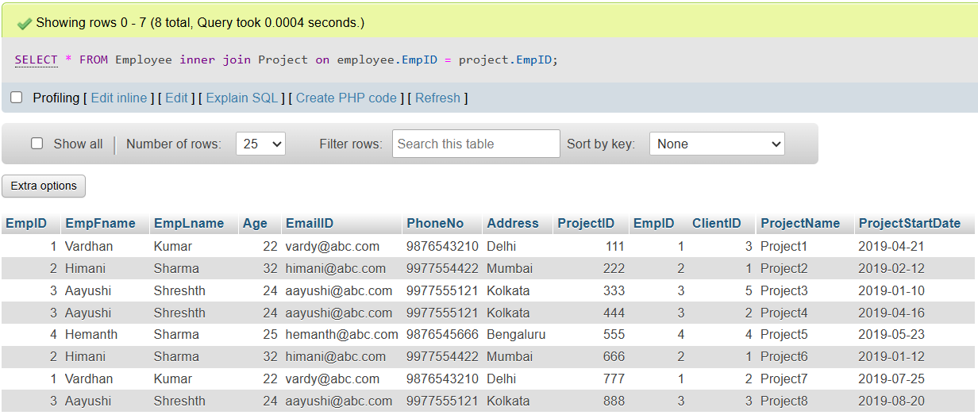
- Right Inner Join Employee & Project
SELECT * FROM Employee right join Project
on employee.EmpID = project.EmpID;
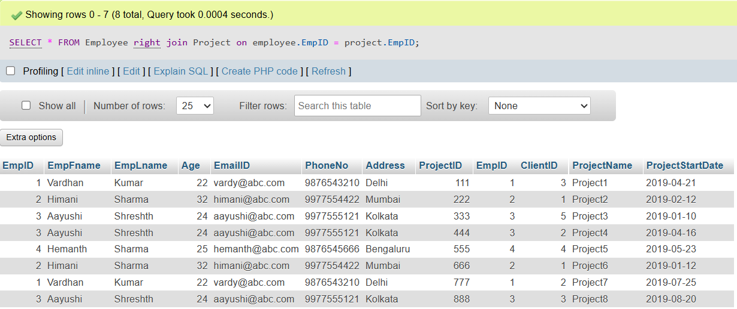
- Left Inner Join Employee & Project
SELECT * FROM Employee left join Project
on employee.EmpID = project.EmpID;
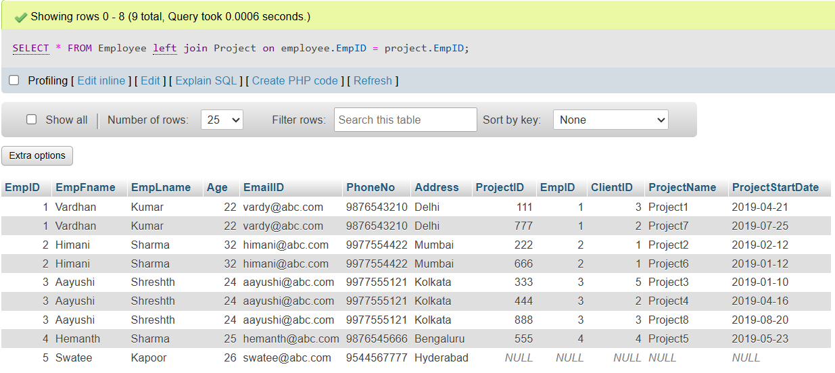
- Inner Join Project & Client
SELECT * FROM Project inner join client
on project.EmpID = client.EmpID;
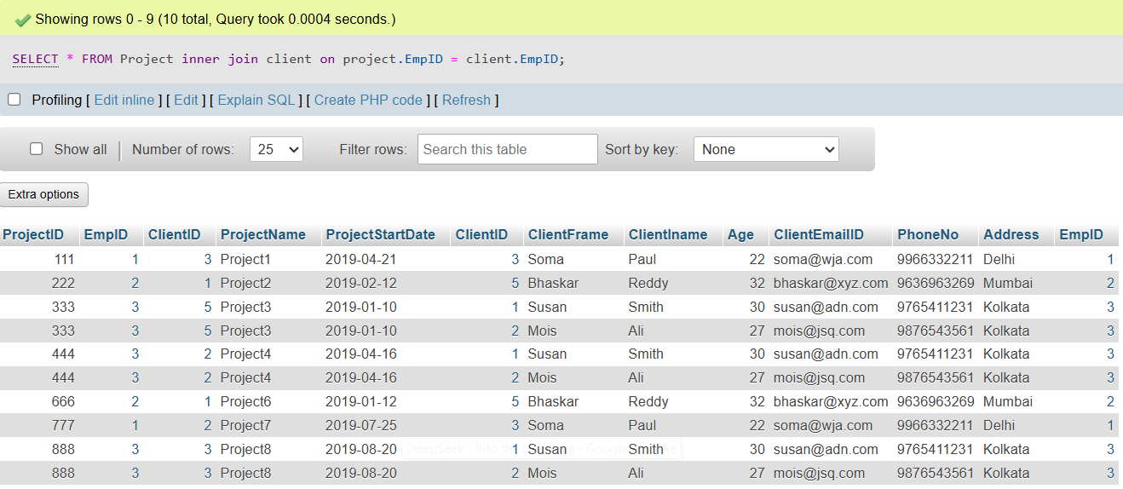
- Right Inner Join Project & Client
SELECT * FROM Project right join client
on project.EmpID = client.EmpID;
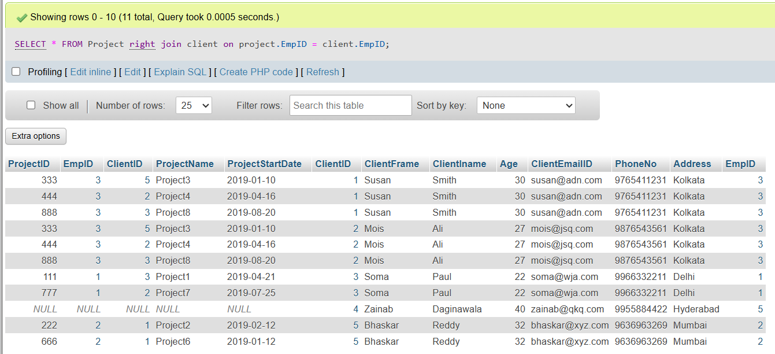
- Left Inner Join Project & Client
SELECT * FROM Project left join client
on project.EmpID = client.EmpID;
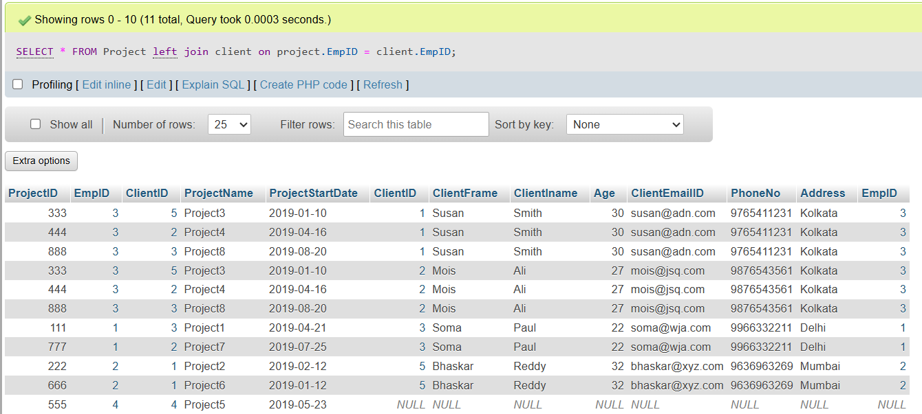
Lab 13 (Self Join, Multiple Join, Union, Union All)
LAB TASK 1:
- Create Coach Table
CREATE TABLE coach (
id INT PRIMARY KEY,
name VARCHAR(100)
);
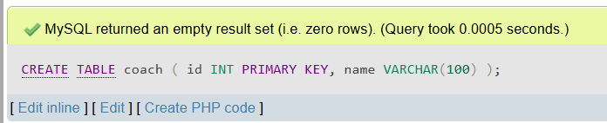
- Insert Values Coach Table
INSERT INTO coach (id, name) VALUES
(1, 'Mark Swanson'),
(2, 'Alice Wright');
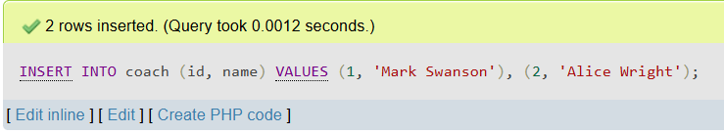
- Show Coach Table
SELECT * from coach;
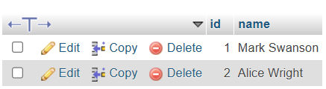
- Create Team Table
CREATE TABLE team (
id INT PRIMARY KEY,
name VARCHAR(100),
coach_id INT,
FOREIGN KEY (coach_id) REFERENCES coach(id)
);
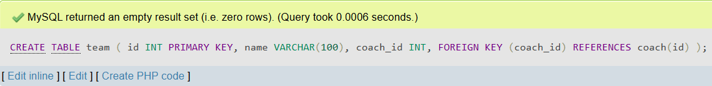
- Insert Values Team Table
INSERT INTO team (id, name, coach_id) VALUES
(1, 'Ambitious Raptors', 2),
(2, 'Fire Pandas', 1),
(3, 'Steel Cats', 2);
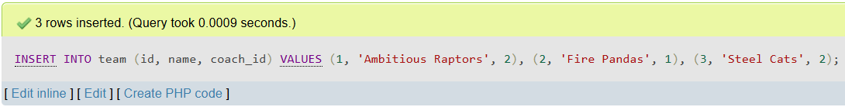
- Show Team Table
SELECT * FROM team;
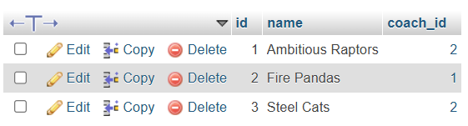
- Create Player Table
CREATE TABLE player (
id INT PRIMARY KEY,
name VARCHAR(100),
team_id INT,
FOREIGN KEY (team_id) REFERENCES team(id)
);
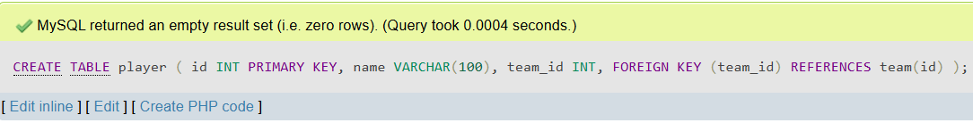
- Insert Values Player Table
INSERT INTO player (id, name, team_id) VALUES
(1, 'John Rodger', 1),
(2, 'Paul Smith', 1),
(3, 'David McDonald', 2),
(4, 'Sarah Grey', 3),
(5, 'Sophie Brown', 3);
- Show Player Table
SELECT * FROM player;
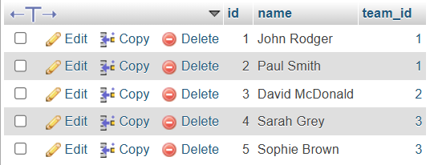
- Self Join Coach Table
SELECT b.id, a.name
FROM coach a, coach b
WHERE a.id = b.id;
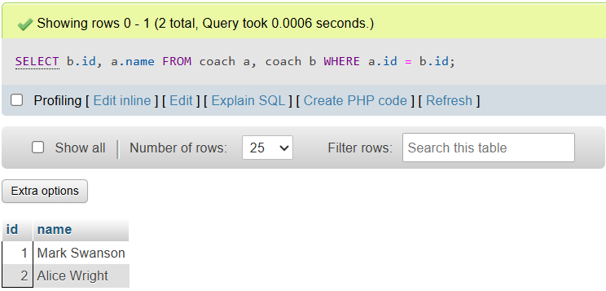
- Multiple Join On Coach, Team & Player
SELECT coach.name,team.coach_id,player.team_id,player.name
FROM coach,team,player
WHERE coach.id=team.coach_id AND
team.id=player.id;
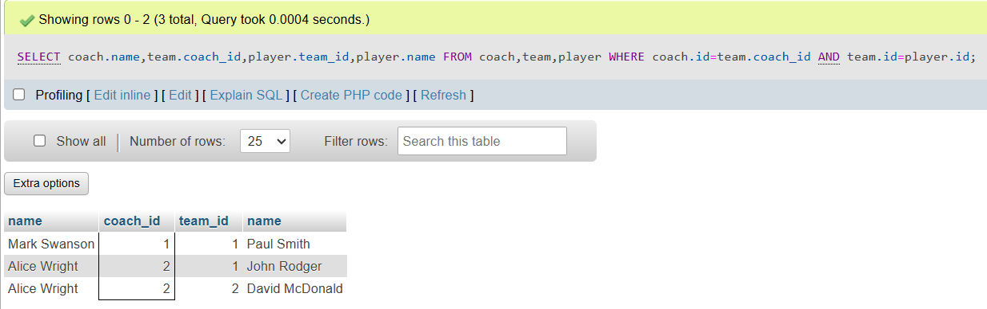
- Union:
SELECT id, name FROM coach
UNION
SELECT id, name FROM team
UNION
SELECT id, name FROM player;
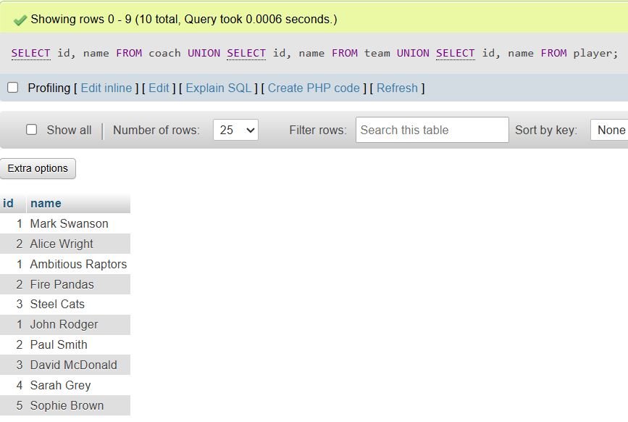

- Union All:
SELECT id, name FROM coach
UNION ALL
SELECT id, name FROM team
UNION ALL
SELECT id, name FROM player;
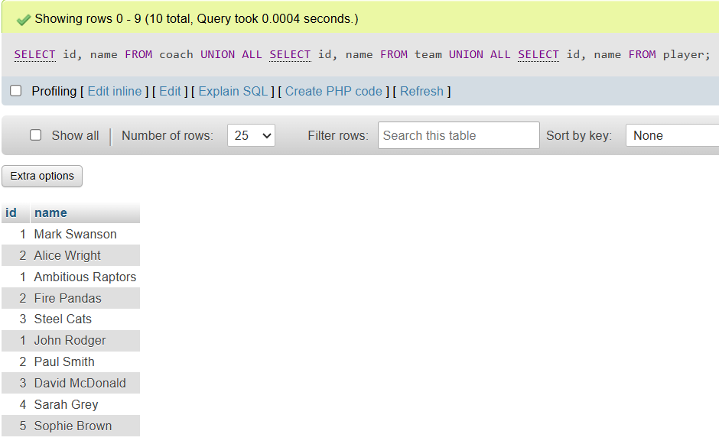
Lab 14 (Math & String Functions)
LAB TASK 1: Math Functions
- Create Book Table
CREATE table book(
ISBN int,
title varchar(50),
quantity int);
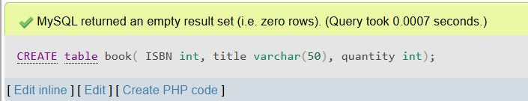
- Insert Values Into Book Table
insert into book
Values(12345,'The Hunger Games',10),
(54321,'The Song of Ice and Fire',15);
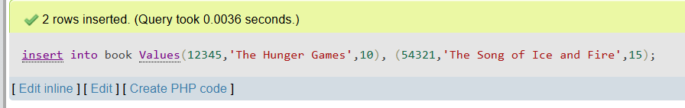
- Show Book Table
Select * from book;
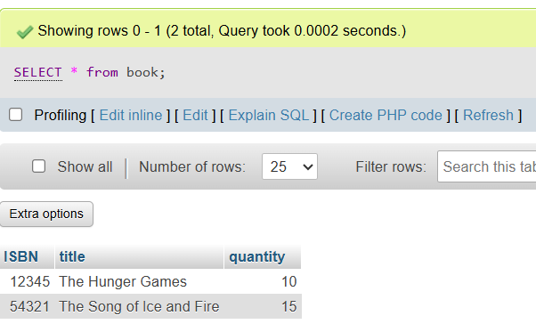
- Applying Math Functionality
SELECT ISBN,title,(quantity+3)*2
FROM book;
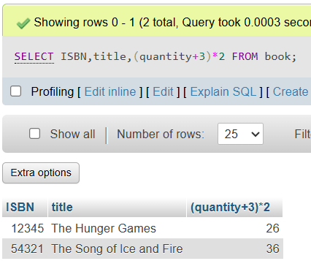
Query:
SELECT ISBN,title,(quantity/5.0)
FROM book;
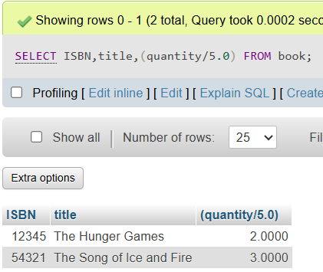
Query:
SELECT ISBN,title,(quantity-30)/2.9
FROM book;
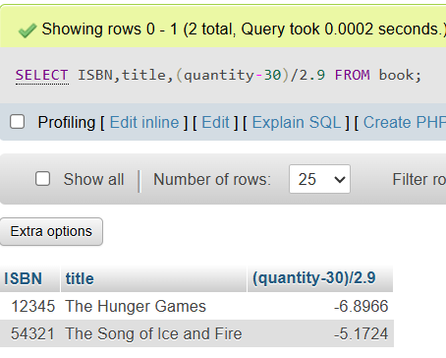
Query:
SELECT ISBN,title,(quantity+3)*2 AS
Qty FROM book;
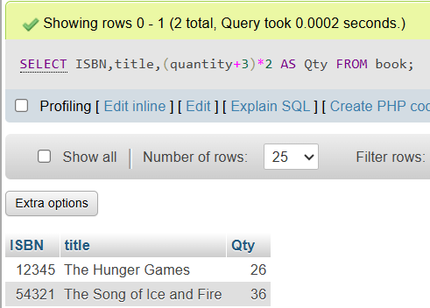
- Absolute Function
SELECT ISBN,quantity-13,ABS(quantity-13)
FROM book;
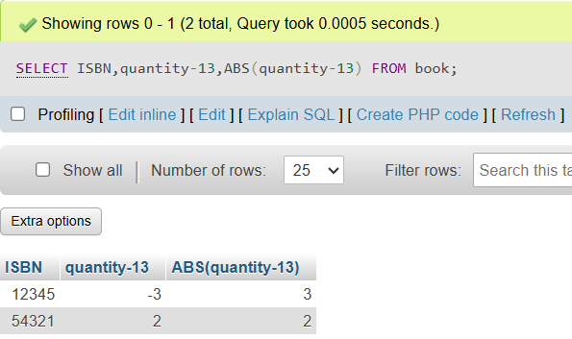
- Power Function
SELECT ISBN,POWER(quantity,2),POWER(quantity,3)
FROM book;
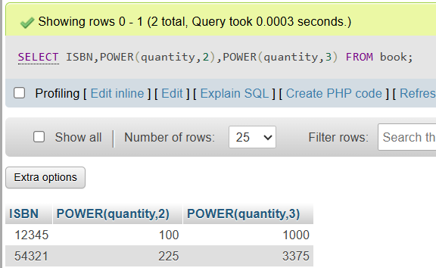
- SQRT Function
SELECT ISBN,quantity,sqrt(quantity)
FROM book;
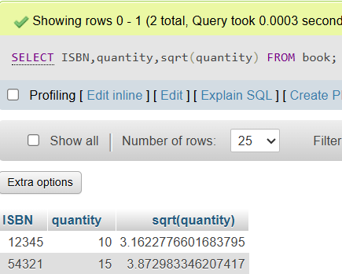
- Add price Column:
ALTER table book
add column price decimal(5,2);
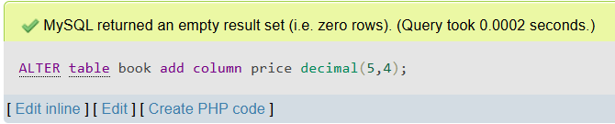
- Insert Values into price:
insert into book
VALUES(12345,'The Hunger Game',10,20.50),
(54321,'The Song of Ice and Fire',15,30.40);
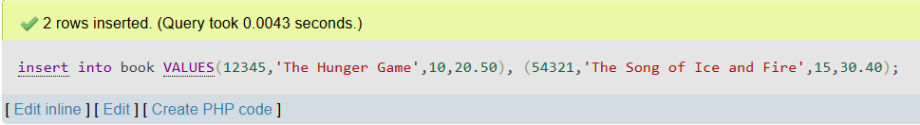
- Round Function
SELECT ISBN,price,round(price)
from book;
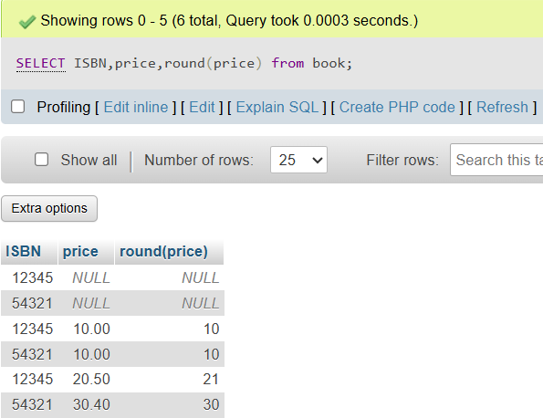
- Ceiling Function:
SELECT ISBN,price,ceiling(price)
from book;
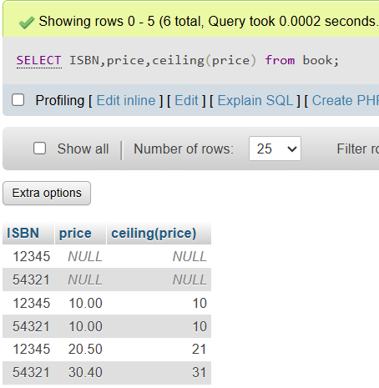

- Floor Function:
SELECT ISBN,price,floor(price)
from book;
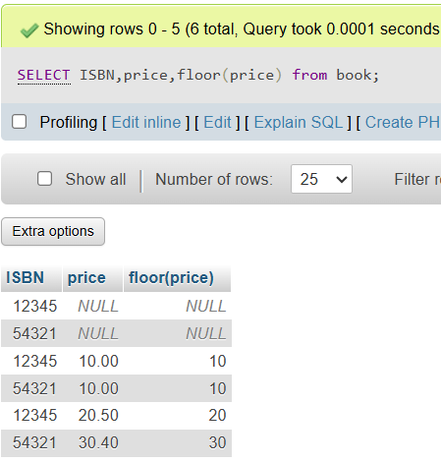
LAB TASK 2: String Functions
- Substring Function:
SELECT ISBN,substring(title,3,4)
from book;
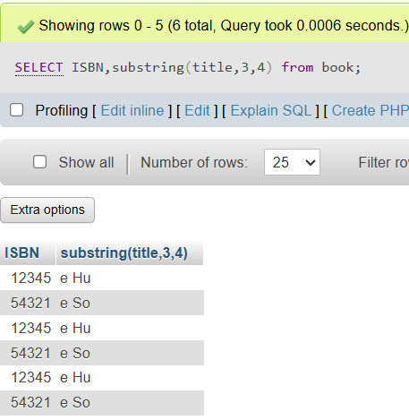
- Upper Function:
SELECT ISBN,Upper(title)
from book;
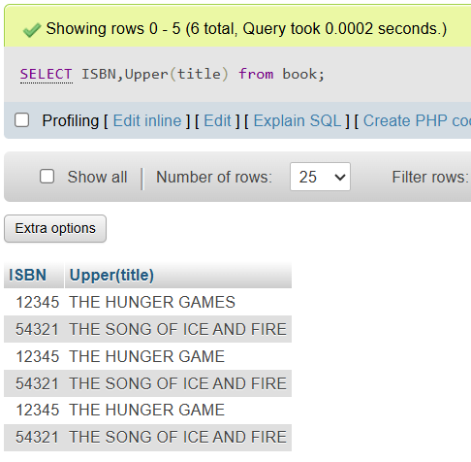
- Lower Function:
SELECT ISBN,Lower(title)
from book;
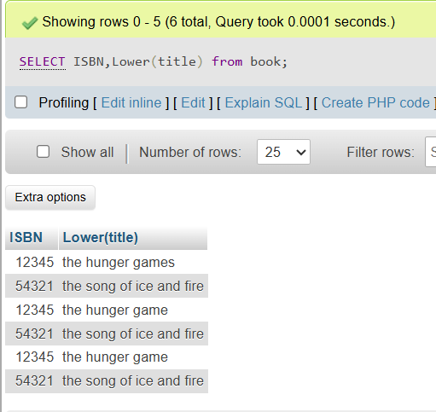
- Reverse Function:
SELECT ISBN,Reverse(title)
from book;
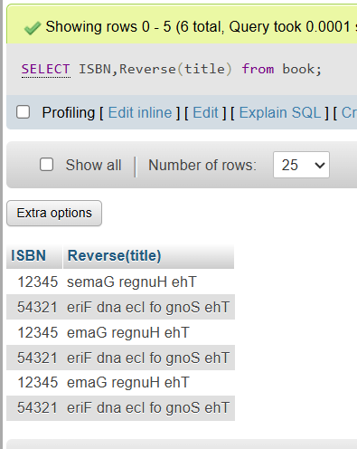
- Length Function:
SELECT ISBN,length(title)
from book;
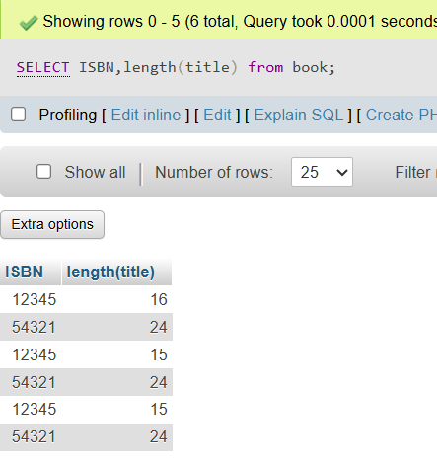
Lab 15 (Date Functions)
- Create Book Table :

CREATE TABLE book1 (
ISBN VARCHAR(20) PRIMARY KEY,
Title VARCHAR(100) NOT NULL,
Published DATETIME NOT NULL
);
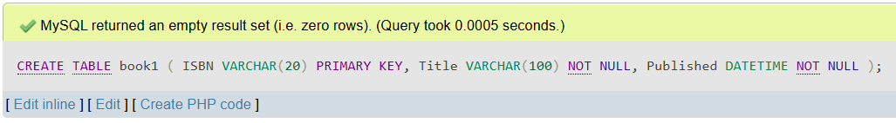
- Insert Values In Book Table :
INSERT INTO book1 (ISBN, Title, Published)
VALUES ('12345', 'The Hunger Game', '2008-10-11 12:12:33');
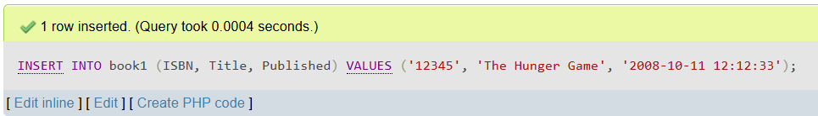
- Now Function :
INSERT INTO book1 (ISBN, Title, Published)
VALUES ('54321', 'A Song of Ice and Fire', NOW());
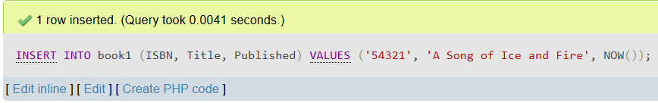
- Show Table :
Select * from book1;
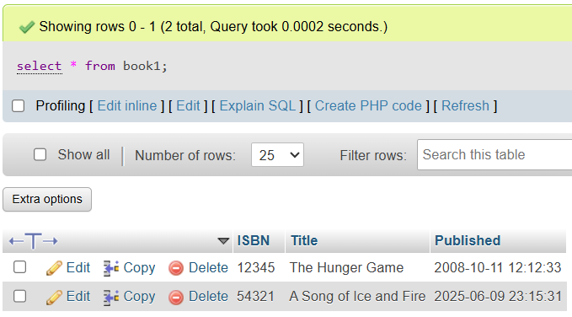
- Extract Function :
SELECT ISBN, Title, EXTRACT(YEAR FROM Published) AS Year FROM Book1;
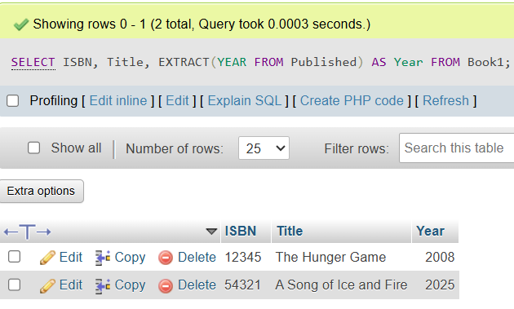
Query:
SELECT ISBN, Title, EXTRACT(month FROM Published) AS Month FROM Book1;
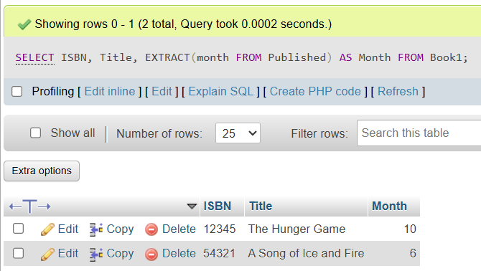
Query:
SELECT ISBN, Title, EXTRACT(day FROM Published) AS day FROM Book1;
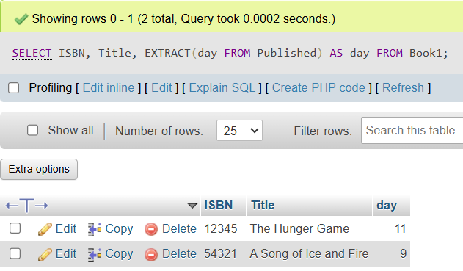
- Date-Add Function :
SELECT ISBN, Title, DATE_ADD(Published, INTERVAL 5 DAY) AS Published FROM Book1;
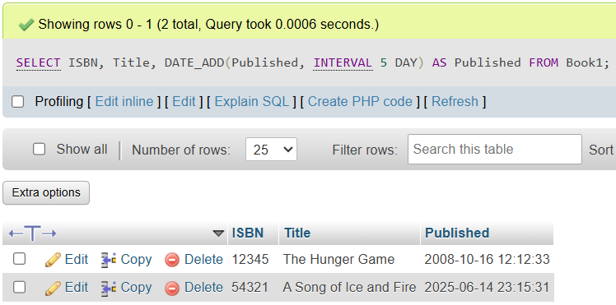
- Date-Sub Function :
SELECT ISBN, Title, DATE_SUB(Published, INTERVAL 3 HOUR) AS Published FROM Book1;
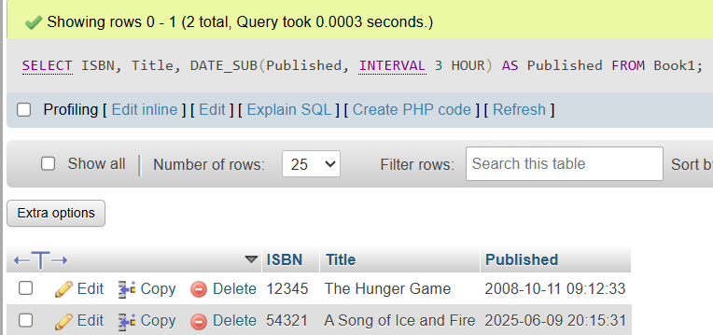
- Create Journey Table :
CREATE TABLE journey (
JourneyId INT PRIMARY KEY,
Start DATETIME NOT NULL,
End DATETIME NOT NULL
);
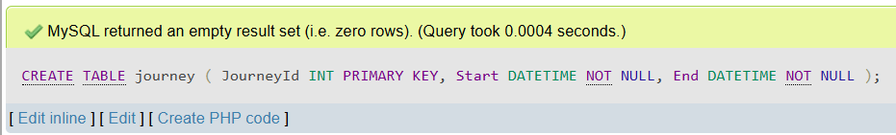
- Insert Values In Journey Table :
INSERT INTO journey (JourneyId, Start, End)
VALUES (1, '2011-11-12 12:12:33', '2011-11-15 12:12:33'),
(2, '2011-11-12 12:12:33', '2011-11-18 17:01:53');
- Date-Diff Function:
SELECT JourneyId, DATEDIFF(End, Start) AS Duration FROM Journey;
