DocBot AI – System Flow Diagrams
Proposal diagrams based on the reviewed workflow specifications.

Figure 1 — Overall DocBot AI System Workflow
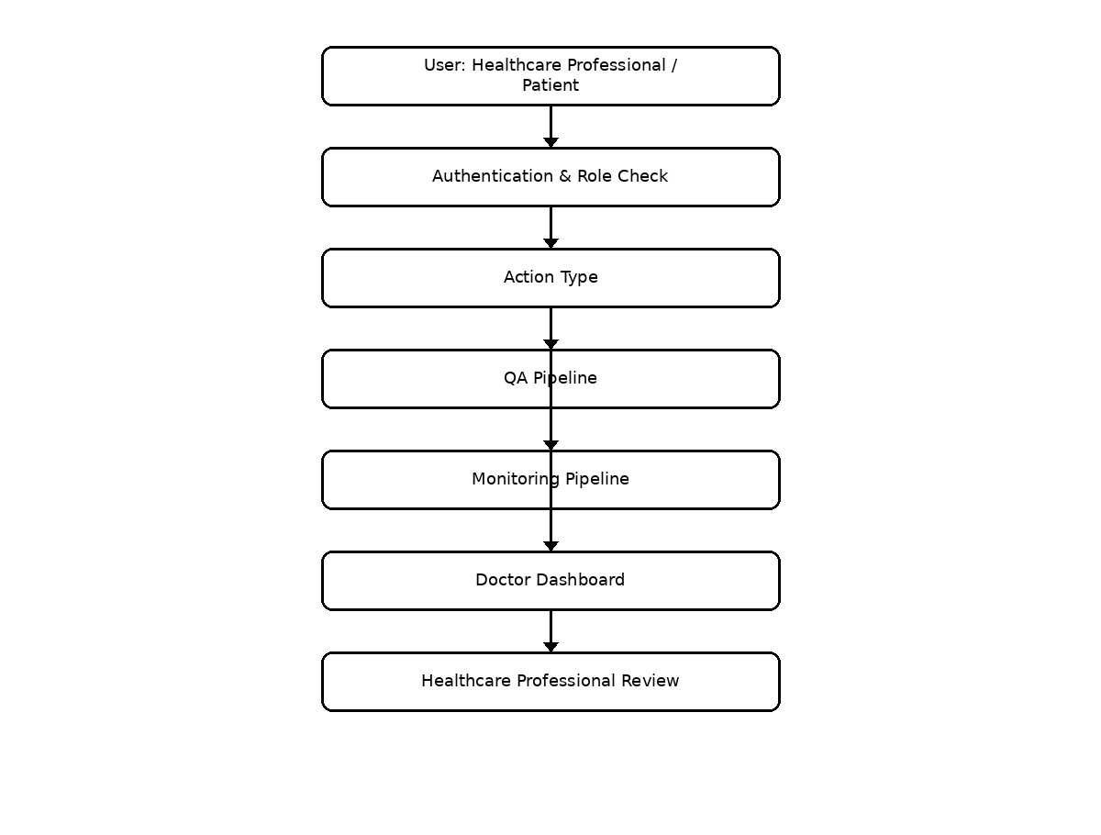

Figure 2 — Evidence-Grounded Clinical QA / RAG Pipeline
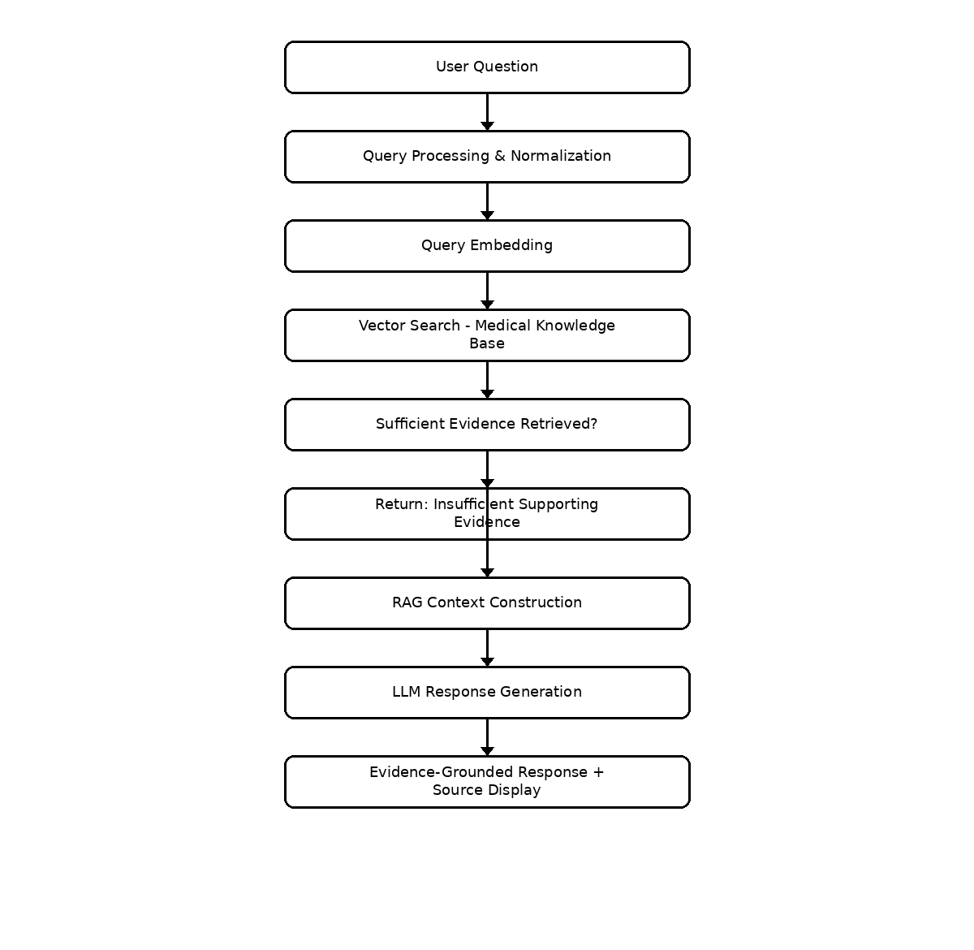

Figure 3 — Longitudinal Patient Monitoring Workflow
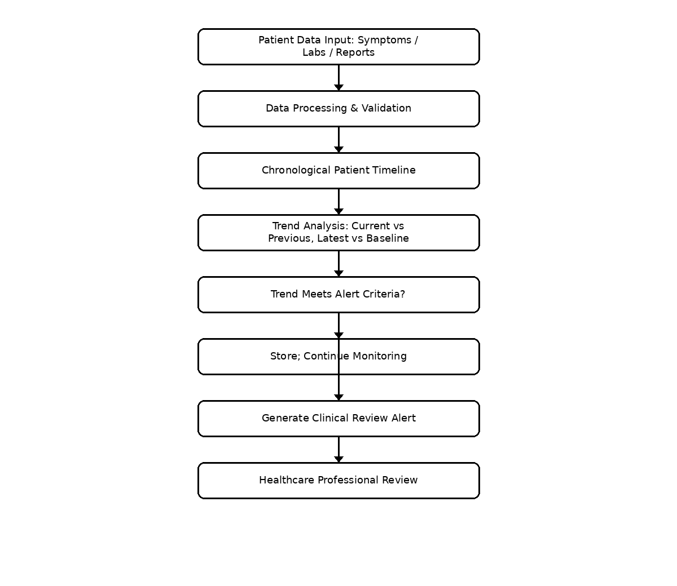

Figure 4 — Overall System Architecture
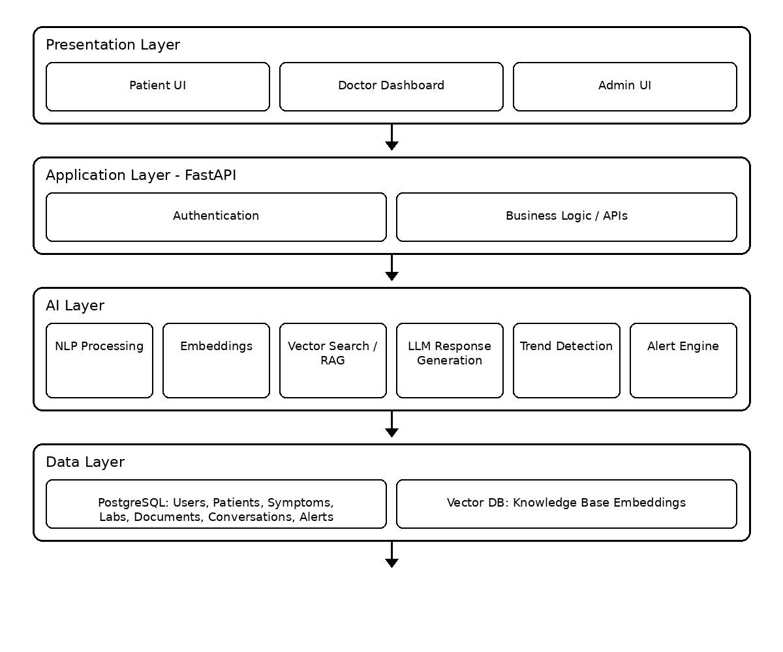

Figure 5 — Data Flow / Information Flow
