FINAL YEAR PROJECT PROPOSAL
DocBot AI
An Evidence-Grounded Clinical Question Answering and
Longitudinal Patient Monitoring System Using RAG and Large Language Models

Project Type | Final Year Project (FYP)
Primary Area | Artificial Intelligence / Healthcare AI
Core Technologies | RAG, LLMs, NLP, Semantic Search, Longitudinal Data Analysis
System Positioning | Clinical information and review support; not autonomous diagnosis
Document Status | Revised proposal for FYP proposal defense

1. Introduction
Healthcare organizations generate large amounts of information through laboratory reports, medical documents, symptoms, patient histories, and clinical records. Reviewing these records manually can be time-consuming when a healthcare professional needs to understand how a patient's information has changed over time.
Recent advances in Natural Language Processing (NLP), Large Language Models (LLMs), and Retrieval-Augmented Generation (RAG) provide methods for supporting medical information retrieval and question answering. However, general-purpose language models are not automatically grounded in a specific, verifiable medical source. The literature reviewed for this proposal therefore places particular emphasis on retrieval-based grounding and evidence provenance.
DocBot AI is proposed as a clinical information-support and review-support prototype. It combines an evidence-grounded clinical question-answering pipeline with a longitudinal patient-monitoring pipeline. The first retrieves relevant medical evidence before generating an answer. The second organizes patient symptoms and laboratory information chronologically and identifies trends that meet predefined review criteria.
The system is explicitly positioned as decision support rather than an autonomous AI doctor. Diagnosis, treatment, and final clinical decisions remain with qualified healthcare professionals.

2. Background
Patient information is often distributed across reports, laboratory results, symptom records, and historical notes. A longitudinal view is useful because clinically relevant change may be gradual rather than visible in a single record.
RAG provides a mechanism for combining retrieval with generation: a query is transformed into a representation suitable for search, relevant document passages are retrieved, and those passages are supplied as context to an LLM. The research reviewed for DocBot AI includes medical RAG systems such as Almanac, RAG², and risk-aware medical QA approaches, while longitudinal work includes EHR-RAG and timeline visualization systems.
These strands have largely developed separately. Medical QA systems emphasize benchmark or knowledge-base question answering, whereas longitudinal systems emphasize patient history, temporal modeling, or visualization. Clinical decision-support research additionally studies alerts and alert fatigue. This separation motivates the integrated prototype proposed here.

3. Problem Statement
Healthcare professionals may need to compare laboratory reports, symptoms, clinical notes, and historical documents to understand a patient's condition over time. Manual comparison can require considerable effort and can make gradual changes difficult to notice.
A related problem concerns evidence grounding. A conversational medical system may produce a fluent answer without showing which authoritative evidence supports the answer. Published work reviewed for this proposal reports concerns about hallucinated references and unsupported guideline claims in clinical QA, while systematic reviews identify retrieval-based grounding as an important hallucination-mitigation approach.
The resulting gap is not simply a lack of another medical chatbot. The more specific gap is the separation between evidence-grounded clinical QA and patient-specific longitudinal monitoring. Existing systems reviewed here generally provide one of these capabilities or combine related subsets without the complete combination of medical evidence retrieval, patient timeline analysis, trend detection, and review-oriented alerts.
DocBot AI addresses this integration problem by connecting the two pipelines in one clinical information-support prototype. It will identify potential changes for professional review rather than making autonomous diagnoses or treatment decisions.

4. Research Questions
- RQ1: How effectively can retrieval-augmented generation provide clinically relevant answers that are traceable to retrieved medical evidence?
- RQ2: Can longitudinal analysis of patient symptoms and laboratory values identify predefined meaningful changes that can be presented as review-oriented alerts?
- RQ3: How well can evidence-grounded QA and longitudinal monitoring be integrated into a single prototype while maintaining appropriate safety-oriented behaviour and clear human oversight?

5. Justification
The justification for DocBot AI follows from the separation identified in the reviewed literature. Medical LLM and RAG systems demonstrate evidence-grounded question answering, while longitudinal and timeline systems demonstrate ways to organize patient information over time. Clinical decision-support studies further show that alert design and alert fatigue are important considerations.
The proposed contribution is therefore an integration contribution rather than a claim of a new LLM, a new embedding algorithm, or a new clinical prediction model. The project will bring established techniques into one prototype and evaluate whether their combination supports clinical information review in a transparent way.
This scope is appropriate for an undergraduate FYP because the system can be evaluated using controlled data and predefined criteria without claiming readiness for autonomous clinical deployment.

6. Research Gap
The comparative literature analysis identifies five capabilities that are individually established but insufficiently integrated within the reviewed systems: (1) evidence-grounded clinical QA, (2) medical knowledge retrieval using embeddings and vector search, (3) longitudinal patient timelines, (4) laboratory/symptom trend detection, and (5) clinical review alerts designed with alert-fatigue considerations.
EHR-RAG is the closest identified work to combining RAG with longitudinal EHR data, but the reviewed description does not include the full combination of a general medical knowledge base for clinical QA, predefined symptom/laboratory trend monitoring, and review-alert generation. The gap should therefore be stated narrowly: an integrated review-support prototype combining these capabilities remains underexplored in the reviewed literature.
DocBot AI does not claim to close every gap in healthcare AI. Its proposed research contribution is to implement and evaluate this particular integration under a controlled prototype scope.

7. Previous Work / Literature Comparison
Study | Main focus | Technique | Reported finding / role | Limitation relevant to DocBot AI
Med-PaLM 2 (Singhal et al., 2025) | Medical LLM QA | Medical LLM methods | High performance on medical QA benchmarks | No patient-specific longitudinal monitoring
Almanac (Zakka et al., 2024) | Evidence-grounded clinical QA | LLM + curated medical retrieval | Improved factuality/safety compared with general-purpose baselines | No patient-specific trend monitoring or review alerts
Zhang et al. (2026) | Risk-aware medical QA | RAG, risk classification, verification | Uses risk handling to improve safety-oriented QA | No longitudinal patient monitoring
EHR-RAG (Cao et al., 2026) | Longitudinal EHR retrieval | Type-aware retrieval, temporal reasoning | Targets multi-event longitudinal EHR retrieval | Does not provide the full medical-KB QA + trend-alert combination
Morid et al. (2020) | Temporal adverse-event prediction | Structural temporal pattern detection | Demonstrates value of temporal trends | Focused on ICU AKI prediction rather than integrated QA
Kwan et al. (2020) | CDSS effectiveness | Meta-analysis of controlled trials | Shows measurable CDSS effects and highlights alert-fatigue concerns | Does not integrate RAG evidence context with longitudinal trends
Singh et al. (2010) | Abnormal lab notification | EMR alerts | Shows that notification alone does not guarantee timely follow-up | Threshold-oriented; no RAG or trend-aware context
Ledesma et al. (2019) | Clinical timeline visualization | Time-based visualization | Reported higher insight value than textual representation | No LLM reasoning, RAG, or automated trend analysis
Low et al. (2025) | Real-world clinical QA | RAG and agentic LLM evaluation | Reports fragmentation across clinical question types | No longitudinal monitoring integration

8. Aim
To develop and evaluate DocBot AI, a clinical information-support prototype that combines Retrieval-Augmented Generation and Large Language Models to answer clinical questions with verifiable evidence, while organizing a patient's symptom and laboratory history over time to identify trends worth flagging for professional review.

9. Objectives
- To design and implement an evidence-grounded clinical question-answering component that retrieves relevant evidence from a curated medical knowledge base using semantic search and generates responses through an LLM while displaying supporting sources.
- To design and implement a longitudinal patient-monitoring component that organizes symptom and laboratory information into a chronological timeline, detects changes using predefined criteria, and generates review-oriented alerts for authorized healthcare professionals.
- To integrate both components into one DocBot AI prototype and evaluate retrieval quality, response relevance, evidence grounding, monitoring and alert usefulness, system functionality, and safety-oriented behaviour.

10. Scope of the Project
The project scope is a prototype clinical information-support platform. It is intended for controlled academic evaluation and does not represent a clinically validated deployment.

10.1 Included Features
- User registration and login
- Role-based access
- Patient management
- Clinical question answering
- Medical document upload and text extraction
- Document preprocessing and text chunking
- Text embeddings and vector-based semantic search
- RAG and LLM response generation
- Evidence/source display
- Symptom and laboratory result management
- Patient timeline
- Longitudinal trend detection
- Clinical review alerts
- Conversation history
- Doctor dashboard
- Administrator functionality
- API-based backend

10.2 Out of Scope
- Replacing qualified doctors
- Autonomous medical diagnosis
- Medication prescription
- Automatic treatment-plan determination
- Replacement of hospital EHR systems
- Final clinical decisions without professional review
- Claims of clinical deployment readiness without further validation

11. Target Users

11.1 Healthcare Professionals
- Review patient history
- Ask clinical information questions
- Inspect retrieved evidence
- Review patient trends
- Review clinical alerts

11.2 Patients
- View permitted personal information
- Upload medical reports where enabled
- Record symptoms
- View their historical timeline
- Ask permitted health-information questions

11.3 Administrator
- Manage users and roles
- Manage knowledge-base documents
- Manage system configuration
- Review logs and administrative information

12. Proposed System Workflow
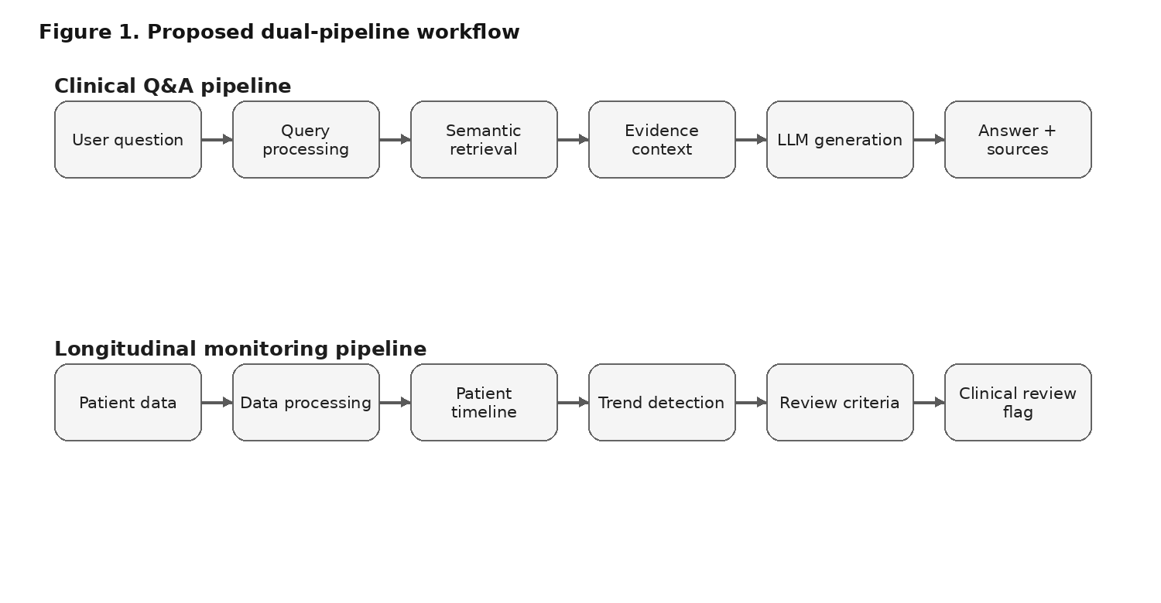
Figure 1. The two pipelines operate as complementary review-support functions.
In the clinical QA pipeline, the question is processed, embedded, searched against the knowledge base, and converted into an evidence context for the LLM. In the longitudinal pipeline, patient information is normalized and ordered chronologically before trend criteria are applied. A review flag is generated only when the configured criteria are met.

13. Methodology
The methodology is organized as a sequence of implementation and evaluation phases rather than as a list of technologies.
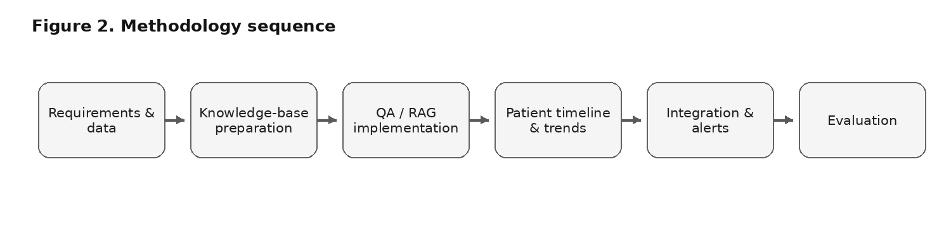
Figure 2. Methodology sequence from requirements through evaluation.

Phase A — Requirements and Data Foundation
Define functional and safety requirements; identify the types of medical knowledge and patient data to be represented; establish a controlled dataset strategy; define user roles and access boundaries.

Phase B — Medical Knowledge Base Preparation
Collect suitable public or institution-approved medical documents within the project scope; extract and clean text; divide documents into retrieval chunks; attach metadata such as title, source, and section where available.

Phase C — Evidence-Grounded QA
Generate embeddings for knowledge-base chunks; index them in the selected vector store; embed user queries; retrieve relevant passages; construct a constrained context; generate an answer with the LLM; display source information; return an insufficient-evidence response when retrieval is inadequate.

Phase D — Longitudinal Monitoring
Represent symptoms and laboratory observations with dates and relevant metadata; construct a chronological timeline; calculate changes such as current-versus-previous and latest-versus-baseline values; apply predefined trend criteria; record review flags without treating them as diagnoses.

Phase E — Integration and Review Alerts
Connect the QA and monitoring services through the application layer; provide a professional dashboard; show evidence alongside answers and contextual information alongside trend flags; enforce role-based access.

Phase F — Evaluation
Evaluate retrieval quality, response relevance, evidence grounding, trend-detection behaviour, alert usefulness, functionality, and safety-oriented behaviour using controlled test cases. Record false positives, false negatives, unsupported answers, and failure-to-retrieve cases where applicable.

14. Artificial Intelligence Methodology

14.1 Natural Language Processing
NLP will support query processing and medical-text preparation. Depending on the selected implementation, operations may include cleaning, tokenization, entity or concept extraction, normalization, and semantic representation.

14.2 Text Embeddings
Medical document chunks and user queries will be transformed into vector representations. Semantic similarity can then be used to retrieve relevant passages even when the wording of the question differs from the wording in the source document.

14.3 Vector Search
The project will use a vector index suitable for the selected deployment. FAISS is retained as the proposed baseline in the current technology plan. Retrieval quality will be tested using known questions and expected supporting passages.

14.4 Retrieval-Augmented Generation
RAG connects retrieval with generation. The system will retrieve evidence before generating an answer and will instruct the LLM to remain within the retrieved context. When the retrieved material is insufficient, the preferred behaviour is to state that supporting information was not found rather than fabricate an answer.

14.5 Longitudinal Trend Detection
For numerical laboratory observations, the prototype will represent basic changes using current-versus-previous and latest-versus-baseline comparisons. Where multiple observations are available, a rate or direction of change can also be calculated. Trend criteria will be explicitly defined before evaluation and will be treated as review rules rather than diagnostic rules.
The project will not claim that a detected trend represents a disease or confirmed clinical outcome. Its purpose is to identify records that may warrant professional attention.

15. Proposed Technology Stack
Component | Proposed technology
Programming language | Python
Backend | FastAPI
Frontend | React (preferred) or Streamlit if implementation constraints require it
Database | PostgreSQL
Vector database | FAISS or another suitable vector store
Embeddings | Sentence Transformers
NLP | Transformers / spaCy
Machine learning | scikit-learn / PyTorch where required
LLM | Suitable LLM API or approved local model
PDF processing | PyMuPDF
DOCX processing | python-docx
Authentication | JWT-based authentication
Containerization | Docker
Version control | Git / GitHub

16. System Architecture
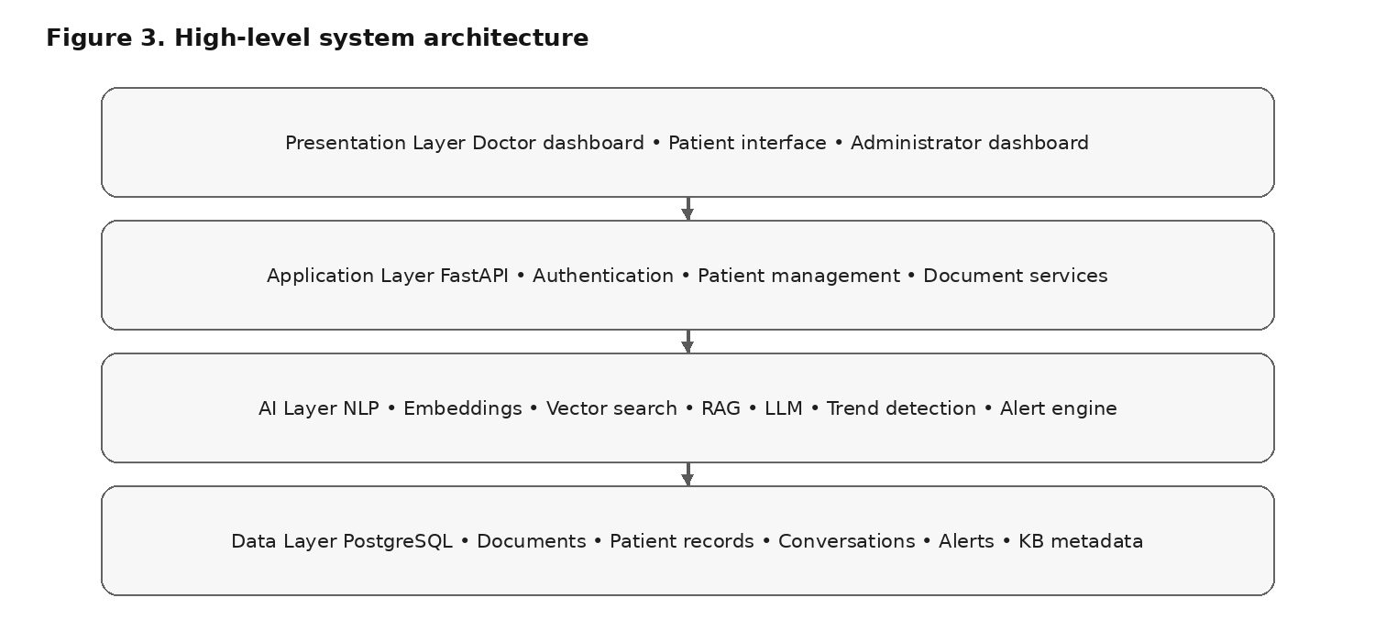
Figure 3. High-level architecture showing the relationship between interfaces, application services, AI services, and stored data.

Presentation Layer
Interfaces for healthcare professionals, patients where enabled, and administrators.

Application Layer
FastAPI handles authentication, business logic, APIs, patient management, document processing, and integration with AI services.

AI Layer
Contains NLP processing, embeddings, vector search, RAG, LLM generation, trend detection, and clinical alert generation.

Data Layer
Stores user information, patient records, symptoms, laboratory results, documents, conversations, alerts, and knowledge-base metadata.

17. Major Functional Modules

Module 1 — Authentication
Registration, login, authentication, and role-based authorization.

Module 2 — Patient Management
Creation and management of patient records by authorized users.

Module 3 — Clinical Chat
Natural-language clinical information question answering.

Module 4 — Medical Document Processing
Upload, text extraction, preprocessing, and chunk preparation.

Module 5 — Knowledge Base
Storage and metadata management for curated medical information.

Module 6 — RAG Engine
Evidence retrieval, context construction, and LLM integration.

Module 7 — Patient Timeline
Chronological display of symptoms, laboratory results, and relevant documents.

Module 8 — Trend Detection
Analysis of historical observations against predefined criteria.

Module 9 — Clinical Alert Engine
Generation and storage of review-oriented flags.

Module 10 — Doctor Dashboard
Review of patients, trends, evidence, conversations, and alerts.

Module 11 — Administrator Dashboard
Management of users, roles, knowledge-base content, and system configuration.

18. Security and Privacy
Because the prototype handles potentially sensitive medical information, security will be treated as a system requirement rather than an optional feature.
- Authentication and role-based access control
- Password hashing and secure credential handling
- Secure API communication
- Least-privilege access to patient records
- Database security and controlled document access
- Audit information for relevant administrative actions
- Secure handling of uploaded files
- Minimum necessary data exposure
- Separation of patient data from public knowledge-base content
The prototype will avoid unnecessary exposure of patient information and will use controlled or synthetic data for development and evaluation where appropriate.

19. Limitations
- Generated-answer quality depends on the quality and coverage of the medical knowledge base and retrieved evidence.
- LLM outputs may still require professional verification.
- Trend detection depends on the quantity, consistency, and quality of historical patient data.
- Alert criteria require validation against suitable test cases and, where possible, expert-defined criteria.
- The prototype may not integrate with real hospital EHR systems.
- Real-world clinical deployment would require additional privacy, security, regulatory, usability, and clinical validation.

20. Ethical Considerations
- Clearly communicate system limitations.
- Avoid presenting uncertain information as confirmed fact.
- Display supporting evidence where possible.
- Encourage professional review for clinically significant matters.
- Do not provide autonomous diagnosis or treatment decisions.
- Protect patient information through appropriate access controls.
- Present alerts as review flags rather than confirmed medical diagnoses.
- Maintain transparency about the use of AI-assisted content and evaluation data.

21. Expected Outcomes
The expected outcome is a working academic prototype demonstrating the integration of evidence-grounded clinical QA and longitudinal patient monitoring.
- Secure authentication and role-based access
- Patient management and longitudinal records
- Medical document processing
- Curated medical knowledge base
- Semantic retrieval and RAG pipeline
- LLM-based clinical information QA
- Evidence/source display
- Patient timeline and trend analysis
- Review-oriented clinical alerts
- Doctor and administrator dashboards
- Conversation history
- API-based backend
- Evaluation results for retrieval, QA, monitoring, alerts, functionality, and safety-oriented behaviour

22. Future Enhancements
- Hospital EHR integration
- Wearable-device integration
- Real-time health monitoring
- More advanced time-series models
- Multilingual clinical interaction
- Voice-based interaction
- Medical image analysis
- Advanced clinical decision-support functions
- Larger validated medical knowledge bases
- Federated or privacy-preserving learning
- Mobile applications
- Advanced analytics dashboards
Any future clinical deployment would require appropriate validation, privacy protection, regulatory review, usability testing, and professional oversight.

23. Feasibility Analysis

23.1 Technical Feasibility
The proposed prototype can be implemented using established software technologies including Python, FastAPI, PostgreSQL, vector search, embedding models, document-processing libraries, and LLM APIs or approved local models.

23.2 Operational Feasibility
The workflow is based on familiar concepts: patient records, medical reports, laboratory results, timelines, evidence retrieval, and professional review. The prototype deliberately keeps the professional user in the decision loop.

23.3 Economic Feasibility
An academic prototype can use open-source frameworks and controlled cloud/API resources. Commercial deployment would require separate analysis of hosting, inference, storage, security, compliance, support, and maintenance costs.

23.4 Schedule Feasibility
- Requirements analysis
- System design
- Database development
- Authentication
- Document processing
- Knowledge-base and retrieval implementation
- Clinical QA
- Patient timeline
- Trend detection
- Alert engine
- Dashboard development
- Testing
- Evaluation
- Documentation and defense preparation

24. Conclusion
DocBot AI is proposed as an evidence-grounded clinical question-answering and longitudinal patient-monitoring prototype. Its central design combines retrieval-based medical evidence with a structured view of patient information over time.
The research gap identified for the project is an integration gap: the reviewed literature contains strong examples of medical QA, RAG, longitudinal EHR reasoning, timeline visualization, trend analysis, and clinical alerting, but does not demonstrate the complete combination targeted by this prototype.
The project therefore focuses on implementing and evaluating the integration rather than claiming a new foundational AI method. It will provide evidence alongside answers, patient timelines alongside historical observations, and review flags alongside the criteria that triggered them. Final diagnosis, treatment, and clinical decisions remain the responsibility of qualified healthcare professionals.

25. References
- Almanac — Zakka, C. et al. (2024). Evidence-grounded clinical language model work using retrieval from curated medical resources. NEJM AI. https://doi.org/10.1056/AIoa2300068
- Basu, S. and Huynh, T. (2026). Systematic review of retrieval-augmented generation and hallucination mitigation in healthcare AI. BMC Health Services Research. https://doi.org/10.1186/s12913-026-14851-1
- Cao, et al. (2026). EHR-RAG: Retrieval-augmented generation for longitudinal structured electronic health records. arXiv:2601.21340. https://arxiv.org/abs/2601.21340
- Kwan, J.L. et al. (2020). Effectiveness of clinical decision support systems in improving care. BMJ. https://doi.org/10.1136/bmj.m3216
- Ledesma, A. et al. (2019). Health Timeline: time-based visualization of patient information. BMC Medical Informatics and Decision Making. https://doi.org/10.1186/s12911-019-0885-x
- Lee, J. et al. (2020). BioBERT: a pre-trained biomedical language representation model for biomedical text mining. Bioinformatics. https://doi.org/10.1093/bioinformatics/btz682
- Lewis, P. et al. (2020). Retrieval-Augmented Generation for Knowledge-Intensive NLP Tasks. arXiv:2005.11401. https://arxiv.org/abs/2005.11401
- Low, et al. (2025). Evaluation of RAG and agentic LLM systems for real-world clinical questions. Digital Health. https://doi.org/10.1177/20552076251348850
- Morid, M.A. et al. (2020). Structural temporal pattern detection for adverse-event prediction in critical care. JMIR Medical Informatics. https://doi.org/10.2196/14272
- Nanua, et al. (2025). Retrieval-augmented generation for clinical laboratory regulatory question answering. Journal of Pathology Informatics. https://doi.org/10.1016/j.jpi.2025.100520
- Plaisant, C. et al. (1996). LifeLines: visualizing personal histories. ACM CHI. https://doi.org/10.1145/257089.257391
- Ray, et al. (2026). Systematic review of alert-fatigue measurement in clinical decision support. Journal of the American Medical Informatics Association. https://doi.org/10.1093/jamia/ocag064
- Singh, H. et al. (2010). Follow-up of abnormal laboratory test results in an electronic medical record: automated notification and safety concerns. American Journal of Medicine. https://doi.org/10.1016/j.amjmed.2009.07.027
- Singhal, K. et al. (2023). Large language models encode clinical knowledge. Nature. https://doi.org/10.1038/s41586-023-06291-2
- Singhal, K. et al. (2025). Large language models as medical assistants / Med-PaLM 2. Nature Medicine. https://doi.org/10.1038/s41591-024-03423-7
- Sohn, et al. (2025). RAG²: rationale-guided retrieval-augmented generation for medical question answering. arXiv:2411.00300. https://arxiv.org/abs/2411.00300
- Tsatsaronis, G. et al. (2015). An overview of the BioASQ large-scale biomedical semantic indexing and question answering competition. BMC Bioinformatics. https://doi.org/10.1186/s12859-015-0564-6
- Xie, et al. (2022). Deep learning approaches for temporal electronic health record data: systematic review. Journal of Biomedical Informatics.
- Yada, S. and Aramaki, E. (2023). HeaRT: timeline generation from unstructured electronic health record text. arXiv:2306.14379. https://ar5iv.labs.arxiv.org/html/2306.14379
- Zhang, et al. (2026). Risk classification and evidence grounding for medical question answering. JMIR Formative Research. https://doi.org/10.2196/84932
- Zakka, C. et al. (2024). Almanac: retrieval-augmented language model for clinical decision support / medical information. NEJM AI. https://doi.org/10.1056/AIoa2300068

Appendix A. Commercialisation Potential
Commercialisation is treated as future potential rather than as a core research objective. The academic prototype should first establish technical feasibility and evaluation results.

A.1 Potential Business Problem
Healthcare organizations manage large volumes of patient information and may need more efficient ways to retrieve medical evidence and review historical patient information while retaining professional oversight.

A.2 Potential Deployment Models
- Institutional licensing
- Subscription-based service for clinics or healthcare organizations
- Enterprise deployment with organization-specific configuration
- Pilot or trial deployments

A.3 Potential Target Organizations
- Private hospitals
- Public healthcare organizations
- Private clinics
- Diagnostic laboratories
- Telemedicine platforms
- Medical research organizations

A.4 Potential Revenue Streams
- Institutional licensing
- Subscription fees
- Enterprise deployment services
- Customized integrations
- Technical support and maintenance
Actual pricing, regulatory requirements, infrastructure costs, and market feasibility would need to be studied separately before any commercial deployment claim is made.

