FINAL YEAR PROJECT PROPOSAL
DocBot AI: An Evidence-Grounded Clinical Question Answering and Longitudinal Patient Monitoring System Using RAG and Large Language Models
Revised Proposal

1. Introduction
Healthcare organizations generate a large amount of medical information in the form of laboratory reports, medical documents, symptoms, patient histories, and clinical records. Reviewing this information manually can be time-consuming, particularly when a healthcare professional needs to understand changes in a patient's health over a long period.
Recent advances in Artificial Intelligence, Natural Language Processing, Large Language Models, and Retrieval-Augmented Generation provide opportunities to support healthcare information management and clinical review. However, a general-purpose language model does not have to base its answer on any specific, checkable source, which is a real limitation when the question is medical.
DocBot AI is proposed as a clinical question-answering and longitudinal patient monitoring system built around this idea. Before answering a clinical question, the system retrieves supporting material from a curated medical knowledge base and supplies that material to a Large Language Model as context, so that the answer is tied to something checkable rather than generated from the model's internal knowledge alone.
Alongside this, DocBot AI keeps a longitudinal record of a patient's symptoms, laboratory results and uploaded reports, and analyzes that record for changes that may be worth a healthcare professional's attention. Where a change meets defined criteria, the system generates a clinical review alert.
DocBot AI is designed as a clinical assistance and review-support system, not as an autonomous AI doctor. Final clinical decisions, diagnosis, and treatment decisions remain with qualified healthcare professionals.

2. Background
The healthcare sector increasingly relies on digital medical information. Patient records may contain laboratory results, medical reports, symptoms, diagnoses, and other clinical information collected at different times, often by different people.
Locating the specific piece of information needed to answer a clinical question, or to work out whether a patient's condition has changed, usually means searching manually across these scattered records. This becomes harder as the volume of information grows, and conventional keyword-based search does not always match a clinical question to the relevant passage when the wording differs from the original document.
Advances in Natural Language Processing and Large Language Models have made it possible to search for information by meaning rather than by exact keyword, and to generate a natural-language answer rather than just a list of documents. This is a genuine improvement, but it introduces a new problem.
An LLM used on its own does not have to base its answer on any specific, checkable source. In an evaluation of real-world clinical question answering, Low et al. (2025) found that no single LLM-based system was reliable across all question types, and that general-purpose models could produce hallucinated references or guideline details. A systematic review of hallucination mitigation strategies in healthcare AI identified retrieval-based grounding as one of the more consistently effective corrections, while also noting that such strategies are rarely evaluated as part of an integrated clinical workflow (Basu & Huynh, 2026).
Retrieval-Augmented Generation addresses this by requiring a model to retrieve relevant material before generating a response, so that the response can be traced back to a specific source (Lewis et al., 2020). This does not remove the need for professional judgement, but it gives a reviewer something concrete to check the answer against.
A related but separate problem is that clinical information about one patient accumulates over time, and a single answer to a single question does not capture how that patient's condition is changing. Research on temporal modelling of electronic health records has identified irregular sampling and inconsistent formatting as ongoing challenges in this area (Xie et al., 2022), and research on timeline visualization has shown that presenting a patient's history in chronological form can produce clearer clinical insight than reading the same information as plain text (Ledesma et al., 2019).
DocBot AI brings these two ideas together: using Retrieval-Augmented Generation to ground clinical answers in retrieved evidence, and organizing a patient's symptom and laboratory history chronologically so that changes over time can be identified and flagged for review.

3. Problem Statement
Healthcare professionals frequently work with patient information that is spread across laboratory reports, clinical notes, symptom records and historical documents rather than held in one place. Identifying whether a patient's condition has changed over weeks or months means manually comparing values across several separate records, which is slow and easy to get wrong, particularly when the change is gradual rather than sudden.
A separate but related problem exists on the AI side. General-purpose conversational AI systems can answer medical questions in natural language, but they are not required to base those answers on any specific, checkable source. Research on clinical question answering has found that even capable LLM-based systems can produce responses that are difficult to verify, including hallucinated references or guideline claims that do not hold up (Low et al., 2025), and systematic work on hallucination mitigation in healthcare AI has pointed to retrieval-based grounding as one of the more consistently useful correctives (Basu & Huynh, 2026). Retrieval-Augmented Generation addresses this by requiring a system to retrieve supporting material before generating an answer, but the published RAG-based medical QA systems that do this, including Almanac (Zakka et al., 2024), RAG² (Sohn et al., 2025) and Zhang et al. (2026), operate against a general knowledge base or benchmark rather than against a specific patient's history.
That leaves a gap between two things that would be more useful combined: a system that grounds its answers in verifiable medical evidence, and a system that understands a specific patient's information as it develops over time. Existing systems tend to do one or the other. Medical QA and RAG systems answer general clinical questions well but have no patient-specific memory. Electronic health record and timeline systems organize a patient's history well but do not answer clinical questions or ground anything in external evidence. Systems that generate alerts from laboratory or symptom data typically rely on simple thresholds rather than any evidence-grounded reasoning, and are known to suffer from inconsistent alert quality and clinician fatigue (Kwan et al., 2020; Singh et al., 2010).
DocBot AI is proposed to address this specific combination: a clinical question-answering system that grounds its responses in retrieved medical evidence, connected to a longitudinal record of an individual patient's symptoms and laboratory results, so that trends in that record can be flagged for professional review rather than reviewed manually. The project does not attempt to replace clinical judgement. The aim is to reduce the manual effort of retrieving evidence and noticing changes over time, while leaving diagnosis and treatment decisions with the healthcare professional.

4. Justification
The case for DocBot AI follows from where the published research currently stops. Medical LLM and RAG-based QA systems, including Med-PaLM 2 (Singhal et al., 2025), Almanac (Zakka et al., 2024) and RAG² (Sohn et al., 2025), have already shown that grounding a model's response in retrieved evidence measurably improves factuality and safety compared with an ungrounded model. What none of these systems do is connect that grounded answer to a specific patient's history; they are built and evaluated against general knowledge bases or benchmark question sets.
On the other side, longitudinal and EHR-focused systems have shown that organizing a patient's data chronologically and detecting trends in it has real value. Timeline visualization improves clinical insight compared with reading raw text (Ledesma et al., 2019), and structural trend detection has outperformed static thresholds in predicting clinically important events (Morid et al., 2020). The closest existing system to combining the two, EHR-RAG (Cao et al., 2026), retrieves over structured longitudinal records, but its own authors note that it was not designed to incorporate a general medical knowledge base, symptom or laboratory trend monitoring against predefined criteria, or review alerts.
This is the gap DocBot AI sits in: evidence-grounded question answering and longitudinal patient monitoring have each been shown to work, separately, but the literature does not show a system that combines them into one review-support tool. Alert-fatigue research (Kwan et al., 2020; Ray et al., 2026; Singh et al., 2010) also indicates that alerts generated without evidence context or thoughtful design tend to be either ignored or unhelpful, which is itself part of the argument for building trend detection and clinical question answering into the same system, so that a flagged trend can be reviewed alongside the evidence that explains it, rather than as an isolated number.
The expected contribution is therefore not a new retrieval method or a new LLM. It is bringing two separately validated capabilities together into a single prototype and evaluating whether that combination is useful as a clinical review-support tool. This is a modest, defensible claim, not a claim that DocBot AI will outperform existing specialized systems at either task individually.

5. Research Gap
Existing research addresses the components of DocBot AI individually rather than together. Medical LLM and RAG-based systems (Singhal et al., 2023, 2025; Zakka et al., 2024; Sohn et al., 2025; Zhang et al., 2026) demonstrate that grounding answers in retrieved evidence improves factuality and safety, but these systems are evaluated against benchmarks or curated knowledge bases, not against an individual patient's history. Longitudinal monitoring and timeline systems (Xie et al., 2022; Ledesma et al., 2019) demonstrate effective ways to organize and visualize a patient's data over time, generally without any LLM-based reasoning or evidence-grounded question answering layered on top. Clinical decision-support research (Kwan et al., 2020; Ray et al., 2026; Singh et al., 2010) shows that alerting clinicians to changes in patient data has measurable but modest benefit, and that poorly designed alerts contribute to alert fatigue rather than useful review.
The system closest to bridging these areas, EHR-RAG (Cao et al., 2026), applies retrieval-augmented generation to longitudinal structured EHR data, but by its own authors' account was not designed to include a general medical knowledge base for clinical question answering, symptom or laboratory trend detection against defined criteria, or review-alert generation. Med-PaLM's authors identify grounding in patient-specific data and clinical workflow integration as directions the research has not yet addressed (Singhal et al., 2025), and a recent systematic review of hallucination mitigation in healthcare AI explicitly calls for these techniques to be integrated into clinical workflows rather than evaluated in isolation (Basu & Huynh, 2026).
A relatively underexplored area, then, is a system that combines evidence-grounded clinical question answering with patient-specific longitudinal monitoring and trend-based review alerts within one platform. DocBot AI is proposed to address this gap, not by inventing new retrieval or trend-detection techniques, but by integrating approaches that have each been separately validated, namely RAG-based grounding, semantic retrieval, chronological trend analysis, and review-oriented alerting, into a single clinical information-support prototype.

6. Previous Work / Literature Comparison
The studies below were selected from the wider literature review carried out for this proposal as the most directly relevant to DocBot AI's two capabilities, covering medical LLM question answering, RAG-based clinical systems, longitudinal and temporal monitoring, timeline visualization, and clinical decision-support alerting.
Previous Work / Research Study | Main Focus | Techniques | Proposed / Reported Result | Gap / Limitation | How DocBot AI Fulfills the Gap
Med-PaLM 2  (Singhal et al., 2025) | Expert-level medical LLM question answering | Medical fine-tuning, ensemble refinement prompting | 86.5% on MedQA; preferred over physician answers on 8/9 axes | No patient-specific data, no longitudinal monitoring, no retrieval-based evidence display | Adds RAG-based evidence display and longitudinal patient monitoring around the QA core
Almanac  (Zakka et al., 2024) | RAG-grounded clinical LLM | LLM plus retrieval from curated medical resources | Improved factuality and safety over ChatGPT-4, Bing and Bard | No patient-specific longitudinal data, no lab trend monitoring, no alerts | Keeps RAG-based grounding and adds longitudinal monitoring and review alerts
Zhang et al. (2026) | Risk-aware medical question answering | RAG pipeline, query risk classification, response verification | Improved safety by deferring high-risk questions | No longitudinal patient data, no trend monitoring or alerts | Adopts evidence-grounded, risk-aware answering and extends it with patient monitoring
EHR-RAG  (Cao et al., 2026) | RAG over longitudinal structured EHR data | Type-aware retrieval, multi-path evidence aggregation, temporal reasoning | Improved RAG performance over longitudinal EHR data | No general medical knowledge-base QA, no symptom or lab trend criteria, no review alerts | Adds general medical-knowledge QA, trend detection and alert generation to longitudinal reasoning
Morid et al. (2020) | Temporal trend detection for adverse events | Structural pattern detection (local and global trends) | Improved AKI prediction versus static and symbolic approaches | Limited to ICU AKI prediction; no QA, no RAG, no alerts | Adopts trend-detection principles and connects them to QA and review alerts
Kwan et al. (2020) | Clinical decision-support effectiveness (meta-analysis of 122 trials) | Multilevel meta-analysis | CDSS improved desired care by 5.8% (95% CI 4.0 to 7.6%); only 14% of trials considered alert fatigue | High heterogeneity; alert-fatigue design largely unaddressed | Designs alerts as review-support flags, informed by known alert-fatigue findings
Singh et al. (2010) | Abnormal laboratory-result notification in EMR | EMR alert tracking, logistic regression | 10.2% of alerts unacknowledged; 6.8% lacked timely follow-up | Threshold-only alerts; no trend detection, no QA | Replaces simple thresholds with trend-based detection tied to evidence-grounded context
Health Timeline  (Ledesma et al., 2019) | Clinical timeline visualization | Time-based visualization, insight-based evaluation | Higher insight value than textual records (1.7 vs. 1.26) | No AI/LLM, no trend detection, no alerts | Builds a similar chronological timeline and adds AI-based trend detection and QA
Low et al. (2025) | Real-world clinical QA evaluation | RAG-based tools, agentic LLMs | No single system sufficient for all clinical question types | Fragmented capabilities; no monitoring integration | Responds to this fragmentation by combining QA with longitudinal monitoring in one platform

7. Aim of the Project
To develop and evaluate DocBot AI, a clinical information-support prototype that combines Retrieval-Augmented Generation and Large Language Models to answer clinical questions with verifiable evidence, and that organizes a patient's symptom and laboratory history over time to identify trends worth flagging for professional review.

8. Objectives
This project has exactly three main objectives.
Objective 1: Evidence-grounded clinical question answering.
To design and implement a clinical question-answering component that retrieves relevant evidence from a curated medical knowledge base using semantic search and text embeddings, and generates responses through an LLM constrained to that retrieved evidence, displaying the supporting sources alongside each answer.
Objective 2: Longitudinal patient monitoring.
To design and implement a longitudinal patient monitoring component that organizes symptom and laboratory information chronologically into a patient timeline, detects meaningful trends within that data, and generates review-oriented alerts for healthcare professionals when predefined criteria are met.
Objective 3: Integration and evaluation.
To integrate the question-answering and monitoring components into a single DocBot AI prototype and evaluate it in terms of retrieval quality, response relevance and evidence grounding, monitoring and alert usefulness, and overall functionality and safety-oriented behaviour.

9. Scope of the Project
The scope of DocBot AI is the development of a prototype clinical information-support platform. This scope was fixed earlier in the project and is preserved unchanged in this revision.

9.1 Included Features
- User registration and login
- Role-based access
- Patient management
- Clinical question answering
- Medical document upload
- Document text extraction
- Document preprocessing
- Text chunking
- Text embeddings
- Vector-based semantic search
- Retrieval-Augmented Generation
- LLM-based response generation
- Evidence and source display
- Patient symptom management
- Laboratory result management
- Patient timeline
- Longitudinal trend detection
- Clinical review alerts
- Conversation history
- Doctor dashboard
- Administrator functionality
- API-based backend

9.2 Out of Scope
The initial prototype will not aim to:
- Replace qualified doctors
- Provide autonomous medical diagnosis
- Prescribe medication
- Automatically determine treatment plans
- Replace hospital Electronic Health Record systems
- Make final clinical decisions without professional review

10. Target Users

10.1 Healthcare Professionals
Doctors and other authorized healthcare professionals can use the system to review patient history, ask clinical information questions, view supporting evidence, review patient trends, and review clinical alerts.

10.2 Patients
Depending on the final system configuration, patients may be able to view their own information, upload medical reports, record symptoms, view their historical timeline, and ask permitted health-information questions.

10.3 Administrator
The administrator can manage users, roles, knowledge-base documents, system configuration, and logs and administrative information.

11. Proposed System Workflow
DocBot AI's workflow is organized into two pipelines that share a common entry point and a common review point, shown in Figure 1: an evidence-grounded clinical question-answering pipeline and a longitudinal patient monitoring pipeline. Each is described in more detail below and shown in Figures 2 and 3.

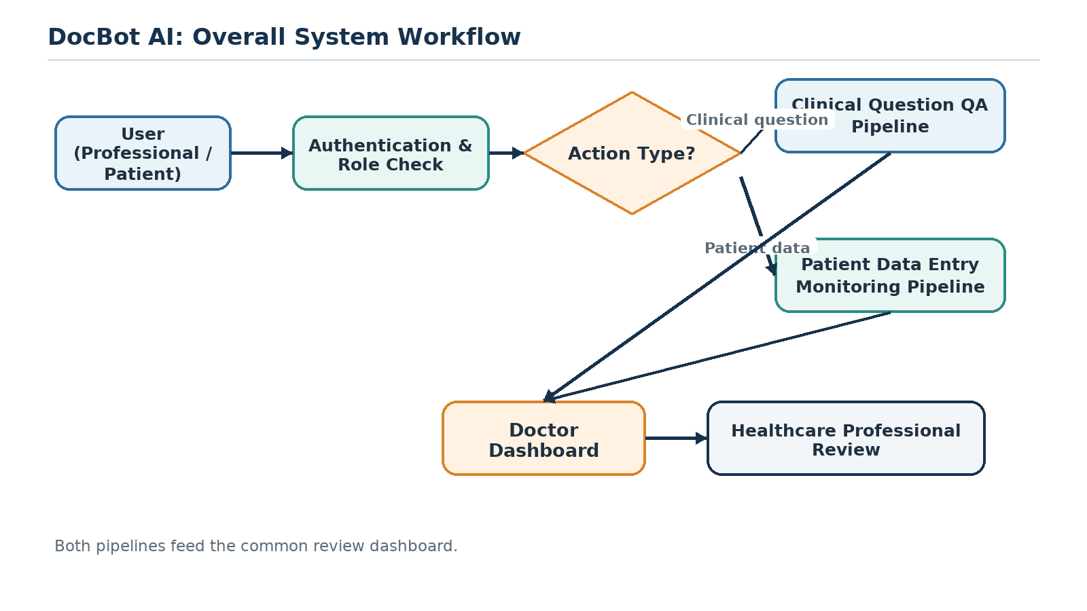
Figure 1. Overall DocBot AI System Workflow

11.1 Evidence-Grounded Clinical Question Answering Pipeline
When a user asks a clinical question, the system processes the question, retrieves relevant evidence from the medical knowledge base, and generates a response grounded in that evidence, as shown in Figure 2. If the retrieved evidence is not sufficient to support an answer, the system indicates that there is insufficient supporting information rather than generating an unsupported response.

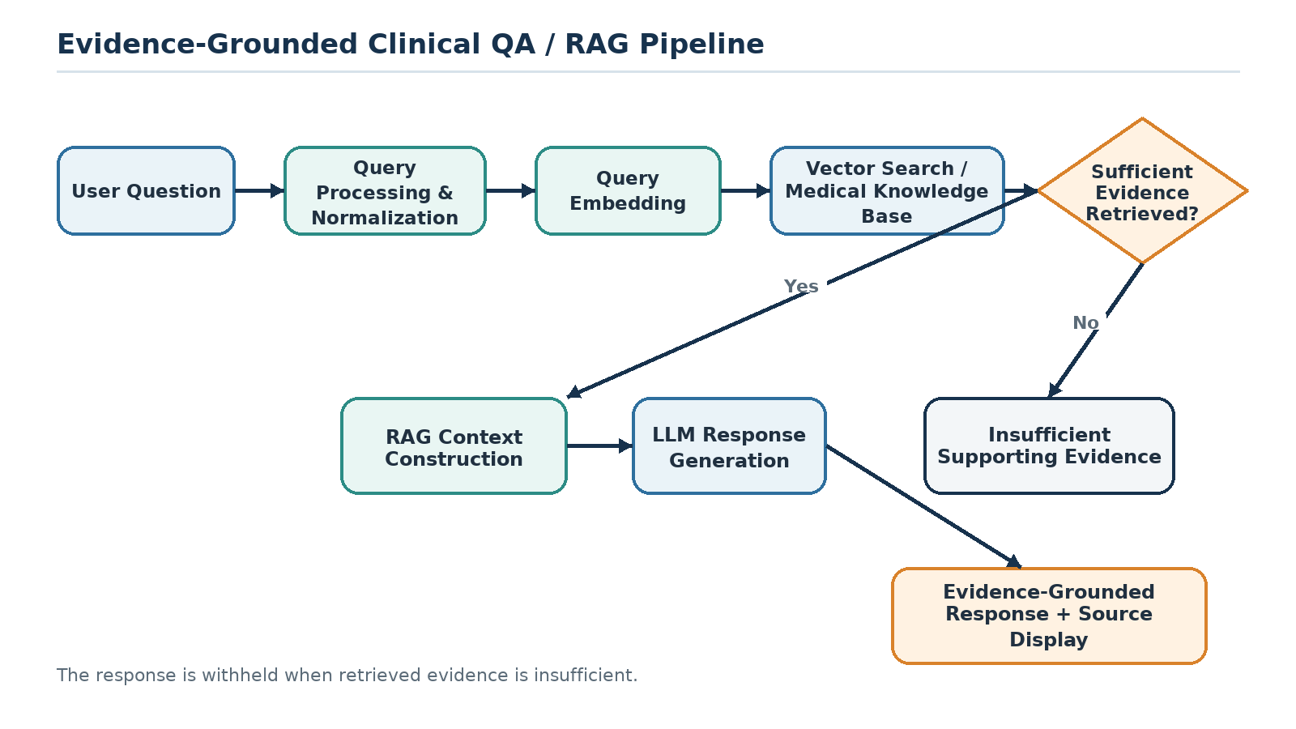
Figure 2. Evidence-Grounded Clinical Question Answering / RAG Pipeline

11.2 Longitudinal Patient Monitoring Pipeline
Authorized users can record a patient's symptoms, laboratory results and medical reports over time. This information is organized into a chronological timeline, and the system analyzes it for trends that may be worth a healthcare professional's attention, as shown in Figure 3. Alerts generated in this way are intended as flags for professional review, not as automated diagnoses.

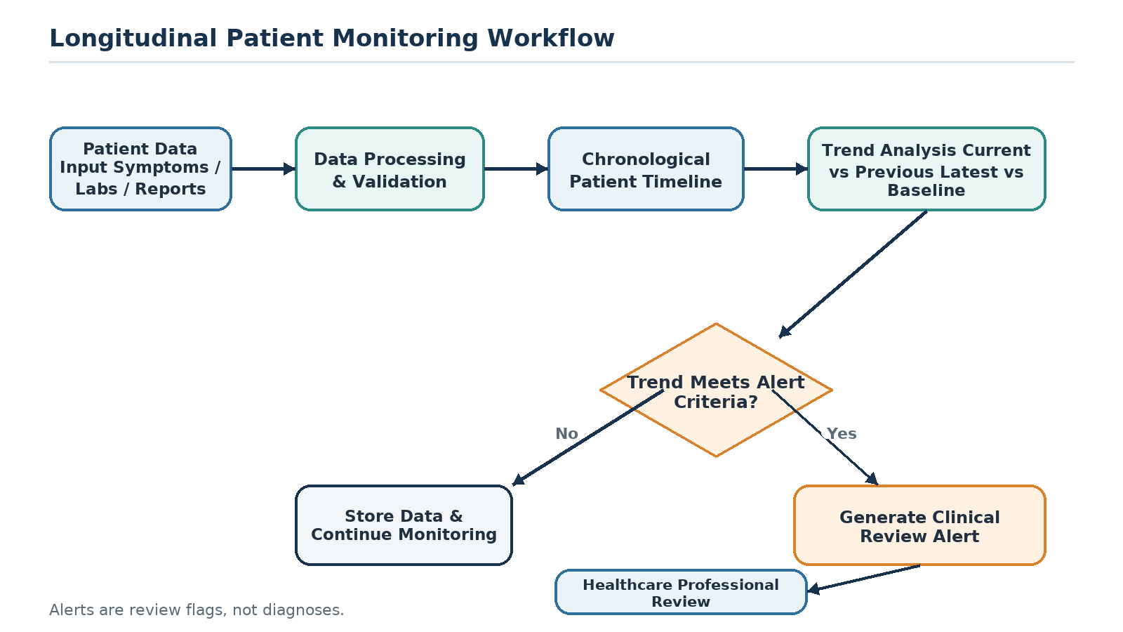
Figure 3. Longitudinal Patient Monitoring Workflow

12. Methodology
The methodology is organized into four phases. The first phase establishes the requirements and data foundation shared by both pipelines. The second and third phases build the evidence-grounded question-answering pipeline and the longitudinal monitoring pipeline described in Objectives 1 and 2. The fourth phase integrates the two pipelines into a single prototype and evaluates the result, corresponding to Objective 3.

12.1 Phase A: Requirement Analysis and Data Foundation
The project begins with a review of the requirements for both pipelines, based on the scope defined in Section 9. Alongside this, the sources that will form the medical knowledge base are identified and collected. These documents are then cleaned and normalized: irrelevant formatting is removed, text is standardized, and documents are prepared for the chunking step described below. This phase supports both Objective 1 and Objective 2, since a clean, well-organized set of source documents and patient data structures is a prerequisite for both pipelines.

12.2 Phase B: Evidence-Grounded Clinical Question Answering (Objective 1)
Collected medical documents are split into smaller chunks so that retrieval can return focused passages rather than whole documents. Each chunk is converted into a vector representation using Sentence Transformers, and the resulting embeddings are stored in a vector database such as FAISS, forming a searchable index of the knowledge base.
When a user submits a clinical question, the query is processed and normalized in the same way and converted into its own embedding. This embedding is compared against the indexed chunk embeddings to retrieve the most semantically relevant passages. If no passage meets a minimum relevance threshold, the system returns a message indicating that there is insufficient supporting evidence rather than generating an unsupported answer.
Where relevant evidence is found, the retrieved passages are assembled into a context window and passed to the LLM along with the original question. The LLM is prompted to generate its answer using only the supplied context, and the response is returned to the user together with the specific passages it was grounded in, so the source of each answer can be checked.

12.3 Phase C: Longitudinal Patient Monitoring (Objective 2)
Authorized users can record a patient's symptoms, including severity and date, laboratory results, including test values and reference ranges, and can upload medical reports and clinical notes. This information is stored against the patient's record and organized chronologically to form a patient timeline.
For numerical values such as laboratory results, the system calculates change relative to the previous recorded value and relative to a baseline value:
Change = Current Value - Previous Value
Long-Term Change = Latest Value - Baseline Value
At the prototype stage, whether a change is flagged for review is decided by a first-pass rule-based approach: a change is flagged when it exceeds a defined threshold for the relevant test or symptom. These thresholds will be set with reference to the literature reviewed for this proposal, for example the trend-based approach used by Morid et al. (2020), and refined during development and testing rather than fixed in advance, since alert design that ignores clinician review burden has been shown to contribute to alert fatigue rather than useful review (Kwan et al., 2020; Ray et al., 2026). More advanced trend-analysis approaches may be incorporated depending on the availability and quality of suitable data. The system does not interpret a trend as a confirmed diagnosis; when a threshold is met, a clinical review alert is generated and made available on the doctor dashboard, and if not, the data point is stored and monitoring continues.

12.4 Phase D: Integration and Evaluation (Objective 3)
The two pipelines are integrated behind a single FastAPI backend, with role-based access separating patient, healthcare professional and administrator functionality, and brought together in the doctor dashboard shown in Figure 1.
Testing is carried out at two levels. Functional testing checks that each module behaves as intended, including authentication, document upload, query handling, timeline construction, and alert generation. Evaluation then assesses the two pipelines against the criteria set out in Objective 3: retrieval quality and response relevance for the question-answering pipeline, for example whether retrieved passages are relevant to the question and whether the generated answer is consistent with them, and monitoring and alert usefulness for the longitudinal pipeline, for example whether flagged trends correspond to changes a reviewer considers worth attention. Where practical, this evaluation will also consider safety-oriented behaviour, such as whether the system correctly withholds an answer when insufficient evidence is retrieved.

13. Technology Stack
The final technologies may be adjusted during implementation according to system requirements, available resources, and evaluation results.
Component | Proposed Technology
Programming Language | Python
Backend | FastAPI
Frontend | React or Streamlit
Database | PostgreSQL
Vector Database | FAISS or a suitable alternative vector database
Embeddings | Sentence Transformers
NLP | Transformers / spaCy
Machine Learning | scikit-learn / PyTorch
LLM | Suitable LLM API or an approved local model
PDF Processing | PyMuPDF
DOCX Processing | python-docx
Authentication | JWT-based authentication
Containerization | Docker
Version Control | Git / GitHub

14. System Architecture
Figure 4 shows the overall architecture, organized into four layers. The Presentation Layer provides separate interfaces for patients, healthcare professionals and administrators. The Application Layer, built with FastAPI, handles authentication and the core business logic, and exposes this functionality through APIs used by the presentation layer. The AI Layer contains the NLP processing, embedding generation, vector search and RAG components that support the question-answering pipeline, alongside the trend detection and alert engine components that support the monitoring pipeline. The Data Layer stores structured patient and application data in PostgreSQL and stores the knowledge-base embeddings in a vector database.

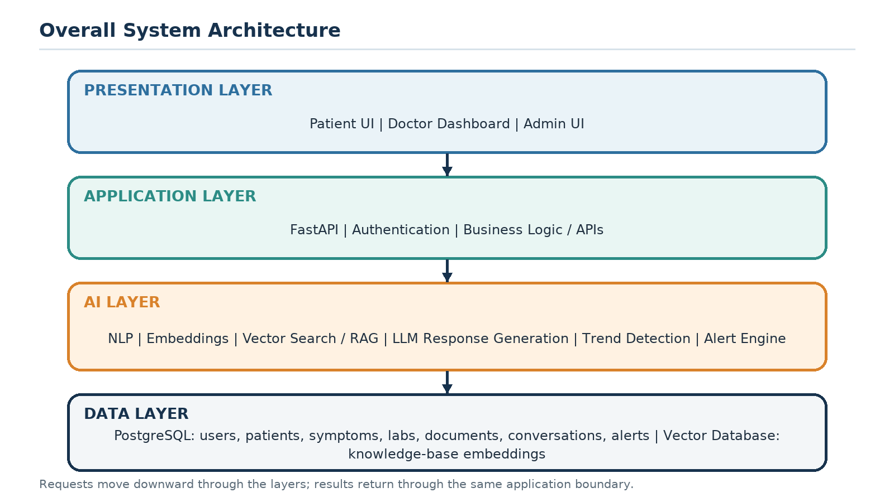
Figure 4. Overall System Architecture
Figure 5 shows how a single piece of information moves through this architecture: an uploaded medical document is followed through preprocessing, chunking, embedding and indexing on one side, and a patient's symptom or laboratory entry is followed through storage and trend analysis on the other, with both paths converging at the doctor dashboard.

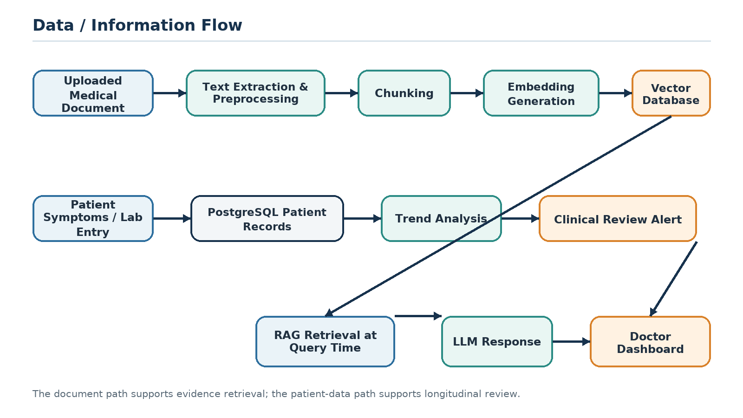
Figure 5. Data / Information Flow

15. Major Functional Modules

Module 1: Authentication
Provides registration, login, authentication, and role-based authorization.

Module 2: Patient Management
Allows authorized users to create and manage patient records.

Module 3: Clinical Chat
Provides the natural-language clinical question-answering interface.

Module 4: Medical Document Processing
Processes uploaded medical documents and extracts relevant text.

Module 5: Knowledge Base
Stores curated medical information used by the retrieval system.

Module 6: RAG Engine
Retrieves relevant medical evidence and supplies it to the LLM.

Module 7: Patient Timeline
Displays patient information chronologically.

Module 8: Trend Detection
Analyzes historical information to identify potentially important changes.

Module 9: Clinical Alert Engine
Generates review flags when predefined criteria are met.

Module 10: Doctor Dashboard
Allows healthcare professionals to review patients, trends, evidence, and alerts.

Module 11: Administrator Dashboard
Provides administrative management functionality.

16. Security and Privacy
Because the system handles potentially sensitive medical information, security and privacy are important design considerations. The system will consider authentication, role-based access control, password hashing, secure API communication, access restrictions, database security, audit information, controlled document access, secure handling of uploaded files, and minimum necessary data exposure. The prototype will be designed to avoid unnecessary exposure of patient information.

17. Limitations
The proposed project has several limitations.
- The accuracy of generated answers depends partly on the quality of the medical knowledge base and retrieved evidence.
- LLM responses may still require professional verification.
- Trend detection depends on the quality, quantity, and consistency of historical patient data.
- Clinical alerts may require validation using appropriate datasets and expert-defined criteria.
- The prototype may not initially integrate with real hospital Electronic Health Record systems.
- Real-world clinical deployment would require additional privacy, security, regulatory, and clinical validation processes.
- The initial trend-detection criteria are expected to be rule-based, for example rate-of-change thresholds, and will require refinement against literature-informed or expert-defined criteria before they could be considered reliable indicators.

18. Ethical Considerations
DocBot AI will be designed as a decision-support and information-support system rather than an autonomous medical decision-maker. The system should clearly communicate its limitations, avoid presenting uncertain information as confirmed fact, display supporting evidence where possible, encourage professional review for clinically significant matters, avoid autonomous diagnosis or treatment recommendations, protect patient information, and maintain appropriate access controls.
Clinical review alerts will be presented as flags for professional attention, not as confirmed medical diagnoses.

19. Expected Outcomes
At the completion of the project, the expected outcome is a working prototype of DocBot AI containing:
- Secure user authentication
- Patient management
- Medical document processing
- Medical knowledge base
- Semantic search
- RAG pipeline
- LLM-based clinical Q&A
- Evidence and source display
- Patient longitudinal timeline
- Symptom tracking
- Laboratory tracking
- Trend detection
- Clinical review alerts
- Doctor dashboard
- Administrator functionality
- Conversation history
- API-based backend
The project will also include testing and evaluation of the major system components.

20. Future Enhancements
Future versions of DocBot AI may include:
- Integration with hospital Electronic Health Records
- Integration with wearable devices
- Real-time health monitoring
- More advanced time-series models
- Multilingual clinical interaction
- Voice-based interaction
- Medical image analysis
- Advanced clinical decision-support features
- Larger validated medical knowledge bases
- Federated or privacy-preserving learning
- Mobile applications
- Advanced analytics dashboards
Any future clinical deployment would require appropriate validation, privacy protection, regulatory review, and professional oversight.

21. Conclusion
DocBot AI is proposed as a prototype that combines two capabilities that the literature has so far treated separately: evidence-grounded clinical question answering through Retrieval-Augmented Generation and Large Language Models, and longitudinal patient monitoring through chronological data organization and trend detection. Neither capability is new on its own. What the project focuses on is bringing them together into a single review-support tool and evaluating whether that combination is genuinely useful to a healthcare professional.
The project is scoped deliberately as an assistance and review-support system. It does not aim to diagnose patients, recommend treatment, or replace a qualified professional's judgement, and the evaluation described under Objective 3 is designed to check retrieval quality, response grounding, and alert usefulness rather than clinical accuracy in a deployed setting. Any future clinical use beyond this prototype would require the additional validation, regulatory review, and professional oversight described in the Limitations and Future Enhancements sections.
Within that scope, the intended contribution of DocBot AI is a working prototype that demonstrates the integration identified in the Research Gap: grounding a clinical answer in retrieved evidence while keeping that answer connected to the specific patient's own history, so that both the answer and any flagged trend can be reviewed by a healthcare professional against the material that produced them.

22. References
The entries below reflect the literature review supplied for this proposal. Full bibliographic details, including complete author lists and confirmed article titles, should be verified against the original publications before final submission.
Basu, A., & Huynh, T. (2026). Systematic review of hallucination mitigation strategies in healthcare AI. BMC Health Services Research. https://doi.org/10.1186/s12913-026-14851-1
Cao, et al. (2026). EHR-RAG: retrieval-augmented generation for longitudinal structured EHR reasoning. arXiv:2601.21340. https://arxiv.org/abs/2601.21340
Kwan, J. L., et al. (2020). Computerised clinical decision support systems and absolute improvements in care: meta-analysis of controlled clinical trials. BMJ, 370, m3216. https://doi.org/10.1136/bmj.m3216
Ledesma, A., et al. (2019). Health Timeline: an insight-based study of a timeline visualization of clinical data. BMC Medical Informatics and Decision Making. https://doi.org/10.1186/s12911-019-0885-x
Lewis, P., et al. (2020). Retrieval-Augmented Generation for Knowledge-Intensive NLP Tasks. arXiv:2005.11401. https://arxiv.org/abs/2005.11401
Low, et al. (2025). Evaluation of RAG and agentic LLM systems for real-world clinical questions. Digital Health. https://doi.org/10.1177/20552076251348850
Morid, M. A., et al. (2020). Temporal pattern detection for adverse-event prediction: application to acute kidney injury. JMIR Medical Informatics. https://doi.org/10.2196/14272
Ray, et al. (2026). Alert fatigue measurement in clinical decision support systems: a systematic review of reviews. JAMIA. https://doi.org/10.1093/jamia/ocag064
Singh, H., et al. (2010). Notification of abnormal laboratory results and timely follow-up in the electronic medical record. American Journal of Medicine. https://doi.org/10.1016/j.amjmed.2009.07.027
Singhal, K., et al. (2023). Large language models encode clinical knowledge. Nature. https://doi.org/10.1038/s41586-023-06291-2
Singhal, K., et al. (2025). Toward expert-level medical question answering with large language models. Nature Medicine. https://doi.org/10.1038/s41591-024-03423-7
Sohn, J., et al. (2025). RAG²: rationale-guided retrieval-augmented generation for biomedical question answering. arXiv:2411.00300. https://arxiv.org/abs/2411.00300
Xie, F., et al. (2022). Deep learning for temporal data representation in electronic health records: a systematic review. Journal of Biomedical Informatics. https://www.sciencedirect.com/science/article/pii/S1532046421003099
Zakka, C., et al. (2024). Almanac: retrieval-augmented language models for clinical medicine. NEJM AI. https://doi.org/10.1056/AIoa2300068
Zhang, et al. (2026). Risk-aware retrieval-augmented medical question answering. JMIR Formative Research. https://doi.org/10.2196/84932

Appendix A: Commercialisation Potential and Feasibility
This appendix preserves the commercialisation and feasibility content from the original proposal. It is included as supporting material rather than as part of the core research proposal.

A.1 Business Problem
Healthcare organizations manage large volumes of patient information. Healthcare professionals may spend significant time searching through reports and historical records. There is also a need for tools that can help users retrieve relevant medical information efficiently while keeping professionals involved in the final review process.

A.2 Proposed Business Solution
DocBot AI could be developed as a healthcare software platform that combines AI-assisted clinical information retrieval, evidence-grounded question answering, patient longitudinal records, trend visualization, and clinical review alerts. The system could be offered to healthcare organizations as a software service or as a customized institutional solution.

A.3 Target Market
- Private hospitals
- Public healthcare organizations
- Private clinics
- Diagnostic laboratories
- Telemedicine platforms
- Medical research organizations
- Healthcare professionals

A.4 Value Proposition
DocBot AI aims to provide healthcare organizations with a platform for retrieving medical evidence and reviewing longitudinal patient information. Potential value includes faster information retrieval, easier access to relevant medical evidence, better organization of historical patient information, identification of potentially important trends, reduced manual searching, and support for professional clinical review.

A.5 Possible Business Models
A subscription model could charge hospitals and clinics on a monthly or annual basis based on the number of healthcare professionals, number of patients, storage requirements, and AI usage. Alternatively, healthcare organizations could purchase an institutional license and deploy the system within their organization. Larger organizations could receive customized enterprise deployments with private infrastructure, customized dashboards, organization-specific knowledge bases, and integration with existing systems. A limited free or trial version could also be offered for evaluation, with advanced features available through paid plans.

A.6 Competitive Differentiation
DocBot AI focuses on combining multiple capabilities within one platform: clinical question answering, medical evidence retrieval, RAG, patient longitudinal memory, trend detection, and clinical review alerts. General-purpose chatbots may provide conversational answers, while electronic health record systems primarily focus on storing and managing patient information. DocBot AI proposes integrating evidence-grounded AI question answering with longitudinal monitoring and professional review support, which is the project's main differentiation.

A.7 Revenue Streams
Potential revenue sources include monthly subscriptions from clinics, annual institutional licensing, enterprise deployment fees, customized healthcare solutions, premium AI usage plans, additional storage and document-processing services, and technical support and maintenance contracts. The actual pricing model would depend on deployment cost, infrastructure requirements, market research, and regulatory considerations.

A.8 Feasibility Analysis
Technical feasibility: the proposed system can be developed using established technologies such as Python, FastAPI, PostgreSQL, vector search, embedding models, and LLM APIs.
Operational feasibility: the system is designed around familiar healthcare workflows such as patient records, medical reports, laboratory results, and professional review.
Economic feasibility: a prototype can initially be developed using open-source frameworks and cloud or API resources where appropriate. Commercial deployment would require further analysis of hosting, security, AI inference, storage, and maintenance costs.
Schedule feasibility: the project can be divided into modules and implemented incrementally:
- Requirements analysis
- System design
- Database development
- Authentication
- Document processing
- RAG implementation
- Clinical chat
- Patient timeline
- Trend detection
- Alert engine
- Dashboard development
- Testing
- Evaluation
- Documentation

