**Test - Testlink and Redmine Integration**

1. **Test suite creation in Testlink.**

**Requirement:** On issue creation, the test suite should be created in TestLink automatically.

**Observation:** Working as expected

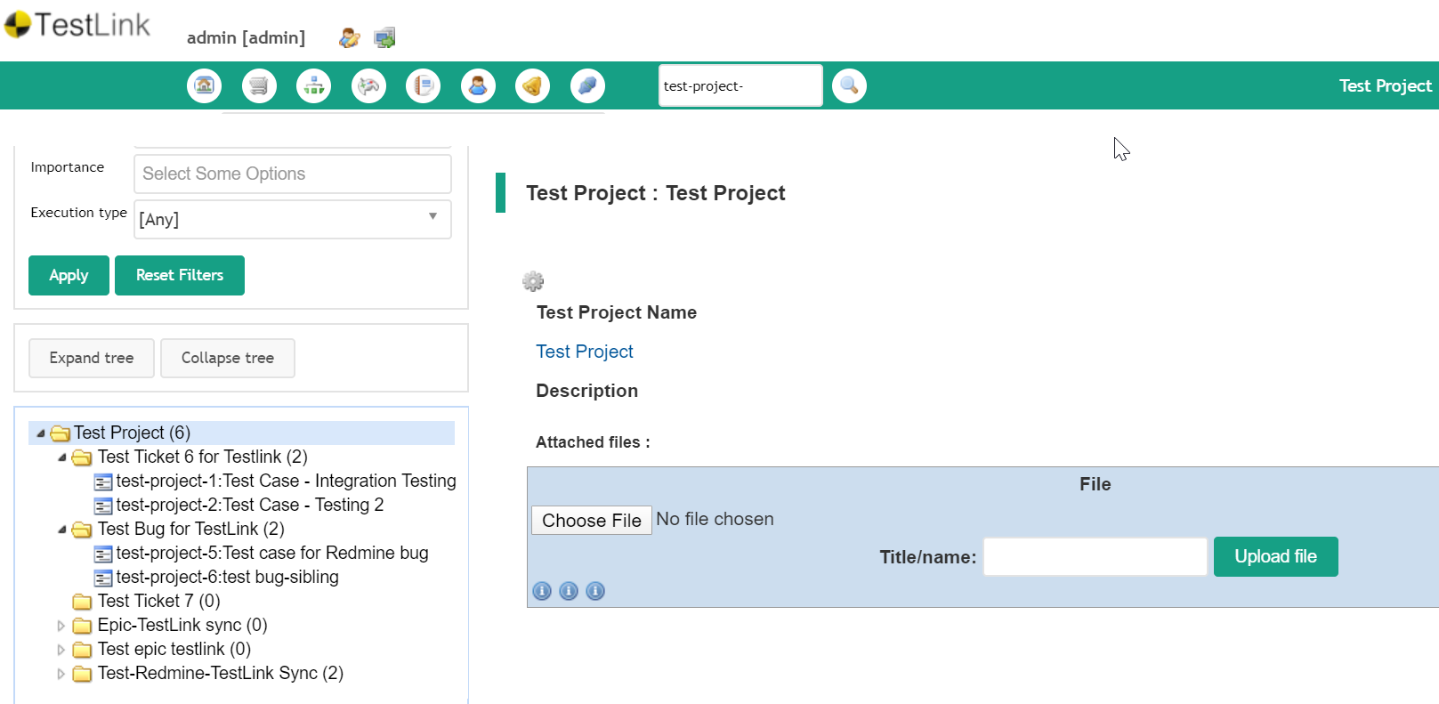

**Requirement:** If project name doesn’t exist, new project and test suite will be created in Testlink automatically.

**Observation: Working as expected**

**Requirement:** If project name matches the Redmine and Testlink (existing project), test suite alone created against the respective project.

**Observation: Working as expected**

1. **Test cases in Redmine**

**Requirement:** Test case ID needs to be displayed in custom fields

**Observation: Working as expected**

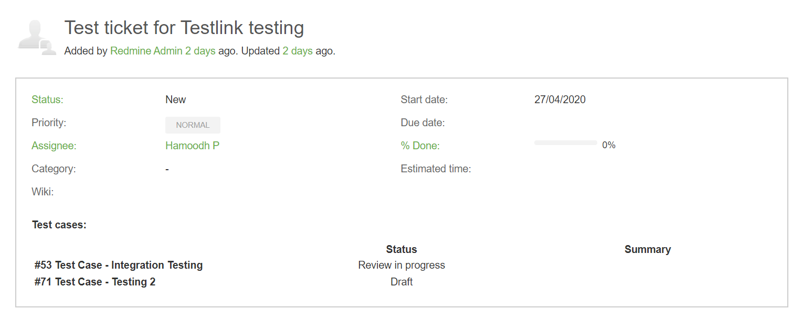

**Requirement:** Test case should be displayed on mouse-over or on-hover or show up link.

**Observation: Functionality is not working as expected.**

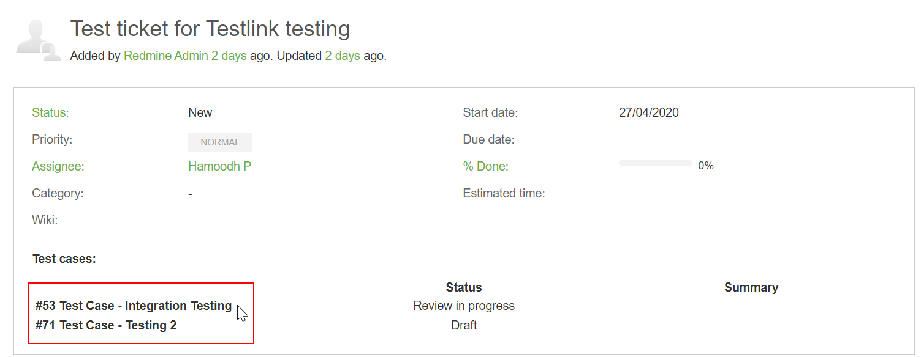

**Requirement:** Test case status need be displayed in Redmine (Status change will be done manually)

**Observation: Working as expected.**

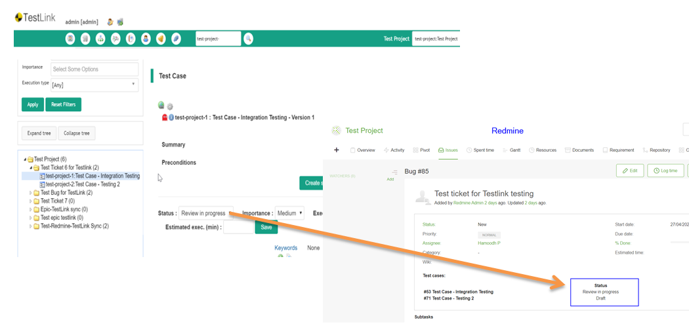

**Requirement:** “Test case execution status” or “Test build status” need to be added in Redmine custom field. (Based on the test build, status will be updated automatically in Testlink).

**Observation: Need to be included.**

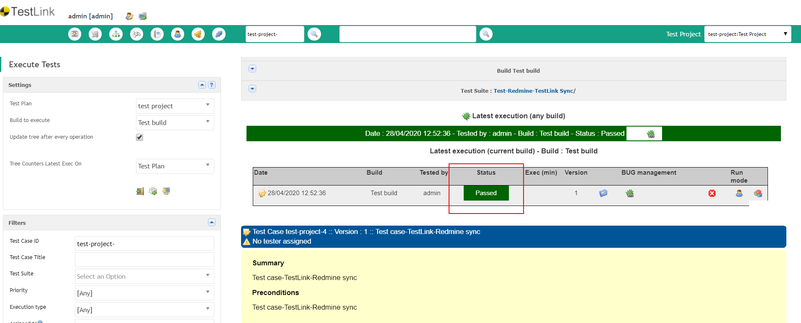

**Requirement:** Test link plugin need to be enabled from allowed projects settings.

**Observation: Working as expected**

