INFORMATION FOR
SOCIAL MEMBERS

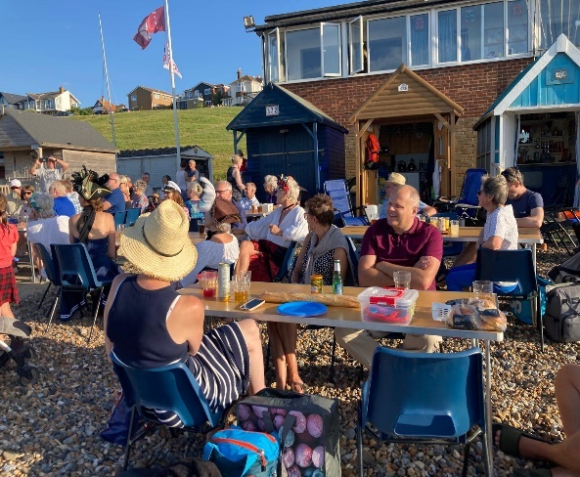

WELCOME AND KEY INFORMATION

We are pleased to welcome you as a social member to Hampton Pier Yacht Club (HPYC)
We pride ourselves on being a welcoming, fun, and inclusive community. Whether you're here to relax, socialise, or get involved in our events and activities, you’ll find a place where everyone is encouraged to feel at home. We’re run by members, for members, which means your ideas, energy, and enthusiasm are always valued. From lively socials to peaceful evenings by the sea, there’s something here for everyone.

See our website https://sailing.myclub.run for more. The latest calendar is at https://sailing.myclub.run/clubs/hpyc/calendars/hpyc2026

To help you settle in, every new member is paired with a Buddy who will

- Help you get the most from your membership

- Be your main contact for questions

- Keep in touch and, where possible, attend events with you

If they can’t be there, they’ll arrange for another Buddy community member to support you.

Make a note of your Buddy’s name and contact details here:

Buddy Name ………………………………………………………………

Telephone number ……………………………………………………….

Email: ………………………………………………………………………

Getting Started
To help you familiarise yourself with the club and its facilities, we recommend:

- Taking a guided tour of the clubhouse, HPYC estate, and receiving a briefing on our Social and Sailing programmes

- Joining the HPYC WhatsApp Training, Support & Social group

- Learning the main door push￼code and obtaining a key (£10 deposit)

- Checking that we have your correct phone number and email address

For updates, contact the Membership Secretary: membership@hpyc.org.uk

Our Facilities

Clubhouse
Members can obtain a key for access to the ground￼floor area, including changing rooms and showers. You will also be given the push￼code for the main entrance door.

Galley
The galley is usually open before and after sailing activities. You’ll often find homemade cakes, snacks, and a selection of hot and cold drinks.
Donations (with an ingredients list) are always welcome.
We also rely on volunteers to help run the galley during sailing days and events

Bar
Our bar opens for social and sailing events,
Members are welcome to bring guests—just please sign them in at the bar.
We’re always happy to have volunteers help out behind the bar, with full training provided.
The club is also available for private hire at an hourly rate, with bar access included (bringing your own drinks isn’t permitted).

Changing Rooms
Changing rooms with toilet and shower facilities are available at all times with access to drinking water

Dogs in the Club House 🐾

- Well‑behaved dogs on a lead are welcome
- Please keep dogs calm and under control at all times
- Dogs should stay away from food preparation and serving areas
- When you’re enjoying food, dogs should relax under the table
- Please don’t allow dogs on seats or tables
- Wet dogs should be kept out of the bar area
- The Club may refuse entry to any dog if needed

How the club runs

HPYC runs on member involvement.
You don’t need sailing experience - just enthusiasm and a little spare time.
Some ways to help are:
- Galley support
- Bar support
- Events
- Safety boat crew (training provided)
- General club tasks

We have two committees keep everything shipshape
- General Management Committee (GMC) oversees day-to-day running of the club
- Sailing Committee manages all sailing, training and racing

GENERAL MANAGEMENT COMMITTEE (GMC)

Commodore - Richard Myers: Leads the club and chairs meetings.

Vice Commodore - Mike Sinden: Responsible for the estate and premises.

Rear Commodore - Karen Jenkins: Manages Sailing duties and sustainability

Honorary Bosun - David Farmer: Boat and equipment maintenance

Honorary Secretary - Ian Morgan: Manages meetings and correspondence.

Honorary Treasurer - Katrina Jordan: Manages club finances.

Honorary Sailing Secretary - Steve Margetts: Oversees sailing, training, racing and the Sailing Committee.

Honorary Membership Secretary - Malcolm Allsopp- Manages membership records and fees.

Additional Officers and responsibilities:

Bar Manager - David Hopkins

Welfare & Safeguarding - Adrian Metcalf

Galley and general support - Gavin Wilson, Rick Tolfrey

Welfare, Safeguarding & Conduct

Everyone at HPYC is expected to:
- Treat others with respect
- Behave fairly and responsibly
- Help create a positive, enjoyable environment
Aggressive or disrespectful behaviour is not acceptable* To view our full safeguarding and welfare policies visit www.hpyc.org.uk/the-clubdocuments

Contact us
Email: Secretary@hpyc.org.uk

Website: https://www.hpyc.org.uk/

