A DEEP STUDY
Coating of Polymers
and Membranes

The science behind every coating, twenty methods with real reaction schemes, membrane-specific design rules, defect troubleshooting, and a one-page Python toolkit at the end.

Inside | What you will find
The science | Wetting, adhesion, film thickness, drying, solvent choice, surface preparation
20 methods | Liquid-applied, reaction-at-the-surface, vapor and plasma. Each with a scheme or process picture, three steps and a plant note
Membrane deep dives | Thin-film composites, gutter layers, hollow-fiber coating, anti-wetting, anti-fouling, solvent-resistant and gas-separation layers
Working tools | Route-finder, defect guide, test methods, scale-up rules, worked numbers
Last page | Python functions for dip, spin, slot-die, LEP, surface energy, solvent distance and defect effects

Contents

1. Start Here
A coating is a thin layer that adds a function to a surface: it can select, seal, repel, protect or resist fouling. On a membrane the layer is often only a few hundred nanometres thick, yet it decides the performance of the whole device.

The big idea
Every coating answers three questions. How do I put the material on (spread)? How does the liquid become a solid (form)? Why does it stay there (adhere)? Each method in this book is a different answer to those three questions.

Five jobs a coating does on a membrane
Job | Typical thickness | Example | What you measure
Selective skin | 50 nm – 2 µm | Polyamide on polysulfone; Pebax on PAN | Permeance and selectivity
Gutter or sealing layer | 0.5 – 5 µm | PDMS under a thin skin, or over defects | Permeability, no defects
Wetting control | 1 nm – 50 µm | HDTMS, PDMS or fluoropolymer on PVDF | Contact angle, liquid entry pressure
Anti-fouling | 5 – 50 nm | Zwitterions, polydopamine, PEG | Flux recovery after fouling
Protection | 10 nm – 10 µm | Crosslinked skin, parylene, ALD alumina | Chemical and solvent resistance
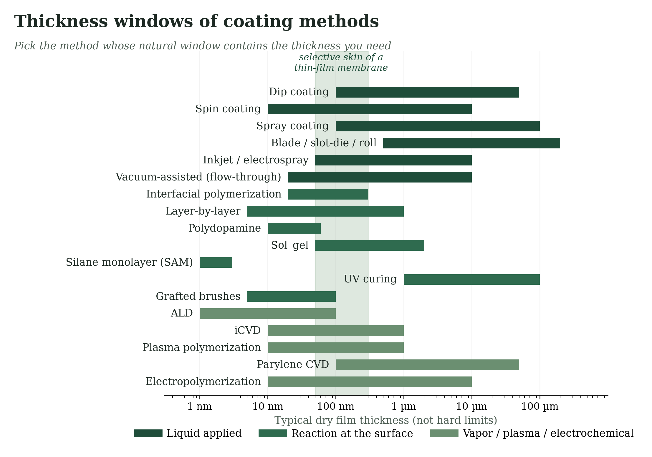
Figure 1 — Typical thickness windows of the coating methods in this book.

Ten numbers worth memorizing
Number | What it tells you
Contact angle < 90° / > 90° | The liquid wets the solid / the liquid beads up
θ > 150° with texture | Superhydrophobic; water rolls off
50–300 nm | Thickness of the selective skin of a thin-film membrane
Dip: h ∝ (ηU)^(2/3) | Doubling speed raises thickness by about 60 %
Spin: h ∝ ω^(−1/2) | Quadrupling spin speed halves thickness
~1 Å per cycle | Growth in atomic layer deposition
2–10 nm per bilayer | Layer-by-layer assembly
10–50 nm | Typical polydopamine film
> 3 bar | Liquid entry pressure goal for contactor fibers
0.01 % bare pores | Enough to cut a skin selectivity of 40 to about 7 (Section 4.2)

2. The Science in Plain Words
Five ideas explain most of what happens in a coating line. Once you can see them, defects stop being mysterious.

2.1 Wetting: will the liquid spread?
Put a drop on a solid and it either spreads or stays as a bead. The balance of three surface tensions sets the contact angle θ (Young's equation). A small angle means the liquid wets the surface; a large angle means it does not.
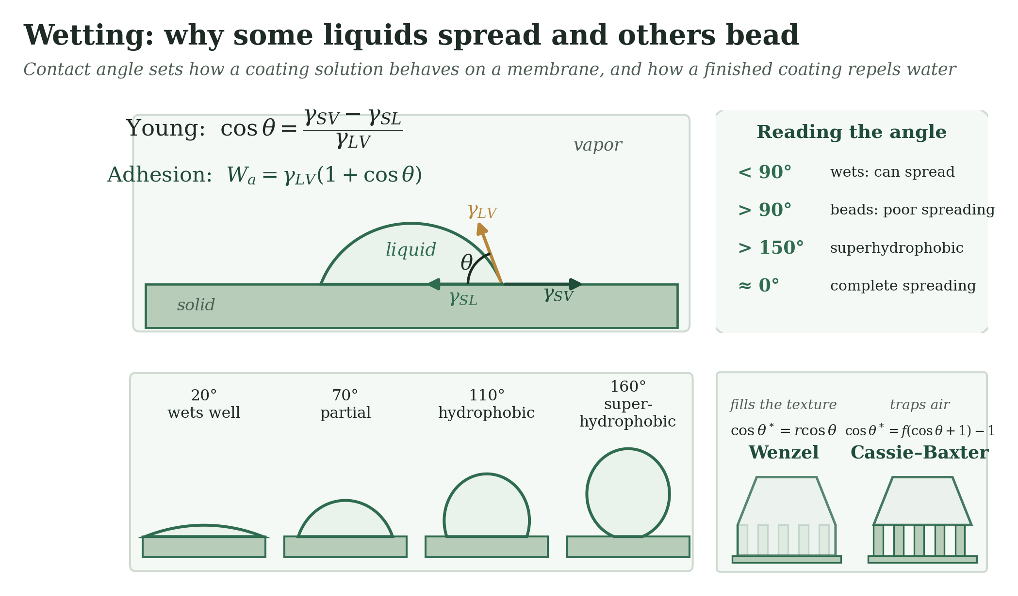
Figure 2 — Contact angle and the balance of surface tensions. Right: texture can trap air and raise the angle.
A coating solution spreads well when its surface tension is lower than the surface energy of the support. That is why water-based coatings bead on PVDF, and why adding ethanol or a surfactant helps. The same rule, reversed, is how you make a finished surface repel water: give it low surface energy and texture.
Surface or liquid | Approximate surface energy or tension (mN/m)
PTFE | 18–20
PDMS | 20–24
PVDF | 25–32
Polypropylene | 29–31
Polystyrene, PMMA | 37–42
Polysulfone, PET, nylon | 41–47
Hexane | 18
Ethanol | 22
Toluene | 28
Water | 72.8
Values are typical literature ranges and vary with measurement method.

2.2 Adhesion: why a coating stays
A coating holds on through some mix of five mechanisms. The strongest are interdiffusion and covalent bonds; the weakest, van der Waals contacts, still add up over a large area. All of them fail if a weak boundary layer (dust, oil, low-molecular-weight material) sits at the interface.
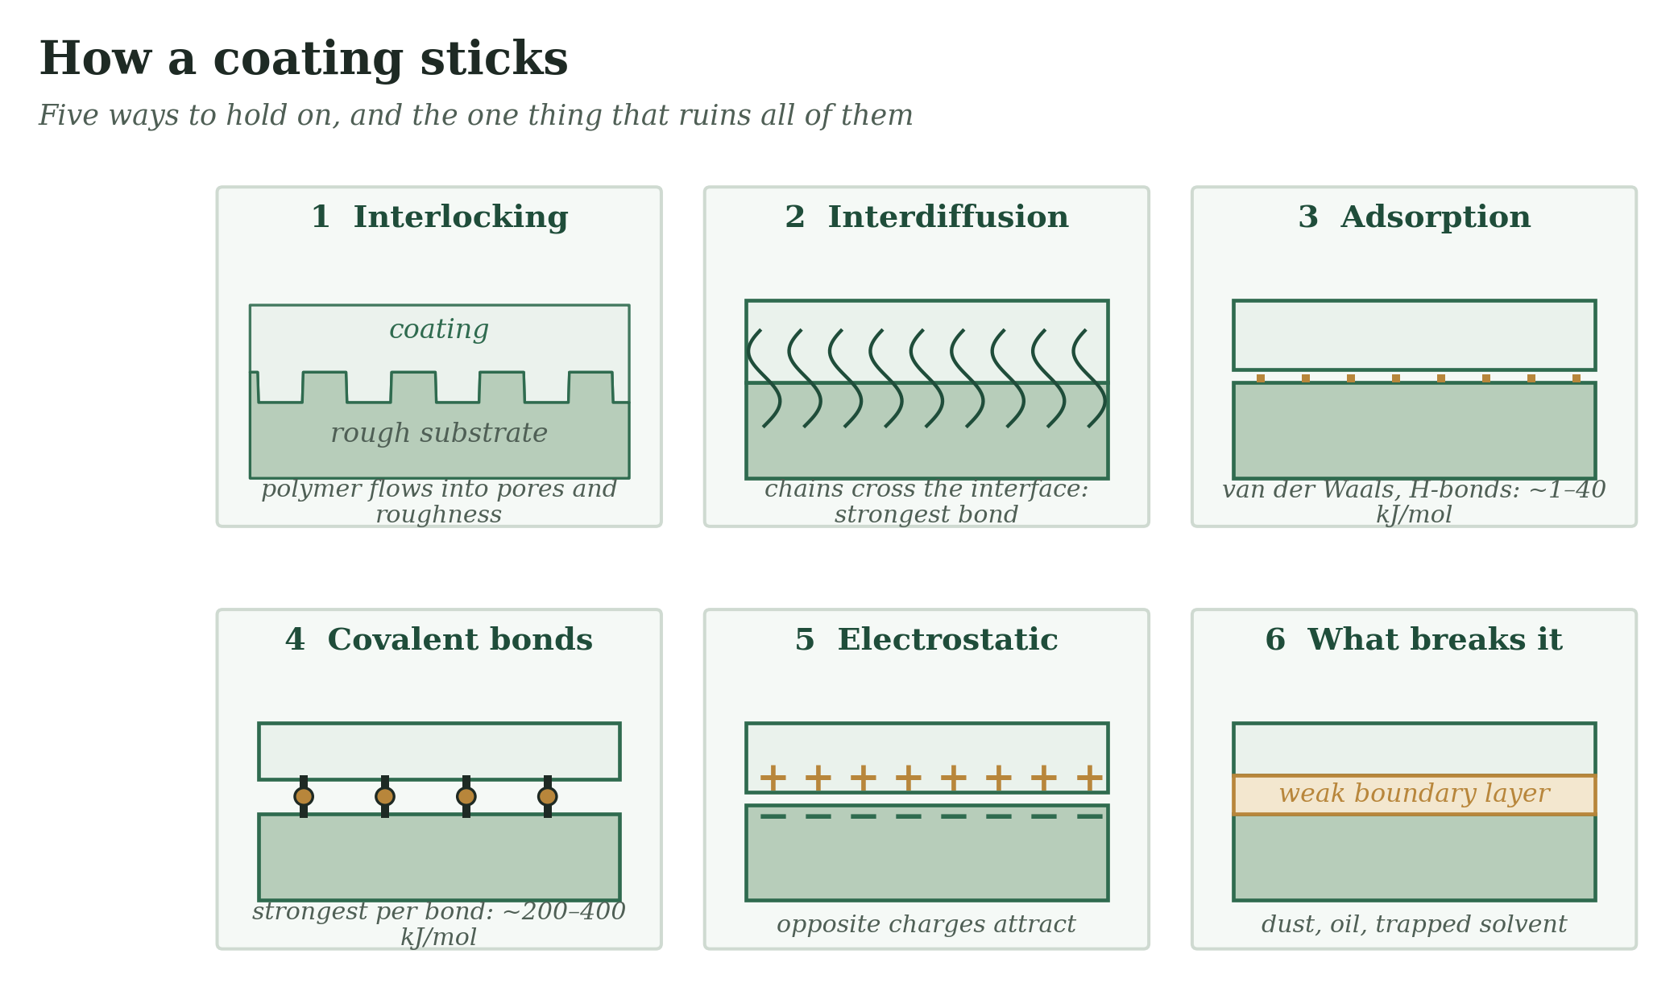
Figure 3 — Five ways a coating holds on, and the weak boundary layer that defeats them.

2.3 Thickness: how much liquid stays?
The wet thickness comes from the application method. Dip coating gives a thickness that grows with speed and viscosity; spin coating gives a thickness that falls with spin speed; blade and slot-die give a thickness set by the gap or by pump rate. Section 3 gives the numbers for each. After drying, the dry thickness is lower than the wet thickness because the solvent leaves:
dry thickness = wet thickness × solids fraction (by weight) × solution density ÷ film density
Example: a 50 µm wet film of a 3 wt % solution (900 kg/m³) of a polymer with density 1100 kg/m³ dries to about 1.2 µm.

2.4 Drying: how liquid becomes film
Drying is where most coatings go wrong. The Péclet number compares how fast the surface moves down (evaporation) with how fast the polymer diffuses away from it. When evaporation is slow, the film dries evenly. When it is fast, polymer piles up at the surface and forms a skin that traps solvent. At a pinned edge, liquid flows outward and carries polymer to the rim, which leaves a coffee ring.
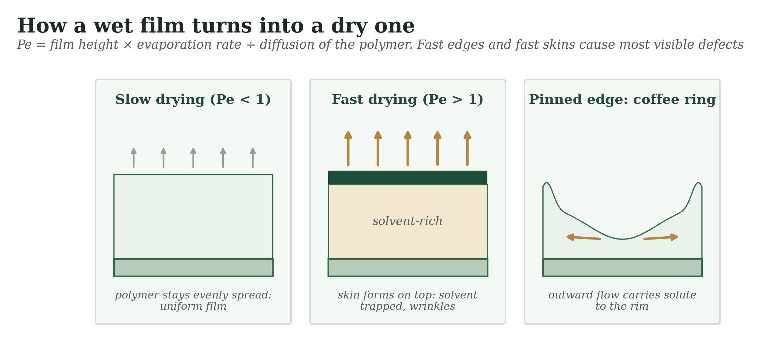
Figure 4 — Three drying behaviours: uniform, skin-forming, and edge-pinned.
Surface-tension differences also drive flow (Marangoni effect). If one spot dries faster, its surface tension rises, and liquid is pulled toward it. That is the origin of orange peel and of hexagonal cell patterns. Mixed solvents, with a slower-evaporating component, calm this effect.

2.5 Choosing the coating solvent
The coating solvent has two jobs: dissolve the coating polymer, and leave the support alone. Hansen solubility parameters make this a number: each material has a dispersion (δD), a polar (δP) and a hydrogen-bonding (δH) component, and the distance Ra between two materials tells you how alike they are. Small Ra means they mix; large Ra means they do not.
Ra² = 4 (δD₁ − δD₂)² + (δP₁ − δP₂)² + (δH₁ − δH₂)²
Solvent | δD | δP | δH | Ra to PVDF | Meaning for PVDF
NMP | 18 | 12.3 | 7.2 | 2.6 | dissolves or swells
DMF | 17.4 | 13.7 | 11.3 | 2.5 | dissolves or swells
Toluene | 18 | 1.4 | 2 | 13.3 | leaves it alone
Ethanol | 15.8 | 8.8 | 19.4 | 11.2 | leaves it alone
Hexane | 14.9 | 0 | 0 | 16.2 | leaves it alone
Water | 15.5 | 16 | 42.3 | 33.5 | leaves it alone
PVDF parameters (17.2, 12.5, 9.2) and solvent values from Hansen's handbook; exact values vary by source and the thresholds are rules of thumb.
Use this to design coatings on polymers. Hexane (Ra 16 to PVDF) is a safe carrier for PDMS on a PVDF fiber. Ethanol/water (Ra 11 or more) can carry Pebax onto polysulfone. NMP or DMF (Ra < 3) would dissolve or swell the PVDF itself, so they must not be used to coat it.

2.6 Preparing the surface
Most failed coatings were applied to a surface that was not ready. Clean it, then activate it. Plasma, UV–ozone and corona add oxygen groups that raise surface energy and give the coating something to bond to. For fluoropolymers such as PVDF, a mild base removes HF and creates reactive C=C sites. A primer such as polydopamine or a silane can connect two materials that otherwise would not stick.
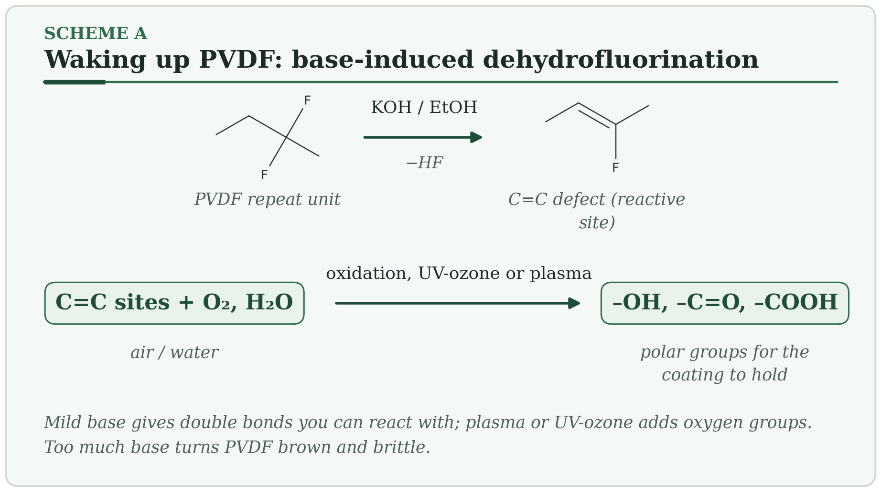
Treatment | What it does | Watch out
Solvent wash and drying | Removes oils and dust | Solvent must not swell the support
Plasma or corona | Adds –OH, –COOH, –C=O; roughens at the nanometre scale | Effect fades in hours to days (hydrophobic recovery); coat soon
UV–ozone | Oxidizes organic contamination and adds oxygen groups | Can embrittle thin polymer layers
Mild alkaline treatment | Dehydrofluorination of PVDF; surface –OH | Over-treatment browns and weakens the polymer
Primer (PDA, silane, polyelectrolyte) | Bridges unlike materials | Adds a layer; check pore blocking

3. Twenty Coating Methods
The methods fall into three families. Liquid-applied methods put a measured amount of liquid on the surface and then dry or cure it. Reaction-at-the-surface methods build the film by chemistry that happens where you want the layer. Vapor, plasma and electrochemical methods grow the film from a gas or from an electrode.

Family A: Liquid-applied methods
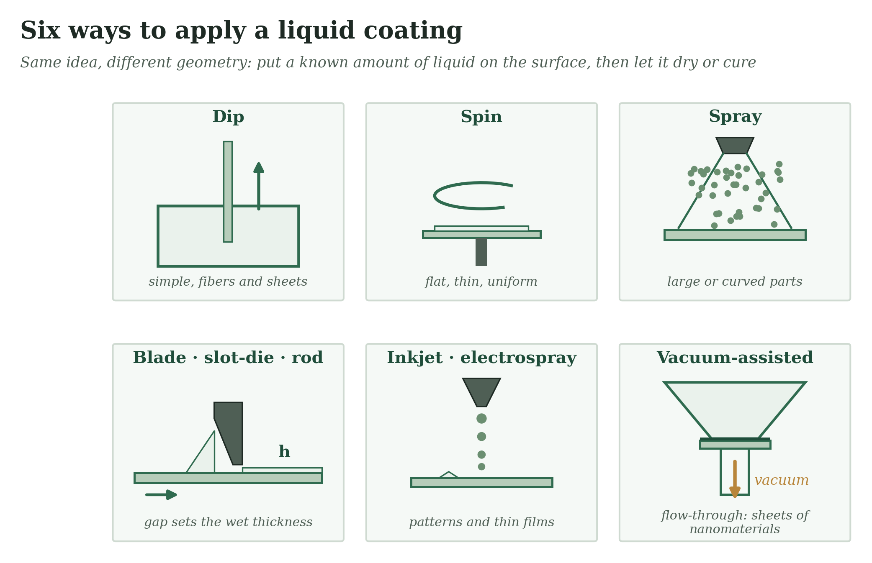
Figure 5 — Six ways to apply a liquid coating.

3.1 Dip Coating Liquid applied
Dip the part into the solution, pull it out at a steady speed, and a liquid film stays behind.
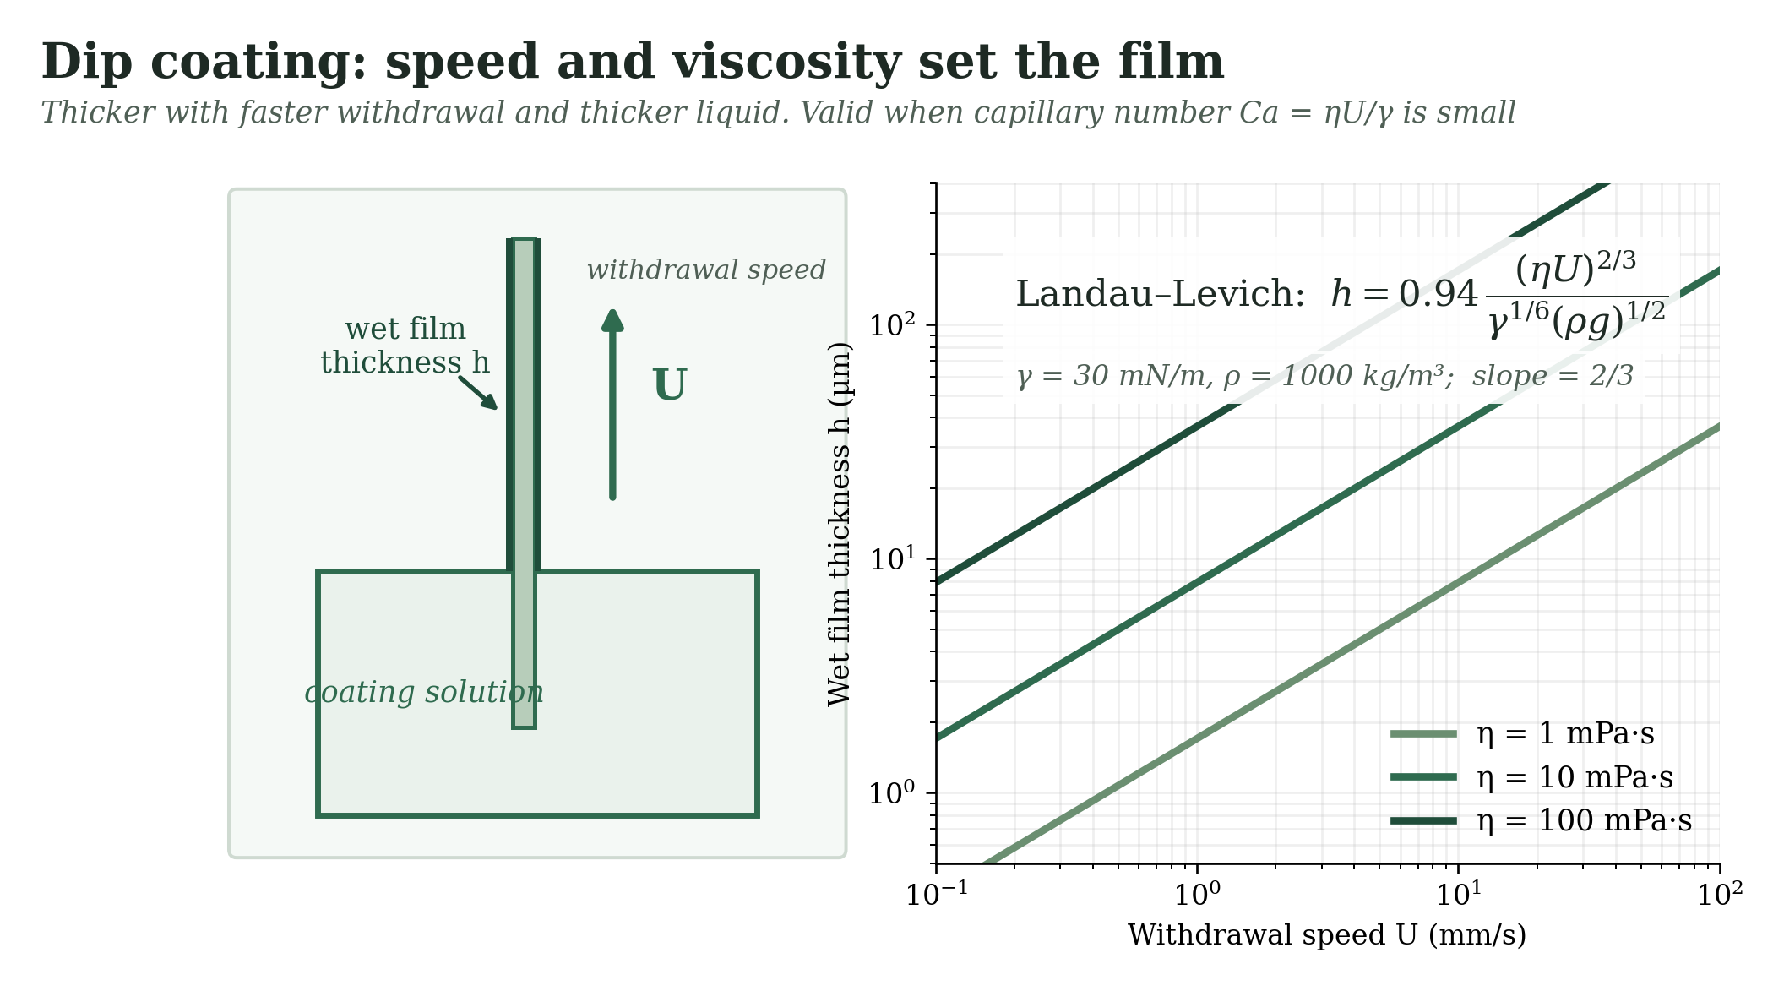
Figure 6 — Dip coating: how withdrawal speed and viscosity set the wet film (Landau–Levich law).
HOW IT WORKS
- The part is immersed and then withdrawn at speed U. The moving surface drags a layer of liquid up with it.
- Viscous drag pulls liquid up while gravity and surface tension pull it back. The balance gives the Landau–Levich result: thickness grows as (viscosity × speed) to the power ⅔.
- Solvent leaves or the film cures. Dry thickness = wet thickness × solids fraction × (solution density ÷ film density).
Typical conditions. Withdrawal speed about 0.1–100 mm/s · wet film about 1–100 µm · flat sheets, tubes and fibers · valid when the capillary number Ca = ηU/γ is small.
Why membranes care. The standard way to put a PDMS or Pebax layer on a flat sheet or a hollow fiber, and to seal small defects. Thick, viscous solutions stay on top of the support; thin, runny ones soak into the pores.
Watch out. At very low speed the film gets thicker again, because evaporation starts to dominate. At high speed the film can ripple. Vibration makes horizontal stripes.
PLANT NOTE | Hold bath level and temperature constant and isolate the bath from vibration. A few degrees of temperature drift changes viscosity, and so thickness.

3.2 Spin Coating Liquid applied
Put a drop in the centre, spin the disc, and centrifugal force spreads and thins the film.
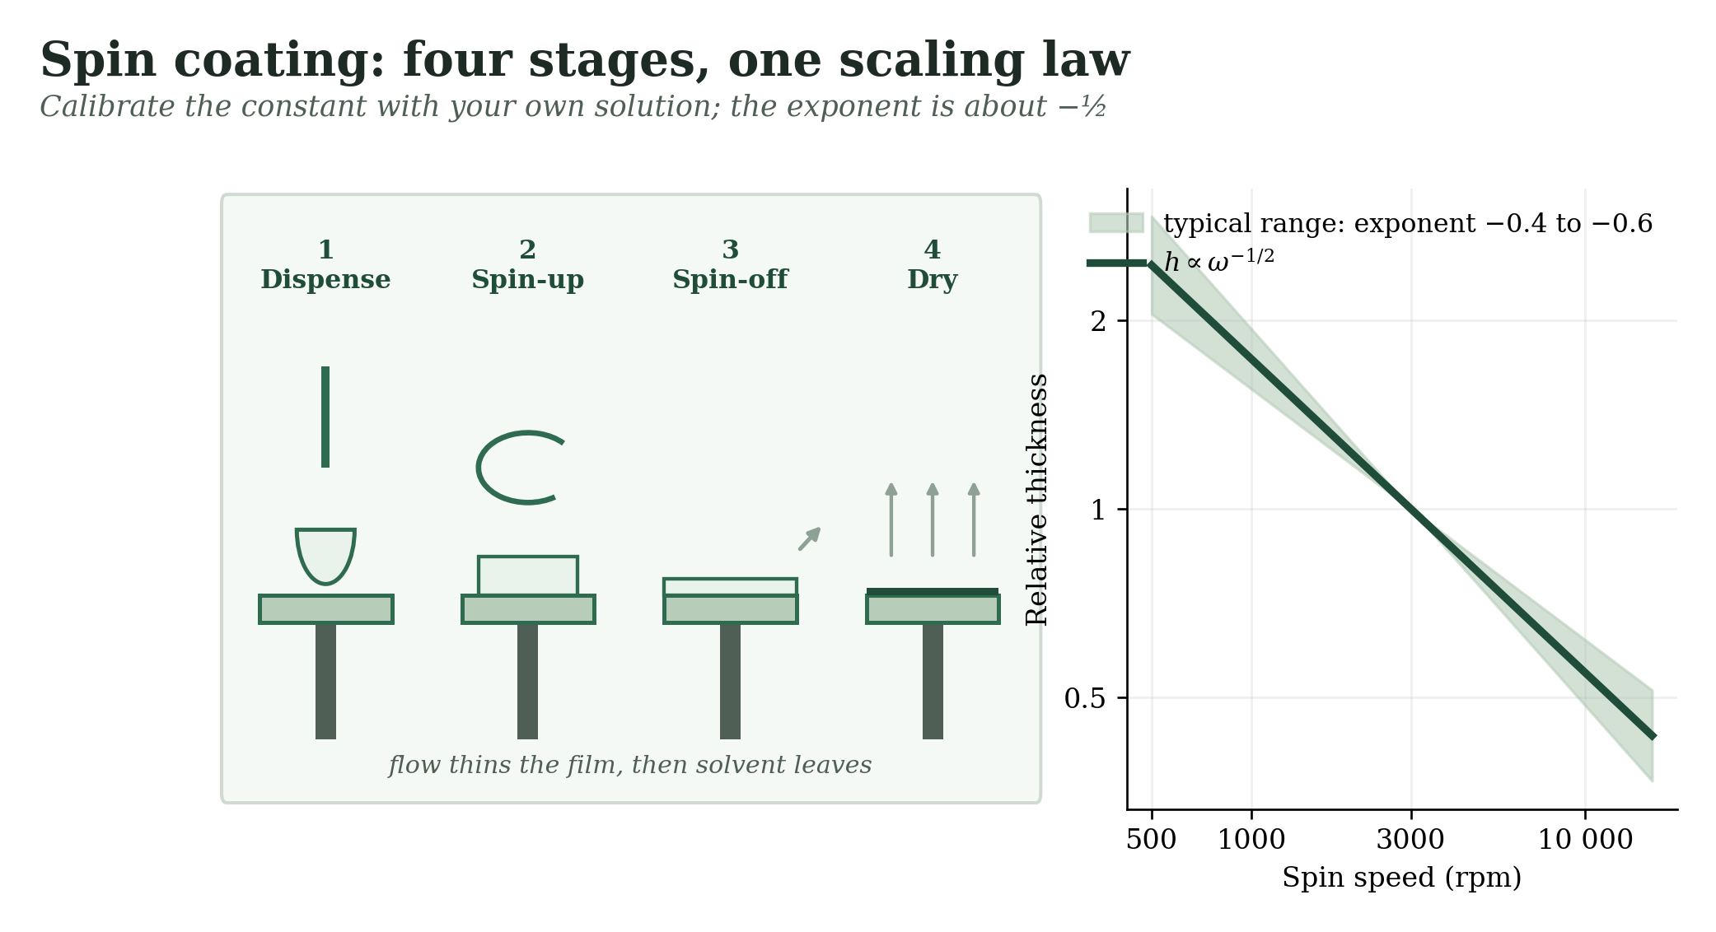
Figure 7 — Spin coating: the four stages and how thickness falls with spin speed.
HOW IT WORKS
- Dispense the solution on the centre of the substrate.
- Spin-up: the liquid flows outward and most of it leaves over the edge.
- Evaporation raises the viscosity until flow stops. The final thickness scales roughly as spin speed to the power −½.
Typical conditions. 500–10 000 rpm · dry film about 10 nm–10 µm · flat samples, coupon to wafer size.
Why membranes care. A laboratory favourite for testing a new selective polymer on a flat porous support. Very uniform films, but most solution is wasted and it does not scale to fibers or rolls.
Watch out. A porous support soaks up the drop: pre-wet it with a non-solvent or use a sacrificial layer. Edges show a thicker bead. The result depends on how fast the solvent evaporates, not only on rpm.
PLANT NOTE | Use spin coating to screen materials, then rebuild the thickness calibration on dip or slot-die equipment. The numbers will not carry over.

3.3 Spray Coating Liquid applied
Break the liquid into tiny droplets and let them land on the surface.
HOW IT WORKS
- Atomize: air pressure, ultrasound or an electric field makes droplets of about 1–50 µm.
- The droplets land, spread and merge; heat or air flow dries them.
- Repeated passes build up thickness.
Typical conditions. Droplets 1–50 µm · dry film about 0.1–100 µm · any shape of part · coverage set by the number of passes.
Why membranes care. Large flat membranes, nanoparticle top layers (for example silica for a superhydrophobic surface) and quick protective coats. Ultrasonic spray is gentle enough for fragile layers.
Watch out. Droplets dry before they land if the nozzle is too far or too hot. Overspray wastes material and is a respiratory and fire risk. Small ring marks form at droplet edges.
PLANT NOTE | Fix nozzle height, speed and flow, and overlap passes by about half the spray width.

3.4 Blade, Rod, Slot-Die and Roll Coating Liquid applied
The gap sets the thickness: push a fixed amount of liquid through a fixed gap over a moving surface.
HOW IT WORKS
- Blade or rod: a fixed gap above the moving support scrapes the liquid to a set height.
- Slot-die: a pump feeds liquid through a slit at flow rate Q. Wet thickness = Q ÷ (width × line speed).
- A controlled oven removes solvent, or a lamp or heater cures the film.
Typical conditions. Wet film about 1–500 µm · line speed from cm/min (lab) to tens of m/min · viscosity from about 1 to thousands of mPa·s.
Why membranes care. The industrial route for flat-sheet composite membranes: polymer solutions on UF supports for gas separation, and the casting step in phase inversion.
Watch out. Slot-dies have a coating window: too much vacuum or too little flow gives ribs and air bubbles. Support roughness and porosity change the effective gap.
PLANT NOTE | For pre-metered slot-die, 10 mL/min over a 0.2 m width at 1 m/min gives 50 µm wet.

3.5 Inkjet and Electrospray Liquid applied
Print or spray tiny, controlled droplets exactly where you want them.
HOW IT WORKS
- Inkjet: a piezo pulse ejects one picolitre droplet at a time.
- Electrospray: a voltage pulls a charged jet from a cone and breaks it into very fine droplets.
- Droplets merge and dry; layers can be patterned or built up.
Typical conditions. Droplets 1–50 µm (inkjet) to sub-µm (electrospray) · film about 50 nm–10 µm · low solids content.
Why membranes care. Patterned catalytic or sensing layers, thin selective layers that use little material, and nanoparticle coatings on membranes.
Watch out. Nozzles clog. The ink needs the right viscosity and surface tension. Coffee-ring marks appear if the drying is not tuned. Throughput is low.
PLANT NOTE | Filter every ink (about 0.45 µm) before it goes near a nozzle.

3.6 Vacuum-Assisted (Flow-Through) Coating Liquid applied
Pull a suspension through the membrane, and the particles stack up on the surface.
HOW IT WORKS
- Place a dilute suspension of nanosheets or particles above the porous support.
- Apply vacuum or pressure: the liquid passes through and the solid is retained.
- Dry the layer and, if needed, crosslink or press it.
Typical conditions. Layer about 20 nm–10 µm · very dilute suspensions · thickness proportional to mass filtered per area.
Why membranes care. The usual route for graphene oxide, MXene, MOF and nanofiber layers. Thickness is simply the mass you filter divided by the area.
Watch out. Particles can enter large pores. Layers can swell and peel in water. Stacking defects usually decide the selectivity.
PLANT NOTE | Set thickness by filtered mass per area, not by time.

Family B: Reaction at the surface

3.7 Interfacial Polymerization Reaction at the surface
Two reactants that cannot mix meet at the boundary between water and oil, and the film forms right there.
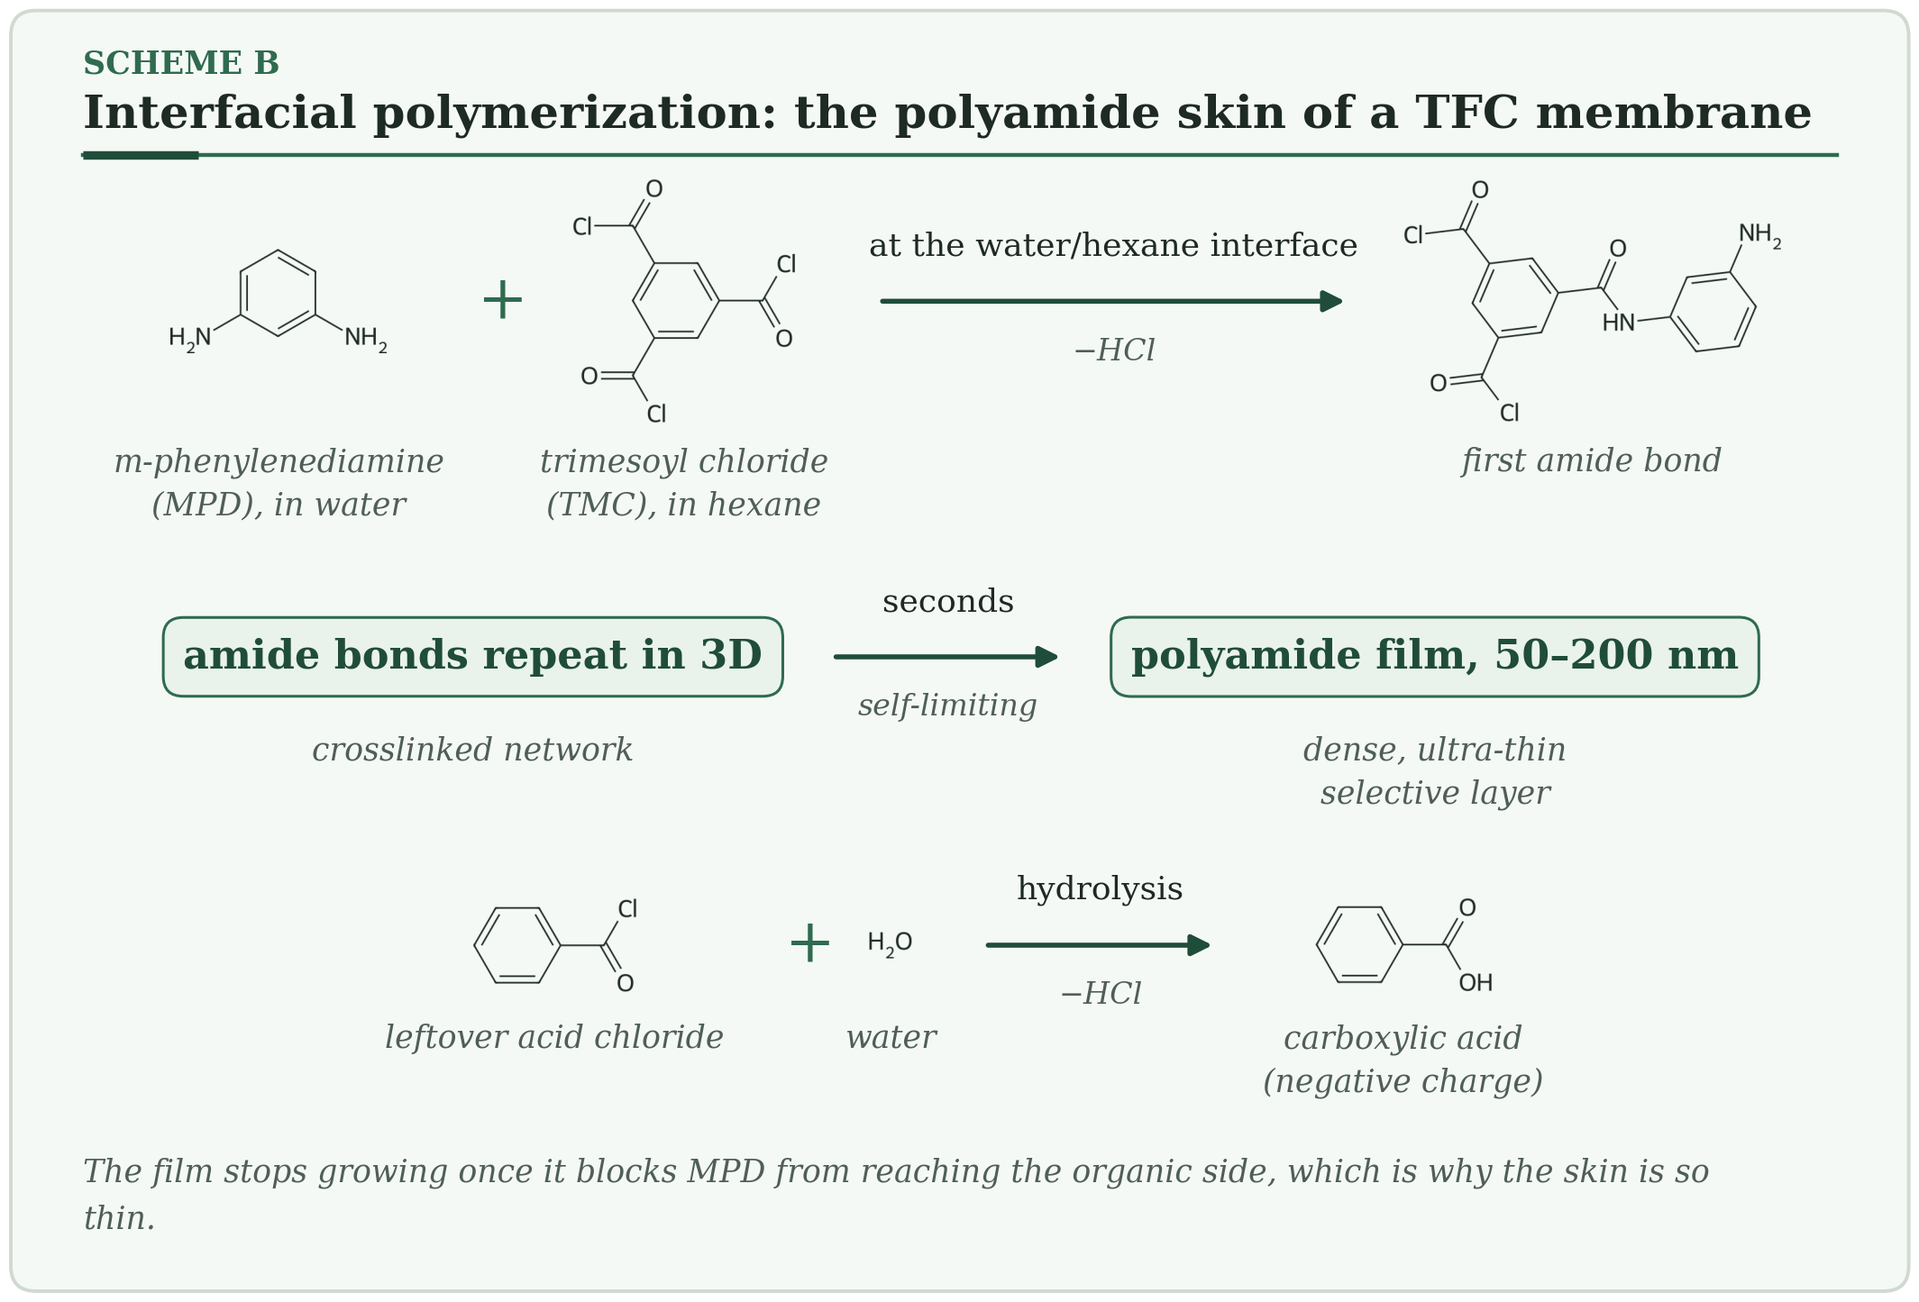
HOW IT WORKS
- A support soaked with water-soluble diamine (MPD, about 2 wt %) is brought into contact with an acid chloride (TMC, about 0.1 wt % in hexane).
- At the interface the amine and acid chloride form amide bonds within seconds and release HCl.
- The growing film blocks MPD from reaching the oil side, so growth stops at about 50–200 nm. Leftover acid chloride groups hydrolyze to carboxylic acids, which carry negative charge.
Typical conditions. MPD 1–3 wt % in water · TMC 0.05–0.2 wt % in alkane · contact 10–60 s · cure about 60–90 °C · film about 50–200 nm.
Why membranes care. The selective skin of nearly all commercial RO and NF membranes. Monomer ratio, additives and rinse conditions tune charge, roughness and permeability.
Watch out. Remove the excess aqueous solution before adding the organic phase (air knife or roller), or droplets cause nodules. Chlorine attacks the amide N–H and degrades the film. Residual HCl and monomers need washing out.
PLANT NOTE | Control how much aqueous solution stays on the support. It sets how much MPD is available, and therefore the skin thickness.

3.8 Polydopamine and Catecholamine Coatings Reaction at the surface
Dopamine oxidizes in mild base and sticks to nearly anything, forming a thin brown film.
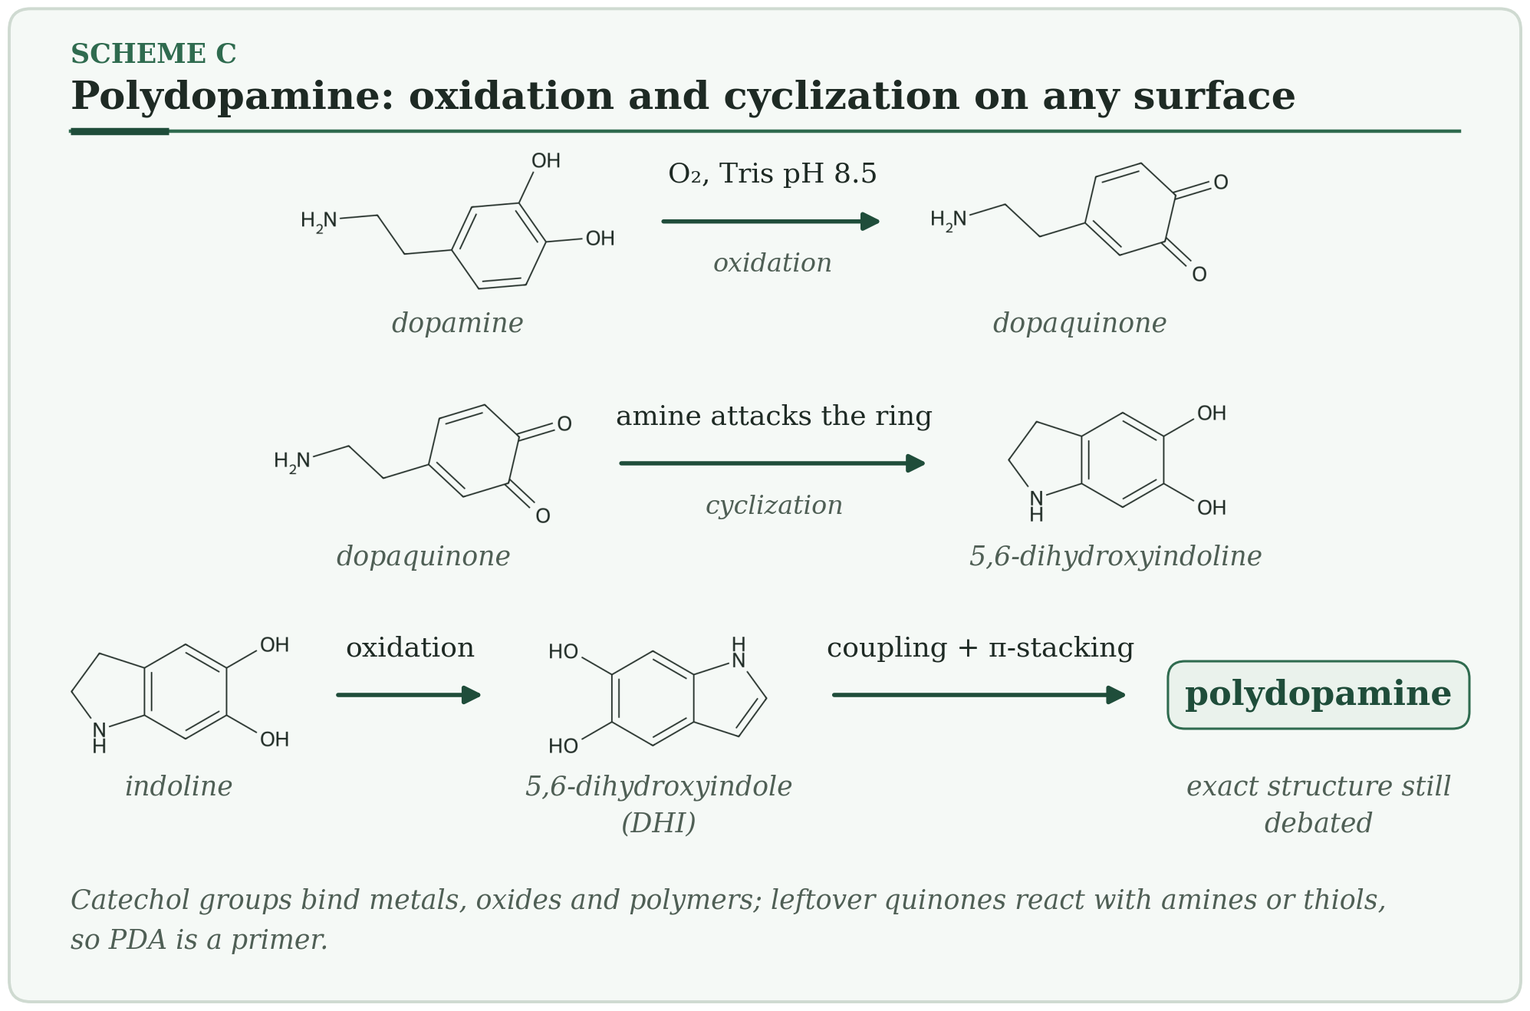
HOW IT WORKS
- Dopamine (about 2 g/L) in pH 8.5 Tris buffer is oxidized by dissolved oxygen to dopaquinone.
- Dopaquinone cyclizes and is oxidized to 5,6-dihydroxyindole (DHI).
- Oligomers, joined by covalent bonds and π-stacking, deposit as a film. Remaining quinones can react with amines and thiols, so you can build on top.
Typical conditions. Room temperature · 2–24 h · pH 8–8.5 · film about 10–50 nm · works on polymers, metals, oxides and ceramics.
Why membranes care. A universal primer: it makes PVDF or PSf wettable, and anchors other layers (PEI co-deposition, silver nanoparticles, zwitterions, silanes). It improves hydrophilicity and fouling resistance.
Watch out. The film keeps growing with time and can narrow pores. Its exact structure is still debated. It is brown, which matters for appearance. Reproducibility depends on oxygen supply and pH.
PLANT NOTE | Fix pH, oxygen supply (stirring, air) and time, and measure thickness on a reference wafer in every batch.

3.9 Layer-by-Layer Assembly Reaction at the surface
Alternate dips in a positive and a negative polymer, and each dip adds one thin, charged layer.
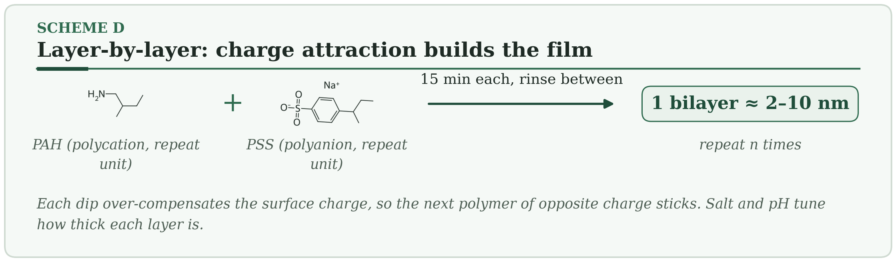
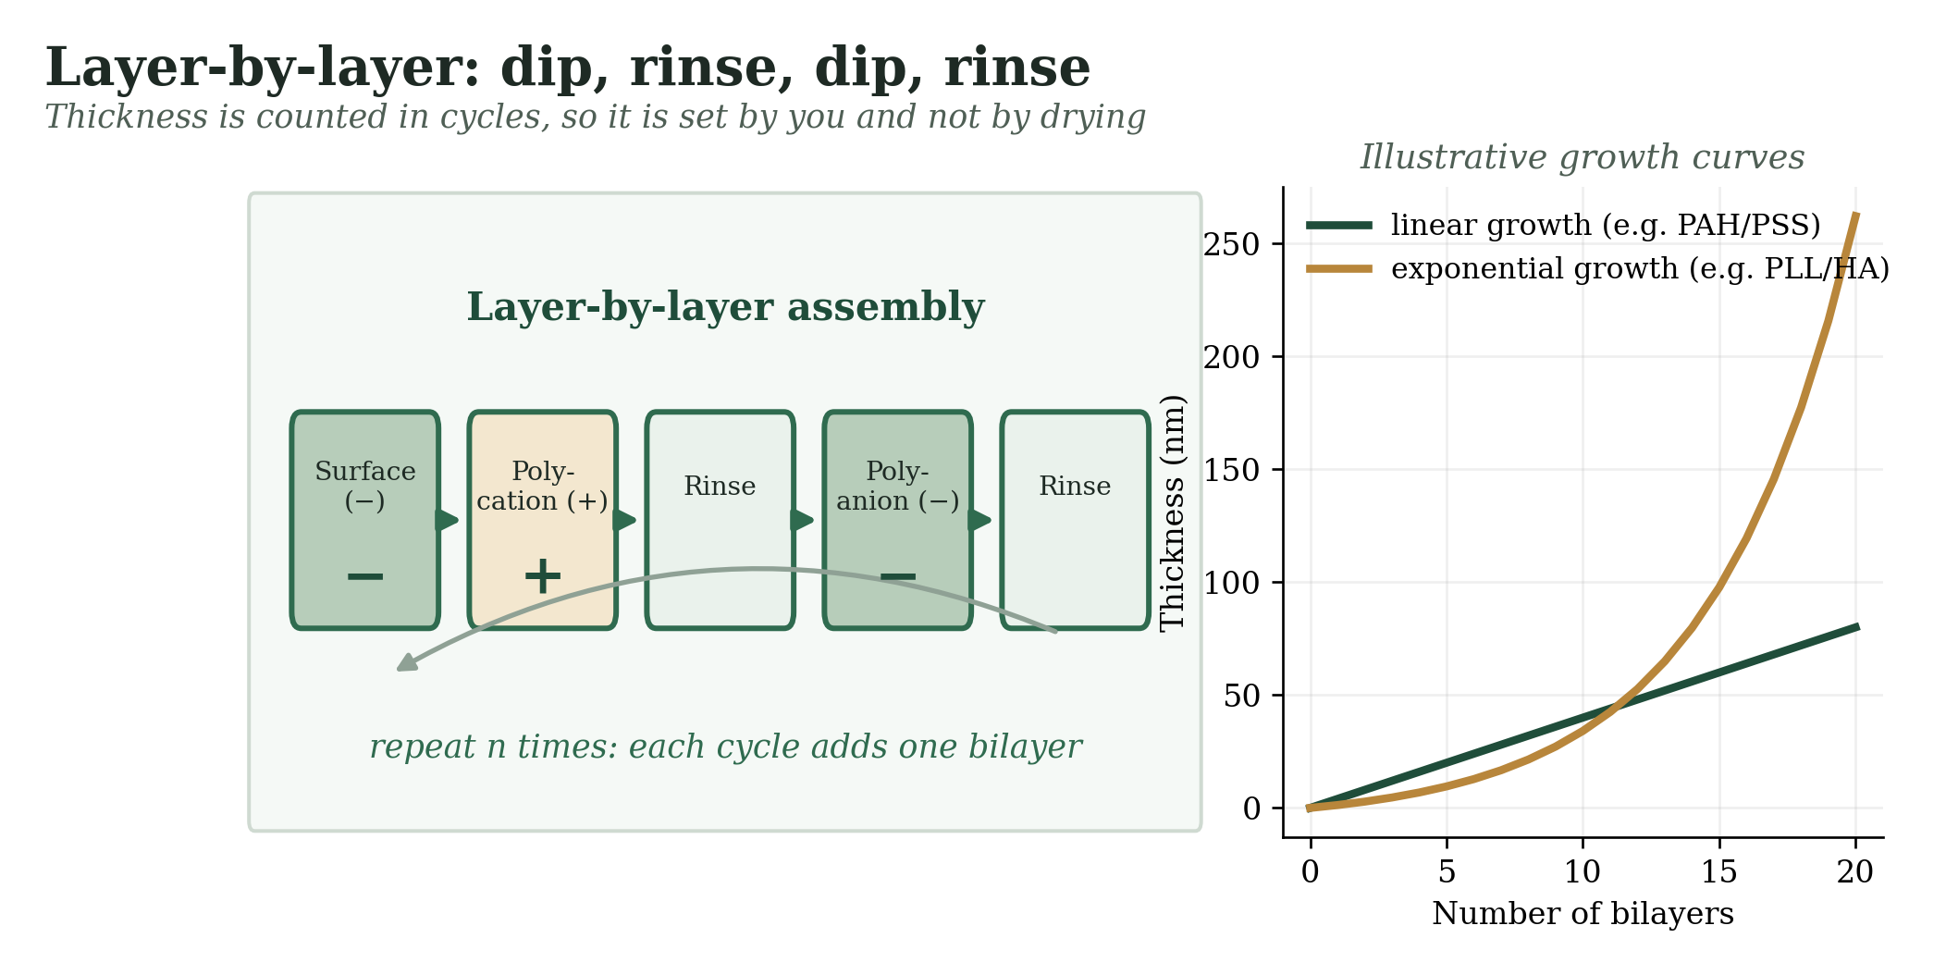
Figure 8 — Layer-by-layer assembly: the dip cycle and typical growth curves.
HOW IT WORKS
- A charged surface adsorbs a polymer of opposite charge, and slightly overcompensates the surface charge.
- Rinse to remove loosely bound chains.
- Dip in the oppositely charged polymer and repeat. Thickness = number of bilayers × thickness per bilayer.
Typical conditions. Polymer 0.1–1 g/L · dip 5–20 min with rinses · about 1–10 nm per bilayer, depending on salt and pH.
Why membranes care. Nanofiltration and pervaporation skins with tunable charge, plus anti-fouling and antibacterial layers. One of the few ways to build a tight skin without organic solvents.
Watch out. Many cycles are slow. Defect density depends on the roughness of the support. Films can be unstable at extreme pH or salt.
PLANT NOTE | Automate the dipping; manual handling is the main source of batch variation.

3.10 Sol–Gel and Silica Coatings Reaction at the surface
Liquid silicon–oxygen precursors turn into a solid, glass-like network at close to room temperature.
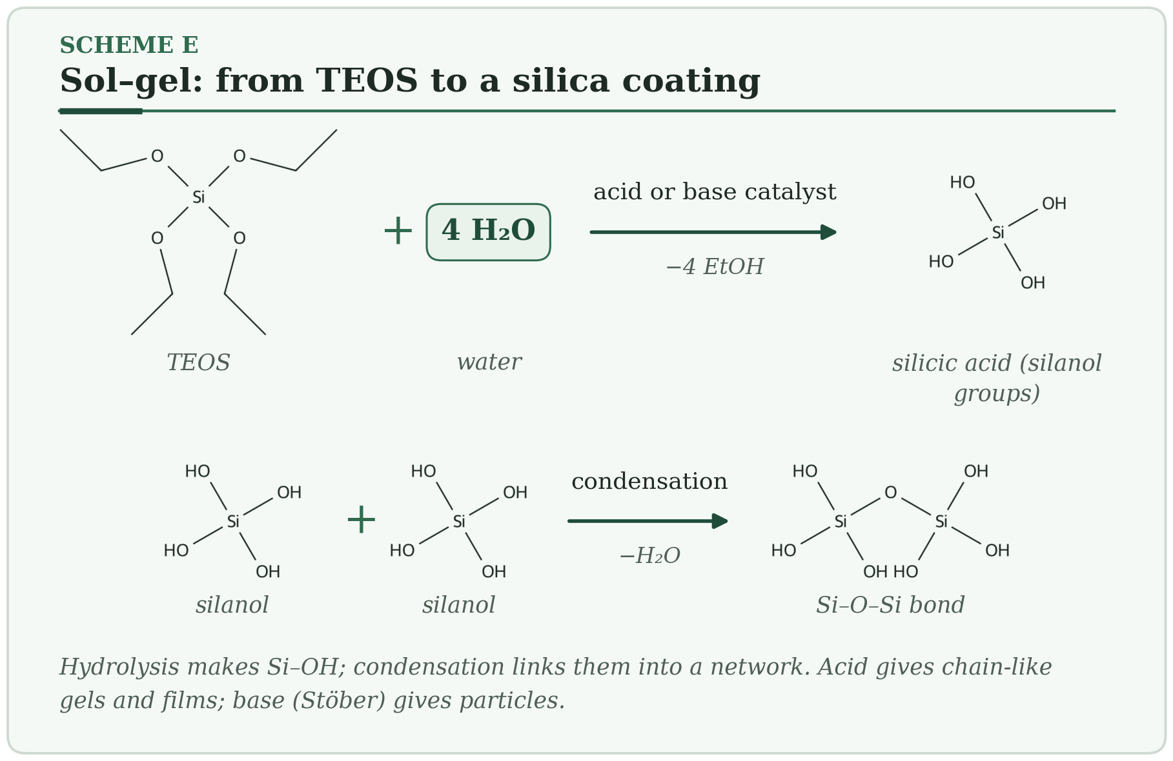
HOW IT WORKS
- A precursor such as TEOS is hydrolyzed by water to silanols (Si–OH).
- Silanols condense and form Si–O–Si bonds, which grow into a network.
- Drying and mild heat remove solvent and strengthen the film.
Typical conditions. Ethanol/water with acid or base catalyst · film about 50 nm–2 µm · cure from room temperature to about 150 °C.
Why membranes care. Hydrophilic or hard inorganic and hybrid coatings. Stöber silica particles give the roughness needed for superhydrophobic surfaces, and organosilanes make organic–inorganic hybrids.
Watch out. A single layer cracks when thicker than about a micrometer, because the network shrinks as it dries. Results depend on humidity and on how old the sol is.
PLANT NOTE | Use fresh sol or standardize its ageing time, and build thick films from several thin layers.

3.11 Silane Monolayers and Hydrophobic Texture Reaction at the surface
Silanes anchor to the surface through Si–O bonds and point their alkyl tails outward.
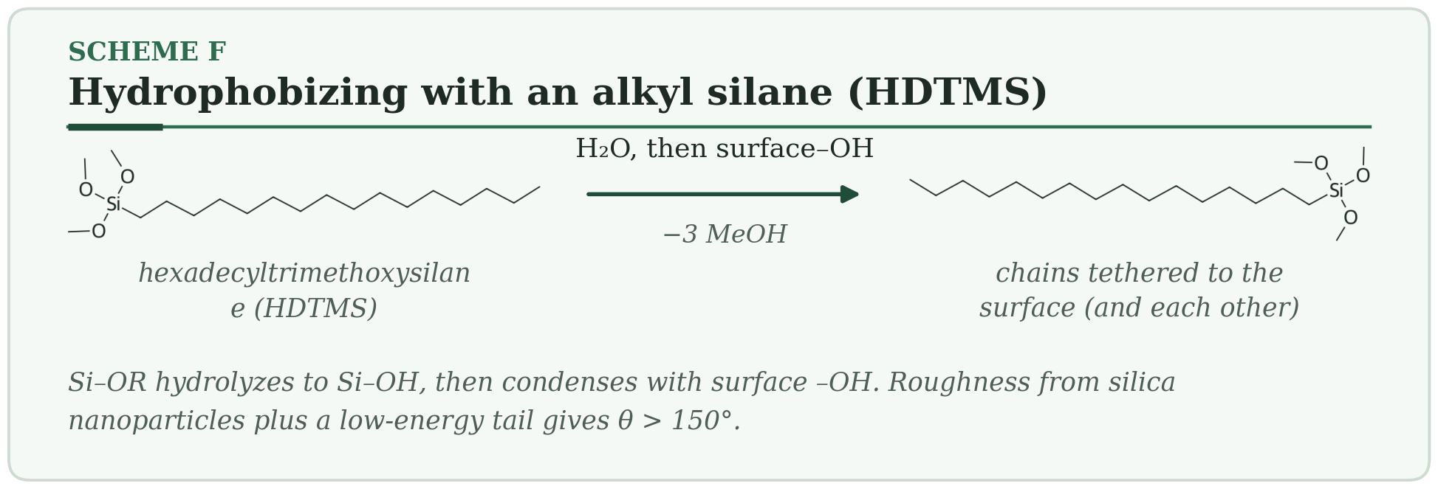
HOW IT WORKS
- The alkoxy groups (Si–OMe) hydrolyze to silanols.
- Silanols condense with surface –OH groups and with each other.
- The tails (C16 in HDTMS) point outward and lower the surface energy. Rough silica underneath raises the water contact angle above 150°.
Typical conditions. 1–5 wt % in ethanol or toluene · 25–120 °C · 1–24 h · layer about 1–3 nm · needs surface –OH groups.
Why membranes care. Anti-wetting for membrane contactors and membrane distillation. Roughness plus low surface energy gives superhydrophobicity.
Watch out. Siloxane bonds can hydrolyze in strong base, which matters for alkaline amine solvents. Long-chain fluorosilanes face PFAS restrictions in many places. Moisture in the bath makes the silane polymerize in solution instead of on the surface.
PLANT NOTE | Test in the real process fluid at process temperature for weeks. A contact angle on day 0 says little about day 90.

3.12 UV Curing (Photopolymerization) Reaction at the surface
Light splits an initiator, and a liquid acrylate turns into a crosslinked solid in seconds.
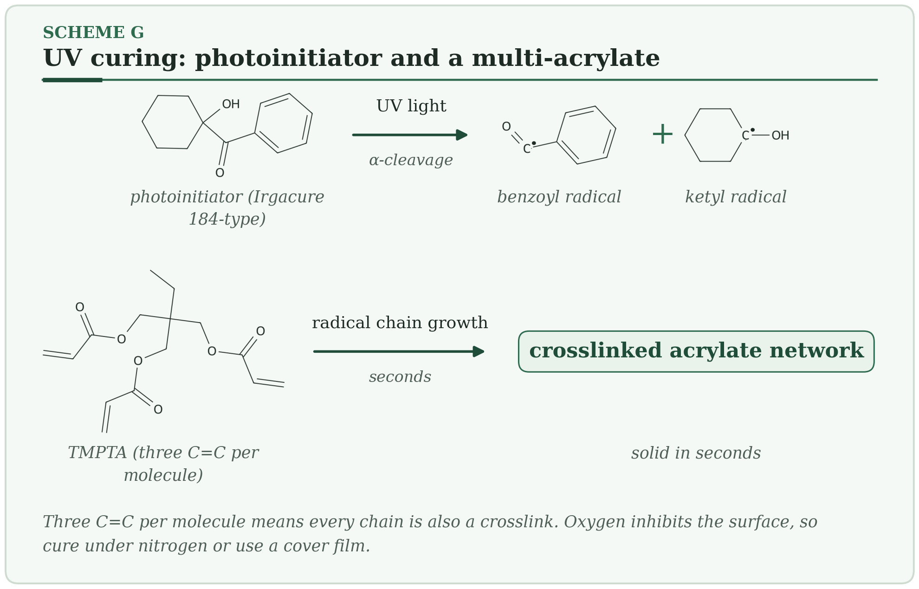
HOW IT WORKS
- The photoinitiator absorbs UV and splits into two radicals (Norrish type I).
- Radicals attack acrylate C=C bonds. Each multi-acrylate molecule joins chains and crosslinks them.
- The liquid becomes a solid network within seconds.
Typical conditions. UV about 250–400 nm · cure time seconds · film about 1–100 µm · can be solvent-free.
Why membranes care. Fast crosslinked coatings, such as acrylate or silicone-acrylate layers, for gutter or protective layers and for locking a polymer into a support. Allows high line speeds.
Watch out. Oxygen inhibits the surface and leaves it tacky: cure under nitrogen or with a cover film. Shrinkage stress. Limited depth in thick or pigmented films. Unreacted monomer can be extracted later.
PLANT NOTE | Measure UV dose (mJ/cm²), not only lamp time.

3.13 Thermal Crosslinking: Hydrosilylation and Epoxy–Amine Reaction at the surface
Heat makes two reactive groups join, and the coating hardens without releasing anything.
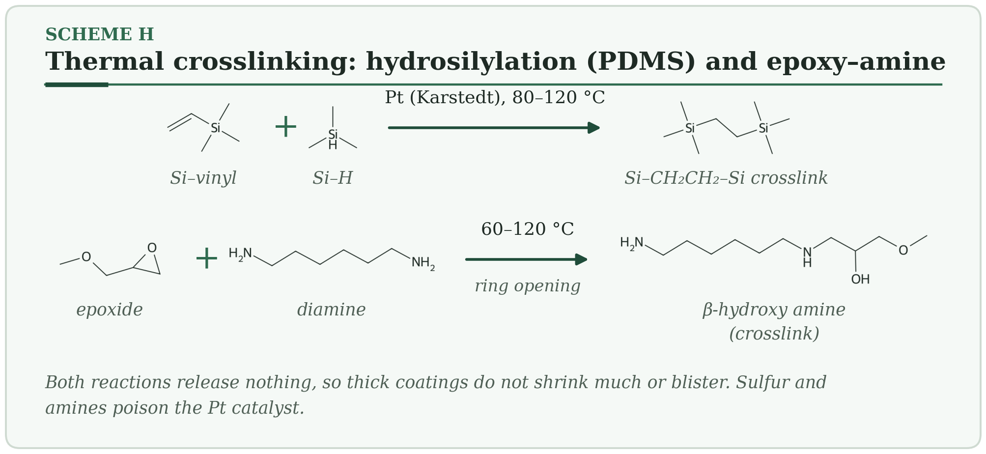
HOW IT WORKS
- Hydrosilylation: a Pt catalyst adds Si–H across a Si–CH=CH₂ group and forms Si–CH₂CH₂–Si crosslinks (PDMS).
- Epoxy–amine: the amine opens the epoxide ring and gives a β-hydroxy amine. A diamine joins two chains.
- Both reactions are sped up by heat, and neither releases a small molecule, so thick films do not blister.
Typical conditions. Hydrosilylation: 60–120 °C with ppm-level Pt · epoxy–amine: 25–120 °C · pot life minutes to hours.
Why membranes care. PDMS gutter and sealing layers on hollow fibers, and chemically resistant protective coatings (epoxy–amine).
Watch out. Platinum is poisoned by sulfur, amines and tin compounds. The mixing ratio sets the crosslink density. Pot life drops quickly with temperature.
PLANT NOTE | Degas, mix by weight, respect pot life, and log the time from mixing to coating.

3.14 Crosslinking a Polyimide Skin (Solvent-Resistant Membranes) Reaction at the surface
A diamine bridges neighbouring polyimide chains, and the skin stops dissolving in solvent.
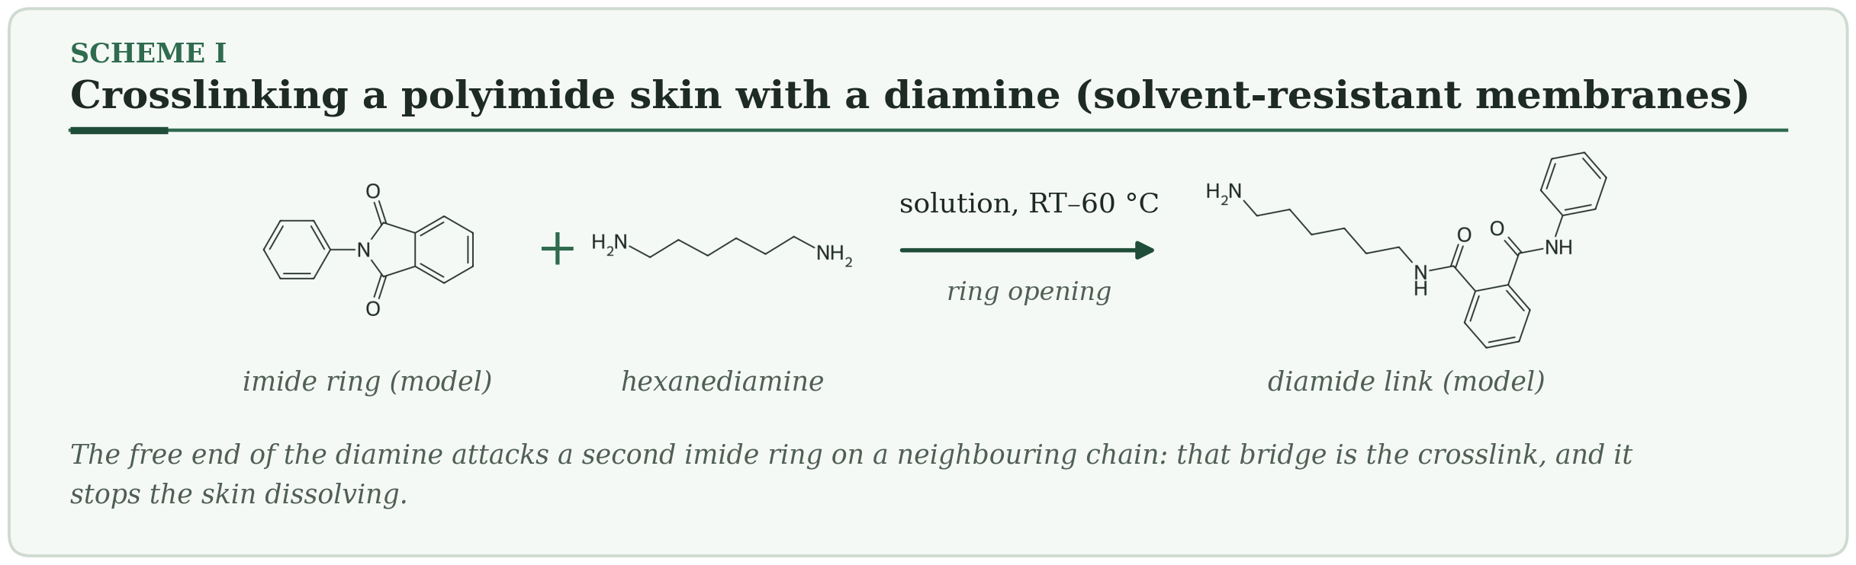
HOW IT WORKS
- A diamine such as hexanediamine attacks an imide carbonyl and opens the ring to an amide.
- The other end of the diamine attacks a neighbouring chain. That bridge is the crosslink.
- The crosslinked skin no longer dissolves in polar aprotic solvents and swells less in organic solvents.
Typical conditions. Diamine about 1–10 wt % in methanol, isopropanol or water · room temperature to 60 °C · minutes to hours · short contact keeps the crosslinking near the surface.
Why membranes care. Turns a soluble polyimide (P84, Matrimid, 6FDA types) into an organic-solvent nanofiltration (OSN) membrane. Crosslink depth sets the trade-off between flux and stability.
Watch out. Over-crosslinking makes the skin brittle and cuts flux. Unreacted amine can migrate out. Dried crosslinked membranes can lose flux by pore collapse, so keep them wet or use a conditioning agent.
PLANT NOTE | Measure solvent flux and rejection before and after crosslinking, in the target solvent.

3.15 Zwitterionic and Brush Coatings Reaction at the surface
Equal positive and negative charges bind a tight water layer that proteins cannot get through.
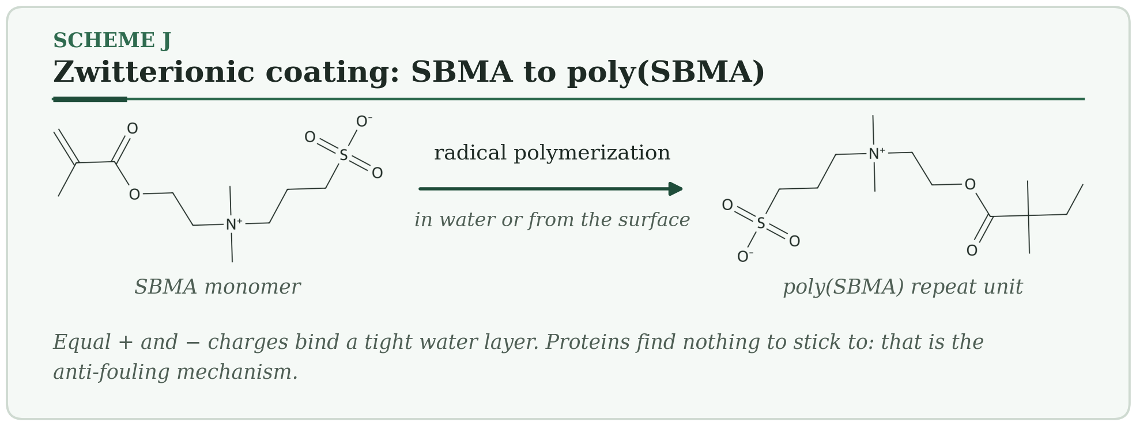
HOW IT WORKS
- Zwitterionic monomers (SBMA, MPC) carry a + and a − charge on the same unit.
- They are grown from the surface (grafting-from), attached to it (grafting-to), or held by a primer such as polydopamine.
- A tightly bound water layer forms around the charges and blocks the adhesion of proteins and cells.
Typical conditions. Water or alcohol/water · room temperature to 60 °C · hours · layer about 5–50 nm.
Why membranes care. Low-fouling UF and MF membranes, hemodialysis membranes, and coatings for ion-exchange membranes.
Watch out. A layer that is too thick blocks pores. Ester-based zwitterions can hydrolyze slowly. Grafting density matters more than chain length.
PLANT NOTE | Report flux recovery and coating thickness together. A coating that costs 30 % of the flux to stop fouling may not pay back.

Family C: Vapor, plasma and electrochemical

3.16 Parylene Chemical Vapor Deposition Vapor and plasma
A reactive gas polymerizes on every surface it touches, even inside pores.
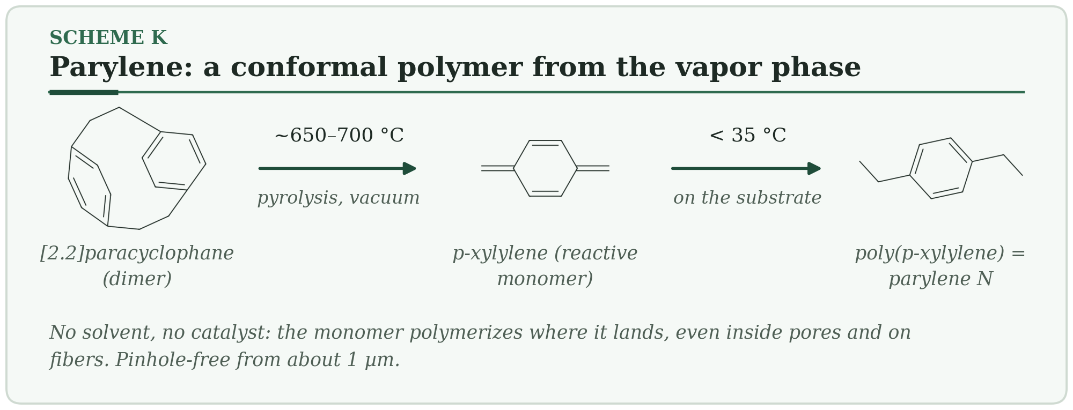
HOW IT WORKS
- The dimer is vaporized (about 150 °C) and cracked at about 650–700 °C into reactive p-xylylene.
- At room temperature the monomer lands on every surface and starts polymerizing.
- A uniform, pinhole-free film forms, even on fibers, in pores and on sharp edges.
Typical conditions. Vacuum (about 0.1 mbar) · substrate near room temperature · film about 0.1–50 µm.
Why membranes care. A pinhole-free barrier or sealing layer on hollow fibers and microporous supports, and biocompatible coatings on devices.
Watch out. Slow, batch process. Adhesion is poor unless the surface has a silane primer. The film is hydrophobic. Parylene N is more permeable than parylene C.
PLANT NOTE | Use a silane adhesion promoter, and coat in one step so layers do not peel from each other.

3.17 Initiated CVD (iCVD) Vapor and plasma
Radical polymerization carried out from the vapor phase on a cool surface.
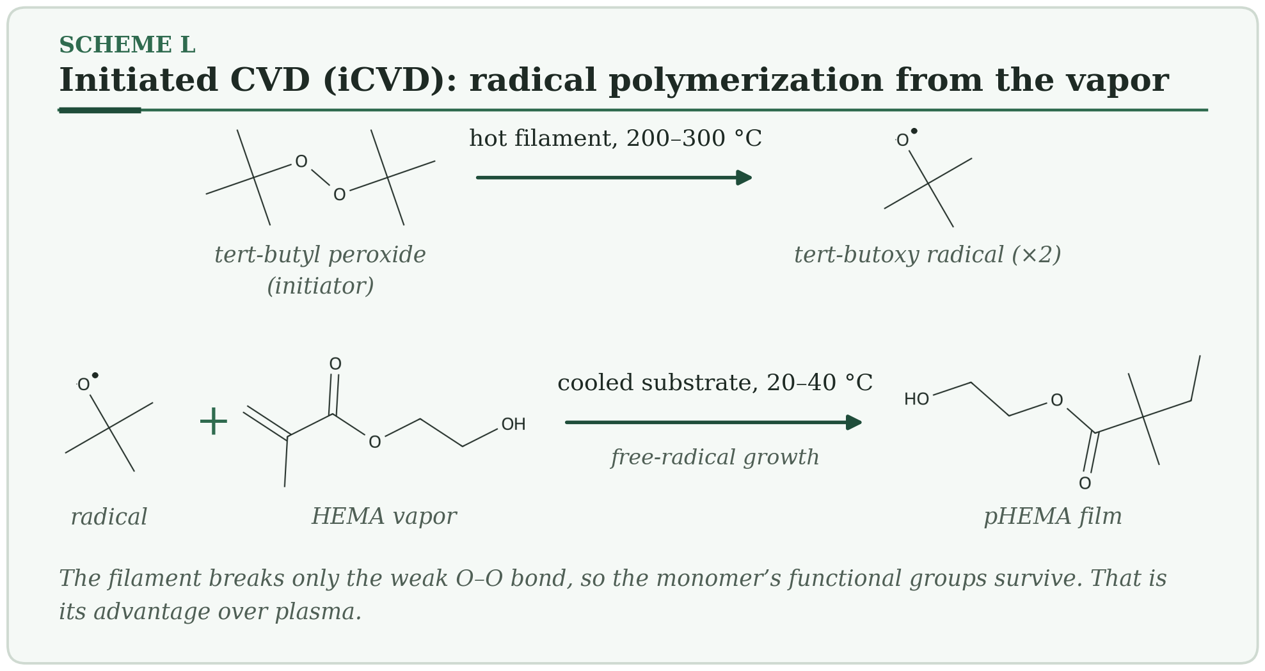
HOW IT WORKS
- A heated filament splits an initiator (tert-butyl peroxide) into radicals.
- Monomer vapor adsorbs on the cooled substrate.
- Radicals start growth on the surface, giving a polymer film that keeps its functional groups.
Typical conditions. Filament 200–300 °C · substrate 20–40 °C · 0.1–1 mbar · film about 10–1000 nm.
Why membranes care. Ultrathin, conformal coatings on porous membranes that do not clog the pores. Hydrophobic and zwitterionic layers, without solvent.
Watch out. Needs vacuum equipment. Monomers must be volatile. Roll-to-roll systems exist, but are less common than solution routes.
PLANT NOTE | Control substrate temperature tightly: it sets monomer concentration on the surface, and therefore the growth rate.

3.18 Plasma Polymerization Vapor and plasma
A plasma shatters a vapor into pieces that crosslink into a hard, pinhole-free film.
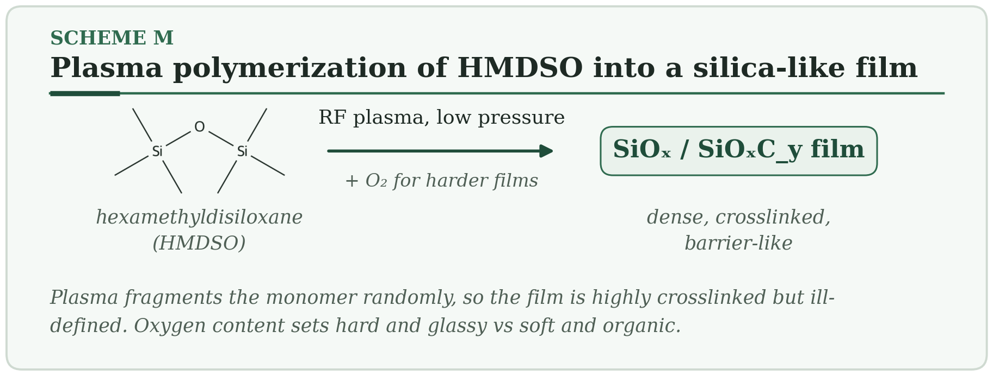
HOW IT WORKS
- A plasma breaks the monomer vapor (HMDSO, a fluorocarbon) into fragments.
- The fragments land on the substrate and crosslink at random.
- The film is dense, pinhole-free and strongly bonded to the surface.
Typical conditions. RF or microwave plasma · 0.01–1 mbar · 10–200 W · film about 10 nm–1 µm.
Why membranes care. Dense barrier or selective layers on porous supports, hydrophobic or anti-fouling layers (SiOₓ, fluorocarbon), and surface activation.
Watch out. Film chemistry depends on power, pressure and flow. Plasma can etch thin polymers. Activated surfaces slowly regain their original wettability (hydrophobic recovery).
PLANT NOTE | Record power per monomer flow (W per sccm). That ratio controls film chemistry better than power alone.

3.19 Atomic Layer Deposition (ALD) and Molecular Layer Deposition Vapor and plasma
Two gases take turns, each reacting only until the surface is full.
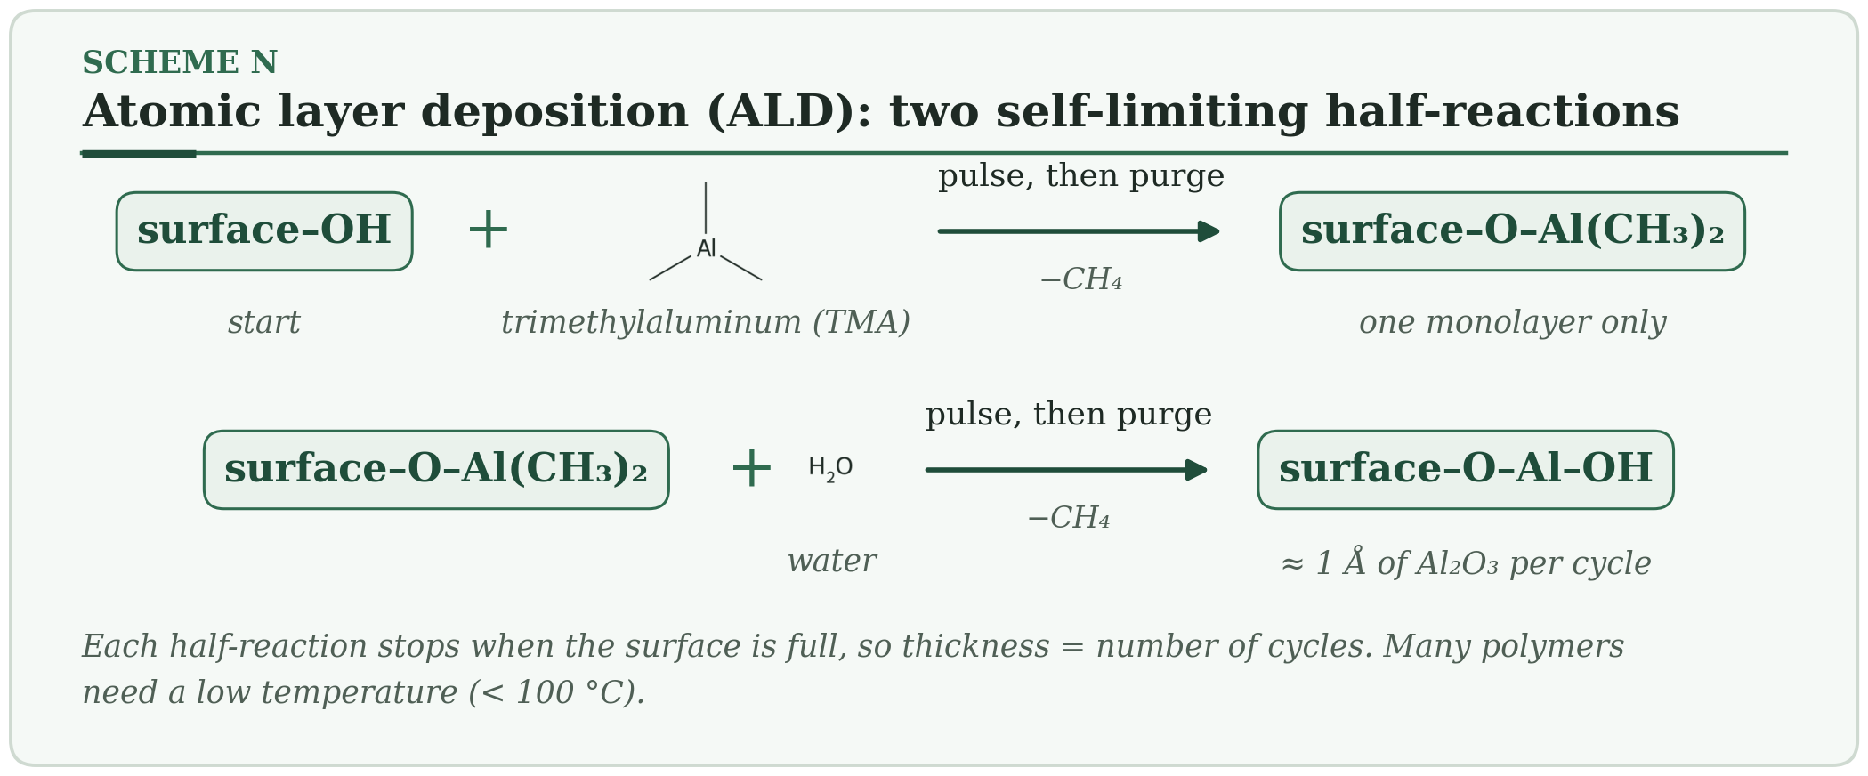
HOW IT WORKS
- Pulse precursor 1 (TMA). It reacts with surface –OH groups until the surface is full.
- Purge, then pulse precursor 2 (water). It converts the surface to Al–OH.
- One cycle adds roughly 1 Å. Repeat for the thickness you need.
Typical conditions. About 50–250 °C (down to about 30–100 °C for polymers) · roughly 0.5–2 Å per cycle · conformal in high-aspect-ratio pores.
Why membranes care. Tunes pore size at the nanometre scale, adds hydrophilic Al₂O₃ or TiO₂ layers, and can infiltrate polymers. MLD builds organic or hybrid layers.
Watch out. Precursors can diffuse into polymers and change them. Porous supports need long purge times. Vacuum equipment and cost.
PLANT NOTE | In porous supports allow long exposure and purge times so the film grows to the full pore depth.

3.20 Electropolymerization Vapor and plasma
Pass a current through a monomer solution, and a polymer film grows on the electrode.
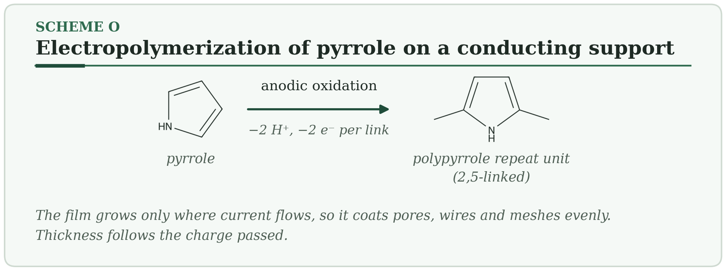
HOW IT WORKS
- The monomer (pyrrole) is oxidized at the anode to a radical cation.
- Radical cations couple and lose protons, building the chain.
- The doped, conducting polymer deposits on the electrode. Thickness follows the charge passed.
Typical conditions. Monomer about 0.05–0.5 M with electrolyte · constant potential or current · film about 10 nm–10 µm.
Why membranes care. Conductive membranes and electrodes, smart gating, and uniform coatings inside porous conductive supports.
Watch out. The support must conduct. Over-oxidation damages the film. Uniform thickness depends on an even current distribution.
PLANT NOTE | Control charge density (C/cm²), not time.

4. Membrane Deep Dives
Coating a membrane is harder than coating a plate. The support is porous, soft, curved and often wet. The next seven sections turn the general methods into design rules for membranes.

4.1 Thin-film composites: one job per layer
A thin-film composite separates the jobs. A very thin skin does the separation. A porous support carries the pressure. A fabric adds strength. For gas separation, a very permeable gutter layer is added between skin and support so that the skin does not sink into the pores.
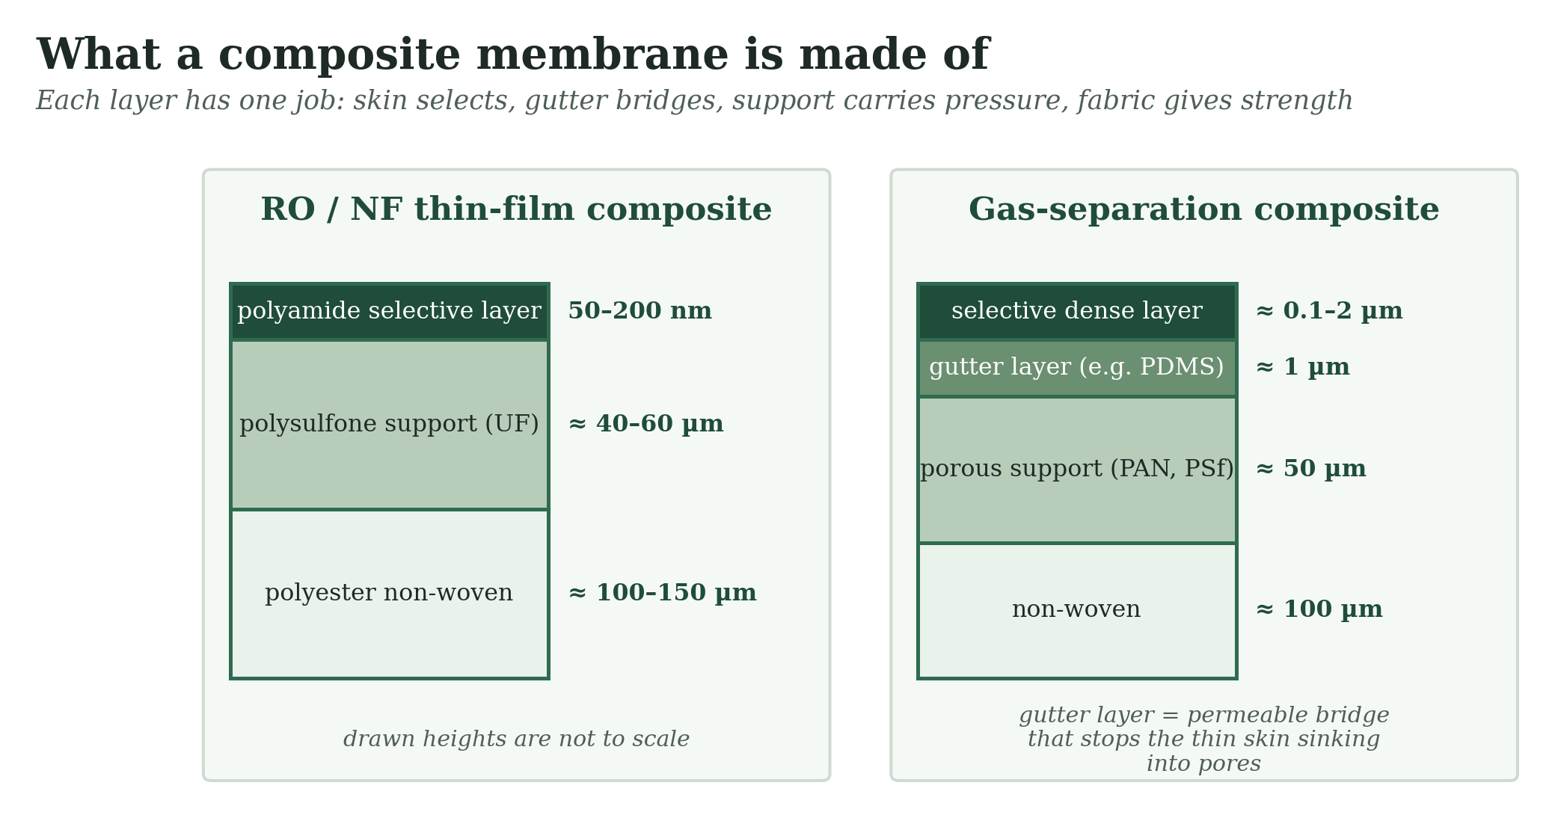
Figure 9 — Layers of a reverse-osmosis or nanofiltration composite and of a gas-separation composite (typical values, not to scale).
The support must offer small, uniform pores at its surface (tens of nanometres), low roughness, and chemical stability against the coating solvent. A support with large pores, or a rough one, forces you to use a thicker skin and loses flux.

4.2 Pores, defects and the resistance model
The coating has to bridge the pore mouths without filling the pores. If it is too thin, it leaves bare pores. If the coating liquid soaks into the pores, the plug adds resistance. The total resistance to flow is the sum of the layers in series (skin, intrusion, support):
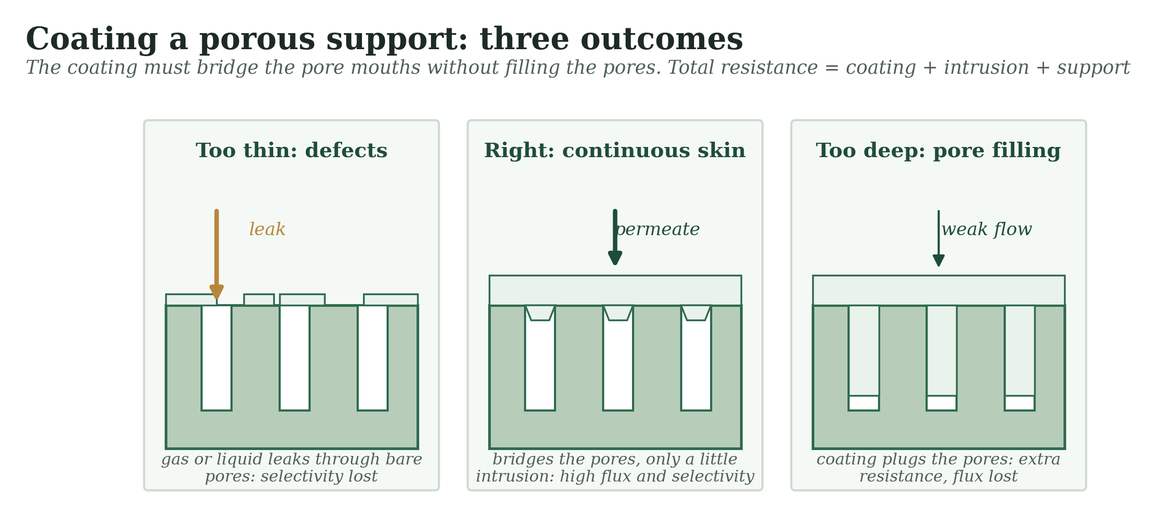
Figure 10 — A coating that is too thin, right, or too deep on a porous support.
1 / P(total) = 1 / P(skin) + 1 / P(gutter) + 1 / P(support)
Defects act in parallel, which is far more dangerous than series resistance, because a gas takes the easy path. The table assumes a skin with CO₂/N₂ selectivity 40, and bare pores that are 1000 times more permeable than the skin and show Knudsen selectivity (0.8).
Bare-pore area | CO₂ permeance (relative) | N₂ permeance (relative) | CO₂/N₂ selectivity
0 (perfect skin) | 1.00 | 0.025 | 40.0
1×10⁻3 % | 1.01 | 0.038 | 26.9
1×10⁻2 % | 1.10 | 0.150 | 7.3
1×10⁻1 % | 2.00 | 1.280 | 1.6
A bare area of only one part in ten thousand cuts the selectivity from 40 to about 7. This is why composite membranes carry a thin sealing layer of a very permeable rubber (usually PDMS): it closes the defects at a small cost in flux. The idea is described by the resistance-model approach of Henis and Tripodi.

4.3 Coating hollow fibers
A hollow fiber has no flat face to lean on, so the coating geometry changes. You can pass the fiber through a coating bath or die and then through a dryer, or you can coat fibers inside a finished module by circulating solution on one side while pressure or vacuum acts on the other.
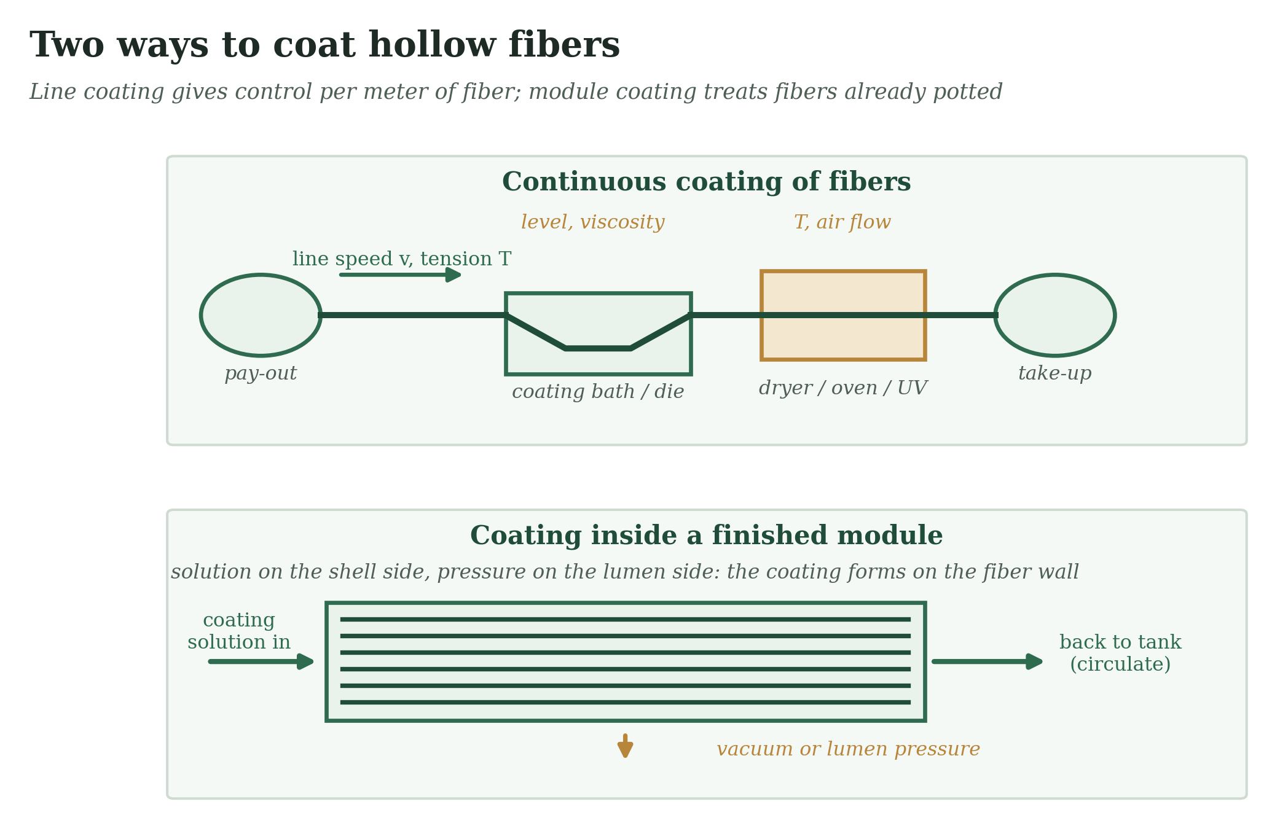
Figure 11 — Continuous line coating and in-module coating of hollow fibers.
- Line speed and bath viscosity set the film thickness (the dip-coating law). Hold both constant.
- Keep the fiber under constant light tension and avoid touching the wet coating before it sets.
- Dry vertically or with centred air flow; sag and one-sided drying make eccentric coatings.
- In-module coating reaches every fiber but gives less control per fiber; use it for repairs or for a sealing coat.
- Check for pore intrusion: a few weight-percent of a viscous polymer solution stays on the surface, while a thin solution soaks in.

4.4 Coatings that keep a contactor dry
A membrane contactor works only while the pores stay gas-filled. The liquid enters the pores when the pressure exceeds the liquid entry pressure (LEP):
LEP = − 2 γ cos θ / r
γ is the liquid surface tension, θ the contact angle and r the largest pore radius. The table uses γ = 60 mN/m, typical of an aqueous amine solution; it shows why both a high contact angle and small pores matter. At 90° the LEP is zero.
Contact angle | r = 0.1 µm | r = 0.2 µm | r = 0.5 µm
90° | 0.0 bar | 0.0 bar | 0.0 bar
110° | 4.1 bar | 2.1 bar | 0.8 bar
130° | 7.7 bar | 3.9 bar | 1.5 bar
150° | 10.4 bar | 5.2 bar | 2.1 bar
- Raise θ: silane (HDTMS) on a roughened surface, a PDMS skin, or a fluoropolymer.
- Lower r: a thin coating that narrows the largest pores helps more than a high angle on a leaky pore.
- Stay stable: siloxane bonds can hydrolyze in strong base, and surfactants or amines lower the surface tension of the liquid and reduce the LEP. Test in the real solvent at process temperature.
- Check regulations: long-chain fluorinated silanes are restricted in many places. Alkyl silanes or PDMS are common alternatives.

4.5 Anti-fouling coatings
Coating | How it works | Good for | Watch out
Zwitterions (SBMA, MPC) | Tightly bound water layer | Proteins, cells, oils | Thick layers block pores
PEG-type chains | Steric repulsion and hydration | Proteins | Oxidizes in service
Polydopamine, PDA + PEI | Hydrophilic primer and anchor | Any substrate, general | Layer keeps growing; brown
Hydrophilic grafts (PHEMA, PAA) | Hydration | Moderate fouling | Less durable than zwitterions
Charged layers (sulfonation, LbL) | Electrostatic repulsion | Charged foulants | Fails at high salt
Judge a coating on flux recovery after fouling and on initial flux together. A layer that stops fouling but halves the flux has not solved the problem.

4.6 Solvent-resistant (OSN) coatings
In organic solvents, the problem is swelling and dissolving. The rule is simple: the further a polymer is from the solvent in Hansen space, the less it swells. Hexane is non-polar (14.9, 0, 0), so polar polymers such as polyimide, PBI and PAN resist it. The three practical routes are crosslinking the support or skin (Scheme I), putting a thin rubbery layer (PDMS) over it, or building a polyamide skin on a crosslinked support. Pick the route by the solvent: crosslinking helps most for polar aprotic solvents; a PDMS layer is the usual choice for alkanes.

4.7 Thin layers for gas separation
Coating polymer | Role | Approximate behaviour | Watch out
PDMS | Gutter and sealing layer; selective layer for vapors | Very permeable rubber; low CO₂/N₂ selectivity (about 10) | Swells in hydrocarbons
Pebax (polyether-block-amide) | Selective layer for CO₂ | Tens to hundreds of Barrer; CO₂/N₂ selectivity about 20–50 depending on grade | Needs alcohol/water solvents; plasticizes
PIM-1 | High-permeability skin | Thousands of Barrer when fresh | Physical aging
Teflon AF, fluoropolymers | Chemically resistant layer | Permeable glassy fluoropolymers | Cost; special solvents
Typical practice is to dip or slot-die coat a dilute solution (about 0.5–5 wt %) of the polymer onto a gutter-coated support, then dry slowly. Thinner is better for flux, but only until defects appear: the thinnest layer that remains defect-free in a pinhole test is usually the right one.

5. Choosing a Method
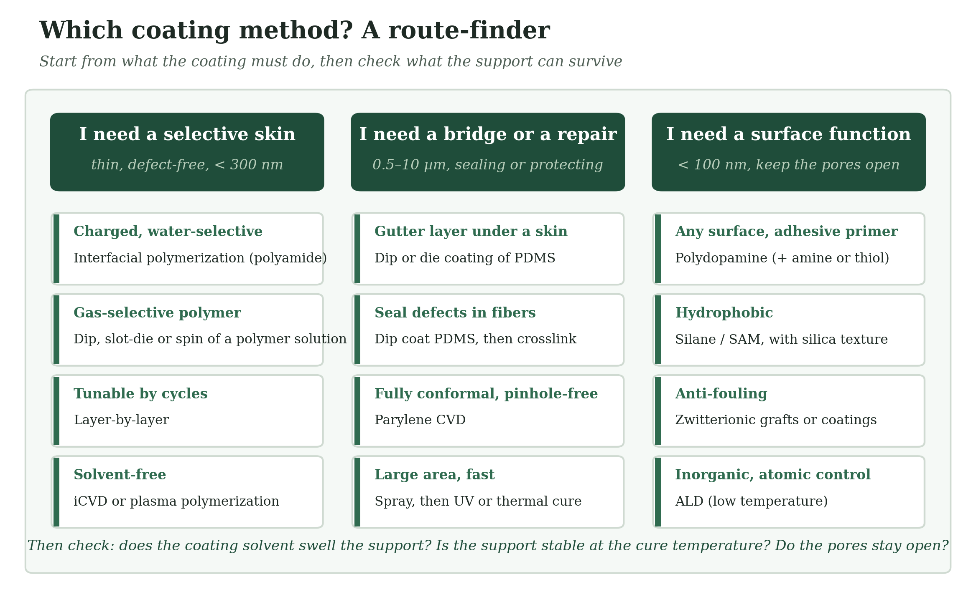
Figure 12 — A route-finder: start from what the coating must do.
Method | Thickness | Evenness | Scale-up | Needs | Fits
Dip | 0.1–50 µm | Good | Easy (fibers, rolls) | Soluble polymer | Gutter, sealing, hydrophobic layers
Spin | 10 nm–10 µm | Excellent | Poor | Flat sample | Screening
Spray | 0.1–100 µm | Fair | Good | Atomizable liquid | Large area, top coats
Slot-die / blade | 1–500 µm wet | Excellent | Excellent | Flat web | Flat-sheet composites
Vacuum-assisted | 20 nm–10 µm | Fair | Fair | Stable suspension | 2D-material layers
Interfacial polymerization | 50–200 nm | Very good | Excellent | Two reactive phases | RO and NF skins
Polydopamine | 10–50 nm | Good | Good | pH 8.5 bath | Primer, anti-fouling
Layer-by-layer | 2 nm–1 µm | Very good | Moderate | Charged polymers | NF, antibacterial
Sol–gel | 50 nm–2 µm | Good | Good | Humidity control | Hydrophilic, texture
Silane | 1–3 nm | Good | Good | Surface –OH | Hydrophobic
UV curing | 1–100 µm | Good | Excellent | Acrylate resin | Protective, gutter
iCVD / plasma / parylene | 10 nm–50 µm | Excellent | Moderate | Vacuum | Conformal in pores
ALD | 1–100 nm | Excellent | Limited | Vacuum, precursors | Pore tuning

6. Defects and Troubleshooting
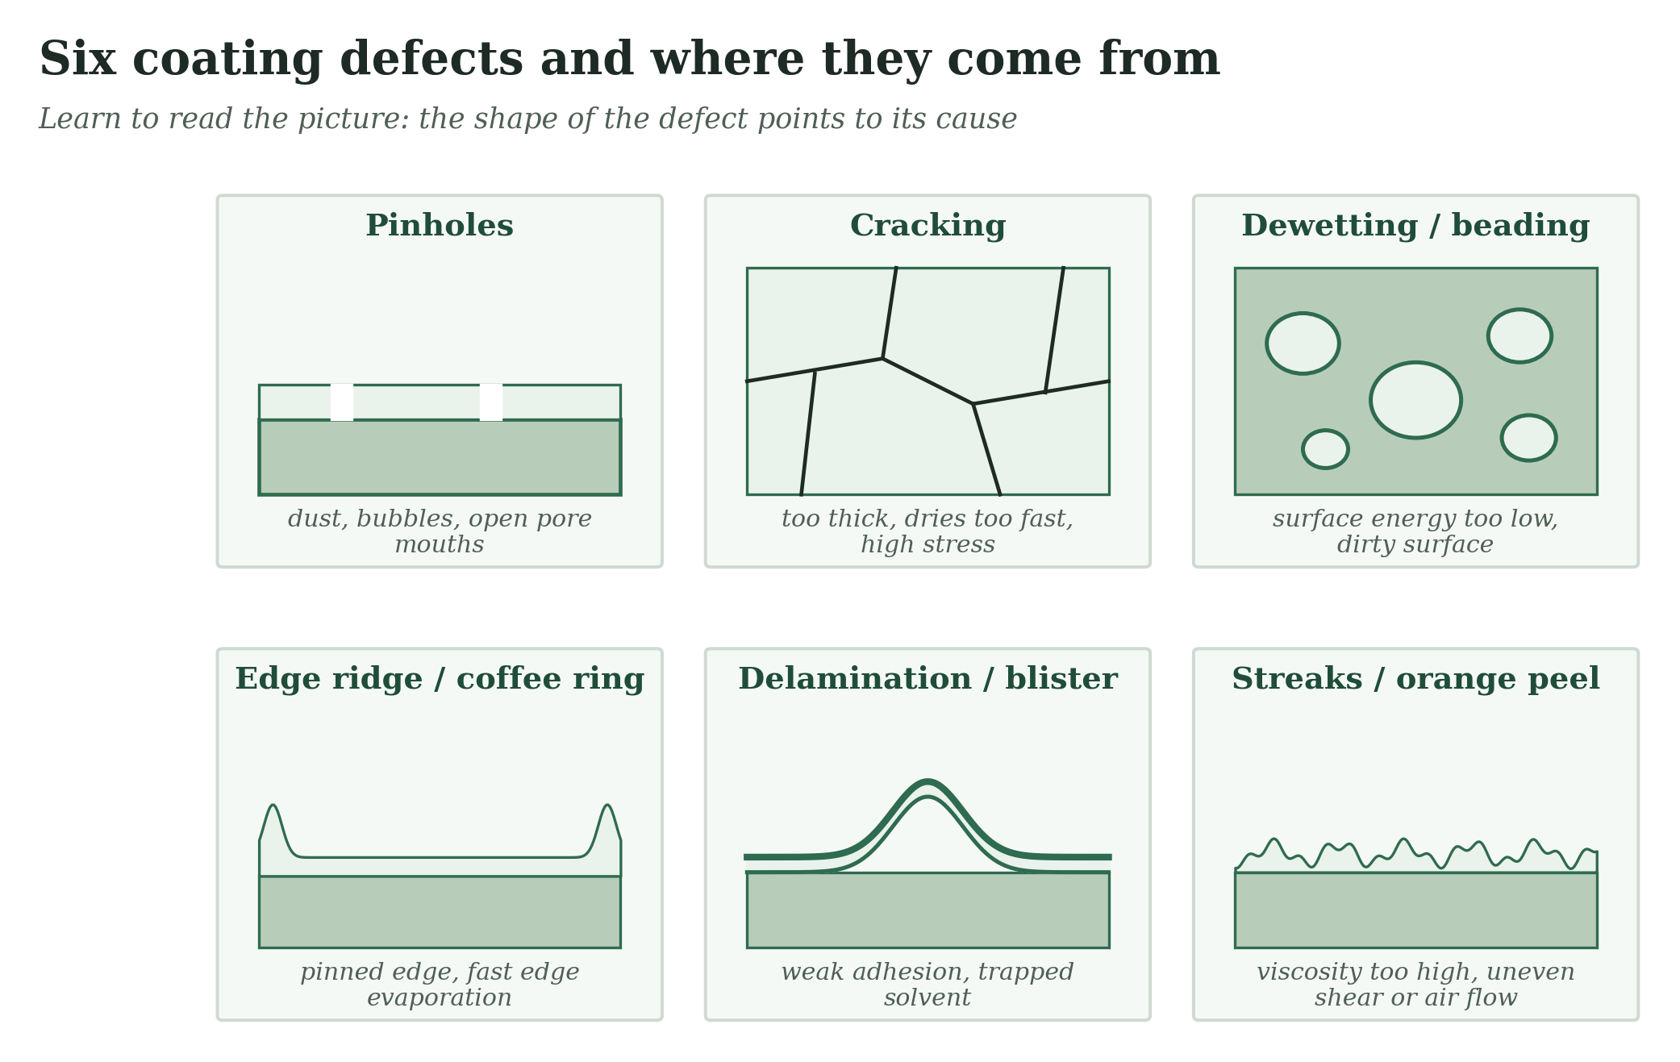
Figure 13 — Six defects and their usual causes.
Symptom | Likely cause | First fix
Coating beads up | Surface energy too low or dirty | Plasma or UV–ozone; add alcohol or surfactant; clean
Pinholes, selectivity low | Dust, bubbles, open pores | Filter solution (0.45 µm), degas, coat in clean air, add a sealing layer
Cracks on drying | Too thick, dries too fast, stress | Thinner layers, slower drying, lower solids, plasticizer
Flux drops after coating | Solution entered the pores | Raise viscosity or solids; pre-fill pores with non-solvent; add gutter
Coating peels | Weak boundary layer, no chemical bond | Clean, primer (PDA, silane), crosslink, roughen
Streaks across film | Vibration, uneven air, damaged die lip | Isolate, level, inspect die
Thick edge or ring | Pinned edge, fast edge drying | Slow edge drying; mixed solvent; trim edge
Orange peel | Marangoni cells, too viscous | Slower-evaporating co-solvent; lower evaporation rate
White haze | Moisture condenses on cold, evaporating film | Lower humidity; warm the substrate
Wrinkled skin | Skin forms before the film is dry | Slower, cooler drying
Tacky surface after UV | Oxygen inhibition | Nitrogen purge or cover film; higher dose
Contact angle or LEP decays in service | Hydrolysis or surfactant attack | Test in process fluid; stronger anchoring
Selectivity drifts over months | Physical aging or plasticization | Crosslink; anneal; control storage

7. Testing and Characterization
Ask a question, then choose the test. One technique rarely answers more than one question.
Question | Test | What you read | Pitfall
Is the coating there? | XPS, ToF-SIMS, ATR-FTIR | New elements and bands | ATR-FTIR probes about 0.5–2 µm, so it can miss a 20 nm coating
How thick is it? | Cross-section SEM, ellipsometry, profilometry or AFM at a scratch, QCM-D | Thickness in nm or µm | Cryo-fracture for SEM; ellipsometry needs a smooth reference wafer
Is it continuous? | Top-view SEM, dye test, gas permeation ratio | Holes, cracks | SEM sees only a small area; permeation sees the whole membrane
Is it hydrophobic or hydrophilic? | Contact angle (advancing and receding), roll-off angle | θ and hysteresis | One static value hides roughness effects
Will it stay dry? | LEP test | Pressure at which the first drop passes | Use the real liquid at process temperature
Does it stick? | Tape test (ASTM D3359 or ISO 2409), pull-off (ASTM D4541), ultrasonication, soak | Loss of coating | Tape tests are qualitative; always test after soaking
Does it separate? | Gas permeance (GPU) and selectivity; flux and rejection; MWCO | Performance | Test under pressure and with real mixtures
Does it foul? | Flux recovery ratio after fouling | FRR | Use a realistic foulant concentration
Is it stable? | Soak in process fluid at temperature, then repeat the above | Change over time | Weeks to months; not hours

Rule of the lab
Always test the coated membrane twice: fresh, and after soaking in the real process fluid at the real temperature. Most coatings look good on day 0.

8. Scale-Up and Industry Insight

Seven rules for moving from the lab to the line
- Rebuild the thickness calibration. Spin-coating numbers do not transfer to dip or slot-die. Use the pump-rate equation for slot-die: wet thickness = Q ÷ (width × speed).
- Design the dryer as carefully as the coater. Temperature, air flow and zones decide skin formation, blushing and cracking.
- Filter and degas the solution inline. Dust and bubbles cause most pinholes.
- Control the room: humidity (sol–gel, blush), temperature (viscosity) and cleanliness (defects).
- Plan for solvent safety. Hexane and other flammable solvents need explosion-rated equipment, ventilation and recovery. Water- or alcohol-based coatings lower this burden.
- Build in-line checks. A simple optical defect scanner and a periodic pinhole or permeance test on a coupon catch problems early.
- Watch materials regulations. Fluorinated coating chemicals face growing restrictions; qualify a non-fluorinated alternative early.

What drives cost
Coating cost is usually dominated by yield, not by chemicals. A line that scraps 15 % of its output because of pinholes costs more than a more expensive resin. Solvent recovery, line speed and the cost of the support (often the largest item) come next.

9. Four Worked Cases
Case 1: A PVDF hollow fiber that must stay dry
Problem: a contactor fiber wets out within days in an alkaline amine solution. Approach: roughen with silica, then hydrophobize with an alkyl silane. Check: LEP and contact angle fresh and after 30 days in the real solvent. Lesson: the weak point is usually bond hydrolysis in base, not the initial contact angle.
Case 2: A polyamide skin that is too thick
Problem: flux is low although rejection is good. Approach: reduce the amount of aqueous MPD left on the support, lower TMC concentration or contact time. Lesson: interfacial polymerization is self-limiting, but the starting amount of amine still sets the thickness.
Case 3: A gas-separation composite with low selectivity
Problem: selectivity is 7 when the polymer should give 40. Approach: a bare-pore area of about 0.01 % is enough (Section 4.2). Add a dilute PDMS sealing layer by dip coating, then crosslink. Lesson: the defect fraction matters more than the polymer.
Case 4: A polyimide fiber that dissolves in the solvent
Problem: a polyimide OSN fiber swells and loses rejection in the target solvent. Approach: crosslink with a diamine (Scheme I) and compare flux before and after. Lesson: crosslink depth is a trade-off, and a short contact time keeps the crosslinking near the surface.

10. Where the Field Is Going
- PFAS-free repellent coatings that last as long as fluorinated ones.
- Roll-to-roll vapor coating (iCVD, ALD) for membranes.
- Two-dimensional material coatings (graphene oxide, MXene) that stay stable in water.
- Self-healing and dynamic coatings that repair scratches and pinholes.
- Bio-based coatings and green solvents for skin formation.
- Machine-learning tools that predict a stable coating window from solution properties.

Open problem | Where it appears | Today's best answer
Hydrolysis of siloxane coatings in base | Contactors, membrane distillation | Test in real fluid; PDMS or fluoropolymer alternatives
Pore intrusion | Hollow-fiber composites | Higher viscosity, gutter layer, pre-wetting
Aging and plasticization of thin glassy layers | Gas separation | Crosslinking, annealing
Thickness uniformity on curved supports | Fibers, spiral modules | Controlled dip speed, centred drying
Defect detection at line speed | All | Optical scanning, coupon permeation tests

11. All the Plant Notes in One Place
Print this page and keep it near the line.
Method | Note
Dip Coating | Hold bath level and temperature constant and isolate the bath from vibration. A few degrees of temperature drift changes viscosity, and so thickness.
Spin Coating | Use spin coating to screen materials, then rebuild the thickness calibration on dip or slot-die equipment. The numbers will not carry over.
Spray Coating | Fix nozzle height, speed and flow, and overlap passes by about half the spray width.
Blade, Rod, Slot-Die and Roll Coating | For pre-metered slot-die, 10 mL/min over a 0.2 m width at 1 m/min gives 50 µm wet.
Inkjet and Electrospray | Filter every ink (about 0.45 µm) before it goes near a nozzle.
Vacuum-Assisted Coating | Set thickness by filtered mass per area, not by time.
Interfacial Polymerization | Control how much aqueous solution stays on the support. It sets how much MPD is available, and therefore the skin thickness.
Polydopamine and Catecholamine Coatings | Fix pH, oxygen supply (stirring, air) and time, and measure thickness on a reference wafer in every batch.
Layer-by-Layer Assembly | Automate the dipping; manual handling is the main source of batch variation.
Sol–Gel and Silica Coatings | Use fresh sol or standardize its ageing time, and build thick films from several thin layers.
Silane Monolayers and Hydrophobic Texture | Test in the real process fluid at process temperature for weeks. A contact angle on day 0 says little about day 90.
UV Curing | Measure UV dose (mJ/cm²), not only lamp time.
Thermal Crosslinking: Hydrosilylation and Epoxy–Amine | Degas, mix by weight, respect pot life, and log the time from mixing to coating.
Crosslinking a Polyimide Skin | Measure solvent flux and rejection before and after crosslinking, in the target solvent.
Zwitterionic and Brush Coatings | Report flux recovery and coating thickness together. A coating that costs 30 % of the flux to stop fouling may not pay back.
Parylene Chemical Vapor Deposition | Use a silane adhesion promoter, and coat in one step so layers do not peel from each other.
Initiated CVD | Control substrate temperature tightly: it sets monomer concentration on the surface, and therefore the growth rate.
Plasma Polymerization | Record power per monomer flow (W per sccm). That ratio controls film chemistry better than power alone.
Atomic Layer Deposition and Molecular Layer Deposition | In porous supports allow long exposure and purge times so the film grows to the full pore depth.
Electropolymerization | Control charge density (C/cm²), not time.

12. References
Books
- Baker, R. W. Membrane Technology and Applications, 3rd ed.; Wiley: Chichester, 2012.
- Hansen, C. M. Hansen Solubility Parameters: A User's Handbook, 2nd ed.; CRC Press: Boca Raton, 2007.
- Kinloch, A. J. Adhesion and Adhesives: Science and Technology; Chapman and Hall: London, 1987.
- Brinker, C. J.; Scherer, G. W. Sol-Gel Science; Academic Press: San Diego, 1990.
- Ismail, A. F.; Khulbe, K. C.; Matsuura, T. Gas Separation Membranes: Polymeric and Inorganic; Springer: Cham, 2015.
Wetting, adhesion and film formation
- Young, T. An essay on the cohesion of fluids. Philos. Trans. R. Soc. London 1805, 95, 65–87.
- Wenzel, R. N. Resistance of solid surfaces to wetting by water. Ind. Eng. Chem. 1936, 28, 988–994.
- Cassie, A. B. D.; Baxter, S. Wettability of porous surfaces. Trans. Faraday Soc. 1944, 40, 546–551.
- Owens, D. K.; Wendt, R. C. Estimation of the surface free energy of polymers. J. Appl. Polym. Sci. 1969, 13, 1741–1747.
- Landau, L.; Levich, B. Dragging of a liquid by a moving plate. Acta Physicochim. URSS 1942, 17, 42–54.
- Emslie, A. G.; Bonner, F. T.; Peck, L. G. Flow of a viscous liquid on a rotating disk. J. Appl. Phys. 1958, 29, 858–862.
- Meyerhofer, D. Characteristics of resist films produced by spinning. J. Appl. Phys. 1978, 49, 3993–3997.
- Scriven, L. E. Physics and applications of dip coating and spin coating. Mater. Res. Soc. Symp. Proc. 1988, 121, 717–729.
- Deegan, R. D.; et al. Capillary flow as the cause of ring stains from dried liquid drops. Nature 1997, 389, 827–829.
Coating methods
- Cadotte, J. E. Interfacially synthesized reverse osmosis membrane. U.S. Patent 4,277,344, 1981.
- Petersen, R. J. Composite reverse osmosis and nanofiltration membranes. J. Membr. Sci. 1993, 83, 81–150.
- Lee, H.; Dellatore, S. M.; Miller, W. M.; Messersmith, P. B. Mussel-inspired surface chemistry for multifunctional coatings. Science 2007, 318, 426–430.
- Decher, G. Fuzzy nanoassemblies: toward layered polymeric multicomposites. Science 1997, 277, 1232–1237.
- Gorham, W. F. A new, general synthetic method for the preparation of linear poly-p-xylylenes. J. Polym. Sci. A-1 1966, 4, 3027–3039.
- Coclite, A. M.; et al. 25th anniversary article: CVD polymers: a new paradigm for surface modification and device fabrication. Adv. Mater. 2013, 25, 5392–5423.
- George, S. M. Atomic layer deposition: an overview. Chem. Rev. 2010, 110, 111–131.
Membranes
- Henis, J. M. S.; Tripodi, M. K. Composite hollow fiber membranes for gas separation: the resistance model approach. J. Membr. Sci. 1981, 8, 233–246.
- Gabelman, A.; Hwang, S.-T. Hollow fiber membrane contactors. J. Membr. Sci. 1999, 159, 61–106.
- Rana, D.; Matsuura, T. Surface modifications for antifouling membranes. Chem. Rev. 2010, 110, 2448–2471.
- Jiang, S.; Cao, Z. Ultralow-fouling, functionalizable, and hydrolyzable zwitterionic materials and their derivatives for biological applications. Adv. Mater. 2010, 22, 920–932.
- Vandezande, P.; Gevers, L. E. M.; Vankelecom, I. F. J. Solvent resistant nanofiltration: separating on a molecular level. Chem. Soc. Rev. 2008, 37, 365–405.
- Marchetti, P.; Jimenez Solomon, M. F.; Szekely, G.; Livingston, A. G. Molecular separation with organic solvent nanofiltration: a critical review. Chem. Rev. 2014, 114, 10735–10806.

Verify page numbers before citing.

13. One Page of Python
Copy this into coating_tools.py and run it. It needs only NumPy. Every formula comes from this book, so you can check your coating numbers in seconds.
import numpy as np
G = 9.81

def landau_levich(eta, U, gamma=0.03, rho=1000): # dip coating: wet film (m), Ca << 1
return 0.94 * (eta * U) ** (2 / 3) / (gamma ** (1 / 6) * np.sqrt(rho * G))

def spin_thinning(h0, eta, rho, rpm, t): # Emslie-Bonner-Peck, no evaporation
w = 2 * np.pi * rpm / 60
return h0 / np.sqrt(1 + 4 * rho * w**2 * h0**2 * t / (3 * eta))

def slot_die_wet(Q_mL_min, width_m, speed_m_min): # pre-metered slot die: wet film (m)
return Q_mL_min * 1e-6 / (width_m * speed_m_min)

def dry_thickness(h_wet, wt_frac, rho_soln, rho_film): # wet film -> dry film (m)
return h_wet * wt_frac * rho_soln / rho_film

def lep(gamma, theta_deg, r, B=1.0): # liquid entry pressure (Pa)
return -2 * B * gamma * np.cos(np.radians(theta_deg)) / r

def owens_wendt(theta_w, theta_d): # solid surface energy (mN/m)
liq = [(72.8, 21.8, 51.0, theta_w), (50.8, 50.8, 0.0, theta_d)] # water, CH2I2
A = [[np.sqrt(gd), np.sqrt(gp)] for _, gd, gp, _ in liq]
b = [g * (1 + np.cos(np.radians(t))) / 2 for g, _, _, t in liq]
xd, xp = np.linalg.solve(A, b)
return xd**2, xp**2 # (dispersive, polar)

def cassie_baxter(theta_deg, f): # apparent angle; f = wetted solid fraction
return np.degrees(np.arccos(f * (np.cos(np.radians(theta_deg)) + 1) - 1))

def hsp_ra(a, b): # Hansen distance; a, b = (dD, dP, dH)
return np.sqrt(4 * (a[0] - b[0])**2 + (a[1] - b[1])**2 + (a[2] - b[2])**2)

def defect_selectivity(alpha, eps, boost, k=0.797): # eps = bare-pore area fraction,
A = (1 - eps) + eps * boost # boost = defect/skin permeance (gas A),
B = (1 - eps) / alpha + eps * boost / k # k = defect selectivity A/B (Knudsen CO2/N2)
return A / B

def series(*P): # layers in series: resistances add
return 1 / sum(1 / p for p in P)

if __name__ == "__main__":
print("dip, 10 mPa.s @ 10 mm/s : %.0f um wet" % (landau_levich(0.01, 0.01) * 1e6))
print("slot die 10 mL/min, 0.2 m, 1 m/min : %.0f um wet" % (slot_die_wet(10, .2, 1) * 1e6))
print("3 wt%% in 900 kg/m3 soln -> %.2f um dry" % (dry_thickness(50e-6, .03, 900, 1100) * 1e6))
print("LEP, 60 mN/m, 130 deg, r=0.1 um : %.1f bar" % (lep(.060, 130, 1e-7) / 1e5))
print("Owens-Wendt (water 90, CH2I2 50): %.1f dispersive + %.1f polar mN/m" % owens_wendt(90, 50))
print("Cassie-Baxter, 110 deg, f=0.1 : %.0f deg" % cassie_baxter(110, .1))
print("Ra(PVDF, NMP) = %.1f" % hsp_ra((17.2, 12.5, 9.2), (18.0, 12.3, 7.2)))
for e in (1e-5, 1e-4, 1e-3): print("bare pores %.0e : CO2/N2 = %.1f (skin: 40)" % (e, defect_selectivity(40, e, 1000)))
print("series: %.1f GPU" % series(300, 1000))
Output when run:
dip, 10 mPa.s @ 10 mm/s : 37 um wet
slot die 10 mL/min, 0.2 m, 1 m/min : 50 um wet
3 wt% in 900 kg/m3 soln -> 1.23 um dry
LEP, 60 mN/m, 130 deg, r=0.1 um : 7.7 bar
Owens-Wendt (water 90, CH2I2 50): 34.3 dispersive + 1.6 polar mN/m
Cassie-Baxter, 110 deg, f=0.1 : 159 deg
Ra(PVDF, NMP) = 2.6
bare pores 1e-05 : CO2/N2 = 26.9 (skin: 40)
bare pores 1e-04 : CO2/N2 = 7.3 (skin: 40)
bare pores 1e-03 : CO2/N2 = 1.6 (skin: 40)
series: 230.8 GPU

