A TECHNICAL REFERENCE
Polymer Synthesis Methods
for Membrane Science

Twenty-one methods, each with a real reaction scheme, a three-step explanation, and a practical note from the plant floor. Written so a new team member can learn the field in a week.

Inside | What you will find
21 reaction schemes | Real chemical structures — monomers, repeat units, catalysts, ligands — not text equations
5 families | Classical · living/controlled · advanced · emerging · bio-related
Every method | One-line idea · scheme · how it works in three steps · conditions · membrane use · what to watch out for
Back of the book | Comparison table, key equations, route-finder, plant notes, verified references

Content
Contents 2
1. Start Here 3
How to read the schemes 3
The five families 4
Ten numbers worth memorizing 5
2. Classical Methods 6
2.1 Step-Growth (Condensation) Polymerization Classical 6
2.2 Free-Radical Chain Polymerization Classical 7
2.3 Anionic Polymerization Classical → living 8
2.4 Cationic Polymerization Classical 9
2.5 Ring-Opening Metathesis Polymerization (ROMP) Classical → living 10
3. Living and Controlled Methods 12
3.1 ATRP — Atom Transfer Radical Polymerization Living / controlled 12
3.2 RAFT — Reversible Addition–Fragmentation Chain Transfer Living / controlled 13
3.3 NMP — Nitroxide-Mediated Polymerization Living / controlled 13
3.4 Ring-Opening Polymerization (ROP) Living / controlled 14
3.5 Anionic Ring-Opening of Cyclosiloxanes Living / controlled 15
4. Advanced Methods 17
4.1 PhotoATRP and PET-RAFT Advanced 17
4.2 Electrochemically Mediated ATRP (eATRP) Advanced 18
4.3 Surface-Initiated Controlled Radical Polymerization Advanced 19
4.4 Iterative Exponential Growth (Sequence-Defined Polymers) Advanced 20
4.5 Metallo-Supramolecular Polymerization Advanced 21
4.6 Multicomponent (Ugi) Polymerization Advanced 22
5. Emerging Methods 24
5.1 Dynamic Covalent Networks and Vitrimers Emerging 24
5.2 Covalent Organic Frameworks (COFs) Emerging 25
5.3 Polymers of Intrinsic Microporosity (PIM-1) Emerging 26
5.4 Ring-Expansion Metathesis Polymerization (REMP) Emerging 27
6. Bio-Related Routes 28
6.1 Enzymatic Polymerization (CALB) Bio-related 28
6.2 PHA Biosynthesis in Bacteria Bio-related 29
7. Comparing the Methods 30
8. Key Equations 32
9. Which Method for Which Membrane? 33
Three priorities for contactor fibers 33
10. Where the Field Is Going 33
Problems that are still open 34
11. All the Plant Notes in One Place 35
12. References 37

1. Start Here
Polymer synthesis is the art of joining small molecules into long chains — and deciding how long, how uniform, and in what pattern. This book organizes twenty-one methods into five families and shows each one the way a chemist would draw it on a whiteboard.
Each method follows the same short pattern, so you can compare them quickly: a one-line idea, a reaction scheme, three steps, the conditions, why membrane scientists care, and what can go wrong.

The big idea
In 1993–1998 chemists learned to keep chains dormant most of the time and wake them briefly and evenly. That trick — controlled radical polymerization — turned polymer synthesis from “make long chains” into “make exactly these chains”.

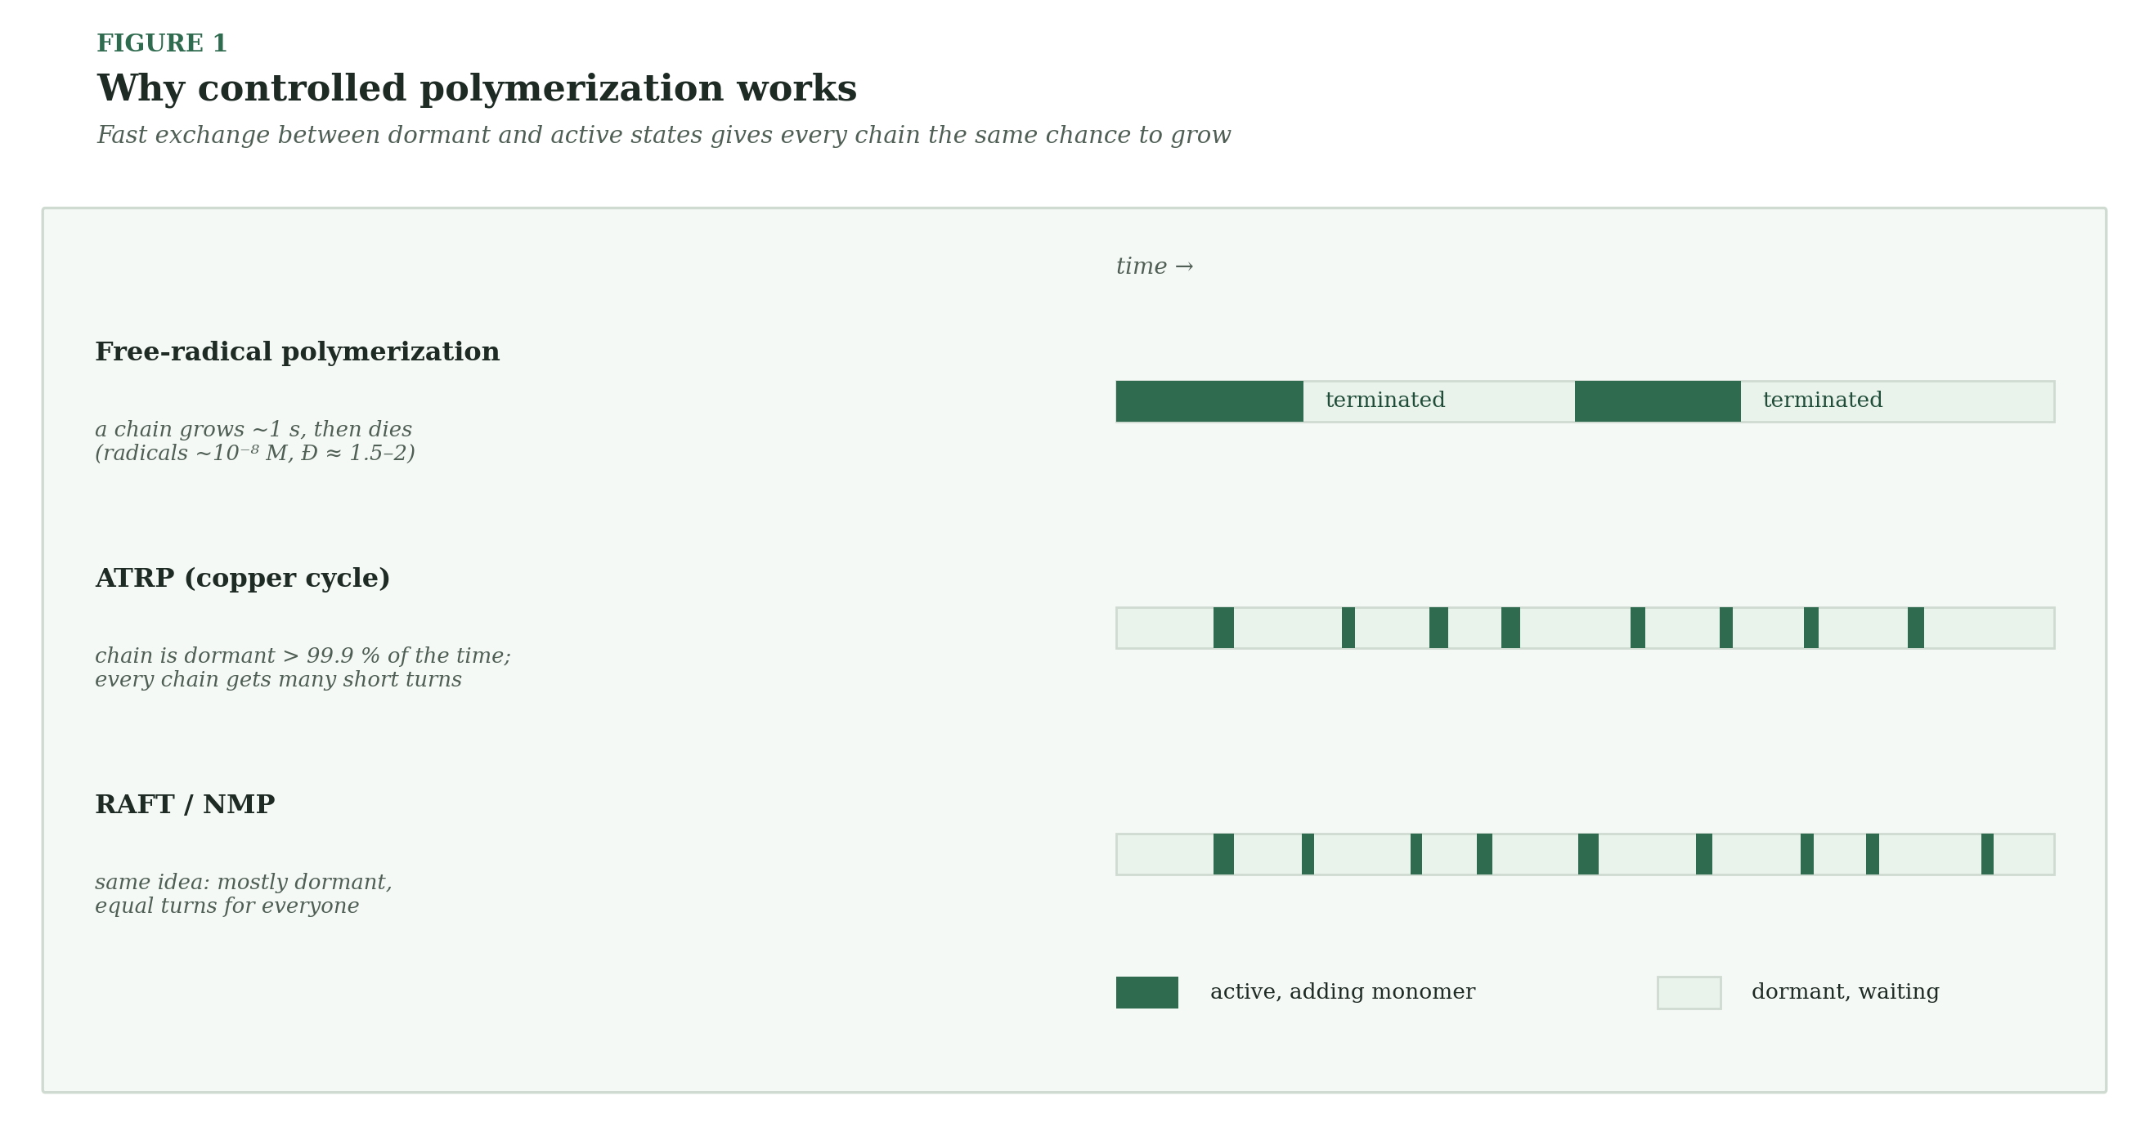
Figure 1 — In free-radical polymerization a chain grows once and dies. In controlled methods every chain is dormant most of the time and gets many short turns.

How to read the schemes
Symbol | Meaning
→ | The reaction goes forward. Text above the arrow gives reagents and conditions; text below gives what is lost or gained.
⇌ | The reaction is reversible. Both directions happen at the same time.
Open bond at the edge of a structure | The polymer continues in that direction: you are looking at one repeat unit.
• (dot) | A radical: an atom with one unpaired electron. This is what grows the chain in radical methods.
Green box | A species that is not drawn as a structure, such as a metal complex or a general formula.
Δ, hν | Heat, light.

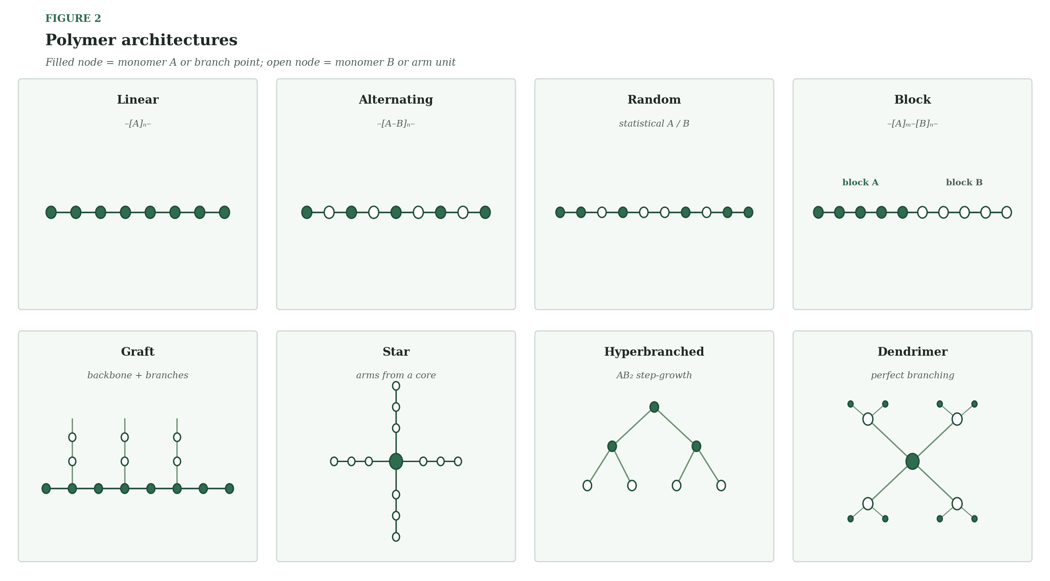
Figure 2 — Chain architectures you can make with the methods in this book.

The five families
Family | Methods | Dispersity (Đ) | What it gives you
Classical | Step-growth, free-radical, anionic, cationic, ROMP | 1.0 – 2.0 | Scale, low cost, wide monomer choice
Living / controlled | ATRP, RAFT, NMP, ROP, siloxane ROP | 1.02 – 1.3 | Narrow distributions, block and graft chains
Advanced | Photo-CRP, eATRP, surface-initiated, IEG, metal–ligand, Ugi | 1.0 – 1.3 | Control in space and time, exact sequences
Emerging | Dynamic covalent, COF, PIM, REMP | — | Healing, crystalline pores, permanent free volume
Bio-related | Enzymatic ROP, PHA in bacteria | 1.1 – 6 | Mild, metal-free, mirror-image purity

Ten numbers worth memorizing
Number | What it tells you
p = 0.99 → Xn = 100 | Carothers: step-growth needs 99 % conversion for even 100 units
1 % monomer imbalance → Xn ≈ 200 | Stoichiometry sets the ceiling on chain length
Đ ≈ 2 / 1.5–2 | Step-growth / free-radical dispersity
Đ ≈ 1.05–1.2 | What ATRP and RAFT usually deliver
Đ ≈ 1.02–1.1 | Living anionic polymerization
K_ATRP ≈ 10⁻⁷ | ATRP chains are dormant almost all the time
−78 °C | Typical temperature for anionic and living cationic work
Tg(PDMS) ≈ −123 °C | Why PDMS is rubbery and so permeable
BET ≈ 700–800 m²/g | PIM-1 micropores
LEP > 3 bar | Target for contactor fibers that must stay dry
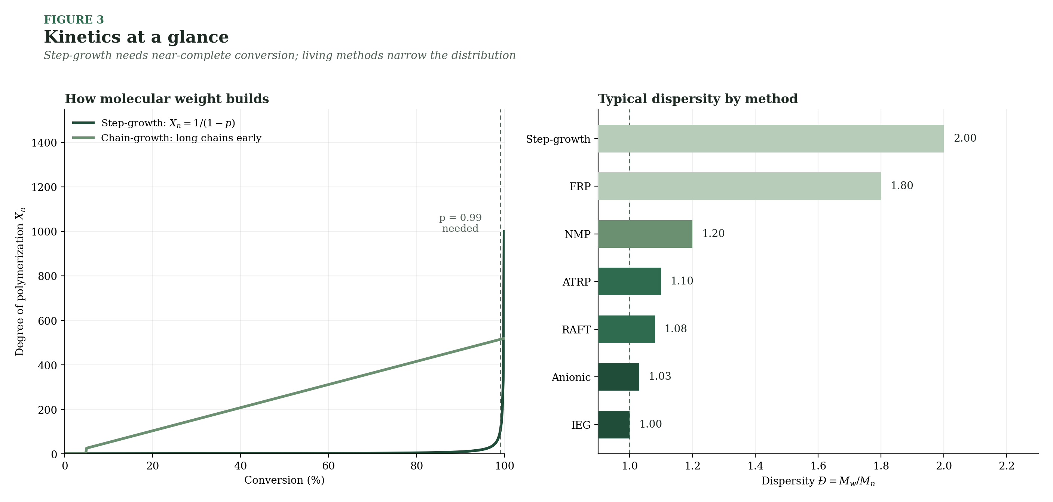
Figure 3 — Left: step-growth builds length late; chain-growth builds it early. Right: typical dispersity by method.

2. Classical Methods
These five methods built the plastics industry. They are not “controlled” in the modern sense (except anionic), but they are cheap, scalable and everywhere in membrane fabrication.

2.1 Step-Growth (Condensation) Polymerization Classical
Two-ended molecules join end to end, like linking train cars — but the long trains only appear when almost every car is connected.
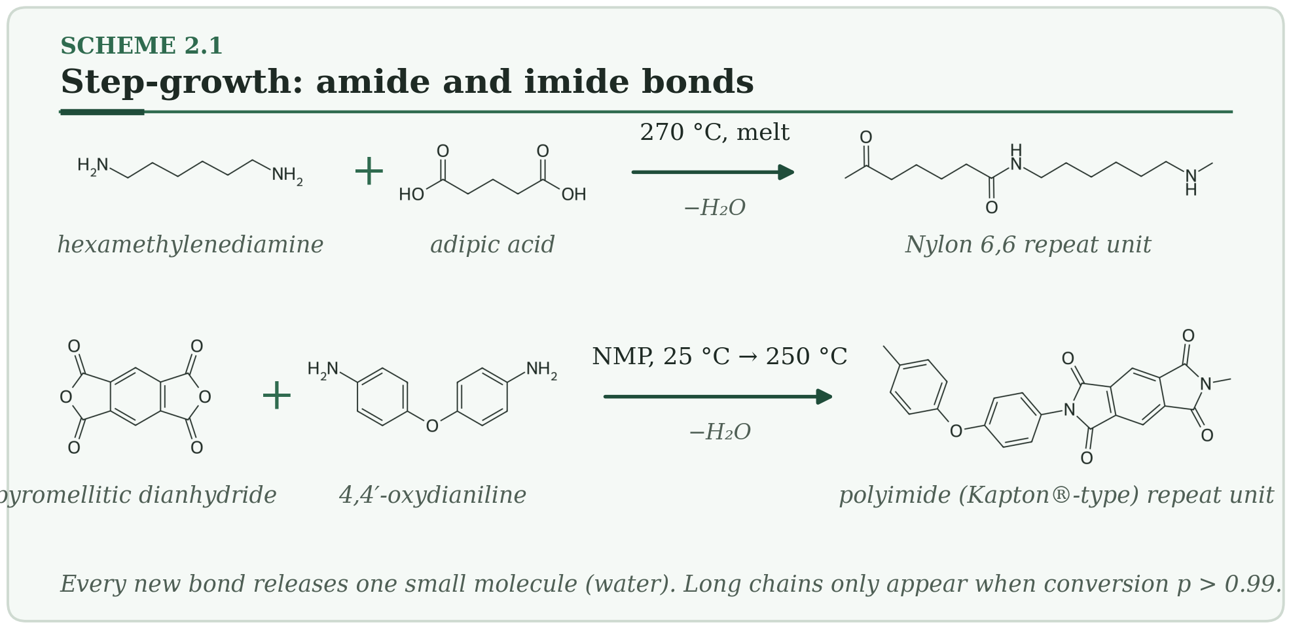
HOW IT WORKS
- A diamine and a diacid meet; the amine nitrogen attacks the carbonyl carbon.
- A molecule of water leaves, and an amide bond is formed (imide bonds form the same way in polyimides).
- Dimers join dimers, then longer chains join each other. Every chain can react with every other chain, so length only explodes near the end (p > 0.99).
Typical conditions. 150–300 °C in the melt, or room temperature in solution with a coupling agent · Đ ≈ 2 · diamines, diacids, diols, diisocyanates, dianhydrides.
Why membranes care. Polysulfone, polyethersulfone, nylon and polyimide — the base polymers of most hollow-fiber UF/NF and gas-separation membranes — are made this way. For polyimide gas-separation membranes, monomer purity sets the final molecular weight.
Watch out. Water must leave the melt or the reaction stalls. Any imbalance in the two monomers limits chain length: a 1 % excess of one monomer caps the degree of polymerization at about 200.
PLANT NOTE | Weigh monomers to ±0.1 % and titrate incoming lots before you charge the reactor.

2.2 Free-Radical Chain Polymerization Classical
A radical hops from monomer to monomer, adding one every millisecond, until it meets another radical and stops.
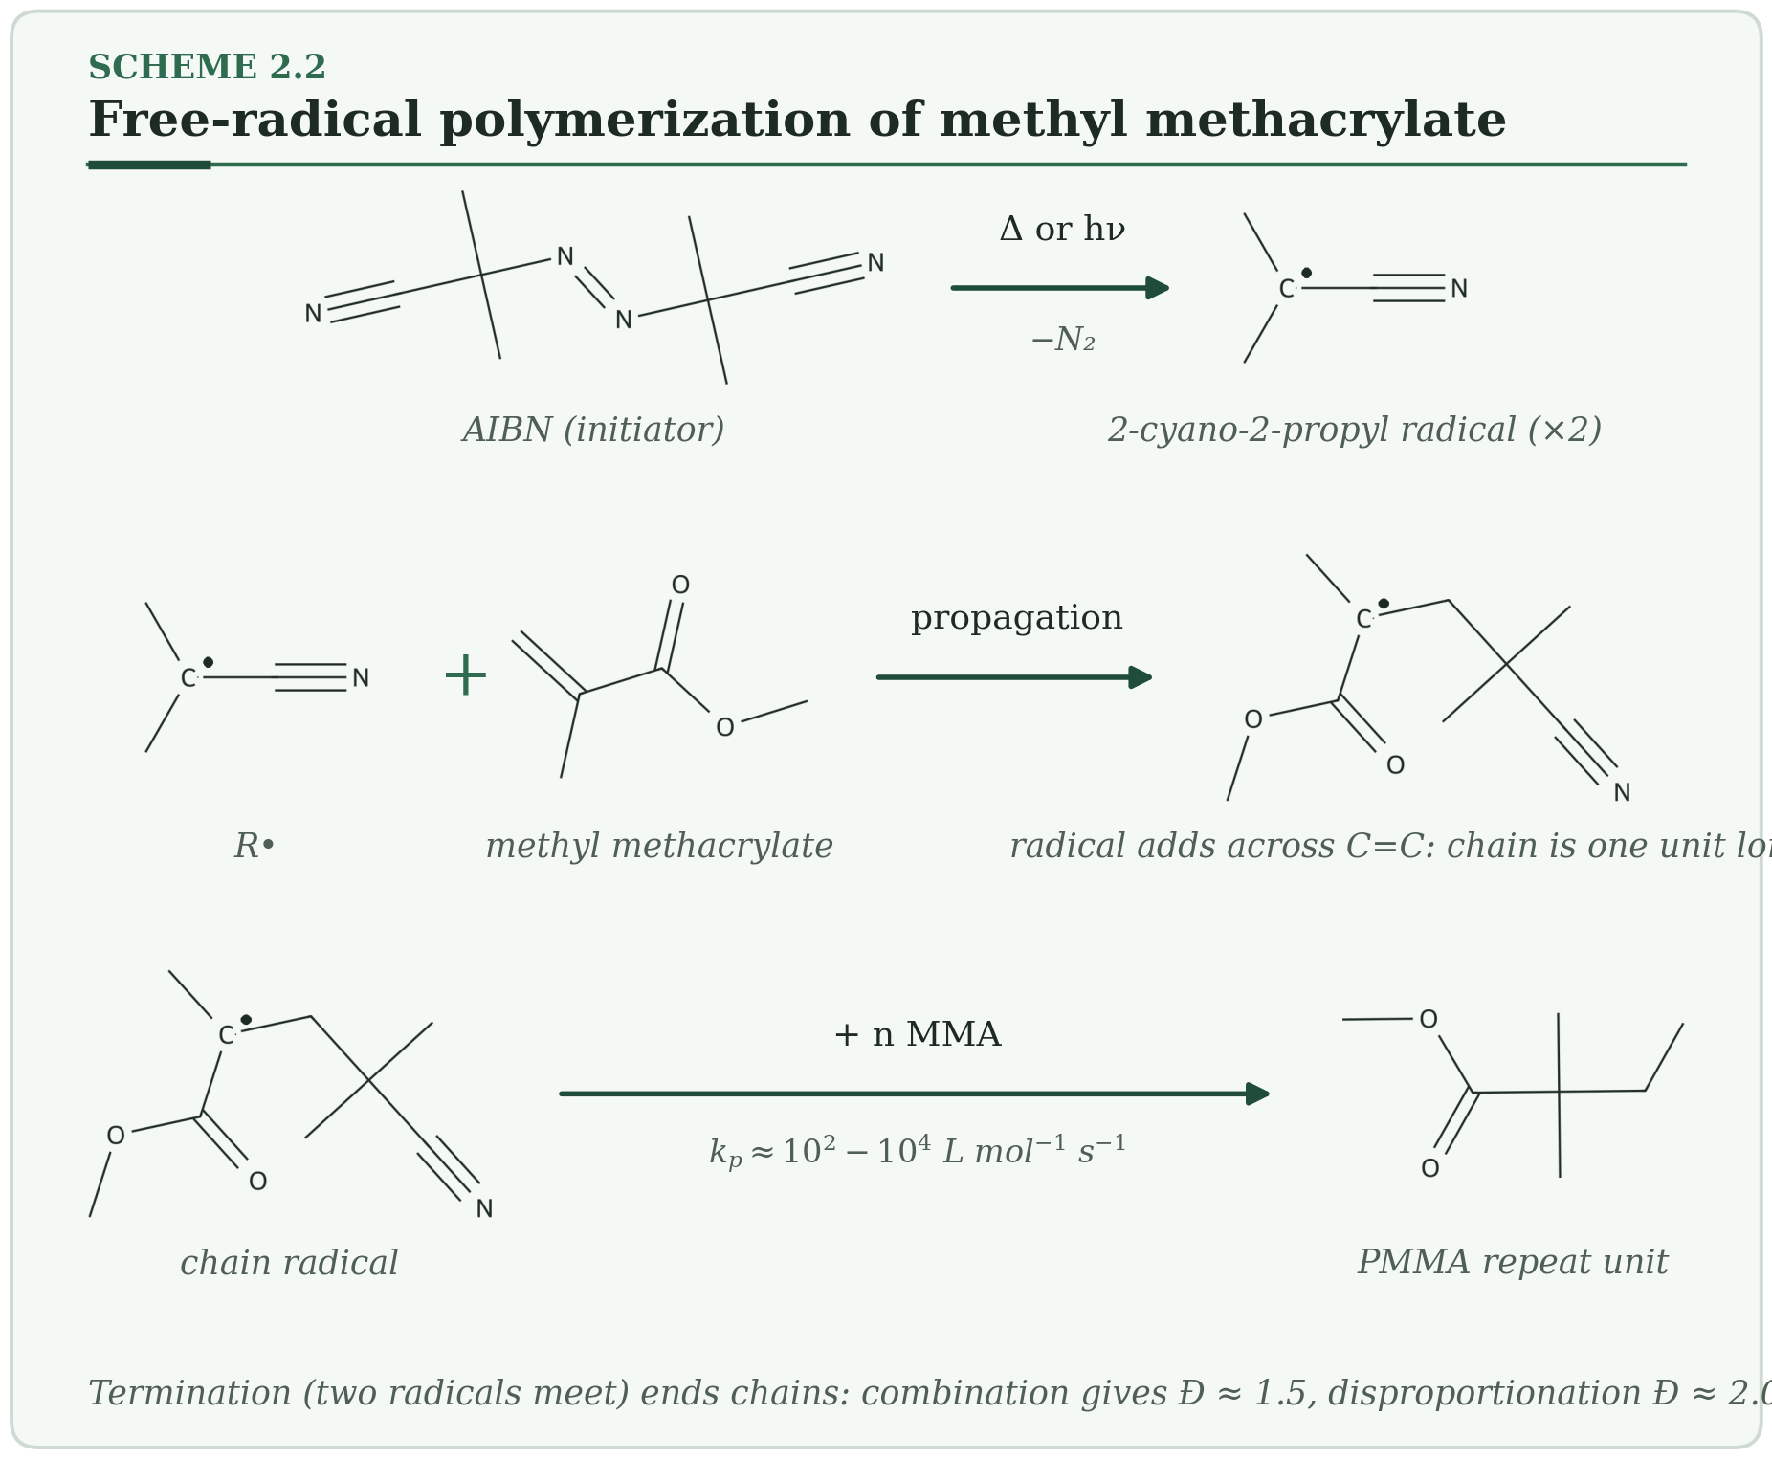
HOW IT WORKS
- Heat or light splits the initiator (AIBN) into two radicals and releases nitrogen.
- A radical adds across the C=C bond of a monomer. The new radical sits at the chain end, ready for the next monomer.
- Two radicals meet and the chain dies: combination (Đ ≈ 1.5) or disproportionation (Đ ≈ 2).
Typical conditions. 50–150 °C · Đ 1.5–2 · acrylates, methacrylates, styrene, vinyl chloride, vinylidene fluoride, acrylonitrile.
Why membranes care. PVDF (by emulsion or suspension polymerization) and PAN, the two most widely used UF/MF membrane polymers, start here and are then shaped by NIPS or TIPS.
Watch out. Oxygen inhibits the reaction. In concentrated systems the gel (Trommsdorff) effect speeds the reaction as viscosity rises, because termination slows — and heat can run away.
PLANT NOTE | Sparge with nitrogen for at least 30 minutes before adding initiator. In bulk, keep conversion below about 60 % unless cooling is strong.

2.3 Anionic Polymerization Classical → living
A negatively charged chain end that never dies by itself — like a candle that only goes out if you blow on it.
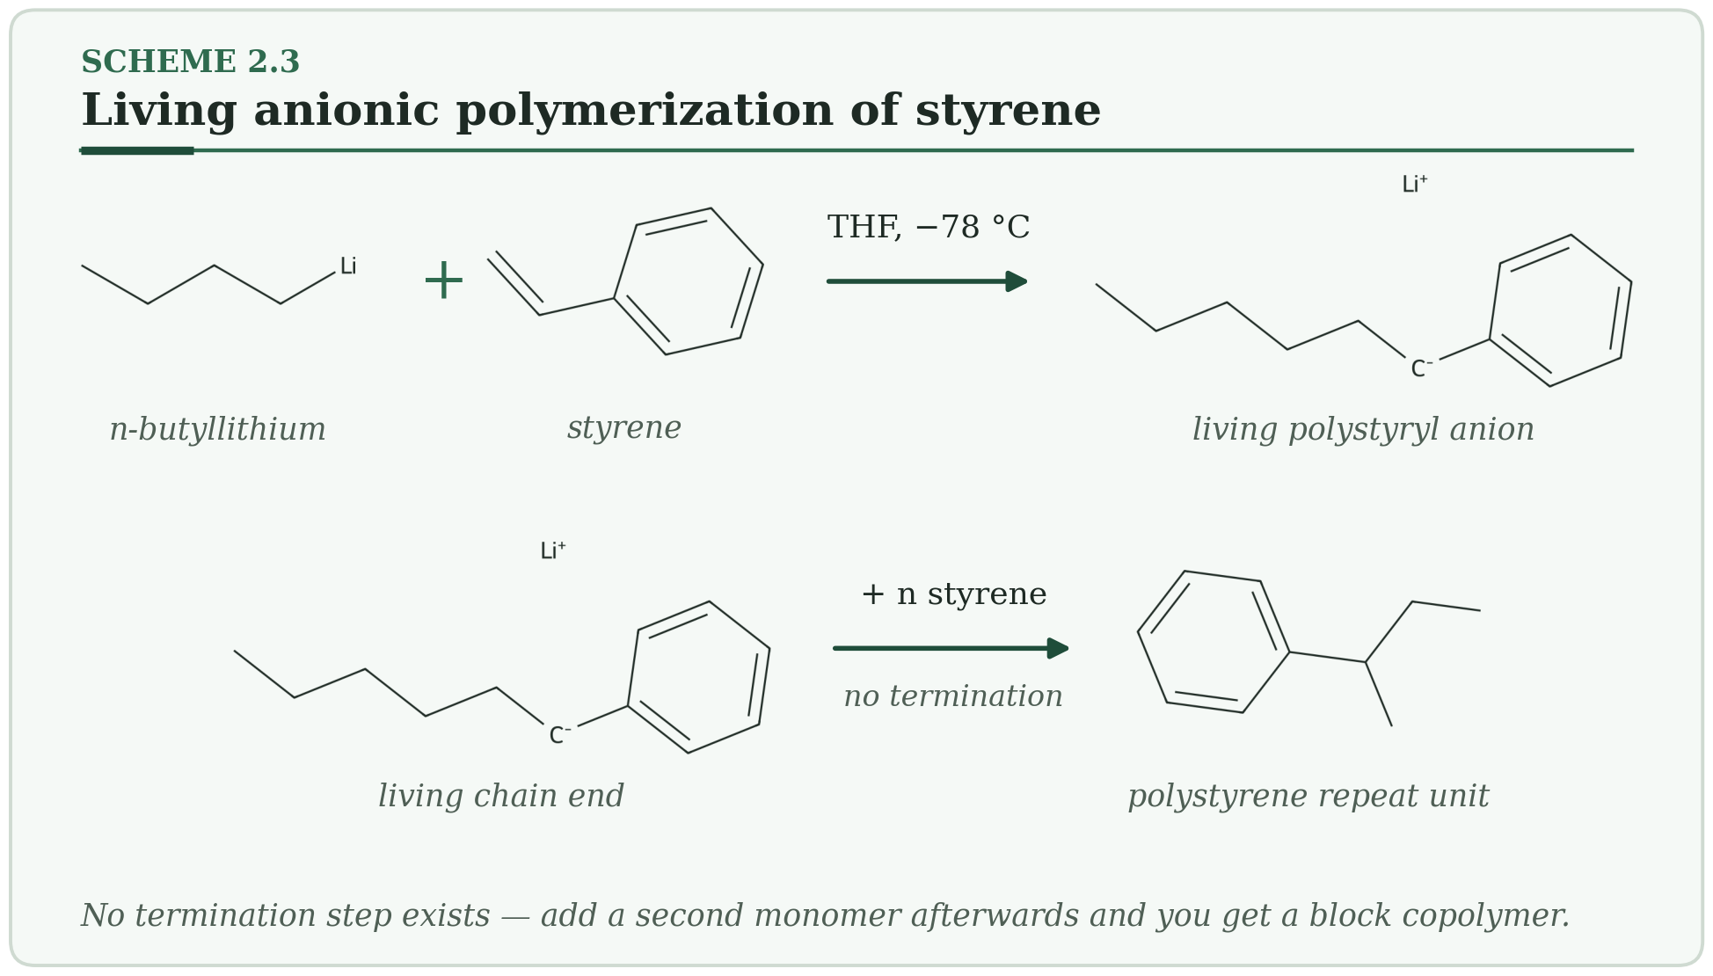
HOW IT WORKS
- n-Butyllithium adds to styrene and creates a carbanion.
- The carbanion keeps adding monomer. Nothing terminates it, so every chain grows at the same rate.
- Add a second monomer for a block copolymer, or an electrophile to cap the chain end.
Typical conditions. −78 °C to room temperature, THF or cyclohexane · Đ 1.02–1.10 · styrene, dienes, ethylene oxide; (meth)acrylates with special care.
Why membranes care. SBS-type triblock copolymers, monodisperse polystyrene standards for GPC calibration, and block copolymers for self-assembled (isoporous) membranes.
Watch out. A few ppm of water, CO₂ or oxygen kills chains. In THF initiation is fast; in cyclohexane, dienes give mostly 1,4-microstructure.
PLANT NOTE | Titrate n-BuLi before every batch — its active concentration sets your molecular weight.

2.4 Cationic Polymerization Classical
A positively charged chain end that is very reactive — so you must keep everything cold and dry.
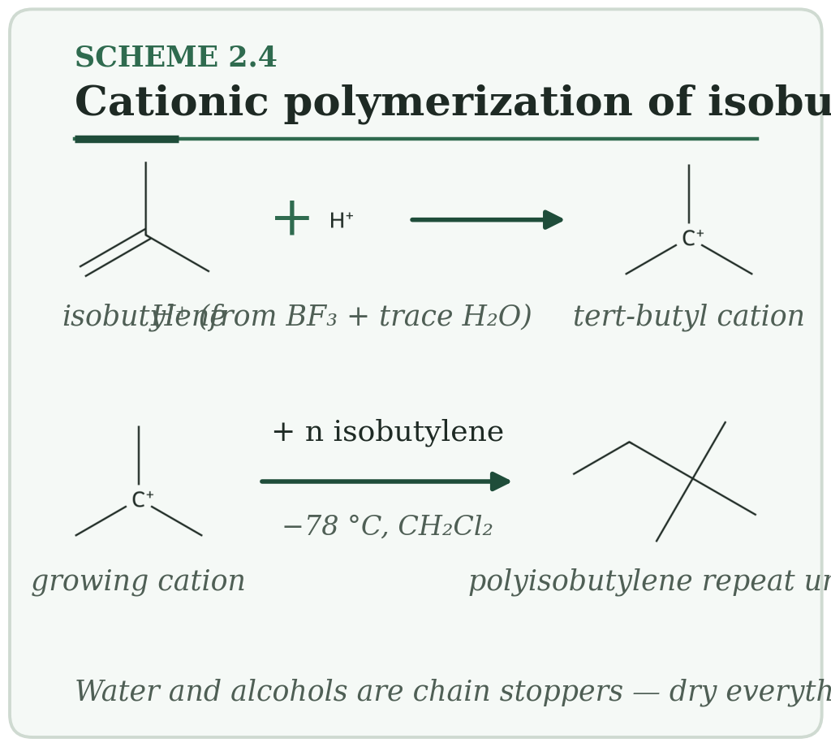
HOW IT WORKS
- A Lewis acid (BF₃, TiCl₄) with a trace of water makes H⁺.
- H⁺ adds to isobutylene and creates a stable tertiary carbocation.
- The cation adds more monomer. At warmer temperatures, loss of a proton ends the chain.
Typical conditions. −100 to 0 °C, CH₂Cl₂ or hexane/methyl chloride · Đ 1.1–3 · isobutylene, vinyl ethers, N-vinylcarbazole, THF.
Why membranes care. Polyisobutylene (butyl rubber) gives gas-barrier layers and soft blocks for sealing and mixed-matrix materials.
Watch out. Alcohols and amines stop chains. Living versions (Kennedy–Faust systems: TiCl₄ with a proton trap near −80 °C) reach Đ < 1.2.
PLANT NOTE | Dry glassware and solvent to a few ppm water. Stray water is the main cause of batch-to-batch scatter.

2.5 Ring-Opening Metathesis Polymerization (ROMP) Classical → living
A metal carbene snips open a strained ring and stitches the pieces into a chain.
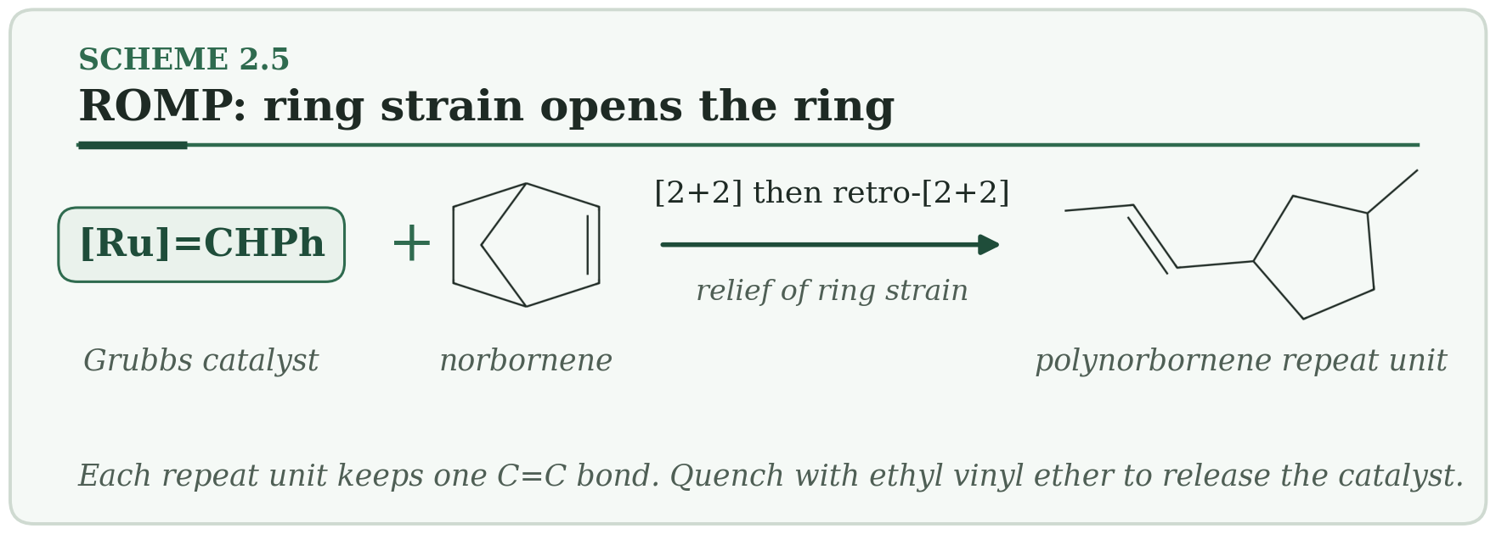
HOW IT WORKS
- The Ru carbene and the C=C bond of norbornene form a four-membered metallacyclobutane ([2+2]).
- The ring opens again (retro-[2+2]). The metal now sits on the new chain end.
- The cycle repeats. Ethyl vinyl ether finally removes the metal and gives an aldehyde end group.
Typical conditions. 20–60 °C, CH₂Cl₂ or toluene · Đ 1.05–1.3 · norbornenes, cyclooctene, dicyclopentadiene.
Why membranes care. Functional polynorbornenes for gas-separation membranes, and poly(dicyclopentadiene) for tough moulded parts.
Watch out. Third-generation Grubbs catalysts start faster than they propagate, which is what makes ROMP living. Free amines and phosphines poison the catalyst.
PLANT NOTE | Store catalyst at −20 °C under argon and weigh it last, just before injection.

3. Living and Controlled Methods
The idea is simple: keep chains dormant, wake them briefly, give each chain the same turn. ATRP, RAFT and NMP do this with radicals; ROP does it with ring-opening. The result is narrow distributions and, with a second monomer, block copolymers.

3.1 ATRP — Atom Transfer Radical Polymerization Living / controlled
Copper keeps almost every chain asleep and wakes each one for a moment, so all chains grow evenly.
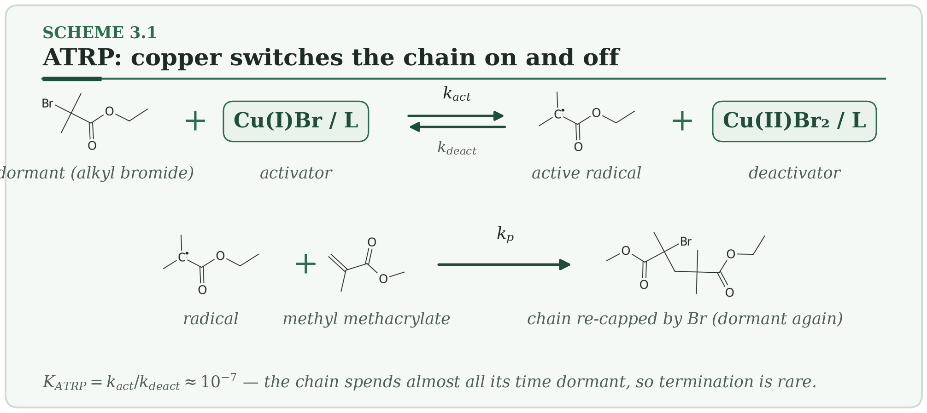
HOW IT WORKS
- Cu(I) removes the bromine from the chain end. This makes a radical and Cu(II)–Br.
- The radical adds a few monomers (k_p) before Cu(II)–Br hands the bromine back.
- Because K_ATRP ≈ 10⁻⁷, the chain is dormant almost all the time, so termination is rare.
Typical conditions. 25–90 °C · Đ 1.05–1.2 · acrylates, methacrylates, styrene, acrylamides, acrylonitrile · 10–100 ppm Cu with ARGET.
Why membranes care. The workhorse for grafting from surfaces: HEMA and SBMA for anti-fouling, DMAEMA for pH response, and silane or fluorinated monomers for anti-wetting on PVDF.
Watch out. Oxygen oxidizes Cu(I): degas, or use ARGET with a reducing agent. Ester-linked initiators can hydrolyze in alkaline amine solutions.
PLANT NOTE | Add 5–10 mol % Cu(II) at the start; it shortens induction and tightens dispersity.

3.2 RAFT — Reversible Addition–Fragmentation Chain Transfer Living / controlled
A chain-transfer agent works like a switchboard, passing the radical from chain to chain so all chains grow together.
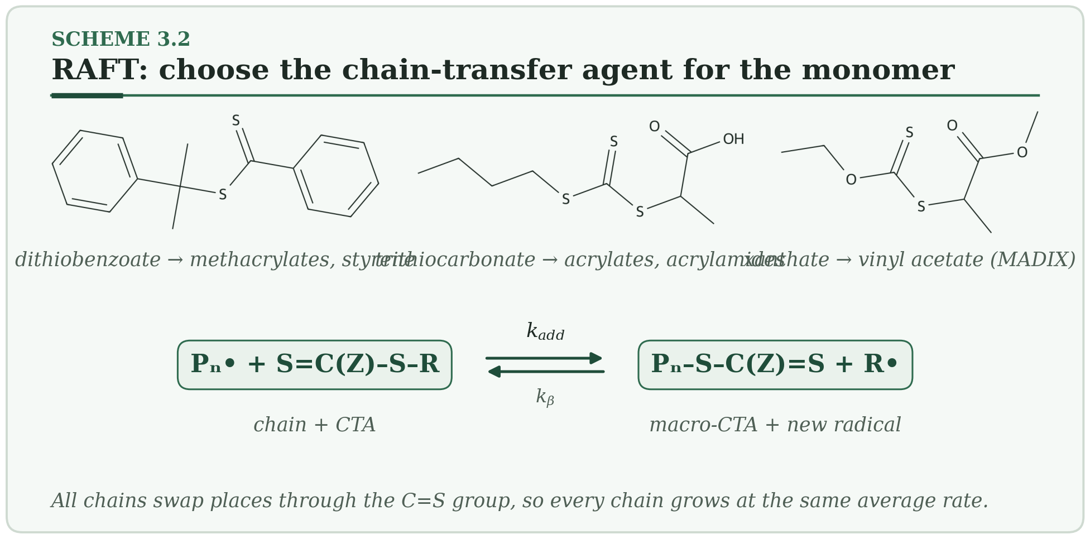
HOW IT WORKS
- A growing radical adds to the C=S bond of the chain-transfer agent (CTA).
- The intermediate fragments, releasing the R group as a new radical and leaving a macro-CTA.
- Fast exchange repeats this for every chain, so each chain gets equal turns.
Typical conditions. 60–80 °C thermal, or room temperature with PET-RAFT · Đ 1.05–1.15 · the widest monomer scope of any controlled radical method.
Why membranes care. No metal is used, which suits ion-exchange and biomedical membranes. SBMA, acrylic acid and DMAEMA brushes are made this way. The CTA end group absorbs near 310 nm, so brush density can be followed.
Watch out. Match the Z and R groups to the monomer (see scheme): a dithiobenzoate will retard vinyl acetate rather than control it. The colored end group can be removed by aminolysis.
PLANT NOTE | Keep CTA under nitrogen in amber glass; thiocarbonylthio groups oxidize in air.

3.3 NMP — Nitroxide-Mediated Polymerization Living / controlled
A stable radical caps the chain end, and heat uncaps it for one more step.
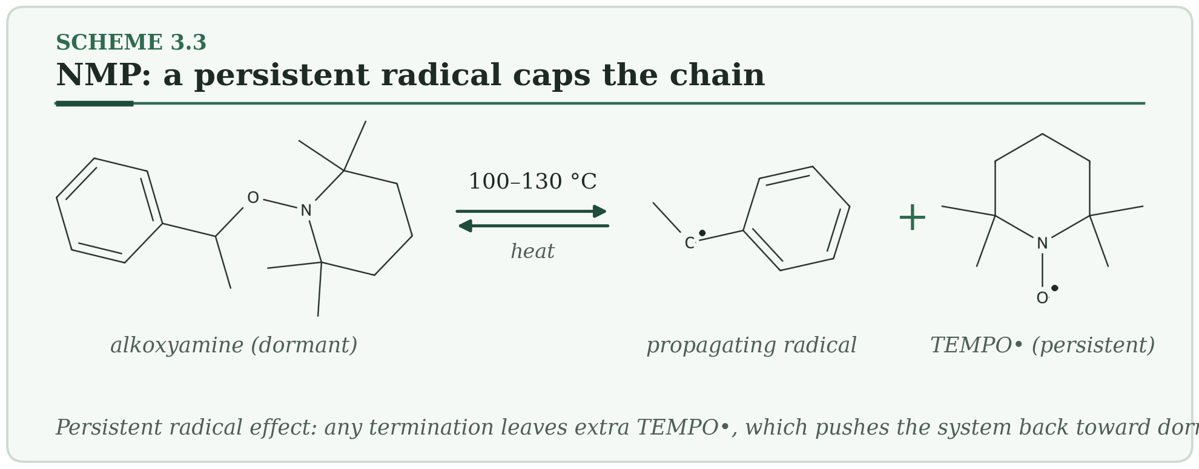
HOW IT WORKS
- Heat breaks the weak C–O bond of the alkoxyamine.
- The carbon radical adds monomer while the nitroxide waits nearby.
- Any terminated chain leaves extra nitroxide behind, which pushes the system back toward capped chains (the persistent radical effect).
Typical conditions. 100–130 °C · Đ 1.1–1.3 · styrene with TEMPO; acrylates and more with SG1.
Why membranes care. A metal-free route to PS-b-PAA and related amphiphilic block copolymers for self-assembled membranes.
Watch out. TEMPO does not control acrylates; use SG1 or TIPNO. Methacrylates are difficult because of a competing hydrogen-transfer reaction.
PLANT NOTE | Do not run below about 100 °C, and keep the headspace under nitrogen for the whole 6–24 h.

3.4 Ring-Opening Polymerization (ROP) Living / controlled
Ring strain does the work: open the ring and the polymer grows, one ring at a time.
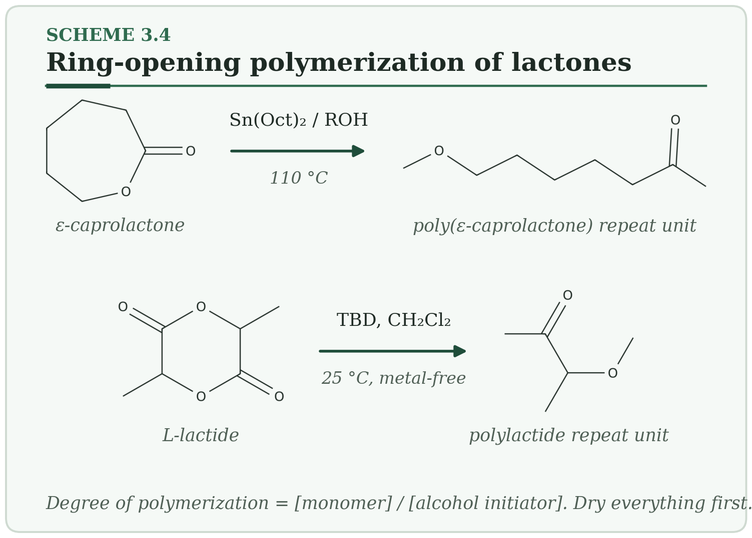
HOW IT WORKS
- An alcohol and Sn(Oct)₂ form a tin alkoxide (or TBD activates the alcohol and the monomer together).
- The alkoxide attacks the ring carbonyl. The ring opens and the chain end becomes a new alkoxide.
- Degree of polymerization = [monomer]/[alcohol]; each alcohol makes one chain.
Typical conditions. 25–180 °C · Đ 1.05–1.2 · lactones, lactide, carbonates, epoxides.
Why membranes care. PLA, PCL and PLGA for biodegradable scaffolds; organocatalytic grades for medical devices; PEO-b-PLA block copolymers for self-assembly.
Watch out. Water is also an initiator, so wet monomer gives low molecular weight. At high conversion, transesterification broadens Đ.
PLANT NOTE | Dry lactide or caprolactone over CaH₂ and distill just before use.

3.5 Anionic Ring-Opening of Cyclosiloxanes Living / controlled
A very flexible Si–O–Si backbone, made by opening a strained ring of three siloxane units.
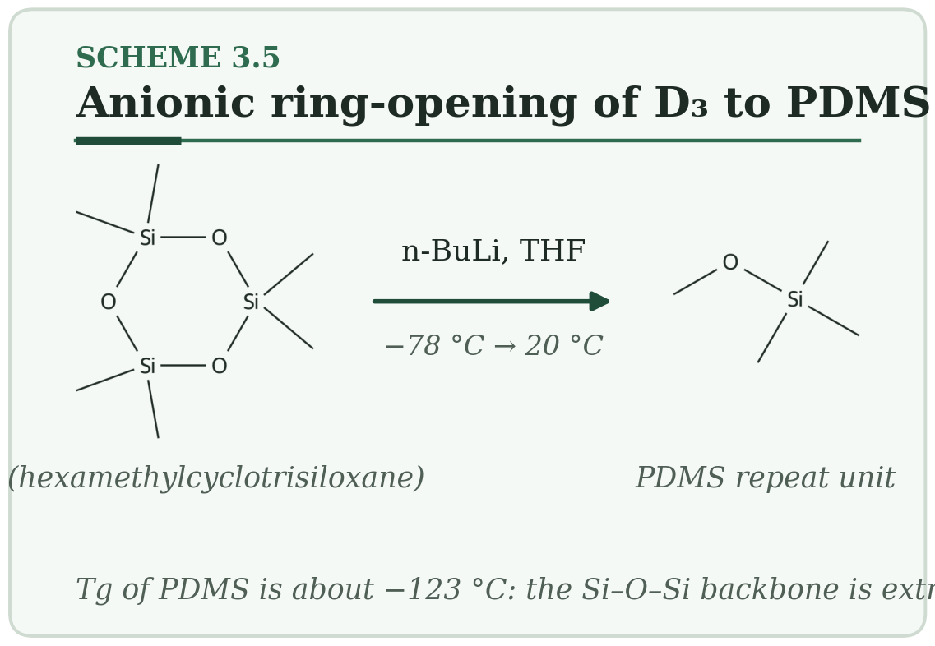
HOW IT WORKS
- n-BuLi attacks silicon in D₃ and opens the ring.
- The silanolate chain end attacks the next D₃ molecule.
- Quench with a chlorosilane to put a functional group on the chain end.
Typical conditions. −78 to 20 °C, THF · Đ 1.05–1.15 · D₃ (strained) polymerizes in a living way; D₄ mostly gives an equilibrium mixture.
Why membranes care. PDMS is the rubbery, high-permeability layer in gas-separation composites; PDMS block copolymers give CO₂-selective domains. Its Tg is about −123 °C.
Watch out. Leftover acid or base slowly redistributes the chains over months (“scrambling”).
PLANT NOTE | Neutralize completely before storage.

4. Advanced Methods
These methods add one more control knob on top of living chemistry: light, voltage, a surface, a protecting group, or a metal ion.

4.1 PhotoATRP and PET-RAFT Advanced
A lamp is the switch: lights on, chains grow; lights off, they pause.
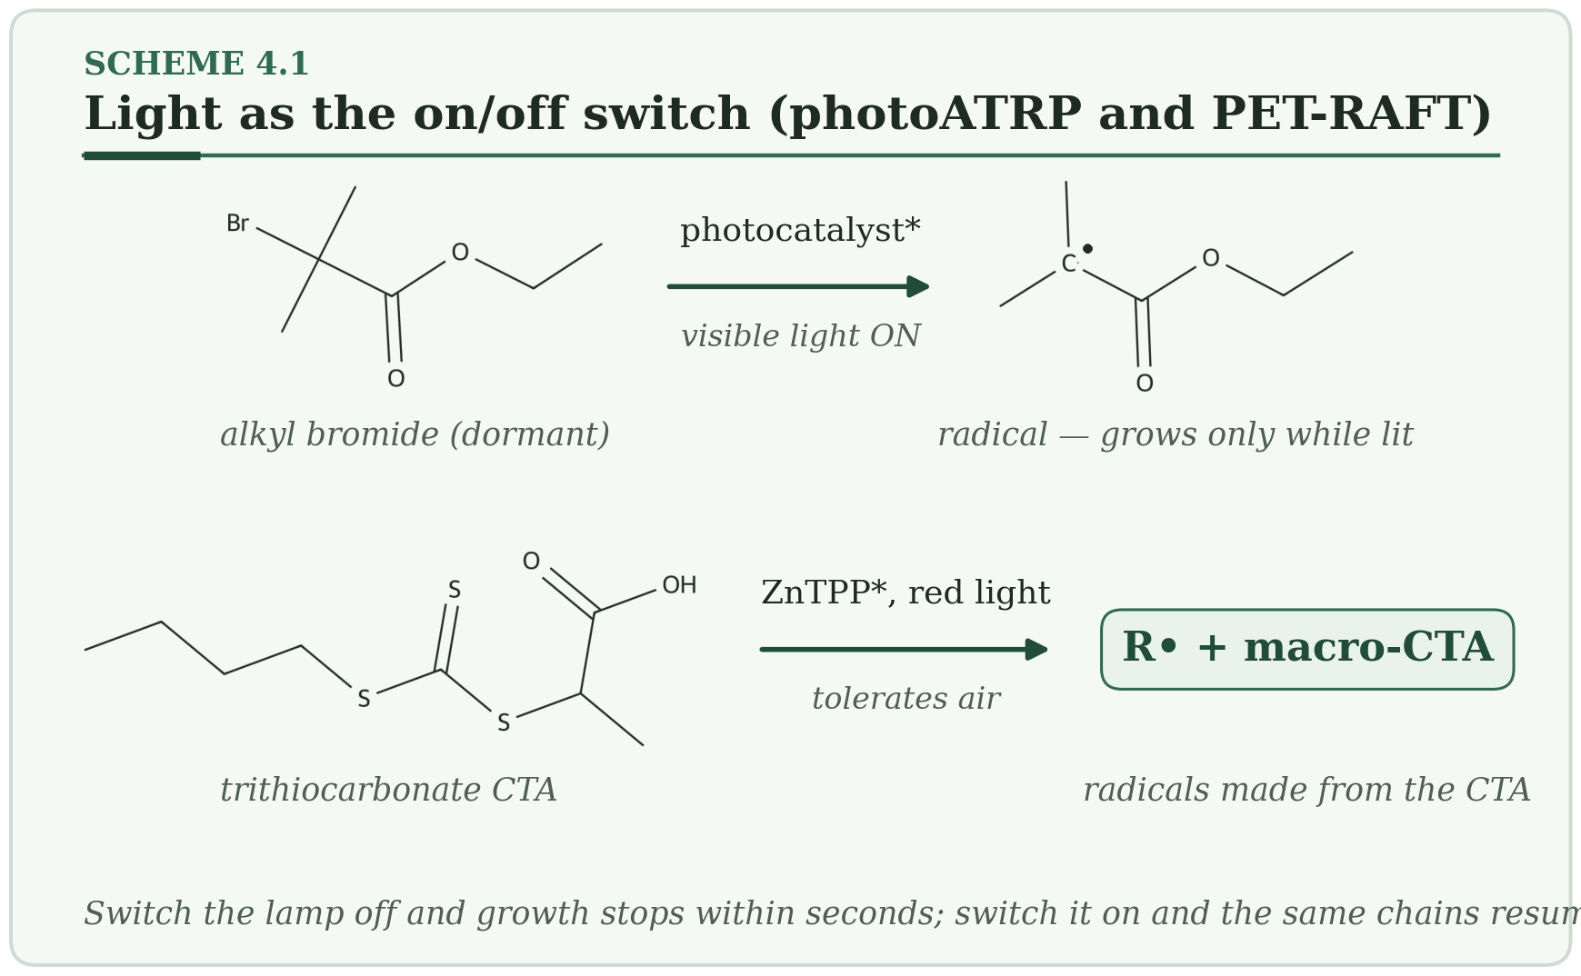
HOW IT WORKS
- A photocatalyst absorbs visible light and reaches an excited state.
- It passes an electron to the C–Br bond (photoATRP) or to the CTA (PET-RAFT), making a radical.
- Turn the light off and the cycle stops; turn it on and the same chains resume.
Typical conditions. Room temperature · Đ 1.05–1.2 · acrylates, methacrylates, acrylamides, HEMA, DMAEMA.
Why membranes care. Photomask patterning of brushes on membranes; PET-RAFT tolerates air, so large surfaces can be grafted in open vessels.
Watch out. Light penetration limits thick samples. Ir(ppy)₃ is costly; eosin Y or fluorescein work for many monomers.
PLANT NOTE | Use organic dyes at pilot scale.

4.2 Electrochemically Mediated ATRP (eATRP) Advanced
Voltage replaces the chemical reducing agent, so you control the polymerization with a dial.
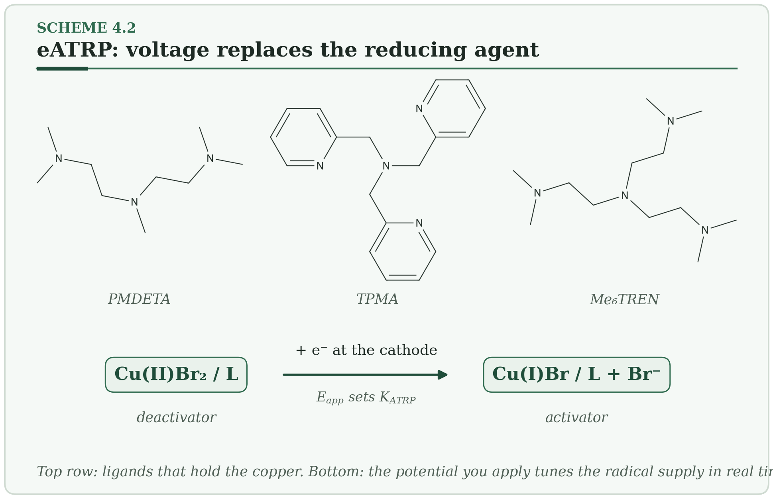
HOW IT WORKS
- At the cathode, Cu(II)–Br gains an electron and becomes Cu(I).
- Cu(I) activates a dormant chain exactly as in normal ATRP.
- A more negative potential gives more Cu(I), more radicals and a faster reaction.
Typical conditions. Room temperature to 40 °C · Đ 1.05–1.1 · below 10 ppm Cu is possible · ligands PMDETA, TPMA or Me₆TREN.
Why membranes care. Brushes on conductive supports (carbon, ITO, graphene) and on electrode membranes.
Watch out. Use a divided cell; otherwise Cu(I) is re-oxidized at the counter electrode and control is lost.
PLANT NOTE | Use a divided cell as standard practice.

4.3 Surface-Initiated Controlled Radical Polymerization Advanced
Grow the chains from the membrane itself, like blades of grass from soil.
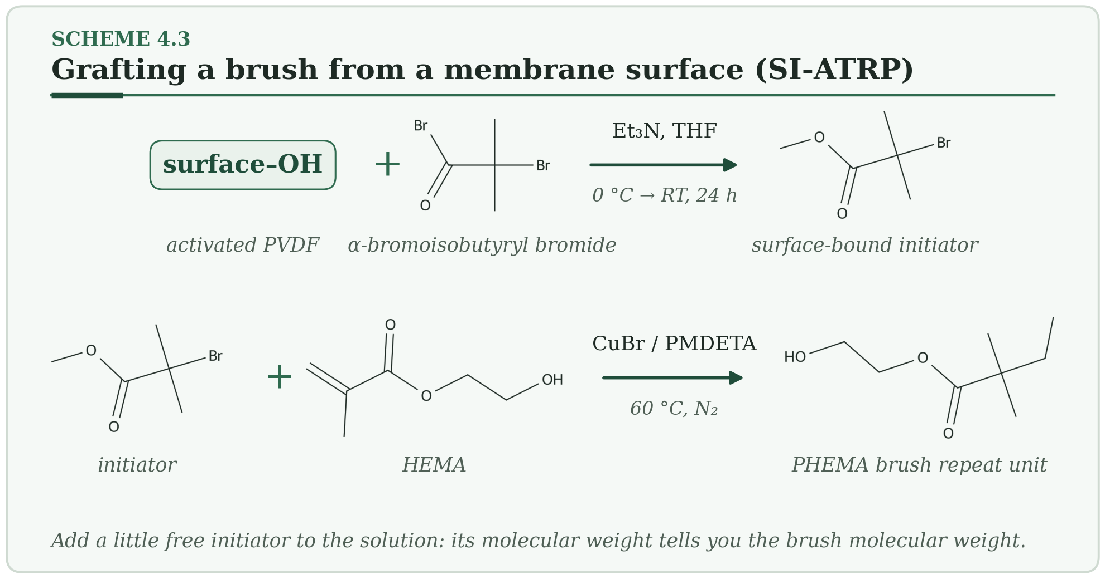
HOW IT WORKS
- Anchor an initiator on the surface (first row of the scheme).
- Grow brushes from it by ATRP or RAFT (second row).
- Chain length is set by [monomer]/[initiator]; grafting density by how much initiator you attached.
Typical conditions. 25–70 °C · brush Đ ≈ 1.1–1.3 (estimated from free chains) · HEMA, SBMA, DMAEMA, NIPAM, acrylic acid.
Why membranes care. Anti-fouling PVDF (PHEMA, PSBMA), pH-responsive pores (PDMAEMA) and anti-wetting fibers for contactors.
Watch out. Very dense brushes terminate each other; aim for heights of 10–50 nm. Ester linkers hydrolyze in alkaline amine solvents.
PLANT NOTE | Run a free-initiator control with every batch — it is your only handle on brush molecular weight.

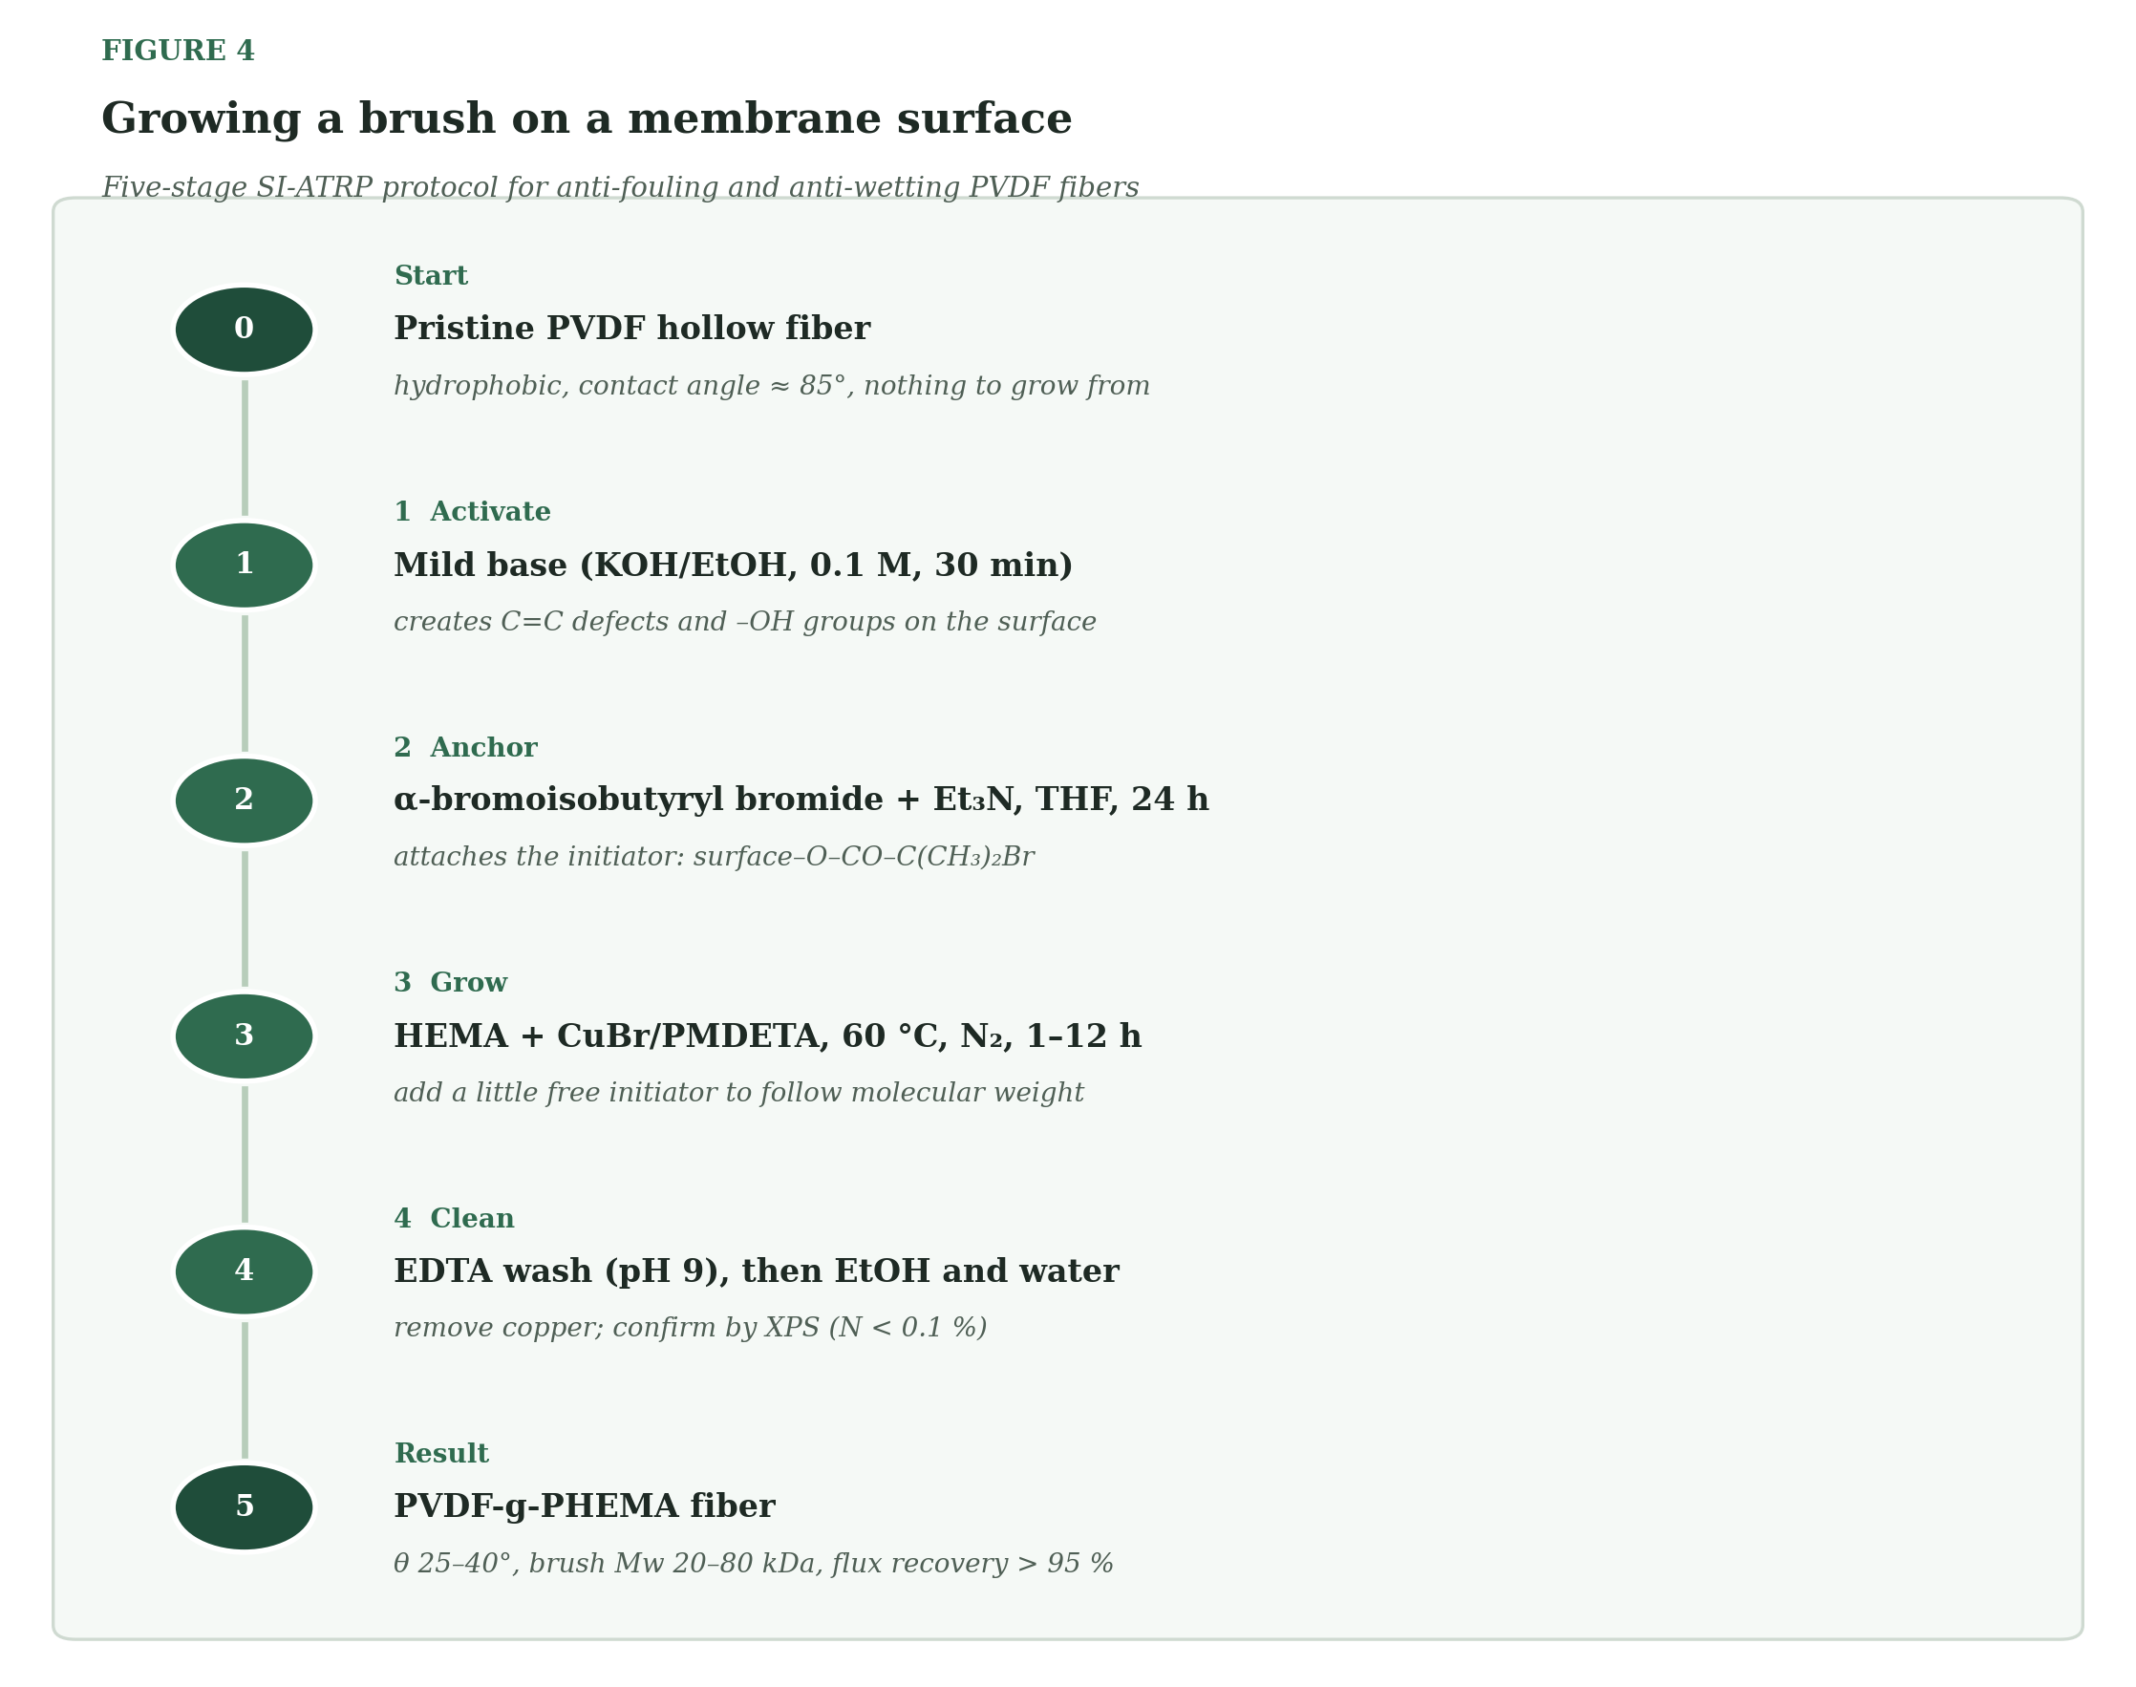
Figure 4 — The five-stage protocol behind Scheme 4.3, applied to a PVDF hollow fiber.

4.4 Iterative Exponential Growth (Sequence-Defined Polymers) Advanced
Build a molecule one defined piece at a time, like spelling a word with letters you choose.
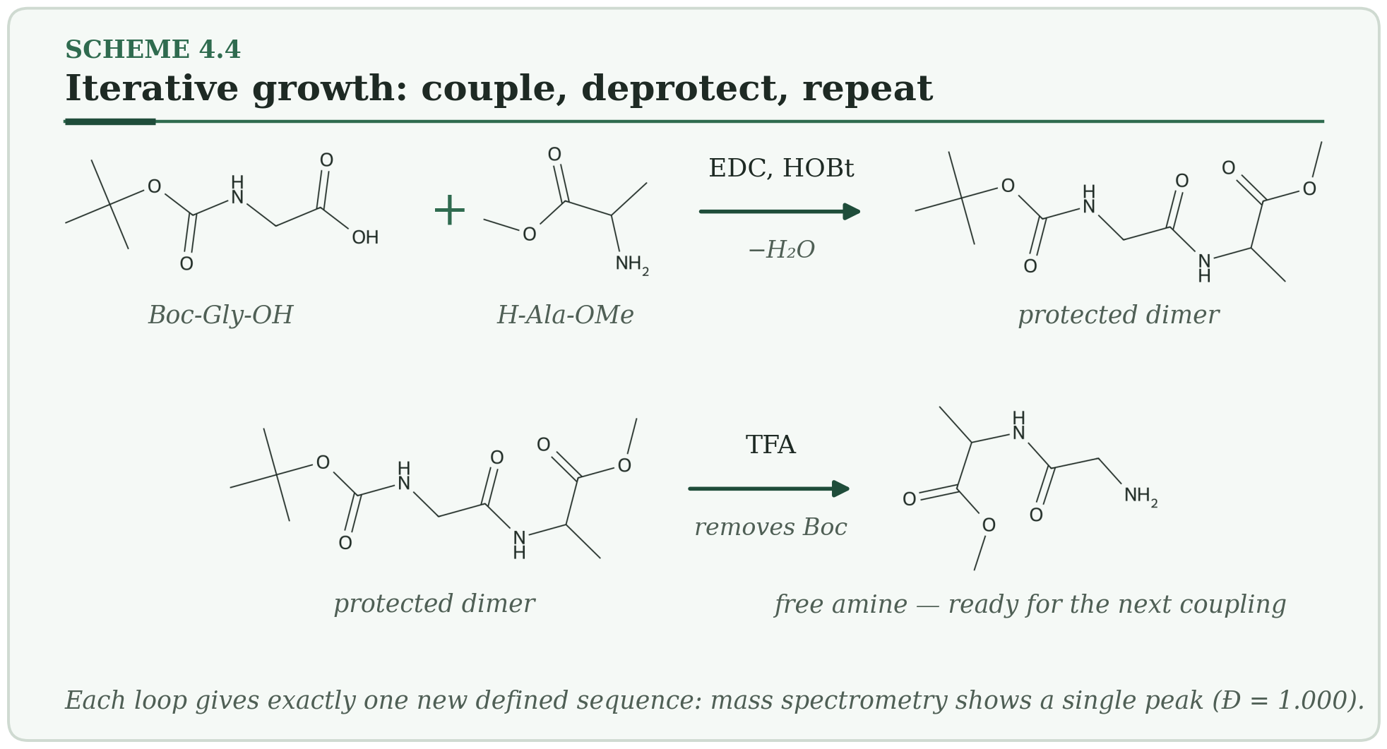
HOW IT WORKS
- Couple two protected units.
- Remove one protecting group.
- Repeat with dimers, then tetramers, then octamers: after n cycles you have a 2ⁿ-mer with one exact sequence.
Typical conditions. Room temperature to 100 °C · Đ = 1.000 · amino acids, hydroxy acids, any pair with orthogonal protection.
Why membranes care. Monodisperse calibration standards and precision oligomers that self-assemble into water channels.
Watch out. Yield compounds: 95 % per cycle is only about 74 % after six cycles.
PLANT NOTE | Track cumulative yield in the route plan.

4.5 Metallo-Supramolecular Polymerization Advanced
Metal ions act as glue between ligand-ended chains, and the glue can come apart and re-form.
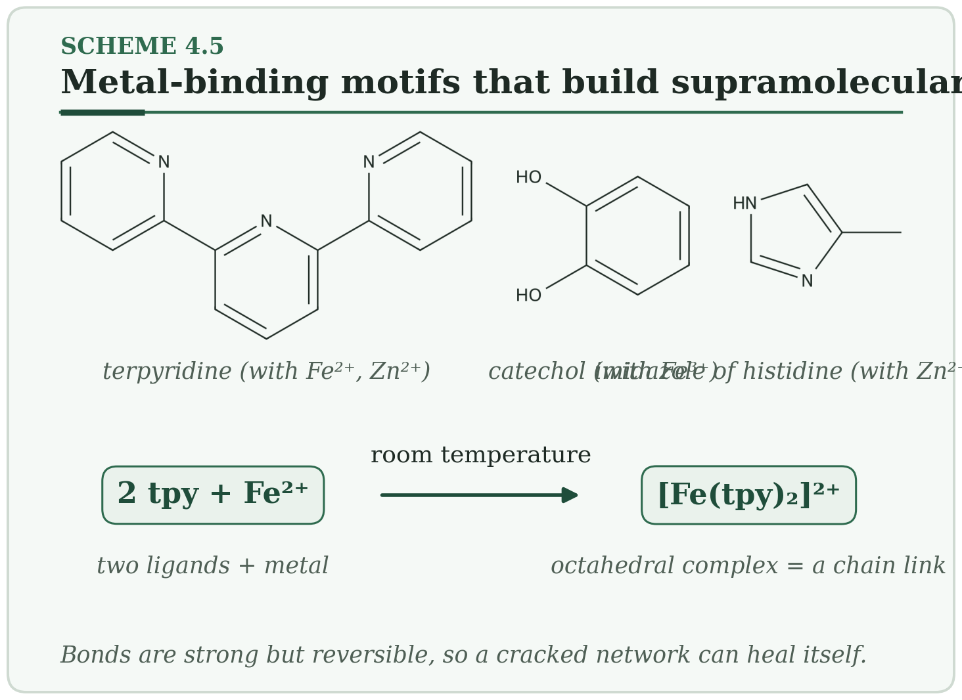
HOW IT WORKS
- Two terpyridine units wrap around one Fe²⁺ ion.
- Many such complexes link into chains or networks.
- A change in redox state, pH or a competing ligand opens the link; it re-forms on its own.
Typical conditions. Room temperature · no classical Đ · terpyridine, bipyridine, catechol and imidazole ligands.
Why membranes care. Self-healing coatings and films; luminescent Eu³⁺ units for detecting membrane defects.
Watch out. Metal leaching matters for food and pharmaceutical service.
PLANT NOTE | Test leaching by ICP-MS before qualifying a membrane.

4.6 Multicomponent (Ugi) Polymerization Advanced
Four ingredients, one pot, one new molecule.
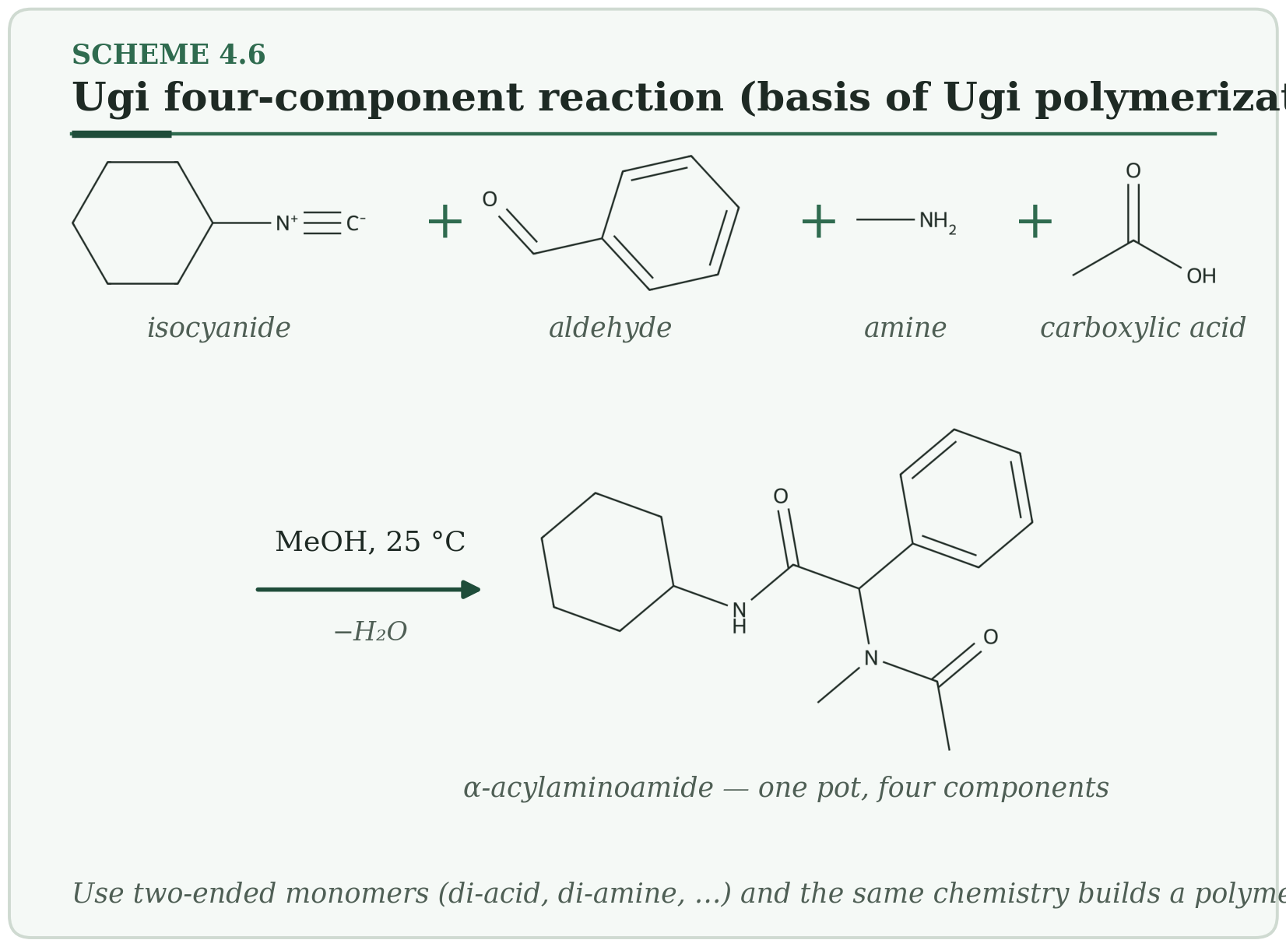
HOW IT WORKS
- Amine and aldehyde make an imine.
- The acid protonates it and the isocyanide adds.
- A Mumm rearrangement gives the α-acylaminoamide; with two-ended monomers this becomes a polymer.
Typical conditions. Room temperature to 60 °C, methanol or solvent-free · Đ ≈ 2 · isocyanides, aldehydes, amines, carboxylic acids.
Why membranes care. Fast libraries of CO₂-philic polymers for membrane screening.
Watch out. Isocyanide supply and odor limit scale-up.
PLANT NOTE | Pilot the isocyanide supply before a screening campaign.

5. Emerging Methods
The common thread is reversibility: bonds that exchange, frameworks that repair themselves, chains that cannot pack, rings that grow.

5.1 Dynamic Covalent Networks and Vitrimers Emerging
Bonds that can swap partners — so a hard network can flow, heal or be recycled.
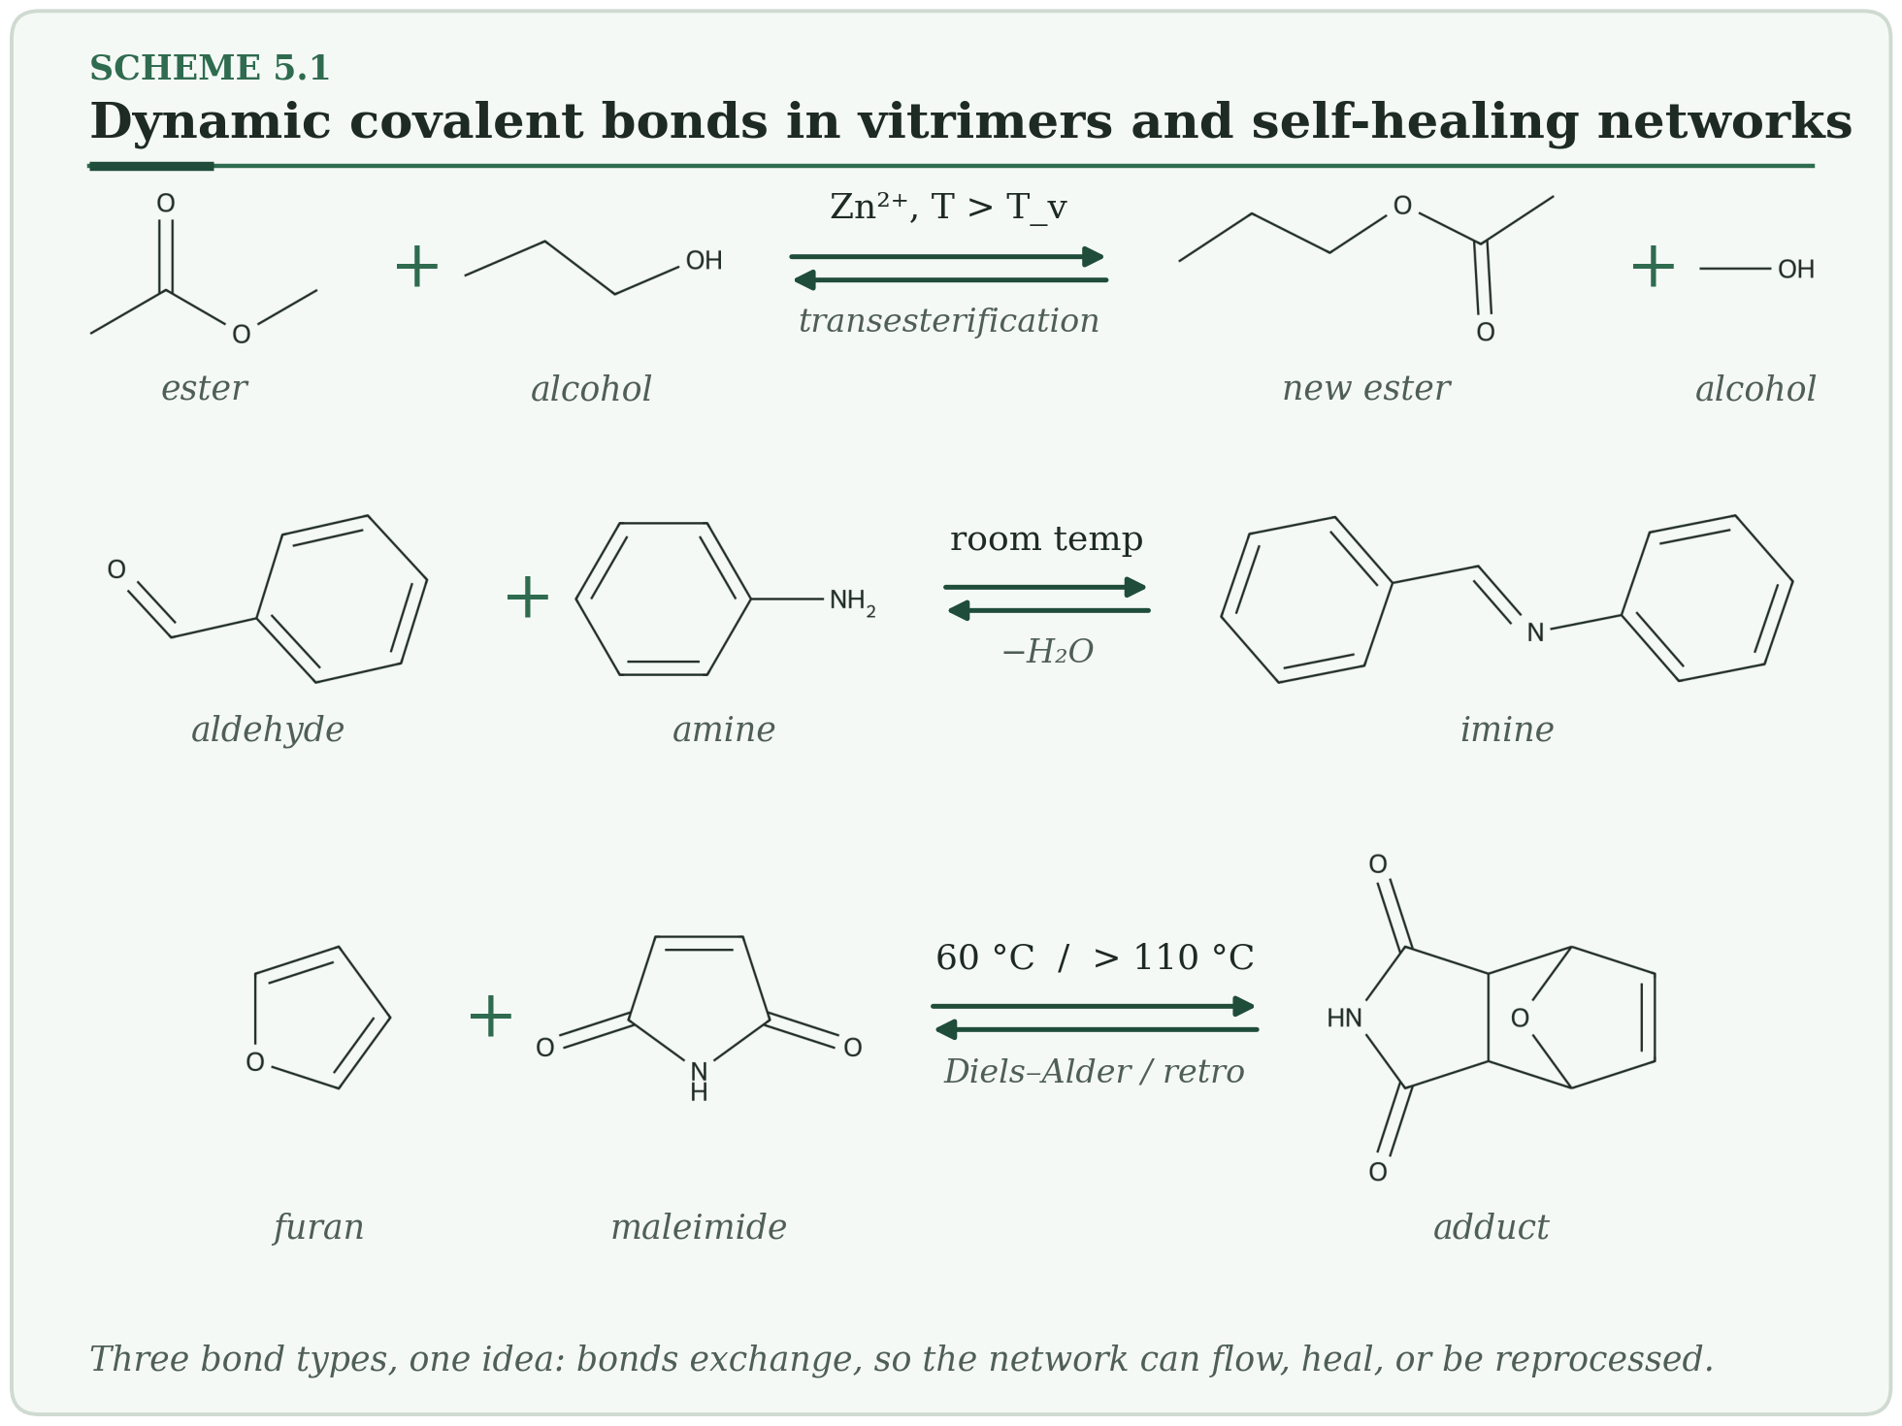
HOW IT WORKS
- Vitrimers: ester + OH gives a new ester + new OH. The number of crosslinks never changes, so the network keeps its integrity.
- Imine and Diels–Alder bonds open and close with pH or temperature.
- Above the topology-freezing temperature T_v the network flows like a viscous liquid; below it, it behaves as a solid.
Typical conditions. 25–200 °C · networks, so no Đ · epoxy–acid, diamine–dialdehyde, furan–maleimide.
Why membranes care. Reprocessable and self-healing membranes and module parts.
Watch out. Catalysts (Zn salts, TBD) can leach. Measure T_v by stress-relaxation rheometry.
PLANT NOTE | Confirm T_v by rheometry before choosing a reprocessing temperature.

5.2 Covalent Organic Frameworks (COFs) Emerging
Rigid building blocks that can undo their own mistakes, so they crystallize into a perfect porous sheet.
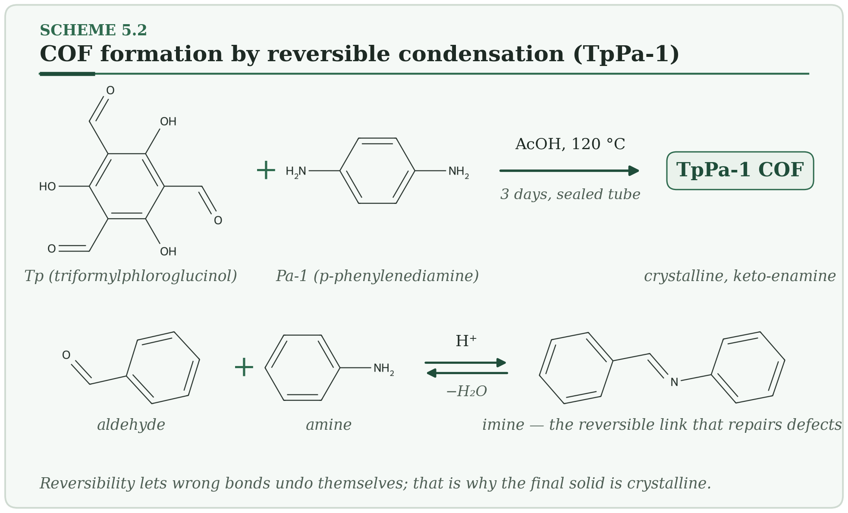
HOW IT WORKS
- Aldehyde and amine groups condense and release water. The reaction is reversible.
- Wrong bonds reopen and reform until the structure is ordered.
- In TpPa-1 the imine tautomerizes to a keto-enamine, which locks the structure and makes it chemically robust.
Typical conditions. About 120 °C for 3 days, AcOH catalyst · crystalline · pore sizes 1–5 nm.
Why membranes care. Thin films by interfacial polymerization, and fillers in PVDF or polyimide mixed-matrix membranes.
Watch out. Free-standing COF films are brittle; boronate-ester COFs hydrolyze at low pH.
PLANT NOTE | Grow the COF directly on a porous support.

5.3 Polymers of Intrinsic Microporosity (PIM-1) Emerging
A polymer that cannot pack — it is built so awkwardly that it leaves holes.
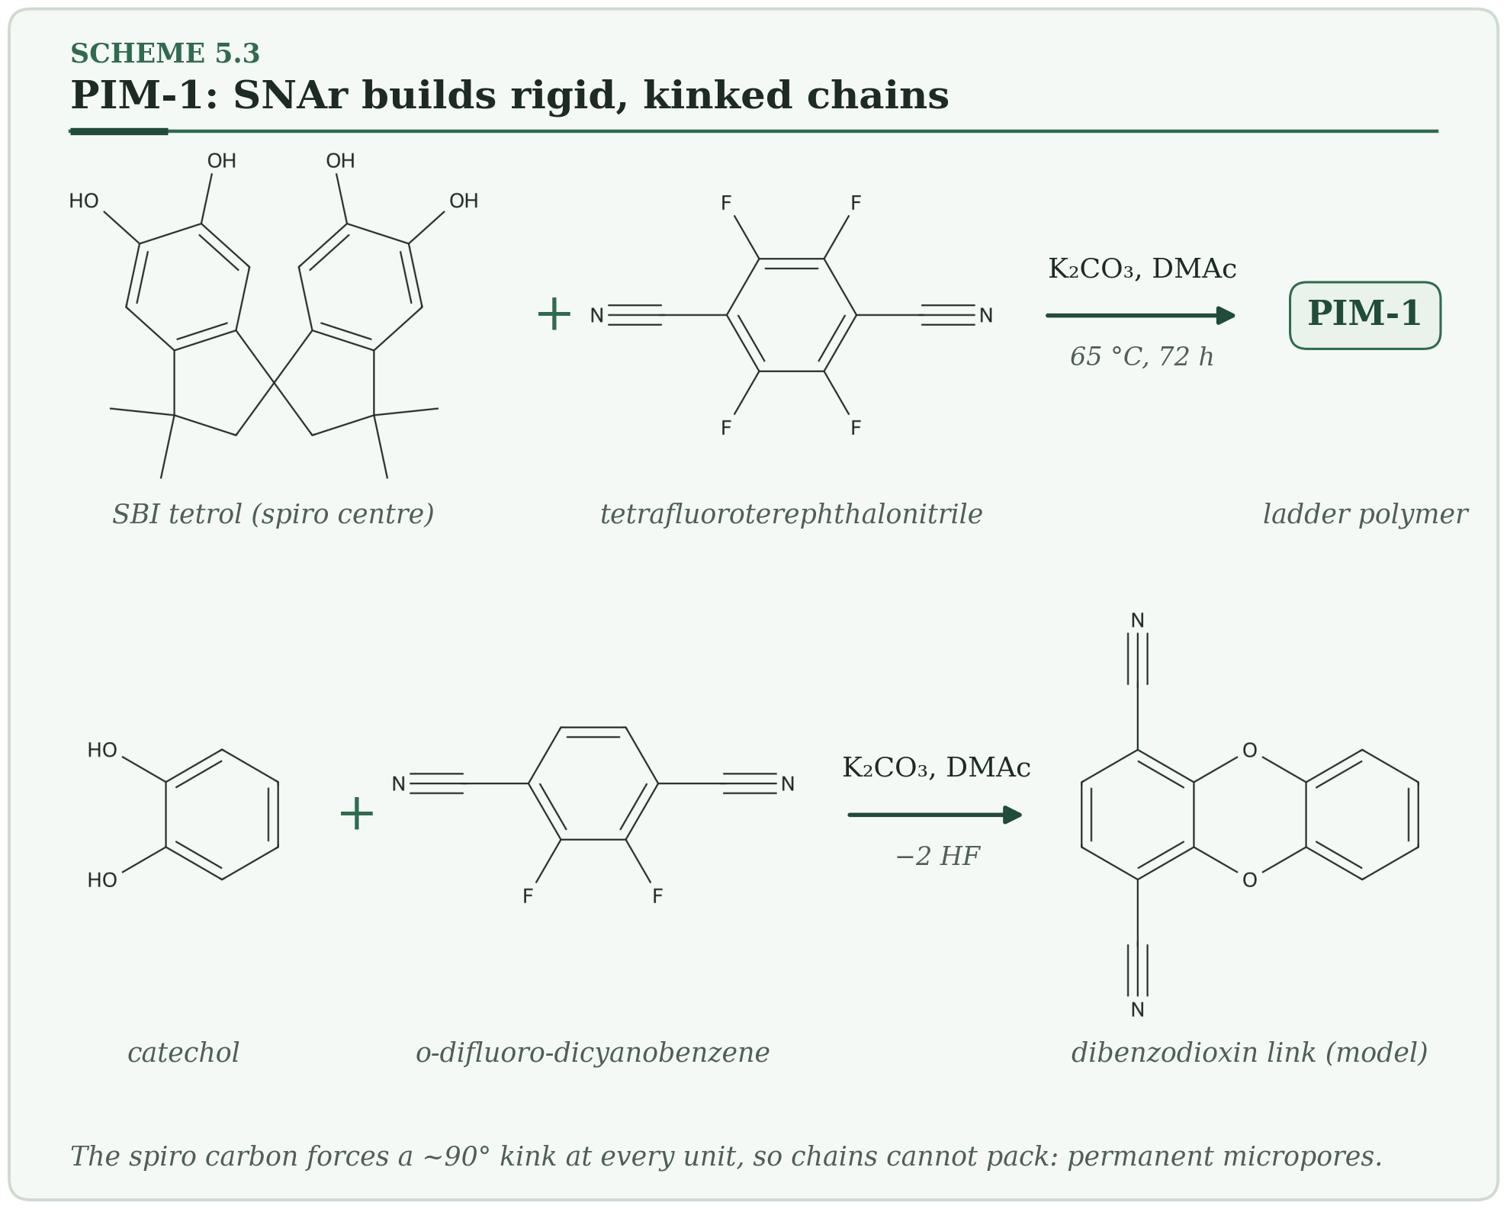
HOW IT WORKS
- A catechol oxygen attacks a carbon bearing fluorine (SNAr); fluoride leaves.
- A second attack on the neighbouring C–F closes a dibenzodioxin ring.
- The spiro centre kinks every unit, so the ladder chains cannot pack and leave interconnected micropores.
Typical conditions. 65 °C, 72 h, K₂CO₃ in DMAc · Đ 2–10 · BET about 700–800 m²/g.
Why membranes care. Gas-separation films that sit above the 2008 Robeson upper bound, and fillers for PVDF or polyimide matrices.
Watch out. Physical aging: permeability falls by tens of percent over months to years as free volume collapses.
PLANT NOTE | Cast promptly, store under vacuum, and crosslink if long-term stability matters.

5.4 Ring-Expansion Metathesis Polymerization (REMP) Emerging
A ring that grows — the polymer has no beginning and no end.
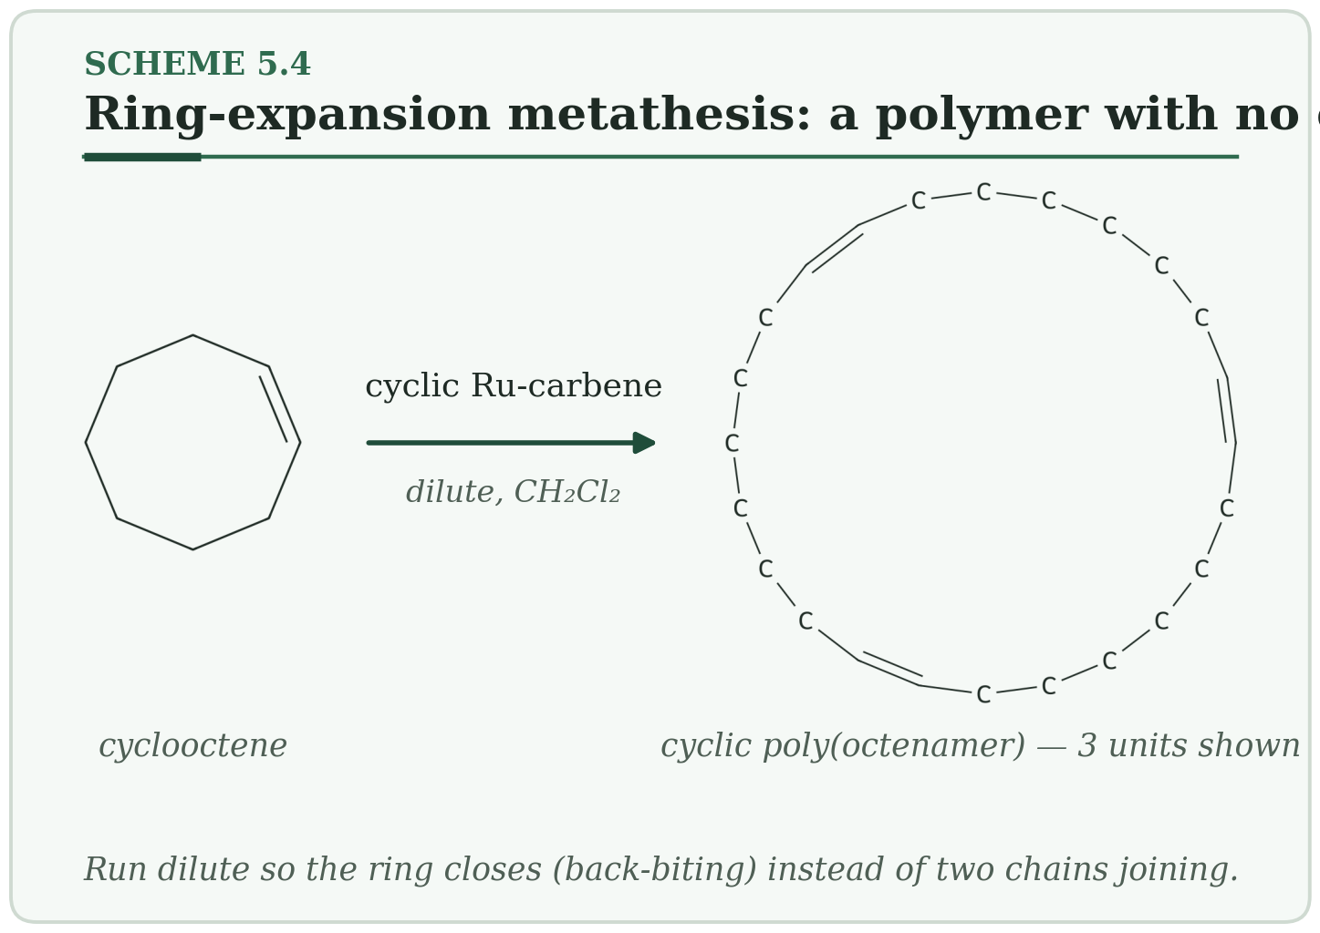
HOW IT WORKS
- A cyclic Ru-carbene opens cyclooctene.
- The ring expands by one unit each time.
- Back-biting finally frees the catalyst and leaves a cyclic polymer.
Typical conditions. Room temperature to 40 °C, dilute · Đ 1.1–1.3.
Why membranes care. Cyclic polymers have a smaller coil size and lower solution viscosity than linear ones, which can help casting solutions.
Watch out. At high concentration, chains join each other and you get linear contaminants.
PLANT NOTE | Keep monomer below about 0.01 M.

6. Bio-Related Routes
Here the catalyst is a protein or a living cell. The reward is mild conditions, no metal and perfect stereochemistry.

6.1 Enzymatic Polymerization (CALB) Bio-related
Use the enzyme that normally breaks esters, run in reverse, to build polyesters.
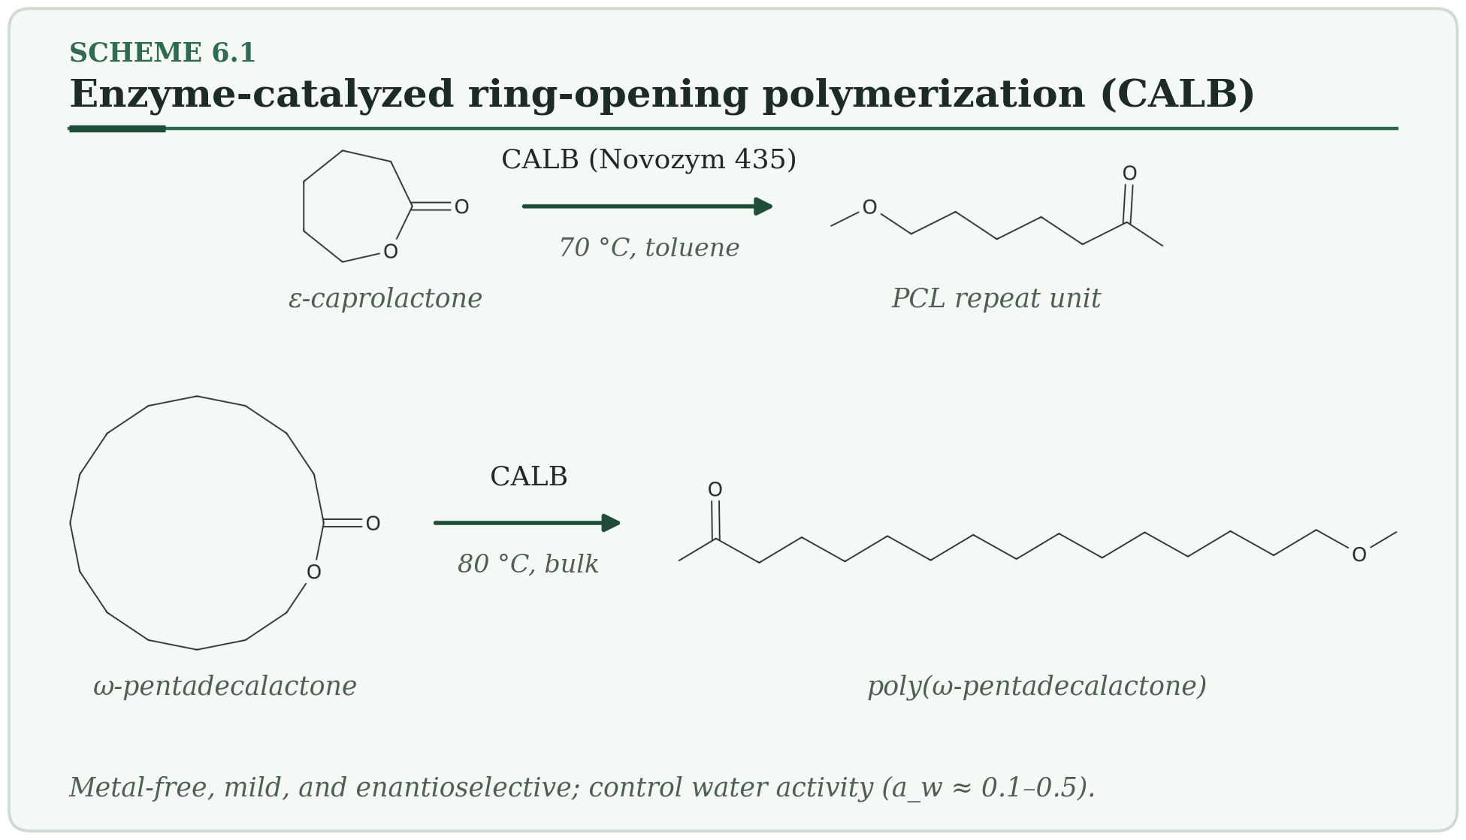
HOW IT WORKS
- Serine-105 of CALB attacks the lactone carbonyl, and the ring opens to an acyl-enzyme.
- The chain-end OH attacks the acyl-enzyme, adds one unit and frees the enzyme.
- The cycle repeats.
Typical conditions. 60–80 °C, toluene or bulk · Đ 1.1–1.3 · water activity a_w 0.1–0.5.
Why membranes care. Metal-free PCL and PLA for biomedical membranes.
Watch out. Too much water gives hydrolysis instead of growth.
PLANT NOTE | Pre-equilibrate the enzyme and solvent to the target water activity.

6.2 PHA Biosynthesis in Bacteria Bio-related
Bacteria store carbon as polyester granules — and they make only one mirror image.
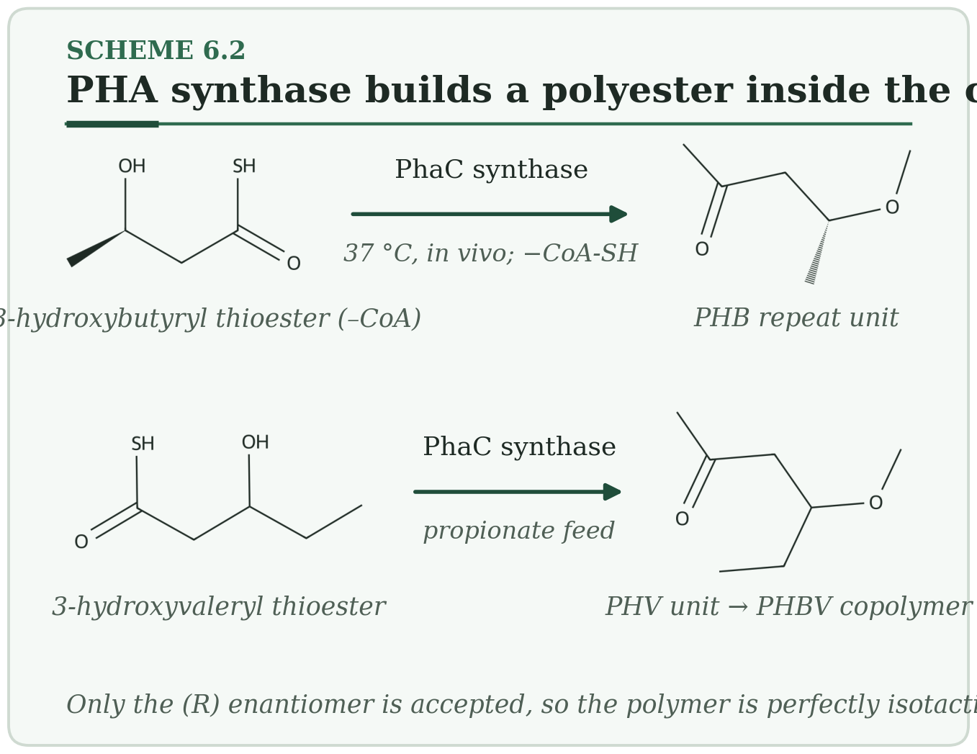
HOW IT WORKS
- The cell makes (R)-3-hydroxyacyl-CoA from sugars or fatty acids.
- PHA synthase links it to the chain and releases CoA.
- Feed propionate as well and you get the copolymer PHBV.
Typical conditions. 37 °C in vivo · Đ 2–6 · molecular weight above 1 million is possible.
Why membranes care. Biodegradable films; PHBV with more than 25 mol % hydroxyvalerate is flexible.
Watch out. The processing window is narrow: PHB degrades above about 200 °C and melts near 175 °C.
PLANT NOTE | Process within 10–15 °C of the melting point and keep melt time under 5 minutes.

7. Comparing the Methods
Use this table to shortlist methods, then read the matching entry for details.
Method | Đ | Control | Metal-free | Blocks | Surface grafting | Best membrane use
Step-growth | ~2 | By ratio | Yes | AB alt. | No | Substrates (PSf, PES, PI, nylon)
Free-radical | 1.5–2 | Low | Yes | No | Limited | PVDF, PAN bulk polymer
Anionic | 1.02–1.10 | Excellent | No (Li) | Yes | No | Block copolymers, standards
Cationic | 1.1–3 | Moderate | No | Yes (living) | No | PIB, vinyl ethers
ROMP | 1.05–1.3 | Good | No (Ru) | Yes | No | Polynorbornenes
ATRP | 1.05–1.2 | Excellent | No (ppm Cu) | Yes | Yes | Brush grafting
RAFT | 1.05–1.15 | Excellent | Yes | Yes | Yes | Biomedical, ion-exchange brushes
NMP | 1.1–1.3 | Good | Yes | Yes | Limited | PS-b-PAA
ROP | 1.05–1.2 | Excellent | Organocat.: yes | Yes | Limited | PLA, PCL scaffolds
Siloxane ROP | 1.05–1.15 | Good | No (Li) | Yes | No | PDMS layers
PhotoATRP / PET-RAFT | 1.05–1.2 | Excellent | Partly | Yes | Patterned | Open-vessel, patterned grafts
eATRP | 1.05–1.1 | Excellent | No | Yes | Conductive | Electrode membranes
Surface-initiated CRP | 1.1–1.3 | Good | Depends | Yes | Yes | Anti-fouling, anti-wetting
IEG | 1.000 | Perfect | Yes | By design | No | Standards, channels
Metal–ligand | — | By ratio | No | — | No | Self-healing films
Ugi (MCP) | ~2 | Low | Yes | No | No | CO₂-philic libraries
Dynamic covalent | — | Design | Yes | — | Limited | Recyclable membranes
COF | 1.000 | Topology | Yes | — | Thin film | Molecular sieves
PIM-1 | 2–10 | Low | Yes | Blends | No | Gas separation
REMP | 1.1–1.3 | Good | No (Ru) | Limited | No | Cyclic polymers
Enzymatic ROP | 1.1–1.3 | Good | Yes | Yes | No | Medical scaffolds
PHA (bacteria) | 2–6 | Cell-set | Yes | PHBV | No | Biodegradable films

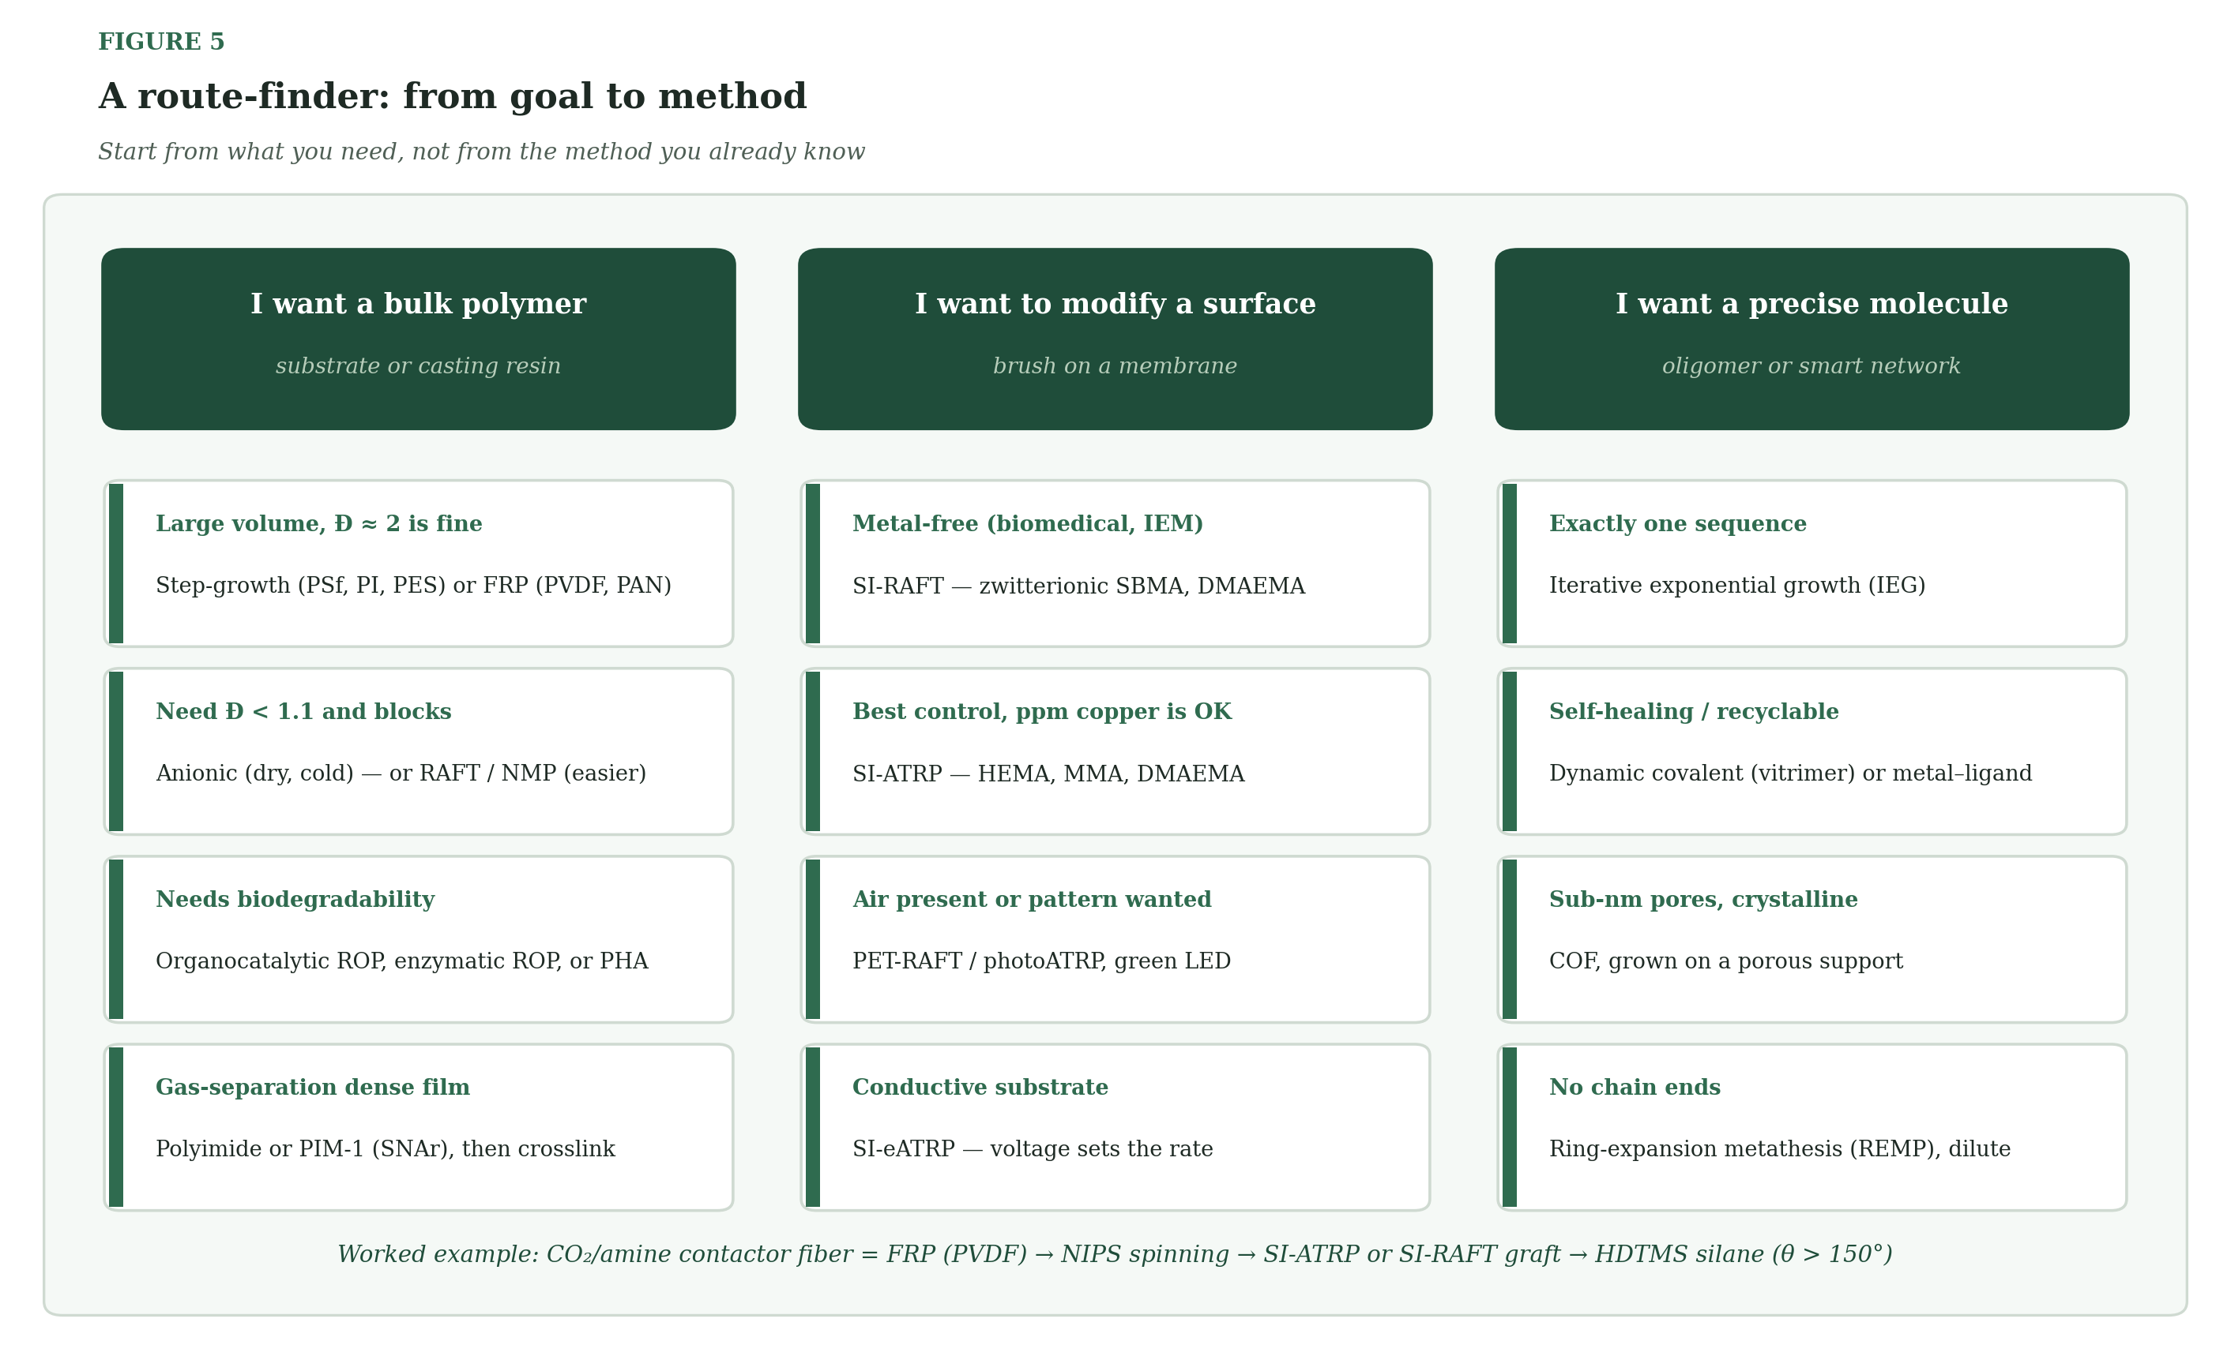
Figure 5 — A route-finder: start from what you need, then pick the method.

8. Key Equations
These are the relations you will use most. Each one answers a practical question.
Question | Equation | Notes
How long will step-growth chains be? | Xn = 1/(1 − p) | p = conversion; Xn is number-average units
What does a monomer imbalance cost? | Xn = (1 + r)/(1 − r) at p = 1 | r = ratio of the two functional groups; r = 0.99 → Xn ≈ 199
How fast does free-radical polymerization go? | Rp = kp[M](f·kd[I]/kt)^½ | Rate is proportional to [I]^½
How long will ATRP chains be? | DPn = [M]₀/[RX]₀ × conversion | Each initiator makes one chain
How narrow will ATRP chains be? | Đ ≈ 1 + kp[RX]₀/(k_deact[Cu(II)]·DPn) | More deactivator gives narrower Đ
How narrow will RAFT chains be? | Đ ≈ 1 + (2/DPn)(kp/k_ex) | Fast exchange (large k_ex) gives narrow Đ
How narrow are living anionic chains? | Đ ≈ 1 + 1/DPn | Poisson distribution
Will a hydrophobic pore stay dry? | LEP = −4γcosθ/dmax | γ liquid surface tension, θ contact angle, dmax largest pore

9. Which Method for Which Membrane?
Application | Route | Target polymer | What success looks like
PVDF hollow fiber for CO₂ / amine contactors | FRP (bulk) + SI-ATRP or SI-RAFT surface | PVDF-g-PHEMA, PVDF with HDTMS silane | LEP > 3 bar, contact angle > 150°
Dense gas-separation membrane | Polyimide step-growth, PIM-1, PDMS ROP | 6FDA-polyimides, PIM-1, PDMS | CO₂/CH₄ selectivity > 30 with high permeability
pH-responsive nanofiltration | SI-ATRP or SI-RAFT of DMAEMA on PAN | PAN-g-PDMAEMA | Flux changes > 5× between pH 4 and pH 10
Anti-fouling ultrafiltration | FRP substrate + SI-RAFT of SBMA | PVDF-g-PSBMA | Flux recovery > 95 % after protein fouling
Self-assembled nanoporous film | ATRP, RAFT or anionic block copolymer | PS-b-P4VP, PS-b-PDMAEMA | Narrow pore-size distribution
COF mixed-matrix membrane | COF + polyimide or PVDF matrix | TpPa-1 in PVDF | Higher H₂/CO₂ or CO₂/N₂ selectivity
Biodegradable scaffold | Enzymatic or organocatalytic ROP | PCL, PLGA | Controlled degradation, no metal
Self-healing membrane | Dynamic covalent crosslinks | Disulfide or imine networks | Cracks heal; selectivity retained

Three priorities for contactor fibers
Staying dry. Surface-initiated ATRP with silane-bearing monomers (or HDTMS on silica) raises the contact angle from about 80° to well above 130°, which raises the liquid entry pressure.
Surviving amines. PVDF can lose HF in strong base. Use amide-linked or ester-free initiator anchors so the graft does not hydrolyze at high pH.
Lasting. Pore wetting and, for glassy polymers, physical aging are the two main ways membranes fail slowly. Crosslinking and good surface chemistry slow both.
PLANT NOTE | Before scaling any PVDF surface treatment, run a 1,000-hour liquid-entry-pressure test at process pH and temperature. Contact angle alone overstates durability.

10. Where the Field Is Going
- Flow photopolymerization: PET-RAFT in tubular reactors to make narrow-dispersity polymers continuously, without inert-gas infrastructure.
- Digital polymers: sequence-defined oligomers read by mass spectrometry, used as molecular tags in membrane materials.
- CO₂ as a monomer: copolymerization with epoxides gives polycarbonates; Ugi-type chemistry can build CO₂ into the backbone.
- Machine learning: property predictors plus robotic casting shorten the design–synthesis–test loop from months to days.

Problems that are still open
Problem | Where it shows up | Today's best answer | What may come next
Physical aging | PIMs, glassy polyimides | UV or thermal crosslinking | Dynamic crosslinks that anneal
Pore wetting | PVDF contactors | Silane or fluorinated brush on PVDF | Self-cleaning zwitterionic layers
Metal residues | ATRP, ROMP, anionic | ARGET with ppm Cu; use RAFT | Recoverable copper; organic photocatalysts
Scale-up | ATRP, RAFT, NMP, IEG | Continuous flow | Automated flow with inline GPC
Brittle films | COF, PIM | Growth on porous supports | Covalent polymer–COF interfaces
Degradation control | PLA, PCL | Copolymer ratio, end-capping | Block architectures

11. All the Plant Notes in One Place
Print this page and keep it near the reactor.
Method | Note
Step-Growth Polymerization | Weigh monomers to ±0.1 % and titrate incoming lots before you charge the reactor.
Free-Radical Chain Polymerization | Sparge with nitrogen for at least 30 minutes before adding initiator. In bulk, keep conversion below about 60 % unless cooling is strong.
Anionic Polymerization | Titrate n-BuLi before every batch — its active concentration sets your molecular weight.
Cationic Polymerization | Dry glassware and solvent to a few ppm water. Stray water is the main cause of batch-to-batch scatter.
Ring-Opening Metathesis Polymerization | Store catalyst at −20 °C under argon and weigh it last, just before injection.
ATRP — Atom Transfer Radical Polymerization | Add 5–10 mol % Cu(II) at the start; it shortens induction and tightens dispersity.
RAFT — Reversible Addition–Fragmentation Chain Transfer | Keep CTA under nitrogen in amber glass; thiocarbonylthio groups oxidize in air.
NMP — Nitroxide-Mediated Polymerization | Do not run below about 100 °C, and keep the headspace under nitrogen for the whole 6–24 h.
Ring-Opening Polymerization | Dry lactide or caprolactone over CaH₂ and distill just before use.
Anionic Ring-Opening of Cyclosiloxanes | Neutralize completely before storage.
PhotoATRP and PET-RAFT | Use organic dyes at pilot scale.
Electrochemically Mediated ATRP | Use a divided cell as standard practice.
Surface-Initiated Controlled Radical Polymerization | Run a free-initiator control with every batch — it is your only handle on brush molecular weight.
Iterative Exponential Growth | Track cumulative yield in the route plan.
Metallo-Supramolecular Polymerization | Test leaching by ICP-MS before qualifying a membrane.
Multicomponent Polymerization | Pilot the isocyanide supply before a screening campaign.
Dynamic Covalent Networks and Vitrimers | Confirm T_v by rheometry before choosing a reprocessing temperature.
Covalent Organic Frameworks | Grow the COF directly on a porous support.
Polymers of Intrinsic Microporosity | Cast promptly, store under vacuum, and crosslink if long-term stability matters.
Ring-Expansion Metathesis Polymerization | Keep monomer below about 0.01 M.
Enzymatic Polymerization | Pre-equilibrate the enzyme and solvent to the target water activity.
PHA Biosynthesis in Bacteria | Process within 10–15 °C of the melting point and keep melt time under 5 minutes.

12. References
Textbooks
- Odian, G. Principles of Polymerization, 4th ed.; Wiley: Hoboken, 2004.
- Baker, R. W. Membrane Technology and Applications, 3rd ed.; Wiley: Chichester, 2012.
- Mulder, M. Basic Principles of Membrane Technology, 2nd ed.; Kluwer: Dordrecht, 1996.
Step-growth, ionic and metathesis polymerization
- Carothers, W. H. Polymers and polyfunctionality. Trans. Faraday Soc. 1936, 32, 39–49.
- Hadjichristidis, N.; Pitsikalis, M.; Pispas, S.; Iatrou, H. Polymers with complex architecture by living anionic polymerization. Chem. Rev. 2001, 101, 3747–3792.
- Bielawski, C. W.; Grubbs, R. H. Living ring-opening metathesis polymerization. Prog. Polym. Sci. 2007, 32, 1–29.
- Dechy-Cabaret, O.; Martin-Vaca, B.; Bourissou, D. Controlled ring-opening polymerization of lactide and glycolide. Chem. Rev. 2004, 104, 6147–6176.
Controlled radical polymerization
- Matyjaszewski, K.; Xia, J. Atom transfer radical polymerization. Chem. Rev. 2001, 101, 2921–2990.
- Matyjaszewski, K. Atom transfer radical polymerization (ATRP): current status and future perspectives. Macromolecules 2012, 45, 4015–4039.
- Chiefari, J.; et al. Living free-radical polymerization by reversible addition–fragmentation chain transfer: the RAFT process. Macromolecules 1998, 31, 5559–5562.
- Moad, G.; Rizzardo, E.; Thang, S. H. Living radical polymerization by the RAFT process. Aust. J. Chem. 2005, 58, 379–410.
- Hawker, C. J.; Bosman, A. W.; Harth, E. New polymer synthesis by nitroxide mediated living radical polymerizations. Chem. Rev. 2001, 101, 3661–3688.
- Braunecker, W. A.; Matyjaszewski, K. Controlled/living radical polymerization: features, developments, and perspectives. Prog. Polym. Sci. 2007, 32, 93–146.
- Xu, J.; Jung, K.; Atme, A.; Shanmugam, S.; Boyer, C. A robust and versatile photoinduced living polymerization of conjugated and unconjugated monomers and its oxygen tolerance. J. Am. Chem. Soc. 2014, 136, 5508–5519.
- Barbey, R.; et al. Polymer brushes via surface-initiated controlled radical polymerization: synthesis, characterization, properties, and applications. Chem. Rev. 2009, 109, 5437–5527.
Advanced and emerging materials
- Lutz, J.-F.; Ouchi, M.; Liu, D. R.; Sawamoto, M. Sequence-controlled polymers. Science 2013, 341, 1238149.
- Dömling, A.; Ugi, I. Multicomponent reactions with isocyanides. Angew. Chem. Int. Ed. 2000, 39, 3168–3210.
- Montarnal, D.; Capelot, M.; Tournilhac, F.; Leibler, L. Silica-like malleable materials from permanent organic networks. Science 2011, 334, 965–968.
- Côté, A. P.; et al. Porous, crystalline, covalent organic frameworks. Science 2005, 310, 1166–1170.
- Kandambeth, S.; et al. Construction of crystalline 2D covalent organic frameworks with remarkable chemical (acid/base) stability via a combined reversible and irreversible route. J. Am. Chem. Soc. 2012, 134, 19524–19527.
- Geng, K.; et al. Covalent organic frameworks: design, synthesis, and functions. Chem. Rev. 2020, 120, 8814–8933.
- Budd, P. M.; et al. Solution-processed, organophilic membrane derived from a polymer of intrinsic microporosity. Adv. Mater. 2004, 16, 456–459.
- McKeown, N. B.; Budd, P. M. Polymers of intrinsic microporosity (PIMs): organic materials for membrane separations, heterogeneous catalysis and hydrogen storage. Chem. Soc. Rev. 2006, 35, 675–683.
- Robeson, L. M. Correlation of separation factor versus permeability for polymeric membranes. J. Membr. Sci. 1991, 62, 165–185.
- Robeson, L. M. The upper bound revisited. J. Membr. Sci. 2008, 320, 390–400.
Bio-related routes and contactors
- Kobayashi, S.; Makino, A. Enzymatic polymer synthesis: an opportunity for green polymer chemistry. Chem. Rev. 2009, 109, 5288–5353.
- Sudesh, K.; Abe, H.; Doi, Y. Synthesis, structure and properties of polyhydroxyalkanoates: biological polyesters. Prog. Polym. Sci. 2000, 25, 1503–1555.
- Gabelman, A.; Hwang, S.-T. Hollow fiber membrane contactors. J. Membr. Sci. 1999, 159, 61–106.

End of reference

