Hybrid Helium Recovery in Alberta
Polymeric membrane pre-concentration + PSA polishing
Professional report | Prepared for strategic discussion |
Executive message. The strongest Alberta concept is not membrane-only and not PSA-only. The best route is a hybrid system: membranes first concentrate dilute helium from selected natural-gas streams, then PSA polishes the enriched stream to saleable purity. This reduces the gas volume entering PSA and makes modular deployment at compressor stations or gas plants more realistic.
Alberta opportunity
Alberta is a credible location for helium recovery because helium can be produced as a by-product of natural gas, while the province already has gas wells, compressor stations, gas plants, and midstream operating capability. The Alberta Energy Regulator reported 2.2 thousand m3/d of helium production in 2024 from six producing wells and forecasts 10.4 thousand m3/d by 2034 under its base case. ^{[1]}
The economic screen should be strict. Canadian Energy Regulator material indicates helium extraction is generally more attractive above about 0.5% He, although the real threshold depends on gas flowrate, pressure, processing cost, transport distance, and helium price. ^{[2]}

Working assumptions learned from the project
Item | Base assumption | Purpose | Decision meaning
Feed He | ~0.3-0.8%; base case ~0.5% | Screen Alberta gas sites | Below ~0.2% is high risk unless flowrate/price is strong
Stage 1 membrane | ~5% He product | Bulk enrichment | Reduces gas volume before deeper enrichment
Stage 2 membrane | ~50-70% crude He | PSA feed preparation | Makes PSA much smaller than raw-gas PSA
PSA outlet | 99.9-99.999% He | Final polishing | Purity depends on adsorbent, cycle, recovery, and feed
Price sensitivity | US$330/Mcf base-price reference; commercial cases may be higher | Revenue model | Use sensitivity, not one fixed price
Note: USGS reported an estimated 2025 Grade-A helium base price of about US$330/Mcf; commercial prices can differ because of grade, contract terms, logistics, and surcharges. ^{[3]}

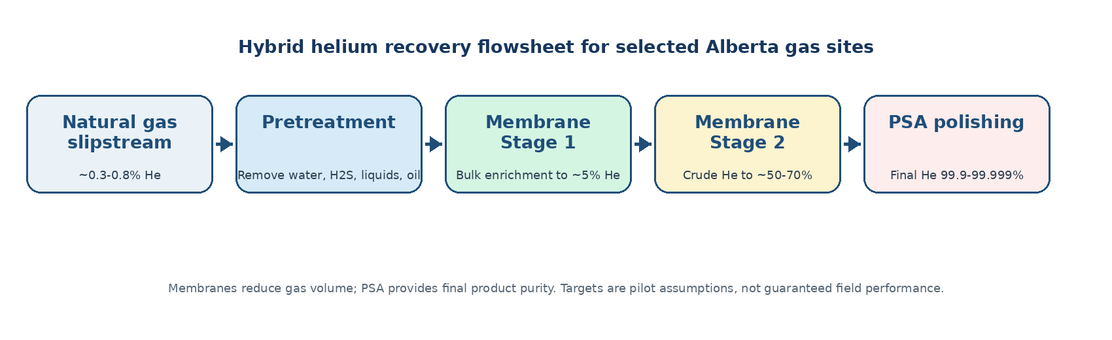
Figure 1. Proposed hybrid flowsheet for selected Alberta natural-gas sites.
Technology Design
Membrane role and required properties
The membrane should have high helium permeance, strong He/CH4 and He/N2 selectivity, low defect density, and stable mixed-gas performance under pressure. For an Alberta field skid, the practical target is a hollow-fiber or spiral-wound polymeric module that can tolerate dry, pretreated natural gas at roughly ambient-to-moderate temperature, about 20-60 °C after temperature control, and feed pressures in the approximate 20-60 bar range; the mechanical module rating should be set above the site maximum pressure, commonly with a 70-100 bar design envelope for safety. It must resist plasticization, fouling, and aging in the presence of CO2, H2S traces, water, heavy hydrocarbons, and compressor oil, so pretreatment is not optional. ^{[4] [5]}

Membrane selection checklist  • High He permeability to reduce membrane area.  • High He/CH4 and He/N2 selectivity to limit methane and nitrogen loss.  • Stable selectivity in mixed gas, not only single-gas tests.  • Sour-gas and hydrocarbon compatibility after pretreatment.  • Module/seal compatibility with pressure, temperature, and field contaminants. | PSA in simple language  PSA separates gases using beds packed with solid adsorbents. At high pressure, the adsorbents hold impurities such as CH4, N2, CO2, water, and heavier hydrocarbons more strongly than helium; helium passes through as the light product, due to inertness of He. At low pressure, the bed is regenerated and the captured impurities are released.  Typical PSA bed materials include activated carbon, zeolite molecular sieves, carbon molecular sieves, and sometimes alumina or silica gel for water/CO2 guard service. The final adsorbent choice depends on the actual gas composition and the required helium recovery. ^{[6]}

Why membrane + PSA is stronger than either technology alone
Route | Strength | Weakness | Strategic fit
Membrane-only | Compact, modular, continuous | Hard to reach final purity from dilute feed | Good for pre-concentration
PSA-only | Can reach high helium purity | Too large/expensive on raw dilute gas | Good for polishing
Hybrid | Small PSA load, modular deployment | Needs pretreatment and real field validation | Best concept for selected Alberta sites
Critical design point. For low-helium natural gas, membrane separation is limited by helium partial pressure. That means high pressure, recycle, and multi-stage design become important. Published process simulations found direct membrane recovery becomes more viable at higher helium feed concentrations and high pressure, while lower-quality fields require better He/CH4 selectivity. ^{[4]}

Alberta Deployment and Pilot Plan
The best commercial strategy is a selective deployment model, not a province-wide claim. The first pilot should target a gas plant or compressor station with enough helium, existing pressure, manageable contaminants, and a producer willing to test a low-disruption revenue-share model. The offer to producers should be simple: no major process interruption, low upfront burden, and shared upside from helium that is otherwise lost or under-monetized.
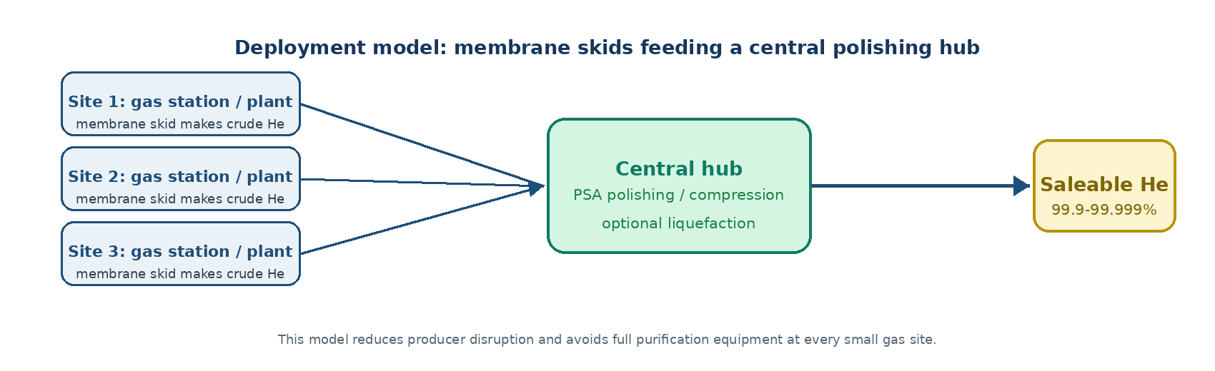
Figure 2. Distributed membrane skids can feed crude helium to a central PSA/compression hub.
Preferred pilot site  • He concentration >=0.3%, ideally >=0.5%.  • Useful existing feed pressure.  • Dry, pretreated gas or easy pretreatment retrofit.  • Low liquids, low oil mist, controlled H2S and CO2.  • Clear route for PSA product, compression, transport, or central polishing. | Main risks to validate  • Mixed-gas membrane selectivity under real field gas.  • Pretreatment cost and pressure drop.  • Helium recovery loss across membrane and PSA stages.  • Compression energy and membrane replacement cost.  • Actual helium offtake price and logistics.
Conclusion. The membrane should do bulk enrichment; PSA should do final purification. This division of labor is the core value of the hybrid method. The next step should be a pilot techno-economic model using actual Alberta gas composition, real pressure, flowrate, contaminants, membrane performance, PSA recovery, and helium offtake price.
References
[1] Alberta Energy Regulator, ST98 Alberta Energy Outlook 2025, Emerging Resources - Helium. link
[2] Canada Energy Regulator, Market Snapshot: Helium - It is not just for balloons. link
[3] U.S. Geological Survey, Mineral Commodity Summaries 2026 - Helium and Rare Gases. link
[4] Scholes, C. A. Helium separation through polymeric membranes, Journal of Membrane Science, 2016. link
[5] Scholes, C. A. Review of Membranes for Helium Separation and Purification, Membranes, 2017. link
[6] Pressure Swing Adsorption overview; common adsorbents include zeolites, activated carbon and molecular sieves. link

