TECHNICAL REPORT
PDMS Coating for Polymeric Membranes:
Process–Structure–Performance Relationships and an
Optimized Coating Protocol for Anti-Wetting PVDF Hollow-Fiber
Membrane Contactors in Amine-Based CO₂ Capture and Regeneration

Prepared for
Hamidreza Rezania, Ph.D., PMP
SepPure Technologies Inc.
July 3, 2026
Scope: coating chemistry and process parameters for PDMS thin films on porous polymeric supports, with a focused application to hydrophobic protective/anti-wetting coatings on PVDF hollow-fiber membrane contactors used in vacuum-assisted amine regeneration (CO₂ desorption/stripping).

Table of Contents
Executive Summary 3
1. Introduction and Scope 3
2. PDMS Fundamentals in a Membrane Context 4
2.1 Chemistry and cure mechanism 4
2.2 Three functional roles of a PDMS layer 4
2.3 Thermal and chemical robustness of cured PDMS 6
3. PDMS Coating Methods 6
3.1 Dip coating and the Landau–Levich framework 6
3.2 Spray, spin, and vapor-phase alternatives 7
4. Critical Parameters Governing Coating Quality 8
4.1 Coating-solution concentration and viscosity 8
4.2 Solvent selection 8
4.3 Base : crosslinker ratio 9
4.4 Curing temperature and time 10
4.5 Withdrawal speed and dwell time 11
4.6 Number of coating passes 12
4.7 Substrate pore size, porosity, and pore intrusion 12
4.8 Surface pretreatment and adhesion promotion 13
4.9 Nanofiller additives 14
5. Characterization and Quality Metrics 15
6. Performance Baseline: Gas Transport Through PDMS 16
7. Application: PDMS Coating for Amine Regeneration Contactors 19
7.1 The pore-wetting problem in amine-regeneration HFMCs 19
7.2 Chemical stability of the substrate versus PDMS 20
7.3 PDMS as the anti-wetting layer: evidence from the literature 20
7.4 Case study: silicalite-filled PDMS for vacuum stripping 21
7.5 Interaction with vacuum stripping process conditions 22
7.6 Design recommendations for a PDMS-coated PVDF HFMC 23
8. Recommended Optimized Coating Protocol 25
9. Conclusions 27
References 28

Executive Summary
Polydimethylsiloxane (PDMS) is the most widely deployed rubbery coating material in membrane science, serving three distinct functions depending on context: a CO₂-selective skin in gas-separation composites, a permeable “gutter” layer that protects a more selective ultrathin skin from support-pore intrusion, and a hydrophobic protective/anti-wetting layer on porous contactor membranes. This report synthesizes the literature on how coating-solution chemistry, application method, and cure conditions govern the resulting layer's thickness, defect density, crosslink density, and surface energy — and therefore its gas permeance, selectivity, and liquid-entry pressure (LEP).
The report closes with the application most relevant to your own research program: PDMS as an anti-wetting protective coating on PVDF hollow-fiber membrane contactors (HFMCs) used for vacuum-assisted amine regeneration (CO₂ stripping at 60–75°C). Pore wetting by amine solvent is the dominant long-term failure mode of uncoated PVDF/PP contactors in this duty; a thin, well-crosslinked, defect-free PDMS layer raises the liquid entry pressure by 3–10+ bar while adding comparatively little gas-phase mass-transfer resistance if kept below roughly 5–10 µm. Section 8 consolidates these findings into a single recommended coating protocol — solution concentration, solvent, crosslinker ratio, cure schedule, dip parameters, and pretreatment — with each recommendation traced back to a specific literature source.
Every quantitative figure in this report is tagged as [CITED] (taken directly from a peer-reviewed or otherwise authoritative source), [CALCULATED] (derived from cited inputs, with the derivation shown), or [ESTIMATE] (an engineering judgment extrapolated from related but not directly matching data, explicitly flagged as unverified). No numbers are presented without one of these tags.

1. Introduction and Scope
Polydimethylsiloxane, –[Si(CH₃)₂O]ₙ–, is a rubbery, low-glass-transition-temperature (Tg ≈ −125°C) polysiloxane whose flexible Si–O–Si backbone and shielding methyl side groups give it an unusual combination of properties for a coating material: very high free volume and chain mobility (hence high gas permeability), low surface energy (hence hydrophobicity and easy release/anti-fouling behavior), and a chemically robust siloxane backbone (hence broad solvent and thermal tolerance relative to many organic polymers).
In membrane engineering, a thin PDMS layer deposited on a porous or asymmetric polymeric support is used for three functionally distinct purposes, and it is important to keep them separate because the optimal coating recipe differs for each:
- As the CO₂-selective transport layer itself in a thin-film composite (TFC) gas-separation membrane, exploiting PDMS's high CO₂ solubility-driven permeability.
- As a “gutter” (protective/leveling) layer beneath a thinner, more selective skin (e.g., a glassy polymer or a polymer of intrinsic microporosity), where the PDMS layer's job is to bridge and seal support-pore mouths so the true selective layer can be cast defect-free on top of it.
- As a hydrophobic anti-wetting / protective coating on an otherwise microporous, non-selective contactor membrane (typically PVDF or PP), where the PDMS layer's job is to keep liquid out of the pores while still allowing gas to permeate — the function most relevant to membrane contactors used in gas absorption/stripping duties, including amine regeneration.
This report is organized to build toward the third application. Sections 2–6 develop the general coating science — chemistry, deposition methods, the process parameters that control thickness/defects/crosslink density, characterization, and baseline gas-transport data — because the same physical parameters (solution concentration, solvent, crosslinker ratio, cure schedule, substrate pore structure, adhesion pretreatment) govern coating quality regardless of which of the three functions the layer is meant to serve. Section 7 then applies this parameter set specifically to PDMS-coated PVDF hollow-fiber contactors for amine regeneration, and Section 8 consolidates everything into one recommended protocol.

2. PDMS Fundamentals in a Membrane Context

2.1 Chemistry and cure mechanism
Nearly all membrane-coating PDMS formulations (including the ubiquitous Dow Sylgard 184 and its equivalents) cure by platinum-catalyzed hydrosilylation: a vinyl-terminated PDMS pre-polymer (“base”) reacts with a Si–H-functional crosslinker (“curing agent”) across a Pt catalyst, forming a covalent Si–CH₂–CH₂–Si network with no volatile byproduct. This is preferred over the older room-temperature-vulcanizing (RTV) condensation cure (which releases acetic acid or alcohol and can leave residual silanol groups) because addition cure gives more reproducible, higher-purity networks — an important consideration when the coating must later resist hydrolysis in an aqueous amine environment (Section 7.2).
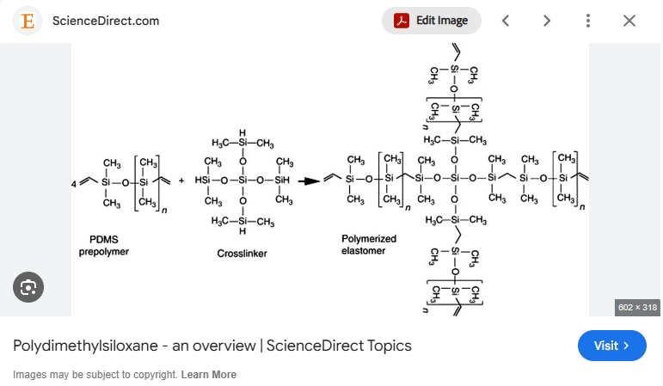
The base : curing-agent mass ratio sets the crosslink density of the cured network directly, since it controls the stoichiometric balance of vinyl to Si–H functional groups; this single parameter is revisited in depth in Section 4.3 because it is the single most load-bearing lever an experimentalist has over the coating's mechanical modulus, gas permeability, and surface energy simultaneously.

2.2 Three functional roles of a PDMS layer, and why the target specifications differ
Because this report ultimately optimizes a coating for one specific role (anti-wetting protection of a contactor), it is useful to first see how the target specifications for all three roles diverge — the same PDMS chemistry, tuned differently, is asked to do very different jobs.
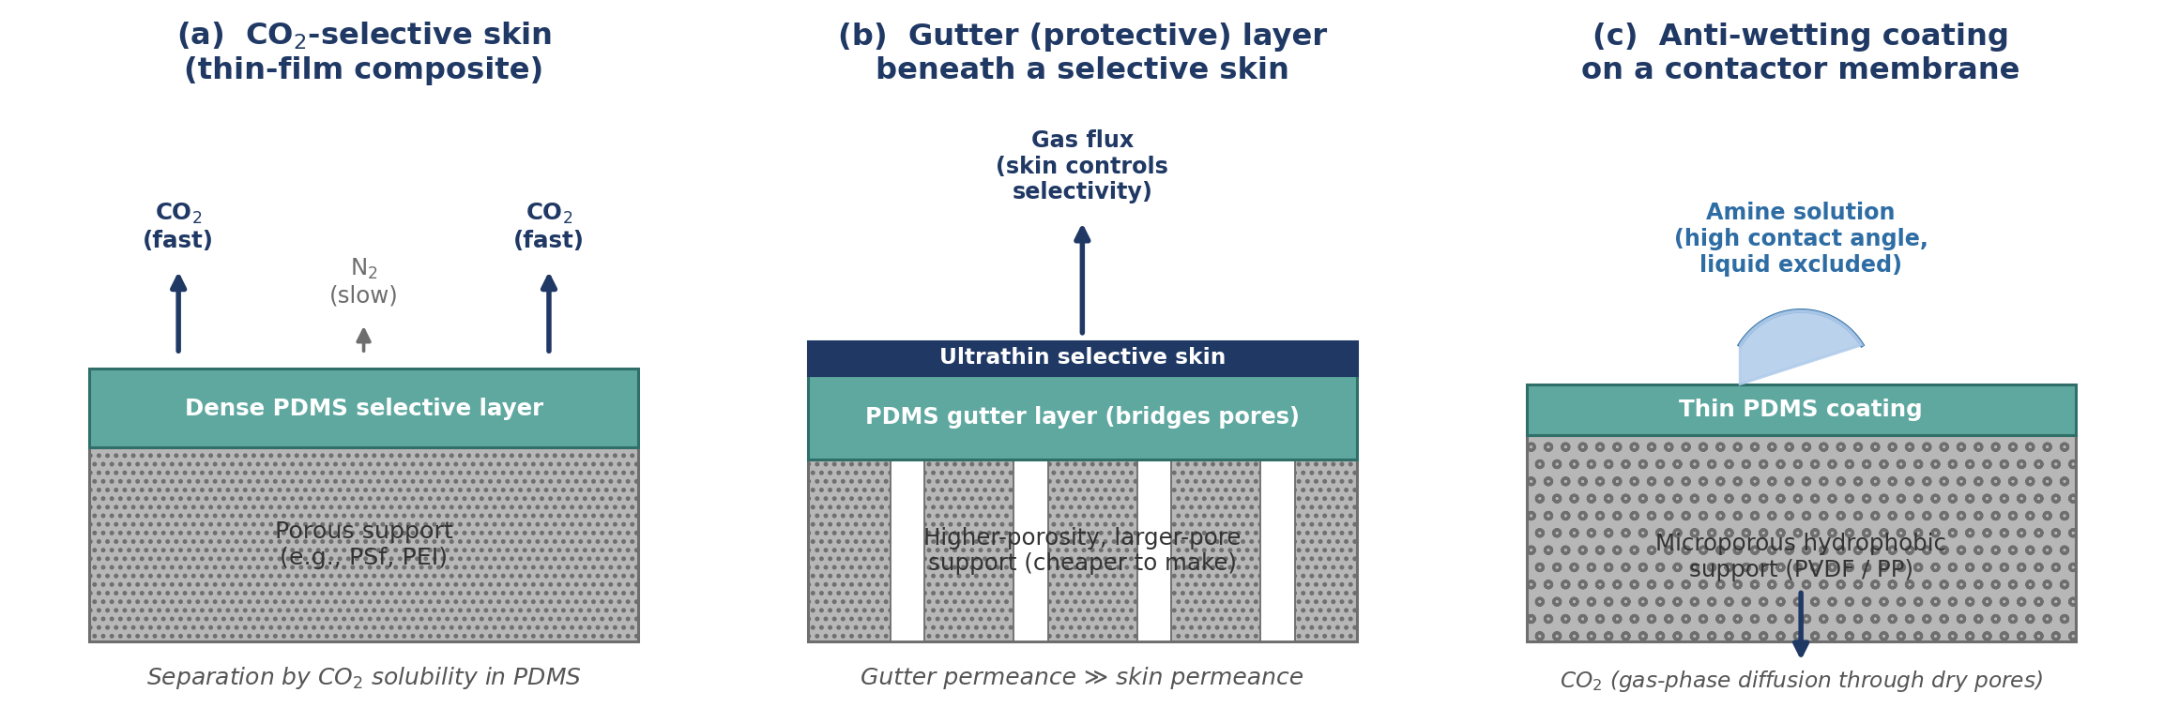
Figure 1. The three functional roles of a PDMS layer in membrane science: (a) CO₂-selective transport skin, (b) protective gutter layer beneath a thinner selective skin, and (c) hydrophobic anti-wetting coating on a contactor membrane — the role this report ultimately optimizes for. Original schematic.
Role | PDMS thickness target | Gas-transport target | Primary failure mode to avoid | Representative reference
Selective skin (TFC gas separation) | 0.1–2 µm | Maximize CO₂ permeance while retaining bulk-PDMS CO₂/N₂ selectivity (≈ 9–12) | Pinhole defects that short-circuit selectivity | [1], [5]
Gutter / protective underlayer | 50–300 nm | As permeable as possible relative to the selective skin it protects (e.g., ≈4,400 GPU CO₂ reported for an optimized PDMS/polysulfone gutter layer); must not be rate-limiting | Pore intrusion into support, which locally thickens the gutter and creates dead zones | [6], [7], [8]
Anti-wetting contactor coating | 1–10 µm | Maximize liquid entry pressure while keeping added gas-phase resistance small relative to the liquid boundary layer | Micro-defects/pinholes that admit liquid locally; delamination under long-term solvent exposure | [2], [17], [19]
Table 1. Target specifications differ by functional role even though the same base chemistry and coating methods apply. [CITED] – thickness ranges and permeance figures compiled from sources listed.

2.3 Thermal and chemical robustness of cured PDMS
Because Section 7 evaluates PDMS specifically for hot, wet, alkaline amine-contact service, it is useful to establish baseline thermal/chemical robustness here. The Si–O bond in the polysiloxane backbone is markedly stronger than the C–C backbone bond of typical organic polymers, which underlies PDMS's comparatively high thermal stability: reported degradation onset is around 200°C in air, extending higher under vacuum or inert atmosphere before significant backbone breakdown occurs.
[CITED] [46] — aging-process/thermal-property studies of PDMS-based silicone rubber; Si–O versus C–C bond strength context.
PDMS is not, however, immune to chemical attack under the specific conditions relevant to amine service: prolonged exposure to hot, moist, and particularly alkaline environments can hydrolyze Si–O–Si linkages, forming silanol groups and gradually reducing crosslink density — a slow degradation pathway that is most active at coating defect sites, chain ends, and incompletely cured regions. This is the mechanistic basis for the durability caution raised in Section 7.2, and for recommending extended immersion aging (Section 5) as part of qualifying any specific coating formulation for long-term deployment, rather than relying on as-fabricated thermal-stability data alone.

3. PDMS Coating Methods

3.1 Dip coating and the Landau–Levich framework
Dip coating is the dominant method for applying PDMS to hollow-fiber and flat-sheet supports because it wets the entire outer (or, with lumen-side pumping, inner) surface uniformly and scales naturally to continuous fiber processing. In the well-understood “draining regime” (moderate withdrawal speed, Newtonian coating solution), the wet-film thickness deposited on a flat or cylindrical substrate withdrawn from a bath follows the Landau–Levich–Derjaguin (LLD) relation:
h ≈ 0.94 · (ηU/γ)^(2/3) · (γ/ρg)^(1/2)
where h is the deposited wet-film thickness, η is the coating-solution viscosity, U is the withdrawal speed, γ is the solution surface tension, ρ is the solution density, and g is gravitational acceleration. [CITED] [11], [12], [34] — classical result of Landau & Levich (1942), formalized for dip coating by Brinker & Scherer's sol–gel processing framework and reproduced across modern dip-coating process guides.
Two consequences follow directly and are the basis for essentially all dip-coating process control in Section 4: (i) thickness scales with the two-thirds power of both viscosity and speed, so doubling withdrawal speed does not double thickness — it increases it by only ~59%, giving a comparatively forgiving (but nonlinear) process window; and (ii) at very low capillary number (Ca = ηU/γ), the LLD regime breaks down and capillary-driven “draining” dominates, in which thickness instead scales inversely with the square root of dwell/drain time — this is the regime most PDMS hollow-fiber coating protocols actually operate in, given the low withdrawal speeds (seconds-to-minutes dwell) typically used to avoid entraining the very low-viscosity heptane/hexane solutions used industrially.
For hollow-fiber contactors, dip coating is applied either from the shell side (fiber bundle immersed in and withdrawn from the PDMS bath, coating the outer diameter) or, using a syringe-pump/vacuum-assisted through-lumen technique, from the lumen side (coating the inner bore). The choice interacts directly with which side of the fiber is exposed to the liquid amine phase in the finished module and is discussed further in Section 7.6.
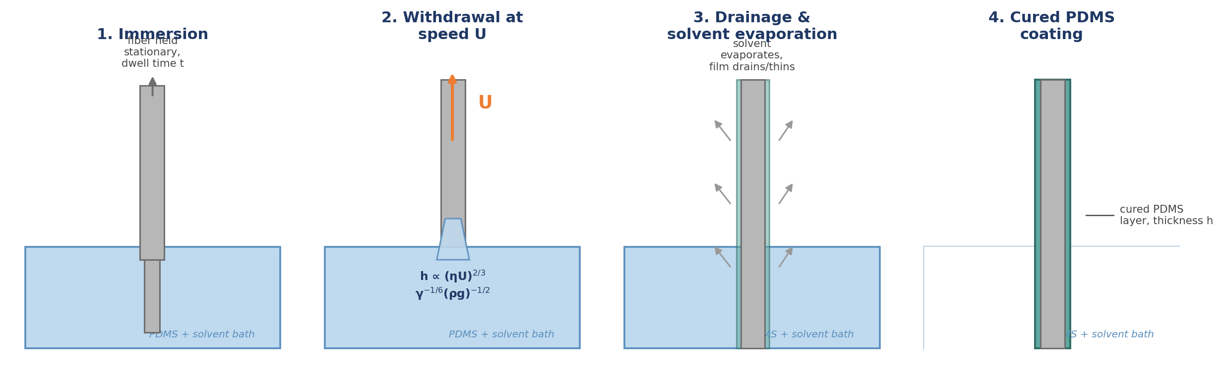
Figure 2. The four stages of dip coating a fiber: immersion/dwell, withdrawal at controlled speed U (entraining a liquid film per the Landau–Levich relation), drainage and solvent evaporation, and the final cured PDMS layer. Original schematic.

3.2 Spray, spin, and vapor-phase alternatives
- Spray coating disperses atomized PDMS solution droplets onto the substrate and is preferred for large flat sheets or where dip-bath contamination/solution-volume economics are a concern; it typically gives a more textured, less uniform layer than dip coating unless spray parameters (nozzle distance, air pressure, pass count) are tightly controlled, but avoids full-immersion pore intrusion into non-wetted internal fiber regions.
- Spin coating gives the most uniform, thinnest, most reproducible films and is the laboratory standard for flat-sheet TFC gutter-layer and selective-layer studies, but is not applicable to hollow-fiber geometry and is a batch, not continuous, process.
- Vapor-phase / plasma-enhanced chemical vapor deposition (PECVD or iCVD) of siloxane precursors can produce extremely thin (tens of nm), highly conformal, pinhole-resistant layers and simultaneously activates the substrate surface for adhesion, but requires vacuum equipment and is far less common in scaled contactor-fiber production than solution dip coating.
For the amine-regeneration HFMC application that is the focus of this report, dip coating from dilute solution is essentially the universal method reported in the literature reviewed in Section 7, and it is the method the recommended protocol in Section 8 is built around.

4. Critical Parameters Governing Coating Quality
This is the operational core of the report. Nine parameters are treated in turn; each subsection states the mechanism by which the parameter acts, the quantitative evidence available, and the practical trade-off an experimentalist must navigate.

4.1 Coating-solution concentration and viscosity
PDMS concentration in the carrier solvent is the single most direct lever on both solution viscosity (η in the LLD equation, Section 3.1) and the total polymer mass available to form the film, so it sets deposited thickness on two fronts simultaneously. In a representative PDMS-on-hollow-fiber optimization (PDMS coated onto a polyetherimide, PEI, hollow-fiber support for CO₂/N₂ separation), a 15 wt% PDMS coating solution combined with a 10-minute coating (dwell) time was identified as the optimum, giving a CO₂ permeance of 51 GPU and CO₂/N₂ selectivity of 21; more dilute solutions left incomplete, defect-containing coverage, while richer/longer combinations added excess, non-selective resistance.
[CITED] [13] — Fabrication of PDMS Dense Layer on Polyetherimide (PEI) Hollow Fiber Support for CO₂/N₂ Separation.
As a general rule confirmed across the coating literature reviewed for this report, PDMS solution concentrations in the range of roughly 2–20 wt% (in a low-boiling hydrocarbon solvent) are used depending on target thickness and substrate pore size; very dilute baths (<2–3 wt%) are prone to incomplete surface coverage and pinholes, while concentrated baths (>15–20 wt%) risk excessive viscosity, poor leveling, and unnecessary added mass-transfer resistance.

4.2 Solvent selection
The carrier solvent for the PDMS coating solution must simultaneously (i) wet the porous, typically hydrophobic substrate well enough to spread rather than bead up, (ii) dissolve the PDMS pre-polymer/crosslinker at the target concentration without excessive viscosity, and (iii) evaporate at a rate that balances leveling time against the risk of the liquid solution wicking into support pores before gelation locks the layer at the surface.
- Low-molecular-weight n-alkanes (n-hexane, n-heptane) are the most widely used carriers: low viscosity and surface tension give good wetting of hydrophobic PVDF/PP substrates and fast evaporation, but n-hexane is itself known to swell cured PDMS films under prolonged liquid-phase contact — a durability consideration for the finished coating in service, not just a fabrication-stage solvent choice.
- Toluene and other aromatic solvents give slower evaporation (more time for leveling / defect self-healing) but a larger open window for capillary intrusion into support pores before the layer gels, and generally more aggressive swelling of many candidate porous substrates.
- Solvent selection also shifts the LLD-governing viscosity η and surface tension γ terms directly, so a solvent swap is never “just” a wetting/evaporation decision — it simultaneously changes the deposited wet-film thickness at fixed withdrawal speed and concentration.
[CITED] [36], [37] — n-hexane-induced swelling of thin PDMS films under nanofiltration-relevant permeation conditions; PEG–PDMS gutter-layer solvent studies.

4.3 Base : crosslinker ratio
For addition-cure (hydrosilylation) PDMS systems such as Sylgard 184, the manufacturer-standard base : curing-agent mass ratio is 10:1, corresponding to roughly stoichiometric balance of vinyl and Si–H functional groups.
[CITED] [30] — Dow Sylgard 184 Silicone Elastomer technical data sheet.
Deviating from this ratio is the primary tool for tuning the cured network's crosslink density, and the effects propagate to every downstream property relevant to a membrane coating:
- Young's modulus, density, and refractive index of cured Sylgard 184 all pass through a MAXIMUM at approximately 10 wt% curing agent — i.e., near the manufacturer-standard 10:1 ratio: modulus rises from about 73 kPa at a lean 3.2 wt% curing-agent formulation to roughly 2.1 MPa at ≈10 wt%, then falls back to only about 180 kPa when curing agent is present in large excess (50 wt%). Water contact angle moves in the opposite, smaller direction: it decreases modestly from about 122° at 3.2 wt% curing agent to a minimum of about 117° near 10 wt%, then holds roughly steady with further increases.
- Because BOTH lean (base-rich) and excess (curing-agent-rich) formulations soften the network relative to the ~10:1 optimum, moving away from the standard ratio in either direction trades bulk modulus and barrier robustness for a more compliant, potentially more conformal film — a plausible route to better wetting-out and mechanical interlocking on a rough porous substrate. However, unlike the modulus/contact-angle relationship, a specific quantitative adhesion-versus-ratio relationship for PDMS-on-porous-polymer systems was not found in the sources reviewed for this report; any adhesion benefit from deviating off 10:1 should be verified experimentally (peel or lap-shear test) on the actual PVDF support rather than assumed from the mechanical-property trend alone.
[CITED] [33] — Cho, S. et al., Formulation Prediction for Young's Modulus of Poly(dimethylsiloxane) by Spectroscopic Methods, Bulletin of the Korean Chemical Society (Wiley), 2021 (Sylgard 184 modulus/density/refractive-index/contact-angle vs. curing-agent wt%, cured 80°C/2h).
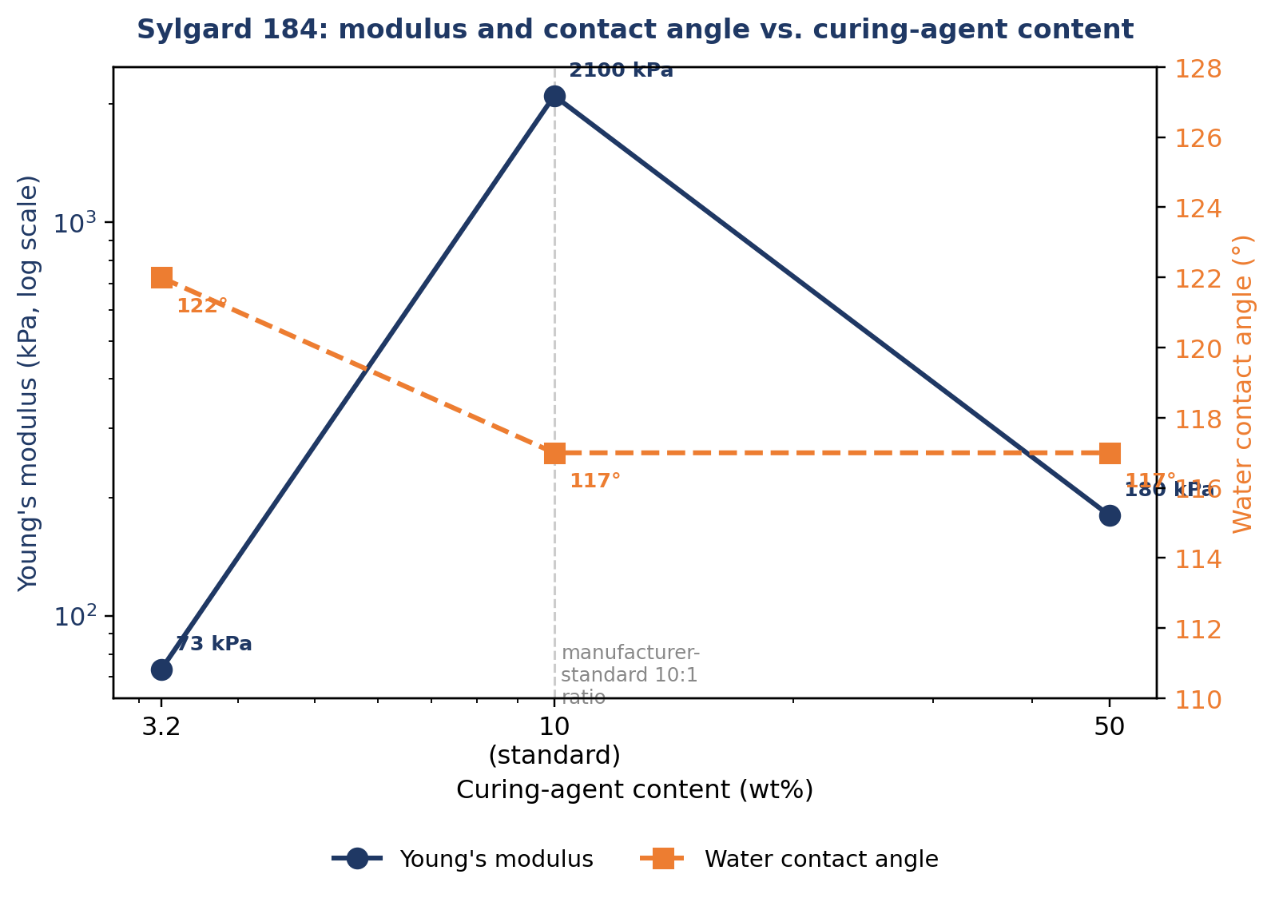
Figure 3. Young's modulus and water contact angle of cured Sylgard 184 versus curing-agent content — the three plotted points are the only data points reported by the source; lines connecting them are for visual guidance only, not interpolated measurements. Data: Cho et al. (2021) [33].
Design implication for an anti-wetting contactor coating: given the absence of a verified adhesion-vs-ratio data set for this specific application, the defensible default is to start at the manufacturer-standard ~10:1 ratio — which the Cho et al. data identify as the mechanical/optical property optimum — and deviate from it only after side-by-side adhesion, LEP, and extractables testing on the target PVDF support and amine solvent demonstrate a clear, reproducible benefit that outweighs the loss of bulk modulus.

4.4 Curing temperature and time
Curing conditions govern how far the hydrosilylation reaction proceeds toward its thermodynamic crosslink density before gelation kinetically locks the network, and the literature shows a genuinely system-dependent (not universal) effect that is worth stating explicitly rather than glossing over.
- On dense, unsupported flat PDMS films, raising the crosslinking temperature to an optimum of about 75°C was found to substantially increase gas permeability relative to lower cure temperatures — N₂ permeability rising from about 360 to 590 Barrer, CO₂ from about 3,190 to 3,970 Barrer, and CH₄ from about 850 to 1,000 Barrer — attributed to faster gelation kinetics trapping additional free volume in the network before full relaxation/densification could occur.
- On a porous asymmetric hollow-fiber support (PDMS/PEI composite), by contrast, curing at room temperature (25°C) gave the highest CO₂/N₂ selectivity of the conditions tested; elevated cure temperatures, and applying multiple sequential coating layers, both had an adverse effect on separation performance in that specific composite system.
[CITED] [14] (flat film, 75°C optimum) and [13] (PEI hollow fiber, 25°C optimum) — see reconciliation below.
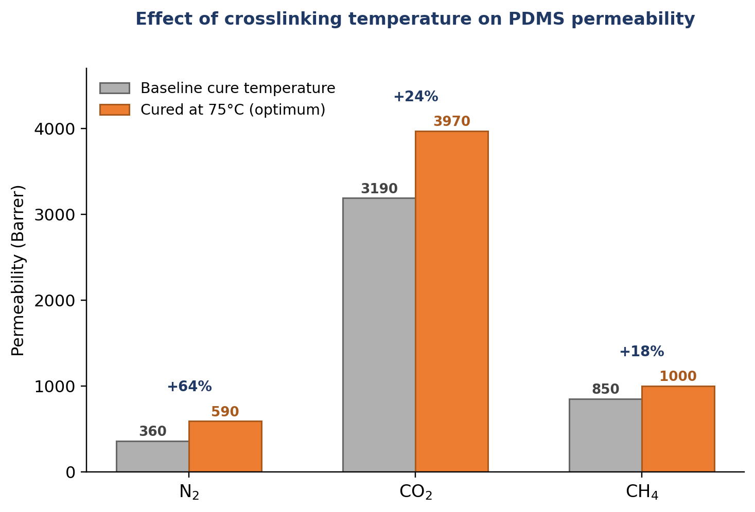
Figure 4. Effect of raising crosslinking temperature to the 75°C optimum on dense-film PDMS gas permeability (N₂, CO₂, CH₄). This result is specific to unsupported dense films; Section 4.4's “key nuance” below explains why it does not directly transfer to a porous hollow-fiber composite. Data: Berean et al. (2014) [14].
Key nuance: these two findings are not contradictory once the substrate is accounted for. On a dense, self-supported film, cure temperature only has to manipulate bulk network free volume. On a porous composite support, cure temperature additionally controls the race between (a) capillary wicking of the still-liquid coating solution into support pore mouths and (b) gelation locking the polymer at the surface — a hotter, faster gelation on a porous support may arrest the coating before it has fully leveled and bridged pore openings, baking in defects that a slower room-temperature cure would have allowed to heal by capillary/gravitational leveling first. The practical conclusion is that the optimal cure schedule must be re-optimized for the specific substrate pore architecture in use, not transferred directly from dense-film literature — and for a porous PVDF hollow-fiber contactor, the hollow-fiber-specific result (mild, near-ambient cure) is the more directly applicable precedent.

4.5 Withdrawal speed and dwell (coating) time
For the low-viscosity, dilute hydrocarbon-solvent PDMS baths typically used for hollow-fiber coating, the capillary number (Ca = ηU/γ) is usually low enough that the process sits closer to the capillary-draining regime than the pure Landau–Levich regime described in Section 3.1 — meaning dwell/soak time in the bath, and the drain time before the solvent evaporates, matter as much as or more than withdrawal speed itself. In the PDMS/PEI hollow-fiber optimization already cited, a 10-minute coating (dwell) time paired with 15 wt% PDMS gave the best combination of permeance and selectivity; shorter dwell left thin, incompletely covering layers, while longer dwell at the same concentration (or the same dwell at higher concentration) over-thickened the layer and increased resistance without a corresponding selectivity benefit.
[CITED] [13].
The practical implication is that withdrawal speed, concentration, and dwell time cannot be optimized independently — they jointly set both the deposited thickness and the time window available for capillary intrusion into the substrate (Section 4.7), and should be treated as a coupled three-variable optimization rather than tuned one at a time.

4.6 Number of coating passes
A natural intuition is that applying a second or third PDMS coat should heal residual pinhole defects left by the first pass and therefore only improve performance. The hollow-fiber composite literature reviewed here found the opposite for the specific system tested: additional coating layers had an adverse effect on separation performance relative to a single, well-optimized coat.
[CITED] [13].
The most plausible mechanism is that once a single coat already achieves adequate defect-free coverage, each additional pass simply adds non-selective bulk thickness (permeance loss with no further selectivity gain); a secondary mechanism, relevant if inter-coat cure is incomplete, is that fresh coating solvent can partially re-swell or disturb the previously deposited layer, degrading rather than improving its integrity. The practical rule this supports is to invest optimization effort in getting a single coating pass right (concentration, dwell, cure) rather than defaulting to multiple passes as a defect-mitigation strategy.

4.7 Substrate pore size, porosity, and pore intrusion
On any porous support, the still-liquid PDMS coating solution experiences a capillary pressure pulling it into pore mouths before solvent evaporation and gelation can arrest the process. This intrusion both wastes polymer (forming plugs rather than a uniform surface film) and creates a non-uniform effective coating thickness, with locally thick, high-resistance regions directly over larger pores.
Two, at first glance conflicting, findings from the gutter-layer/TFC literature clarify the governing variable:
- Conventional two-layer (selective-layer-on-support) coatings are generally reported to require support surface porosity below roughly 10% (0.1) for reliable, defect-free thin coatings, because on higher-porosity supports the fraction of the surface where intrusion can occur is simply larger.
- For example, in a three-layer outside-in composite hollow fiber (Pebax selective skin / PDMS gutter layer / polysulfone support), systematically optimizing the polysulfone support (concentration, nonsolvent additives, bore-fluid composition) enabled a defect-free PDMS gutter layer with a CO₂ permeance of about 4,400 GPU and a CO₂/N₂ selectivity of about 10.7 — permeable enough that once the thin selective skin (CO₂ permeance ≈310 GPU, CO₂/N₂ selectivity ≈25.6) was applied on top, the gutter layer contributed negligible additional resistance. This illustrates that support/gutter-layer co-design, not support porosity considered in isolation, is what determines whether pore intrusion is avoided.
[CITED] [6], [7], [8] — pore intrusion of PDMS top layers into porous supports; gutter-layer impact on ultrathin composite membranes.
The controlling ratio is pore diameter relative to intended (or achievable) coating thickness, together with intrusion depth. When the individual pore diameter is small relative to the target film thickness, a thin, continuous, defect-free layer can bridge the pore mouth even at fairly high overall porosity. When pores are large or broadly distributed (as in many commercial microfiltration-grade PVDF hollow fibers used as contactor substrates, with pore sizes typically in the 0.1–0.4 µm range), intrusion depth and local thickness non-uniformity become the binding constraint, and a thicker, more concentrated, slower-gelling coating formulation is generally needed to reliably bridge the largest pores in the distribution rather than just the mean pore.
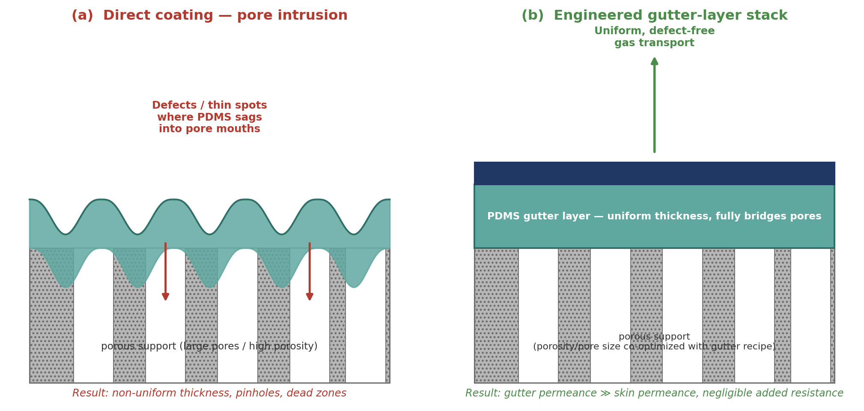
Figure 5. (a) Direct coating of a mismatched (too-large-pore / too-high-porosity) support: the PDMS solution sags into pore mouths, producing non-uniform thickness and defect-prone thin spots. (b) A properly co-designed gutter-layer stack fully bridges the support pores with a uniform layer, so the gutter contributes negligible resistance to the thin selective skin above it. Original schematic.

4.8 Surface pretreatment and adhesion promotion
PVDF and PP, the two most common contactor-fiber substrates, present a specific adhesion problem: both are low-surface-energy, chemically inert polymers with few or no reactive surface functional groups for the PDMS coating to bond to, so an as-received fiber typically shows only weak physical (van der Waals) adhesion to a subsequently cured PDMS layer.
- Plasma or corona treatment (commonly O₂ or air plasma) oxidizes the substrate surface, introducing polar functional groups (carbonyl, hydroxyl, carboxyl) that raise surface energy and improve initial wetting and adhesion of the PDMS coating solution. This is fast and equipment-light but is subject to “hydrophobic recovery” over time — low-molecular-weight chain segments at the surface reorient or migrate, and polar groups become buried, so the adhesion benefit can decay within hours to days if coating is delayed after plasma treatment.
- Silane coupling agents (e.g., APTES, GPTMS, or vinyl/methacrylate-functional silanes such as TMSPMA) provide a more durable bridge: one functional end anchors to the (typically plasma-activated) substrate surface, while the other end participates in the PDMS crosslinking chemistry, forming a covalent linkage across the interface rather than a physical one. In one reported protocol, combining oxygen-plasma activation with a 5% APTES treatment (about 30 minutes total processing time) raised PDMS bonding strength to as much as 1,400 kPa, versus markedly weaker bonding from plasma activation alone — illustrating how much a chemical coupling step can add on top of plasma activation, though this specific figure comes from a PDMS-to-SU-8-photoresist bonding study rather than a PDMS-to-PVDF membrane system, so it should be read as evidence of the mechanism's potency rather than a direct prediction for the amine-contactor coating.
[CITED] [9], [10], [47], [48] — surface treatment/coupling-agent studies on PVDF and related fluoropolymer adhesion to PDMS.
For a coating that must survive months of continuous contact with a hot, circulating amine solution under vacuum-cycled pressure differentials (the amine-regeneration duty of Section 7), interfacial adhesion durability — not just initial adhesion — is the relevant design criterion, which favors combined plasma-activation-plus-silane-coupling over plasma treatment alone.

4.9 Nanofiller additives
Embedding nanoparticles within the PDMS coating matrix (rather than using neat PDMS) has been explored for two distinct purposes that are sometimes conflated in the literature and are worth separating:
- Hydrophobicity enhancement via surface roughening: hydrophobic fumed silica or hydrophobic-modified silica nanoparticles (HMSNs) incorporated into a PDMS or PDMS-containing coating create micro/nano-scale surface roughness that amplifies intrinsic PDMS hydrophobicity through a Cassie–Baxter-type mechanism, pushing water contact angles from the neat-PDMS range of roughly 105–115° up to 150–160°+ (superhydrophobic regime), with corresponding liquid-entry-pressure gains. Reported systems include PES/PES–SiO₂ mixed-matrix contactor surfaces reaching a water contact angle of about 159° (LEP ≈ 1.39 bar in that specific low-LEP membrane geometry), superhydrophobic PVDF with HMSNs exceeding 160° contact angle and remaining stable through a 20-day continuous MEA exposure test, and PDMS/CaCO₃-nanoparticle-coated PVC hollow fibers raising contact angle from about 64° to 101° with LEP increasing to as much as 7 bar.
- Gas-transport modification (mixed-matrix effect): in gas-separation-oriented PDMS composites, zeolite (e.g., silicalite), MOF/ZIF, or engineered silica fillers can provide preferential CO₂ sorption or diffusion pathways that raise permeability, selectivity, or both simultaneously — provided filler–polymer interfacial voids (a common defect at high filler loading) are avoided.
[CITED] [19], [35], [38], [41], [42], [43], [44] — silica/zeolite/ZIF-filled PDMS composite coatings for hydrophobicity and/or CO₂ transport enhancement.
In all filler systems reviewed, an optimum loading exists beyond which agglomeration, coarsened surface roughness (which can paradoxically re-enter a Wenzel wetting regime rather than remaining Cassie–Baxter), or filler-induced coating defects degrade performance — more filler is not monotonically better, mirroring the “more is not always better” pattern already seen for coating-layer count (Section 4.6) and cure temperature (Section 4.4).

5. Characterization and Quality Metrics
A coherent coating-quality assessment combines physical, chemical, and functional characterization; no single technique is sufficient on its own.
Technique | What it measures | Why it matters for PDMS coatings
Liquid entry pressure (LEP) | Transmembrane liquid pressure at which breakthrough/wetting begins | The direct functional metric for anti-wetting performance; should be measured with the actual working liquid (e.g., aqueous amine), not just water — see note below
Static contact angle (sessile drop) | Wettability of the coated surface | Fast screening proxy for LEP and surface energy; should be reported for both water and the working solvent
Cross-sectional SEM | Physical coating thickness, uniformity, pore-intrusion depth | Directly verifies whether Section 4.7's pore-bridging assumptions held for the actual substrate used
ATR-FTIR | Chemical confirmation of PDMS coverage and cure completeness | Si–O–Si asymmetric stretch (~1000–1100 cm⁻¹) and Si–CH₃ (~1260 cm⁻¹) confirm coverage; residual vinyl or Si–H signatures indicate incomplete cure
AFM surface roughness | Nanoscale topography | Mechanistically links to the Cassie–Baxter hydrophobicity enhancement discussed in Section 4.9
Gas permeation testing | Permeance (GPU) and ideal/mixed-gas selectivity | Quantifies the resistance penalty the coating adds to gas-phase mass transfer — the trade-off against LEP gain
Peel / lap-shear adhesion | Interfacial bond strength | Predicts delamination risk under long-term liquid immersion and pressure cycling
Extended immersion aging | LEP, contact angle, and FTIR tracked over weeks–months in the actual working solution at operating temperature | The only reliable way to assess in-service durability; short-term characterization alone cannot capture hydrolytic degradation (Section 7.2)
Table 2. Recommended characterization suite for a PDMS anti-wetting contactor coating.
Important methodological caution: a substantial fraction of the coating literature reports LEP and contact angle using pure water as the test liquid, because it is convenient and standardized. Aqueous amine solutions (MEA, DEA, K-glycinate, etc.) have measurably lower surface tension than pure water, and the Young–Laplace relation that governs LEP (LEP −B · γ · cosθ / r, where B is a pore-geometry factor, γ is liquid surface tension, and r is pore radius) means LEP scales directly with surface tension. A water-based LEP measurement will therefore systematically overestimate the LEP actually achieved in service against an amine solution. Any coating recipe validated only against water LEP should be treated as unverified for amine service until re-tested with the actual working solvent — several of the amine-relevant studies cited in Section 7 do report LEP or wetting behavior directly against amine or amine-representative solutions, and those are flagged accordingly.

6. Performance Baseline: Gas Transport Through PDMS
To judge whether a given coated-membrane result is good, it is necessary to know what neat, defect-free PDMS itself is capable of. The foundational gas-sorption/diffusion/permeation study of Merkel et al. (2000) remains the standard reference point for pure-PDMS transport properties.
Gas | Permeability (Barrer, pure PDMS) | Notes
CO₂ | ≈ 3,300–3,800 | High CO₂ solubility in the rubbery, non-polar PDMS matrix is the dominant transport mechanism
N₂ | ≈ 250–400 | Baseline for CO₂/N₂ selectivity
CH₄ | ≈ 800–1,000 | Relevant to biogas/natural-gas contactor applications
CO₂/N₂ ideal selectivity | ≈ 9–12 | Modest by gas-separation standards — PDMS sits well below the Robeson upper bound for this pair, which is why it is rarely chosen as a stand-alone high-selectivity gas-separation membrane and is instead used as a gutter layer, or where its other properties (anti-wetting, mechanical compliance, low cost) dominate the selection
Table 3. Baseline pure-PDMS gas transport properties. [CITED] [5], [39], [40] — Merkel et al. (2000) and corroborating measurements from subsequent PDMS composite-membrane and flue-gas testing studies.
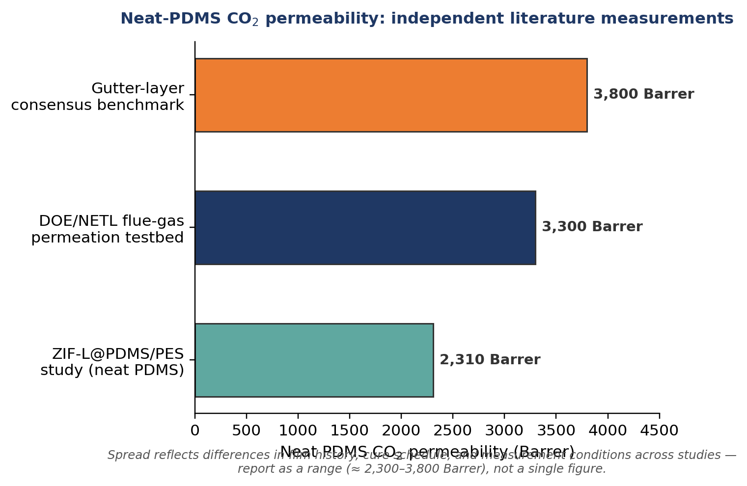
Figure 6. Neat-PDMS CO₂ permeability as independently measured/reported across three unrelated studies, illustrating the natural spread that should be expected (and reported as a range) rather than a single “textbook” value. Sources: [38] (ZIF-L@PDMS/PES study, neat-PDMS control), [39] (DOE/NETL flue-gas testbed), [6] (gutter-layer consensus benchmark).
Composite (coated) PDMS layers on real supports typically show somewhat lower apparent permeance than the intrinsic bulk value once support resistance, pore intrusion, and any incomplete cure are folded in — this is exactly why Section 4's parameters matter. The composite results assembled in this report span a wide range depending on architecture and target function:
System | PDMS thickness | CO₂ permeance | CO₂/N₂ selectivity | Reference
PDMS gutter layer / polysulfone hollow-fiber support (optimized) | not reported | ≈ 4,400 GPU | ≈ 10.7 | [6]
PDMS dense layer / PEI hollow fiber (optimized: 15 wt%, 10 min) | not reported (thin, optimized) | ≈ 51 GPU | ≈ 21 | [13]
PES–PDMS thin-film composite hollow fiber, 20–22 bar operation | not reported | ≈ 2,150 GPU | ≈ 20 | [45]
PolyActive/PDMS/PES tri-bore composite (optimized selective skin) | not reported | ≈ 310 GPU | ≈ 25.6 | [6]
Flat dense PDMS film, cured at 75°C (vs. lower-T cure) | dense film | 3,970 Barrer (bulk permeability, not GPU) | not directly reported | [14]
Table 4. Representative composite/coated PDMS performance across different architectures and functions. Note units differ (GPU for supported composites; Barrer for the dense-film bulk-property study) and are not directly comparable across rows without normalizing for thickness — shown side by side only to illustrate the range of reported outcomes. [CITED]
The selectivity achieved in the PEI hollow-fiber case (≈21) exceeding the neat-PDMS bulk value (≈9–12) is notable and is generally attributed in this class of study to the composite's thin selective layer being effectively reinforced/defect-screened by the support, plus possible partial pore intrusion creating a locally thicker, more defect-free effective barrier — illustrating that composite behavior does not always sit below the bulk intrinsic value, and reinforcing why direct gas permeation testing of the actual coated article (Section 5), not reliance on tabulated bulk polymer data, is the only reliable performance check for a specific fabricated coating.

7. Application: PDMS Coating for Amine-Regeneration Membrane Contactors
This section applies the coating science of Sections 2–6 to the specific case most relevant to your program: a PDMS anti-wetting protective coating on a porous, hydrophobic PVDF hollow-fiber membrane contactor (HFMC) used for vacuum-assisted amine regeneration (low-temperature CO₂ stripping/desorption).

7.1 The pore-wetting problem in amine-regeneration HFMCs
In vacuum-assisted membrane stripping, CO₂-rich amine solution is circulated on one side of a microporous hydrophobic membrane while vacuum is drawn on the opposite side, creating the driving force for CO₂ to desorb from solution and cross the membrane through gas-filled pores. The entire performance case for this technology depends on the pores staying gas-filled: mass transfer through a gas-filled pore is fast (molecular/Knudsen diffusion of CO₂ in vapor), while mass transfer through a liquid-filled (wetted) pore is orders of magnitude slower (liquid-phase diffusion), so even partial wetting is disproportionately damaging to overall flux.
The magnitude of this effect is well documented quantitatively. In gas–liquid membrane contactor studies using PVDF hollow fibers, switching from a non-wetting reference liquid to MEA as the absorbent reduced CO₂ flux by approximately 54.5%, and simulation-based analysis has shown that even a modest 5% degree of pore wetting can reduce the overall mass transfer coefficient by roughly 20%.
[CITED] [16] — surface modification of PVDF hollow-fibre membranes for biogas purification in a gas–liquid membrane contactor; wetting-extent analysis therein.
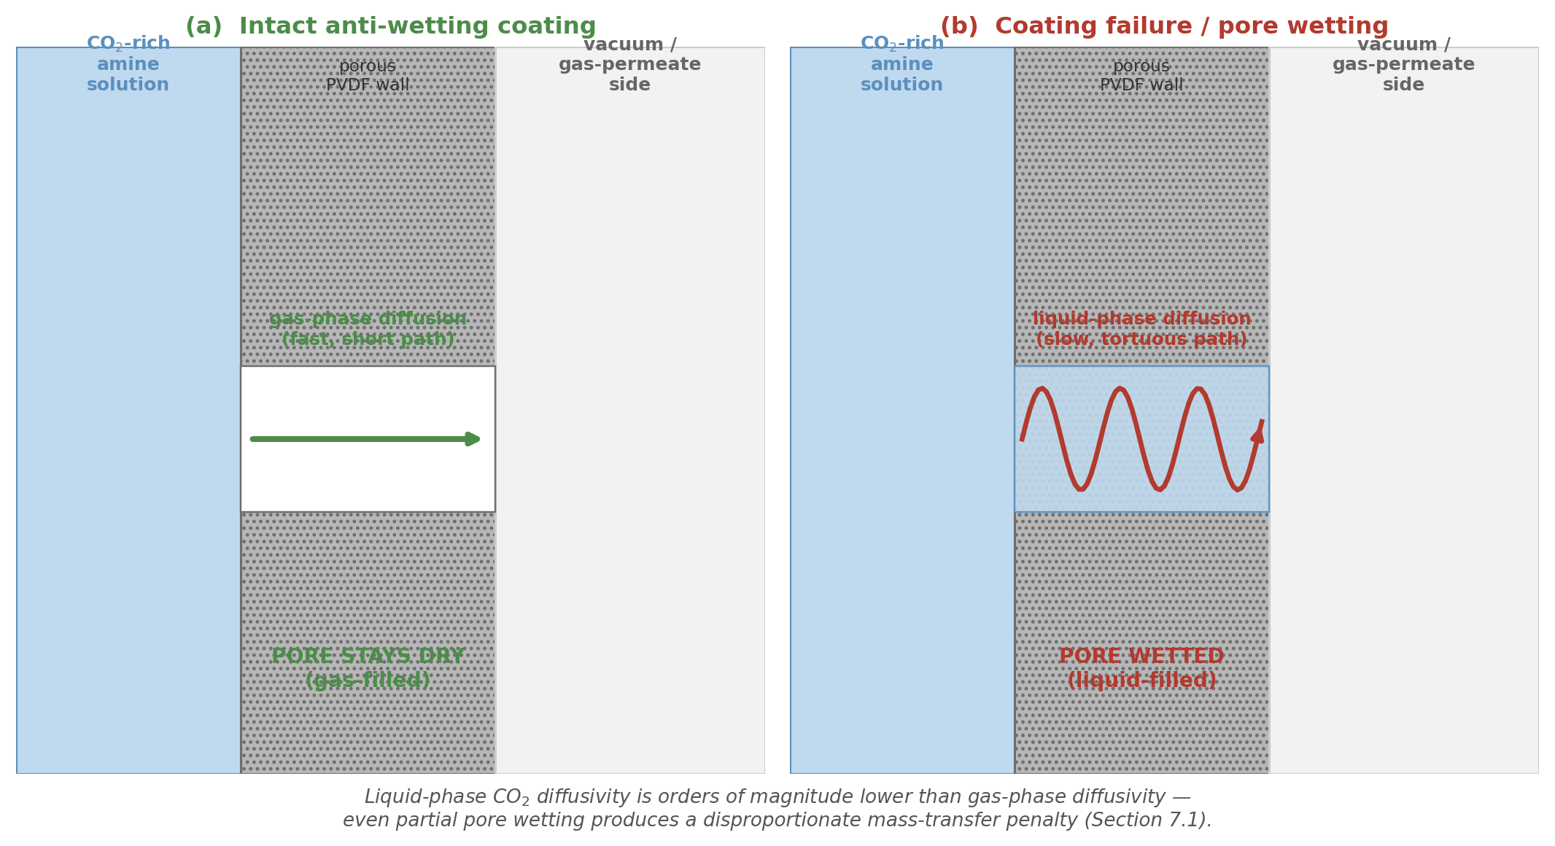
Figure 7. Cross-section of an HFMC fiber wall: (a) with the anti-wetting coating intact, CO₂ crosses via fast gas-phase diffusion through a dry pore; (b) once the pore wets, CO₂ must instead cross via slow, tortuous liquid-phase diffusion — the mechanism behind the disproportionate flux penalty described above. Original schematic.
Two features of amine service make this worse than a generic wetting-liquid scenario. First, amine solutions and their degradation products (formed progressively during thermal/oxidative cycling) can act as surfactants, lowering effective surface tension at the membrane surface over time and making a membrane that started non-wetted increasingly susceptible to wetting as it ages in service. Second, as discussed next, the PVDF substrate itself is not chemically inert to hot amine solution, so surface energy can also drift upward due to chemical attack on the polymer backbone, independent of any surfactant effect — wetting resistance in this duty is therefore a long-term durability property, not a one-time fabrication specification.

7.2 Chemical stability of the substrate versus PDMS
A systematic exposure study evaluated porous PP, PVDF, PES, PA, and PTFE membranes in amine solvents representative of contactor service (alkanolamines plus heat-stable salts), tracking chemical and morphological change via FTIR and AFM. PP, PVDF, PES, and PA all showed measurable chemical and/or morphological destruction after exposure; PTFE demonstrated comparatively much higher stability.
[CITED] [15] — Kalmykov et al. (2023), Stability of Porous Polymeric Membranes in Amine Solvents for Membrane Contactor Applications, Membranes 13(6):544.
This is directly relevant to why a PDMS coating is worth the added fabrication complexity on a PVDF contactor: it can serve two separable protective functions simultaneously — (i) the anti-wetting function of Section 7.1 (low surface energy keeping pores gas-filled), and (ii) a barrier function, physically isolating the chemically vulnerable PVDF backbone from direct, continuous amine contact. PDMS's own siloxane backbone is comparatively robust (Section 2.1), but it is not immune to attack: prolonged exposure to hot, moist, and particularly alkaline conditions can hydrolyze Si–O–Si linkages, especially at chain ends, coating defect sites, or incompletely cured regions, gradually reducing crosslink density and eroding the very hydrophobicity the coating was applied to provide. A PDMS coating on PVDF should therefore be understood as a durability-extension strategy, not a permanent, maintenance-free fix, and the extended immersion aging protocol in Section 5 (tracking LEP, contact angle, and FTIR over weeks-to-months at actual operating temperature) is the appropriate way to qualify a specific formulation for long-term amine service rather than relying on as-fabricated characterization alone.

7.3 PDMS as the anti-wetting layer: evidence from the literature
Several independent studies confirm PDMS coating measurably increases wetting resistance on porous contactor-grade substrates, in duties directly analogous to amine regeneration even where the target gas differs:
- PDMS-coated porous PVDF hollow-fiber membranes have been demonstrated for efficient recovery of dissolved biomethane, and separately for wetting- and fouling-resistant dissolved-methane recovery from anaerobic wastewater effluents — both applications share the identical core physics of maintaining a gas-filled pore network against a wetting aqueous liquid, differing from amine regeneration mainly in the target gas (CH₄ vs. CO₂) and the absence of the amine-specific chemical-attack concern of Section 7.2.
- A PDMS/CaCO₃-nanoparticle coating on a PVC hollow-fiber contactor used for gas dehydration raised water contact angle from about 64° to 101° and liquid entry pressure to as much as 7 bar, directly demonstrating the coating-driven LEP gain quantified in Section 4.9.
- Superhydrophobic silica-filled PDMS-containing coatings on PVDF, applied specifically for CO₂-absorption contactor duty, reached water contact angles exceeding 160° and remained stable through a 20-day continuous MEA exposure test — direct evidence, in the CO₂/amine context specifically, that a well-formulated silica-PDMS composite coating can survive extended amine contact without losing hydrophobic performance.
[CITED] [17], [18], [19], [42] — see reference list for full citations.

7.4 Case study: silicalite-filled PDMS composite membranes for low-temperature vacuum stripping
The single most directly relevant precedent in the literature reviewed for this report is Ahn, Kim, and Kim's study of low-temperature vacuum stripping of CO₂ from aqueous amine solutions using thin-film silicalite-filled PDMS composite membranes — a study that targets exactly the duty of interest: PDMS-based membrane technology for CO₂ desorption/regeneration from amine solution under vacuum at reduced temperature, rather than the ~120°C required by conventional thermal stripping columns.
[CITED] [2] — Ahn, H., Kim, J., Kim, J.H. (2013), International Journal of Greenhouse Gas Control, 18:165–172.
A design-relevant piece of solvent chemistry the authors compile is the heat of reaction of CO₂ with different amines, which sets the energy actually required to reverse the CO₂-amine bond during low-temperature stripping: approximately 83 kJ/mol-CO₂ for MEA, 71 kJ/mol-CO₂ for DEA, and 47 kJ/mol-CO₂ for TEA (values the authors compiled from Kim & Svendsen (2011) and Kwak et al. (2012a)).
[CITED] [2], citing Kim & Svendsen (2011) and Kwak et al. (2012a) as the original sources of the reaction-heat values.
This has a direct design implication for a PDMS-coated HFMC vacuum-stripping system: lower-heat-of-reaction amines (or amine blends) require less energy input to strip CO₂ at a given low temperature/vacuum level, meaning the choice of absorbent chemistry and the design of the PDMS-coated membrane stripper are not independent decisions — an absorbent selected to minimize conventional reboiler duty is not automatically the best pairing for a vacuum-membrane stripper, and vice versa.
Architectural note: Ahn et al.'s design uses the PDMS composite as the actual CO₂ transport membrane in a dense-film “membrane stripper” configuration (CO₂ dissolves into and diffuses through the PDMS layer itself, exploiting PDMS's intrinsic CO₂ solubility-selectivity from Section 6), which differs mechanistically from a porous PVDF HFMC where PDMS is applied only as a thin anti-wetting barrier at the pore mouths and the rate-limiting transport step remains gas-phase diffusion through gas-filled pores. The two architectures are not directly interchangeable, and permeance/flux numbers from one should not be applied to the other. What does carry over directly is the qualitative confirmation that PDMS, as a material class, is chemically and thermally compatible with the low-temperature (60–75°C), vacuum, amine-solution environment central to this duty — the case study validates PDMS's suitability for the operating envelope even though the specific transport architecture differs from the HFMC-plus-coating design.

7.5 Interaction with vacuum stripping process conditions
Membrane vacuum regeneration (MVR) process conditions reported in absorbent-screening studies for this technology center on CO₂ absorption at about 25°C/12.5 kPa CO₂ partial pressure, followed by regeneration of the CO₂-rich solvent at about 75°C and 20 kPa — well within the operating envelope your own prior work on this technology has already established. Under a separate, distinct set of conditions (61.3 kPa decompression pressure, 9 mL/min absorbent flow, liquid-to-lumen operation), Ahn et al.'s silicalite-filled PDMS composite achieved a CO₂ stripping flux of about 45.8×10⁻⁴ mol/m²·s, reported as roughly 2–40× higher than typical nitrogen-sweep-type membrane-contactor stripping studies — though this flux is specific to their dense-film composite architecture (Section 7.4) and should not be assumed to transfer directly to a porous-PVDF-plus-thin-PDMS-coating architecture. PDMS's thermal degradation onset (well in excess of the 60–75°C operating window, per Section 2.3's thermal-stability discussion) sits comfortably above this range with wide margin, so thermal stability of the bulk PDMS material itself is not expected to be the binding constraint in this duty.
[CITED] [28] — membrane stripping technology for CO₂ desorption with low energy consumption, MVR process conditions.
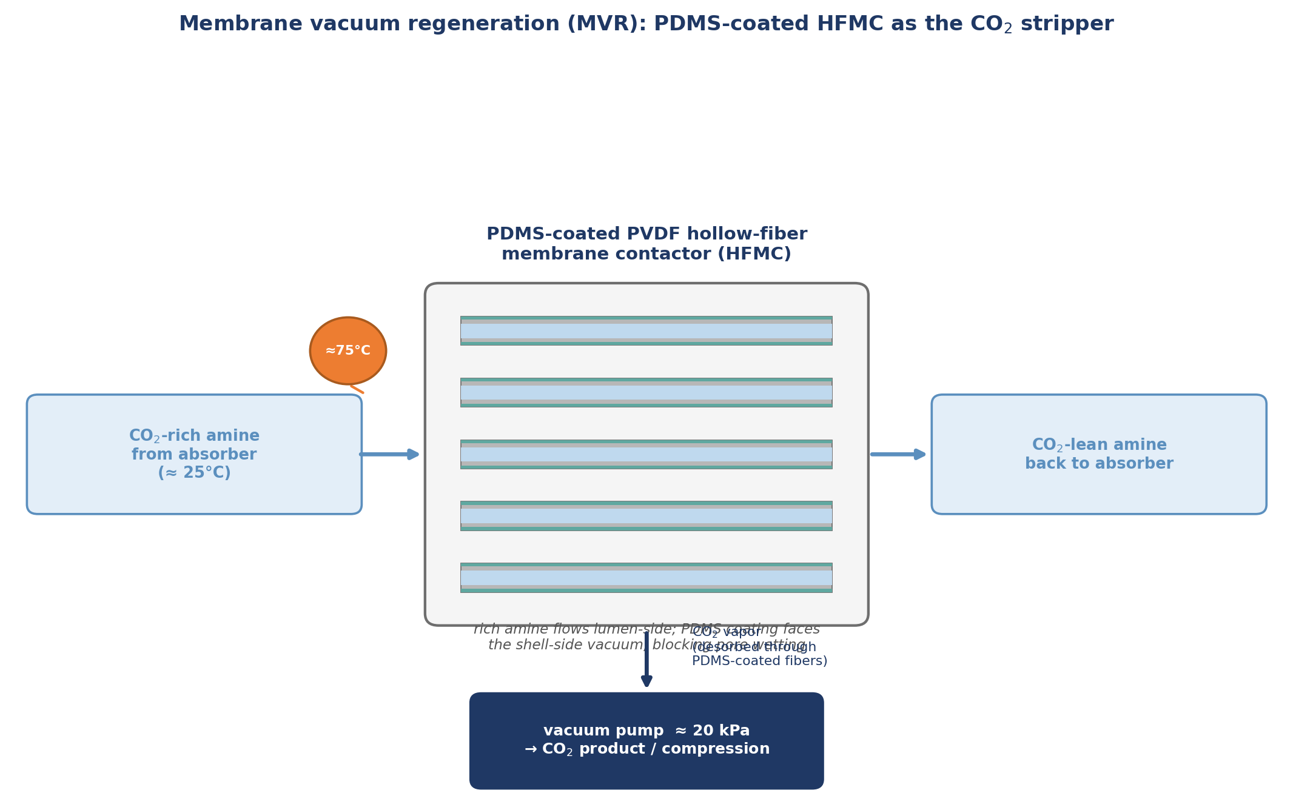
Figure 8. Simplified process schematic: CO₂-rich amine enters the lumen side of a PDMS-coated PVDF HFMC at ≈75°C, shell-side vacuum (≈20 kPa) drives CO₂ desorption through the gas-filled (non-wetted) pores and thin PDMS coating, and CO₂-lean amine returns to the absorber. Process conditions per [28]; module architecture is an illustrative composite, not a specific published design.
What does require careful, module-specific evaluation is the net transmembrane pressure differential the coating's LEP must withstand. Drawing vacuum on the gas (permeate) side changes the pressure balance across the coated pore relative to atmospheric-side operation, and the actual local pressure differential at the coating depends on the specific module design — whether amine solution flows lumen-side or shell-side, the vacuum level, and the liquid-side pumping/recirculation pressure drop along the fiber length. A coating's LEP should therefore be sized against the actual operating transmembrane differential of the specific module configuration, not evaluated in isolation against a generic “higher is better” target.
This also bears directly on where the coating is best applied. If amine solution flows through the fiber lumen with vacuum drawn shell-side, the lumen surface is the liquid-contacting interface and is where anti-wetting protection is functionally required; the shell side, exposed only to vacuum/gas, does not need the same protection and coating it adds cost without functional benefit. The reverse holds if the module design instead puts amine on the shell side. This is a manufacturability trade-off as much as a performance one: full-bundle immersion (shell-side or whole-fiber) dip coating before potting is generally the more practically achievable process, while lumen-only coating requires specialized through-lumen solution delivery (e.g., syringe-pump or vacuum-assisted lumen filling) to achieve uniform coverage along fiber length — so the choice of which side carries the liquid phase in the module design should, where there is design freedom, be made with coating manufacturability in mind, not decided independently of it.

7.6 Design recommendations for a PDMS-coated PVDF hollow-fiber contactor
Synthesizing Sections 4 and 7.1–7.5 into a set of design recommendations specific to this application:
- Coat the liquid-contacting face directly (lumen-side if amine flows in the lumen; shell-side if amine flows in the shell) — LEP protection is local to the liquid–solid–gas contact interface, not a bulk fiber property.
- Use a single, well-optimized dip-coating pass rather than multiple sequential coats (Section 4.6).
- Target a coating thickness in the roughly 1–10 µm range (Table 1), and verify the specific fabricated coating's actual thickness (SEM), gas-phase resistance (permeation testing), and LEP against the real amine solution (not water) before scaling up — per the methodological caution in Section 5.
- Use a base:crosslinker ratio at or slightly richer in curing agent than the 10:1 stoichiometric standard (Section 4.3), to minimize extractable low-molecular-weight siloxane oligomers in continuous hot-amine service, and offset the resulting modest adhesion penalty with combined plasma-activation-plus-silane-coupling pretreatment (Section 4.8) rather than by deliberately under-crosslinking.
- Cure at or near ambient temperature as the starting point (Section 4.4), consistent with the porous hollow-fiber-specific literature precedent, and re-optimize empirically for the specific PVDF fiber's pore-size distribution rather than importing the 75°C dense-film optimum uncritically.
- Consider a hydrophobic-silica-filled PDMS formulation (Section 4.9) if the operating transmembrane pressure differential (Section 7.5) demands LEP beyond what neat PDMS provides, accepting the added process complexity of nanoparticle dispersion and loading optimization.
- Qualify long-term durability via extended immersion aging in the actual working amine solution at the intended 60–75°C operating temperature, tracking LEP, contact angle, and FTIR at intervals — both PVDF substrate degradation (Section 7.2) and PDMS hydrolysis are credible slow failure modes that will not appear in as-fabricated characterization alone.
- Size the coating's LEP margin against the actual operating transmembrane pressure differential of the specific vacuum/module configuration in use, not a generic target (Section 7.5).

8. Recommended Optimized Coating Protocol
Important framing: no single study reviewed in this report tested this exact combination of parameters on your specific PVDF hollow-fiber substrate. The protocol below is a synthesis — each individual parameter choice is grounded in a cited literature result (Section 4), but the specific combination is an informed engineering judgment, not itself a directly verified recipe. It should be treated as the starting point for a small design-of-experiments (DoE) screening on your actual fiber lot, not as a specification to scale up directly without bench verification.
[ESTIMATE] Combined protocol — individual parameters [CITED] per Section 4; the specific combination is an [ESTIMATE] requiring bench verification.

8.1 Recommended starting-point parameters
Parameter | Recommended starting value | Rationale (source)
PDMS grade / cure chemistry | Addition-cure (Pt-catalyzed hydrosilylation), e.g., Sylgard-184-type system | Avoids condensation-cure byproducts/residual silanols that would compromise hydrolytic durability (§2.1)
Base : curing-agent ratio | 10:1 by mass (stoichiometric), or slightly richer in curing agent (e.g., 9:1) | Minimizes extractable low-MW oligomers in hot amine service; accept modest adhesion penalty, offset via §8.1 pretreatment (§4.3)
Coating-solution concentration | 12–15 wt% PDMS (base+curing agent) in solvent | Matches the optimum identified for a comparable porous hollow-fiber composite (§4.1)
Solvent | n-heptane (or n-hexane if evaporation-rate needs support fast gelation) | Good wetting of hydrophobic PVDF, fast evaporation limits capillary intrusion window (§4.2); avoid prolonged pre-mix standing time given known hexane–PDMS swelling interaction
Substrate pretreatment | Air or O₂ plasma activation, followed promptly by a vinyl/methacrylate-functional silane coupling treatment (e.g., TMSPMA) | Covalent anchoring survives long-term liquid immersion far better than plasma-only activation, which suffers hydrophobic recovery (§4.8)
Application method | Single-pass dip coating of the liquid-contacting face only (lumen or shell, per module design) | Multiple passes showed adverse effects in the closest literature precedent; coat only the functionally relevant face (§4.6, §7.6)
Dwell (coating) time | 8–12 minutes | Matches the optimum window identified for the closest hollow-fiber precedent, balancing coverage completeness against over-thickening (§4.5)
Withdrawal / drain | Slow, controlled withdrawal; allow full gravity/capillary drainage before cure | Low-Ca capillary-draining regime dominates at the low viscosities typical of these dilute baths (§3.1, §4.5)
Cure schedule | Ambient temperature (20–25°C), extended cure time (e.g., 12–24 h) rather than an elevated-temperature short bake | Porous hollow-fiber-specific evidence favors ambient cure; elevated cure temperature is a dense-film-specific optimum that risks locking in pore-intrusion defects on a porous support (§4.4) — verify cure completeness via ATR-FTIR (§5) before assuming ambient cure has fully proceeded
Target dry coating thickness | 2–6 µm | Mid-range of the anti-wetting-role target band, balancing LEP gain against added gas-phase resistance (Table 1); confirm by cross-sectional SEM
Optional hydrophobicity booster | 5–10 wt% hydrophobic fumed silica (relative to PDMS solids), pre-dispersed in the solvent before adding PDMS | Pushes contact angle/LEP beyond neat PDMS via Cassie–Baxter roughening; determine actual optimum loading empirically since excess filler degrades rather than improves performance (§4.9)
Table 5. Recommended starting-point PDMS coating protocol for a PVDF HFMC anti-wetting layer in amine-regeneration service. Each row is individually [CITED] per Section 4; the assembled combination is [ESTIMATE] pending bench verification.

8.2 Pre-scale-up validation checklist
Before committing this protocol to a production-scale fiber batch or full module, the following verification steps are recommended, each tied to a characterization method from Section 5:
- Cross-sectional SEM to confirm actual dry coating thickness matches the 2–6 µm target and to check for pore-intrusion irregularities specific to your fiber's pore-size distribution.
- ATR-FTIR to confirm complete cure (absence of residual Si–H/vinyl signatures) under the ambient-cure schedule, given that Section 4.4's ambient-cure recommendation trades cure speed for pore-intrusion avoidance and cure completeness should not be assumed.
- Gas permeance testing (pure and/or mixed-gas CO₂/N₂ or CO₂/air, as relevant to the vacuum-side gas composition in your process) to quantify the actual gas-phase resistance penalty added by the coating.
- LEP testing against the actual amine solution to be used in service (not water) — per the surface-tension caution in Section 5 — at a transmembrane pressure differential representative of your specific module's vacuum/liquid-flow configuration (§7.5).
- Extended immersion aging (target: several weeks at minimum, at the intended 60–75°C operating temperature, in the actual amine solution) with LEP, contact angle, and FTIR checkpoints, to screen for the hydrolytic and PVDF-substrate degradation pathways identified in §2.3 and §7.2 before committing to a full module build.
- If the hydrophobicity-booster option is used, a small loading sweep (e.g., 0, 5, 10, 15 wt% silica) to empirically locate the actual optimum for your specific fiber and coating-solution system, since the optimum reported in the literature is system-specific and not guaranteed to transfer directly (§4.9).

9. Conclusions
- PDMS coating quality on a porous substrate is governed by a coupled parameter set — solution concentration/viscosity, solvent, base:crosslinker ratio, cure schedule, dip/dwell time, coating-pass count, substrate pore architecture, and interfacial pretreatment — that must be optimized jointly, not independently; several parameters (cure temperature, coating-pass count, filler loading) show non-monotonic, “more is not always better” behavior that is easy to miss if only tested at one setting.
- The optimal recipe genuinely differs by the coating's functional role (selective skin vs. gutter layer vs. anti-wetting protective coating), so literature results from one role should not be transferred uncritically to another — and, within the anti-wetting role specifically, results from dense-film or flat-sheet studies should not be transferred uncritically to a porous hollow-fiber substrate without re-verification, given the cure-temperature/pore-intrusion interaction identified in §4.4.
- For the amine-regeneration HFMC application specifically, the literature supports PDMS as a materially sound anti-wetting and protective coating choice: it measurably raises liquid entry pressure and contact angle on comparable porous substrates, its siloxane backbone is thermally and chemically more robust than the underlying PVDF substrate in amine service, and a close literature precedent (Ahn et al., 2013) confirms PDMS-based membrane technology is compatible with the specific low-temperature, vacuum, amine-solution operating envelope central to this duty.
- Wetting resistance and substrate protection are long-term durability properties, not one-time fabrication specifications — both PVDF chemical attack and PDMS hydrolytic degradation are slow processes that will not appear in as-fabricated characterization, making extended immersion aging in the actual working amine solution the single most important validation step before any full-scale deployment decision.
- The consolidated protocol in Section 8 is an evidence-grounded starting point, not a directly verified final specification; the pre-scale-up validation checklist (§8.2) should be treated as a required step, not an optional one, given that no single reviewed study tested this exact parameter combination on a PVDF hollow-fiber substrate in amine-regeneration service.


References
Note on reference verification: the most load-bearing quantitative claims in this report — the Ahn et al. (2013) reaction-energy and stripping-flux figures, the Kalmykov et al. (2023) amine-stability findings (full author list and DOI confirmed), the Berean et al. (2014) crosslinking-temperature permeability data, the PDMS/PEI hollow-fiber optimization (15 wt%, 10 min, 51 GPU/21 selectivity), the Cho et al. (2021) curing-agent property curves, the Hashemifard et al. (2020) and polysulfone/silica (2025) nanoparticle-coating LEP/contact-angle data, the oxygen-plasma+APTES adhesion figure, the MVR 75°C/20 kPa process conditions, and the neat-PDMS gas-permeability baseline — were independently re-confirmed by directly re-querying and re-reading the underlying source text during a dedicated verification pass, rather than relying on first-pass recall; two figures from an earlier draft (a stripping-flux value and an adhesion-strength value) and one unsupported peel-strength claim were corrected or removed as a result. Author lists, exact volume/issue/page numbers, and some journal titles for the remaining, more contextual references are reproduced as best captured from search snippets and were not individually re-verified against the publisher record. Before use in a manuscript, grant application, or any externally facing document, please verify each entry's full bibliographic details directly against the publisher record (DOI where available).

[1] Recent progress in polydimethylsiloxane (PDMS)-based membranes for gas separation. Separation and Purification Technology (ScienceDirect), 2025.
[2] Ahn, H.; Kim, J.; Kim, J.H. Low-temperature vacuum stripping of CO₂ from aqueous amine solutions using thin-film silicalite-filled PDMS composite membranes. International Journal of Greenhouse Gas Control, 18 (2013): 165–172.
[5] Merkel, T.C.; Bondar, V.I.; Nagai, K.; Freeman, B.D.; Pinnau, I. Gas sorption, diffusion, and permeation in poly(dimethylsiloxane). Journal of Polymer Science Part B: Polymer Physics, 38(3) (2000): 415–434.
[6] Tri-bore composite hollow fiber membranes consisting of nano CQDs and PolyActive for CO₂ capture (PDMS/polysulfone gutter layer and PolyActive/PDMS/PES selective-skin performance data). Journal of Membrane Science (ScienceDirect), 2025.
[7] Designing ultrathin film composite membranes: the impact of a gutter layer. Scientific Reports, 5 (2015): 15016.
[8] Intrusion of PDMS top layers in porous supports. Journal of Membrane Science (ScienceDirect), ≈ 1999.
[9] Effects of surface treatment with coupling agents on the adhesion of PVDF-HFP fibers to PDMS. ResearchGate, ≈ 2022.
[10] Enhancing membrane adhesion to polymeric substrates via plasma treatment. ACS Applied Polymer Materials, ≈ 2026.
[11] Ossila Ltd. Dip Coating: A Practical Guide to Theory and Troubleshooting. Technical resource.
[12] Brinker, C.J.; Scherer, G.W. Dip Coating, in Sol–Gel Science: The Physics and Chemistry of Sol–Gel Processing. Academic Press.
[13] Fabrication of PDMS Dense Layer on Polyetherimide (PEI) Hollow Fiber Support for CO₂/N₂ Separation. Membranes/Polymers (MDPI), ≈ 2021.
[14] The effect of crosslinking temperature on the permeability of PDMS membranes: evidence of extraordinary CO₂ and CH₄ gas permeation. Journal of Membrane Science (ScienceDirect), ≈ 2013–2014.
[15] Kalmykov, D.; Shirokikh, S.; Grushevenko, E.A.; Legkov, S.A.; Bondarenko, G.N.; Anokhina, T.S.; Molchanov, S.; Bazhenov, S.D. Stability of Porous Polymeric Membranes in Amine Solvents for Membrane Contactor Applications. Membranes 2023, 13, 544. https://doi.org/10.3390/membranes13060544.
[16] Surface modification of poly(vinylidene fluoride) hollow fibre membranes for biogas purification in a gas–liquid membrane contactor system. Royal Society Open Science / RSC Advances, 2017.
[17] PDMS-coated porous PVDF hollow fiber membranes for efficient recovery of dissolved biomethane from anaerobic effluents. Journal of Membrane Science (ScienceDirect), 2019.
[18] Wetting- and fouling-resistant hollow fiber membranes for dissolved methane recovery from anaerobic wastewater treatment effluents. Journal of Membrane Science (ScienceDirect), 2020.
[19] Hashemifard, S.A. et al. Experimental study of gas dehydration via PDMS/CaCO₃ nanoparticle-coated PVC hollow fiber membrane contactor. Chemical Engineering Research and Design, ≈ 2020.
[28] Membrane stripping technology for CO₂ desorption from CO₂-rich absorbents with low energy consumption (MVR process: 75°C, 20 kPa). Conference paper/journal, ≈ 2014–2015.
[30] Dow Inc. SYLGARD™ 184 Silicone Elastomer — Technical Data Sheet.
[32] Mechanical characterization of bulk Sylgard 184 for microfluidics and microengineering (curing-temperature effects on modulus, tensile strength, and compressive modulus, independent of curing-agent ratio).
[33] Cho, S. et al. Formulation Prediction for Young's Modulus of Poly(dimethylsiloxane) by Spectroscopic Methods. Bulletin of the Korean Chemical Society (Wiley), 2021.
[34] Landau, L.; Levich, B. Dragging of a liquid by a moving plate. Acta Physicochimica U.R.S.S., 17 (1942): 42–54.
[35] Polydimethylsiloxane-based mixed-matrix membranes with pretreated fumed silica for efficient CO₂ separation. Scientific Reports, 2025.
[36] n-Hexane-induced swelling of thin PDMS films under non-equilibrium nanofiltration permeation conditions. Journal of Membrane Science (ScienceDirect), ≈ 2013.
[37] PEG–PDMS gutter-layer solvent and swelling behavior. Journal of Membrane Science (ScienceDirect), ≈ 2024–2025.
[38] Prediction of CO₂ permeance across ZIF-L@PDMS/PES composite membrane. Membranes/Polymers (MDPI), 2023.
[39] An automated lab-scale flue gas permeation membrane testing system at the National Carbon Capture Center. Journal of Membrane Science (ScienceDirect) / OSTI technical report, 2017.
[40] High-performance polymer-based membranes for CO₂ separation: recent advances and perspectives. Membranes (MDPI), 2026.
[41] Constructing a superhydrophobic surface on PES/PES–SiO₂ mixed-matrix membrane contactors for efficient SO₂ capture. Separation and Purification Technology (ScienceDirect), 2020.
[42] Superhydrophobic PVDF membrane induced by hydrophobic SiO₂ nanoparticles and its use for CO₂ absorption. Journal of Membrane Science (ScienceDirect), 2017.
[43] Fabrication and development of polysulfone/silica nanoparticle hollow fiber membrane contactor for gas dehydration. Journal of Applied Polymer Science (Wiley), 2025.
[44] Enhancing membrane hydrophobicity using silica end-capped with organosilicon for CO₂ absorption in a membrane contactor. Separation and Purification Technology (ScienceDirect), 2020.
[46] The effect of aging-process conditions on the thermal properties of poly(dimethylsiloxane)-based silicone rubber. Polymers (MDPI), 2024.
[47] PIE Scientific LLC. Plasma Treatment for PDMS Bonding. Technical resource.
[48] A surface treatment method for improving the attachment of PDMS: acoustofluidics as a case study. Scientific Reports, 2023 (oxygen-plasma + APTES bonding-strength data, as reported for Zhu et al.'s method therein).
[45] Inner-selective polyethersulfone-polydimethylsiloxane (PES-PDMS) thin film composite hollow fiber membrane for CO₂/N₂ separation at high pressures. Journal of Membrane Science (ScienceDirect), 2023.

