Projet :

**Instructions**

1. Create a folder called learn_git.

mkdir learn_git

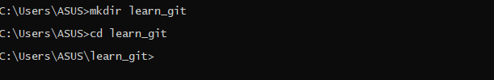

1. Cd (change directory) into the learn_git folder.

Cd learn_git



1. Create a file called third.txt

third.txt



1. Initialize an empty git repository

git init

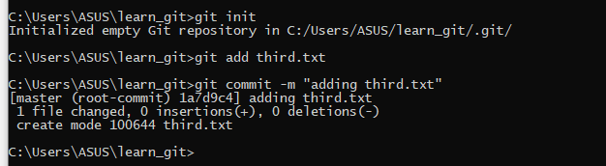

1. Add third.txt to the staging area.

git add third.txt



1. Commit with the message "adding third.txt".

git commit –m « adding third.txt »



1. Check out your commit with git log.

Gig log

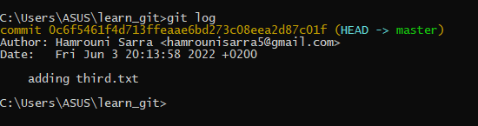

1. Create another file called fourth.txt.

fourth.txt



1. Add fourth.txt to the staging area.

Git add fouth.txt

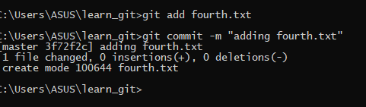

1. Commit with the message "adding fourth.txt"

git commit –m « adding fourth.txt »



1. Remove the third.txt file.

git rm third.txt

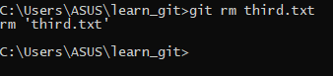

1. Add this change to the staging area. (Using the command "git add . "

git add .

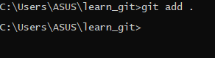

1. Commit with the message "removing third.txt".

git commit –m « removing third.txt »

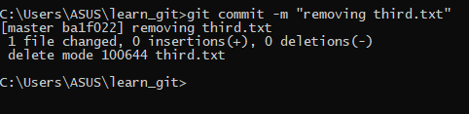

1. Check out your commits using git log.

git log

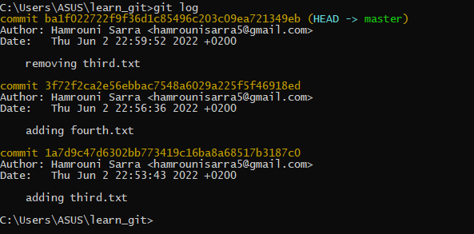

1. Change your global settings to core.pager=cat - you can read more about that [here](https://git-scm.com/book/en/v2/Customizing-Git-Git-Configuration).

**git config --global core.pager "cat"**

12.png

1. Write the appropriate command to list all the global configurations for git on your machine.

git config --global user.name « Hamrouni Sarra »

git config --global user.email « hamrounisarra5@gmail.com »

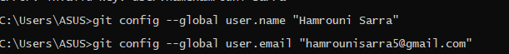

1. You can type git config --global to find out how to do this

**git config --global --list**

