
SCHOOL OF COMPUTER SCIENCE ENGINEERING AND INFORMATION SYSTEMS(SCORE)
WINTER-SEMESTER 2025 – 2026 – (BCA)
MACHINE LEARNING – COURSE PROJECT
Name: S Hamrutha
Regno: 24BCA0116

CREDIT LOAN PREDICTION USING MACHINE LEARNING AND ENSEMBLE TECHNIQUES

- ABSTRACT:

Credit risk assessment is a critical task in the financial sector to determine whether a loan applicant is eligible for approval. This study presents a machine learning-based approach for predicting loan approval using structured applicant data. The dataset undergoes preprocessing, feature engineering, and correlation-based feature selection to improve model performance.
Multiple classification algorithms including Logistic Regression, Decision Tree, Random Forest, and Gradient Boosting are implemented. To enhance predictive accuracy, ensemble techniques such as soft voting, hybrid averaging, and stacking are applied. The models are evaluated using accuracy, classification report, and confusion matrix.
The results demonstrate that ensemble models outperform individual classifiers, providing more robust and reliable predictions. This approach can assist financial institutions in automating and improving the loan approval process.

- INTRODUCTION:

In modern banking systems, loan approval decisions must be accurate, fast, and unbiased. Traditional manual evaluation methods are time-consuming and prone to human error. Machine learning offers a data-driven approach to automate credit risk assessment.
This project focuses on predicting loan approval status based on applicant details such as income, loan amount, credit history, and demographic attributes. The goal is to build a predictive model that can classify whether a loan should be approved or rejected.
The study incorporates:
- Data preprocessing and handling missing values
- Feature engineering to improve model input
- Correlation-based feature selection
- Implementation of multiple machine learning models
- Ensemble learning techniques for performance improvement

- ARCHITECTURE DIAGRAM:

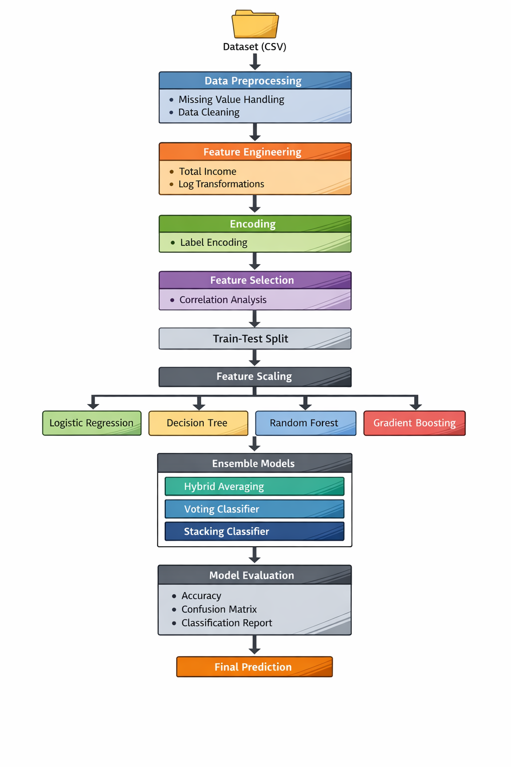

- EXPLANATION OF ARCHITECTURE DIAGRAM:

The system begins with loading the dataset containing loan applicant information. Data preprocessing is performed to handle missing values and clean inconsistencies.
Feature engineering is applied to create new meaningful attributes such as total income and logarithmic transformations to reduce skewness in numerical features. Categorical variables are converted into numerical format using label encoding.
A correlation-based feature selection technique is used to retain only relevant features that significantly influence the target variable (loan status).
The dataset is then split into training and testing sets. Feature scaling is applied to standardize the data for improved model performance.
Multiple machine learning models are trained, including Logistic Regression, Decision Tree, Random Forest, and Gradient Boosting. Ensemble techniques are then implemented:
- Hybrid model using manual probability averaging
- Voting classifier using soft voting
- Stacking classifier combining multiple models
Finally, models are evaluated using accuracy, confusion matrix, and classification metrics to determine the best-performing approach.

- RESULTS AND DISCUSSION:

The performance of individual and ensemble models was evaluated using standard classification metrics.
- Logistic Regression provided a good baseline with stable performance.
- Decision Tree showed moderate accuracy but was prone to overfitting.
- Random Forest improved performance by reducing variance.
- Gradient Boosting achieved better accuracy due to sequential learning.
Among all approaches:
- The Hybrid Model (manual averaging) improved prediction stability.
- The Voting Classifier performed better by combining probabilities.
- The Stacking Model achieved the best overall performance by learning from multiple base models.
Ensemble methods significantly enhanced prediction accuracy and reduced model bias and variance. Feature engineering and preprocessing also played a crucial role in improving model efficiency.

- CONCLUSION:

This study demonstrates the effectiveness of machine learning in predicting loan approval status. By applying preprocessing, feature engineering, and multiple classification algorithms, a robust predictive system was developed.
Ensemble techniques such as voting and stacking improved model performance compared to individual models. The stacking classifier achieved the highest accuracy, making it the most suitable approach for this problem.
The proposed system can assist financial institutions in making faster and more accurate loan approval decisions, reducing risk and improving operational efficiency.

- REFERENCES:

1. Pedregosa et al., “Scikit-learn: Machine Learning in Python,” Journal of Machine Learning Research
2. Han, Kamber, Pei – Data Mining: Concepts and Techniques
3. Géron, Aurélien – Hands-On Machine Learning with Scikit-Learn and TensorFlow
4. Kaggle – Loan Prediction Dataset
5. Documentation of Scikit-learn: https://scikit-learn.org
6. NumPy and Pandas Official Documentation

- CODING:

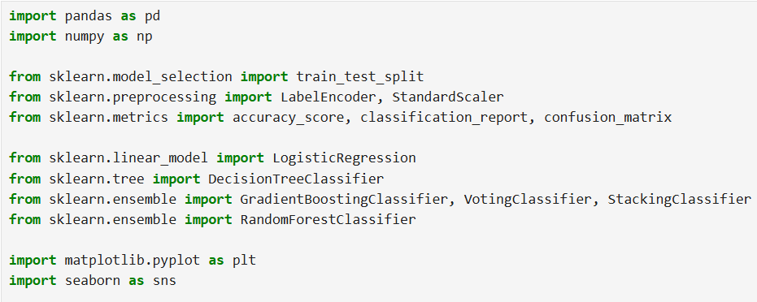

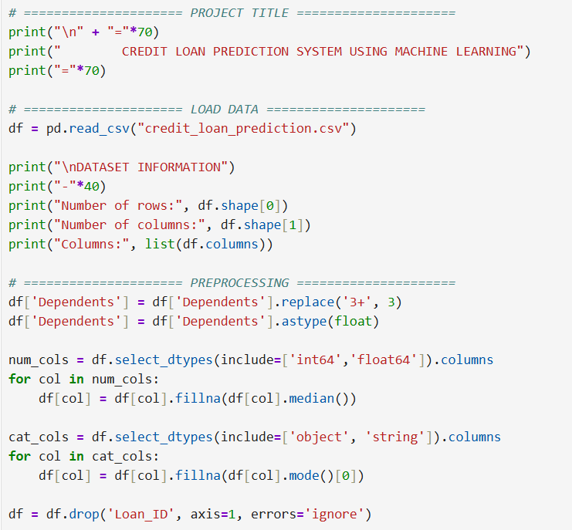
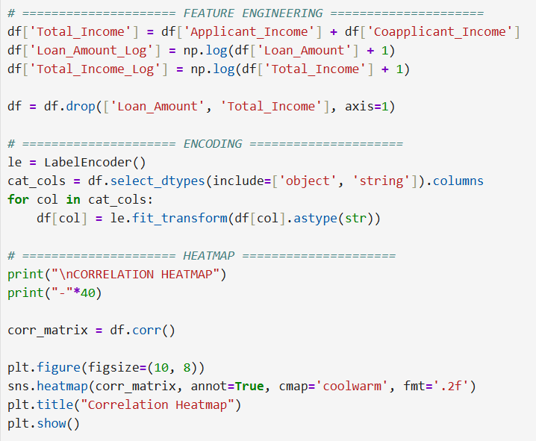

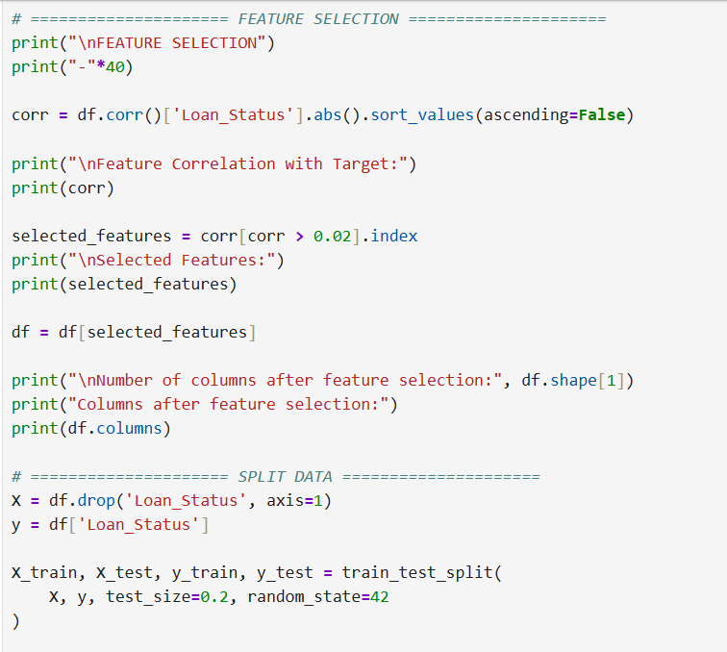

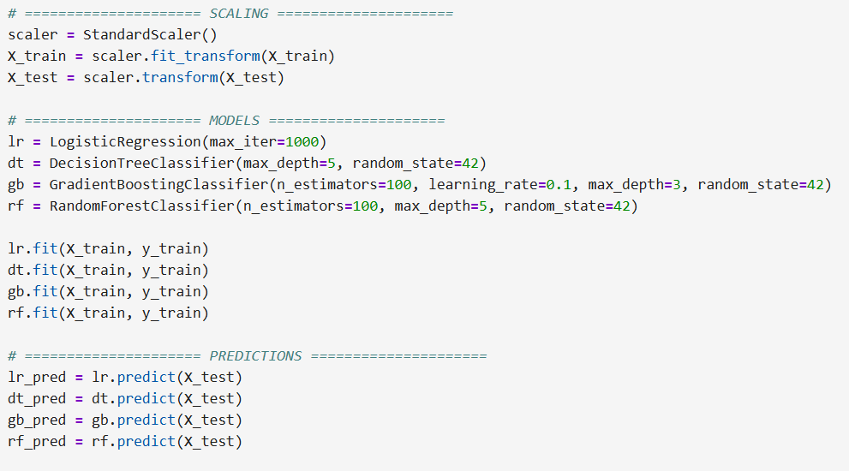
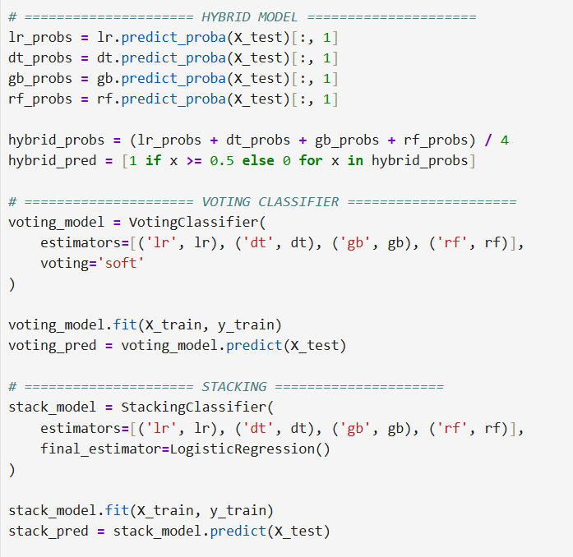

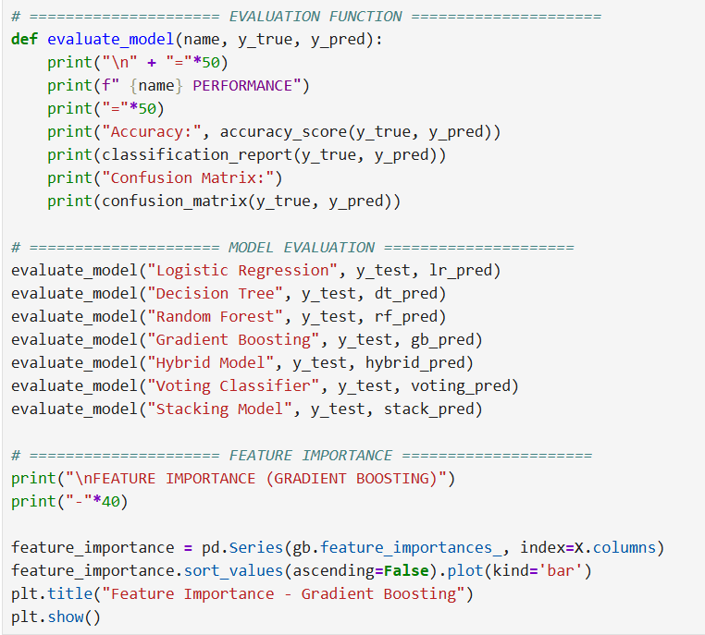

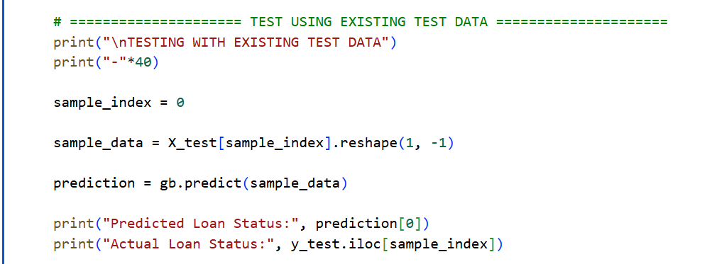

OUTPUTS:

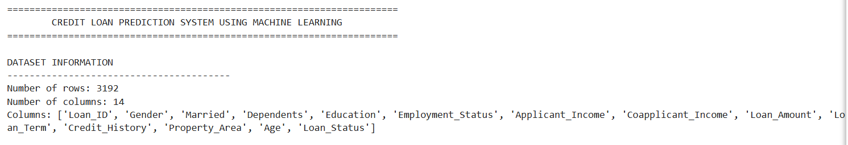

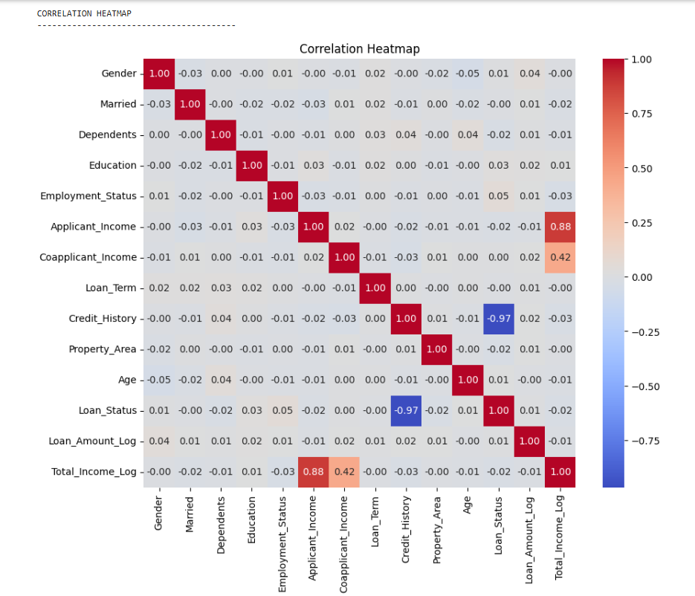

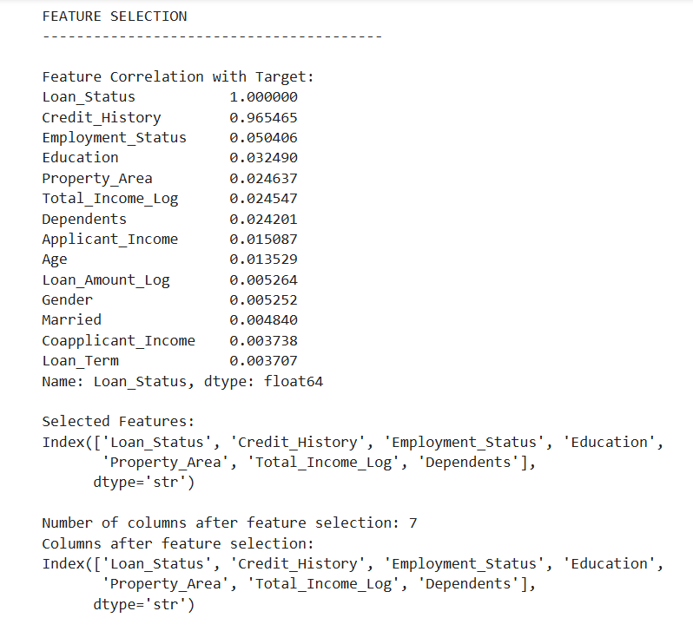

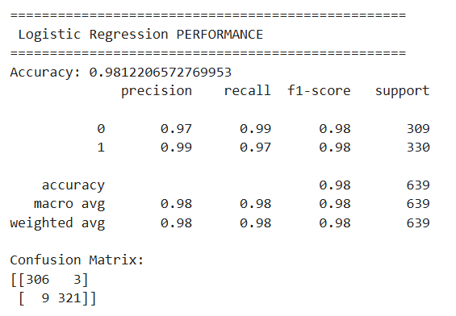
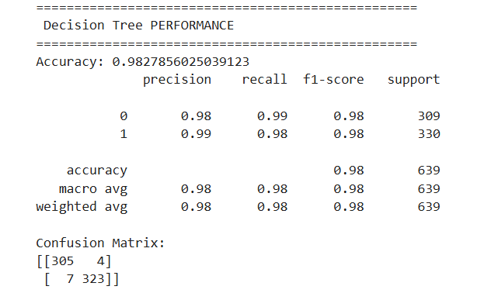

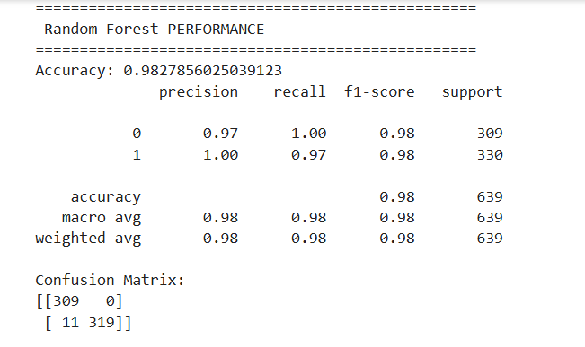

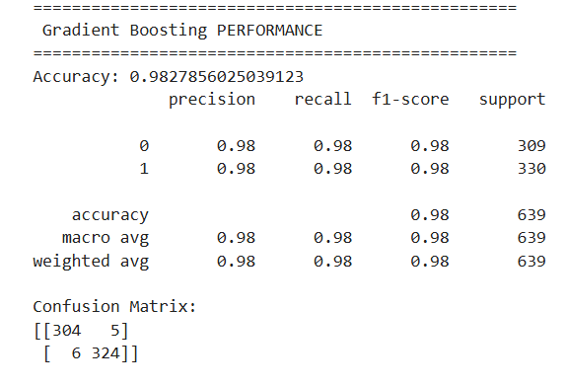

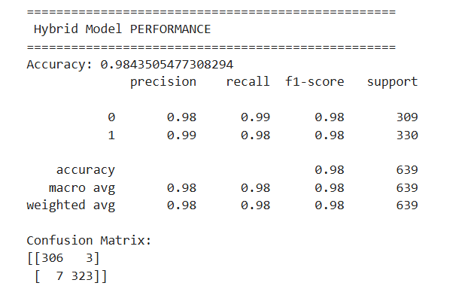

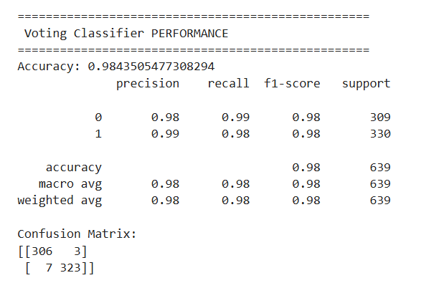

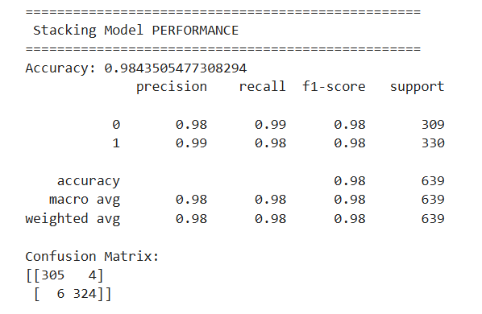

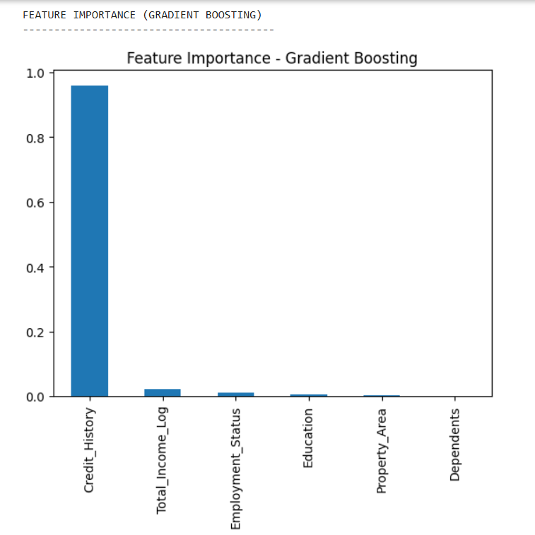

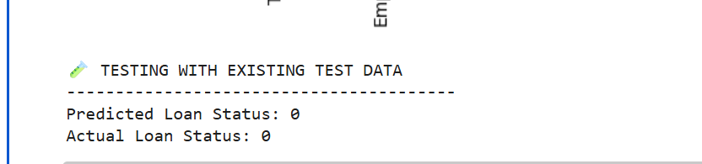

- CODE EXPLANATION

Model | Accuracy
Logistic Regression | 98.12%
Decision Tree | 98.27%
Random Forest | 98.27%
Gradient Boosting | 98.27%
Hybrid | 98.43%
Voting | 98.43%
Stacking | 98.43%

It was observed that multiple models such as Logistic Regression, Decision Tree, Random Forest and Gradient Boosting produced identical accuracy scores. This is due to the presence of highly influential features (e.g., Credit History), which strongly determine the target variable. As a result, different models converge to similar predictions, indicating that the dataset is highly structured and easily separable.

