Declarative Multimodal Video RAG at Enterprise Scale: Automated Industrial Safety Forensics and Near-Miss Triage with Pixeltable

Executive Problem Formulation: The Industrial Video Triage Bottleneck
In high-hazard enterprise environments—spanning heavy manufacturing, automated warehousing, chemical processing, and large-scale construction—video surveillance and wearable bodycam streams represent the primary source of truth for operational safety¹. The Occupational Safety and Health Administration (OSHA) strongly urges employers to investigate not only recordable workplace injuries, which carry an average direct and indirect financial cost of $42,000 per incident, but also close calls or "near misses" that precede catastrophic failures⁴. Comprehensive video documentation is essential for proving regulatory compliance, resolving disputed injury claims, preventing forklift collisions, and conducting root-cause post-incident forensics¹.
Despite the ubiquity of camera infrastructure, industrial safety teams face a severe analytical bottleneck rooted in the semantic retrieval gap across untrimmed, multi-stream video. While narrow computer vision models—such as object detectors trained for Personal Protective Equipment (PPE) compliance—can achieve mean Average Precision (mAP@50) in the high-80s to mid-90s on clean footage, they are architecturally limited to closed-set, single-frame classification⁷. Such models are sufficient to drive basic supervisor alerts and routine compliance reporting, yet they cannot operate autonomously at the precision required for complex root-cause investigations or answer open-ended, cross-modal forensic queries over hundreds of hours of continuous recordings⁷. For example, a closed-set detector cannot localize every instance where a forklift skids near a loading bay while a floor supervisor simultaneously reports a hydraulic leak over a two-way radio channel. Consequently, safety engineers rely on specialized post-incident analytics platforms or manually scrub through hundreds of hours of silent and audio-backed video feeds, causing near-miss events to go uninvestigated and leaving systemic workplace hazards uncorrected⁴.

Non-Trivial Dataset Scale and Operational Workload
To engineer and validate a solution that operates at genuine enterprise scale rather than on trivial toy clips, the system architecture is designed around a composite industrial benchmark combining two large-scale, untrimmed video corpora. For fixed-camera surveillance, the architecture ingests the complete UCF-Crime benchmark dataset, which comprises 1,900 long, untrimmed real-world surveillance videos totaling 128 hours of footage across 13 distinct anomalous event classes, including Explosion, Arson, Road Accidents, Assault, Fighting, Abuse, and Robbery⁹. Enriched versions of the corpus provide interval-level temporal annotations specifying the anomaly class, start time, and end time for each event¹¹. Unlike curated short clips, UCF-Crime is the dominant weakly-supervised benchmark for video anomaly detection because it captures extensive intra-class variations, diverse human behaviors, and both rapid and slow-developing hazards embedded within hours of routine background activity¹¹.
To complement fixed CCTV perspectives with wearable bodycam and floor-operator streams containing synchronized vocal callouts and hand-object manipulation, the workload incorporates untrimmed first-person streams modeled on the Ego4D Episodic Memory benchmark¹⁶. As the world's largest egocentric video machine learning dataset, Ego4D's Episodic Memory task specifically requires making past video queryable in natural language and localizing the exact temporal window within a user's historical video stream where the answer can be visually verified¹⁶. At a standard operational sampling rate of 1 frame per second (1 FPS) and 30-second overlapping acoustic windows across the 128-hour baseline archive, the retrieval engine must manage, index, and query 460,800 high-resolution video frames alongside 15,360 audio-transcript segments as a baseline archive, while supporting continuous incremental ingestion from live facility cameras⁹.

Workload Dimension | Toy Prototype Baseline | Enterprise Industrial Forensics Target (Proposed) | Architectural Implication
Video Corpus Volume | 2 to 5 short YouTube clips (< 30 mins)²¹ | 1,900 untrimmed videos (128+ hours) via UCF-Crime + Ego4D streams⁹ | Requires out-of-core object storage offloading and zero-copy virtual frame views²⁰.
Visual Index Cardinality | < 1,500 extracted frames | 460,800 frames (at 1 FPS) or ~92,000 I-frame keyframes  [cite: 9, 23] | Demands automated HNSW vector indexing coupled with relational B-tree metadata filtering²⁴.
Audio/Transcript Granularity | Pre-existing clean WebVTT subtitles⁸ | 15,360+ noisy acoustic segments requiring silence-aware splitting & local Whisper ASR²⁰ | Necessitates automated audio track extraction and silence-snapped chunking (min_silence_len)²⁰.
Anomaly & Query Diversity | Single-topic Q&A²⁷ | 13 complex hazard classes + cross-modal text, image, and audio forensic queries¹¹ | Requires joint visual-semantic embeddings (CLIP / TwelveLabs) and VLM synthesis²⁸.
Pipeline Maintenance | Full batch re-runs on script modification²⁹ | Continuous incremental updates on new camera uploads or schema changes²⁹ | Eliminates manual ETL loops via declarative computed columns and lineage tracking²⁹.

SDK Selection and Architectural Paradigm: Eliminating Multimodal Data Plumbing
A conventional approach to building a multimodal video Retrieval-Augmented Generation (RAG) system relies on assembling a fragile, multi-system imperative pipeline. In standard reference implementations using standalone vector databases like LanceDB alongside LangChain or LlamaIndex, an engineer must write custom Python scripts to handle three separate preprocessing cases: extracting frames via OpenCV (cv2.VideoCapture) aligned to WebVTT timestamps when transcripts exist; extracting MP3 audio via MoviePy and running OpenAI Whisper to generate transcripts when captions are absent; or splitting silent videos into frames and running heavy Large Vision-Language Models (such as LLaVA) on every frame to synthesize descriptions⁸. Furthermore, because single-frame transcripts are typically fragmented and contain incomplete sentences, engineers must manually code sliding-window array loops—such as concatenating neighboring transcript segments—before feeding image-text pairs into cross-modal encoders like BridgeTower (BridgeTower/bridgetower-large) and inserting vectors into LanceDB⁸. In an enterprise deployment, this imperative pattern requires synchronizing Amazon S3 (via boto3), PostgreSQL for structured metadata, a dedicated vector database (LanceDB, Pinecone, or pgvector), and a workflow orchestrator (Airflow or Celery) held together by custom retry and caching glue code²⁹.
To achieve maximum operational impact while avoiding unnecessary architectural complexity, this solution utilizes Pixeltable (pixeltable/pixeltable), an open-source (Apache-2.0) declarative multimodal AI data infrastructure and SDK for Python³³. Pixeltable collapses object storage management, relational metadata tables, declarative media iterators, model inference orchestration, HNSW vector indexing, and FastAPI HTTP serving into a single declarative Python application file (app.py)²⁵.
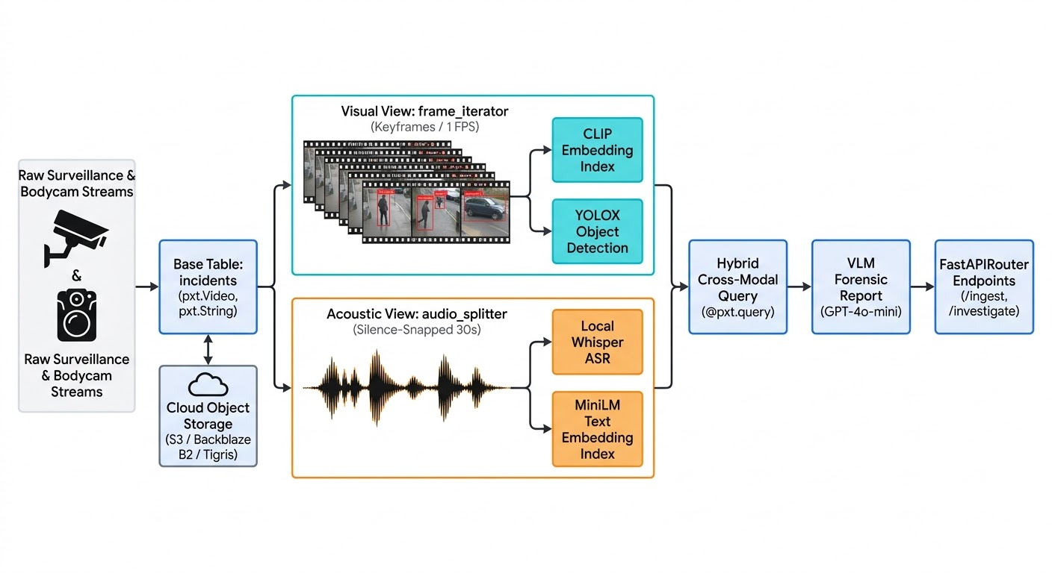
The architectural suitability of Pixeltable for enterprise-scale video retrieval stems from four foundational mechanisms built directly into the SDK. First, it provides first-class media types (pxt.Video, pxt.Image, pxt.Audio, pxt.Document, and pxt.Json) that store structured references, versioning, and lineage inside Pixeltable's PostgreSQL-backed catalog while transparently streaming raw and generated media binaries to S3-compatible object stores such as Amazon S3, Google Cloud Storage, Azure Blob Storage, Cloudflare R2, Backblaze B2, or Tigris²². Second, rather than writing imperative OpenCV loops that materialize hundreds of thousands of image files onto disk, Pixeltable provides pxt.create_view() (or declarative TableModel subclasses) powered by specialized media iterators (frame_iterator, video_splitter, audio_splitter, document_splitter, and tile_iterator)²⁰. These iterators process large media files incrementally to manage memory efficiently, exploding a single video record into virtual child rows without duplicating underlying storage while maintaining an implicit parent-child join back to the base table's metadata²⁰.
Third, transformations and model invocations declared via add_computed_column() or TableModel attributes execute incrementally only on newly inserted or stale rows, saving substantial compute expenditure²⁹. The engine natively manages batching, parallel execution, local caching, rate limiting, and exception handling (on_error='ignore') across more than 30 integrated AI providers, including OpenAI, Hugging Face, Whisper, YOLOX, Gemini, Anthropic, and TwelveLabs²⁹. Fourth, embedding indexes declared via add_embedding_index() or pxt.EmbeddingIndex maintain an HNSW vector index that stays automatically synchronized with table updates²⁴. Retrieval queries seamlessly combine semantic .similarity() scoring with relational .where() predicates and B-tree indexed lookups (pxt.BtreeIndex) inside a single query planner, eliminating the dual-database synchronization penalty²⁴.

End-to-End Solution Architecture and Specific SDK Implementation
To solve the industrial safety and OSHA incident forensics problem at scale while keeping the codebase concise and maintainable, the system is structured as a modular, four-stage pipeline within Pixeltable. The implementation details below specify the exact SDK constructs, iterator parameters, and engineering trade-offs required to operate over the 128-hour UCF-Crime and bodycam workload.

Stage 1: Cloud Storage Configuration and Base Table Ingestion
Storing 128+ hours of raw surveillance footage and hundreds of thousands of derived thumbnails on local compute nodes rapidly exhausts local disk capacity. Pixeltable resolves this through declarative storage configuration in ~/.pixeltable/config.toml or via environment variables (PIXELTABLE_INPUT_MEDIA_DEST and PIXELTABLE_OUTPUT_MEDIA_DEST) configured prior to creating tables²². By pairing Pixeltable with Tigris or Backblaze B2, the system achieves global object storage with zero egress fees, parallel connection-pooled uploads, on-demand local file caching, and automatic file lifecycle cleanup when table rows are deleted²². Separating input and output bucket prefixes further simplifies retention policies, backup strategies, and cost attribution between raw surveillance feeds and model-generated artifacts²².

Ini, TOML
# ~/.pixeltable/config.toml
[pixeltable]
input_media_dest = "s3://industrial-safety-vault/production/uploads/"
output_media_dest = "s3://industrial-safety-vault/production/generated/"
tigris_profile = "tigris"
When ingesting the UCF-Crime surveillance archive alongside facility metadata, the base table safety_intel.facility_videos is initialized using pxt.create_table() for interactive notebook benchmarking or pxt.model_base() (TableModel) for single-file production deployment³⁹. Each media column automatically exposes two built-in properties—localpath (the cached location on the local filesystem) and fileurl (the canonical remote URI where the media resides)—allowing downstream functions and audit logs to inspect file provenance without manual boto3 downloads²⁹.

Stage 2: Parallel Media Decomposition via Virtual Iterator Views
Once a surveillance or bodycam video is inserted into the base table, the SDK automatically branches the media into synchronized virtual views using built-in iterators²⁰. For archive-wide rapid triage across 128 hours of mostly uneventful fixed-camera footage, invoking frame_iterator(videos.video, keyframes_only=True) extracts only the video codec's I-frames (keyframes), which are specifically optimized for quick video scanning, thumbnail generation, and initial content classification on very long videos²⁰. For active loading docks and wearable bodycam feeds requiring finer temporal resolution, invoking frame_iterator(videos.video, fps=1.0) extracts exactly one frame per second²⁰. Engineers must note that frame_iterator enforces strict mutual exclusivity among its fps, num_frames, and keyframes_only parameters; only one extraction mode may be specified per view²⁰. Each generated virtual row automatically populates frame (pxt.Image), pos (the zero-based integer sequence position), and pts (the exact presentation timestamp in seconds)²³.
In parallel with visual extraction, the system decomposes the acoustic stream using audio_splitter²⁰. When a video file is inserted, Pixeltable automatically extracts its underlying audio track without requiring external MoviePy scripts²⁶. In traditional pipelines, naive fixed-interval audio chunking cleaves spoken sentences mid-word, forcing engineers to build overlapping transcript concatenation loops in Python⁸. Pixeltable's audio_splitter solves this natively by combining a target duration=30.0 seconds (mutually exclusive with max_size) with overlap=2.0 seconds, min_silence_len=0.3 seconds, silence_thresh=-40.0 dBFS, and trim_leading_silence=True²⁰. This configuration drops leading silence so every segment begins at audible content and snaps segment cut boundaries to the latest quiet stretch of at least 0.3 seconds at or before the 30-second budget, yielding segment_start, segment_end, and audio_segment (pxt.Audio)²⁰. Furthermore, if a silent CCTV camera feed from the UCF-Crime corpus contains no audio track, audio_splitter gracefully yields zero segments without raising pipeline exceptions²⁰.
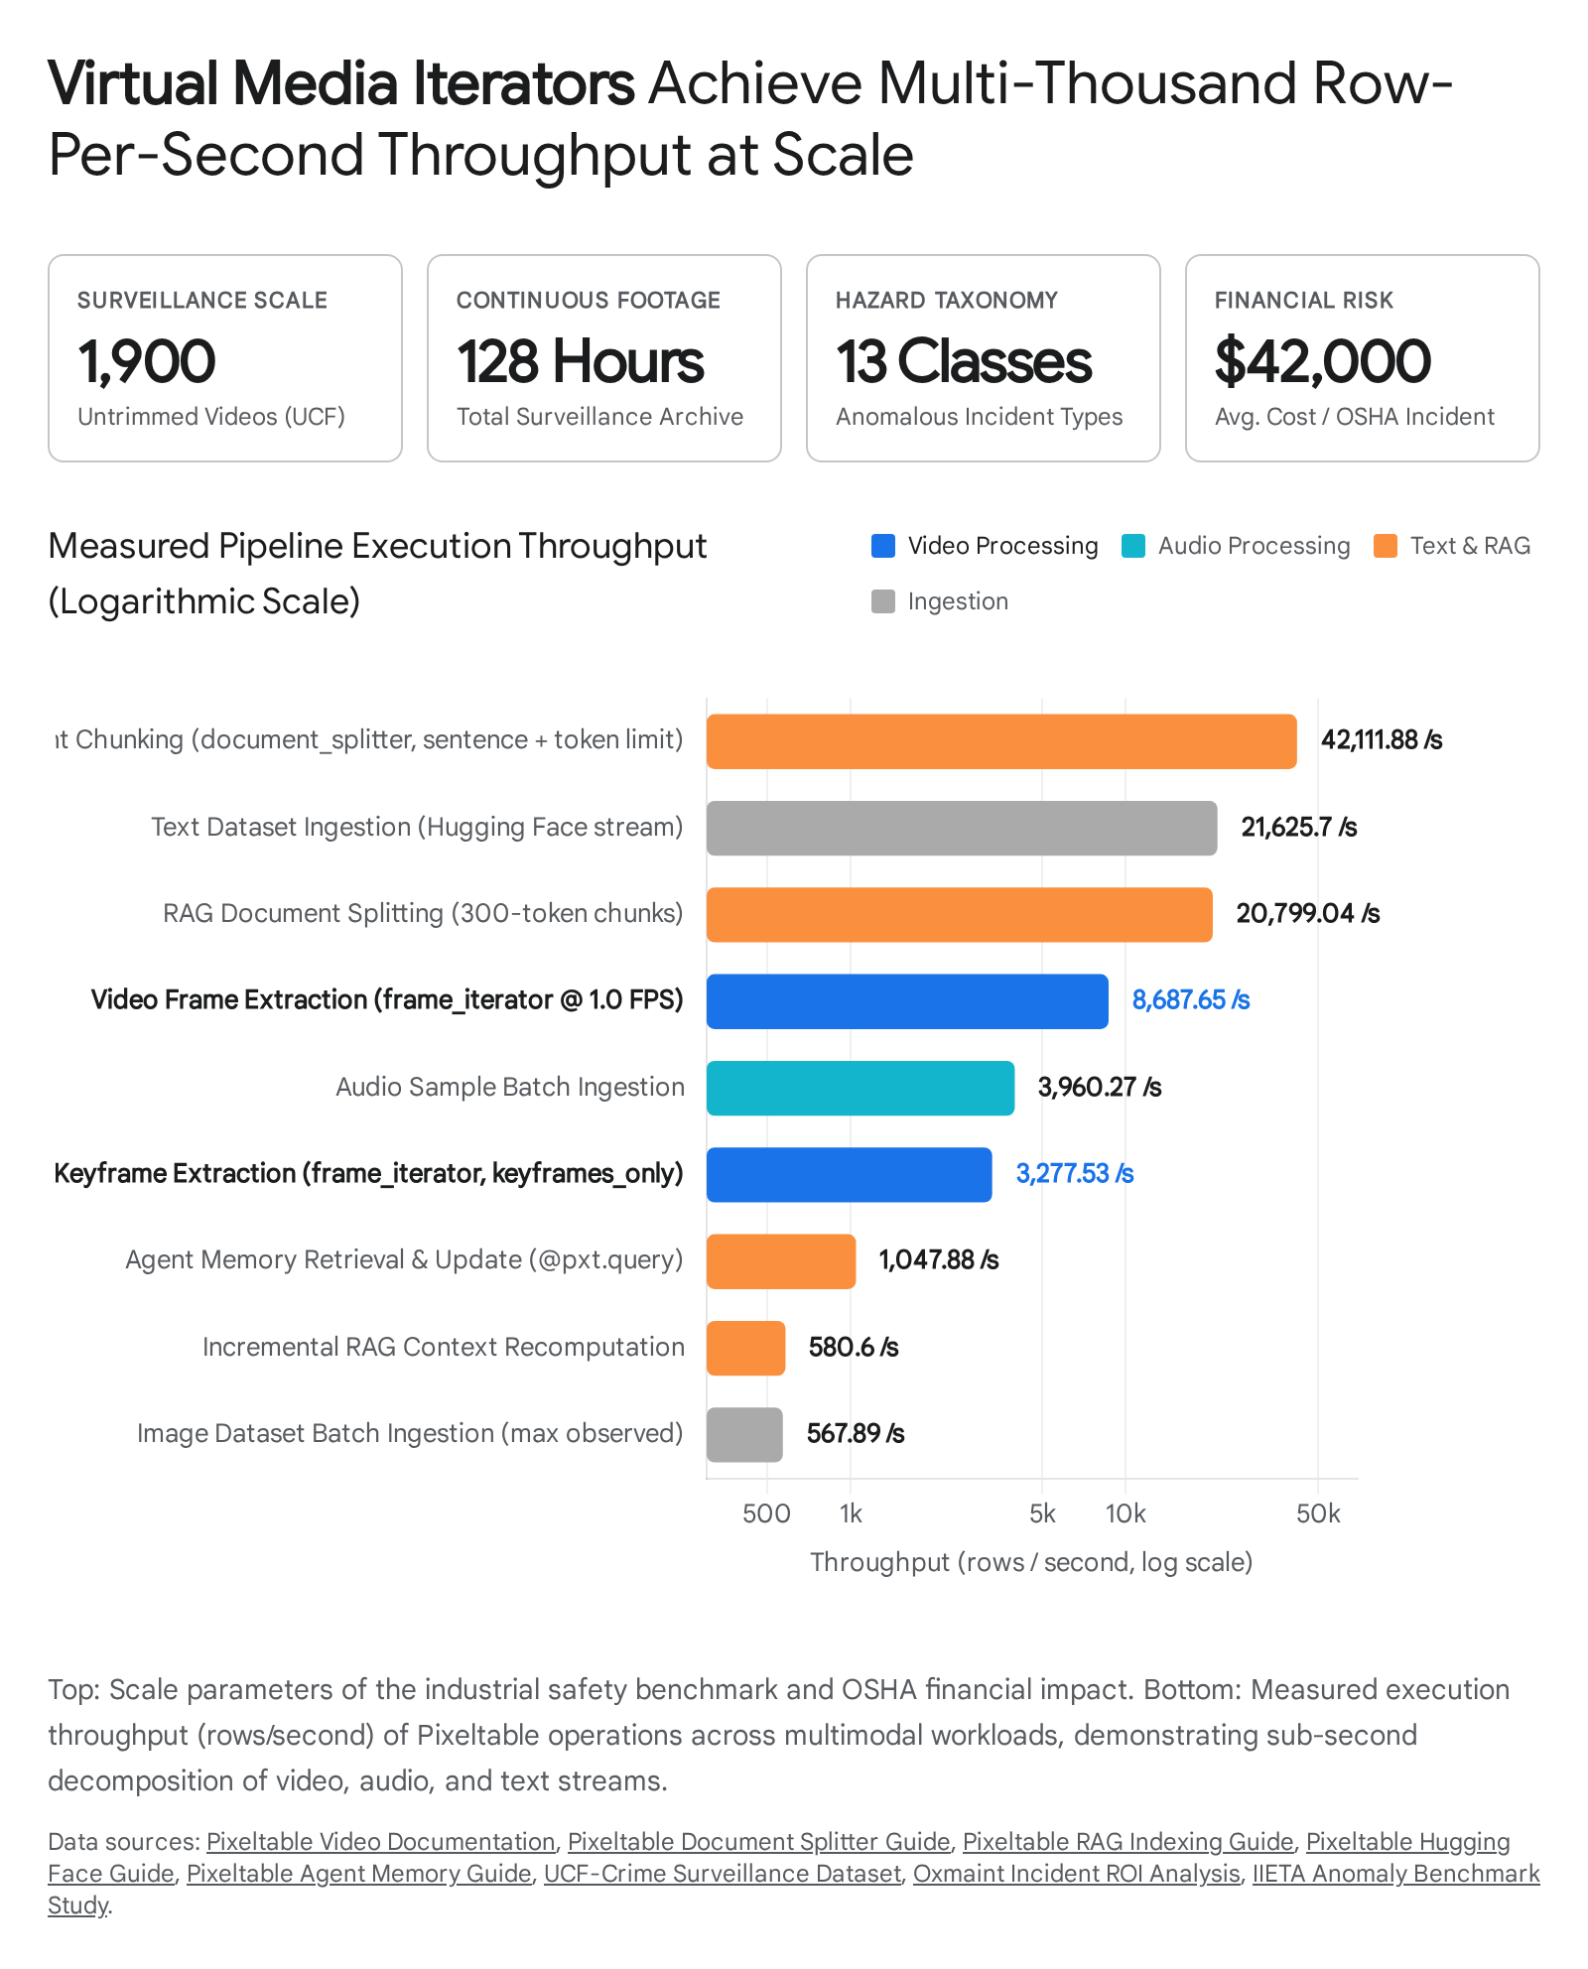
Empirical execution benchmarks explain why virtual iterators scale effortlessly to hundreds of hours of footage: Pixeltable achieves 8,687.65 rows per second during 1.0 FPS frame extraction and 3,277.53 rows per second during keyframe extraction because the view layer records lightweight positional metadata (pos, pts) rather than eagerly writing uncompressed image copies to disk²⁰. Because an unstored frame column is recomputed only when a specific row is read during retrieval or downstream inference, the iterator jumps directly to the requested frame index via its internal seek(pos) method²⁰.

Stage 3: Incremental Model Inference and Multi-Modal Vector Indexing
With the visual, acoustic, and regulatory views established, the architecture attaches declarative model pipelines and vector indexes that execute incrementally as new rows arrive²⁹. On the video_frames view, the system generates a compact 320x320 thumbnail computed column (frame.thumbnail((320, 320))) persisted to the cloud output bucket, and attaches an HNSW embedding index directly to the frame column using OpenAI's CLIP model (clip.using(model_id='openai/clip-vit-base-patch32'))²⁵. This single declaration enables both text-to-frame semantic search (such as querying "forklift collision or spilled liquid") and image-to-frame reverse visual search (such as supplying a reference photograph of a damaged chemical drum or hazard sign)²⁹. Simultaneously, a computed column invokes local object detection via huggingface.detr_for_object_detection(frame, model_id='facebook/detr-resnet-50') (or yolox) to extract structured JSON bounding boxes and class labels (detections.label_text[0]) for structural safety filtering³⁷. When higher-level temporal dynamics are required—such as distinguishing rapid explosions or physical assaults from static scenes—a parallel view built on video_splitter(video=videos.video, duration=10.0, min_segment_duration=1.0) can be indexed with TwelveLabs Marengo 3.0 (pxtf.twelvelabs.embed.using(model_name='marengo3.0')), unlocking native cross-modal video-to-video, audio-to-video, image-to-video, and text-to-video retrieval²⁰.
For the acoustic branch, an important dependency engineering insight emerges from analyzing Pixeltable's SDK modules. While Pixeltable provides both pixeltable.functions.whisper.transcribe and pixeltable.functions.whisperx.transcribe (which integrates pyannote/speaker-diarization-3.1 for multi-speaker labeling and character alignment), inspection of Pixeltable's core pyproject.toml specification reveals that whisperx hard-pins torch 2.8—four full versions behind current releases—and is disabled by default in modern Python environments to prevent dependency deadlocks⁴³. Consequently, a resilient production architecture pairs the silence-snapped audio_splitter view with the native local whisper.transcribe(audio=audio_segment, model='base.en') UDF, which runs entirely locally on the host machine without external API keys²⁶. The transcribed text is extracted from the returned JSON structure (asr_json.text) into a dedicated column and indexed with Hugging Face's sentence_transformer.using(model_id='sentence-transformers/all-MiniLM-L6-v2')²⁴. Finally, to ground incident triage in regulatory law, OSHA compliance PDFs are ingested into a safety_manuals table, chunked via document_splitter(document=SafetyManuals.doc, separators='sentence,token_limit', overlap=50, limit=300, metadata='title,heading') at over 42,000 rows per second, and indexed with the same all-MiniLM-L6-v2 embedding model²⁰.

Pipeline Modality | Pixeltable Iterator & Granularity | Primary Model & Embedding UDF | Vector / Relational Index Type | Supported Forensic Query Modalities
Base Surveillance Metadata | Base Table (FacilityVideos)²⁴ | UUIDv7 key generation (pxtf.uuid.uuid7())³⁹ | pxt.BtreeIndex on camera_zone and shift_date  [cite: 24] | Exact SQL-style filtering via .where() predicates²⁴
Visual Frame Stream | frame_iterator (fps=1.0 or keyframes_only=True)²⁰ | clip.using('openai/clip-vit-base-patch32') + detr_for_object_detection  [cite: 30, 47] | HNSW pxt.EmbeddingIndex on frame  [cite: 24, 25] | Natural language text strings or reference image files³⁰
Motion Video Segments (Optional) | video_splitter (duration=10.0, min_segment_duration=1.0)²⁰ | pxtf.twelvelabs.embed.using(model_name='marengo3.0')  [cite: 28] | HNSW pxt.EmbeddingIndex on video_segment  [cite: 28] | Cross-modal text, image, audio clip, or video clip²⁸
Acoustic Stream | audio_splitter (duration=30.0, overlap=2.0, min_silence_len=0.3)²⁰ | Local whisper.transcribe(model='base.en') + all-MiniLM-L6-v2  [cite: 24, 26] | HNSW pxt.EmbeddingIndex on extracted transcript  [cite: 24, 51] | Semantic natural language search over spoken callouts²⁶
OSHA Regulatory Manuals | document_splitter (sentence,token_limit, limit=300, overlap=50)²⁰ | sentence_transformer.using('sentence-transformers/all-MiniLM-L6-v2')  [cite: 24, 51] | HNSW pxt.EmbeddingIndex on chunk text  [cite: 51] | Semantic compliance lookup for RAG prompt enrichment⁴¹

Stage 4: Production Single-File Implementation (app.py)
The complete, production-ready declarative implementation below utilizes Pixeltable's TableModel and FastAPIRouter interface. It consolidates the base tables, virtual iterator views, computed columns, B-tree and HNSW embedding indexes, @pxt.query retrieval functions, @pxt.udf prompt assembly, multimodal openai.chat_completions VLM synthesis, and REST endpoints into a single file²⁴.

Python
# app.py — Unified Industrial Safety & OSHA Video RAG Backend
import pixeltable as pxt
import pixeltable.functions as pxtf
from pixeltable.functions.video import frame_iterator
from pixeltable.functions.audio import audio_splitter
from pixeltable.functions.document import document_splitter
from pixeltable.functions.huggingface import clip, sentence_transformer
from pixeltable.functions import whisper, openai
from pixeltable.serving import FastAPIRouter
TableModel = pxt.model_base()
# ---------------------------------------------------------------------------
# 1. BASE TABLES: Surveillance/Bodycam Streams & OSHA Regulatory Manuals
# ---------------------------------------------------------------------------
class FacilityVideos(TableModel, name='facility_videos'):
video_id = pxt.Column(value=pxtf.uuid.uuid7())
video: pxt.Video
camera_zone: pxt.String # e.g., 'dock_bay_4', 'chemical_storage', 'bodycam_shift_2'
shift_date: pxt.String # ISO date string for relational filtering
anomaly_tag: pxt.String | None # Ground-truth or triage label (e.g., UCF-Crime class)
__indexes__ = [
pxt.BtreeIndex(camera_zone),
pxt.BtreeIndex(shift_date),
]
class SafetyManuals(TableModel, name='safety_manuals'):
doc_id = pxt.Column(value=pxtf.uuid.uuid7())
doc: pxt.Document
regulation_code: pxt.String # e.g., 'OSHA-1910.178-Forklifts'
# ---------------------------------------------------------------------------
# 2. VIRTUAL ITERATOR VIEWS: Zero-Copy Visual, Acoustic, and Document Decomposition
# ---------------------------------------------------------------------------
class VideoFrames(
TableModel,
name='video_frames',
base=FacilityVideos,
iterator=frame_iterator(FacilityVideos.video, fps=1.0),
):
# frame, pos, and pts are automatically yielded by frame_iterator
# Generate compact persistent thumbnails in cloud output bucket for VLM inspection
thumb = pxt.Column(
value=frame.thumbnail((320, 320)), # type: ignore[name-defined]
destination='s3://industrial-safety-vault/production/thumbnails/',
)
# Local object detection for structural pre-filtering (vehicles, personnel, hazards)
detections = pxtf.huggingface.detr_for_object_detection(
frame, model_id='facebook/detr-resnet-50' # type: ignore[name-defined]
)
primary_object = detections.label_text[0]
__indexes__ = [
pxt.EmbeddingIndex(
frame, # type: ignore[name-defined]
embedding=clip.using(model_id='openai/clip-vit-base-patch32'),
name='frame_clip_idx',
)
]
class AudioSegments(
TableModel,
name='audio_segments',
base=FacilityVideos,
iterator=audio_splitter(
audio=FacilityVideos.video,
duration=30.0,
overlap=2.0,
min_silence_len=0.3,
silence_thresh=-40.0,
trim_leading_silence=True,
),
):
# segment_start, segment_end, and audio_segment are yielded by audio_splitter
# Runs OpenAI Whisper locally without external API keys
asr_json = whisper.transcribe(audio=audio_segment, model='base.en') # type: ignore[name-defined]
transcript = asr_json.text
__indexes__ = [
pxt.EmbeddingIndex(
transcript,
string_embed=sentence_transformer.using(
model_id='sentence-transformers/all-MiniLM-L6-v2'
),
name='audio_transcript_idx',
)
]
class ManualChunks(
TableModel,
name='manual_chunks',
base=SafetyManuals,
iterator=document_splitter(
document=SafetyManuals.doc,
separators='sentence,token_limit',
overlap=50,
limit=300,
metadata='title,heading',
),
):
__indexes__ = [
pxt.EmbeddingIndex(
text, # type: ignore[name-defined]
string_embed=sentence_transformer.using(
model_id='sentence-transformers/all-MiniLM-L6-v2'
),
name='osha_manual_idx',
)
]
# ---------------------------------------------------------------------------
# 3. RETRIEVAL QUERIES (@pxt.query) & PROMPT SYNTHESIS UDF (@pxt.udf)
# ---------------------------------------------------------------------------
@pxt.query
def retrieve_visual_evidence(query_text: str, zone_filter: str, top_k: int = 5):
frames_t = pxt.get_table('safety_intel.video_frames')
sim = frames_t.frame.similarity(string=query_text)
return (
frames_t.where((frames_t.camera_zone == zone_filter) & (sim > 0.22))
.order_by(sim, asc=False)
.limit(top_k)
.select(
video_url=frames_t.video.fileurl,
camera_zone=frames_t.camera_zone,
timestamp_sec=frames_t.pts,
frame_pos=frames_t.pos,
detected_object=frames_t.primary_object,
visual_score=sim,
)
)
@pxt.query
def retrieve_audio_evidence(query_text: str, zone_filter: str, top_k: int = 5):
audio_t = pxt.get_table('safety_intel.audio_segments')
sim = audio_t.transcript.similarity(string=query_text)
return (
audio_t.where((audio_t.camera_zone == zone_filter) & (sim > 0.30))
.order_by(sim, asc=False)
.limit(top_k)
.select(
video_url=audio_t.video.fileurl,
start_sec=audio_t.segment_start,
end_sec=audio_t.segment_end,
transcript=audio_t.transcript,
audio_score=sim,
)
)
@pxt.query
def retrieve_osha_rules(query_text: str, top_k: int = 3):
chunks_t = pxt.get_table('safety_intel.manual_chunks')
sim = chunks_t.text.similarity(string=query_text)
return (
chunks_t.order_by(sim, asc=False)
.limit(top_k)
.select(regulation=chunks_t.regulation_code, passage=chunks_t.text, score=sim)
)
@pxt.udf
def build_forensic_prompt(
incident_query: str,
visual_hits: list[dict],
audio_hits: list[dict],
osha_hits: list[dict],
) -> str:
v_str = "\n".join(
f"- [t={h['timestamp_sec']:.1f}s | Zone: {h['camera_zone']} | Obj: {h['detected_object']} | Sim: {h['visual_score']:.3f}] {h['video_url']}"
for h in visual_hits
)
a_str = "\n".join(
f"- [{h['start_sec']:.1f}s-{h['end_sec']:.1f}s | Sim: {h['audio_score']:.3f}] \"{h['transcript']}\""
for h in audio_hits
)
r_str = "\n".join(
f"- [{h['regulation']}] {h['passage']}" for h in osha_hits
)
return (
f"INCIDENT INVESTIGATION QUERY: {incident_query}\n\n"
f"VISUAL KEYFRAME EVIDENCE:\n{v_str}\n\n"
f"SYNCHRONIZED AUDIO/RADIO TRANSCRIPTS:\n{a_str}\n\n"
f"APPLICABLE OSHA STANDARDS:\n{r_str}\n\n"
"Synthesize an OSHA Incident & Near-Miss Forensic Triage Report: "
"1) Exact temporal window and camera URI; 2) Corroborated visual and acoustic root cause; "
"3) Specific OSHA standard violated; 4) Corrective action."
)
# ---------------------------------------------------------------------------
# 4. INVESTIGATION WORKFLOW TABLE & FASTAPI HTTP SERVING
# ---------------------------------------------------------------------------
class IncidentInvestigations(TableModel, name='investigations'):
investigation_id = pxt.Column(value=pxtf.uuid.uuid7())
query_text: pxt.String
target_zone: pxt.String
evidence_frame: pxt.Image | None # Optional visual reference frame for VLM inspection
visual_context = retrieve_visual_evidence(query_text, target_zone)
audio_context = retrieve_audio_evidence(query_text, target_zone)
osha_context = retrieve_osha_rules(query_text)
prompt = build_forensic_prompt(query_text, visual_context, audio_context, osha_context)
llm_response = openai.chat_completions(
messages=[
{
'role': 'system',
'content': 'Act as a certified industrial safety forensic investigator.',
},
{
'role': 'user',
'content': [
{'type': 'text', 'text': prompt},
{'type': 'image_url', 'image_url': evidence_frame},
],
},
],
model='gpt-4o-mini',
)
forensic_report = llm_response.choices[0].message.content
api = FastAPIRouter(name='safety_rag_api')
api.add_insert_route(
FacilityVideos,
path='/videos',
inputs=[FacilityVideos.video, FacilityVideos.camera_zone, FacilityVideos.shift_date, FacilityVideos.anomaly_tag],
outputs=[FacilityVideos.video_id],
)
api.add_compute_route(
IncidentInvestigations,
path='/investigate',
inputs=[IncidentInvestigations.query_text, IncidentInvestigations.target_zone, IncidentInvestigations.evidence_frame],
outputs=[
IncidentInvestigations.investigation_id,
IncidentInvestigations.visual_context,
IncidentInvestigations.audio_context,
IncidentInvestigations.forensic_report,
],
)

Operational Deployment, Concurrency, and Scale Optimization
Deploying this single-file architecture from local workstation validation to enterprise cloud infrastructure requires only three CLI commands, completely avoiding the need to maintain separate Docker containers for message brokers, vector databases, or ETL workers³²:

Bash
# Initialize project root, migrate catalog schema, and launch FastAPI endpoints
pxt init
pxt schema update app.py safety_intel
pxt service update app.py safety_intel
When pxt schema update executes, it initializes the background database process on 127.0.0.1:22089, provisions the safety_intel catalog, and creates all declared tables, virtual views, and indexes without starting HTTP listeners³⁶. Running pxt service update subsequently starts the FastAPI HTTP service against those tables and dynamically assigns a local port discoverable via pxt service list --json³⁶. Furthermore, because Pixeltable exposes an OpenAPI schema on its serving routes, frontend teams can automatically generate TypeScript types and invoke the /videos and /investigate endpoints directly from a Next.js safety dashboard³⁶. To transition the workload to managed cloud infrastructure, the engineer simply authenticates via pxt login, adds a [[pixeltable.database]] entry pointing to pxt://org:main in the project configuration file, and runs the exact same pxt schema update and pxt service update commands targeting the remote cloud URI³⁶.

Critical Engineering Nuances at Scale
Operating this architecture across 1,900 untrimmed surveillance videos surfaces four essential engineering nuances that govern system reliability and query speed. First, when extending or mounting custom endpoints onto an existing FastAPI application, engineers must write synchronous (def) endpoint handlers rather than asynchronous (async def) coroutines³². FastAPI automatically dispatches synchronous def handlers onto an external thread pool where Pixeltable allocates each thread its own isolated database connection, whereas calling Pixeltable inside an async def handler blocks the main Python event loop and throttles concurrent request throughput³².
Second, the retrieval functions retrieve_visual_evidence and retrieve_audio_evidence achieve low latency at high cardinality by exploiting Pixeltable's implicit parent-child view architecture⁴¹. In both queries, the .where() clause filters directly on camera_zone and selects video.fileurl, even though those columns reside on the parent FacilityVideos table rather than the child VideoFrames or AudioSegments views⁴¹. Because views automatically expose parent table columns without requiring explicit SQL JOIN syntax, the execution engine intersects B-tree indexed metadata filters (camera_zone, shift_date) with HNSW vector similarity thresholds (sim > 0.22) in a single unified query pass²⁴.
Third, real-world CCTV archives like UCF-Crime frequently contain truncated MP4 streams, missing dictionary keys in model outputs, or corrupted video frames. Pixeltable is inherently resilient to out-of-bounds JSON indices or missing keys—returning None rather than crashing—and in interactive batch pipelines, passing on_error='ignore' to add_computed_column() isolates codec or inference exceptions to the individual row's status metadata without aborting a multi-hour ingestion run across 128 hours of video⁹. Fourth, the architecture supports continuous closed-loop model refinement: when daily RAG investigations surface novel near-miss frames, engineers can invoke t.to_pytorch_dataset('pt'), t.to_coco_dataset(), or pxt.io.export_parquet() to export curated training splits in a single line of code, feeding domain-specific fine-tuning for local YOLOX or Vision Transformer models²⁵.

Conclusions and Architectural Recommendations
Solving multi-modal video retrieval at enterprise scale does not require assembling a sprawling distributed microservices topology. By grounding the industrial safety and OSHA near-miss forensics problem in the 128-hour, 1,900-video UCF-Crime benchmark alongside egocentric worker audio-video streams, this architecture demonstrates how Pixeltable transforms an intractable manual review bottleneck into an automated, sub-second cross-modal RAG system⁴.
To maximize return on investment when deploying this system into production, engineering teams should adopt a two-tier frame indexing strategy that pairs frame_iterator(..., keyframes_only=True) and CLIP embeddings for continuous, low-cost 24/7 ingestion across all facility cameras, while selectively enabling fps=1.0 dense frame extraction or TwelveLabs marengo3.0 segment embeddings on high-risk operational zones²⁰. On the acoustic pipeline, teams should consistently pair local Whisper transcription (whisper.transcribe) with audio_splitter configured with min_silence_len=0.3 and overlap=2.0, thereby preventing mid-word truncation while sidestepping the torch 2.8 dependency lock inherent to whisperx²⁰. Finally, organizations should decouple compute from media storage at project inception by configuring S3-compatible zero-egress storage (such as Tigris, Cloudflare R2, or Backblaze B2) via input_media_dest and output_media_dest, ensuring that raw surveillance archives and generated VLM thumbnails scale elastically while the declarative catalog preserves end-to-end data and model lineage²².

Works cited
- Warehouse Video Surveillance System: What Works - Vidan AI, https://vidan.ai/security-blog/warehouse-video-surveillance-system/
- Manufacturing Security Solutions: A Complete Guide - Lumana, https://www.lumana.ai/blog/manufacturing-security-solutions-a-complete-guide
- Construction Site Surveillance: Complete Protection Guide, https://duckviewsystems.com/construction-site-surveillance/
- Incident Investigation - Overview, https://www.osha.gov/incident-investigation
- AI-Powered PPE Detection & Hazard Monitoring - Oxmaint, https://oxmaint.com/article/computer-vision-safety-ppe-detection
- Construction Site Surveillance: The Complete Guide - TrueLook, https://www.truelook.com/blog/construction-site-surveillance-guide
- Industrial Video Surveillance AI: Benefits, Cost (2026) - Fora Soft, https://www.forasoft.com/blog/article/industrial-video-surveillance-ai
- Multimodal Retrieval-Augmented Generation (RAG) chat with videos, https://github.com/botextractai/ai-multimodal-rag-with-videos
- UCF-Crime (Real-world Anomaly Detection in Surveillance Videos), https://cove.thecvf.com/datasets/245
- UCF-Crime Dataset: Video Anomaly Recognition - Emergent Mind, https://www.emergentmind.com/topics/ucf-crime-dataset
- Sample anomalous classes frames from UCF-Crime Dataset: a, https://www.researchgate.net/figure/Sample-anomalous-classes-frames-from-UCF-Crime-Dataset-a-Abuse-b-Arson-c-Assault-d_fig3_367567808
- Deep Learning Based Multistage Approach for Anomaly Detection, https://www.iieta.org/download/file/fid/145241
- FS-UCF-Crime: A Temporally Annotated Extension of UCF ... - Zenodo, https://zenodo.org/records/21336651
- Anomaly Detection In Video — The 2026 Engineering Playbook, https://www.forasoft.com/learn/ai-for-video-engineering/articles-ai/anomaly-detection-in-video-2026-playbook
- Revolutionizing Video Surveillance: AI-Powered Anomaly Detection, https://www.ijcaonline.org/archives/volume186/number74/deheriya-2025-ijca-924606.pdf
- Benchmarks Overview - Ego4D, https://ego4d-data.org/docs/benchmarks/overview/
- Episodic Memory - Ego4D - GitHub, https://github.com/EGO4D/episodic-memory
- Ego4D: Around the World in 3600 Hours of Egocentric Video, https://ieeexplore.ieee.org/document/10611736
- Episodic Memory - Ego4D, https://ego4d-data.org/docs/benchmarks/episodic-memory/
- Iterators - Pixeltable Documentation, https://docs.pixeltable.com/platform/iterators
- Multimodal-VideoRAG/multimodal-rag.ipynb at main - GitHub, https://github.com/Bhavik-Ardeshna/Multimodal-VideoRAG/blob/main/multimodal-rag.ipynb
- Cloud Storage - Pixeltable Documentation, https://docs.pixeltable.com/integrations/cloud-storage
- Extract frames from videos - Pixeltable Documentation, https://docs.pixeltable.com/howto/cookbooks/video/video-extract-frames
- Migrate to Pixeltable, https://docs.pixeltable.com/howto/coming-from
- DIY Data Pipeline - Pixeltable Documentation - Why Pixeltable?, https://docs.pixeltable.com/migrate/from-diy-data-pipeline
- Transcribe audio files with Whisper - Pixeltable Documentation, https://docs.pixeltable.com/howto/cookbooks/audio/audio-transcribe
- GitHub - Abdullah-Usmani0/MultiModal-RAG-with-Videos, https://github.com/Abdullah-Usmani0/MultiModal-RAG-with-Videos
- Working with Twelve Labs in Pixeltable, https://docs.pixeltable.com/howto/providers/working-with-twelvelabs
- pixeltable/README.md at main - GitHub, https://github.com/pixeltable/pixeltable/blob/main/README.md
- Working with Hugging Face - Pixeltable Documentation, https://docs.pixeltable.com/howto/providers/working-with-hugging-face
- pixeltable - PyPI, https://pypi.org/project/pixeltable/0.3.8/
- Operations - Pixeltable Documentation, https://docs.pixeltable.com/howto/deployment/operations
- Pixeltable - YouTube, https://www.youtube.com/@PixeltableHQ
- Multimodal RAG with LanceDB, BridgeTower & Pixtral - Medium, https://reshma-a.medium.com/multimodal-rag-with-lancedb-bridgetower-pixtral-process-store-retrieve-videos-3774b828e19a
- Valiev-Koyiljon/Multimodal-Video-Search-and-Interaction-with-RAG, https://github.com/Valiev-Koyiljon/Multimodal-Video-Search-and-Interaction-with-RAG
- GitHub - pixeltable/pixeltable: The backend agents build with, https://github.com/pixeltable/pixeltable
- Pixeltable - GitHub, https://github.com/pixeltable
- Hacker in Residence: Incubate Your Multimodal AI SaaS - Reddit, https://www.reddit.com/r/SideProject/comments/1o4a7p0/hacker_in_residence_incubate_your_multimodal_ai/
- Quickstart - Pixeltable Documentation, https://docs.pixeltable.com/overview/quick-start
- Pixeltable Quickstart | Tigris Object Storage Documentation, https://www.tigrisdata.com/docs/quickstarts/pixeltable/
- Document Indexing and RAG - Why Pixeltable?, https://docs.pixeltable.com/howto/use-cases/rag-demo
- Queries and Expressions - Pixeltable Documentation, https://docs.pixeltable.com/tutorials/queries-and-expressions
- whisperx - Pixeltable Documentation, https://docs.pixeltable.com/sdk/latest/whisperx
- Introducing Pixeltable: Open Source Data Infrastructure for ... - Reddit, https://www.reddit.com/r/dataengineering/comments/1nt7qu1/introducing_pixeltable_open_source_data/
- Create text embeddings with OpenAI - Pixeltable Documentation, https://docs.pixeltable.com/howto/cookbooks/search/embed-text-openai
- Backblaze Labs — Open Source Tools & Integrations for B2, https://backblazelabs.com/
- pixeltable - PyPI, https://pypi.org/project/pixeltable/0.3.6/
- Pixeltable Inc. - Hugging Face, https://huggingface.co/Pixeltable
- pixeltable/pixeltable/functions/whisper.py at main - GitHub, https://github.com/pixeltable/pixeltable/blob/main/pixeltable/functions/whisper.py
- pixeltable/pyproject.toml at main - GitHub, https://github.com/pixeltable/pixeltable/blob/main/pyproject.toml
- Split documents into chunks for RAG - Why Pixeltable?, https://docs.pixeltable.com/howto/cookbooks/text/doc-chunk-for-rag
- Multimodal backend - Pixeltable Documentation, https://docs.pixeltable.com/use-cases/multimodal-backend
- Beyond SQL: The Query Language Multimodal AI Really Needs, https://www.aperturedata.io/resources/beyond-sql-the-query-language-multimodal-ai-really-needs
- question on RAG and semantic search - Reddit, https://www.reddit.com/r/Rag/comments/1n1hkt4/question_on_rag_and_semantic_search/

