Executive Summary
This report presents the strategic planning and initial data exploration phase of a logistics analytics project. The project focuses on delivery performance, cost efficiency, and operational factors that may influence delays. A delivery logistics dataset containing 25,000 records and 15 variables was explored using Python, Pandas, Matplotlib, Seaborn, and Scikit-learn. The analysis included data-quality checks, KPI calculation, exploratory analysis, correlation analysis, a Random Forest regression model for delivery-time prediction, K-Means clustering, and a Random Forest classification model for delayed-delivery prediction.
The exploratory results show an on-time delivery rate of 73.324%, an average delivery cost of approximately 864.94, and an average delivery time of 6.248 hours. Distance and delivery time showed a correlation of 0.686, indicating a moderately strong positive relationship in this dataset. The regression model achieved an R² score of approximately 0.710, while the delay-classification model achieved 88.94% accuracy on the test set. The clustering analysis identified three operational groups with different distance, time, and cost profiles.

1. Background Research
Logistics operations generate data from orders, transportation, delivery schedules, carriers, vehicles, regions, costs, and customer interactions. Supply-chain analytics uses this information to measure performance, understand why operational problems occur, forecast future outcomes, and support better decisions. IBM describes supply-chain analytics as the use of data from across the supply chain to support more informed decisions and highlights the importance of monitoring metrics such as on-time delivery rates and inventory turnover.
For transportation operations, on-time delivery is a particularly useful KPI because it directly compares actual delivery performance with the service commitment. Transportation KPI reporting commonly combines planned and actual arrival information, shipment counts, costs, distances, and on-time percentages. These principles support the choice of delivery time, delay rate, delivery cost, and customer rating as the main performance indicators for this project.

2. Project Definition and Logistics Scenario
The proposed scenario is a logistics company operating multi-partner deliveries across different regions of India. The company handles different package types using multiple vehicle types and delivery modes. Delivery performance can vary according to distance, package weight, weather, delivery partner, region, and expected delivery time.
The company wants to use historical delivery data to answer three practical questions: (1) How efficiently are deliveries being completed? (2) Which operational factors are associated with longer or more expensive deliveries? and (3) Can machine-learning techniques help predict delivery time and identify shipments at risk of delay?

2.1 Problem Statement
Without systematic analysis, logistics managers may have difficulty identifying the operational conditions associated with delivery delays and high delivery costs. This project therefore proposes a data-driven framework for measuring delivery performance, exploring operational relationships, predicting delivery outcomes, and grouping deliveries into meaningful operational segments.

2.2 Project Objectives
- Understand and profile the available delivery logistics data.
- Check the dataset for missing values and duplicate records and prepare variables for analysis.
- Measure delivery performance using relevant logistics KPIs.
- Explore relationships between delivery time, distance, cost, delivery mode, region, and other operational variables.
- Develop predictive models for delivery time and delivery-delay risk.
- Use clustering to identify groups of deliveries with similar operational characteristics.
- Translate analytical findings into recommendations for logistics planning and resource allocation.

3. Dataset and Data Understanding
The analysis used the Delivery Logistics Dataset published on Kaggle by Muhammad Ahmad. The dataset is described as covering delivery performance, timing, and cost insights. The notebook used for this report contains 25,000 records and 15 columns.
Category | Details
Records | 25,000
Variables | 15
Numerical variables | Distance, package weight, delivery time, expected time, delivery rating, delivery cost, and delivery ID
Categorical variables | Delivery partner, package type, vehicle type, delivery mode, region, weather condition, delay status, delivery status
Primary analytical target | Delivery time in hours
Secondary analytical target | Delayed delivery (yes/no)

3.1 Key Variables
Variable | Purpose in the Analysis
delivery_partner | Compare performance across delivery partners.
package_type | Capture differences between types of packages.
vehicle_type | Represent the transportation resource used.
delivery_mode | Compare express, same-day, standard, and two-day deliveries.
region | Identify geographic differences in delivery performance and cost.
weather_condition | Represent environmental operating conditions.
distance_km | Measure delivery distance and analyze its relationship with delivery time.
package_weight_kg | Represent shipment weight and operational load.
delivery_time_hours | Actual delivery time and main regression target.
expected_time_hours | Expected delivery time used for comparison with actual time.
delayed | Binary indicator used for delay-rate analysis and classification.
delivery_status | Categorical delivery status used for distribution analysis.
delivery_rating | Customer/service rating used as a quality indicator.
delivery_cost | Delivery cost used for cost-efficiency analysis.

4. Data Preparation and Quality Checks
The notebook first loaded the CSV file into a Pandas DataFrame and inspected the first rows, shape, columns, data types, and descriptive statistics. The dataset contained 25,000 rows and 15 columns. The missing-value check returned zero missing values for every column.
Duplicate records were checked using Pandas and duplicate rows were removed. The delivery-time and expected-time fields were transformed into numeric hour values for analysis. A delay-hours variable was then created by subtracting expected delivery time from actual delivery time.
import pandas as pd
df = pd.read_csv("Delivery_Logistics.csv")
print(df.head())
print(df.shape)
print(df.columns)
print(df.info())
print(df.describe())
# Missing values
print(df.isnull().sum())
# Duplicate records
df = df.drop_duplicates()
# Delay calculation
df["delay_hours"] = (
df["delivery_time_hours"] -
df["expected_time_hours"]
)
Note: The notebook contains multiple cells that reload and transform the time columns. For the final project version, the time conversion should be consolidated into one clean preprocessing step so that the notebook is easier to reproduce.

5. Key Performance Indicators (KPIs)
The selected KPIs are directly connected to the project's logistics objective. On-time delivery is a standard transportation performance measure, while delivery time and cost describe speed and resource efficiency. Customer rating provides an additional service-quality perspective.
KPI | Definition / Calculation | Purpose | Observed Result
On-Time Delivery Rate | (On-time deliveries / total deliveries) × 100 | Measures delivery reliability. | 73.324%
Late Delivery Rate | (Late deliveries / total deliveries) × 100 | Identifies the share of deliveries experiencing delay. | 26.676%
Average Delivery Time | Mean actual delivery time in hours. | Measures delivery speed. | 6.248 hours
Average Delivery Cost | Mean delivery cost per record. | Measures average transportation cost. | 864.945
Average Delivery Rating | Mean customer/service rating. | Provides a service-quality indicator. | 3.666 / 5
Average Delivery Delay | Actual delivery time − expected delivery time. | Measures deviation from the expected time. | Calculated in notebook; distribution analyzed

The on-time delivery rate of 73.324% means that approximately three out of four deliveries in the analyzed dataset were marked as not delayed. The remaining 26.676% were marked as delayed.
total_deliveries = len(df)
on_time = (df["delayed"] == "no").sum()
on_time_rate = (on_time / total_deliveries) * 100
average_shipping_cost = df["delivery_cost"].mean()
average_delivery_time = df["Delivery Time"].mean()
print("On-Time Delivery Rate:", on_time_rate)
print("Average Shipping Cost:", average_shipping_cost)
print("Average Delivery Time:", average_delivery_time)

6. Exploratory Data Analysis
The exploratory analysis examined delivery status, delivery mode, region, delivery cost, delivery rating, distance, and delivery time. The purpose was to identify patterns that could later guide predictive modeling and operational decisions.

6.1 Delivery Mode Performance
Delivery Mode | Average Delivery Time (hours) | Average Delivery Cost
Express | 6.231 | 880.426
Same day | 6.245 | 929.872
Standard | 6.237 | 819.336
Two day | 6.279 | 829.711

Average delivery time is relatively similar across the four delivery modes, with two-day delivery showing the highest average time in the notebook results. Same-day delivery has the highest average cost, while standard delivery has the lowest average cost among the four modes.

6.2 Regional Delay Analysis
Region | Late-Delivery Proportion
Central | 27.253%
East | 25.798%
North | 26.571%
South | 26.783%
West | 26.948%

The regional late-delivery proportions are relatively close to one another. Central has the highest observed late delivery proportion at approximately 27.25%, while East has the lowest at approximately 25.80%. This suggests that region alone does not explain all delivery-delay variation and should be considered together with other operational variables.

6.3 Distance and Delivery Time
The correlation between distance and delivery time was approximately 0.686. This indicates a moderately strong positive relationship: deliveries involving greater distances tend to require more delivery time in this dataset. Correlation does not by itself establish causation, but it provides a useful signal for further modeling.

6.4 Delivery Ratings
The notebook also examined the distribution of delivery ratings. The overall mean rating was 3.666 out of 5, providing a useful service-quality KPI alongside operational measures such as time and cost.

6.5 Visual Analysis
The notebook generated the following visual analyses:
- Delivery status distribution.
- Average delivery time by delivery mode.
- Average delivery cost by region.
- Distance versus delivery time.
- Delivery rating distribution.
- Actual versus predicted delivery time.
- Delivery clusters based on operational variables.
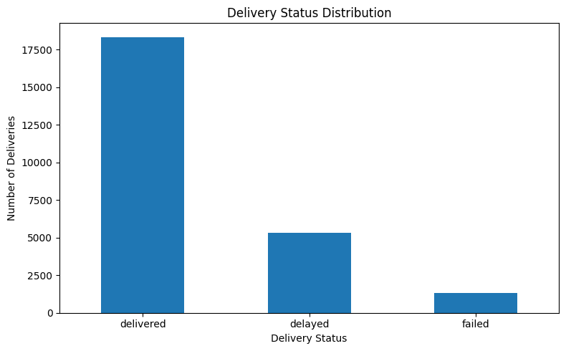
Figure: Notebook visualization from analysis cell 11.
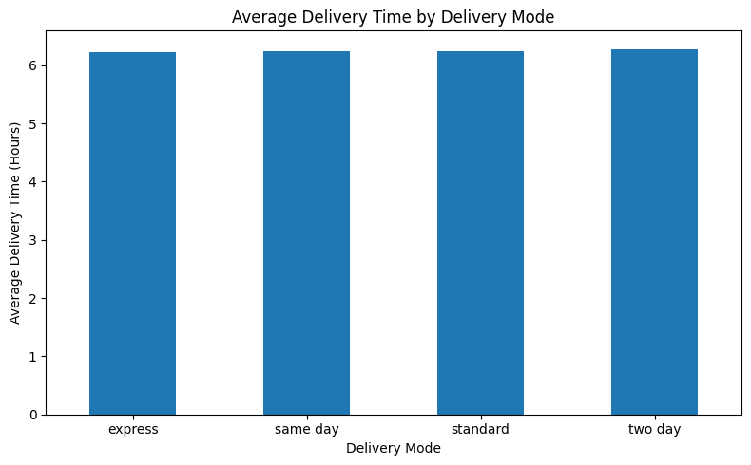
Figure: Notebook visualization from analysis cell 12.
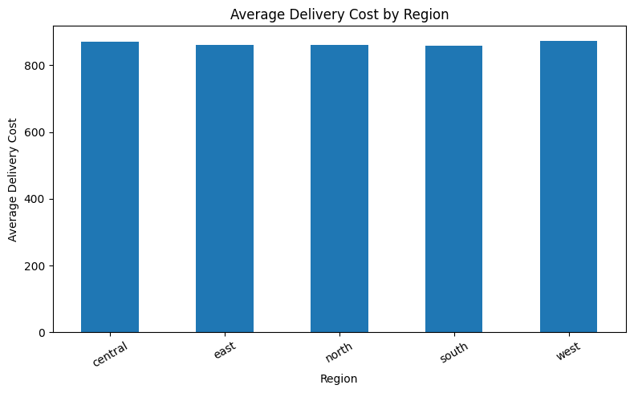
Figure: Notebook visualization from analysis cell 13.
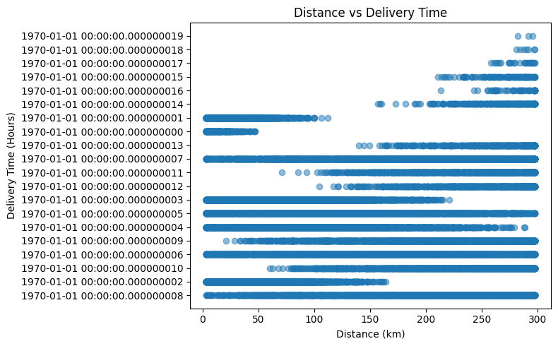
Figure: Notebook visualization from analysis cell 14.
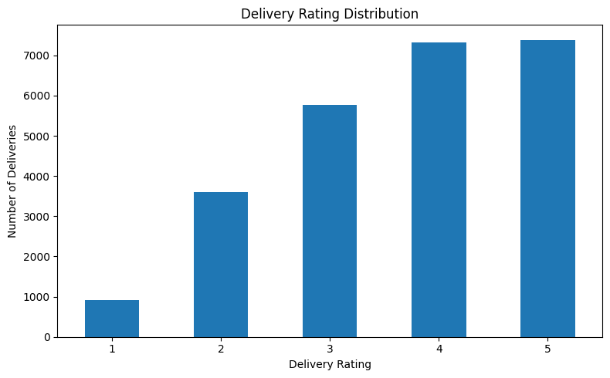
Figure: Notebook visualization from analysis cell 16.
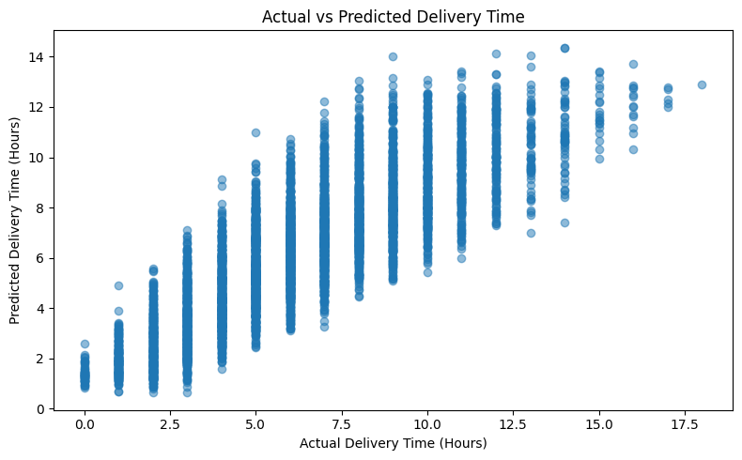
Figure: Notebook visualization from analysis cell 21.
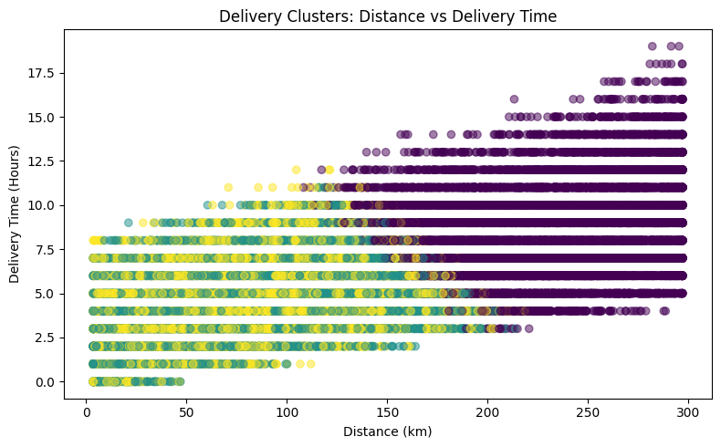
Figure: Notebook visualization from analysis cell 24.

7. Data Science Methodology

7.1 Regression: Predicting Delivery Time
A Random Forest Regressor was trained to predict actual delivery time. Numerical inputs included distance, package weight, and expected time. Categorical inputs included delivery partner, package type, vehicle type, delivery mode, region, and weather condition. Categorical variables were one-hot encoded and missing values were handled through imputation within a Scikit-learn pipeline.
from sklearn.ensemble import RandomForestRegressor
model = RandomForestRegressor(
n_estimators=100,
random_state=42
)
# Train/test split: 80% / 20%
pipeline.fit(X_train, y_train)
y_pred = pipeline.predict(X_test)
Metric | Result | Interpretation
MAE | 1.326 hours | Predictions differed from actual delivery time by about 1.33 hours on average.
RMSE | 1.675 hours | Shows the model's overall prediction error with greater weight on larger errors.
R² | 0.710 | The model explained approximately 71.0% of the variation in delivery time on the test set.

7.2 Classification: Predicting Delayed Deliveries
A Random Forest Classifier was also trained to predict whether a delivery would be delayed. The target variable was converted from yes/no into 1/0. The same operational feature groups were used, and stratified train/test splitting was applied.
from sklearn.ensemble import RandomForestClassifier
from sklearn.metrics import accuracy_score, classification_report
y = df["delayed"].map({"yes": 1, "no": 0})
classifier = RandomForestClassifier(
n_estimators=100,
random_state=42
)
classification_pipeline.fit(X_train, y_train)
y_pred = classification_pipeline.predict(X_test)
print("Accuracy:", accuracy_score(y_test, y_pred))
print(classification_report(y_test, y_pred))
Metric | Result
Accuracy | 88.94%
Precision — Not delayed | 0.93
Recall — Not delayed | 0.92
F1 — Not delayed | 0.92
Precision — Delayed | 0.79
Recall — Delayed | 0.80
F1 — Delayed | 0.79

The classifier achieved 88.94% accuracy. More importantly for logistics operations, the model achieved 0.80 recall for the delayed class, meaning it identified a substantial portion of delayed deliveries in the test set. This could support early-risk identification, although further validation would be required before operational deployment.

7.3 Clustering: Identifying Delivery Segments
K-Means clustering was applied to distance, package weight, actual delivery time, expected delivery time, and delivery cost. The variables were standardized before clustering, and three clusters were selected.
Cluster | Distance (km) | Weight (kg) | Actual Time (h) | Expected Time (h) | Cost
0 | 231.92 | 25.80 | 8.60 | 13.24 | 1275.27
1 | 85.09 | 24.61 | 4.32 | 5.56 | 573.36
2 | 86.05 | 24.65 | 4.44 | 20.25 | 505.02

Cluster 0 represents longer-distance, higher-cost deliveries with the highest average actual delivery time. Clusters 1 and 2 represent shorter-distance, lower-cost deliveries, but differ substantially in expected delivery time. These segments can be useful for operational planning because different groups may require different service strategies.

8. Strategic Roadmap
The proposed end-to-end analytical process is:
- Data collection — obtain the delivery dataset and document the source and variables.
- Data understanding — inspect dimensions, data types, descriptive statistics, and categorical distributions.
- Data cleaning — check missing values, duplicates, inconsistent data types, and time representations.
- Feature engineering — create variables such as delay hours and binary delay indicators.
- KPI calculation — establish baseline delivery performance, time, cost, delay, and service-quality metrics.
- Exploratory analysis — compare performance across delivery modes, regions, partners, vehicles, and weather conditions.
- Predictive modeling — predict delivery time and delayed-delivery risk using machine-learning models.
- Clustering — segment deliveries into operationally similar groups.
- Optimization extension — use the identified patterns as inputs for future vehicle allocation, route planning, or service-level decisions.
- Decision support — communicate findings through dashboards/reports and recommend operational actions.

9. Preliminary Insights and Strategic Recommendations
- Monitor on-time delivery as a core operational KPI because the current baseline is 73.324%.
- Investigate distance-related operational constraints because distance and delivery time have a correlation of approximately 0.686.
- Review the cost-performance trade-off of delivery modes. Same-day delivery has the highest average cost in the current analysis, while standard delivery has the lowest.
- Use regional monitoring rather than assuming that one region is solely responsible for delays. The regional delay proportions are relatively close and should be analyzed alongside distance, weather, mode, and partner.
- Use the classification model as a potential early-warning mechanism for shipments at risk of delay, subject to further validation.
- Use cluster profiles to differentiate operational strategies for long-distance/high-cost deliveries versus shorter, lower-cost delivery groups.
- Continue monitoring customer ratings so that cost reduction does not unintentionally reduce service quality.

10. Expected Outcomes and Business Impact
The analysis is expected to provide logistics managers with a structured view of delivery performance and the factors associated with operational variation. KPI monitoring can establish a baseline against which future improvements can be measured. Predictive modeling can support proactive identification of deliveries likely to require attention, while clustering can help managers design differentiated operating policies.
In a future production system, these analytical outputs could be integrated into a logistics dashboard. Managers could monitor on-time performance, cost, delay risk, and segment-level performance and then use the information to allocate vehicles, prioritize shipments, review delivery partners, and improve route or service planning.

11. Limitations and Future Work
- The analysis is based on the available dataset and therefore reflects its variables and data-generation assumptions.
- The observed relationships are not sufficient by themselves to establish causality.
- The notebook uses a Random Forest model with a single train/test split; cross-validation and hyperparameter tuning should be considered for a stronger evaluation.
- Feature importance and explainability analysis should be added before using predictions for operational decisions.
- The current work does not implement a full vehicle-routing or mathematical optimization model. That can be treated as a later project phase.
- The time-field preprocessing should be consolidated and documented more clearly in the final notebook for reproducibility.

12. Conclusion
This Week 1 project establishes a practical data-science framework for delivery logistics analysis. The dataset was profiled and checked for missing values and duplicates, relevant KPIs were calculated, and exploratory analysis was used to understand delivery time, cost, delay, distance, region, and delivery-mode patterns. The analysis then extended into machine learning through Random Forest regression and classification and K-Means clustering.
The results demonstrate how Python-based analytics can move logistics decision-making from simple reporting toward prediction and operational segmentation. The next stage can build on these findings by improving model validation, adding explainability, and eventually applying optimization techniques to resource allocation and route planning.

13. References
- Muhammad Ahmad. Delivery Logistics Dataset: Performance, Timing & Cost Insights. Kaggle. https://www.kaggle.com/muhammadahmaddaar/delivery-logistics-dataset-india-multi-partner
- IBM. Supply chain analytics: Examples, applications and use cases. 2026. https://www.ibm.com/think/topics/supply-chain-analytics-use-cases
- IBM. Key Performance Indicator Report. https://www.ibm.com/support/pages/key-performance-indicator-report
- IBM. On Time Delivery Summary Report. https://www.ibm.com/support/pages/time-delivery-summary-report
- Scikit-learn documentation. RandomForestRegressor, RandomForestClassifier, KMeans, preprocessing and model evaluation. https://scikit-learn.org/
- Pandas documentation. Data manipulation and analysis in Python. https://pandas.pydata.org/
- Matplotlib documentation. Visualization in Python. https://matplotlib.org/

Appendix A — Main Python Workflow
# 1. Load data
import pandas as pd
import numpy as np
import matplotlib.pyplot as plt
import seaborn as sns
df = pd.read_csv("Delivery_Logistics.csv")
# 2. Inspect
df.head()
df.shape
df.info()
df.describe()
df.isnull().sum()
# 3. Remove duplicates
df = df.drop_duplicates()
# 4. Create delay indicator
df["Is_Late_Delivery"] = df["delayed"].apply(
lambda x: 1 if x == "yes" else 0
)
# 5. KPI analysis
on_time_rate = (df["delayed"].eq("no").sum() / len(df)) * 100
avg_cost = df["delivery_cost"].mean()
avg_time = df["delivery_time_hours"].mean()
# 6. Exploratory analysis
df.groupby("delivery_mode")["delivery_time_hours"].mean()
df.groupby("region")["Is_Late_Delivery"].mean()
df.groupby("delivery_mode")["delivery_cost"].mean()
# 7. Correlation
df[["distance_km", "delivery_time_hours"]].corr()
# 8. Machine learning
# Random Forest regression and classification
# K-Means clustering

Appendix B — Repository Recommendation
For the weekly GitHub submission, the Week 1 folder can contain the Colab notebook, report, selected figures, and a short README. If the dataset license permits redistribution, the CSV can also be included; otherwise, document the original Kaggle source and provide instructions for downloading it.
logistics-data-analysis/
│
├── README.md
├── Week-01/
│ ├── notebook/
│ │ └── Yuva.ipynb
│ ├── report/
│ │ └── Week_1_Strategic_Planning_Logistics_Report.docx
│ └── figures/
│
├── Week-02/
├── Week-03/
└── Week-04/

