1. Introduction
Logistics operations generate large amounts of data related to shipment distance, package weight, delivery time, expected delivery time, transportation cost, delivery status, region, vehicle type, weather conditions and customer ratings. Analyzing these variables helps identify operational patterns, delays and cost drivers.
This Week 3 task extends the analysis performed in the previous week by using the cleaned logistics dataset for exploratory data analysis (EDA), statistical analysis and visualization. The objective is to understand delivery performance, identify relationships between important logistics variables, and derive practical insights for logistics decision-making.

2. Dataset Description
The analysis uses the cleaned logistics dataset prepared in Week 2. It contains 25,000 shipment records and 17 variables.
Variable | Description
delivery_id | Unique delivery identifier
delivery_partner | Delivery service provider
package_type | Type/category of package
vehicle_type | Vehicle used for delivery
delivery_mode | Delivery service mode
region | Geographical operating region
weather_condition | Weather during delivery
distance_km | Delivery distance in kilometres
package_weight_kg | Package weight in kilograms
delivery_time_hours | Actual delivery time
expected_time_hours | Expected delivery time
delayed | Whether the shipment was affected by delay
delivery_status | Delivered, delayed or failed
delivery_rating | Delivery rating
delivery_cost | Transportation/delivery cost
delay_hours | Difference between actual and expected time
delay_status | On-time/delay classification

3. Methodology
The analysis was performed using Python. Pandas was used for data loading, descriptive statistics and grouping operations. Matplotlib and Seaborn were used for visualization. The workflow consisted of data-quality verification, descriptive analysis, outlier analysis, delivery-status analysis, regional analysis, correlation analysis and visualization.
- Load the cleaned Week 2 dataset.
- Verify the number of records, columns, missing values and duplicate rows.
- Calculate descriptive statistics and central tendencies for numerical variables.
- Apply the IQR method to examine potential outliers in package weight.
- Analyze delivery status and delay proportions.
- Compare delivery performance across regions.
- Calculate correlations between distance, delivery time and delivery cost.
- Create six visualizations to communicate the major findings.

4. Exploratory Data Analysis

4.1 Dataset and Data Quality
The dataset contains 25,000 rows and 17 columns. The data-quality check showed zero missing values in all variables and zero completely duplicated rows. Therefore, no missing-value imputation or row deletion was required for this analysis.
A check of delivery IDs showed 498 repeated IDs. These repeated IDs were not treated as duplicate records because the complete rows themselves were not duplicated. The delivery ID was therefore not used as a numerical analytical variable.
print("Missing Values:")
print(df.isnull().sum())
print("\nDuplicate Rows:")
print(df.duplicated().sum())
print("\nDuplicate Delivery IDs:")
print(df["delivery_id"].duplicated().sum())

4.2 Descriptive Statistics
Variable | Mean | Median | Range
Distance (km) | 150.39 | 151.00 | 3.60–297.10
Package weight (kg) | 25.15 | 25.145 | 0.67–49.52
Delivery time (hours) | 6.25 | 6.00 | 0–19
Expected time (hours) | 13.11 | 8.00 | 2–24
Delivery rating | 3.67 | 4.00 | 1–5
Delivery cost | 864.94 | 867.54 | 95.67–1632.72
Delay hours | -6.86 | -6.00 | -24–12
The average delivery distance is 150.39 km and the average package weight is 25.15 kg. The average actual delivery time is 6.25 hours, with a median of 6 hours. Delivery cost has an average of approximately 864.94, while the average delivery rating is 3.67 out of 5.

4.3 Outlier Analysis: Package Weight
The IQR method was used to identify potential outliers in package_weight_kg. The first quartile (Q1) was 12.68 kg and the third quartile (Q3) was 37.66 kg, giving an IQR of 24.98 kg. The calculated lower bound was -24.79 kg and the upper bound was 75.13 kg. No observations fell outside these limits, so zero outliers were detected and no outlier treatment was required.
Q1 = df["package_weight_kg"].quantile(0.25)
Q3 = df["package_weight_kg"].quantile(0.75)
IQR = Q3 - Q1
lower_bound = Q1 - 1.5 * IQR
upper_bound = Q3 + 1.5 * IQR
outliers = df[
(df["package_weight_kg"] < lower_bound) |
(df["package_weight_kg"] > upper_bound)
]

5. Visualizations and Interpretation

5.1 Distribution of Delivery Time
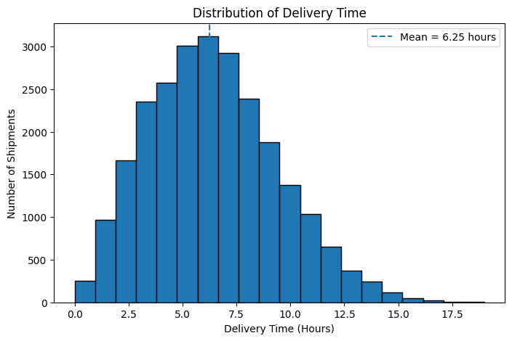
Why this visualization was selected: A histogram was selected because delivery time is a numerical variable and the histogram shows how frequently different delivery-time values occur.
Interpretation: The mean delivery time is 6.25 hours and the median is 6 hours. Delivery time ranges from 0 to 19 hours. The slightly higher mean indicates that some longer deliveries influence the average.

5.2 Distribution of Delivery Status
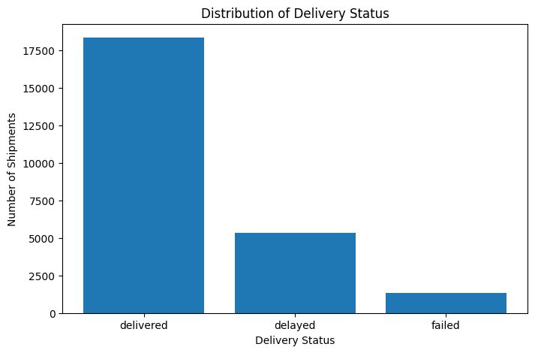
Why this visualization was selected: A bar chart was selected because delivery status is a categorical variable. It provides a direct comparison of delivered, delayed and failed shipments.
Interpretation: Out of 25,000 shipments, 18,331 (73.32%) were delivered successfully, 5,341 (21.36%) were delayed, and 1,328 (5.31%) failed. Therefore, 26.68% of shipments were affected by delay or failure.

5.3 Delivery Performance by Region
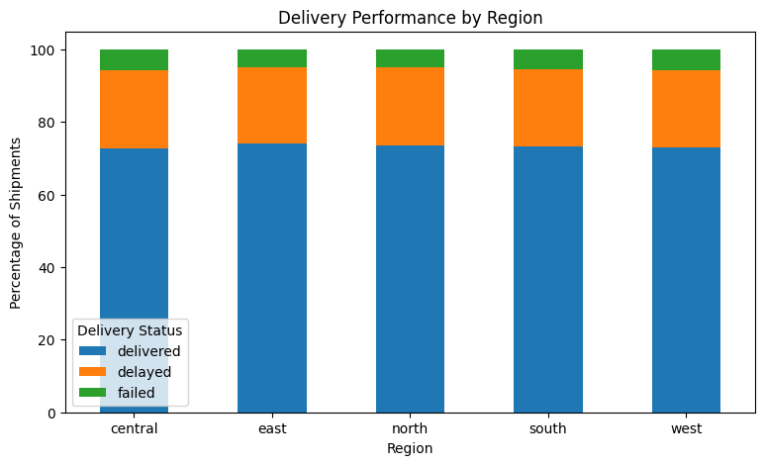
Why this visualization was selected: A 100% stacked bar chart was selected to compare the composition of delivery outcomes within each region.
Interpretation: Regional performance is relatively consistent. East has the highest delivered proportion (74.20%) and lowest delayed proportion (20.82%). North has the highest delayed proportion (21.80%), while Central has the highest failure proportion (5.65%). The small differences suggest that region alone may not be the main source of delivery problems.

5.4 Distance vs Delivery Time
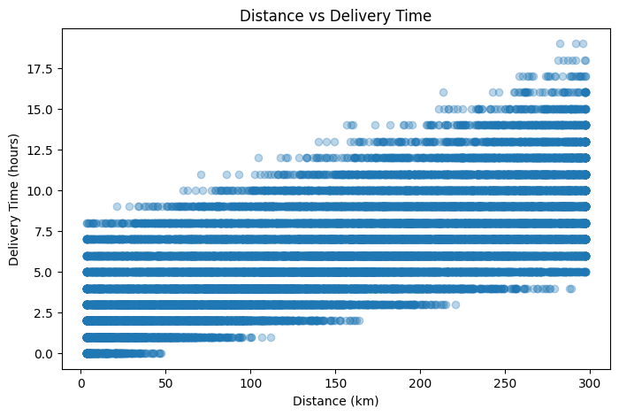
Why this visualization was selected: A scatter plot was selected because both distance and delivery time are numerical variables. It helps visualize whether delivery time tends to change as distance increases.
Interpretation: The Pearson correlation coefficient is 0.686, indicating a moderately strong positive association. Longer-distance shipments generally tend to have longer delivery times. This is an association and should not be interpreted as proof of causation.

5.5 Distance vs Delivery Cost
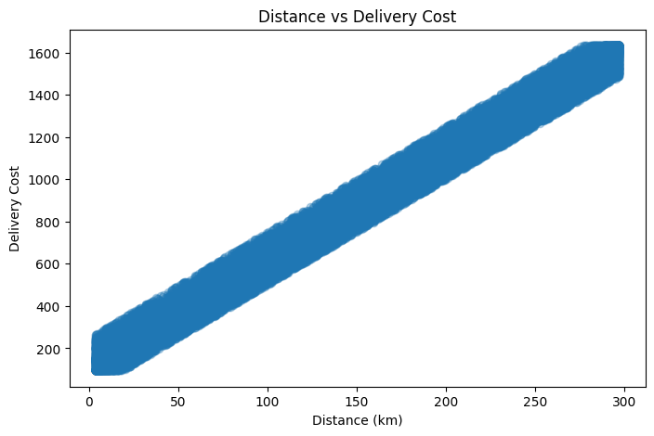
Why this visualization was selected: A scatter plot was selected to examine the relationship between shipment distance and transportation cost.
Interpretation: The correlation coefficient is 0.991, indicating an extremely strong positive association between distance and delivery cost. Distance is therefore a major cost-related variable in this dataset.

5.6 Correlation Heatmap
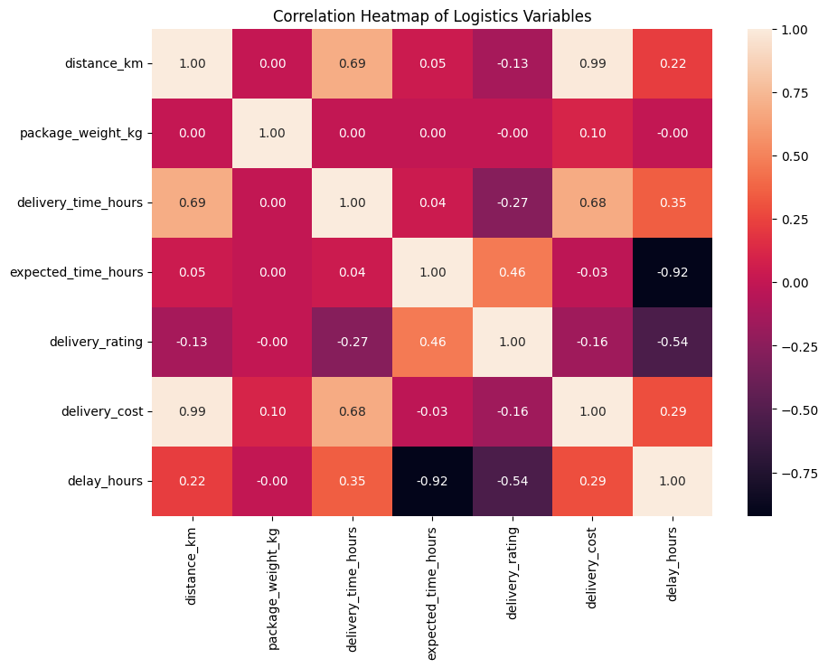
Why this visualization was selected: A heatmap provides a compact view of correlations among several numerical logistics variables and helps identify strong positive or negative relationships.
Interpretation: The heatmap should be used to compare the strength and direction of relationships among distance, package weight, delivery time, expected time, rating, delivery cost and delay hours. The two strongest relationships confirmed in the analysis are distance with delivery time (0.686) and distance with delivery cost (0.991).

6. Key Analytical Insights
- The dataset contains 25,000 shipments with no missing values and no completely duplicated rows.
- Average delivery time is 6.25 hours, with a median of 6 hours and a range of 0–19 hours.
- 73.32% of shipments were successfully delivered, while 21.36% were delayed and 5.31% failed.
- The combined proportion of delayed and failed shipments is 26.68%, indicating room for improvement in delivery reliability.
- Regional delivery performance is fairly consistent, with only modest differences among Central, East, North, South and West.
- Distance and delivery time have a correlation of 0.686, showing a moderately strong positive association.
- Distance and delivery cost have a correlation of 0.991, showing an extremely strong positive association and identifying distance as a major cost-related factor.
- No IQR-based outliers were detected in package_weight_kg, so no outlier treatment was necessary.

7. Recommendations
- Use distance-based planning when estimating delivery time and transportation cost.
- Monitor delayed and failed shipments separately so that operational teams can distinguish timing problems from delivery failures.
- Investigate the causes of delays and failures using additional factors such as weather condition, vehicle type, delivery mode and delivery partner.
- Use regional performance as a monitoring metric, but avoid treating region as the only explanation because regional differences are relatively small.
- Use historical delivery-distance patterns to improve cost forecasting and route planning.
- Continue monitoring package weight and other numerical variables even though no package-weight outliers were detected in this dataset.

8. Python Tools and Techniques Used
Python libraries used in the analysis were Pandas for data manipulation and statistical summaries, NumPy for numerical operations, Matplotlib for charts, and Seaborn for the correlation heatmap.
import pandas as pd
import numpy as np
import matplotlib.pyplot as plt
import seaborn as sns
df = pd.read_csv("cleaned_delivery_logistics.csv")
# Descriptive statistics
df.describe()
# Correlation
df["distance_km"].corr(df["delivery_time_hours"])
df["distance_km"].corr(df["delivery_cost"])
# Correlation heatmap
correlation_matrix = df[numerical_columns].corr()
sns.heatmap(correlation_matrix, annot=True, fmt=".2f")

9. Conclusion
The Week 3 analysis demonstrates how exploratory data analysis and visualization can be used to understand logistics performance. The analysis found that most shipments were successfully delivered, but a substantial proportion experienced delays or failures. Regional performance was relatively stable, while distance showed meaningful positive relationships with both delivery time and delivery cost. In particular, the 0.991 correlation between distance and delivery cost highlights distance as a major cost-related factor in the dataset. These findings demonstrate how data-driven analysis can support delivery planning, cost estimation and operational monitoring.

10. Visualization Evidence
Screenshots of the six visualizations generated in the Week 3 Google Colab notebook should be inserted in Section 5 in place of the marked placeholders. The notebook contains the Python code used to generate each visualization.

