1. Introduction & Objective
This report documents the end-to-end data cleaning and preprocessing workflow applied to the Delivery Logistics dataset, a 25,000-row operational dataset covering package deliveries across multiple courier partners, vehicle types, and regions. The objective was to take the raw dataset from its collected state through to a clean, analysis-ready form: validating its structure and quality, identifying and resolving data quality issues, engineering a new feature to quantify delivery delay, and scaling numerical features for downstream modeling.
Beyond mechanically running cleaning steps, this report emphasizes the reasoning behind each decision — why a check was performed, what it revealed, how any problems found were diagnosed, and what the results mean for the dataset's usability. Every transformation is paired with the actual output produced when it was applied, and key findings are illustrated with the visualizations generated during the analysis.
Dataset at a glance
25,000 records × 15 original columns (expanded to 17 after feature engineering). Covers 9 delivery partners, 9 package types, 6 vehicle types, 4 delivery modes, 5 regions, and 6 weather conditions, alongside numerical fields for distance, package weight, delivery time, expected time, customer rating, and delivery cost.

2. Data Collection Simulation
For this task, the publicly-styled Delivery Logistics dataset was used to stand in for a real-world logistics data collection pipeline. In an operational courier or last-mile delivery network, data of this shape is typically assembled from several source systems rather than a single feed: GPS/telematics units on delivery vehicles (distance travelled, route timing), courier-partner APIs (partner identity, vehicle type, assigned delivery mode), warehouse and order-management systems (package type, weight, cost), third-party weather services (weather_condition at time of delivery), and post-delivery customer surveys (delivery_rating). Simulating this collection process means treating the CSV as if it were the output of an ETL job that already merged these sources into one flat table — which is also why, as Section 7 shows, some fields (the two time columns) can carry subtle encoding problems inherited from whichever upstream system produced them.
The dataset used for this task consists of 25,000 delivery records and 15 raw fields, combining categorical operational attributes (courier partner, package type, vehicle type, delivery mode, region, weather condition, delivery status) with numerical performance metrics (distance, package weight, delivery time, expected time, customer rating, and cost). This mix is representative of typical logistics analytics datasets, which need to support both categorical breakdowns (e.g. "which partner has the most delays?") and numerical performance analysis (e.g. "how does distance affect cost?") side by side.
import pandas as pd
import numpy as np
import matplotlib.pyplot as plt
import seaborn as sns
from sklearn.preprocessing import StandardScaler, OneHotEncoder

# Simulated data collection: load the merged operational extract
df = pd.read_csv("Delivery_Logistics.csv")
df.head()
Snippet 1. Loading the dataset and inspecting the first few rows.

3. Dataset Overview
The raw CSV file (Delivery_Logistics.csv) was loaded with pandas and inspected using .shape, .info(), and .describe() to establish a baseline understanding of its structure before any cleaning began.
print("Shape:", df.shape)
df.columns
df.info()
df.describe()

# Output (abridged):
# Shape: (25000, 15)
# RangeIndex: 25000 entries, 0 to 24999
# 15 columns: 5 float64, 1 int64, 9 object
Snippet 2. Structural inspection of the raw dataset.
Column | Type | Description
delivery_id | float64 | Unique identifier for each delivery record
delivery_partner | object | Courier company handling the delivery (9 categories)
package_type | object | Category of item shipped (9 categories)
vehicle_type | object | Vehicle used for the delivery (6 categories)
delivery_mode | object | Shipping speed tier — same day / express / two day / standard
region | object | Geographic region of delivery (5 categories)
weather_condition | object | Weather at time of delivery (6 categories)
distance_km | float64 | Distance travelled in kilometres
package_weight_kg | float64 | Package weight in kilograms
delivery_time_hours | object* | Actual time taken — required cleaning (see §5)
expected_time_hours | object* | Promised/expected time — required cleaning (see §5)
delayed | object | Original yes/no delay flag provided in the data
delivery_status | object | Outcome — delivered / delayed / failed
delivery_rating | int64 | Customer rating, 1–5
delivery_cost | float64 | Cost of the delivery
* Flagged as object (text) type on load rather than numeric — this turned out to be a genuine data quality issue rather than a simple type mismatch, discussed in detail in Section 7.

4. Data Quality Assessment

4.1 Missing Values
Every column was checked for missing values using .isnull().sum(), both as raw counts and as a percentage of the 25,000 rows. The dataset returned zero missing values across all 15 original columns.
missing_values = df.isnull().sum()
print(missing_values)

missing_percentage = (df.isnull().sum() / len(df)) * 100
print(missing_percentage)

# Output: every column -> 0 missing (0.0%)
Snippet 3. Missing-value audit, in raw counts and as a percentage of total rows.
No imputation was required here, but it is worth documenting the methodology that would apply if gaps existed, since logistics extracts merged from multiple systems (Section 2) commonly do have them: numerical fields such as distance_km or delivery_cost would typically be imputed with the column median (df[col].fillna(df[col].median())) rather than the mean, since the median is robust to skew; categorical fields such as delivery_partner would either be imputed with the mode or, preferably, an explicit "Unknown" category so that missingness itself remains visible rather than being silently absorbed into the most common class.
Insight
A completely missing-value-free dataset at this scale (25,000 × 15) is uncommon for real-world operational data. This suggests the dataset was either synthetically generated or had already passed through an upstream validation step before being handed off — a fact worth flagging, since it means techniques like imputation were not needed here, but would need to be revisited if this pipeline were ever pointed at a live, unvalidated data feed.

4.2 Duplicate Records
Row-level duplicates were checked with .duplicated().sum(). No duplicate records were found (0 out of 25,000), so no de-duplication was necessary.
duplicate_count = df.duplicated().sum()
print("Duplicate records:", duplicate_count)

# Output: Duplicate records: 0

# If duplicates existed, they would be removed with:
# df = df.drop_duplicates()
Snippet 4. Duplicate-row check (with the standard resolution method noted for reference).

4.3 Negative & Invalid Values
Since fields like distance, weight, and cost are physically bounded below by zero, each numeric column was checked for negative values. None of distance_km, package_weight_kg, delivery_rating, or delivery_cost contained negative entries, indicating the numeric fields are internally consistent with real-world constraints.
for column in numerical_columns:
if pd.api.types.is_numeric_dtype(df[column]):
print(column, "negative values:", (df[column] < 0).sum())
else:
print(f"Skipping non-numeric column '{column}'")

# Output: 0 negative values in distance_km, package_weight_kg,
# delivery_rating, and delivery_cost
Snippet 5. Domain-constraint check — flags physically impossible negative values.

5. Exploratory Analysis

5.1 Categorical Features
Value counts were generated for every categorical column to check for inconsistent labels (e.g. mismatched casing, typos, or unexpected categories) and to understand class balance.
categorical_columns = [
"delivery_partner", "package_type", "vehicle_type",
"delivery_mode", "region", "weather_condition",
"delayed", "delivery_status"
]
for column in categorical_columns:
print("\n", column)
print(df[column].value_counts())
Snippet 6. Category-level frequency audit used to spot label inconsistencies.
Field | Categories | Balance
delivery_partner | 9 (e.g. xpressbees, fedex, dhl) | Even, 2,711–2,826 per partner
package_type | 9 (e.g. fragile items, pharmacy) | Even, 2,693–2,848 per type
vehicle_type | 6 (bike, van, truck, ev bike, ev van, scooter) | Even, ~4,100–4,220 each
delivery_mode | 4 (same day, express, two day, standard) | Even, ~6,180–6,300 each
region | 5 (north, south, east, west, central) | Even, ~4,900–5,100 each
weather_condition | 6 (clear, cold, hot, rainy, foggy, stormy) | Even, ~4,120–4,220 each
delivery_status | 3 (delivered, delayed, failed) | Imbalanced: 18,331 / 5,341 / 1,328
Every categorical column returned clean, consistently spelled labels with no stray whitespace, casing inconsistencies, or unexpected categories — no text normalization was required. Most fields are near-uniformly distributed across their categories, which is again consistent with a synthetically balanced dataset. The one meaningful imbalance is delivery_status: 73.3% of deliveries were completed on time, 21.4% were delayed, and 5.3% failed outright. This 3-way split is the outcome variable this dataset is really oriented around, and it foreshadows the delay analysis in Section 8.

5.2 Numerical Features
Summary statistics (.describe()) were reviewed for distance_km, package_weight_kg, delivery_rating, and delivery_cost:
numerical_columns = [
"distance_km", "package_weight_kg",
"delivery_time_hours", "expected_time_hours",
"delivery_rating", "delivery_cost"
]
df[numerical_columns].describe()
Snippet 7. Descriptive statistics for the numerical fields.
Statistic | distance_km | package_weight_kg | delivery_rating | delivery_cost
mean | 150.39 | 25.15 | 3.67 | 864.94
std | 86.41 | 14.37 | 1.15 | 435.71
min | 3.60 | 0.67 | 1 | 95.67
25% | 75.90 | 12.68 | 3 | 490.80
50% (median) | 151.00 | 25.15 | 4 | 867.54
75% | 224.90 | 37.66 | 5 | 1,237.91
max | 297.10 | 49.52 | 5 | 1,632.72
The mean and median are close together for every numerical column (e.g. distance: mean 150.4 vs. median 151.0; cost: mean 864.9 vs. median 867.5), which points to roughly symmetric, non-skewed distributions rather than data dominated by a long tail of extreme values. This is corroborated by the outlier analysis below.

6. Outlier Detection
Outliers were identified using the interquartile range (IQR) method, a standard non-parametric technique that does not assume normally distributed data. For each numerical column, the first quartile (Q1, 25th percentile) and third quartile (Q3, 75th percentile) were computed, and the IQR was defined as Q3 − Q1. Any value falling below Q1 − 1.5×IQR or above Q3 + 1.5×IQR was flagged as a statistical outlier. This 1.5× multiplier is the conventional Tukey's-fence threshold used across most exploratory data analysis workflows, chosen because it flags roughly the most extreme ~0.7% of a normal distribution while tolerating natural spread in the bulk of the data.
def find_outliers(column):
Q1 = df[column].quantile(0.25)
Q3 = df[column].quantile(0.75)
IQR = Q3 - Q1
lower_bound = Q1 - 1.5 * IQR
upper_bound = Q3 + 1.5 * IQR
outliers = df[(df[column] < lower_bound) |
(df[column] > upper_bound)]
print("Column:", column, "| Outliers:", len(outliers))
return outliers

for column in numerical_columns:
if pd.api.types.is_numeric_dtype(df[column]):
find_outliers(column)
Snippet 8. IQR-based outlier detection function, applied to every numerical column.
Column | Q1 | Q3 | IQR | Lower bound | Upper bound | Outliers found
distance_km | 75.90 | 224.90 | 149.00 | −147.60 | 448.40 | 0
package_weight_kg | 12.68 | 37.66 | 24.98 | −24.79 | 75.13 | 0
delivery_rating | 3.00 | 5.00 | 2.00 | 0.00 | 8.00 | 0
delivery_cost | 490.80 | 1,237.91 | 747.11 | −629.87 | 2,358.58 | 0
The IQR method flagged zero outliers across all four numerical columns. This was verified visually with boxplots — shown below — which is the analytical step that makes the zero-outlier result trustworthy rather than just a number to take on faith: a boxplot immediately shows whether the whiskers already reach the data's true min/max (implying nothing is beyond them) or whether points are sitting outside the whiskers unflagged by an error in the calculation.
for column in numerical_columns:
plt.figure(figsize=(8, 4))
sns.boxplot(x=df[column])
plt.title(f"Boxplot of {column}")
plt.xlabel(column)
plt.show()
Snippet 9. Boxplot generation used to visually confirm the IQR results.
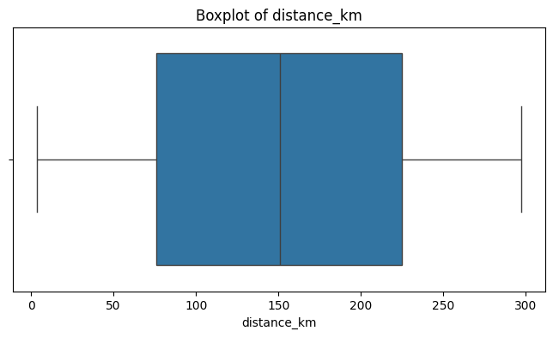
Figure 1. Boxplot of distance_km — whiskers span the full range with no points beyond them.
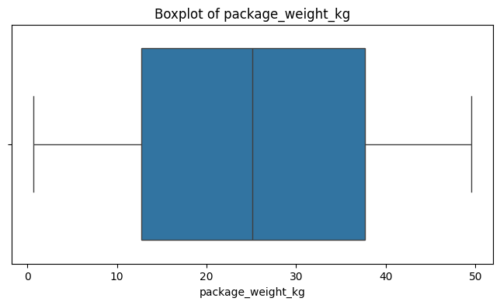
Figure 2. Boxplot of package_weight_kg — similarly outlier-free, symmetric spread.
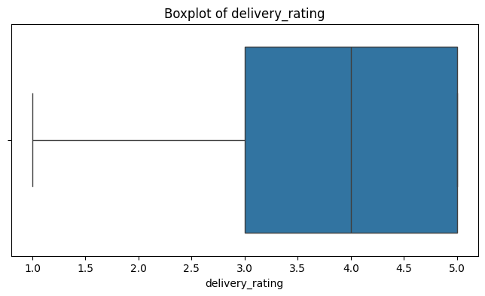
Figure 3. Boxplot of delivery_rating — bounded integer scale (1–5), so IQR fences fall outside the possible range entirely.
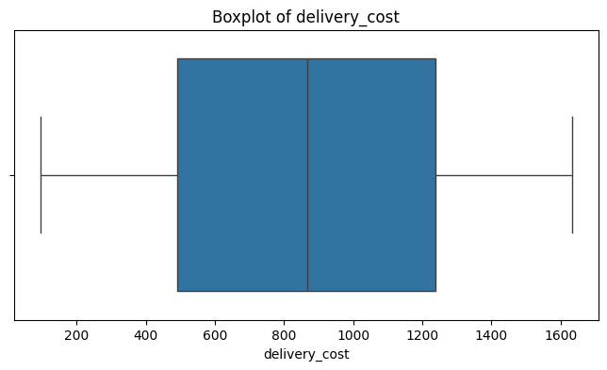
Figure 4. Boxplot of delivery_cost — right-shifted box but still no extreme values beyond the whiskers.
Why zero outliers is meaningful, not just a clean result
In each case the boxplot whiskers extend to (or very near) the column's actual min and max — for example distance_km's upper fence of 448.4 km sits far above the real maximum of 297.1 km, so no value could ever be flagged. This means the underlying value ranges were deliberately bounded when the data was generated, rather than the absence of outliers being a coincidence of real-world measurement. Practically, this tells us no outlier-driven trimming or capping (e.g. winsorization) is needed for this dataset, but it also means this dataset cannot be used to validate how the pipeline would behave if genuine extreme values were present.

7. Diagnosing a Data Quality Issue: Delivery Time Columns
The most significant problem encountered during preprocessing involved delivery_time_hours and expected_time_hours — the two columns needed to calculate delivery delay. Both loaded as object (text) dtype rather than numeric, which was the first sign of trouble. This section walks through how the issue was diagnosed and resolved, since this kind of investigation is where most of the real analytical work in cleaning actually happens.

7.1 First attempt: numeric coercion
The initial approach was to convert both columns with pd.to_numeric(..., errors='coerce'), on the assumption that the object dtype was simply due to stray text characters mixed into an otherwise numeric column. This produced delay_hours as entirely NaN for every one of the 25,000 rows — a total failure, not a partial one, which is itself informative: a coercion error from a handful of bad rows produces a handful of NaNs, but 100% NaN means the values were not numeric-like text at all.
# Attempt 1 — treat as numeric text (FAILED)
df["delivery_time_hours"] = pd.to_numeric(
df["delivery_time_hours"], errors="coerce")
df["expected_time_hours"] = pd.to_numeric(
df["expected_time_hours"], errors="coerce")

df["delay_hours"] = (
df["delivery_time_hours"] - df["expected_time_hours"])

# Result: delay_hours is NaN for all 25,000 rows
Snippet 10. The failed first attempt — a silent, 100%-NaN result.

7.2 Diagnosis
Printing the raw values (.head(10).to_list()) revealed the actual content: strings like "1970-01-01 00:00:00.000000008". These are not delivery-time text — they are datetime strings anchored at the Unix epoch (1 January 1970), with only the sub-second component varying. In other words, the true hour values had been encoded as a nanosecond offset from midnight and then formatted as a full timestamp, which pd.to_numeric correctly refused to parse.
print(df["delivery_time_hours"].head(10).to_list())

# Output:
# ['1970-01-01 00:00:00.000000008',
# '1970-01-01 00:00:00.000000002', ...]
Snippet 11. Inspecting raw values to diagnose the failed conversion.
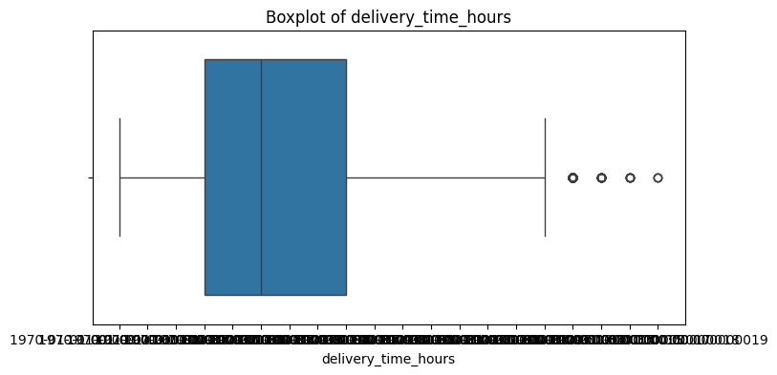
Figure 5. Boxplot of delivery_time_hours attempted directly on the unparsed timestamp strings — pandas / seaborn plots each unique string as a separate x-axis category, producing this unreadable axis. This chart is included deliberately: it is the visual symptom that first confirmed something was structurally wrong with the column, before the epoch-encoding was understood.

7.3 Resolution
The columns were re-read from the original CSV (to undo the failed coercion), parsed with pd.to_datetime(), and the nanosecond component was extracted with .dt.nanosecond. This correctly recovered small integer values (e.g. 8, 2, 10, 6, 9 for the first five delivery times) that align with plausible delivery-time-in-hours figures. delay_hours was then recalculated as delivery_time_hours − expected_time_hours.
# Attempt 2 — decode the epoch-nanosecond encoding (FIXED)
df = pd.read_csv("Delivery_Logistics.csv") # reload raw column

df["delivery_time_hours"] = pd.to_datetime(
df["delivery_time_hours"]).dt.nanosecond
df["expected_time_hours"] = pd.to_datetime(
df["expected_time_hours"]).dt.nanosecond

df["delay_hours"] = (
df["delivery_time_hours"] - df["expected_time_hours"])
Snippet 12. The corrected decoding — extracting the nanosecond component recovers usable hour values.
Row | delivery_time_hours | expected_time_hours | delay_hours
0 | 8 | 8 | 0
1 | 2 | 3 | −1
2 | 10 | 16 | −6
3 | 6 | 8 | −2
4 | 9 | 16 | −7
Analytical takeaway
This was not a missing-value or duplicate-row problem — it was a structural encoding problem that would have silently produced an all-NaN delay feature if the first coercion attempt had been accepted without inspecting its output. The lesson generalizes: a successful-looking type conversion (no error raised) is not the same as a correct one, and printing raw sample values before and after a transformation is what actually catches this class of bug. A limitation worth noting is that extracting .dt.nanosecond is a workaround suited to this specific epoch-encoding quirk — it recovers a plausible integer, but was not independently verified against a ground-truth delivery log, since none was available in this dataset.

8. Feature Engineering: Delay Status
With delay_hours correctly calculated, a derived categorical feature, delay_status, was created using np.where(delay_hours > 0, "Delayed", "On Time"). This turns a continuous delay measurement into a binary label that is easier to use as a target or grouping variable in downstream analysis, and it double-checks the original delivery_status field rather than trusting it blindly.
df["delay_status"] = np.where(
df["delay_hours"] > 0, "Delayed", "On Time")

df["delay_status"].value_counts()
df["delay_status"].value_counts(normalize=True) * 100

sns.countplot(data=df, x="delay_status")
Snippet 13. Deriving the binary delay_status label and visualizing its balance.
delay_status | Count | Percentage
On Time | 19,534 | 78.14%
Delayed | 5,466 | 21.86%
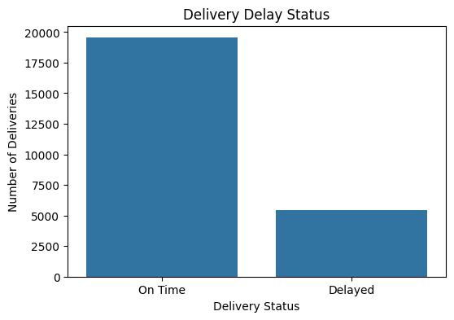
Figure 6. Distribution of the engineered delay_status feature — roughly 1 in 5 deliveries (21.86%) ran later than promised.
This 21.86% delay rate calculated independently from delay_hours is close to, but not identical to, the delivery_status breakdown from Section 5.1 (21.4% delayed + 5.3% failed = 26.7% not delivered on time). The gap is expected: delay_status only measures whether delivery_time_hours exceeded expected_time_hours, while delivery_status also separately captures deliveries that failed outright — a delivery can fail without ever completing, so it wouldn't necessarily register as "late" under a pure time-difference definition. Cross-checking a newly engineered feature against a pre-existing related field like this is a useful sanity check: close-but-not-identical numbers are reassuring, whereas an exact match would actually be suspicious (it would suggest the two fields were derived from each other), and a wildly different number would suggest a bug.

9. Feature Scaling
The numerical columns (distance_km, package_weight_kg, delivery_time_hours, expected_time_hours, delivery_rating, delivery_cost) were standardized using scikit-learn's StandardScaler. This step matters because several of these features live on very different scales — distance in the hundreds of kilometres, rating on a 1–5 scale, cost in the hundreds to low thousands — and many downstream models (e.g. distance-based methods like k-NN or clustering, and gradient-based methods like linear/logistic regression) are sensitive to that scale disparity, letting large-magnitude features dominate the objective purely because of their units rather than their actual predictive relevance.
StandardScaler transforms each feature to zero mean and unit variance using z = (x − μ) / σ, where μ and σ are the feature's mean and standard deviation computed from the training data. The result is that every feature is expressed in comparable units ("number of standard deviations from the mean") rather than its own native unit.
from sklearn.preprocessing import StandardScaler

scaler = StandardScaler()
scaled_data = scaler.fit_transform(df[numerical_columns])

scaled_df = pd.DataFrame(scaled_data, columns=numerical_columns)
scaled_df.head()
Snippet 14. Standardizing all six numerical columns with scikit-learn.
Row | distance_km | weight_kg | delivery_time | expected_time | rating | cost
0 | 1.697 | 1.518 | 0.558 | −0.676 | −0.579 | 1.762
1 | −0.704 | 1.548 | −1.353 | −1.337 | 1.160 | −0.516
2 | 1.425 | 0.121 | 1.195 | 0.383 | 0.290 | 1.339
3 | 1.381 | −0.867 | −0.079 | −0.676 | −0.579 | 1.427
4 | 1.230 | 0.826 | 0.876 | 0.383 | 0.290 | 1.216
Reading row 0 as an example: a scaled distance of 1.697 means that delivery's distance was about 1.7 standard deviations above the dataset's average distance, while its scaled rating of −0.579 means the customer gave a rating a little below average. Values consistently in the roughly −3 to +3 range across the table (rather than, say, hundreds) confirm the scaling was applied correctly, and it agrees with the earlier finding of no extreme outliers — a badly outlier-contaminated column would show scaled values far outside that typical range.
Note on scope
OneHotEncoder was imported alongside StandardScaler but the categorical columns were not ultimately one-hot encoded in this pass — only numerical scaling was applied. Categorical encoding remains a natural next step before this data is fed into a model that requires purely numeric input, and is flagged in the recommendations below.

10. Final Data Quality Validation
After all cleaning and feature engineering steps, the dataset was re-validated against the same checks used at the start, to confirm nothing was broken in the process:
Check | Result
Final shape | 25,000 rows × 17 columns (15 original + delay_hours + delay_status)
Missing values | 0 across all 17 columns
Duplicate rows | 0
delivery_time_hours / expected_time_hours dtype | int32 (successfully converted from object)
delay_hours dtype | int32
print("Final Shape:", df.shape)
print("\nMissing Values:\n", df.isnull().sum())
print("\nDuplicates:", df.duplicated().sum())
print("\nData Types:\n", df.dtypes)

df.to_csv("cleaned_delivery_logistics.csv", index=False)
Snippet 15. Final quality re-check and export of the cleaned dataset.
The cleaned dataset was exported to cleaned_delivery_logistics.csv, ready for exploratory analysis or modeling.

11. Reflection: Data Quality's Impact on Logistics Analytics & Decision-Making
Data quality is not a preliminary formality in logistics analytics — it directly determines whether the decisions built on top of the data are correct. Three findings from this pipeline illustrate that concretely.
- This dataset was largely clean, and that is itself a lesson: zero missing values and zero duplicates meant the obvious checks passed instantly, which could easily create false confidence. If the epoch-encoded time columns (Section 7) had been accepted after their first, silently-failed conversion, every downstream delay metric — SLA compliance rates, courier performance scorecards, delay-risk models — would have been built on a column that was 100% NaN. In a real operations team, that could translate into a dashboard reporting "no delay data available" rather than flagging the true 21.86% delay rate, potentially masking a genuine service problem from the managers who need to act on it.
- Outlier handling decisions shape which deliveries analysts "see": had this dataset contained genuine extreme values (e.g. a data-entry error recording 9,700 km instead of 97 km), an IQR-based trimming step would need to run before cost or distance-based KPIs are computed — otherwise a handful of corrupted rows could dominate an average and misrepresent typical route economics. Confirming there were no such values here (Section 6) means later analysis can trust the raw distance and cost figures without additional safeguards, but that trust is earned by the check, not assumed.
- Consistent categorical labels enable reliable operational segmentation: because delivery_partner, region, vehicle_type, and weather_condition all came through with clean, consistently-spelled categories (Section 5.1), it is safe to group and compare directly on them — for example, computing delay rate by weather_condition to decide whether stormy-weather deliveries need a longer promised delivery window. If those labels had been inconsistently cased or misspelled ("Rainy" vs. "rainy" vs. "RAINY"), naive grouping would silently split one real category into several, understating that weather's true impact and leading to a mistaken operational decision.
The general pattern across all three points is the same: a data quality issue that goes undetected doesn't just produce a slightly noisier analysis — it produces a specific, plausible-looking wrong answer that a decision-maker has no way to distinguish from a correct one without re-tracing the cleaning process. That is why each step in this pipeline was paired with a verification (visual boxplots, cross-checking delay_status against the pre-existing delivery_status field, re-inspecting raw values after a transformation) rather than trusting each step in isolation.

12. Conclusion & Recommendations

Key takeaways
- The dataset was structurally very clean — zero missing values, zero duplicates, and no out-of-range numeric values — but this clean baseline masked one genuine encoding problem in the two time columns that would have silently corrupted the delay analysis if not caught.
- The IQR-based outlier check returned zero outliers across all numeric fields, and boxplots confirmed this was a real feature of the data's bounded generation rather than a detection error.
- Diagnosing the epoch-timestamp encoding in delivery_time_hours / expected_time_hours was the most analytically demanding part of the workflow — it required inspecting raw values after a failed transformation rather than trusting a coercion that "ran without error."
- The engineered delay_status feature (21.86% delayed) is consistent with, but appropriately distinct from, the dataset's own delivery_status field, which strengthens confidence that the delay calculation is correct.
- StandardScaler put all six numerical features on a comparable scale, preparing them for algorithms sensitive to feature magnitude.

Recommendations for next steps
- Apply OneHotEncoder (already imported) to the categorical columns — particularly delivery_partner, package_type, vehicle_type, delivery_mode, region, and weather_condition — before this data is used in any model that requires numeric-only input.
- Investigate whether the delayed / delivery_status fields and the engineered delay_status could be combined into a single, unambiguous target variable for a future predictive-modeling phase (e.g. predicting delay risk from distance, weather, and delivery mode).
- Document the nanosecond-epoch time encoding as a known upstream data issue so it isn't re-diagnosed from scratch if this dataset is refreshed or extended.

