**Alumni Network: An Academic Portal using Machine Learning**

**Abstract**

The Alumni Network: An Academic Portal using Machine Learning is an innovative web platform designed to enhance engagement between alumni and their academic institution. The system enables alumni to register, interact with fellow alumni, participate in academy events, and stay updated with academy news. Administrators can manage alumni data, approve registration and event requests, and update academy content, such as events, news, and galleries. The platform also integrates an advanced chatbot powered by Long Short-Term Memory (LSTM) networks to efficiently handle user inquiries. This portal serves multiple user roles: Admin, Alumni, and Guests. Alumni can register, chat with others via the chatbox, and book events, while prospective users can explore the gallery, news, and interact with the chatbot for information about the academy. Admins handle backend processes, such as managing alumni registrations and event requests. The system’s user-friendly design, coupled with automated features like the chatbot and email notification system, creates an efficient and streamlined experience for both administrators and alumni. Additionally, the system ensures security through robust authentication and validation mechanisms, safeguarding user data and interactions. This project provides a seamless digital platform for strengthening alumni relationships, enhancing event management, and fostering ongoing engagement between alumni and their alma mater.

**Keywords:** Alumni Network, Admin, User, Chabot, Chat box, Academy.

**OBJECTIVE OF STUDY**

The objective of this project is to create a seamless, secure platform for alumni to engage, administrators to manage data, and users to explore academy content, enhanced by an LSTM-based Chabot.

**PROBLEM STATEMENT**

Educational institutions often struggle to maintain ongoing engagement with their alumni and effectively manage alumni data, event participation, and communication. Existing platforms lack streamlined tools for alumni networking and interaction, administrative oversight, and automated assistance. This project aims to address these challenges by developing a centralized Alumni Network Portal using Machine Learning, incorporating advanced chatbot features to facilitate alumni communication, event management, and overall engagement, while ensuring secure data handling and user authentication.

**MOTIVATION**

The motivation behind this project stems from the need to strengthen the relationship between academic institutions and their alumni, fostering long-term engagement and networking. Alumni represent a vital resource for institutions, contributing to their reputation, mentorship, and potential funding. However, many institutions lack an efficient and user-friendly system for alumni to stay connected, access important updates, and engage in meaningful ways. By leveraging machine learning, particularly an LSTM-based chatbot, this project aims to create a platform that not only simplifies alumni interactions but also automates administrative tasks, ensuring a seamless experience for both alumni and administrators.

**SCOPE**

The scope of this project includes the development of a comprehensive web platform that facilitates interaction between alumni and their alma mater. Key features include alumni registration, event participation, networking through a chat system, and access to academy updates like news and gallery content. The system provides a secure admin panel for managing alumni data, event requests, and academy content. Additionally, a machine learning-powered LSTM chatbot will handle user inquiries. Future enhancements could include personalized event recommendations, advanced analytics for alumni engagement, and the integration of mobile-friendly interfaces for better accessibility.

**EXISTING METHOD**

In many educational institutions, alumni engagement and management are often handled through basic websites, social media groups, or manual processes such as email communications and event coordination. These systems typically lack integration, automation, and a dedicated platform for seamless alumni interaction.

**DISADVANTAGES**

1. **Manual Processes:** Alumni data management, event booking, and communication often rely on manual effort, leading to delays and errors.
2. **Lack of Engagement:** Alumni interaction is limited to social media or isolated channels, which do not foster continuous engagement with the institution.
3. **No Centralized Platform:** Information about alumni, events, and academy news is scattered, making it hard to access relevant updates efficiently.
4. **Poor Data Management:** The absence of a proper system for alumni data management results in unstructured or outdated databases.

**PROPOSED SYSTEM**

The proposed system, Alumni Network: An Academic Portal using Machine Learning, is a dedicated web platform that centralizes alumni registration, event management, and communication. The platform features an LSTM-based chatbot for automated assistance, a chatbox for alumni interaction, and an admin panel for managing alumni requests and academy updates.

**ADVANTAGES**

* **Centralized Platform: Alumni, admins, and users can access all necessary information—alumni data, event bookings, academy news, galleries—through a single, organized platform.**
* **Enhanced Alumni Engagement: The chatbox allows alumni to communicate and network with each other, fostering a sense of community and long-term engagement.**
* **Streamlined Admin Management: Administrators can easily manage alumni registrations, event bookings, and content updates, reducing the need for manual oversight.**
* **Email Notification System: Alumni are notified about event registration or booking statuses via automated email notifications, improving communication efficiency.**

**HARDWARE & SOFTWARE REQUIREMENTS**

**SOFTWARE REQUIREMENS**

Operating System : Windows 7/8/10

Server side Script : HTML, CSS, Bootstrap & JS

Programming Language : Python

IDE/Workbench : VSCode

Server Deployment : Xampp Server

Database : MySQL

**HARDWARE REQUIREMENTS**

Processor - I3/Intel Processor

RAM - 8GB (min)

Hard Disk - 128 GB

Key Board - Standard Windows Keyboard

Mouse - Two or Three Button Mouse

Monitor - Any

**ARCHITECTURE DIAGRAM:**

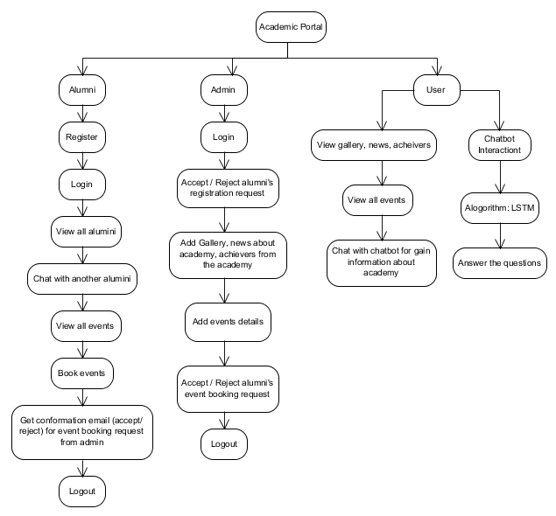

**MODULES**

1. **Admin Module:**
   * Manage alumni registrations: Approve or reject alumni registration requests.
   * Manage event bookings: Review and accept or reject alumni event booking requests.
   * Update academy content: Add and manage events, news, gallery images, and information about academy achievers.
   * Email notifications: Automatically send email notifications to alumni regarding the status of event booking requests.
   * View alumni and event data: Admin can view registered alumni details and event booking statuses.
2. **Alumni Module:**
   * Registration: Alumni can submit a registration request, which requires admin approval.
   * Login: After admin approval, alumni can log in to their personalized dashboard.
   * Explore other alumni: Alumni can view profiles of other alumni registered in the system.
   * Chatbox: Alumni can interact with other alumni using a one-on-one chatbox system.
   * Event booking: Alumni can view academy events and send booking requests to the admin.
   * Email notifications: Receive email notifications about the status of event bookings.
   * Logout: Alumni can securely log out of their session.
3. **User Module (Guest/Visitor):**
   * Explore academy content: Users can browse gallery images, academy news, and information about achievers.
   * View event details: Guests can view upcoming academy events without logging in.
   * Chat with the LSTM chatbot: Guests can use the chatbot to get general information about the academy, such as courses, fees, and more.
   * Register as an alumni: Guests who are interested in alumni-related activities can register to become alumni.
4. **LSTM-Based Chatbot Module:**
   * Automated user assistance: The chatbot answers user queries regarding academy details such as fee structure, courses, and more.
   * Accessible by all users: The chatbot is available on the homepage and can be accessed by both registered and non-registered users.
5. **Chatbox Module:**
   * Alumni communication: Allows alumni to chat and interact with each other one-on-one.
   * Secure interaction: Messages exchanged between alumni are stored securely in the database.