Project Proposal Form
Due 1/21/2020
Limit 1 page

Project title | MIMIC III ICU Passive Sensing for Outcome Prediction
Team members | 1. Ted Linghu  2. Meghan Hutch  3. Sam Hamilton

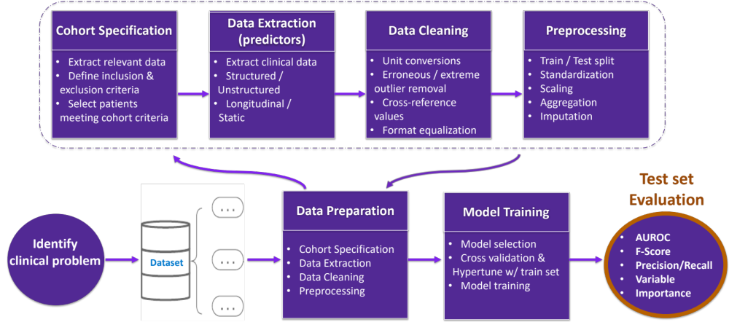
Example: Clinical Predictive Analytics Workflow (many other structures exist)
(note this for reference, you don’t need to make this)

Clinical Problem statement
- Describe the problem that your project will address.
  - Given the complexity of the pathology of ICU patients, building predictive models that might alert physicians to high-risk patients is of high interest. As a result, there is a large body of literature on building predictive models. These models are only as good as the features on which they are trained. As a result, there would be significant clinical value in identifying novel predictive features which might be used to train more powerful models. To address this, we propose to build a model that predicts patient outcomes based on a combination of latent variables created from Approximate Entropy(ApEn) and clinical variables reported from the MIMIC dataset. To be succinct, ApEn is a measure of the regularity of time-series data. ApEn has been demonstrated to be discriminant in distinguishing diseased from healthy individuals across a variety of health conditions. However, its predictive value in a large critical care dataset such as MIMIC has never been evaluated.

- Explain the significance of the problem, and who would benefit from a solution.
Developing predictive models that can quantify the risk of ICU patients is a major clinical goal that many researchers have investigated and that promises to improve care and save lives. Identifying a new feature for use in these models would be a modest but meaningful contribution in this collaborative effort and could provide new information from well-known variables that provide actionable insights.

Dataset
- Briefly Describe the dataset that you’ll be using.
  - How big is it?
    - MIMIC Waveform III database has 22,317 waveform and 22,247 numeric records which have been matched and time aligned to 10,282 MIMIC-III Clinical Database records.
  - Does it contain enough training examples for your clinical problem?
    - Yes, in particular because our goal is to explore the predictive value of ApEn.
  - Is the dataset representative of the problem?
    - Yes, as it represents an ICU population on which predictive models are highly desired.
  - What kind of bias in the dataset can you foresee?
    - Sicker patients might be more heavily monitored.
    - Alternatively, critical or routine events might disturb monitoring.

Proposed Technical Approach
- Briefly describe your proposed technical approach.
  - What are you trying to predict?
    - We are mainly trying to predict patient outcome. We envision either a binary classification using well established methods or survival analysis if we are able to acquire censor data. We will apply this to a specific disease, such as cardiac events. As time permits, we are interested in evaluating more specific problems such as cardiac events.
  - What kinds of methods do you anticipate using?
    - We plan to test an assortment of algorithms, including linear and logistic regression, support vector machines, and random forest models to predict outcomes. We will incorporate the ApEn features, demographic and other clinical events such as medication administration, lab values, and procedures. If clear documentation and code is available, we plan to test a Recurrent Attentive and Intensive Model (RAIM) which incorporates both waveform and discrete events.
  - What kinds of challenges do you anticipate?
    - Longitudinal data has unique challenges. Unbalanced and missing data are two of these. In addition, many algorithms for feature extraction may be affected by inconsistent measurement durations or missing data. Given the novelty of this approach, it may be difficult to find out of the box code that will allow us to test our hypotheses of interest. Coding novel functions will be a significant part of this problem. Additionally, though RAIM utilizes attention based mechanisms which help provide a level of interpretability in contrast to other “black-box” deep learning methods, full interpretation of ApEn features and their effects on outcomes may be hard to delineate.

- If you’re modifying example code, reference where you got the code from.

Backup plan
If things don’t turn out the way you expect due to inadequate data, unforeseen challenges, or if you just run out of time.
- What milestones can be achieved?
  - Isolation of features from ICU waveform data
  - Evaluation of ApEn
  - Generation of predictive model using ApEn and other demographic and clinical predictors
  - Benchmarking across other models
- What is the “minimum viable product” for your project?
  - Evaluation of ApEn
  - Isolation of features from ICU waveform data
  - Assessment of the utility of simple predictors (demographic and clinical data) and simpler models (linear or logistic regression) on predicting outcomes of interest

