**Configuration of Protractor in eclipse**

Below are the steps I performed to configure protractor tests in eclipse

1. Download Eclipse mars and open eclipse IDE.
2. Open Eclipse market place > Search for AngularJS Eclipse > Install AngularJS Eclipse 1.2.0
3. Create Java Script Project
4. Add conf.js and example-spec.js in the java script project (copy the files from example folder of protractor directory)
5. Now from command prompt navigate inside this java script directory and execute command npm install protractor (this command will load node_modules folder inside our project directory)

webdriver-manager update

1. Convert Java Script Project to Tern Project
2. Right click on project > Configure > Convert to Tern Project
3. Now select > Select Jasmine & Protractor check box > Apply
4. Run configuration of your project (Right click on your project > Run > Run configuration)
5. Under protractor(in left pane)> Add a new configuration of Protractor > Add path of conf.js (Main tab)> Add path of Working Directory (Main tab)
6. From the second tab >protractor > Add path of cli.js (this must be with in protractor folder > built > cli.js)

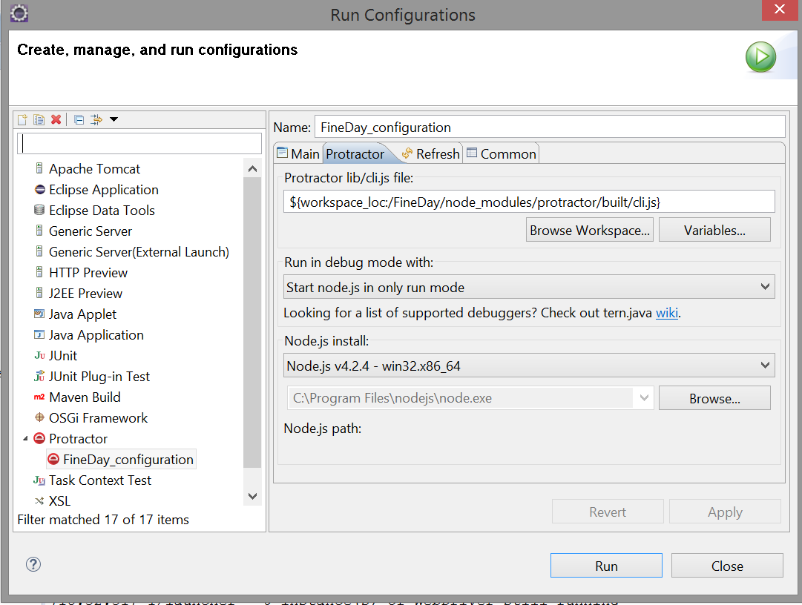

1. Select apply and run

**Framework used in my project**

POM : Page Object Model Framework

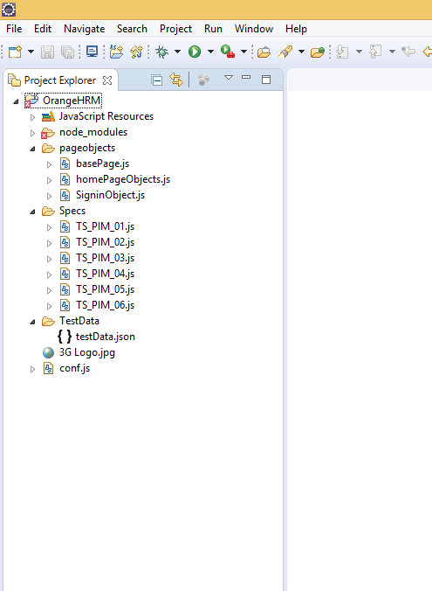

It's the basic structure of Page object model (POM) where all Web Elements/locators of the application are placed inside the **pageobjects** folder and the testscripts that operate on these Web Elements are maintained inside **Specs** folder.

The testdata used by the test scripts is in **TestData** folder i.e testData.json

The test script to be run is specified in **conf.js** and we can run through eclipse-run configurations to execute the test scripts.