VISVESVARAYA TECHNOLOGICAL UNIVERSITY
“JnanaSangama”, Belgaum -590014, Karnataka.


LAB REPORT

On

ANALYSIS AND DESIGN OF ALGORITHMS (23CS4PCADA)

Submitted by

HAMSA S (1BM25CS447)

in partial fulfillment for the award of the degree of
BACHELOR OF ENGINEERING
in
COMPUTER SCIENCE AND ENGINEERING



B.M.S. COLLEGE OF ENGINEERING
(Autonomous Institution under VTU)
BENGALURU-560019
February to June 2026
CERTIFICATE

B. M. S. College of Engineering,
Bull Temple Road, Bangalore 560019
(Affiliated To Visvesvaraya Technological University, Belgaum)
Department of Computer Science and Engineering



This is to certify that the Lab work entitled “ANALYSIS AND DESIGN OF ALGORITHMS” carried out by HAMSA S (1BM25CS447), who is bonafide student of B. M. S. College of Engineering. It is in partial fulfillment for the award of Bachelor of Engineering in Computer Science and Engineering of the Visvesvaraya Technological University, Belgaum during the year 2025-26. The Lab report has been approved as it satisfies the academic requirements in respect of Analysis and Design of Algorithms Lab - (23CS4PCADA) work prescribed for the said degree.

Dr. Kavitha Sooda
Assistant Professor Professor and Head
Department of CSE Department of CSE
BMSCE, Bengaluru BMSCE, Bengaluru

Index Sheet
Sl.  No. | Experiment Title | Page No.
1 | Write program to obtain the Topological ordering of vertices in a given digraph.
2 | Implement Johnson Trotter algorithm to generate permutations.
3 | Sort a given set of N integer elements using Merge Sort technique and compute its time taken. Run the program for different values of N and record the time taken to sort.
4 | Sort a given set of N integer elements using Quick Sort technique and compute its time taken.
5 | Sort a given set of N integer elements using Heap Sort technique and compute its time taken.
6 | Implement 0/1 Knapsack problem using dynamic programming. (5 Marks)
7 | Implement All Pair Shortest paths problem using Floyd’s algorithm.
8 | - Find Minimum Cost Spanning Tree of a given undirected graph using Prim’s algorithm.  - Find Minimum Cost Spanning Tree of a given undirected graph using Kruskal’s algorithm.
9 | Implement Fractional Knapsack using Greedy technique.
10 | From a given vertex in a weighted connected graph, find shortest paths to other vertices using Dijkstra’s algorithm.
11 | Implement “N-Queens Problem” using Backtracking.

Course outcomes:
CO1 | Analyze time complexity of algorithms using asymptotic notations.
CO2 | Apply various algorithm design techniques for the given problem.
CO3 | Evaluate the appropriate algorithm/design technique for solving a given problem.
CO4 | Conduct practical experiments by applying appropriate algorithm design technique to solve problems.

Lab program 1:
1 | Write program to obtain the Topological ordering of vertices in a given digraph.

#include <stdio.h>
int main()
{
int n, i, j;
printf("Enter number of vertices: ");
scanf("%d", &n);
int adj[n][n], indegree[n], queue[n], top[n];
printf("Enter adjacency matrix:\n");
for(i = 0; i < n; i++)
{ indegree[i] = 0;
for(j = 0; j < n; j++)
{
scanf("%d", &adj[i][j]);
if(adj[i][j] == 1)
{
indegree[j]++;
}
}
}
int front = 0, rear = -1;
for(i = 0; i < n; i++)
{
if(indegree[i] == 0)
{
queue[++rear] = i;
}
}
int k = 0;
while(front <= rear)
{
int u = queue[front++];
top[k++] = u;
for(i = 0; i < n; i++)
{
if(adj[u][i] == 1)
{
indegree[i]--
if(indegree[i] == 0)
{
queue[++rear] = i;
}
}
}
}
if(k != n)
{
printf("Topological ordering not possible\n");
}
else
{
printf("Topological Ordering:\n");

for(i = 0; i < n; i++)
{
printf("%d ", top[i]);
}
}
return 0;
}

Output:
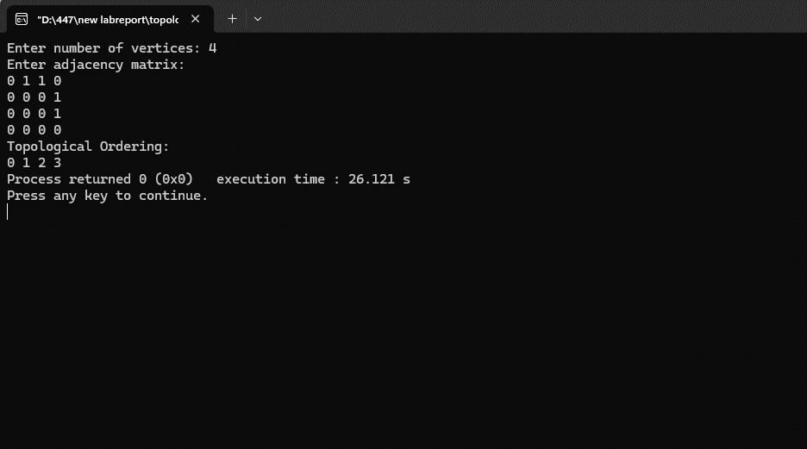

Leetcode :
Course Schedule :
bool canFinish(int numCourses, int** prerequisites, int prerequisitesSize, int* prerequisitesColSize) {
int indegree[2000] = {0};
int graph[2000][2000];
int graphSize[2000] = {0};
for(int i = 0; i < prerequisitesSize; i++) {
int course = prerequisites[i][0];
int prereq = prerequisites[i][1];
graph[prereq][graphSize[prereq]++] = course;
indegree[course]++;
}
int queue[2000];
int front = 0, rear = 0;
for(int i = 0; i < numCourses; i++) {
if(indegree[i] == 0) {
queue[rear++] = i;
}
}
int completed = 0;
while(front < rear) {
int current = queue[front++];
completed++;
for(int i = 0; i < graphSize[current]; i++) {
int neighbor = graph[current][i];
indegree[neighbor]--;
if(indegree[neighbor] == 0) {
queue[rear++] = neighbor;
}
}
}
return completed == numCourses;
}

Output:
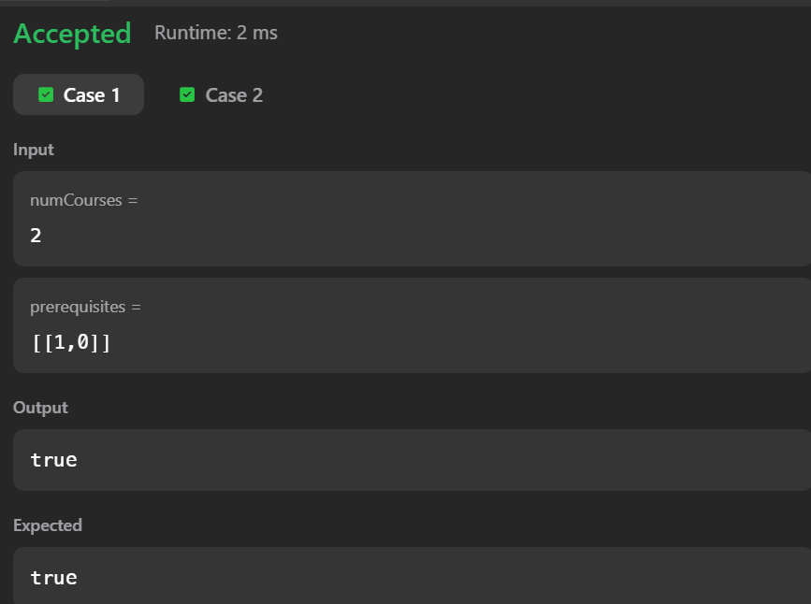

Graph:

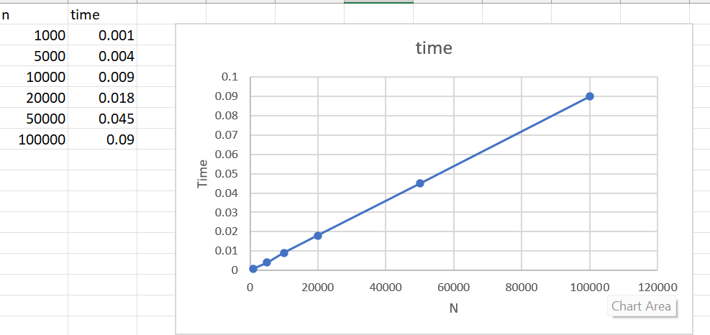

Topological Sort
Complexity:
$$O(V+E)$$

2 | Implement Johnson Trotter algorithm to generate permutations.

#include <stdio.h>
#define LEFT -1
#define RIGHT 1
int getMobile(int a[], int dir[], int n)
{
int mobile = 0, mobileIndex = -1;
for(int i = 0; i < n; i++)
{
if(dir[i] == LEFT && i != 0 && a[i] > a[i - 1])
{
if(a[i] > mobile)
{
mobile = a[i];
mobileIndex = i;
}
}
if(dir[i] == RIGHT && i != n - 1 && a[i] > a[i + 1])
{
if(a[i] > mobile)
{
mobile = a[i];
mobileIndex = i;
}
}
}
return mobileIndex;
}

void printPermutation(int a[], int n)
{
for(int i = 0; i < n; i++)
{
printf("%d ", a[i]);
}
printf("\n");
}
int main()
{
int n;
printf("Enter value of n: ");
scanf("%d", &n);
int a[n], dir[n];
for(int i = 0; i < n; i++)
{
a[i] = i + 1;
dir[i] = LEFT;
}
printPermutation(a, n);
while(1)
{
int mobileIndex = getMobile(a, dir, n);
if(mobileIndex == -1)
{
break;
}
int swapIndex;
if(dir[mobileIndex] == LEFT)
{
swapIndex = mobileIndex - 1;
}
else
{
swapIndex = mobileIndex + 1;
}
int temp = a[mobileIndex];
a[mobileIndex] = a[swapIndex];
a[swapIndex] = temp;
temp = dir[mobileIndex];
dir[mobileIndex] = dir[swapIndex];
dir[swapIndex] = temp;
mobileIndex = swapIndex;
for(int i = 0; i < n; i++)
{
if(a[i] > a[mobileIndex])
{
dir[i] = -dir[i];
}
}
printPermutation(a, n);
}
return 0;
}

Output:
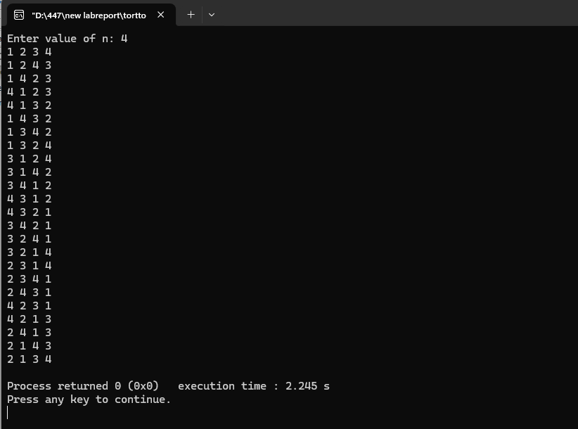

3 | Sort a given set of N integer elements using Merge Sort technique and compute its time taken. Run the program for different values of N and record the time taken to sort.

#include <stdio.h>
#include <stdlib.h>
#include <time.h>

void merge(int a[], int low, int mid, int high)
{
int i = low;
int j = mid + 1;
int k = low;
int temp[high + 1];
while(i <= mid && j <= high)
{
if(a[i] < a[j])
{
temp[k++] = a[i++];
}
else
{
temp[k++] = a[j++];
}
}
while(i <= mid)
{
temp[k++] = a[i++];
}
while(j <= high)
{
temp[k++] = a[j++];
}
for(i = low; i <= high; i++)
{
a[i] = temp[i];
}
}
void mergeSort(int a[], int low, int high)
{
if(low < high)
{
int mid = (low + high) / 2;
mergeSort(a, low, mid);
mergeSort(a, mid + 1, high);
merge(a, low, mid, high);
}
}
int main()
{
int n;
printf("Enter number of elements: ");
scanf("%d", &n);
int a[n];
printf("Enter elements:\n");
for(int i = 0; i < n; i++)
{
scanf("%d", &a[i]);
}
clock_t start, end
start = clock();
mergeSort(a, 0, n - 1);
end = clock();
printf("Sorted elements:\n");
for(int i = 0; i < n; i++)
{
printf("%d ", a[i]);
}
double time_taken = ((double)(end - start)) / CLOCKS_PER_SEC;
printf("\nTime taken = %f seconds\n", time_taken);
return 0;
}

Output:
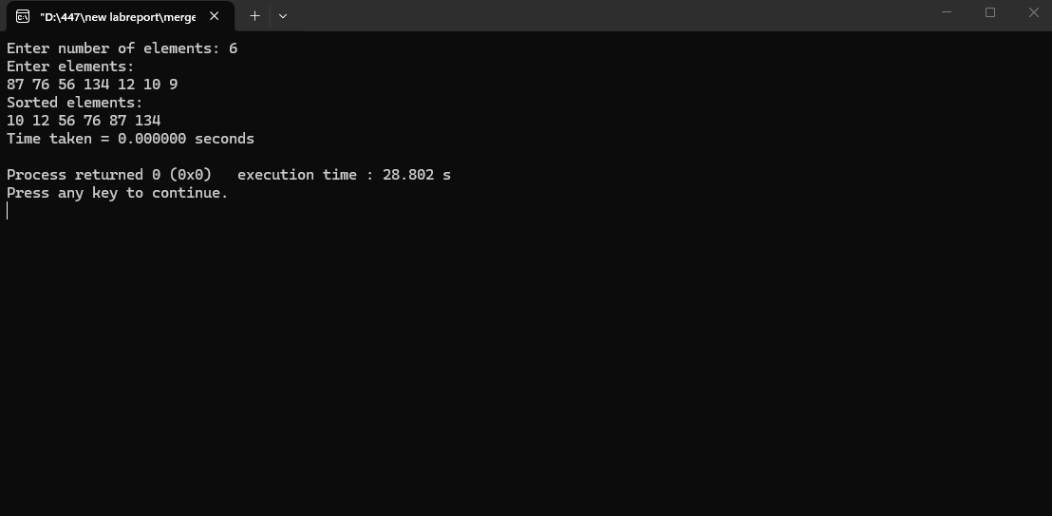

Graph :

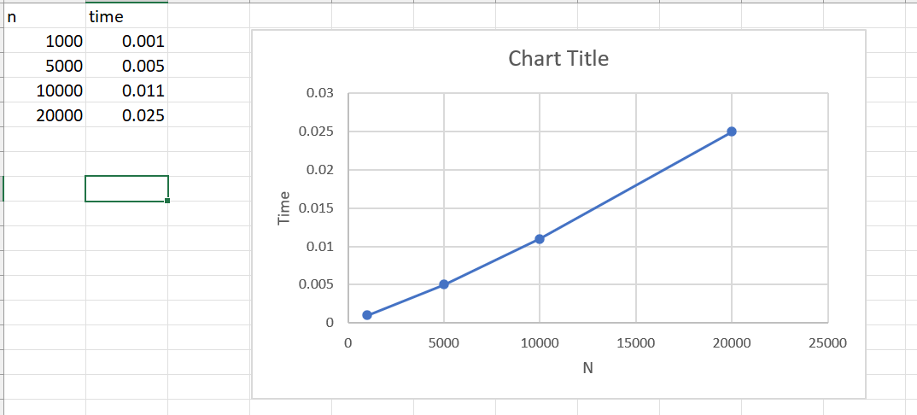

Merge Sort
Complexity:
$$O(nlog⁡n)$$

4 | Sort a given set of N integer elements using Quick Sort technique and compute its time taken.

#include <stdio.h>
#include <time.h>
void swap(int *a, int *b) {
int temp = *a;
*b = *a;
*a = temp;
}
int partition(int arr[], int low, int high) {
int pivot = arr[low];
int i = low + 1;
int j = high;
while (i <= j) {
while (i <= high && arr[i] <= pivot)
i++;
while (arr[j] > pivot)
j--;
if (i < j) {
int temp = arr[i];
arr[i] = arr[j];
arr[j] = temp;
}
}
arr[low] = arr[j];
arr[j] = pivot;
return j;
}
void quickSort(int arr[], int low, int high) {
if (low < high) {
int pos = partition(arr, low, high);
quickSort(arr, low, pos - 1);
quickSort(arr, pos + 1, high);
}
}
int main() {
int n, i;
printf("Enter number of elements: ");
scanf("%d", &n);
int arr[n];
printf("Enter elements:\n");
for (i = 0; i < n; i++)
scanf("%d", &arr[i]);
clock_t start, end;
start = clock();
quickSort(arr, 0, n - 1);
end = clock();
printf("\nSorted array:\n");
for (i = 0; i < n; i++)
printf("%d ", arr[i]);
double time_taken = (double)(end - start) / CLOCKS_PER_SEC;
printf("\nTime taken: %f seconds\n", time_taken);
return 0;
}

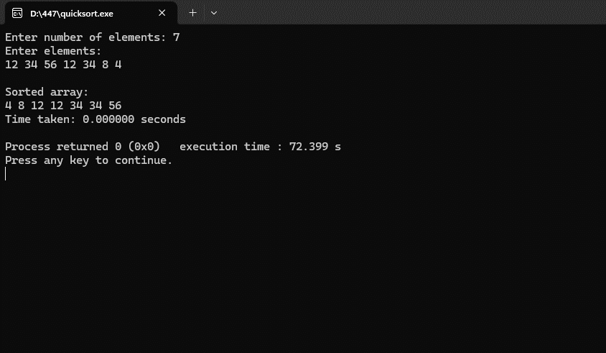

Graph :

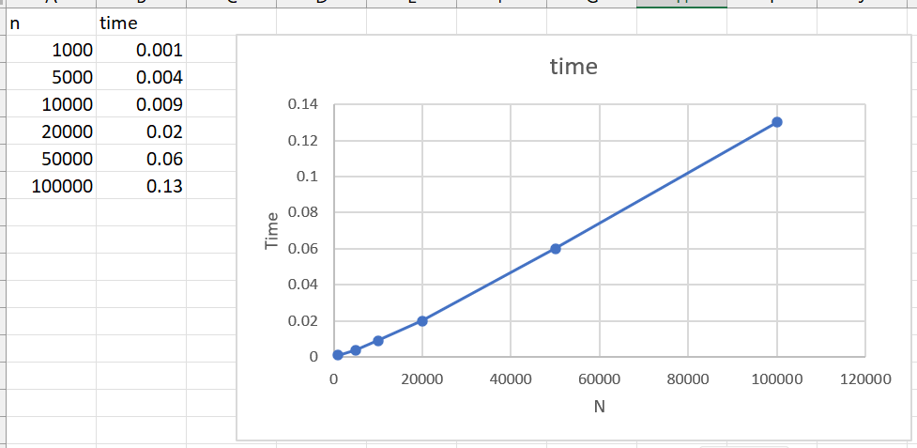
Quick Sort
Average case:
$$O(nlog⁡n)$$
Worst case:
$$O(n^{2})$$

5 | Sort a given set of N integer elements using Heap Sort technique and compute its time taken.

#include <stdio.h>
#include <time.h>
void heapify(int a[], int n, int i)
{
int largest = i;
int left = 2 * i + 1;
int right = 2 * i + 2;
if(left < n && a[left] > a[largest])
{
largest = left;
}
if(right < n && a[right] > a[largest])
{
largest = right;
}
if(largest != i)
{
int temp = a[i];
a[i] = a[largest];
a[largest] = temp;
heapify(a, n, largest);
}
}

void heapSort(int a[], int n)
{
for(int i = n / 2 - 1; i >= 0; i--)
{
heapify(a, n, i);
}
for(int i = n - 1; i > 0; i--)
{
int temp = a[0];
a[0] = a[i];
a[i] = temp;

heapify(a, i, 0);
}
}
int main()
{
int n;
printf("Enter number of elements: ");
scanf("%d", &n);
int a[n];
printf("Enter elements:\n");
for(int i = 0; i < n; i++)
{
scanf("%d", &a[i]);
}
clock_t start, end;

start = clock();
heapSort(a, n);
end = clock();
printf("Sorted elements:\n");
for(int i = 0; i < n; i++)
{
printf("%d ", a[i]);
}
double time_taken = ((double)(end - start)) / CLOCKS_PER_SEC;
printf("\nTime taken = %f seconds\n", time_taken);
return 0;
}
Output:
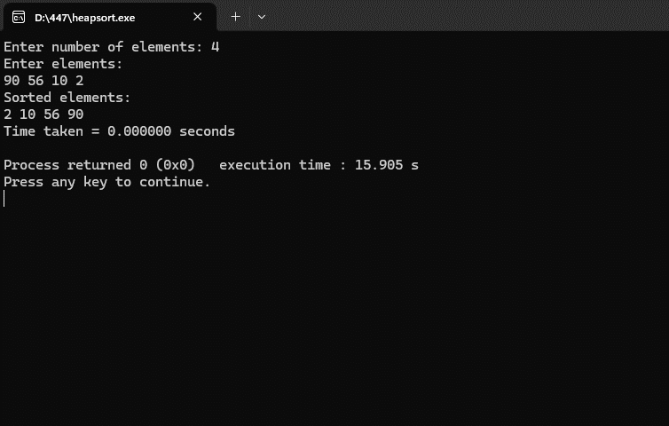

Graph :
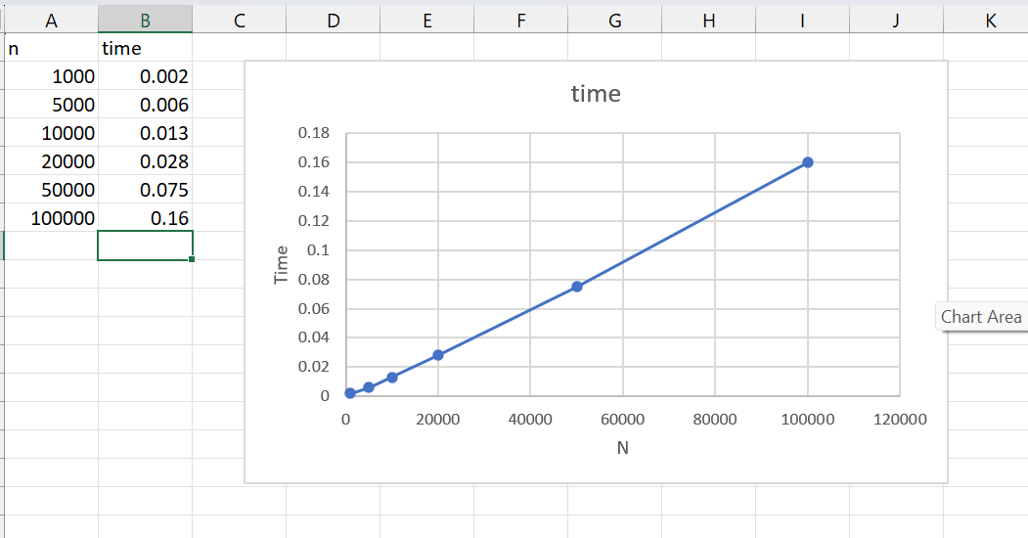

Heap Sort
Complexity:
$$O(nlog⁡n)$$

6 | Implement 0/1 Knapsack problem using dynamic programming.

#include <stdio.h>
int max(int a, int b) {
return (a > b) ? a : b;
}
int main() {
int n, M;
printf("Enter number of items: ");
scanf("%d", &n);
int W[n+1], P[n+1];
printf("Enter weights:\n");
for(int i = 1; i <= n; i++) {
scanf("%d", &W[i]);
}
printf("Enter profits:\n");
for(int i = 1; i <= n; i++) {
scanf("%d", &P[i]);
}
printf("Enter capacity of knapsack: ");
scanf("%d", &M);
int Table[n+1][M+1];
for(int i = 0; i <= n; i++) {
Table[i][0] = 0;
}
for(int j = 0; j <= M; j++) {
Table[0][j] = 0;
}
for(int i = 1; i <= n; i++) {
for(int j = 1; j <= M; j++) {
if(j < W[i]) {
Table[i][j] = Table[i-1][j];
}
else {
Table[i][j] = max(
Table[i-1][j],
P[i] + Table[i-1][j - W[i]]
);
}
}
}
printf("Maximum Profit = %d\n", Table[n][M]);
return 0;
}
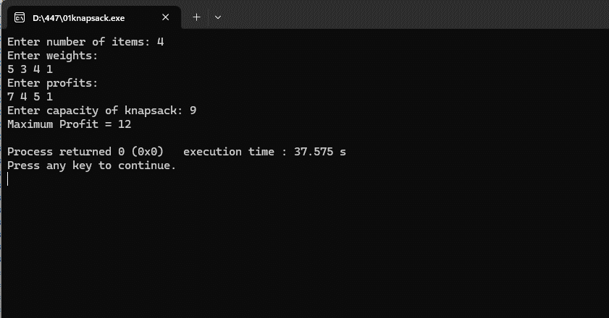

Leetcode: Minimum Swaps To Make Sequences Increasing
int min(int a, int b) {
return a < b ? a : b;
}
int minSwap(int* nums1, int nums1Size, int* nums2, int nums2Size) {
int keep = 0;
int swap = 1;
for(int i = 1; i < nums1Size; i++) {
int newKeep = 1000000;
int newSwap = 1000000;
if(nums1[i] > nums1[i - 1] && nums2[i] > nums2[i - 1]) {
newKeep = min(newKeep, keep);
newSwap = min(newSwap, swap + 1);
}
if(nums1[i] > nums2[i - 1] && nums2[i] > nums1[i - 1]) {
newKeep = min(newKeep, swap);
newSwap = min(newSwap, keep + 1);
}
keep = newKeep;
swap = newSwap;
}
return min(keep, swap);
}

Output:
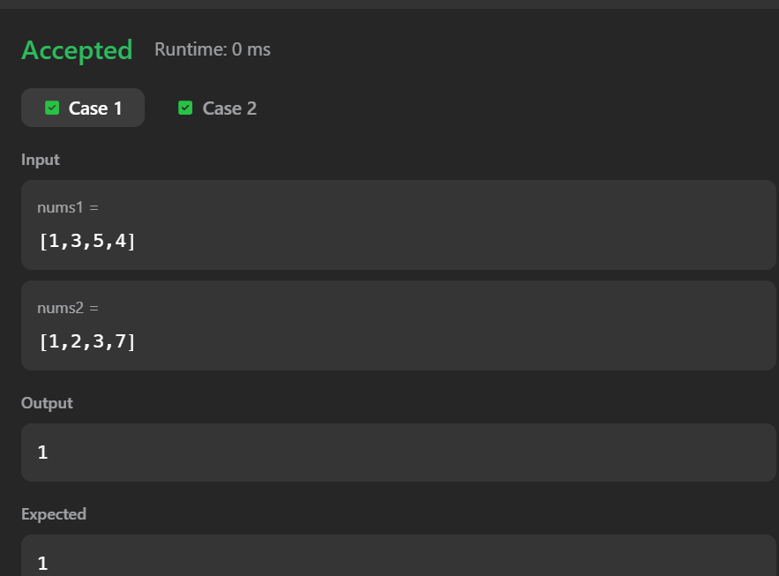

7 | Implement All Pair Shortest paths problem using Floyd’s algorithm.

#include <stdio.h>
#define INF 9999
int main()
{
int n;
printf("Enter number of vertices: ");
scanf("%d", &n);
int a[n][n];
printf("Enter adjacency matrix:\n");
for(int i = 0; i < n; i++)
{
for(int j = 0; j < n; j++)
{
scanf("%d", &a[i][j]);
if(i != j && a[i][j] == 0)
{
a[i][j] = INF;
}
}
}
for(int k = 0; k < n; k++)
{
for(int i = 0; i < n; i++)
{
for(int j = 0; j < n; j++)
{
if(a[i][k] + a[k][j] < a[i][j])
{
a[i][j] = a[i][k] + a[k][j];
}
}
}
}
printf("Shortest Path Matrix:\n");
for(int i = 0; i < n; i++)
{
for(int j = 0; j < n; j++)
{
if(a[i][j] == INF)
{
printf("INF ");
}
else
{
printf("%d ", a[i][j]);
}
}
printf("\n");
}
return 0;
}

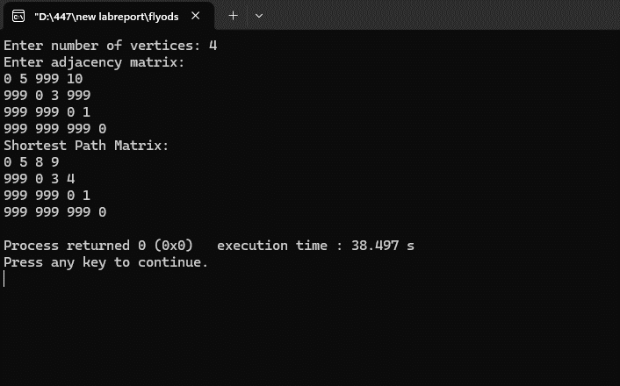

Leetcode : Find the duplicate number

int findDuplicate(int* nums, int numsSize) {
int slow = nums[0];
int fast = nums[0];
do {
slow = nums[slow];
fast = nums[nums[fast]];
} while(slow != fast);
slow = nums[0];
while(slow != fast) {
slow = nums[slow];
fast = nums[fast];
}

return slow;
}

Output :
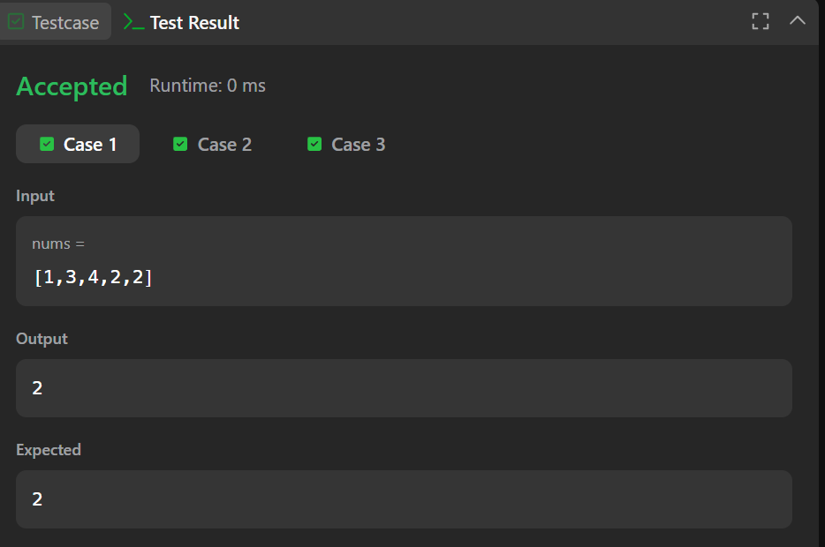

8 | - Find Minimum Cost Spanning Tree of a given undirected graph using Prim’s algorithm.  - Find Minimum Cost Spanning Tree of a given undirected graph using Kruskal’s algorithm.

a)
#include <stdio.h>
#include <limits.h>
#define MAX 100
int minKey(int key[], int mstSet[], int V) {
int min = INT_MAX, min_index;
for (int v = 0; v < V; v++)
if (mstSet[v] == 0 && key[v] < min)
min = key[v], min_index = v;
return min_index;
}
void primMST(int graph[MAX][MAX], int V) {
int parent[V];
int key[V];
int mstSet[V];
for (int i = 0; i < V; i++) {
key[i] = INT_MAX;
mstSet[i] = 0;
}
key[0] = 0;
parent[0] = -1;

for (int count = 0; count < V - 1; count++) {
int u = minKey(key, mstSet, V);
mstSet[u] = 1;
for (int v = 0; v < V; v++) {
if (graph[u][v] && mstSet[v] == 0 && graph[u][v] < key[v]) {
parent[v] = u;
key[v] = graph[u][v];
}
}
}
printf("Edge \tWeight\n");
int total = 0;
for (int i = 1; i < V; i++) {
printf("%d - %d \t%d\n", parent[i], i, graph[i][parent[i]]);
total += graph[i][parent[i]];
}
printf("Total Cost = %d\n", total);
}
int main() {
int V;
int graph[MAX][MAX];
printf("Enter number of vertices: ");
scanf("%d", &V);
printf("Enter adjacency matrix:\n");
for (int i = 0; i < V; i++)
for (int j = 0; j < V; j++)
scanf("%d", &graph[i][j]);
primMST(graph, V);
return 0;
}

Output:
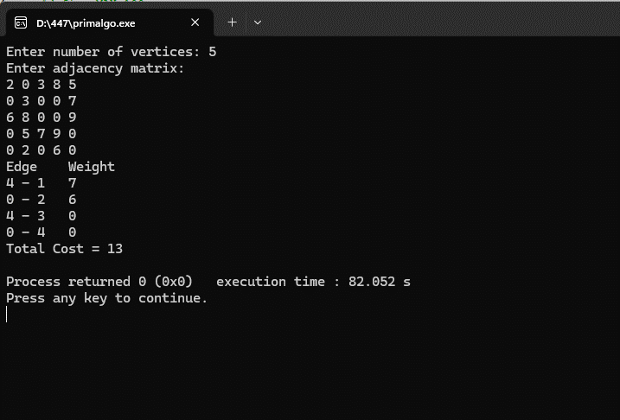

b) Find Minimum Cost Spanning Tree of a given undirected graph using Kruskal’s algorithm.
#include <stdio.h>
int parent[20];
int find(int i)
{
while(parent[i])
i = parent[i];
return i;
}
int uni(int i, int j)
{
if(i != j)
{
parent[j] = i;
return 1;
}
return 0;
}
int main()
{
int n, i, j, a, b, u, v, ne = 1;
int min, mincost = 0;
int cost[20][20];
printf("Enter number of vertices: ");
scanf("%d", &n);

printf("Enter cost adjacency matrix:\n");
for(i = 1; i <= n; i++)
{
for(j = 1; j <= n; j++)
{
scanf("%d", &cost[i][j]);

if(cost[i][j] == 0)
cost[i][j] = 999; // no edge
}
}
printf("\nEdges of Minimum Spanning Tree:\n");
while(ne < n)
{
min = 999;
for(i = 1; i <= n; i++)
{
for(j = 1; j <= n; j++)
{
if(cost[i][j] < min)
{
min = cost[i][j];
a = u = i;
b = v = j;
}
}
}

u = find(u);
v = find(v);
if(uni(u, v))
{
printf("%d edge (%d,%d) = %d\n", ne++, a, b, min);
mincost += min;
}
cost[a][b] = cost[b][a] = 999;
}
printf("\nMinimum cost = %d\n", mincost);
return 0;
}

Output :
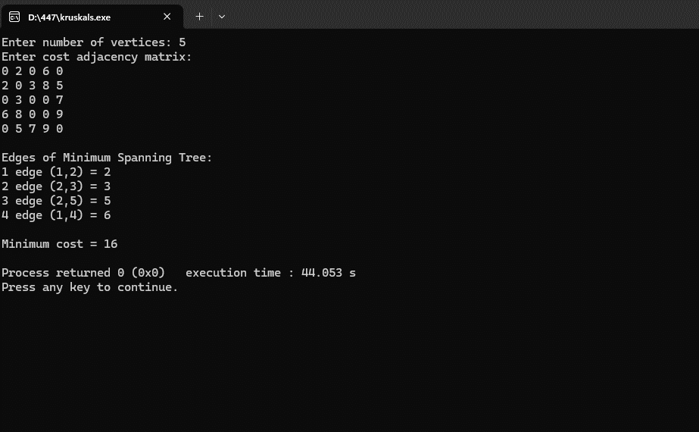

9 | Implement Fractional Knapsack using Greedy technique.

#include <stdio.h>
struct Item
{
int weight;
int profit;
float ratio;
};
void sort(struct Item item[], int n)
{
for(int i = 0; i < n - 1; i++)
{
for(int j = 0; j < n - i - 1; j++)
{
if(item[j].ratio < item[j + 1].ratio)
{
struct Item temp = item[j];
item[j] = item[j + 1];
item[j + 1] = temp;
}
}
}
}
int main()
{
int n;
float capacity, totalProfit = 0;
printf("Enter number of items: ");
scanf("%d", &n);
struct Item item[n];
printf("Enter profit and weight:\n");
for(int i = 0; i < n; i++)
{
scanf("%d %d", &item[i].profit, &item[i].weight);
item[i].ratio = (float)item[i].profit / item[i].weight;
}
printf("Enter knapsack capacity: ");
scanf("%f", &capacity);
sort(item, n);
for(int i = 0; i < n; i++)
{
if(item[i].weight <= capacity)
{
totalProfit += item[i].profit;
capacity -= item[i].weight;
}
else
{
totalProfit += item[i].ratio * capacity;
break;
}
}
printf("Maximum Profit = %.2f\n", totalProfit);
return 0;
}

Output :
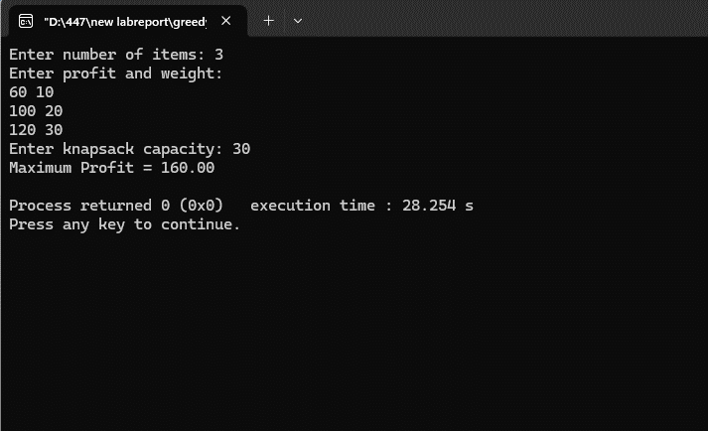

10 | From a given vertex in a weighted connected graph, find shortest paths to other vertices using Dijkstra’s algorithm.

#include <stdio.h>
#define INF 9999
int main()
{
int n;
printf("Enter number of vertices: ");
scanf("%d", &n);
int cost[n][n];
printf("Enter adjacency matrix:\n");
for(int i = 0; i < n; i++)
{
for(int j = 0; j < n; j++)
{
scanf("%d", &cost[i][j]);

if(i != j && cost[i][j] == 0)
{
cost[i][j] = INF;
}
}
}
int source;
printf("Enter source vertex: ");
scanf("%d", &source);
int dist[n], visited[n];
for(int i = 0; i < n; i++)
{
dist[i] = cost[source][i];
visited[i] = 0;
}
dist[source] = 0;
visited[source] = 1;
for(int count = 1; count < n - 1; count++)
{
int min = INF;
int next = -1;
for(int i = 0; i < n; i++)
{
if(!visited[i] && dist[i] < min)
{
min = dist[i];
next = i;
}
}
visited[next] = 1;
for(int i = 0; i < n; i++)
{
if(!visited[i] && min + cost[next][i] < dist[i])
{
dist[i] = min + cost[next][i];
}
}
}
printf("Shortest distances from vertex %d:\n", source);
for(int i = 0; i < n; i++)
{
printf("%d -> %d = %d\n", source, i, dist[i]);
}
return 0;
}

Output:
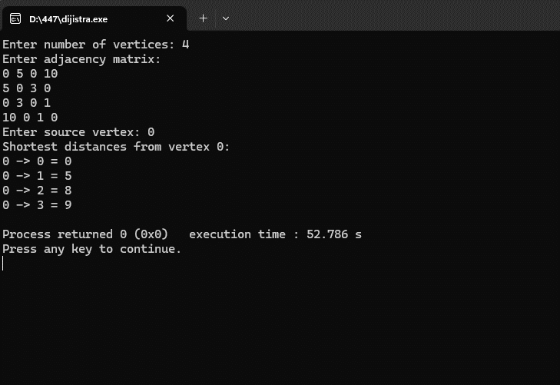

11 | Implement “N-Queens Problem” using Backtracking.

#include <stdio.h>
#define MAX 20
int board[MAX][MAX];
int N;
int isSafe(int row, int col)
{
int i, j;
for(i = 0; i < col; i++)
{
if(board[row][i] == 1)
return 0;
}
for(i = row, j = col; i >= 0 && j >= 0; i--, j--)
{
if(board[i][j] == 1)
return 0;
}
for(i = row, j = col; i < N && j >= 0; i++, j--)
{
if(board[i][j] == 1)
return 0;
}
return 1;
}

int solveNQueens(int col)
{
int i;
if(col >= N)
return 1;
for(i = 0; i < N; i++)
{
if(isSafe(i, col))
{
board[i][col] = 1;
if(solveNQueens(col + 1))
return 1;
board[i][col] = 0;
}
}
return 0;
}
void printBoard()
{
int i, j;
printf("\nSolution Exists:\n\n");
for(i = 0; i < N; i++)
{
for(j = 0; j < N; j++)
{
if(board[i][j] == 1)
printf("Q ");
else
printf(". ");
}
printf("\n");
}
}
int main()
{
int i, j;
printf("Enter value of N: ");
scanf("%d", &N);
for(i = 0; i < N; i++)
{
for(j = 0; j < N; j++)
{
board[i][j] = 0;
}
}
if(solveNQueens(0))
{
printBoard();
}
else
{
printf("No Solution Exists\n");
}

return 0;
}

Output :
