WEEK 9
Hamsika Peddina – 2520030586

Step 1:
Extract the zip
Step 2:
Open the folder in vs code
Step 3:
Open spring boot and create a project week9
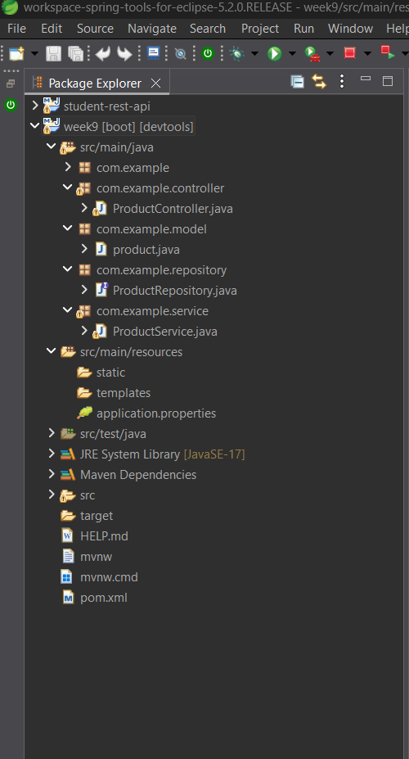 Create packages and classes

Step 4:
Com.example.controller -> ProductController.java
package com.example.controller;
import java.util.List;
import org.springframework.beans.factory.annotation.Autowired;
import org.springframework.web.bind.annotation.*;
import com.example.model.product;
import com.example.service.ProductService;
@RestController
@RequestMapping("/api/products")
@CrossOrigin(origins = "http://localhost:5173")
public class ProductController {
@Autowired
private ProductService service;
// Get all products
@GetMapping
public List<product> getAllProducts() {
return service.getAllProducts();
}
// Get product by ID
@GetMapping("/{id}")
public product getProductById(@PathVariable Long id) {
return service.getProductById(id);
}
// Add product
@PostMapping
public product addProduct(@RequestBody product p) {
return service.addProduct(p);
}
// Update product
@PutMapping("/{id}")
public product updateProduct(@PathVariable Long id,
@RequestBody product p) {
return service.updateProduct(id, p);
}
// Delete product
@DeleteMapping("/{id}")
public void deleteProduct(@PathVariable Long id) {
service.deleteProduct(id);
}
}

Com.example.model->product.java
package com.example.model;
import jakarta.persistence.Entity;
import jakarta.persistence.GeneratedValue;
import jakarta.persistence.GenerationType;
import jakarta.persistence.Id;
@Entity
public class product {
@Id
@GeneratedValue(strategy = GenerationType.IDENTITY)
private Long id;
private String name;
private String description;
private double price;
private int quantity;
public product() {
}
public Long getId() {
return id;
}
public void setId(Long id) {
this.id = id;
}
public String getName() {
return name;
}
public void setName(String name) {
this.name = name;
}
public String getDescription() {
return description;
}
public void setDescription(String description) {
this.description = description;
}
public double getPrice() {
return price;
}
public void setPrice(double price) {
this.price = price;
}
public int getQuantity() {
return quantity;
}
public void setQuantity(int quantity) {
this.quantity = quantity;
}
}

Com.example.repository ->ProductRepository.java
package com.example.repository;
import org.springframework.data.jpa.repository.JpaRepository;
import com.example.model.product;
public interface ProductRepository extends JpaRepository<product, Long> {
}

Com.example.services -> ProductService.java
package com.example.service;
import java.util.List;
import org.springframework.beans.factory.annotation.Autowired;
import org.springframework.stereotype.Service;
import com.example.model.product;
import com.example.repository.ProductRepository;
@Service
public class ProductService {
@Autowired
private ProductRepository repository;
public List<product> getAllProducts() {
return repository.findAll();
}
public product getProductById(Long id) {
return repository.findById(id).orElse(null);
}
public product addProduct(product p) {
return repository.save(p);
}
public product updateProduct(Long id, product p) {
product existing = repository.findById(id).orElse(null);
if (existing != null) {
existing.setName(p.getName());
existing.setDescription(p.getDescription());
existing.setPrice(p.getPrice());
existing.setQuantity(p.getQuantity());
return repository.save(existing);
}
return null;
}
public void deleteProduct(Long id) {
repository.deleteById(id);
}
}

application.properties:
spring.application.name=week9
server.port=8085
spring.datasource.url=jdbc:mysql://localhost:3306/productdb
spring.datasource.username=root
spring.datasource.password=root
spring.jpa.hibernate.ddl-auto=update
spring.jpa.show-sql=true
spring.jpa.properties.hibernate.format_sql=true

Step 5:
Run as springboot app
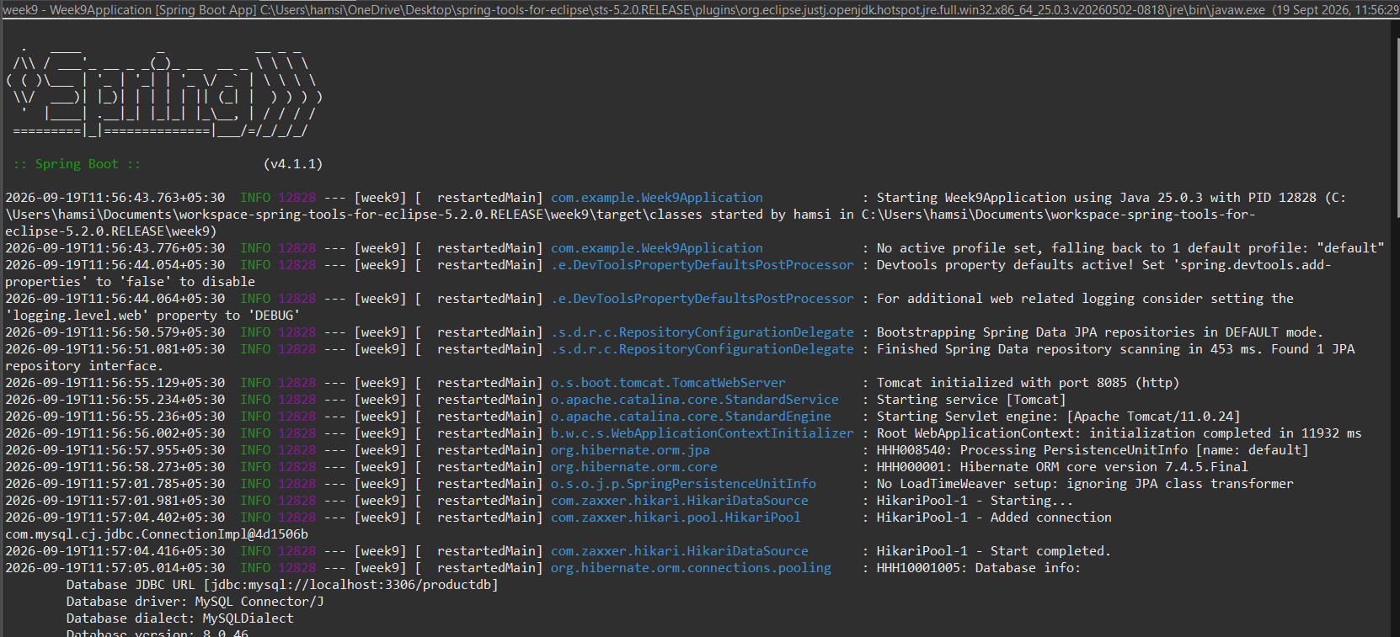
Step 6:
Open SQL Workbench
Create database “productdb”
Step 7:
Open postman
Use http://localhost:8085/api/products
Post the data and get the data
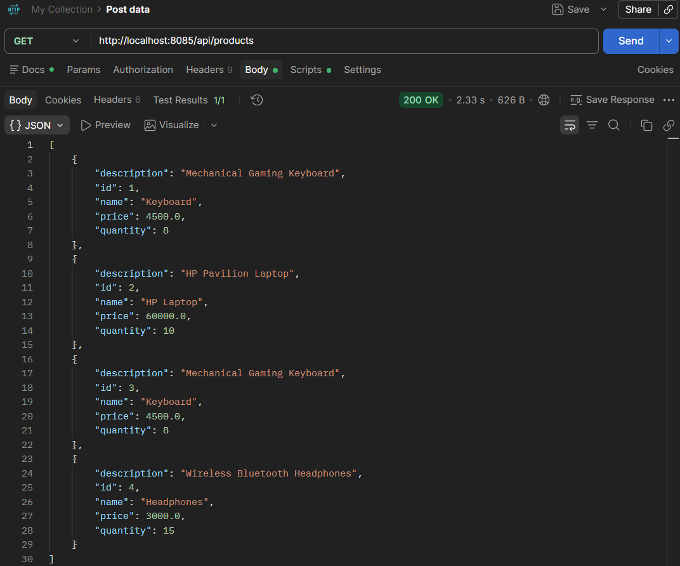
Step 8:
Check the entered data in mySQL
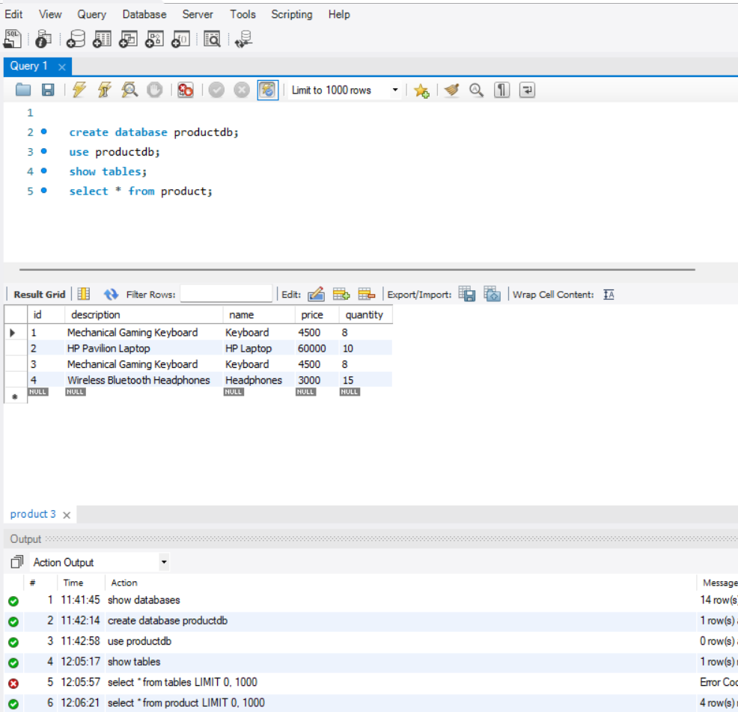

Step 9:
Now open the Vs code
and run the week 9
npm install (to install packages)
npm run dev (to run the program)

Open local host
