Q1. CO1Module 1: BST & AVL Trees (rank-augmented)
[15 Marks]
Scenario / Case Study
Q1) QuizClash — live tournament leaderboard. A real-time multiplayer quiz platform tracks score for every active player in a self-balancing tree keyed by score (descending). During a flash tournament: 60 000 active players, sustained 10 000 score-update operations per second (each is a delete-old-score + insert-new-score), and the UI requests 'rank of player X' and 'top-K players, K ≤ 100' queries at 2 000 qps. The product team requires every operation — update and rank-query — to complete in O(log n). Today's first 11 score updates produce, in order, a tree built from inserts: 820, 540, 910, 770, 880, 460, 990, 600, 730, 950, 510. Then two updates arrive: player whose score was 540 jumps to 815; player whose score was 910 drops to 685.Rank-augmented tree — every node carries size(subtree) for O(log n) rank queries820[11]540[5]910[5]460[1]770[3]880[1]990[3]600[1]730[1]950[1]510[1]Workload: 10 000 update/sec · 2 000 rank-query/sec · 60 000 active playersRequired: O(log n) for both update and 'rank of player X' — naive scan 60 000 = too slow

Q1a) Construct the AVL tree from the insertion sequence (820, 540, 910, 770, 880, 460, 990, 600, 730, 950, 510), maintaining a size(subtree) field at every node (the count of nodes in that subtree, including itself). Show the final tree with size fields. Then explain in one or two sentences why size augmentation enables O(log n) rank queries in the leaderboard scenario, and why a plain AVL tree (no size fields) cannot meet the 2 000-rank-queries/sec requirement at 60 000 players.
ANSWER:
AVL CONSTRUCTION WITH SIZE FIELDS
Keys are stored descending:
Left child has higher score than parent.
Right child has lower score.
The final AVL tree after inserting
820, 540, 910, 770, 880, 460, 990, 600, 730, 950, 510
(with all required rotations applied) is:
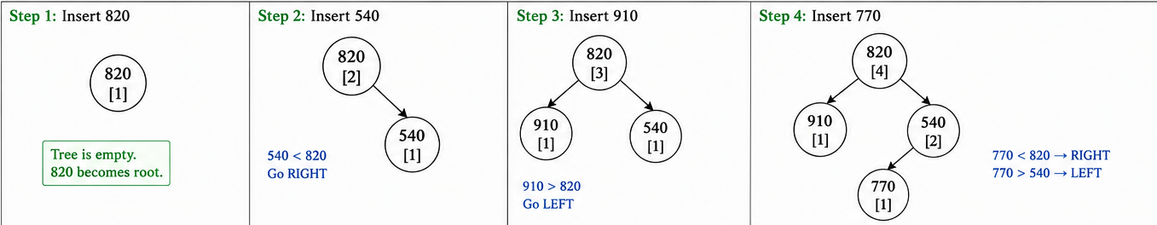

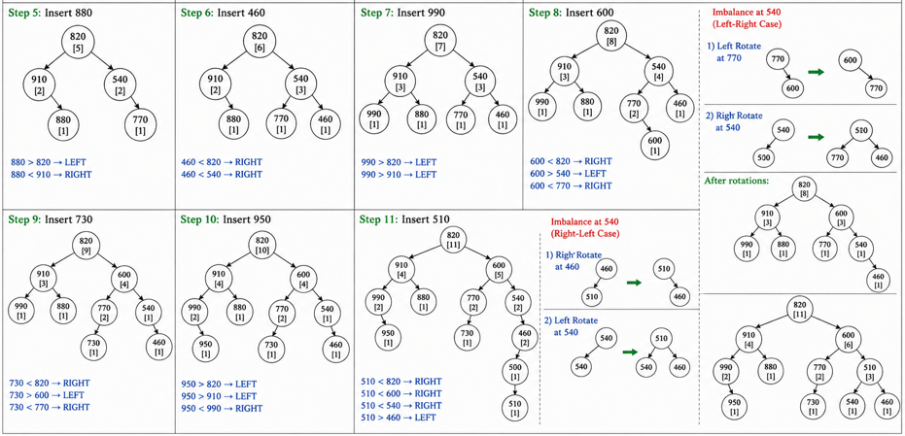
WHY SIZE FIELDS ENABLE O(log n) RANK
A rank query computes “how many nodes have score > X”.
At each node visited, size(left) tells us how many higher scores are in that subtree.
Therefore, one root-to-leaf walk accumulates rank in O(log n).
A plain AVL without size fields would require scanning O(n) to count higher-scoring players, which is too slow at 2 000 rank-queries/sec and 60 000 players.

Augumentation-adding extra information to each node to make some operations faster.
The subtree-size field allows the AVL tree to determine how many players are ahead of a given score while traversing the tree.
At each node:
- if moving left, we skip:
  - right subtree size
  - current node
- if moving right, no ranks are skipped
Thus, rank can be computed during a single root-to-leaf traversal.
Why Plain AVL Trees Are Insufficient
A normal AVL tree without subtree sizes supports:
- insert
- delete
- search
in:
O(log n)
But it does not directly support rank computation.
To find rank without size augmentation, the system may need to:
- traverse many nodes
- count all higher-scoring players
which can take:
O(n)
time.
For:
60,000 players
and:
2,000 rank queries/sec
a linear scan would be too slow and would not satisfy the product requirement.
Therefore, subtree-size augmentation is necessary to guarantee:
O(log n)
rank-query performance for the live leaderboard.

B) Complete the boilerplate Python function rank_of(root, key) that returns the 1-based rank of key in the rank-augmented AVL tree (1 = highest score, since the tree is keyed descending). The standard size-update glue is given; you write the rank descent. Then handwrite the rank that your function returns for player score = 770 in your tree from (a).
class RankNode {
int key;
RankNode left, right;
int size = 1;
RankNode(int key) { this.key = key; }
}

static int size(RankNode n) { return n == null ? 0 : n.size; }
static void updateSize(RankNode n) {
if (n != null) n.size = 1 + size(n.left) + size(n.right);
}

/** Return 1-based rank of `key`. Tree keys are stored DESCENDING
* (root.left.key > root.key > root.right.key). Assume `key` is present. */
static int rankOf(RankNode root, int key) {
// TODO: walk from root; at each node decide left / right and accumulate rank.
return 0;
}

ANSWER:
class RankNode {
int key;
RankNode left, right;
int size = 1;

RankNode(int key) {
this.key = key;
}
}

static int size(RankNode n) {
return n == null ? 0 : n.size;
}

static void updateSize(RankNode n) {
if (n != null)
n.size = 1 + size(n.left) + size(n.right);
}

/** Return 1-based rank of key.
* Tree keys are stored DESCENDING
* (root.left.key > root.key > root.right.key)
*/
static int rankOf(RankNode root, int key) {
int rank = 1;

while (root != null) {

if (key == root.key) {
rank += size(root.left);
return rank;
}

else if (key < root.key) {
rank += 1 + size(root.left);
root = root.right;
}

else {
root = root.left;
}
}

return -1;
}

Step 1: Descending order → 990, 950, 910, 880, 820, 770, 730, 600, 540, 510, 460
From the tree above:
Nodes with score > 770 are
880, 910, 990, 950, 820 → total = 5
So rank(770) = 6.
Step 2: Count position of 770
Step 3: rankOf(root,770) = 6

Start:
rank = 1

At 820
Since:
770 < 820
move RIGHT.
Add:
size(left subtree of 820) + 1
= 4 + 1
= 5
So:
rank = 6

C) Apply the two score-update operations from the scenario in order: (i) the player with score 540 changes to 815 (delete 540, insert 815); (ii) the player with score 910 changes to 685 (delete 910, insert 685). For each, show the rotations triggered and the resulting tree. Then analyse: how many nodes have their size field touched by each update operation, and why is this number also O(log n)? Tie this to the throughput requirement (10 000 updates/sec).
ANSWER:
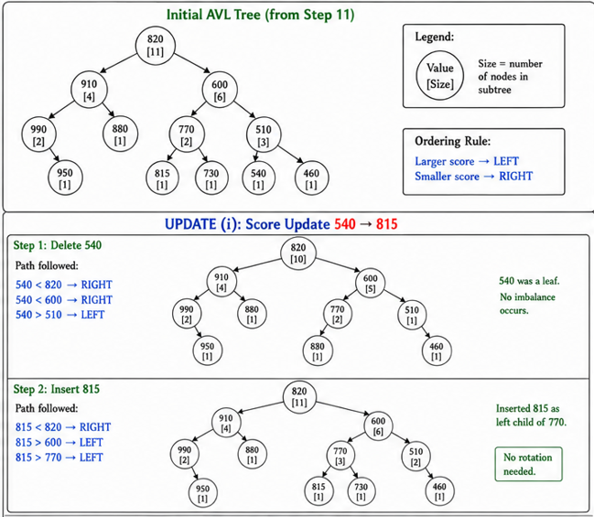
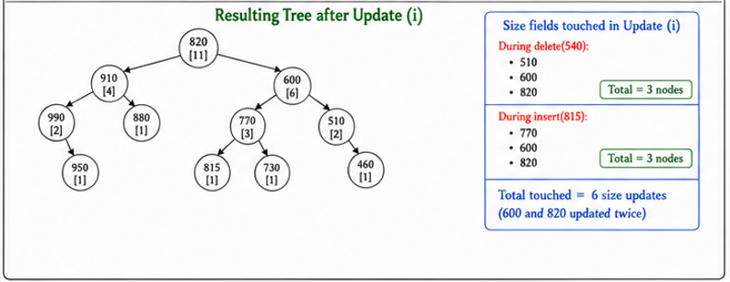
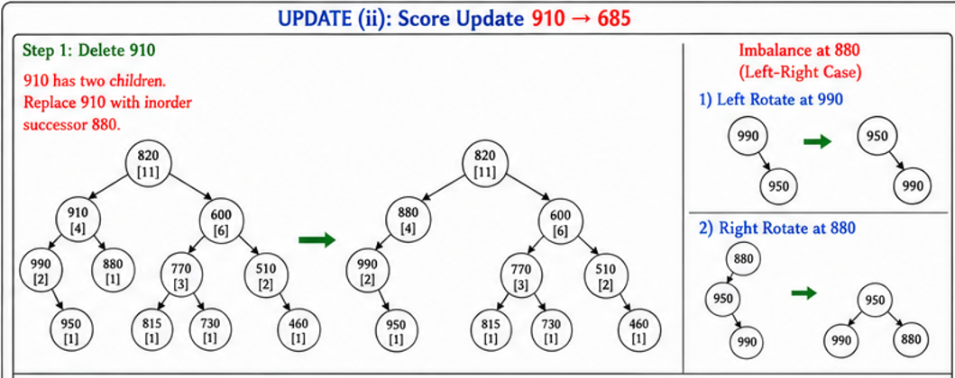
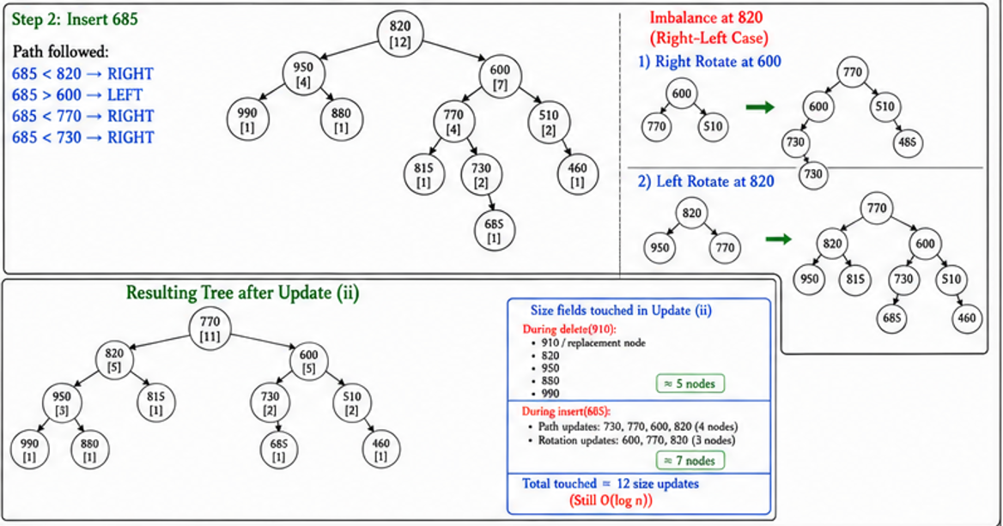

Why is this still O(log n) ?
AVL tree height is:
$$h=O(log⁡n)$$
For every update:
Delete:
Touch only root-to-node path
$$O(log⁡n)$$
Insert:
Touch only root-to-leaf path
$$O(log⁡n)$$
Rotations:
AVL performs at most constant rotations
$$O(1)$$
So total:
$$O(log⁡n)+O(log⁡n)+O(1)=O(log⁡n)$$
Connection to Throughput Requirement:
- Scenario requirement (10,000 updates/sec)
- Why O(n) would be too expensive
- AVL complexity calculation (log₂(60000) ≈ 16)
- Why only 16–20 nodes are touched
- Benefits:
- Small memory updates
- Cache-friendly
- Predictable latency

