**BIODATA**

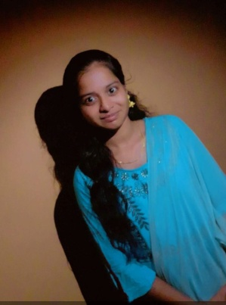

**NAME :** R.Hamsika

**Father’s Name :** L.Ramachandran

**Email Id :** hamsikar03@gmail.com

**Mobile Number :** 6381644139

**Date of Birth :** 03.06.2003

**Gender :** Female

**Nationality :** Indian

**Religion :** Hindu

**Marital Status :** unmarried

**Address :** 1/83, west street,

Ambadhumelnagaram,

Thiruvaiyaru (taluk),

Thanjavur (DT).

**Language Known :** Tamil, English

**Hobbies :** Listening music, Drawing, playing

With tom, etc...

**Educational Qualification:**

|  |  |  |  |
| --- | --- | --- | --- |
| **Qualification** | **Name of institute** | **Year of passing** | **Marks percentage** |
| 10th |  |  | 56% |
| 12th |  |  |  |
|  |  |  |  |