**REACT**

1. **ReactJS – HOL**

**Create a react app for Student Management Portal named StudentApp and create a component named Home which will display the Message “Welcome to the Home page of Student Management Portal”. Create another component named About and display the Message “Welcome to the About page of the Student Management Portal”. Create a third component named Contact and display the Message “Welcome to the Contact page of the Student Management Portal”. Call all the three components.**

1. Create a React project named “studentapp” type the following command in cmd.



1. Navigate into the project folder

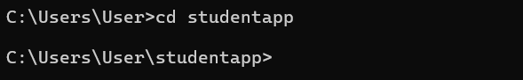

1. Enter code . to open the folder directly in visual studio code.



1. Create a new folder under Src folder with the name “Components”. Add a new file named “Home.js”
2. Type the following code in Home.js

import React, { Component } from "react";

class Home extends Component {

  render() {

    return (

      <div>

        <h2>Welcome to the Home page of Student Management Portal</h2>

      </div>

    );

  }

}

export default Home;

1. Add a new file named “About.js”
2. Type the following code in About.js

import React, { Component } from 'react';

class About extends Component {

  render() {

    return (

      <div>

        <h2>Welcome to the About page of Student Management Portal</h2>

      </div>

    );

  }

}

export default About;

1. Add a new file named “Contact.js”
2. Type the following code in Contact.js

import React, { Component } from 'react';

class Contact extends Component {

  render() {

    return (

      <div>

        <h2>Welcome to the Contact page of Student Management Portal</h2>

      </div>

    );

  }

}

export default Contact;

1. Edit the App.js to invoke the Home, About and Contact component as follows:

import React from 'react';

import './App.css';

import Home from './Components/Home';

import About from './Components/About';

import Contact from './Components/Contact';

function App() {

  return (

    <div className="App">

      <Home />

      <About />

      <Contact />

    </div>

  );

}

export default App;

1. Structure:

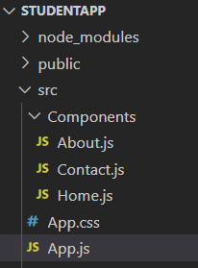

1. In command Prompt, navigate into studentapp and execute the code by typing the following command:



Or

1. In Visual Studio Code : Terminal -> New Terminal -> npm start

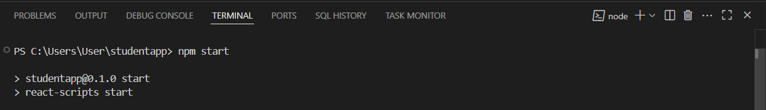

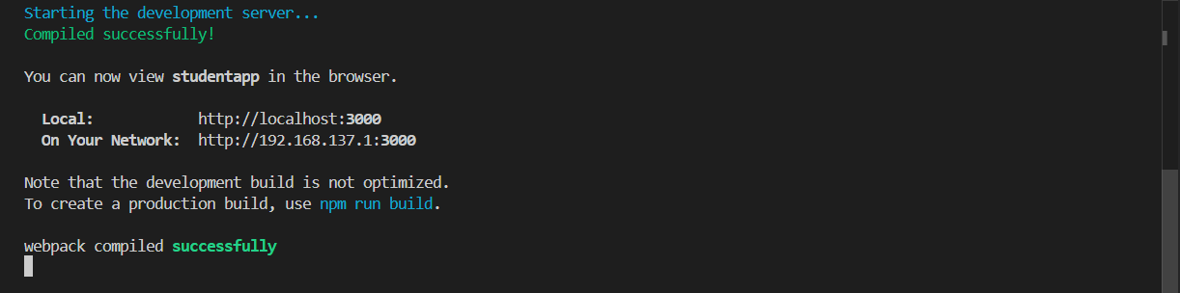

1. It will directly open browser if not open browser and type “localhost:3000” in the address bar:

