**REACT**

**4. ReactJS – HOL**

1. Create a new react application using create-react-app tool with the name as “blogapp”



1. Open the application using cmd



1. Create a new file named as Post.js in src folder with following properties

class Post {

  constructor(id, title, body) {

  this.id=id;

  this.title=title;

  this.body=body;

  }

}

export default Post;

1. Structure:

import React from 'react';

import Post from './Post';

class Posts extends React.Component {

  constructor(props) {

    //code

  }

  loadPosts() {

    //code

  }

  componentDidMount() {

    //code

  }

  componentDidCatch(error, info) {

    //code

  }

  render() {

    //code

    }

  }

export default Posts;

1. Create a new class based component named as Posts inside Posts.js file

class Posts extends React.Component {

  constructor(props) {

    super(props);

    this.state = {

      posts: [],

      hasError: false

    };

  }

}

1. Initialize the component with a list of Post in state of the component using the constructor
2. Create a new method in component with the name as loadPosts() which will be responsible for using Fetch API and assign it to the component state created earlier. To get the posts use the url (<https://jsonplaceholder.typicode.com/posts>)

loadPosts() {

    fetch('https://jsonplaceholder.typicode.com/posts')

      .then(response => response.json())

      .then(data => {

        const postList = data.map(p => new Post(p.id, p.title, p.body));

        this.setState({ posts: postList });

      })

      .catch(error => {

        console.error("Fetch error:", error);

        this.setState({ hasError: true });

      });

  }

1. Implement the componentDidMount() hook to make calls to loadPosts() which will fetch the posts

componentDidMount() {

    this.loadPosts();

  }

1. Implement the render() which will display the title and post of posts in html page using heading and paragraphs respectively.

render() {

    if (this.state.hasError) {

      return <h1>Something went wrong.</h1>;

    }

    return (

      <div>

        {this.state.posts.map(post => (

          <div key={post.id}>

            <h2>{post.title}</h2>

            <p>{post.body}</p>

            <hr />

          </div>

        ))}

      </div>

    );

  }

export default Posts;

1. Define a componentDidCatch() method which will be responsible for displaying any error happing in the component as alert messages.

componentDidCatch(error, info) {

    alert("An error occurred in the component.");

    console.error("componentDidCatch:", error, info);

  }

1. Add the Posts component to App component.(App.js)

import React from 'react';

import './App.css';

import Posts from './Posts';

function App() {

  return (

    <div className="App">

      <h1>Blog Posts</h1>

      <Posts />

    </div>

  );

}

export default App;

1. Build and Run the application using



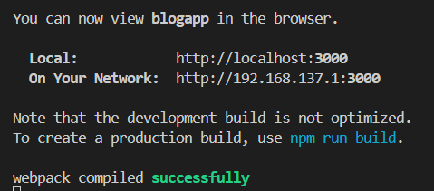

1. It will directly open browser or open browser manually, type localhost:3000

