**REACT**

**10. ReactJS – HOL**

1. Create a React Application named “officespacerentalapp” which uses React JSX to create elements, attributes and renders DOM to display the page.





Open in vs code using cmd



2. Create an element to display the heading of the page.

const element = "Office Space";

3. Attribute to display the image of the office space. Make sure that image should be in react application.

const jsxatt = <img src="/myoffice.jpeg" width="15%" height="15%" alt="My Office Space" />;

5. Create an object of office to display the details like Name, Rent and Address.

const officeList = [

    { Name: "DBS", Rent: 50000, Address: "Chennai" },

    { Name: "SmartWorks", Rent: 70000, Address: "Mumbai" },

  ];

div key={index}>

            <h1>Name: {office.Name}</h1>

            <h3 className={rentClass}>Rent: Rs. {office.Rent}</h3>

            <h3>Address: {office.Address}</h3>

          </div>

6. Create a list of Object and loop through the office space item to display more data.

const officeList = [

    { Name: "DBS", Rent: 50000, Address: "Chennai" },

    { Name: "SmartWorks", Rent: 70000, Address: "Mumbai" },

  ];

  return (

    <div className="center-container">

      <h1>{element}, at Affordable Range</h1>

      {jsxatt}

      {officeList.map((office, index) => {

        const rentClass = office.Rent <= 60000 ? 'textRed' : 'textGreen';

        return (

          <div key={index}>

            <h1>Name: {office.Name}</h1>

            <h3 className={rentClass}>Rent: Rs. {office.Rent}</h3>

            <h3>Address: {office.Address}</h3>

          </div>

        );

      })}

7. To apply Css, Display the color of the Rent in Red if it’s below 60000 and in Green if it’s above 60000.

 {officeList.map((office, index) => {

       const rentClass = office.Rent <= 60000 ? 'textRed' : 'textGreen';

}

App.js

import React from 'react';

import './App.css';

function App() {

  const element = "Office Space";

  const imagePath = "/myoffice.jpeg";

  const officeList = [

    { Name: "DBS", Rent: 50000, Address: "Chennai" },

    { Name: "Smartworks", Rent: 70000, Address: "Mumbai" }

  ];

  return (

    <div className="center-container">

      <h1>{element}, at Affordable Range</h1>

      {officeList.map((office, index) => {

        const rentClass = office.Rent <= 60000 ? 'textRed' : 'textGreen';

        return (

          <div key={index}>

            <img src={imagePath} width="15%" height="15%" alt="Office Space" />

            <h1>Name: {office.Name}</h1>

            <h3 className={rentClass}>Rent: Rs. {office.Rent}</h3>

            <h3>Address: {office.Address}</h3>

          </div>

        );

      })}

    </div>

  );

}

export default App;

OUTPUT:

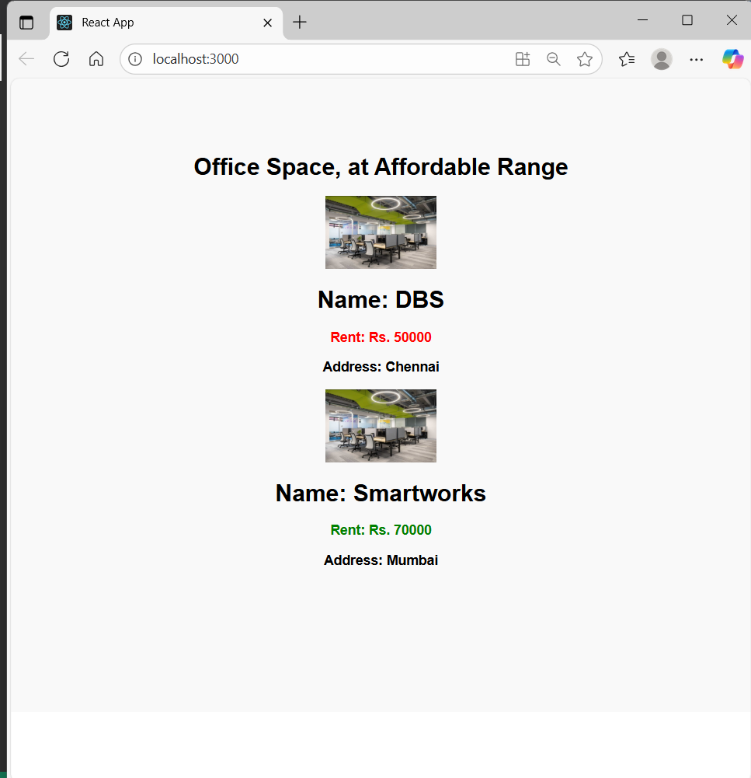

App.css

body {

  margin: 0;

  padding: 0;

  font-family: Arial, sans-serif;

}

.center-container {

  display: flex;

  flex-direction: column;

  align-items: center;

  justify-content: center;

  min-height: 100vh;

  text-align: center;

  background-color: #f9f9f9;

}

.textRed {

  color: red;

  font-weight: bold;

}

.textGreen {

  color: green;

  font-weight: bold;

}