**REACT**

**11. ReactJS – HOL**

**Create a React Application “eventexamplesapp” to handle various events of the form elements in HTML.**

1. In cmd enter:



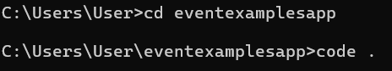

1. Create “Increment” button to increase the value of the counter and “Decrement” button to decrease the value of the counter. The “Increase” button should invoke multiple methods.
   1. To increment the value
   2. Say Hello followed by a static message.

const handleIncrement = () => {

    incrementCount();

    sayHello();

  };

  const incrementCount = () => {

    setCount(count + 1);

  };

  const sayHello = () => {

    alert('Hello! Member1');

  };

  const handleDecrement = () => {

    setCount(count - 1);

  };

<div>

        <button onClick={handleIncrement}>Increment</button><br></br>

        <button onClick={handleDecrement}>Decrement</button><br></br>

        <button onClick={() => handleWelcome("welcome")}>Say welcome</button><br></br>

        <button onClick={handleClick}>Click on me</button>

      </div>

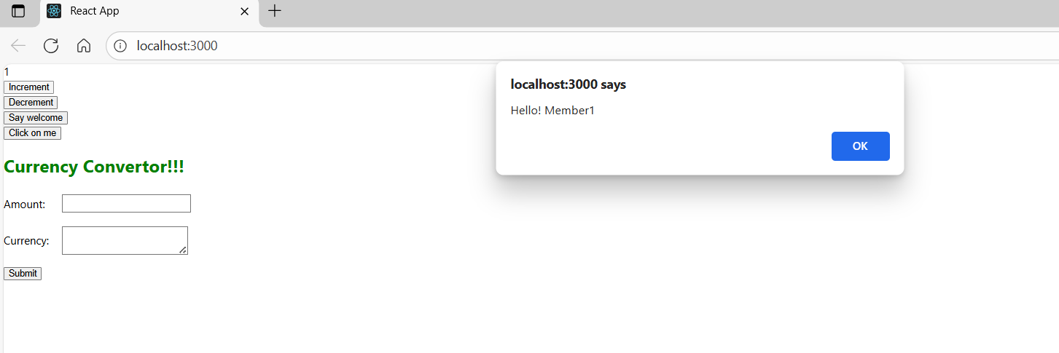

1. Create a button “Say Welcome” which invokes the function which takes “welcome” as an argument.

const handleWelcome = (message) => {

    alert(message);

  };

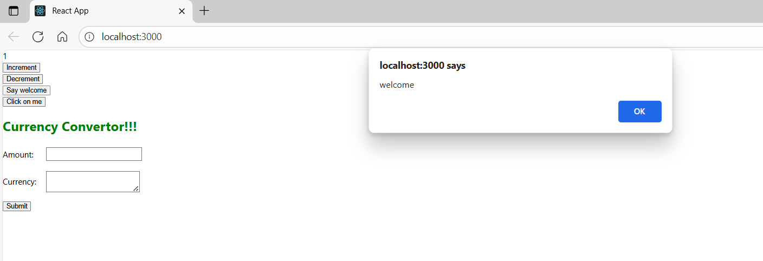

1. Create a button which invokes synthetic event “OnPress” which display “I was clicked”

const handleClick = () => {

    alert('I was clicked');

  };

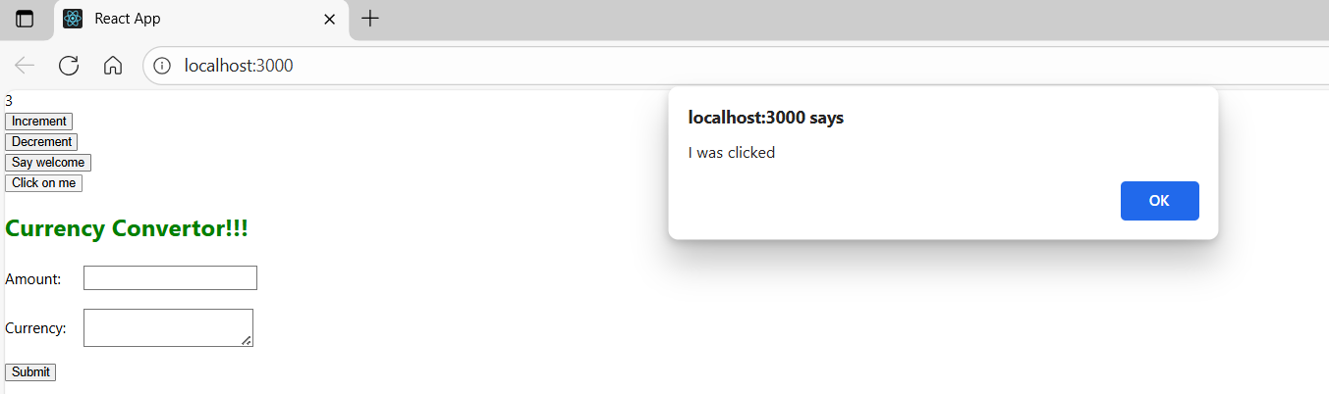

1. Create a “CurrencyConvertor” component which will convert the Indian Rupees to Euro when the Convert button is clicked.
2. Handle the Click event of the button to invoke the handleSubmit event and handle the conversion of the euro to rupees.

const handleSubmit = (e) => {

    e.preventDefault();

    if (currency.toLowerCase() === 'euro') {

      const euroValue = parseFloat(amount) * 80; // 1 Euro = ₹80

      alert(`Converting to Euro Amount is ${euroValue}`);

    } else {

      alert('Currency not supported');

    }

  };

<h2 className="green-title">Currency Convertor!!!</h2>

      <form onSubmit={handleSubmit} className="form-container">

        <div style={{ display: 'flex', alignItems: 'center', marginBottom: '10px' }}>

          <label style={{ width: '80px' }}>Amount:</label>

          <input

            type="text"

            value={amount}

            onChange={(e) => setAmount(e.target.value)}

          />

        </div>

        <div style={{ display: 'flex', alignItems: 'center' }}>

          <label style={{ width: '80px' }}>Currency:</label>

          <textarea

            rows="2"

            cols="20"

            value={currency}

            onChange={(e) => setCurrency(e.target.value)}

          />

        </div>

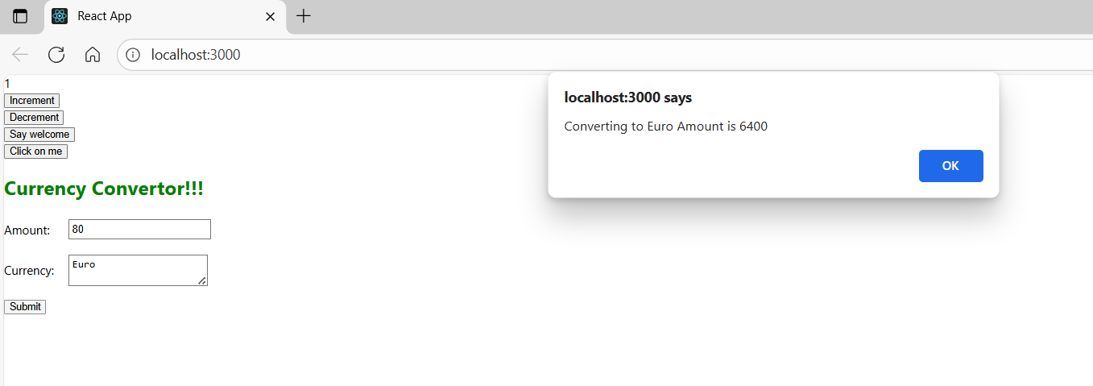

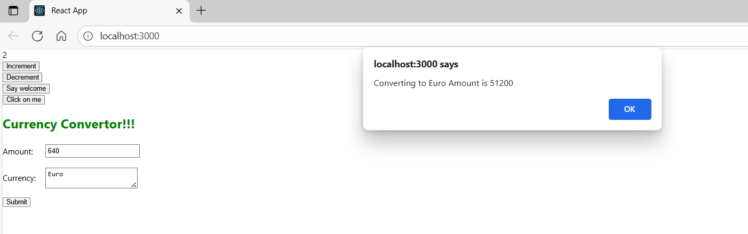

Run Application:



App.js code:

import React, { useState } from 'react';

import './App.css';

function App() {

  const [count, setCount] = useState(1);

  const [amount, setAmount] = useState('');

  const [currency, setCurrency] = useState('');

  const handleIncrement = () => {

    incrementCount();

    sayHello();

  };

  const incrementCount = () => {

    setCount(count + 1);

  };

  const sayHello = () => {

    alert('Hello! Member1');

  };

  const handleDecrement = () => {

    setCount(count - 1);

  };

  const handleWelcome = (message) => {

    alert(message);

  };

  const handleClick = () => {

    alert('I was clicked');

  };

  const handleSubmit = (e) => {

    e.preventDefault();

    if (currency.toLowerCase() === 'euro') {

      const euroValue = parseFloat(amount) * 80; // 1 Euro = rs.80

      alert(`Converting to Euro Amount is ${euroValue}`);

    } else {

      alert('Currency not supported');

    }

  };

  return (

    <div className="App">

      <div className="counter">{count}</div>

      <div>

        <button onClick={handleIncrement}>Increment</button><br></br>

        <button onClick={handleDecrement}>Decrement</button><br></br>

        <button onClick={() => handleWelcome("welcome")}>Say welcome</button><br></br>

        <button onClick={handleClick}>Click on me</button>

      </div>

      <h2 className="green-title">Currency Convertor!!!</h2>

      <form onSubmit={handleSubmit} className="form-container">

        <div style={{ display: 'flex', alignItems: 'center', marginBottom: '10px' }}>

          <label style={{ width: '80px' }}>Amount:</label>

          <input

            type="text"

            value={amount}

            onChange={(e) => setAmount(e.target.value)}

          />

        </div>

        <div style={{ display: 'flex', alignItems: 'center' }}>

          <label style={{ width: '80px' }}>Currency:</label>

          <textarea

            rows="2"

            cols="20"

            value={currency}

            onChange={(e) => setCurrency(e.target.value)}

          />

        </div>

        <div style={{marginTop: '10px' }}>

          <button type="submit">Submit</button>

        </div>

      </form>

    </div>

  );

}

export default App;

App.css:

.App input,

.App textarea {

  margin: 5px;

  padding: 4px;

  font-size: 14px;

}

.App h2 {

  font-weight: bold;

}

.green-title {

  color: green;

  font-weight: bold;

  font-size: 26px;

  margin-top: 20px;

}