**REACT**

**9. ReactJS – HOL**

1. Open cmd, enter



Navigate to that project



Open application in vs code



1. ListofPlayers

* Declare an array with 11 players and store details of their names and scores using the map feature of ES6
* Filter the players with scores below 70 using arrow functions of ES6.

import React from 'react';

function ListofPlayers({ players }) {

  return (

    <ul>

      {players.map((item, index) => (

        <li key={index}>

          Mr. {item.name} <span>{item.score}</span>

        </li>

      ))}

    </ul>

  );

}

export default ListofPlayers;

1. IndianPlayers
   1. Display the Odd Team Player and Even Team players using the Destructuring features of ES6

* Src/OddPlayers.js

import React from 'react';

function OddPlayers({ team }) {

  const [first, , third, , fifth] = team;

  return (

    <ul>

      <li>First : {first}</li>

      <li>Third : {third}</li>

      <li>Fifth : {fifth}</li>

    </ul>

  );

}

export default OddPlayers;

* Src/EvenPlayers.js

import React from 'react';

function EvenPlayers({ team }) {

  const [, second, , fourth, , sixth] = team;

  return (

    <ul>

      <li>Second : {second}</li>

      <li>Fourth : {fourth}</li>

      <li>Sixth : {sixth}</li>

    </ul>

  );

}

export default EvenPlayers;

* 1. Declare two arrays T20players and RanjiTrophy players and merge the two arrays and display them using the Merge feature of ES6

const T20Players = ["Mr. First Player", "Mr. Second Player", "Mr. Third Player"];

  const RanjiTrophyPlayers = ["Mr. Fourth Player", "Mr. Fifth Player", "Mr. Sixth Player"];

  const IndianPlayers = [...T20Players, ...RanjiTrophyPlayers];

1. Display these two components in the same home page using a simple if else in the flag variable.

App.js:

import React from 'react';

import OddPlayers from './OddPlayers';

import EvenPlayers from './EvenPlayers';

function App() {

  const flag = true; // Change to true or false

  const players = [

    { name: "Jack", score: 50 },

    { name: "Michael", score: 70 },

    { name: "John", score: 40 },

    { name: "Ann", score: 61 },

    { name: "Elisabeth", score: 61 },

    { name: "Sachin", score: 95 },

    { name: "Dhoni", score: 100 },

    { name: "Virat", score: 84 },

    { name: "Jadeja", score: 64 },

    { name: "Raina", score: 75 },

    { name: "Rohit", score: 80 }

  ];

  const players70 = [];

  players.map((item) => {

    if (item.score <= 70) {

      players70.push(item);

    }

    return null;

  });

  const IndianTeam = [

    "First : Sachin1",

    "Second : Dhoni2",

    "Third : Virat3",

    "Fourth : Rohit4",

    "Fifth : Yuvraj5",

    "Sixth : Raina6"

  ];

  const T20Players = ['Mr. First Player', 'Mr. Second Player', 'Mr. Third Player'];

  const RanjiTrophyPlayers = ['Mr. Fourth Player', 'Mr. Fifth Player', 'Mr. Sixth Player'];

  const IndianPlayers = [...T20Players, ...RanjiTrophyPlayers];

  if (flag === true) {

    return (

      <div>

        <h1>List of Players</h1>

        <ul>

          {players.map((item, index) => (

            <li key={index}>

              Mr. {item.name} <span>{item.score}</span>

            </li>

          ))}

        </ul>

        <hr />

        <h1>List of Players having Scores Less than 70</h1>

        <ul>

          {players70.map((item, index) => (

            <li key={index}>

              Mr. {item.name} <span>{item.score}</span>

            </li>

          ))}

        </ul>

      </div>

    );

  } else {

    return (

      <div>

        <h1>Odd Players</h1>

        <OddPlayers team={IndianTeam} />

        <hr />

        <h1>Even Players</h1>

        <EvenPlayers team={IndianTeam} />

        <hr />

        <h1>List of Indian Players Merged:</h1>

        <ul>

          {IndianPlayers.map((player, index) => (

            <li key={index}>{player}</li>

          ))}

        </ul>

      </div>

    );

  }

}

export default App;



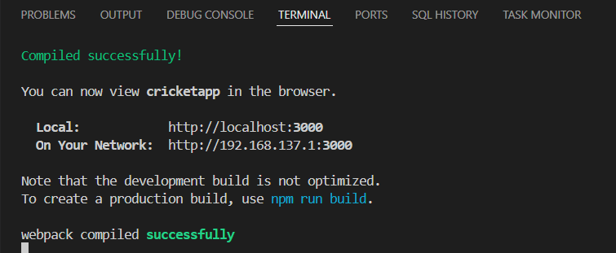

**Output:** When Flag=true

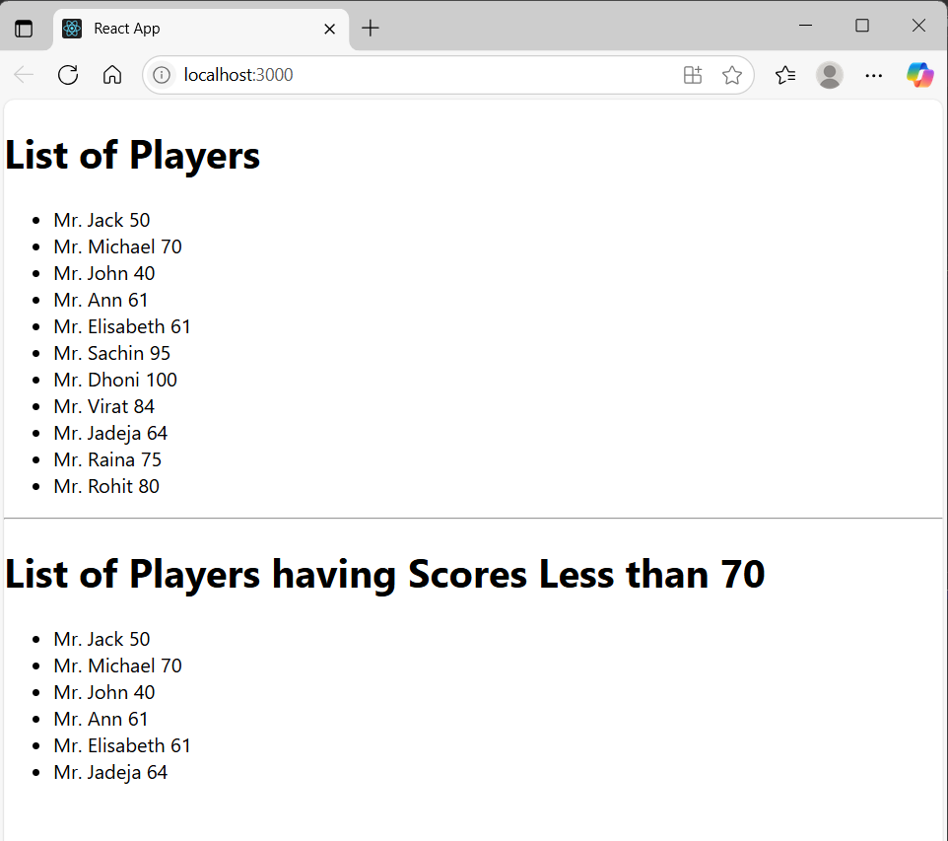

When Flag=false

