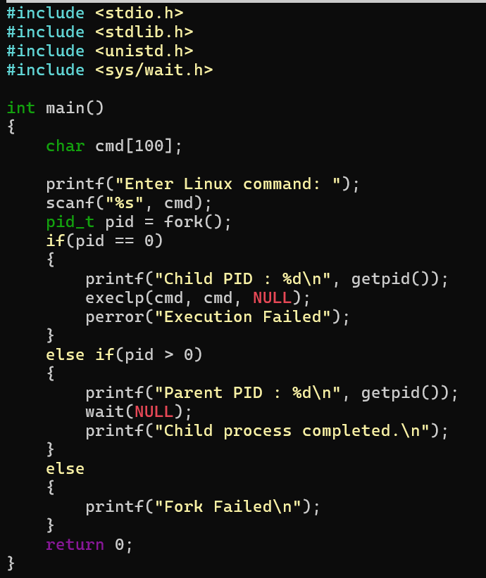

Try uname, lscpu, lsblk, ps, top commands after this program
Output:
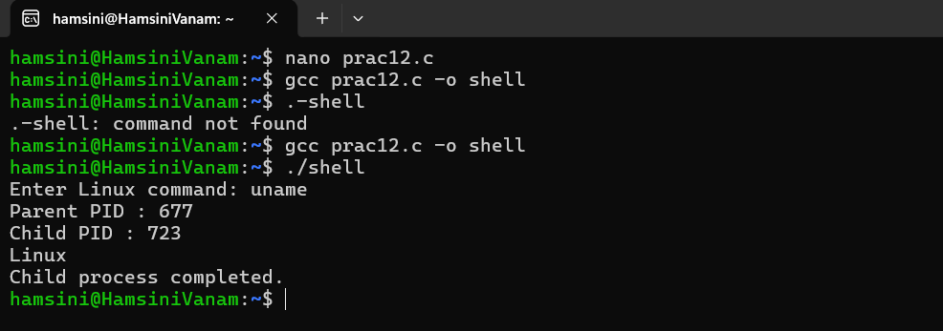

2. copying the contents from one file to another file

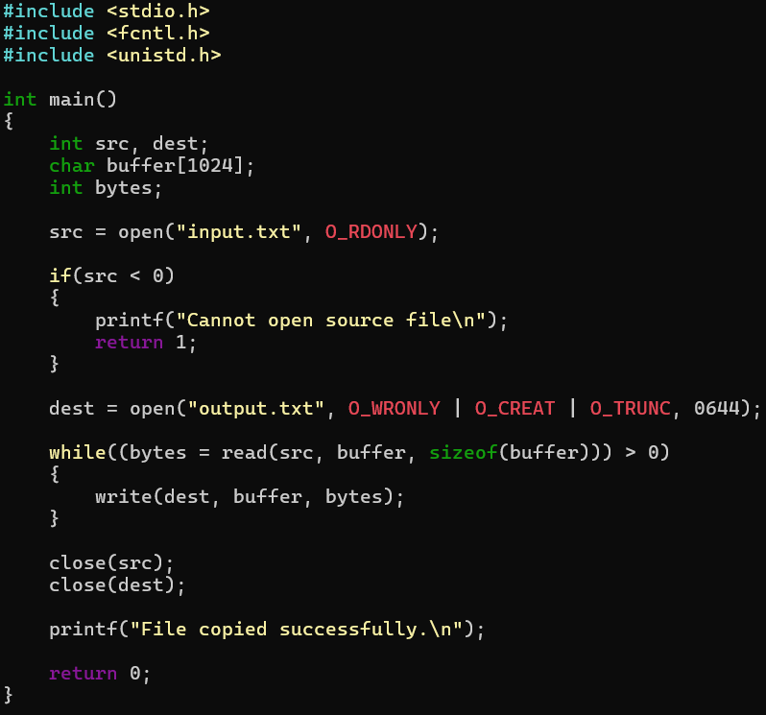

Output:
