Human Factors Survey Report

Human Factors Division - SER Directorate

19/02/2020

## Introduction

This report was produced on 2020-02-20 by Amy.

Lorem ipsum dolor sit amet, consectetur adipiscing elit, sed do eiusmod tempor incididunt ut labore et dolore magna aliqua. Facilisis gravida neque convallis a cras semper auctor neque. Aenean euismod elementum nisi quis eleifend. Turpis massa sed elementum tempus egestas sed sed risus. Facilisis gravida neque convallis a cras semper auctor.

## Table of the Data that was collected

A total of 6 survey responses were recorded.

Lorem ipsum dolor sit amet, consectetur adipiscing elit, sed do eiusmod tempor incididunt ut labore et dolore magna aliqua. Facilisis gravida neque convallis a cras semper auctor neque. Aenean euismod elementum nisi quis eleifend. Turpis massa sed elementum tempus egestas sed sed risus. Facilisis gravida neque convallis a cras semper auctor.

Table 1: Complete table of responses

|  |  |  |  |  |  |  |
| --- | --- | --- | --- | --- | --- | --- |
| Respondent ID | Collector ID | Gender | Age | Rail Experience | Transport Agency | Sydney Trains Directorate |
| 11311860666 | 253194773 | Female | 50-60 years | Class 3 | 1 | 9 |
| 11311783075 | 253194773 | Female | 30-40 years | Class 1 | 1 | 9 |
| 11306468027 | 253194773 | Male | 40-50 years | Class 7 | 1 | 9 |
| 11306431661 | 253194773 | Male | 30-40 years | Class 1 | 1 | 7 |
| 11306276984 | 253194773 | Missing | 40-50 years | Class 4 | 1 | 9 |
| 11306032069 | 253194773 | Male | 10-30 years | Class 5 | 1 | 2 |

## Tables for Each Class of Respondent

### Gender

The split of **Gender** responses was important this year.

Lorem ipsum dolor sit amet, consectetur adipiscing elit, sed do eiusmod tempor incididunt ut labore et dolore magna aliqua. Facilisis gravida neque convallis a cras semper auctor neque. Aenean euismod elementum nisi quis eleifend. Turpis massa sed elementum tempus egestas sed sed risus. Facilisis gravida neque convallis a cras semper auctor.

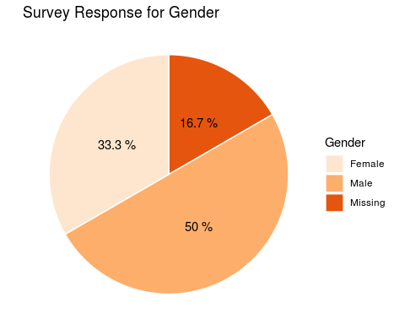

“Gender Responses”

|  |  |
| --- | --- |
| Gender | count |
| Female | 2 |
| Male | 3 |
| Missing | 1 |

Lorem ipsum dolor sit amet, consectetur adipiscing elit, sed do eiusmod tempor incididunt ut labore et dolore magna aliqua. Facilisis gravida neque convallis a cras semper auctor neque. Aenean euismod elementum nisi quis eleifend. Turpis massa sed elementum tempus egestas sed sed risus. Facilisis gravida neque convallis a cras semper auctor.

### Age

The split of **Age** responses was important this year.

Lorem ipsum dolor sit amet, consectetur adipiscing elit, sed do eiusmod tempor incididunt ut labore et dolore magna aliqua. Facilisis gravida neque convallis a cras semper auctor neque. Aenean euismod elementum nisi quis eleifend. Turpis massa sed elementum tempus egestas sed sed risus. Facilisis gravida neque convallis a cras semper auctor.

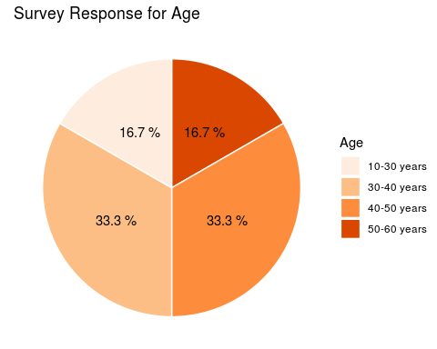

“Age Responses”

|  |  |
| --- | --- |
| Age | count |
| 10-30 years | 1 |
| 30-40 years | 2 |
| 40-50 years | 2 |
| 50-60 years | 1 |

Lorem ipsum dolor sit amet, consectetur adipiscing elit, sed do eiusmod tempor incididunt ut labore et dolore magna aliqua. Facilisis gravida neque convallis a cras semper auctor neque. Aenean euismod elementum nisi quis eleifend. Turpis massa sed elementum tempus egestas sed sed risus. Facilisis gravida neque convallis a cras semper auctor.

### Rail Experience

The split of **Rail Experience** responses as a class was not important this year.

Lorem ipsum dolor sit amet, consectetur adipiscing elit, sed do eiusmod tempor incididunt ut labore et dolore magna aliqua. Facilisis gravida neque convallis a cras semper auctor neque. Aenean euismod elementum nisi quis eleifend. Turpis massa sed elementum tempus egestas sed sed risus. Facilisis gravida neque convallis a cras semper auctor.

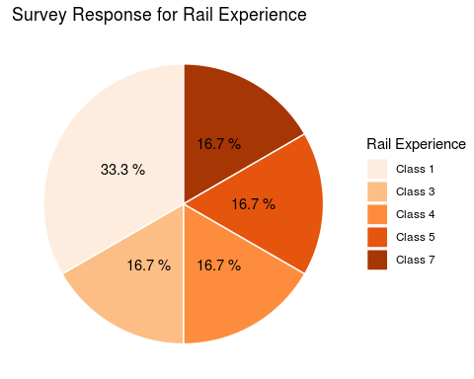

“Rail Experience Responses”

|  |  |
| --- | --- |
| Rail Experience | count |
| Class 1 | 2 |
| Class 3 | 1 |
| Class 4 | 1 |
| Class 5 | 1 |
| Class 7 | 1 |

Lorem ipsum dolor sit amet, consectetur adipiscing elit, sed do eiusmod tempor incididunt ut labore et dolore magna aliqua. Facilisis gravida neque convallis a cras semper auctor neque. Aenean euismod elementum nisi quis eleifend. Turpis massa sed elementum tempus egestas sed sed risus. Facilisis gravida neque convallis a cras semper auctor.