Ham Spot Inc
http://hamspot.com/

HS-736USB

FT-736R to HRD USB Interface

The HS-736USB translates between the FT-736R CAT protocol and FT-847 CAT Protocol via USB serial interface. This allows computer software to see the FT-736R as if it were a FT-847. All radio functions are supported including 1200 MHz operation.

Using with Ham Radio Deluxe

Once you have the board recognized as a USB device you can connect to HRD. (See: Windows Driver Installation) On the Connect pop-up of HRD you need to first click on the “Serial ports” tab to see which comport your device has been assigned.

If you are not sure which COM port to select then go to Control panel → System → Hardware tab → Device Manager button → expand Ports (Com & LPT). Locate the port labeled “Location 0 (CDC RS-232 Emulation Demo)” and open properties to find the COM port number. Remember this port number.

Make your new connection in HRD using the correct COM port for your FT-736R. Also, make sure you set the Radio model to FT-847.

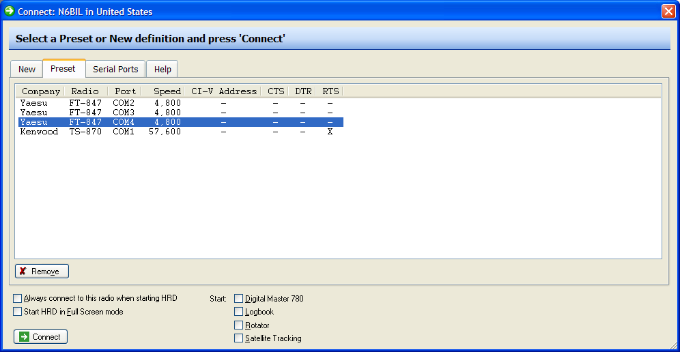
Known Issues with HRD

If you press the SAT button on the FT-736R then HRD will correctly show SAT mode as highlighted. However, if you use the HRD software PTT function you may experience a bug in HRD where it drops out of SAT mode even though the FT-736R is still in SAT mode. A workaround is to always use the PTT or MOX switch on the FT-736R itself to transmit rather than using the software PTT function.

Band changing is challenging in satellite mode even manually. If you have a two band FT-736R you may not be able to change swap bands between TX/RX in satellite mode via HRD. If you have a three or four band FT-736R this is much easier. If your TX is set to 2m and RX is set to 70cm then you can swap TX to 6m/220/1200 temporarily, swap RX to 2m and then finally TX to 70cm.
Windows Driver Installation
1. Windows should recognize the HS-736USB as “CDC RS232 Emulation Demo”.
Windows will now prompt the user for driver information.
2. In the “Welcome to the Found New Hardware Wizard” window, select “No, not
this time” and then Next.

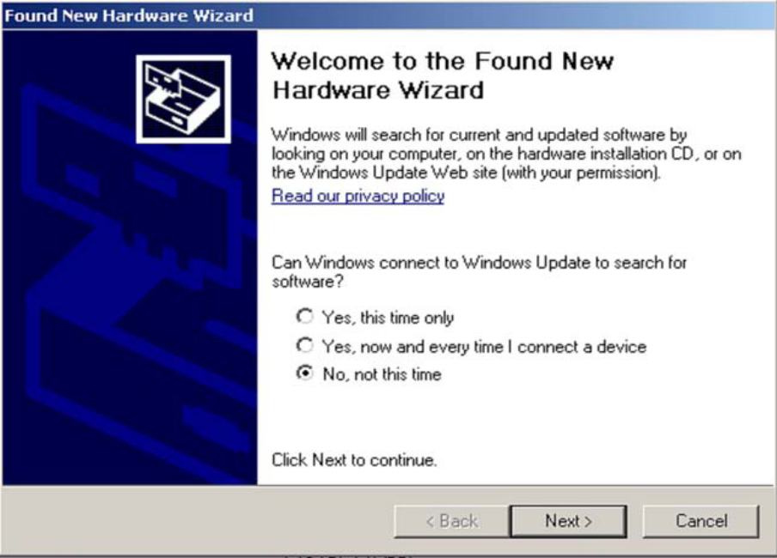

- The wizard will then prompt the user for a location from which to load the software for the communication port. Select ”Install from a list or specific location (Advanced)” and click Next.

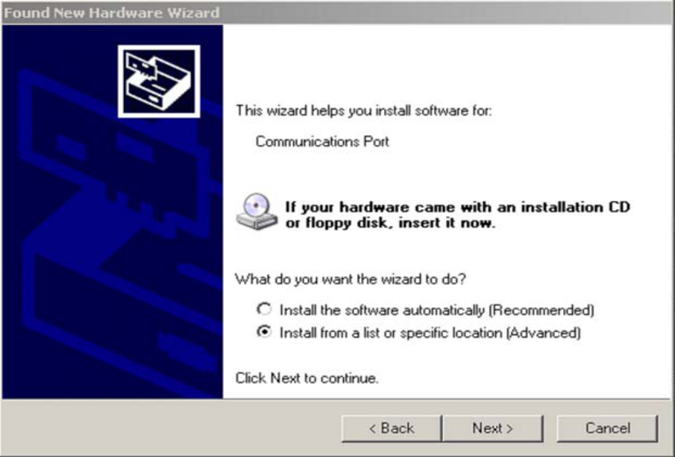
The wizard now prompts the user for the location of the .inf file that Windows will use
to automatically configure the binary driver files (.sys files) to create the Virtual COM
Port connection for the USB. Ensure that both “Search for the best driver in these locations”
and “Include this location in the search” are both selected. Select Browse and
navigate to the mchpcdc.inf which is attached in the email.

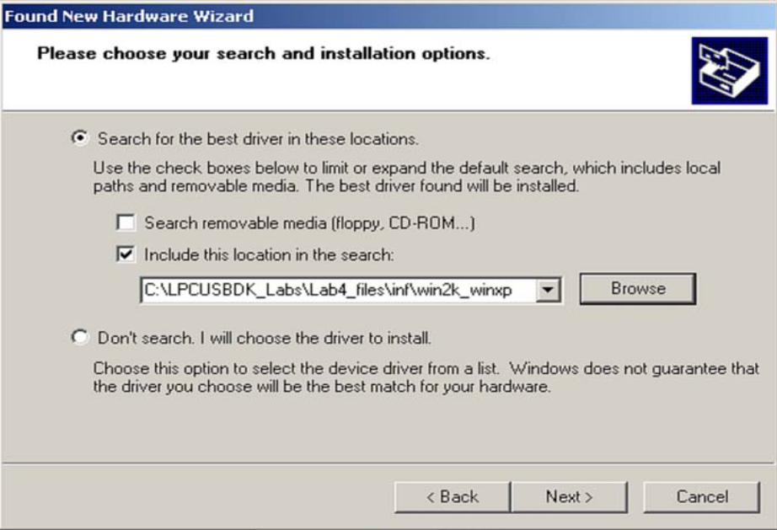
The window should now begin loading the software. If any warnings are issued, select
Continue Anyway.
4. The wizard should indicate that the software for the Communications port was
successfully installed. Select Finish.

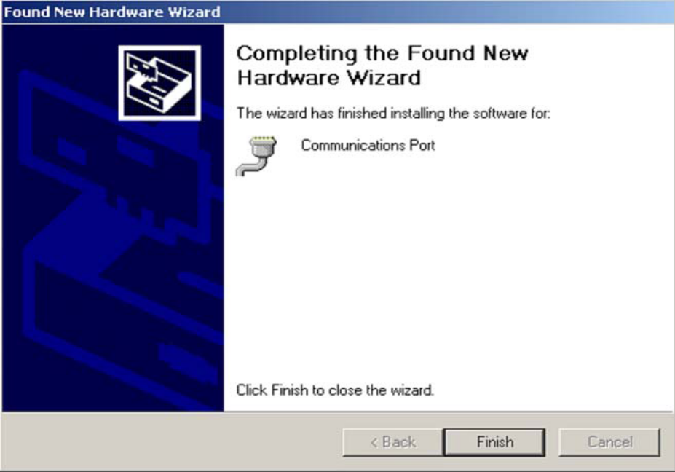

Credits

The concept for this interface was developed by Dave, KA6BFB in 2010. He developed a proof of concept in software using VB and Windows. It was however quite cumbersome and used 3 virtual serial ports to work with HRD. But an excellent proof of concept nonetheless. This software can be found here:
http://home.comcast.net/~tinkyr/736/KA6BFB%20Windows%20Emulator.htm

The hardware version was developed by Chuck, N6BIL. The source code is GPL licensed and the Eagle CAD files were published along with the code. The hardware CAD files, source code and binaries can be found here:
http://home.comcast.net/~tinkyr/736/N6BIL%20Hardware%20Emulator.htm

Ham Spot Inc based the HS-736USB on their great work and thanks them immensely for their hard work on solving a challenging problem! The goal of Ham Spot Inc is that if this interface is popular we will develop similar interfaces for other older rigs which are also not supported by HRD. Specifically in mind are the FT-757GXII, FT-890 and various Icom and Kenwood radios. There will likely be firmware updates to this hardware available on the http://hamspot.com/ website in the future. If you have a PIC programmer the chip has been socketed to allow you to flash new firmware or easily replace the device. If not, there will be made available an inexpensive preprogrammed chip that you can plugin to upgrade the firmware or convert the FT-736USB to another model Yaesu rig as they become supported.

Legal Notices
FT-736R HRD USB Interface
Copyright © 2010 Albert “Chuck” Jones, N6BIL
Copyright © 2014 Ham Spot Inc
This program is free software: you can redistribute it and/or modify it under the terms of the GNU General Public License as published by the Free Software Foundation, either version 3 of the License, or (at your option) any later version.
This program is distributed in the hope that it will be useful, but WITHOUT ANY WARRANTY; without even the implied warranty of MERCHANTABILITY or FITNESS FOR A PARTICULAR PURPOSE. See the GNU General Public License for more details.
You should have received a copy of the GNU General Public License along with this program. If not, see <http://www.gnu.org/licenses/>.

