Hugh A. Miles II

09/21/16

COP3530

Circular Linked List

* Summary
  + My Circular Linked List a basic Linked List Class, but instead of the last Node (tail) pointing to nothing its points to the head. This is a templated so the Nodes can hold any type based upon the type templated at its instantiation. Each node has its own index, a bool value indicating whether it’s the head or not, and the address of the next Node in the list.
* Structure
  + Node<type>
    - Constructor (type initValue, int strIndex)
      * In the constructor you need to indicate the value to be set, and where the Node is being placed with the strIndex.
    - Int index
      * Location in the list
    - Type value
      * The data value stored in side the node.
    - Node<type>\* nextNode
      * Address for the next Node in the list
    - Bool isHead
      * Value that indicated whether you are at the front of the list.
  + LinkedList
    - Head<type>
      * Pointer to start of the list (index = 0)
    - Int curLength
      * Keeps track of the number of Nodes in the current list.
* Methods
  + Insert (type value, int index)
    - Allow users to insert element at a certain spot in the current list that is less than the this.length + 1.
  + DeleteNode(int index)
    - Allows user to delete Node at any point in the current list that is less than this.length + 1
  + Print
    - Prints entire list sequentially.
  + PrintAtIndex(int index)
    - Prints element at index given in the parameter
  + Helper Methods
    - Append(type value)
    - ResetIndexs
      * Since each node contains its own index. This method resets the node.index for each node in the list after a delete or insert.
* Test Cases

1. Given Set >> Inputs

19

I 1 0

I 2 1

I 3 2

I 4 3

I 5 4

I 6 5

I 7 6

I 8 7

I 9 8

I 10 9

S

I 0 2

S

P 5

D 5

P 5

S

P 165

J 3 2 34 23 22

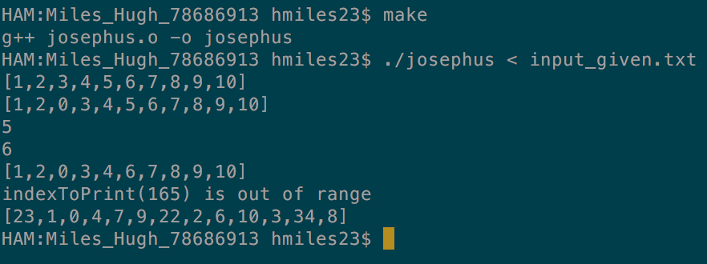



1. Small Set

17

I 1 0

I 2 1

I 3 2

I 4 3

I 5 4

S

I 111 0

S

I 555 7

S

I 777 4

S

D 0

D 6

D 3

S

J 4 3 5 4 3 2

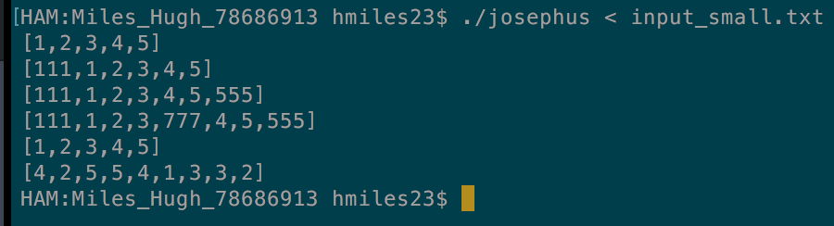

1. Medium Set

34

S

I 1 0

I 2 1

I 3 2

I 4 3

I 5 4

I 6 5

I 7 6

I 8 7

I 9 8

I 10 9

I 11 10

I 12 11

S

D 0

S

D 11

D 5

S

P 0

P 1

P 2

P 3

P 4

P 5

P 6

P 7

P 8

P 9

P 10

P 11

P 19

S

J 10 5 100 201 342 54 66 234 1312 313 808 2131

