# Tugas JS Variable

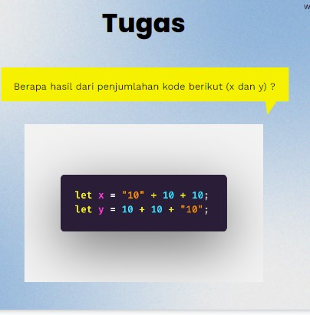

Pertama lalukan pengisian kode berikut ini :

|  |
| --- |
| <!DOCTYPE html>  <html>  <body>  <h1>Java Script Variables</h1>  <p id="demo"></p>  let X = "10"+10+10;  let Y = 10+10+"10";  document.getElementById("demo").innerHTML =  X  + Y;  </script>  </body>  </html> |

Pengkodean sesuai tugas :

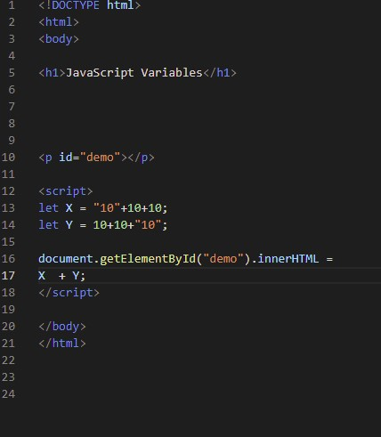

Hasil setelah running debugging :

