# Tugas Step Definition



Dengan mengikuti Scenario BDD yang saya buat di tugas sebelumnya,

Feature: Search Feature

    On this Website have a much Content and Feature

    As a visitor of Website

    I want to track some of the Features

Scenario: with Feature what I need

Given I am visits the Website

And I am looking for the Search Field

When I starting typing something

Then I should see the Results of

But  No Results found

Berikut ini adalah Step Definition yang saya buat, dengan nama (*cypress/integration/Search/SeachTest.js).* Berdasarkan scenario tersebut inilah isi scriptnya :

/// <reference types="cypress" />

import { Given, And, When, Then, But } from "cypress-cucumber-preprocessor/steps";

Given ('I am visits the Website', () => {

    cy.visit('http://zero.webappsecurity.com/')

});

And ('I am looking for the Search Field', () => {

    cy.get('input[name="searchTerm"]').clear();

});

When ('I starting typing something', () => {

    cy.get('input[name="searchTerm"]').type('something {enter}');

});

Then ('I should see the Results of', () => {

    cy.get('h2').contains('Search Results')

    cy.contains('No results were found for the query: something').should('be.visible');

});

Then ('No Results found', () => {

    cy.contains('No results were found for the query: something').should('be.visible');

});

Tidak puas rasanya jika kita tidak menguji/ Runing Test hasilnya. Inilah sedikit dari dokumentasinya:

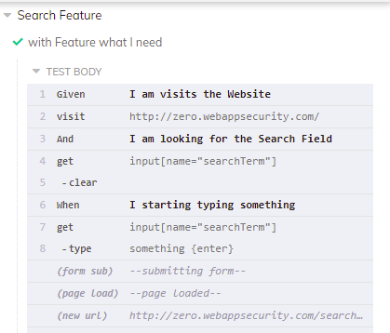

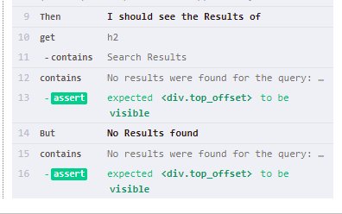

**Given I am visits the Website**

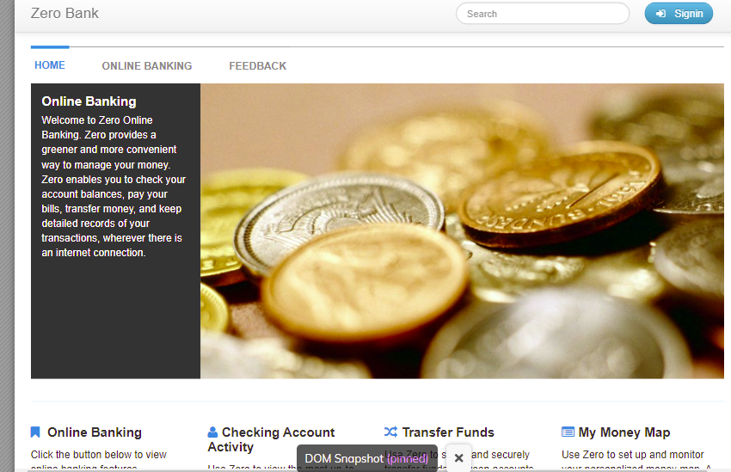

**And I am looking for the Search Field**





**When I starting typing something**





**Then I should see the Results of**

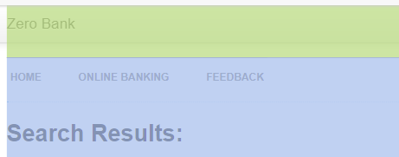



**But No Results found**

