# Tugas Run Test (Complete BDD)

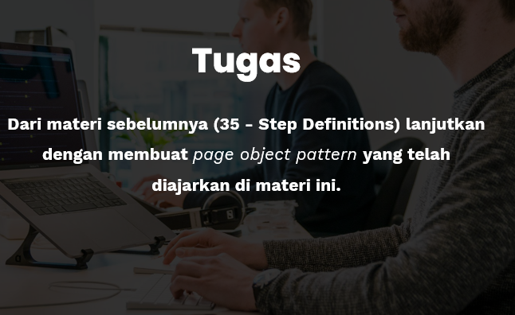

Ini adalah file Scenario BDD yang saya buat pada tugas-34 (cypress/integration/Search.feature):

Feature: Search Feature

    On this Website have a much Content and Feature

    As a visitor of Website

    I want to track some of the Features

Scenario: with Feature what I need

Given I am visits the Website

And I am looking for the Search Field

When I starting typing something

Then I should see the Results of

But  No Results found

Kemudian yang berikutnya adalah Step definition dari tugas-35 yang baru setelah penambahan atau pengeditan,

( cypress/integration/Search/SearchStep.js ) :

/// <reference types="cypress" />

import { Given, And, When, Then, But } from "cypress-cucumber-preprocessor/steps";

import SearchObject from "./SearchObject";

Given ('I am visits the Website', () => {

    SearchObject.visit()

});

And ('I am looking for the Search Field', () => {

    SearchObject.lookingFor()

});

When ('I starting typing something', () => {

    SearchObject.inputObject()

});

Then ('I should see the Results of', () => {

    SearchObject.showResulst()

});

Then ('No Results found', () => {

    SearchObject.finalResults()

});

yang ketiga yang utama dalam tugas kali ini, di bawah ini adalah **Object Patern** yang sudah saya selesaikan (cypress/integration/Search/SearchObject ), ini lah isi dari tugas nya:

const URL = 'http://zero.webappsecurity.com/'

const GET = 'input[name="searchTerm"]'

const INPUT = 'input[name="searchTerm"]'

const RESULTS = 'h2'

const FINAL = 'No results were found for the query: something'

class SearchObject {

    static visit () {

      cy.visit(URL)

    }

    static lookingFor() {

        cy.get(GET).clear()

    }

    static inputObject() {

        cy.get(INPUT).type('something{enter}')

    }

    static showResulst() {

        cy.get(RESULTS).contains('Search Results')

    }

    static finalResults() {

        cy.contains(FINAL).should('be.visible')

    }

}

export default SearchObject

Yang terakhir inilah sebuah doumentasi Test Run dari keseluruhan file BDD tersebut :

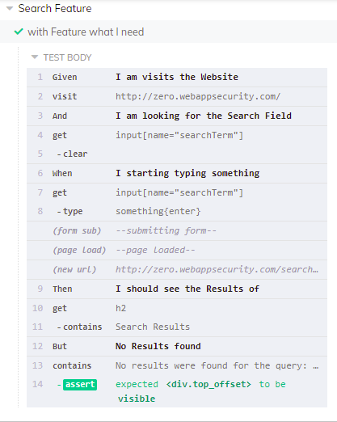

Result dari Test Scenario secara berurutan

