**DS LAB 07**

**Task 01:**

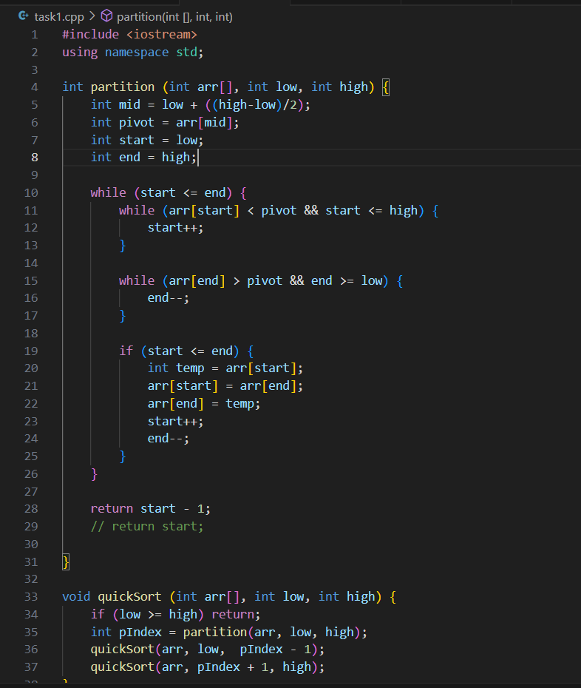

**Task 02:**

**Task 03:**

