**DS LAB 08**

**Task 01:**

**Task 02:**

**Task 03:**

**Task 04:**

**Task 05:**

**Task 06:**

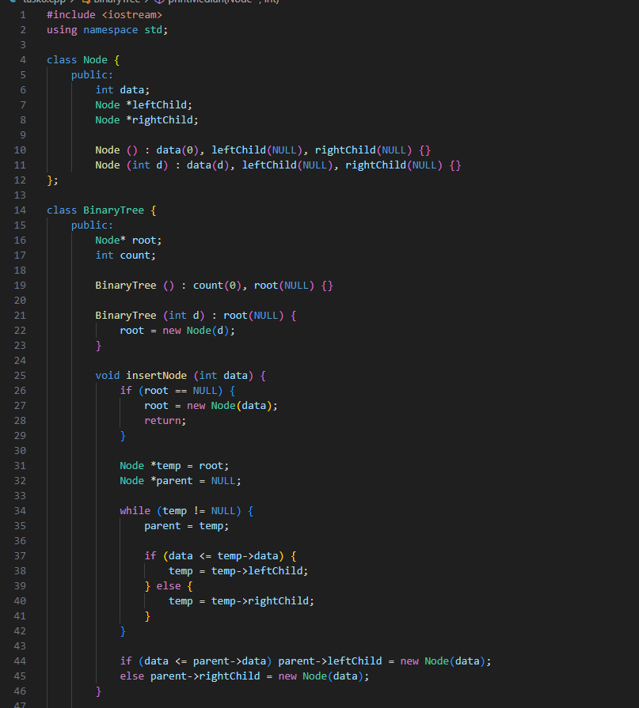

**Task 07:**

