**DS LAB 09**

**Task 01:**

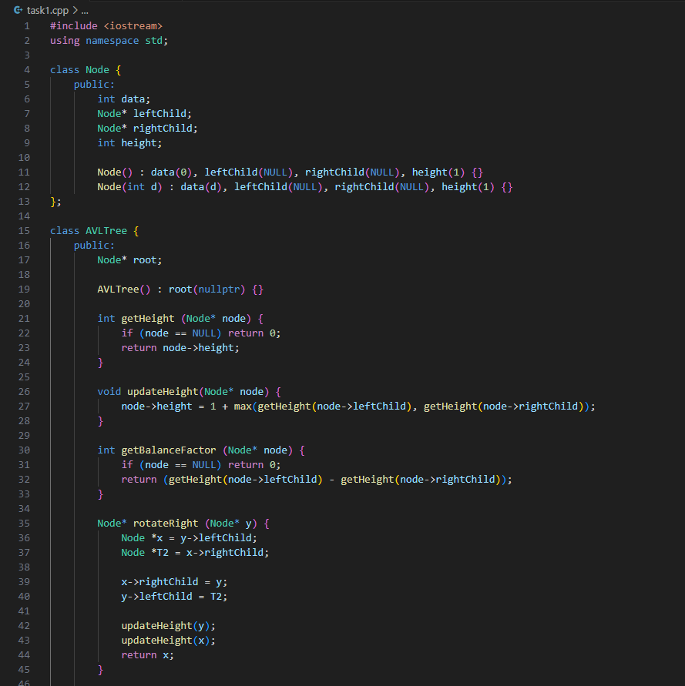

**Task 02:**

**Task 03:**



**Task 04:**

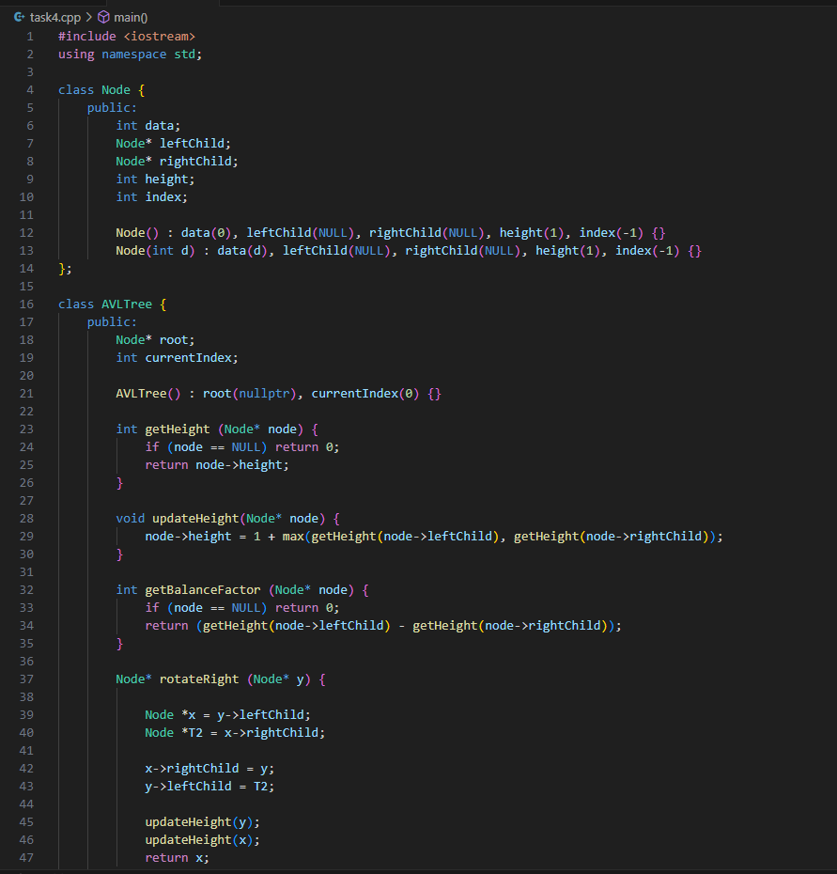

**Task 05:**



