How to build a new version of HAL

1) Label HearingLanguage project in StarTeam
1) Delete existing versions on your local PC if exists (including .meta folder)
2) Start your Eclipse
3) Set Workspace to “W:\Workspace\HearingLanguage1.0.0\Source”
4) Close Welcome dialog
5) Open StarTeam Classic perspective (open perspective)
6) Menu: “File\New\Open project from StarTeam”
7) Navigate to:
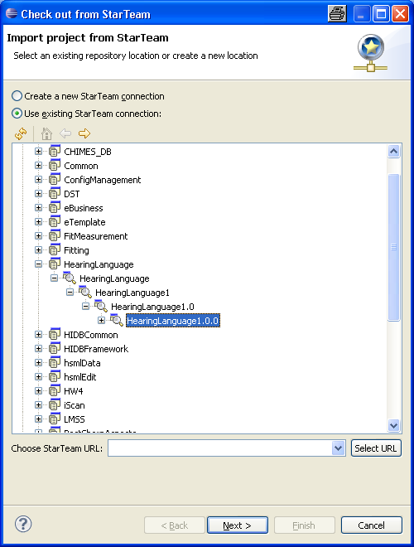
And press next
8) Navigate to:
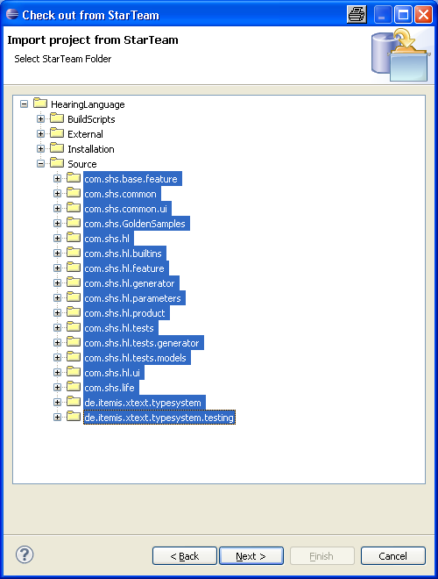
Select all projects and press next
9) 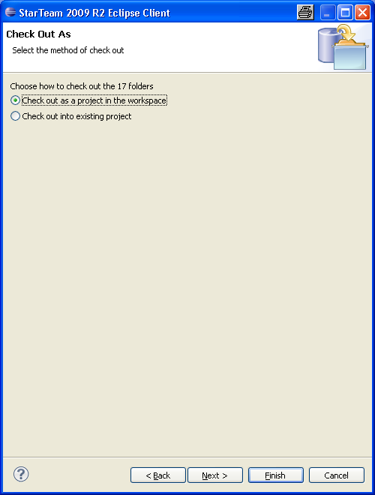
Press next
10) 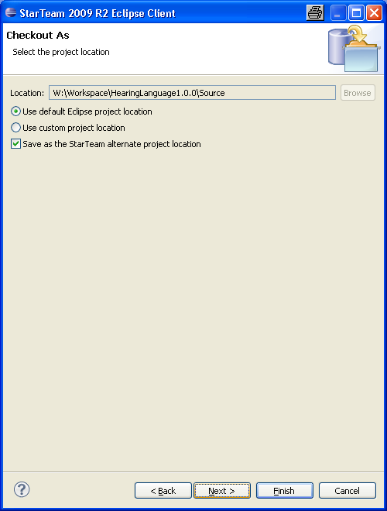
Press next
11) 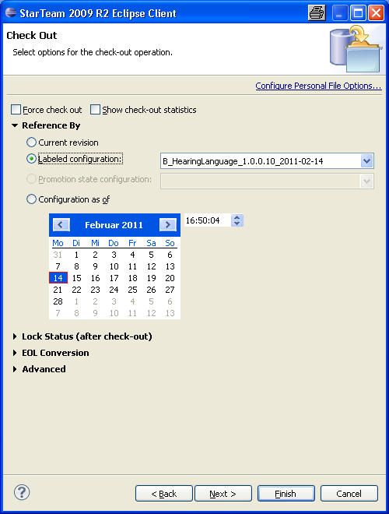
Select the lable you defined and press finish
12) Change perspective to “Java”
13) Deselect version 1.0 of google plugins
14) Start shs.common workflow
15) Start shs.hl workflow
16) Open „shs product“
17) Start „Eclipse Product export wizard“
18) Fill Root diirectory to HAL_Workbench, Directory to C:\Program Files\SAT and deselect „Generate metadata repository
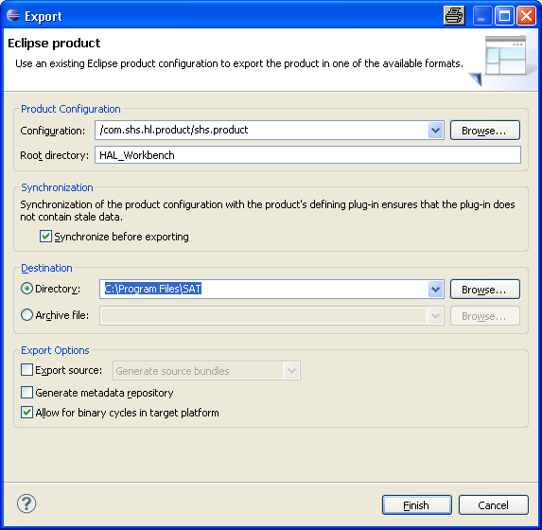
And press finish
19) Copy „Properties folder“, „BuildAssembly.bat“, „BuildAssemblyDebug.bat“ and „HearingLanguageRuntime.ProjectTemplate.csproj“ from SIFIT_SW to the HAL_Workbench directory (C:\Program Files\SAT \HAL_Workbench)
20) Open HAL_Workbench (C:\Program Files\SAT \HAL_Workbench\HAL_Workbench.exe)
21) Select “Use this as the default and do not ask again and press OK
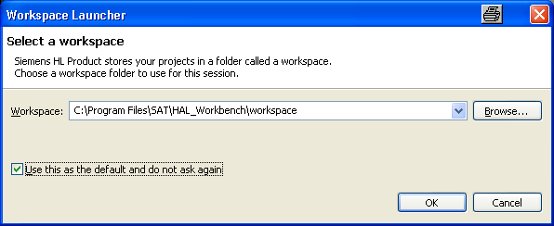
22) Open StarTeam Classic perspective (open perspective)
23) Menu: “File\New\Open project from StarTeam”
24) Navigate to:
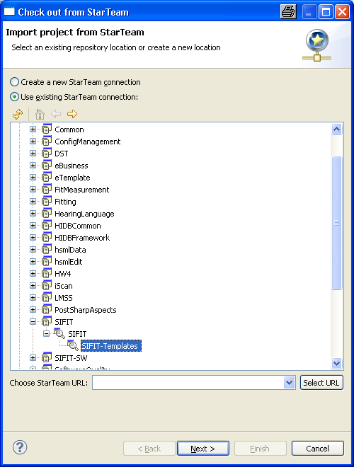
And press next
25) Navigate to:
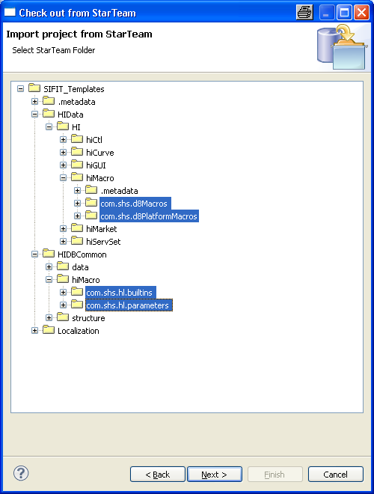
Select shown project and press next
26) 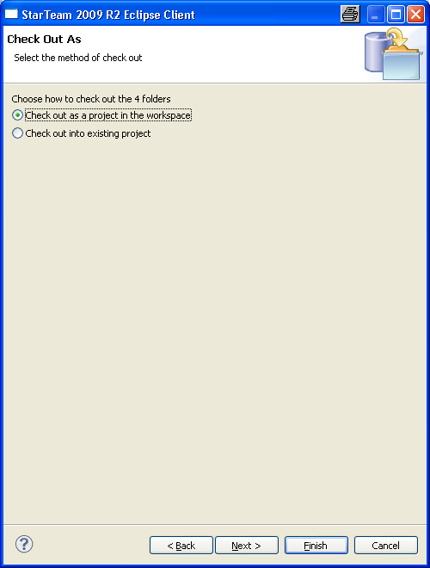
Press finish
27) Open “Run/External tools/External tools configuration”
28) Create new entry for start test application
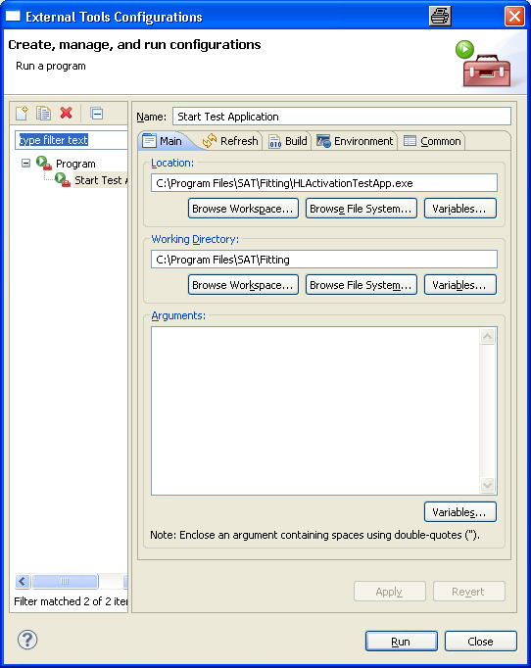
29) Close HAL_Workbench
30) Copy HAL-Workbench folder from c:\program files\sat to file://deerlh1sat5srv.ww005.siemens.net/satdfs/AES-Shares/CommonDsk/HAL/Alpha/1.0/IT1/New where New = name of build lable (see 1.)
31) Copy needed Fitting files in a fitting folder in file://deerlh1sat5srv.ww005.siemens.net/satdfs/AES-Shares/CommonDsk/HAL/Alpha/1.0/IT1/New

