

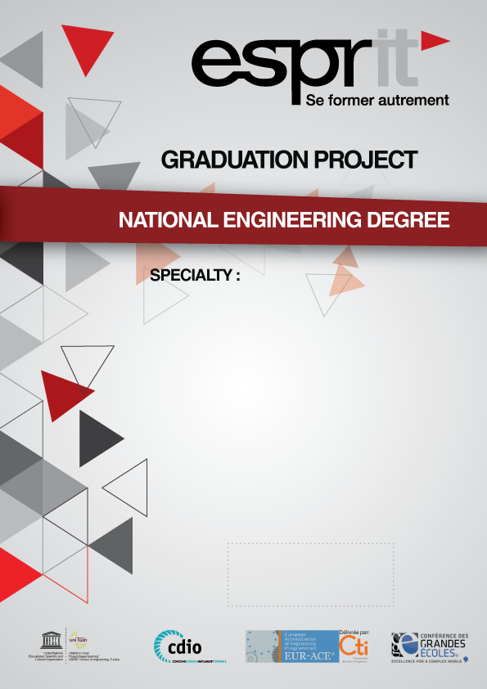

INFORMATION TECHNOLOGY
2025 - 2026
By: Hamza Mbarki

Academic supervisor: Mr. Taoufik Chaouachi

Corporate Internship Supervisor: Mr. Anis Mdaini

TITLE : Design and Implementation of an Asset Management and Predictive Maintenance Platform for Industrial Equipment (EAM)

