

**BAHRIA UNIVERSITY (KARACHI CAMPUS**)

OPEN ENDED LAB 1 – SPRING 2022

(CLO-1)

**Course Title:**  Web Engineering  **Course Code**: SEL 310

**Course Instructor: Class**: BSE-6(B)

**Lab Engineer:** Engr. Ayesha Khan  **Name: ____HAMZA_____________**

**Max. Marks:** 12 Marks **Reg no: _65179_______________**

**Time: 120** Min **Date: 19/5/2022**

**Note:**

* Save Document of your solution with your name+enrollment like xyz015
* Include all imp code and pictures related to solution in that document.

**QUESTION # 01:** Assume a scenario and create related website having at least following properties:

Ali is a student of 2nd semester, BSE program. His father has an event management venture named “Khushian” which was going well until pandemic hit the globe. Now, he is unable to get more events due to lack of marketing. To make it easier for his father and customers to reach, Ali decides to make a website. However, being at beginner level he is unable to make it that professional and ignores some of the important features of good website design ie: responsiveness, good graphic, validation etc.

Your task is to recreate responsive website according to your own understanding of event management with the technologies of your own choice.

**Must Include:** Make sure you add **Reviews Carousal** as feedback of previous customers. Customers should be able to **search** events. For **registration form** of customer, password field should not be weak. Data related to events must be in the form of **objects**.

**(9 Marks)**

**QUESTION # 02: Viva (3 marks)**

**QUESTION 1:**

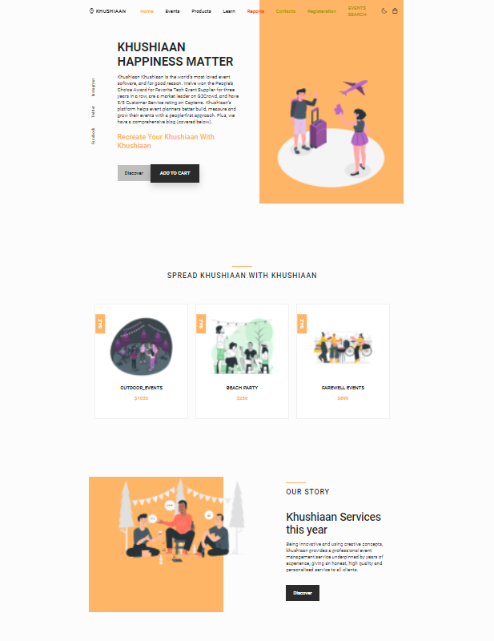

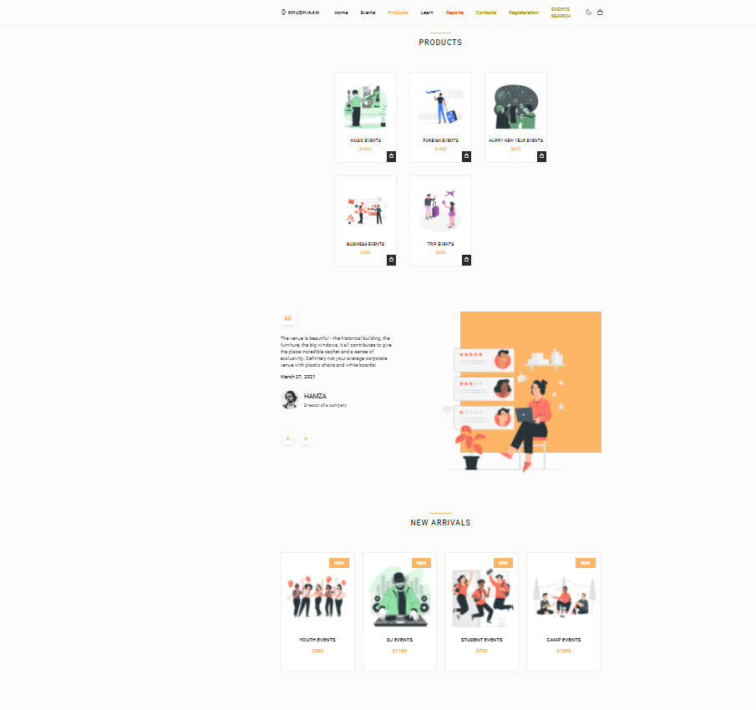



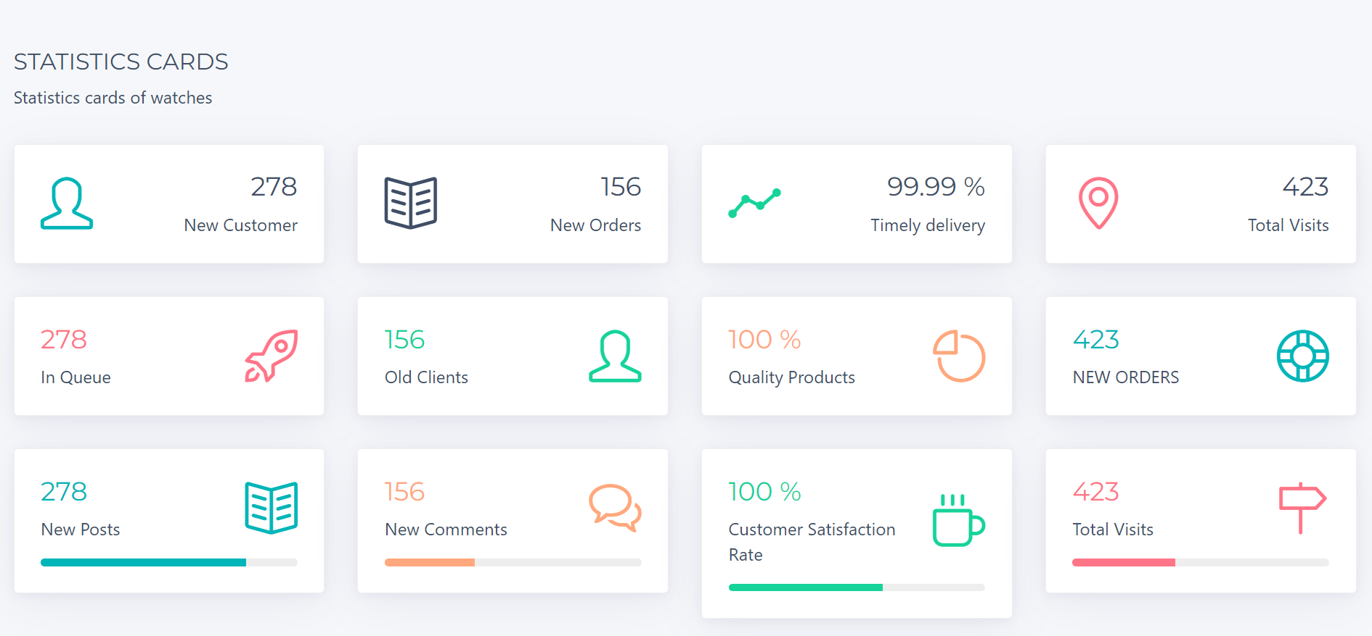

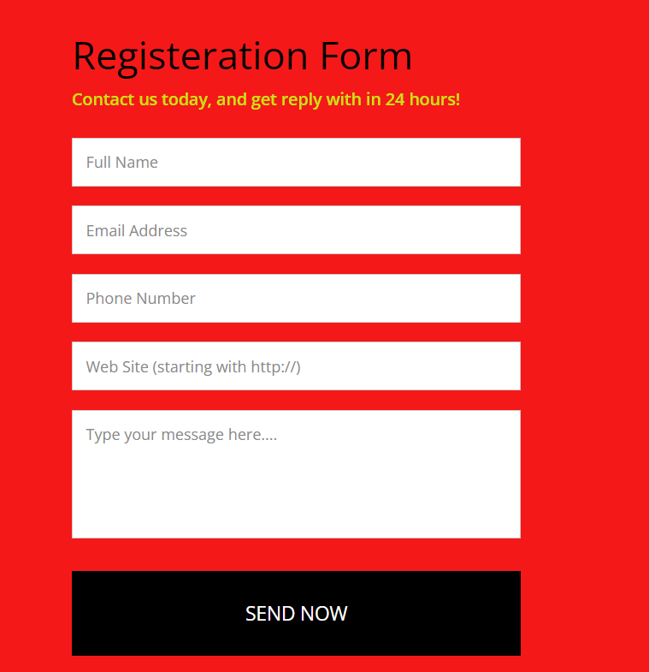

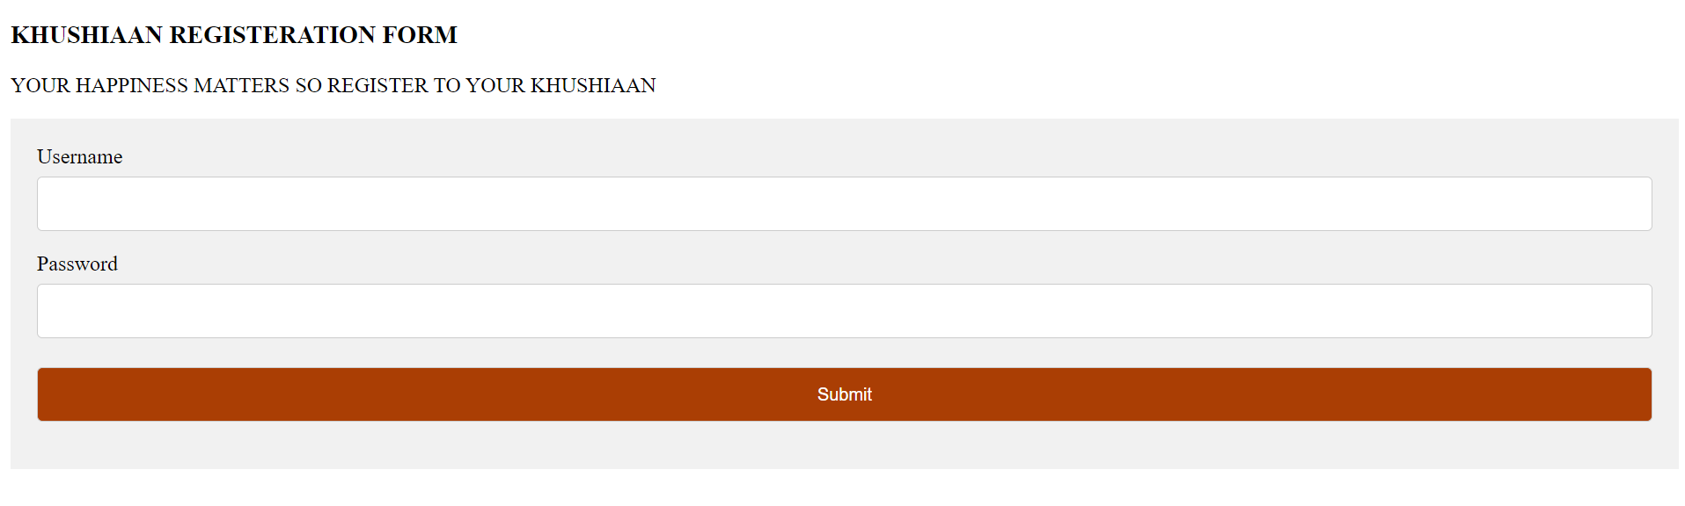

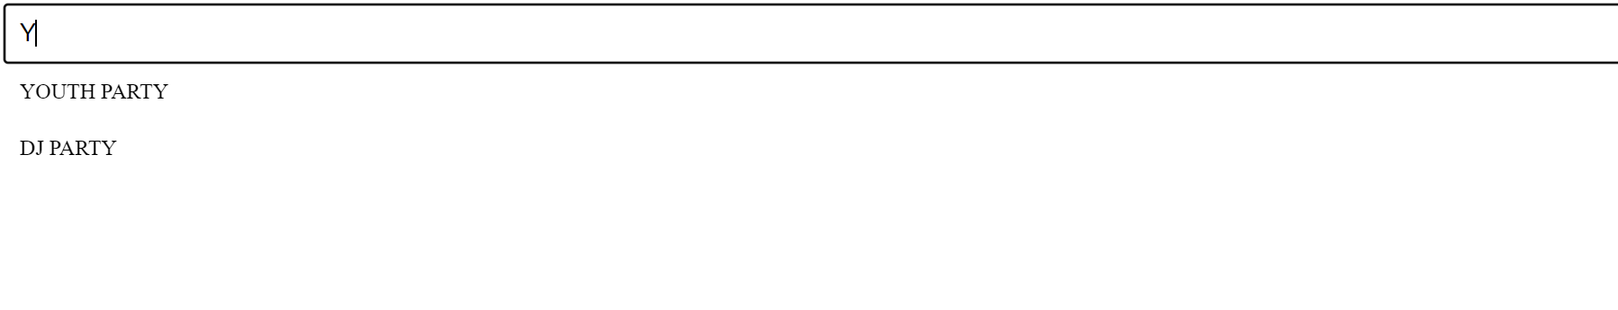

GITHUB LINK:

https://github.com/shaheen0987/OEL-WEB.git

**OEL SPRING 2021**

Student Name: _____________________ Semester: **6(B)**

**Web Engineering OEL Rubrics**

|  |  |  |  |  |
| --- | --- | --- | --- | --- |
| **CATEGORY** | **Excellent (1)** | **Good (0.5)** | **Poor (0)** | **Marks** |
| Layout | The Web site has an exceptionally attractive and usable layout. It is easy to locate all-important elements. Layout must include all semantic tags | The Web pages have an attractive and usable layout. It is easy to locate all important elements. | The Web pages have a usable layout, but may appear busy or boring. It is easy to locate most of the important elements. |  |
| Field Selection | Approximately 5 different field and more included in webpage | Approximately 4 different field is included in webpage  And 1 or 2 same type of filed | Approximately 2 different field is included in webpage  And 2 or 3 same type of filed |  |
| Html Validation | Html Validation was done on whole form | Html Validation was done on some fields | Html Validation was done on few fields |  |
| Color | Colors of background, fonts, unvisited and visited links form a pleasing palette, do not detract from the content, and are consistent across page. | Colors of background, fonts, unvisited and visited links do not detract from the content, and are consistent across page. | Colors of background, fonts, unvisited and visited links do not detract from the content. |  |
| Responsiveness | Student uses a style sheet to define attributes (along with some inline style), which makes page attractive looking, | Student uses a style sheet, however there is some inconsistencies in relation to the styles on some elements on the webpage. | Student uses a style sheet, however, it is not consistent on page, which disrupts consistency of page. |  |
| Graphics and images | Graphics are related to the theme or purpose of the site, are of high quality and enhance reader interest or understanding. Images include animation and other styling | Graphics are related to the theme or purpose of the site, are of good quality and enhance reader interest or understanding. Limited animation applied on images | Graphics are of fair design, unoriginal, with elements that need enhancing. |  |
| Java script Validation | All Fields include Java script validation | Majority of fields include Java Script validation | Few Fields include Java Script validation |  |
| Java script functions Implementation | Use of different mathematical function and string function used in a web page as discussed in class | Use of different mathematical function in a web page as discussed in class | Use of different string function used in a web page as discuss in class |  |
| Manipulation operation | Manipulation operation is performed on all important fields professionally | Manipulation operation is performed on numeric fields professionally | Manipulation operation is performed on string fields professionally |  |

**Teacher Signature: ____________________________________**