Hospital Patient Triage & Bed Allocator
Operating Systems Lab Project Final Report
Group Members:
- Samar Qayyum (24F-0703)
- Muhammad Hamza (24F-6038)
Date: May 2026

Table of Contents
- Introduction
- System Design & Architecture
- Phase 1: Shell Scripting & Environment Setup
- Phase 2: Process Management, IPC & Scheduling
- Phase 3: Threads & Synchronization
- Phase 4: Memory Management
- Testing & Valgrind Output
- Challenges & Lessons Learned
- Individual Contribution

1. Introduction
This project simulates an emergency room’s patient triage and bed allocation system. The primary goal was to build a system-level C application demonstrating core Operating System concepts, including concurrent process management, Inter-Process Communication (IPC), multithreading, synchronization, and contiguous memory allocation.

2. System Design & Architecture
The system follows a Producer-Consumer architecture divided into three main components:
- Triage Script (triage.sh): Acts as the external producer. It validates user input and pipes formatted patient data to the admissions manager.
- Admissions Manager (admissions.c): The central hub. It uses threads to queue patients, run bed allocation algorithms (Best-Fit), and spawn child processes for treatment.
- Patient Simulator (patient_simulator.c): The child processes. They simulate treatment duration and use a named FIFO to notify the admissions manager upon discharge.

3. Phase 1: Shell Scripting & Environment Setup
We utilized bash scripts to handle environment setup, teardown, and input validation.
- triage.sh: Enforces strict input validation (e.g., names must be letters only, severity 1-10) before mapping severity to a priority level (1-5).
- start_hospital.sh & stop_hospital.sh: Handles the creation and cleanup of POSIX IPC objects (FIFOs, Shared Memory, Semaphores) to ensure clean startups and graceful shutdowns.
- Makefile: Automates compilation with -Wall -Wextra -pthread and includes a make test target for rapid stress testing.
Phase 1

Clean start :
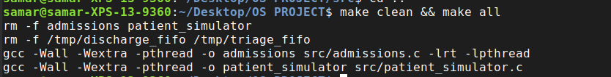
Validation :
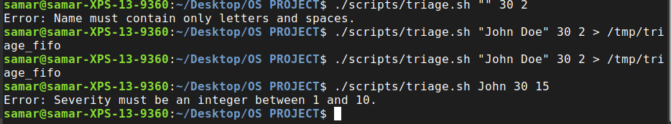
Start Hospital :
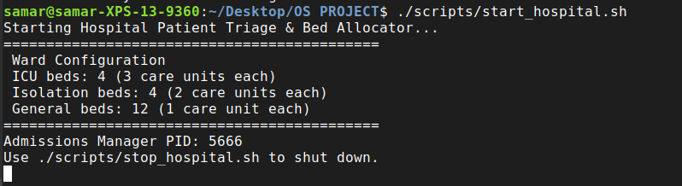
Stop Hospital :
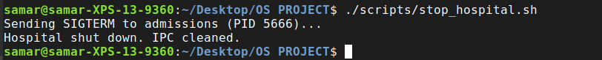

4. Phase 2: Process Management, IPC & Scheduling
This phase handles the core concurrency and communication of the hospital.

Process Management & Zombie Reaping
The Scheduler thread uses fork() and execv() to spawn a unique patient_simulator process for every admitted patient. To prevent memory leaks from terminated child processes, we implemented a SIGCHLD handler.
- How it works: When a patient finishes treatment, it sends a SIGCHLD signal to the parent. Our handler uses waitpid(-1, NULL, WNOHANG) in a while loop to reap the process immediately, ensuring no zombie processes are left behind.
Zombie Process Check:
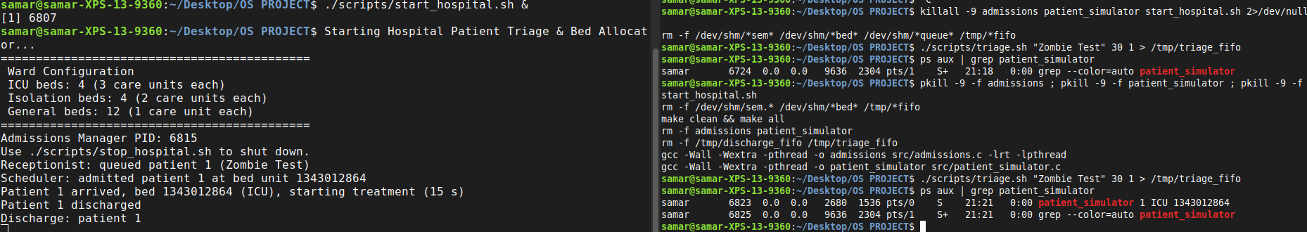

Inter-Process Communication (IPC)
- Pipes: We used an ordinary pipe (| via terminal or /tmp/triage_fifo) to send data from the triage script to the admissions process.
- Named FIFOs: The patient_simulator writes its Patient ID to /tmp/discharge_fifo upon completion. A dedicated listener thread in admissions reads this FIFO to trigger bed deallocation.
IPC Verification :

Live simulation:

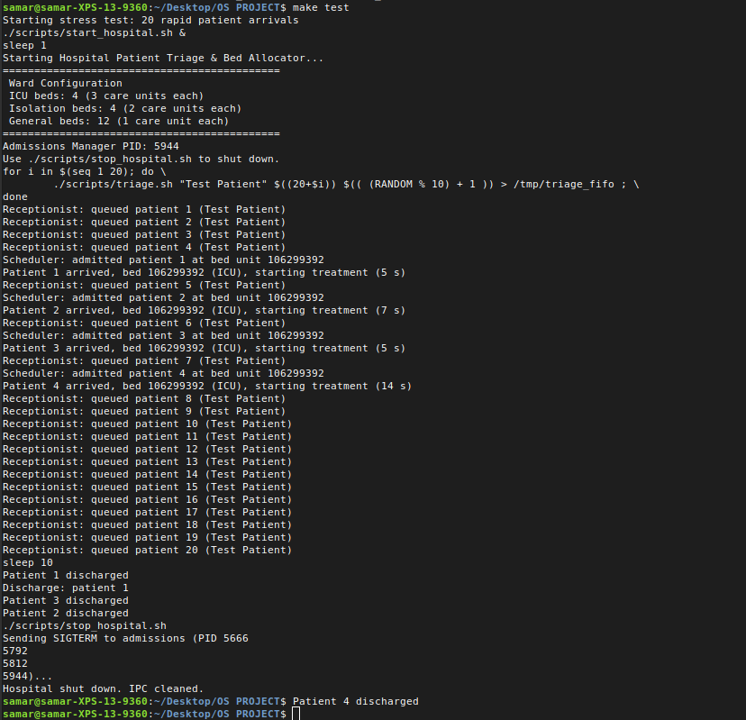

CPU Scheduling
Patients are queued using a Priority Queue (Priority 1 being the highest). We also simulated FCFS and Priority algorithms to calculate Average Waiting Time and Turnaround Time, outputting a Gantt-style log.

Screenshot 4 (The Scheduling Log)

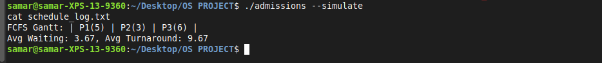

5. Phase 3: Threads & Synchronization
To handle concurrent tasks within the admissions manager, we utilized POSIX threads (pthreads) and synchronization primitives.

Thread Roles
- Receptionist Thread: Reads incoming IPC pipes and enqueues patients.
- Scheduler Thread: Dequeues patients, allocates memory, and forks child processes.
- Nurse Threads & Discharge Listener: Monitor the FIFO and broadcast signals to free up beds.

Mutexes and Condition Variables
A pthread_mutex_t strictly protects the shared memory bed bitmap to prevent data races. A condition variable (pthread_cond_t bed_freed) is used by the Scheduler. If no beds are available, the Scheduler sleeps. When a Nurse thread frees a bed, it broadcasts the condition variable to wake the Scheduler.

Semaphores & The "Ghost Semaphore" Deadlock
We used counting semaphores (sem_t) to enforce hard limits on ICU (4 beds) and Isolation (4 beds) capacities.
Technical Challenge: During testing, the hospital deadlocked. The Scheduler refused to admit patients even when beds were visually empty.
The Cause: POSIX semaphores are persistent and stored in the RAM at /dev/shm. Because the program was force-killed during early testing, "ghost" semaphores were left in memory. When the new hospital started, it read the old ghost semaphores, thought the ICU was still full, and blocked the Scheduler indefinitely.
The Solution (Nuclear Reset): We wrote a strict bash command to aggressively hunt down and clear specific Linux Mint/Ubuntu shared memory files to reset the RAM:
Bash
pkill -9 -f admissions ; pkill -9 -f patient_simulator
rm -f /dev/shm/sem.* /dev/shm/*bed* /tmp/*fifo

Screenshot 1: Semaphore Blocking
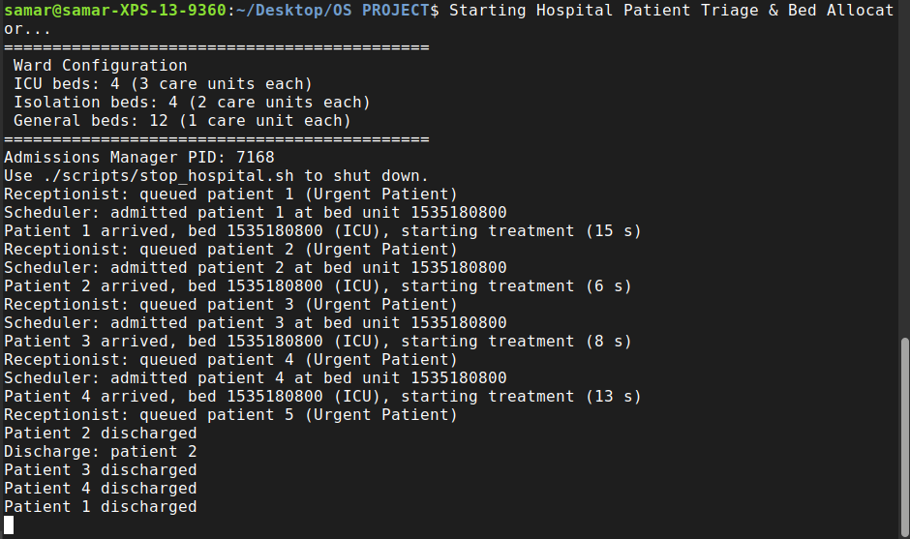

6. Phase 4: Memory Management
The hospital ward is simulated as a contiguous array of memory (Care Units).
- Allocation (Best-Fit): When the Scheduler receives a patient, it scans the shared memory bitmap to find the smallest contiguous free block of the required bed type that is large enough to hold the patient. We also successfully implemented First-Fit and Worst-Fit toggles via command-line flags.
- Coalescing: Upon discharge, adjacent free blocks are logically merged.
- Fragmentation: External fragmentation is calculated dynamically based on scattered free blocks. We also simulated internal fragmentation via Paging (assuming a 2-unit page size).

Screenshot 1: Fragmentation & Paging Log:
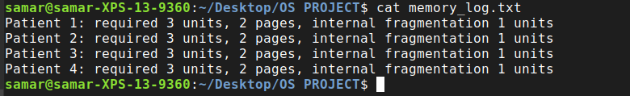

Screenshot 2: Strategy Flag Comparison:
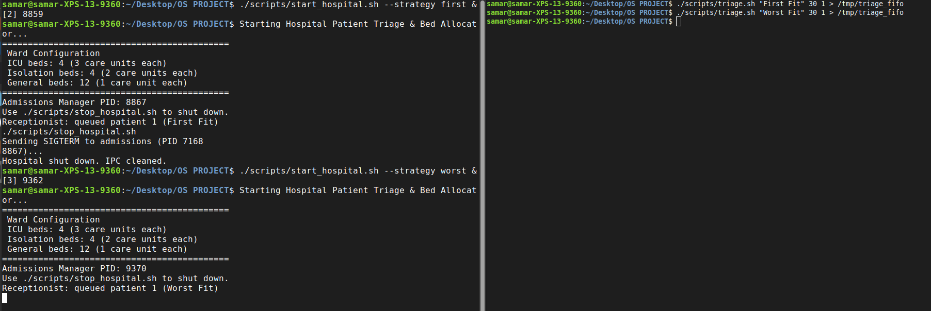

7. Testing & Valgrind Output
The system was stress-tested using rapid bash loops. To guarantee the C application handles dynamic memory safely, we ran the process through Valgrind.



8. Challenges & Lessons Learned
- The Validation Loop Trap: During stress testing, our bash loop tried to name patients "Patient 1", "Patient 2", etc. Our triage.sh validation immediately crashed the script because we strictly enforced a "letters and spaces only" rule for names. We learned that robust security validation requires equally robust testing scripts.
- Signal Handling Safety: We learned that calling waitpid inside a SIGCHLD handler can overwrite the global errno variable, corrupting other system calls. We solved this by saving and restoring errno manually inside the handler.
- IPC Persistence: Encountering the "ghost semaphore" deadlock taught us the critical difference between process memory and system-level shared memory (/dev/shm), reinforcing the need for flawless cleanup routines (stop_hospital.sh).

9. Individual Contribution
Phase | Samar Qayyum (24F-0703) | Muhammad Hamza (24F-6038)
Phase 1: Shell & Make | Authored triage.sh and validation logic | Authored start/stop scripts and Makefile
Phase 2: Process & IPC | Implemented fork/exec and SIGCHLD handler | Built FIFOs and Patient Simulator
Phase 3: Threads & Sync | Programmed Scheduler and Condition Variables | Programmed Receptionist and Semaphores
Phase 4: Memory Mgmt | Implemented Best-Fit and Coalescing | Implemented Logging and Fragmentation Calc
Testing & Documentation | Conducted edge-case testing & Valgrind | Compiled report and recorded demo video

