
THEORY OF AUTOMATA
PROJECT BASED LEARNING(PBL)

SUBMITTED BY: MUHAMMAD ZAIN ILYAS
SUBMITTED TO: SIR NAVEED YOUSAF
CLASS: CS-B-24
ID: F24605115

CREATIVE TRACK
Title: A text-based pushdown adventure game.
Name: the vault.
Project overview:
This is a browser-based text-adventure escape game in which the player must execute a precise sequence of actions to break into a secure vault and escape. The core mechanic is powered by a Pushdown Automaton (PDA): every player action is an input symbol, the player's acquired items form the stack, and the game is won (string accepted) only when the player reaches the ESCAPED state with the stack reduced back to the bottom marker.
The game was built for the Creative Track. The PDA is not merely a metaphor — it is the literal engine that validates or rejects every move the player makes. The interface exposes the underlying PDA state, stack top, and last input symbol in real-time so that the theoretical model is visible to the player at all times.

Technology used:
- Platform: Single-page HTML5 + JavaScript (no backend, no install)
- PDA engine: Pure JavaScript object mapping (state, inputSymbol) → transition
- Stack: JavaScript array with push/pop operations
- Interface: Real-time PDA state panel (current state, stack top, last input, alarm level)
- Trace log: Every transition recorded with pop/push description for post-game review

Mathematical model:
The system is defined as a 7-tuple:

M = (Q, Σ, Γ, δ, q0, Z0, F)
States:
There is total six states in this games that are
State | Symbol | Description
Entry Hall | q0 | Initial state — player enters the building
Corridor B | q1 | Access control zone — keycard required
Server Room | q2 | Restricted zone — data extraction
Vault Door | q3 | Final obstacle — multi-factor unlock
Escaped | qf | Accepting state — mission complete
Caught | qd | Dead/reject state — security triggered

Input alphabet:
Σ = { SEARCH_DESK, CHECK_CLOSET, TRIGGER_ALARM, SWIPE_CARD, HACK_TERMINAL, DISABLE_CAMERA, SEARCH_SERVERS, COPY_CODE, DOWNLOAD_SCHEMA, USE_KEY, ENTER_CODE, USE_RETINAL }
Stack alphabet:
Γ = { ⊥, KEYCARD, VAULT_KEY, ACCESS_GRANTED, PARTIAL_CODE, SERVER_DATA, OVERRIDE_CODE, LOCK_OPEN, SCHEMATICS }
⊥ (bottom-of-stack marker) is always pushed first and must be the only symbol remaining on the stack when the accepting state is reached.

Initial state:
q0 = q_Entry Z0 = ⊥
Accepting state:
F = { qf } (ESCAPED)
Acceptance condition: the PDA reaches qf and the stack contains only ⊥.

Transition function:
The transition function δ is defined as:

δ(current_state, input_symbol, stack_top) → (next_state, stack_operation)

A transition fires only if the required stack items are present. If the precondition is not met, the machine enters an implicit error configuration and the alarm level increases.

Transition table:

From State | Input Symbol | Stack Precondition | Stack Operation | To State
q0 (Entry) | SEARCH_DESK | — | push KEYCARD | q0
q0 (Entry) | CHECK_CLOSET | — | push VAULT_KEY | q1
q0 (Entry) | TRIGGER_ALARM | — | — | qd
q1 (Corridor) | SWIPE_CARD | KEYCARD on stack | pop KEYCARD, push ACCESS_GRANTED | q2
q1 (Corridor) | HACK_TERMINAL | — | push PARTIAL_CODE | q1 (alarm+1)
q1 (Corridor) | DISABLE_CAMERA | — | no change | q1
q2 (Server) | SEARCH_SERVERS | — | push SERVER_DATA | q2
q2 (Server) | COPY_CODE | SERVER_DATA on stack | pop SERVER_DATA, push OVERRIDE_CODE | q3
q2 (Server) | DOWNLOAD_SCHEMA | — | push SCHEMATICS | q2 (alarm+1)
q3 (Vault) | USE_KEY | VAULT_KEY on stack | pop VAULT_KEY, push LOCK_OPEN | q3
q3 (Vault) | ENTER_CODE | OVERRIDE_CODE + LOCK_OPEN | pop both → stack = {⊥} | qf (ACCEPT)
q3 (Vault) | USE_RETINAL | — | — | qd (REJECT)

Canonical accepting computation:
The shortest accepted input string is:

w = CHECK_CLOSET · SWIPE_CARD · SEARCH_SERVERS · COPY_CODE · USE_KEY · ENTER_CODE

Table:

Step | Input Symbol | State Before | Stack Before | Stack After | State After
0 | — | q0 | [ ⊥ ] | [ ⊥ ] | q0
1 | CHECK_CLOSET | q0 | [ ⊥ ] | [ ⊥, VAULT_KEY ] | q1
2 | SWIPE_CARD | q1 | [ ⊥, VAULT_KEY ] | [ ⊥, VAULT_KEY, ACCESS_GRANTED ] | q2
3 | SEARCH_SERVERS | q2 | [ ⊥, VAULT_KEY, ACCESS_GRANTED ] | [ ..., SERVER_DATA ] | q2
4 | COPY_CODE | q2 | [ ..., SERVER_DATA ] | [ ..., OVERRIDE_CODE ] | q3
5 | USE_KEY | q3 | [ ..., OVERRIDE_CODE ] | [ ..., OVERRIDE_CODE, LOCK_OPEN ] | q3
6 | ENTER_CODE | q3 | [ ..., OVERRIDE_CODE, LOCK_OPEN ] | [ ⊥ ] | qf ✓

At step 6, the stack is reduced to { ⊥ } and the machine enters qf. This satisfies the acceptance condition → the string is ACCEPTED.
Test cases:
5 success cases:
# | Input Sequence | Final State | Result | Notes
1 | CHECK_CLOSET → SWIPE_CARD → SEARCH_SERVERS → COPY_CODE → USE_KEY → ENTER_CODE | qf | ACCEPT | Canonical shortest path
2 | SEARCH_DESK → CHECK_CLOSET → DISABLE_CAMERA → SWIPE_CARD → SEARCH_SERVERS → COPY_CODE → USE_KEY → ENTER_CODE | qf | ACCEPT | Camera disabled before moving — extra step, still accepted
3 | CHECK_CLOSET → DISABLE_CAMERA → SWIPE_CARD → SEARCH_SERVERS → DOWNLOAD_SCHEMA (alarm+1) → COPY_CODE → USE_KEY → ENTER_CODE | qf | ACCEPT | Alarm raised but below threshold — still reaches qf
4 | SEARCH_DESK → CHECK_CLOSET → SWIPE_CARD → SEARCH_SERVERS → SEARCH_SERVERS → COPY_CODE → USE_KEY → ENTER_CODE | qf | ACCEPT | Redundant SEARCH_SERVERS — stack accumulates then clears correctly
5 | CHECK_CLOSET → HACK_TERMINAL (alarm+1) → SWIPE_CARD → SEARCH_SERVERS → COPY_CODE → USE_KEY → ENTER_CODE | qf | ACCEPT | Risky path — alarm raised in Corridor but mission succeeds

5 failed cases (rejected strings)
# | Input Sequence | Final State | Result | Notes
1 | TRIGGER_ALARM | qd | REJECT | Immediate dead state — alarm transition from q0
2 | CHECK_CLOSET → ENTER_CODE | qd | REJECT | ENTER_CODE fired without OVERRIDE_CODE or LOCK_OPEN on stack — precondition fails → alarm max → caught
3 | CHECK_CLOSET → SWIPE_CARD → COPY_CODE (no SERVER_DATA) | qd | REJECT | COPY_CODE requires SERVER_DATA on stack — not present, repeated fails trigger lockdown
4 | USE_RETINAL | qd | REJECT | Retinal scanner fired without credentials — security lockdown immediately
5 | CHECK_CLOSET → SWIPE_CARD → SEARCH_SERVERS → COPY_CODE → ENTER_CODE (no LOCK_OPEN) | qd | REJECT | LOCK_OPEN missing — vault requires both OVERRIDE_CODE and LOCK_OPEN simultaneously

Complexity and non trivial functions:
Stack based access control:
Every locked action requires a specific stack configuration. The ENTER_CODE transition requires two items simultaneously (OVERRIDE_CODE and LOCK_OPEN), which is a genuine multi-symbol stack check. This is not achievable with a DFA or NFA — it requires the full power of a PDA.

Alarm level as a parallel counter:
The alarm system acts as a parallel integer counter (0–5) that tracks cumulative invalid transitions. Reaching alarm level 5 forces a transition to the dead state qd regardless of current state. This models a real-world security system and adds non-trivial branching logic on top of the base PDA.

Non determinism via optional paths:
Several actions (DISABLE_CAMERA, DOWNLOAD_SCHEMA, SEARCH_DESK) are optional and do not block the main accepting path. The PDA is deterministic in its core transitions but the player experiences non-determinism in the sense that multiple accepted strings exist — some shorter, some with more stack tokens accumulated.
Stack residue and rejection:
A key property of the acceptance condition is that the stack must be empty (only ⊥ remains) when qf is reached. An incomplete run — such as reaching the vault without USE_KEY — will fail ENTER_CODE because LOCK_OPEN is absent. This enforces ordering constraints that a regular grammar cannot express.

Screen shots:
Starting state:
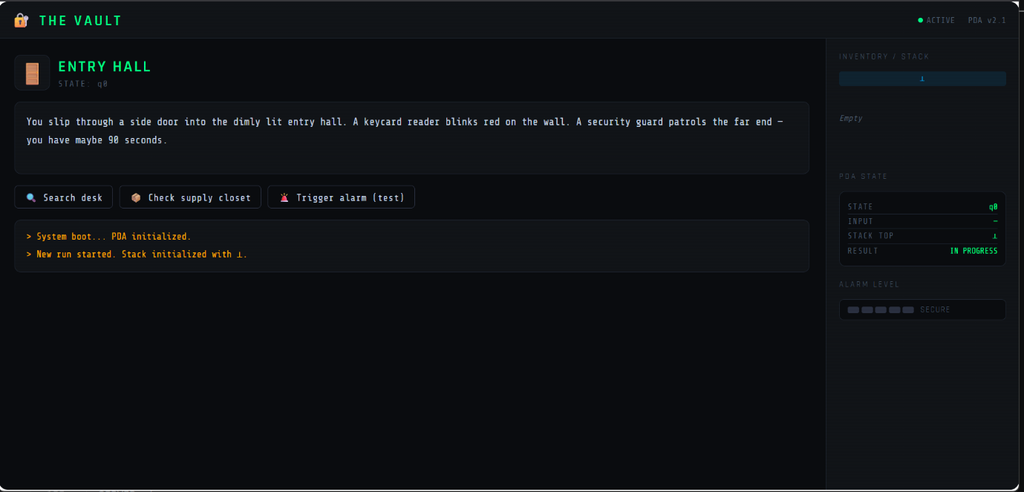
Entering second state:
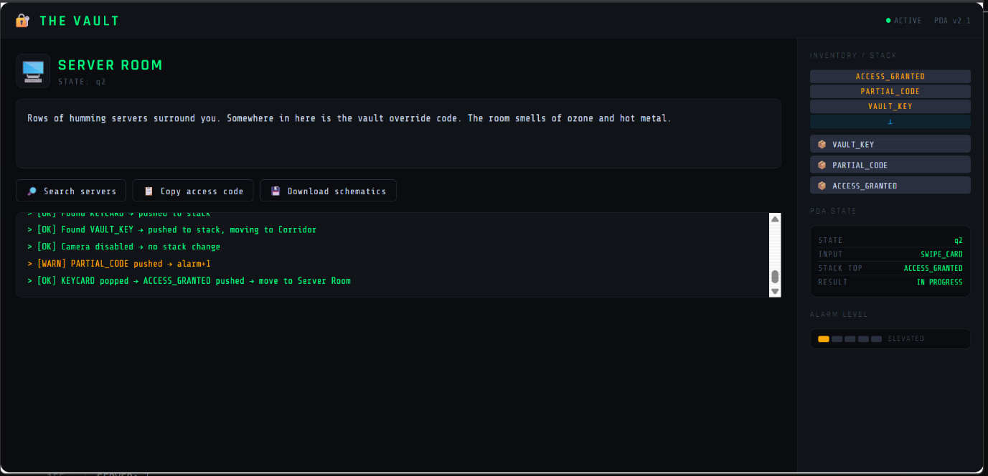

Third state:
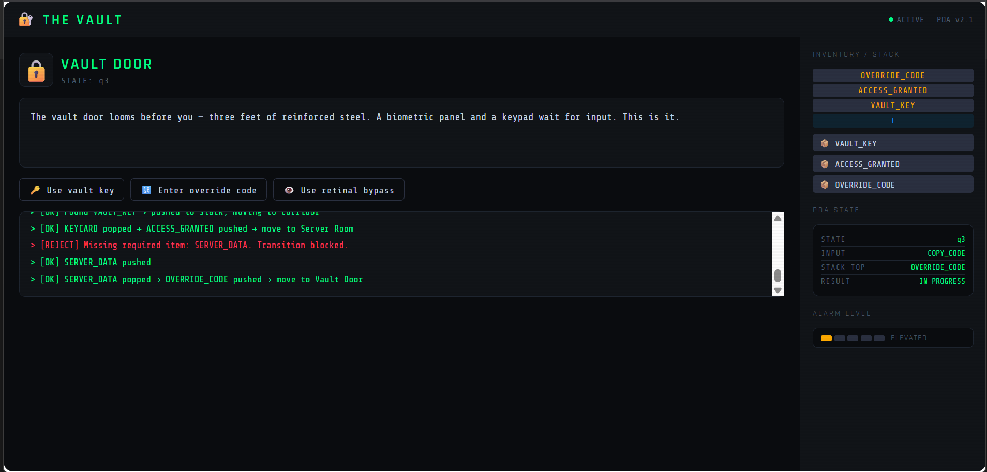
Dead end state:
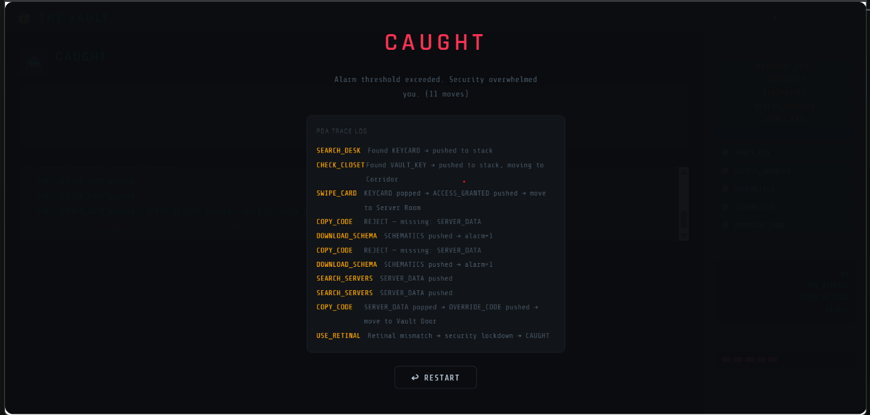

Final state:
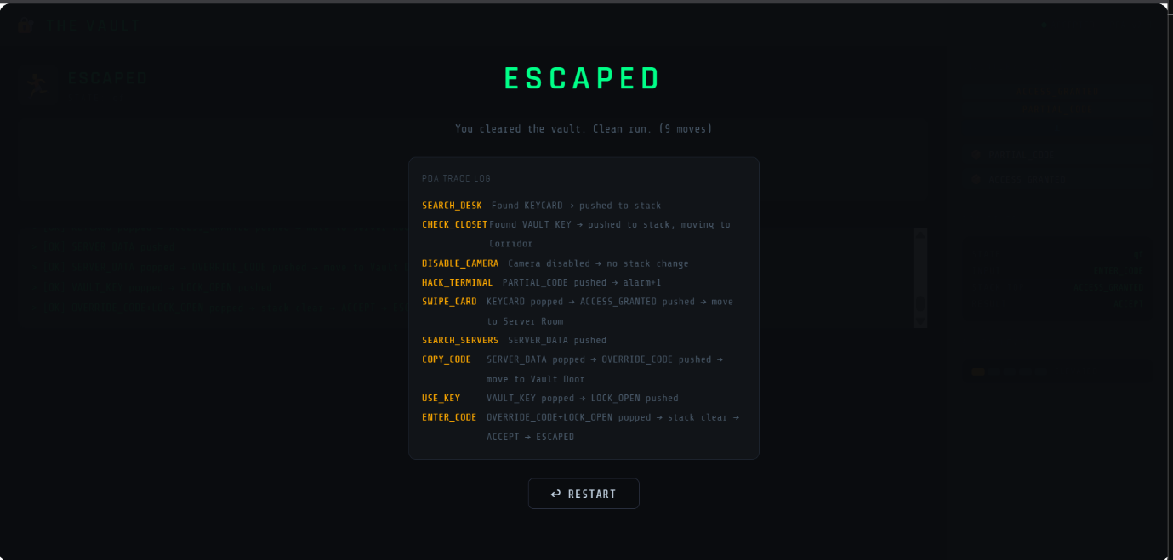

References:
I deploy this game on Netlify drop
click this link to play
git-hub repo link:
https://github.com/zainilyas2005/TOA_pbl.git

