This is the database design in sql server

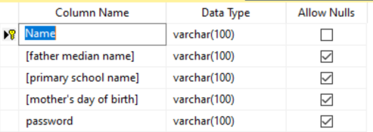

To establish a connection with sql server using ado.net to you may use instructions in the video url bellow

https://youtu.be/ZX7_12fwQLU?t=493

the first tab in the application is for adding a user .

the second tab is for resetting the password for the added user .

