Club Management system(group project)

### Overview:

### The following document encloses the following diagrams:

### Use case diagram

### Class diagram

### Object diagram

### Sequence diagram

### Collaboration diagram

### Activity diagram

### Statechart diagram

### Component diagram

### The project is about an online club management system in which members of the club can log in and view various options such as the option to view all the available facilities in the club such courts, pools, multi purpose halls, drink bar and café, gym etc etc.

### The members will also have access to a message board which doubles as an Information center and chatting platform, the schedules for various events being held in the club are also listed here. The schedules for the maintenance of facilities and reserved facilities are also shown here and members have the convenience of being able to reserve halls, grounds and other facilities in advance for their own use or for private functions.

### The system has an admin whose permission is needed to reserve the facilities and the admin overlooks the moderation in the message board as well. The admin has access to the user database and holds the right to promote or demote the membership level.

### The system has the added convenience of being compatible with online payment systems such as easy paisa and credit cards.

### The diagrams given below will shed some light on the inner workings of the system.

### Use case diagram:

The following diagram showcases the general layout and actors involved in the system. There is an admin and a user, the user has to login before using the system. The user interface allows the user to access all of the options provided by the system.

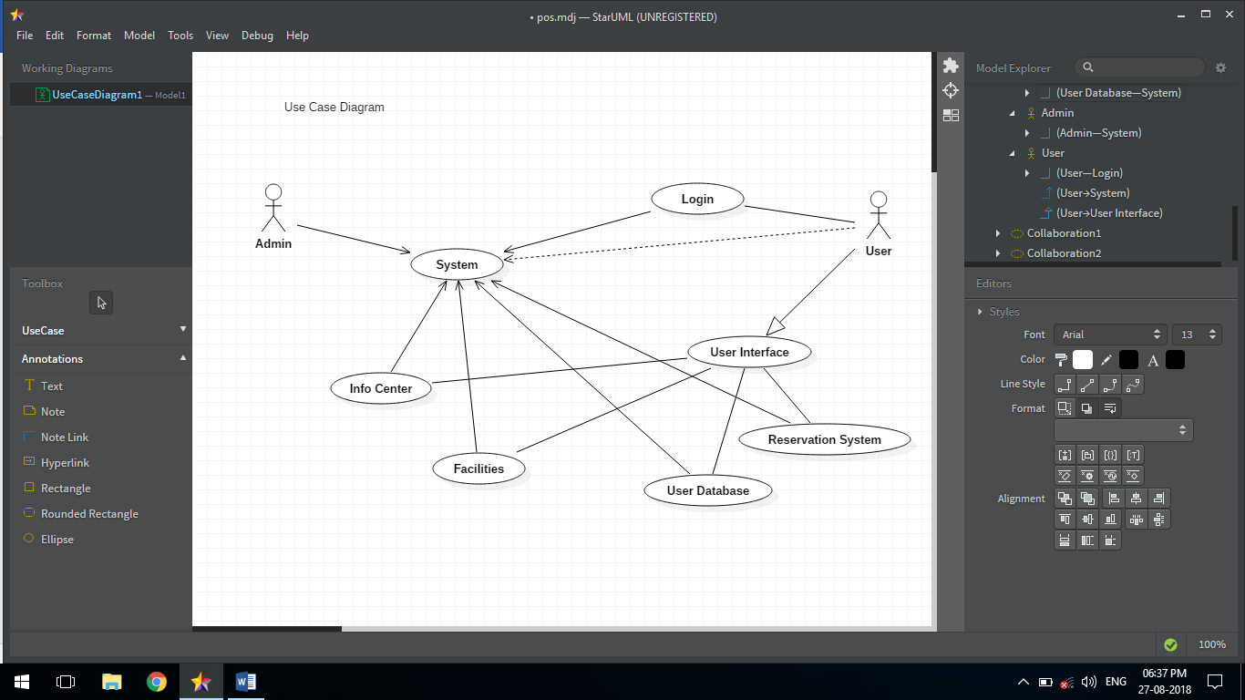

Class diagram:

The following diagram showcases how the system works, it is pretty self explanatory and easily understandable, the headings are showing the various parts of the system and the arrows and other shapes show how the various components are meshing together and their relationship with each other. The diagrams give a conceptual understanding of the system. The diagrams differ from each other according to the behavior they showcase.

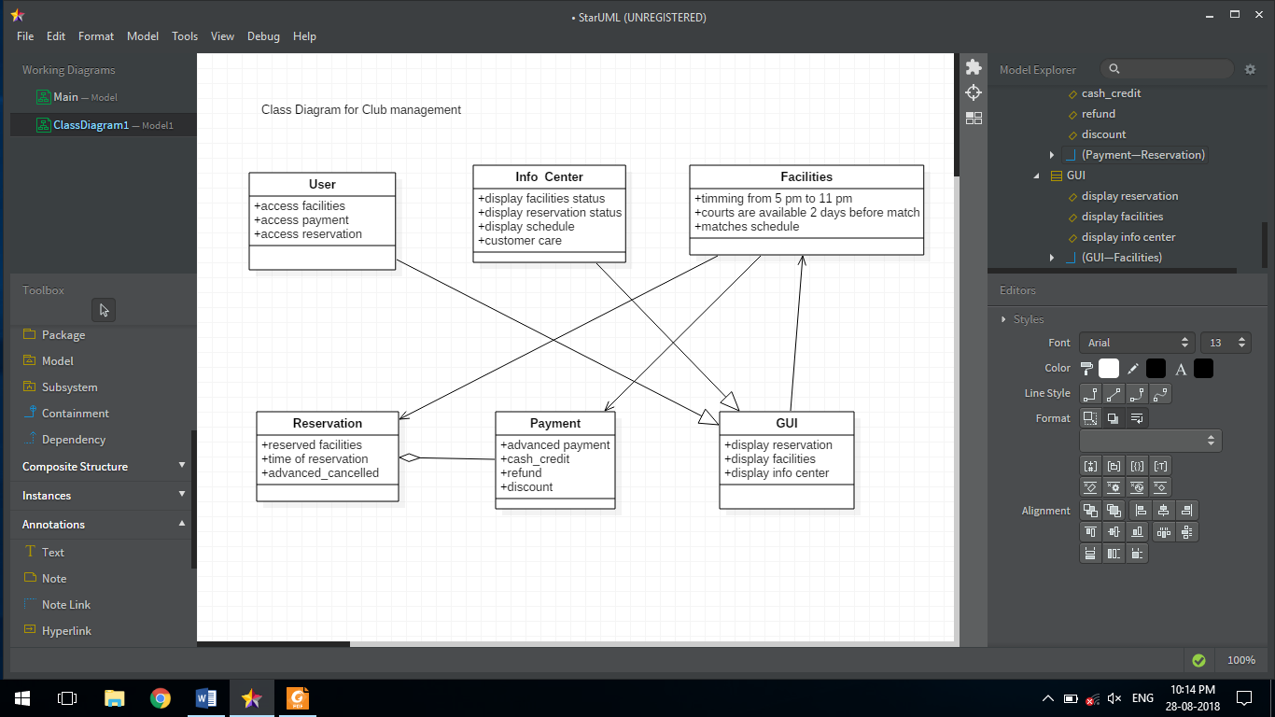

Object Diagram:

The following diagram showcases how the system works, it is pretty self explanatory and easily understandable, the headings are showing the various parts of the system and the arrows and other shapes show how the various components are meshing together and their relationship with each other. The diagrams give a conceptual understanding of the system. The diagrams differ from each other according to the behavior they showcase.

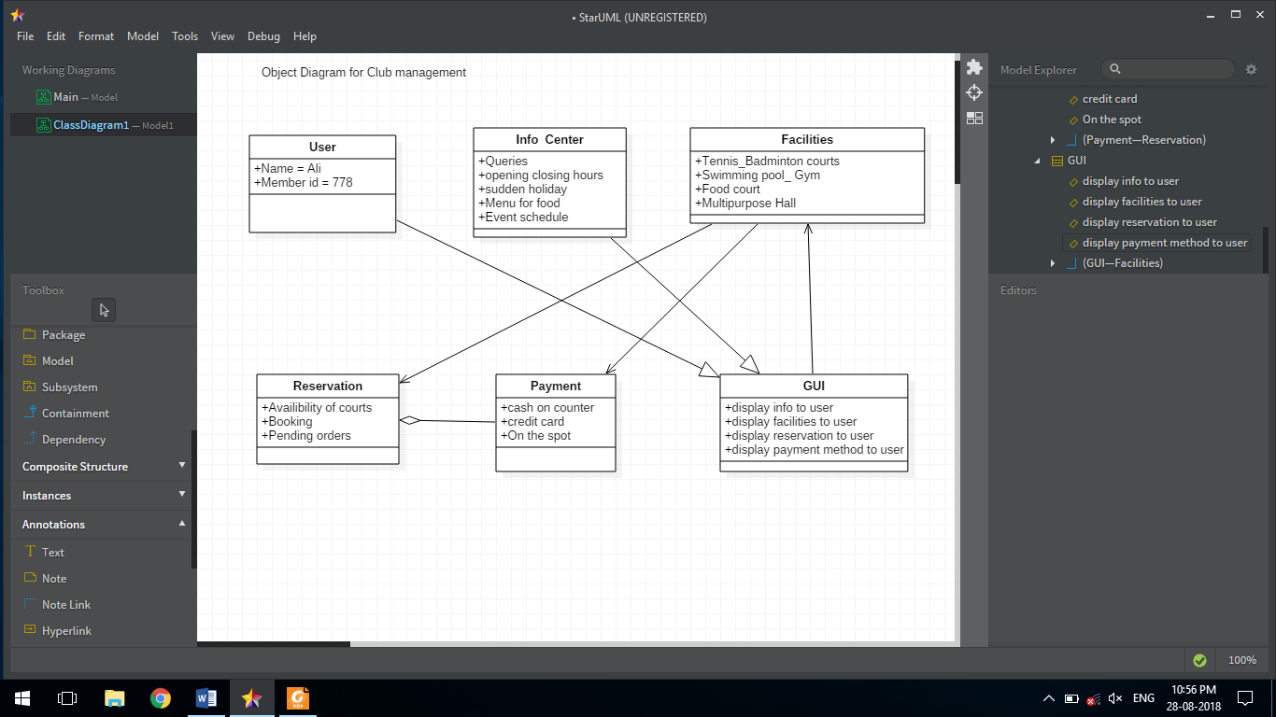

Statechart Diagram:

The following diagram showcases how the system works, it is pretty self explanatory and easily understandable, the headings are showing the various parts of the system and the arrows and other shapes show how the various components are meshing together and their relationship with each other. The diagrams give a conceptual understanding of the system. The diagrams differ from each other according to the behavior they showcase.

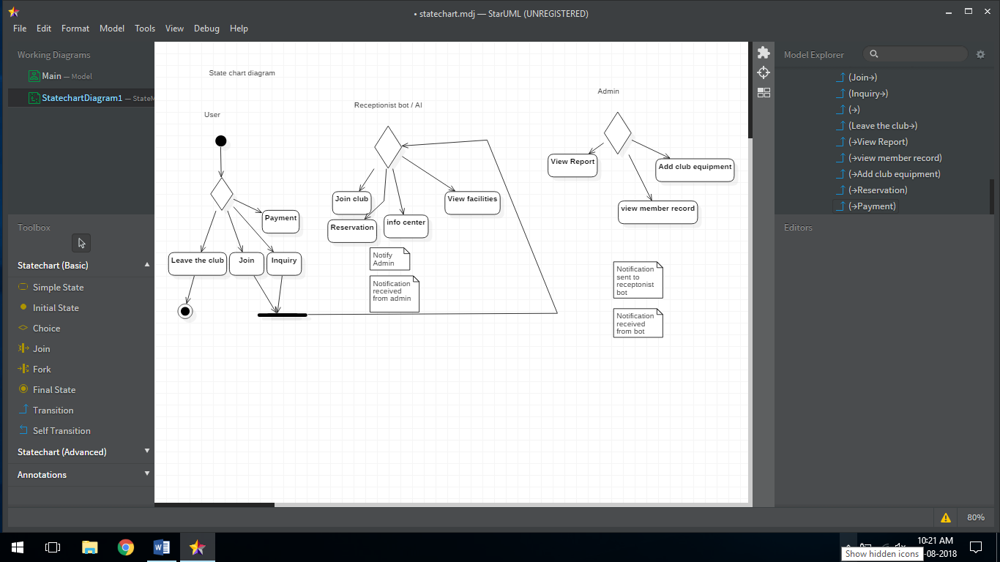

Activity Diagram:

The following diagram showcases how the system works, it is pretty self explanatory and easily understandable, the headings are showing the various parts of the system and the arrows and other shapes show how the various components are meshing together and their relationship with each other. The diagrams give a conceptual understanding of the system. The diagrams differ from each other according to the behavior they showcase.

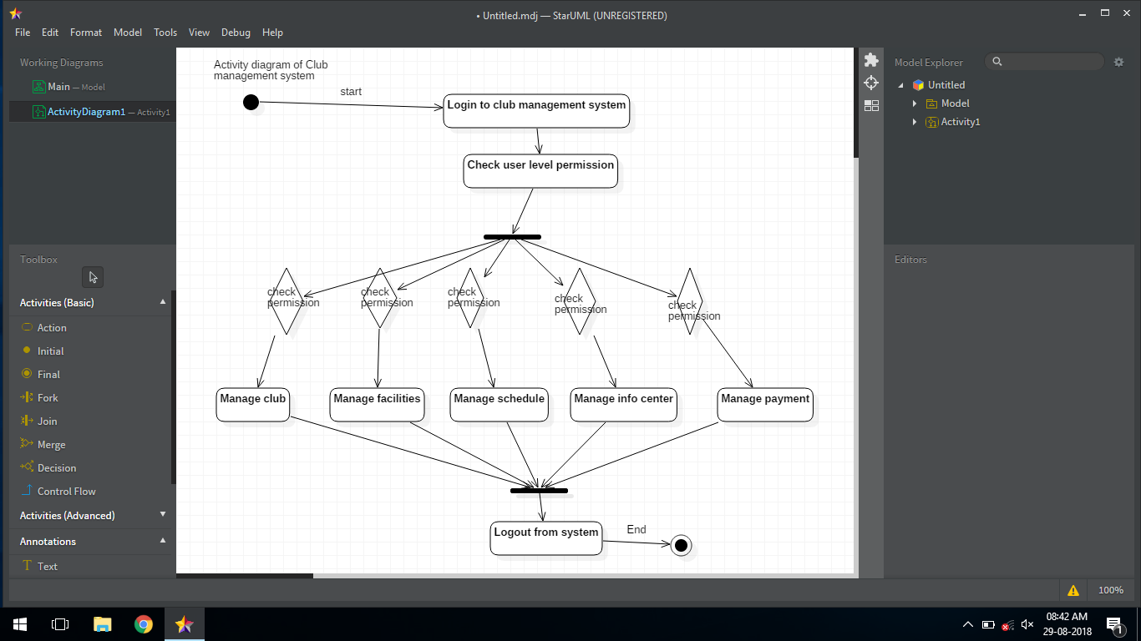

Component Diagram:

The following diagram showcases how the system works, it is pretty self explanatory and easily understandable, the headings are showing the various parts of the system and the arrows and other shapes show how the various components are meshing together and their relationship with each other. The diagrams give a conceptual understanding of the system. The diagrams differ from each other according to the behavior they showcase.

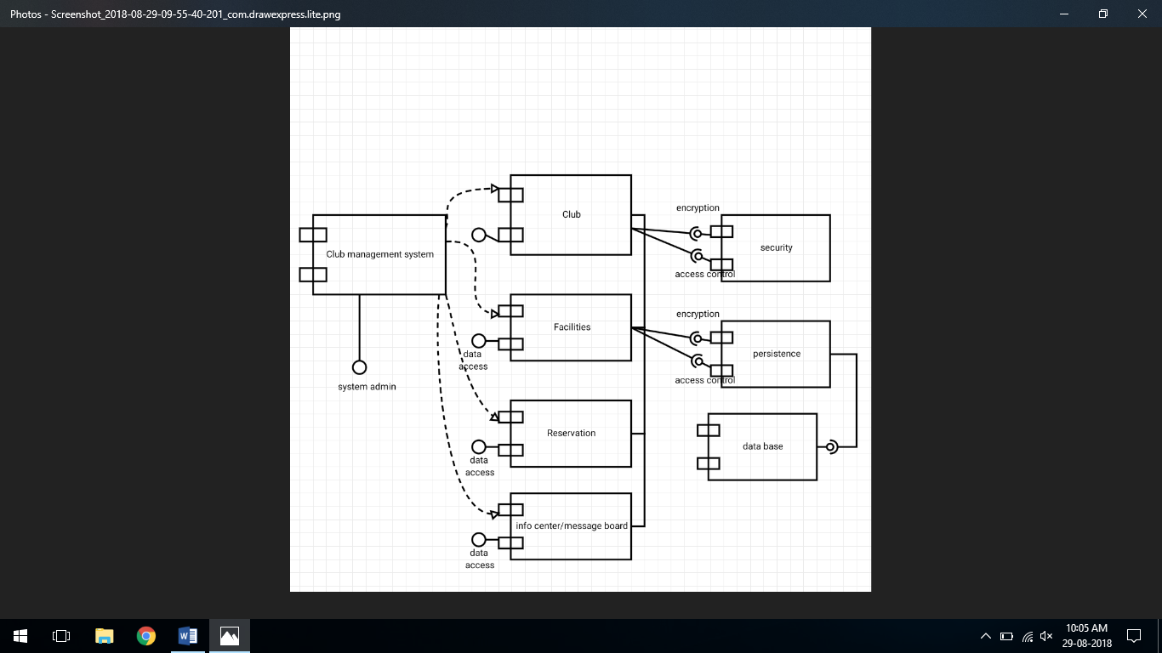

Collaboration Diagram:

The following diagram showcases how the system works, it is pretty self explanatory and easily understandable, the headings are showing the various parts of the system and the arrows and other shapes show how the various components are meshing together and their relationship with each other. The diagrams give a conceptual understanding of the system. The diagrams differ from each other according to the behavior they showcase.

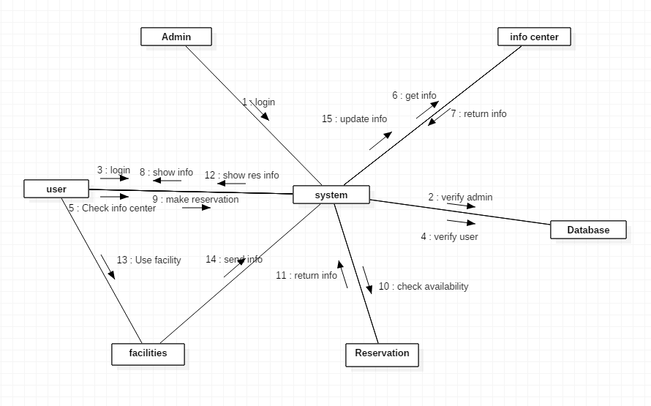

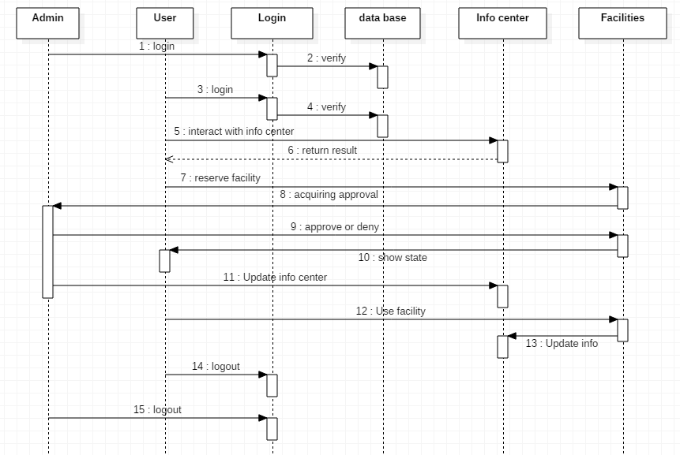Sequence Diagram:

The following diagram showcases how the system works, it is pretty self explanatory and easily understandable, the headings are showing the various parts of the system and the arrows and other shapes show how the various components are meshing together and their relationship with each other. The diagrams give a conceptual understanding of the system. The diagrams differ from each other according to the behavior they showcase.