**Experiments with features (The following should be done for headlines and content separately)**

**TFIDF**

* Try different n gram’s

**Word2Vec**

* Use Google pre-trained model and create features based on that for the current dataset
* Fine-tune the google pre-trained model for our dataset: Problem of using pre-trained word embedding is that they are unable to deal with out-of-vocabulary (OOV) words, i.e. words that have not been seen during training. Typically, such words are set to the UNK token and are assigned the same vector, which is an ineffective choice if the number of OOV words is large.
* Training from scratch (Won't really work because the neural network needs a lot of data to learn the weights)
* For parameters we can fine-tune the model based on both Continuous bag of words and skip grams.

**Experiment with models (The following should be tested with all the possible features experimented above**

**SVM**

* Different kernel functions

**Logistic Regression**

* Hyper parameters (L1,L2)

**Naïve Bayes**

**Model Pipeline**

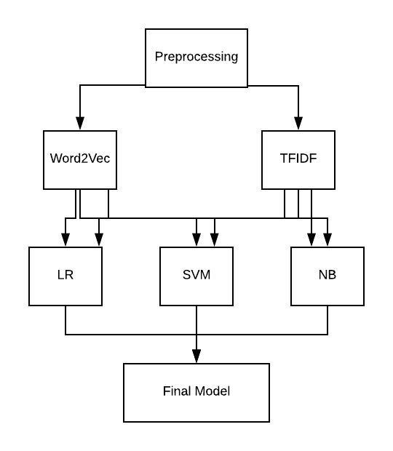

**Experiment 1:**

**Text to Features:** TFIDF using the article content (Try different n grams)

**Classification Model:** Logistic Regression (Different Penalties)

**Experiment 2:**

**Text to Features:** TFIDF using the article content (Try different n grams)

**Classification Model:** Support Vector Machine

**Experiment 3:**

**Text to Features:** Word2Vec (Hyper parameter)

**Classification Model:** Support Vector Machine

**Experiment 3:**

**Text to Features:** TFIDF, Keywords, Length of each article

**Classification Model:**

**Imbalanced classes**

**Different preprocessing**